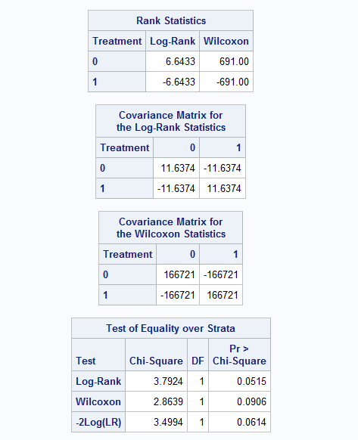

We would like to test the hypothesis of no difference in the rate of staphylococcus infection between patients whose burns were cared for with a routine bathing care method versus those whose body cleansing was initially performed using 4% chlorhexidine gluconate. We set up the hypothesis as follows:

With h1(t) and h2(t) defined as follows

h1(t) : hazard rate of 4% chlorhexidine gluconate cleansing method

h2(t): hazard rate of routine bathing method

So from the above table we can discern a log-rank Chi-square statistic of 3.7924 with a p-value of 0.0515 which is greater than 0.05. This implies we will not reject H0 at 5% significance level and conclude that there is no significant difference between the hazard rates.

For the Gehan-Wilcoxon test, the test statistic is 2.8639 and we have a p-value of 0.0906 and we conclude the same as for the log-rank test. We do not reject H0 and conclude that there is no significant difference between the hazard rates.

