|  |  |  |
| --- | --- | --- |
| Assignment 5 | September 17  15338673 | |
| PW Janse van Rensburg | | Survival Analysis |

Contents

Question 1 2

Question 2 3

Question 3 4

8.4.a) 4

8.4.b) 5

8.4.d) 6

8.4.e&f) 7

Appendix A 8

SAS Code 8

R Code 10

# Question 1

We are testing the hypothesis whether the distribution of times to infection for the routine bathing are the same as for the chlorhexidine gluconate dressing, without any model assumptions. Formally, we have the following hypothesis:

H0: hroutine(t) = hchlorh(t) vs H1: hroutine(t) ≠ hchlorh(t)

**Figure 1: Kaplan-Meier estimate of survival vs time to infection (days)**

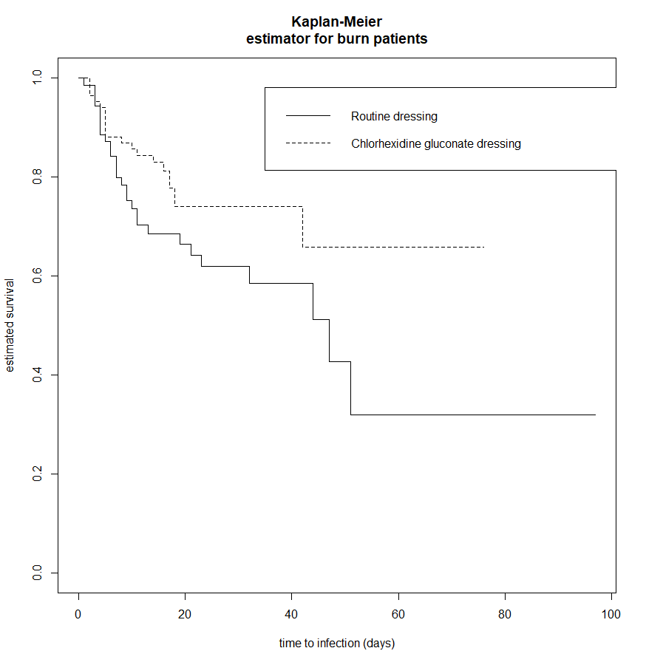

**Table 1: Tests for Staphylococcus infection**

|  |  |  |  |
| --- | --- | --- | --- |
| Test of Equality over Strata | | | |
| Test | **ꭓ2 statistics** | **DF** | **p-value** |
| Log-Rank | 3.7924 | 1 | 0.0515 |

Utilizing the log-rank test, we have a p-value of 0.0515. It is on the upper limit of the rejection region, but we still accept the hypothesis that there is no difference between the hazard rates for the routine bathing and the chlorhexidine gluconate dressing.

# Question 2

**Table 2: Tests for Staphylococcus infection using Breslow and Efron’s method**

|  |  |  |  |  |  |  |
| --- | --- | --- | --- | --- | --- | --- |
| Cox model summary | | | | | | |
| Test | Breslow | | | Efron | | |
|  | **ꭓ2 statistics** | **DF** | **p-value** | **ꭓ2 statistics** | **DF** | **p-value** |
| Likelihood ratio test | 3.71 | 1 | 0.05 | 3.73 | 1 | 0.05 |
| Wald test | 3.64 | 1 | 0.06 | 3.66 | 1 | 0.06 |
| Score (logrank) test | 3.74 | 1 | 0.05 | 3.76 | 1 | 0.05 |

For the proportional hazards model, we adjust the hypothesis as follows:

$$H_{0}: β_{treat}=0$$

We have a model of the form:

$${h(t|Z)=h}_{0}\left(t\right)e^{β_{treat}Z_{treat}}$$

Where,

$$Z_{treat}=1 if the body cleansing treatment was applied, 0 otherwise$$

$$β_{treat}≡associated coefficient for the treatment dummy variable$$

$$h_{0}\left(t\right)≡the baseline hazard rate (associated with the routine bathing treatment, i.e. Z_{treat}=0)$$

From Table 2 we can see that for all the associated tests (Likelihood ratio, Wald and Score tests) and for the Breslow and Efron methodologies, the p-values are on the upper limit of the rejection region, but none exceed the 0.05 threshold. We can therefore not reject the null hypothesis, the same as when we made no model assumptions.

# Question 3

We estimate a model as follows:

$$h\left(t | Z\right)=h_{0}\left(t\right)e^{β_{rad}Z_{rad}+β_{BPA}Z_{BPA}}$$

Where,

$$Z_{rad}=1 if animal is in the "radiation only" group, 0 otherwise$$

$$β_{rad}≡the associated coefficient of Z_{rad}$$

$$Z_{BPA}=1 if animal is in the "radiation plus BPA" group, 0 otherwise$$

$$β_{BPA}≡the associated coefficient of Z_{BPA}$$

$h_{0}\left(t\right)≡the baseline hazard rate (associated with the untreated animal, i.e. Z_{rad}=0 and Z_{BPA}=0)$

**Table 3: Maximum likelihood estimates of the coefficients of the proportional hazards model for cancer rats using the Breslow method**

|  |  |  |  |  |  |  |
| --- | --- | --- | --- | --- | --- | --- |
| Analysis of Maximum Likelihood Estimates | | | | | | |
| Parameter | **DF** |  | **σ** | **ꭓ2** | **p-value** | **Hazard Ratio** |
| $$β_{rad}$$ | 1 | -1.81196 | 0.55971 | 10.4802 | 0.0012 | 0.163 |
| $$β_{BPA}$$ | 1 | -3.55737 | 0.75825 | 22.0104 | <.0001 | 0.029 |

## 8.4.a)

From table 3 we can see that $\hat{β_{rad}}= -1.81196 (σ_{rad}= 0.55971)$ and the variable $Z_{rad}$ is significant in the model with a p-value = 0.0012 which is less than 0.05 (and we therefore reject $H_{0}:β_{rad}=0$ at a 0.05 confidence level). Similarly $\hat{β_{BPA}}= -3.55737 (σ_{BPA}= 0.75825)$ with a p-value < 0.001.

For a 95% confidence interval for the relative risk of death of a radiated animal only compared to an untreated animal we define the relative risk as:

$$RR(radiated only/untreated)= \frac{h_{0}\left(t\right)e^{\hat{β_{rad}}}}{h_{0}(t)}$$

Using the asymptotic normality of $\hat{β_{rad}}$ a 95% confidence interval for the relative risk is:

$$e^{-1.81196±1.96×0.55971}$$

Which gives us: (0.05453069,0.4892271)

## 8.4.b)

**Table 4: Tests for effect of radiation and radiation plus BPA treatments on rats using Breslow method**

|  |  |  |  |
| --- | --- | --- | --- |
| Testing Global Null Hypothesis: BETA=0 | | | |
| Test | **ꭓ2** | **DF** | **p-value** |
| Likelihood Ratio | 27.3707 | 2 | <.0001 |
| Score | 31.7386 | 2 | <.0001 |
| Wald | 22.4464 | 2 | <.0001 |

We wish to test:

$$H_{0}: β_{rad}=β_{BPA}=0$$

From table 4 we can see that for all 3 tests (Likelihood Ratio, Score and Wald) the p-values are below 0.05. For the likelihood ratio the p-value is < 0.0001 and similarly the p-value for the Score test < 0.0001 and the p-value for the Wald test is < 0.0001.

We can therefore safely reject the null hypothesis and can conclude that the radiation and radiation plus BPA does indeed have an impact on survival.

## 8.4.d)

We again refer to table 3 where we can see that $\hat{β_{rad}}= -1.81196 (σ_{rad}= 0.55971)$ and $\hat{β_{BPA}}= -3.55737 (σ_{BPA}= 0.75825)$

For a 95% confidence interval for the relative risk of death of a radiated plus BPA animal compared to a radiated only animal we define the relative risk as:

$$RR\left(radiated plus BPA/ radiated only\right)= \frac{h_{0}\left(t\right)e^{\hat{β_{BPA}}}}{h_{0}\left(t\right)e^{\hat{β_{rad}}}}$$

$$= e^{\hat{β_{BPA}}- \hat{β_{rad}}}$$

$$\hat{RR}=0.180184$$

We need the covariance matrix to be able to calculate the confidence interval:

**Table 5: Covariance matrix for effect of radiation and radiation plus BPA treatments on rats**

|  |  |  |
| --- | --- | --- |
| Estimated Covariance Matrix | | |
| Parameter | $$β_{rad}$$ | $$β_{BPA}$$ |
| $$β_{rad}$$ | 0.3132770447 | 0.2439763104 |
| $$β_{BPA}$$ | 0.2439763104 | 0.5749487185 |

$$=>Var\left(β_{BPA}- β_{rad}\right)= 0.3132770447+0.5749487185-2\left(0.2439763104\right)$$

$$Var\left(β_{BPA}- β_{rad}\right)= 0.4002731$$

Using the asymptotic normality of $β_{rad}$ and $β_{BPA}$ (and seeing as a linear combination of a normal distribution is still a normal distribution) a 95% confidence interval for the relative risk is:

$$e^{(-3.55737+1.81196)±1.96×\sqrt{0.4002731}}$$

Which gives us: (0.05214052, 0.6226685)

## 8.4.e&f)

We re-estimate the model as follows:

$$h\left(t | Z\right)=h_{0}\left(t\right)e^{β_{rad}Z_{rad}}$$

Where,

$$Z_{rad}=1 if animal receives any form of radiation treatment, 0 otherwise$$

$$β_{rad}≡the associated coefficient of Z_{rad}$$

$h_{0}\left(t\right)≡the baseline hazard rate (associated with the untreated animal, i.e. Z_{rad}=0 )$

**Table 6: Tests for effect of any radiation treatments on rats using Breslow method**

|  |  |  |  |
| --- | --- | --- | --- |
| Testing Global Null Hypothesis: BETA=0 | | | |
| Test | **ꭓ2** | **DF** | **p-value** |
| Likelihood Ratio | 18.9311 | 1 | <.0001 |
| Wald | 18.8558 | 1 | <.0001 |

In both cases, we test the following hypothesis:

$$H_{0}: β=0$$

With a p-value well below 0.05 for both tests (Likelihood ratio’s p-value <.0001 and Wald’s p-value = <.0001) we can safely reject the null hypothesis and conclude that $β_{rad}≠0$, so there is indeed an effect on the survival of animals treated with radiation (in any form)

# Appendix A

### SAS Code

title 'Infecion time of burn patients';

**data** burn;

label t3 ='Days to first infection'

group ='Treatment Group';

infile 'H:\Werk\Survival Analysis\survival_analysis\assignment_5\Section1_6.dat';

input pst group z2 z3 z4 z5 z6 z7 z8 z9

z10 z11 t1 cens1 t2 cens2 t3 cens3 @@;

**run**;

**proc** **lifetest** data = burn plots = (s,ls,lls);

time t3*cens3(**0**);

strata group;

**run**;

**data** rats;

input death_times Z1 Z2 censored @@;

cards;

20 0 0 1

21 0 0 1

23 0 0 1

24 0 0 1

24 0 0 1

26 0 0 1

26 0 0 1

27 0 0 1

28 0 0 1

30 0 0 1

26 1 0 1

28 1 0 1

29 1 0 1

29 1 0 1

30 1 0 1

30 1 0 1

31 1 0 1

31 1 0 1

32 1 0 1

35 1 0 0

31 0 1 1

32 0 1 1

34 0 1 1

35 0 1 1

36 0 1 1

38 0 1 1

38 0 1 1

39 0 1 1

42 0 1 0

42 0 1 0

;

**run**;

**proc** **print** data=rats;

**run**;

**proc** **phreg** data=rats;

model death_times*censored(**0**)=Z1 Z2 / ties=BRESLOW covb;

**run**;

**data** rats2;

input death_times Z1 censored @@;

cards;

20 0 1

21 0 1

23 0 1

24 0 1

24 0 1

26 0 1

26 0 1

27 0 1

28 0 1

30 0 1

26 1 1

28 1 1

29 1 1

29 1 1

30 1 1

30 1 1

31 1 1

31 1 1

32 1 1

35 1 0

31 1 1

32 1 1

34 1 1

35 1 1

36 1 1

38 1 1

38 1 1

39 1 1

42 1 0

42 1 0

;

**run**;

**proc** **phreg** data=rats;

model death_times*censored(**0**)=Z1 / ties=BRESLOW;

**run**;

## R Code

library(data.table)  
library(readxl)  
library(survival)

burn_data <- read_xlsx('Section1_6.xlsx')

surv_obj<-survfit(Surv(T3,D3)~Z1, data = burn_data)

plot(surv_obj,xlab="time to infection (days)",lty=c(1,2),ylab="estimated survival",main="Kaplan-Meier estimator for burn patients")

legend(x=35,y=0.98,legend=c("Routine dressing","Chlorhexidine gluconate dressing"),lty=c(1,2))

cox_obj_bres <- coxph(Surv(T3,D3)~Z1, data = burn_data, method="breslow")

summary(cox_obj_bres)

cox_obj_efr <- coxph(Surv(T3,D3)~Z1, data = burn_data, method="efron")

summary(cox_obj_efr)

rat_data <- read_xlsx('rat_data.xlsx')

cox_obj_rat <- coxph(Surv(Death_Times, Censored)~Z1+Z2, data = rat_data, method="breslow")

summary(cox_obj_rat)

exp(-1.81196+(1.96*0.55971))

exp(-1.81196-(1.96*0.55971))

exp(-3.525737+1.81196)

0.3132770447+0.5749487185-(2*(0.2439763104))

exp((-3.525737+1.81196)+(1.96*sqrt(0.4002731)))

exp((-3.525737+1.81196)-(1.96*sqrt(0.4002731)))