**Family Size and Socioeconomic Well-being in the Philippines: A Regional Analysis**

**Abstract**

This study investigates the relationship between family size and various socioeconomic outcomes in the Philippines, employing a regional lens to analyze disparities and trends. Using household-level data, we explore correlations between family size and household income, expenditures, access to basic services, housing conditions, and asset ownership. Visualizations such as choropleth maps, histograms, scatter plots, and boxplots illustrate these relationships. A regression analysis further examines the influence of family size on socioeconomic indicators. Results highlight significant regional disparities, with larger family sizes often correlating with lower per capita income and limited access to essential services. These findings provide valuable insights for policymakers aiming to improve living standards and address inequalities.

**1. Introduction**

Family size significantly influences household dynamics, impacting income allocation, expenditure patterns, and access to resources. In developing countries like the Philippines, where socioeconomic inequalities are pronounced, understanding these dynamics is crucial for informed policymaking. This study aims to analyze the relationship between family size and socioeconomic well-being across Philippine regions, focusing on disparities in income, expenditures, access to basic services, housing conditions, and asset ownership.

**Research Objectives**

1. To assess the correlation between family size and household income and expenditures.
2. To evaluate the relationship between family size and access to basic services.
3. To examine how family size impacts housing conditions and asset ownership.
4. To identify regional disparities in the socioeconomic effects of family size.

**2. Methods**

**2.1. Data Source**

The analysis uses household-level survey data, comprising variables on family size, income, expenditures, access to services, housing characteristics, and asset ownership. The dataset includes regional and provincial identifiers for mapping and clustering purposes.

**2.2. Data Processing**

* **Normalization:** Columns such as income, expenditures, and per capita income were normalized to allow comparisons across regions.
* **Mapping:** Regional-level data were aggregated for visualizations.
* **Regression Preparation:** Variables were prepared for regression analysis by ensuring no multicollinearity and addressing missing values.

**2.3. Analytical Techniques**

1. **Descriptive Analysis:** Histograms, boxplots, and bar charts were used to summarize data trends.
2. **Geospatial Analysis:** Choropleth maps illustrated regional disparities in household data, income, and service access.
3. **Regression Analysis:** Multivariate regression modeled the impact of family size on socioeconomic outcomes, including income and expenditures.
4. **Correlation Analysis:** A correlation matrix identified relationships between key variables.

## 3. Results

### 3.1. Descriptive Statistics

### **Regional Distribution**

### 

Figure 1 displays the distribution of household data across regions in the Philippines, highlighting significant regional variation in the number of households sampled. While most regions show relatively similar household counts, notable exceptions emerge:

* **Region 13 (CARAGA):** This region has the highest number of households sampled, possibly reflecting a denser population or more comprehensive data collection efforts.
* **Region 4 (CALABARZON) and Region 3 (Central Luzon):** These regions also have high household counts, consistent with their status as densely populated areas.
* **Region 9 (Zamboanga Peninsula) and Region 10 (Northern Mindanao):** These regions report significantly lower household counts compared to others.

These variations carry important implications:

1. **Representativeness of Findings:** Disparities in household counts across regions raise questions about the representativeness of findings. Potential biases and limitations due to uneven sampling should be carefully considered.
2. **Regional Comparisons:** Comparisons across regions with differing sample sizes might yield misleading conclusions. Using weighted averages or adjustments for regional sample sizes is recommended.
3. **Resource Allocation:** Insights into the spatial distribution of household data can inform resource allocation and policy decisions. Regions with fewer sampled households may require increased data collection efforts to ensure adequate representation.

**Family Size Distribution**

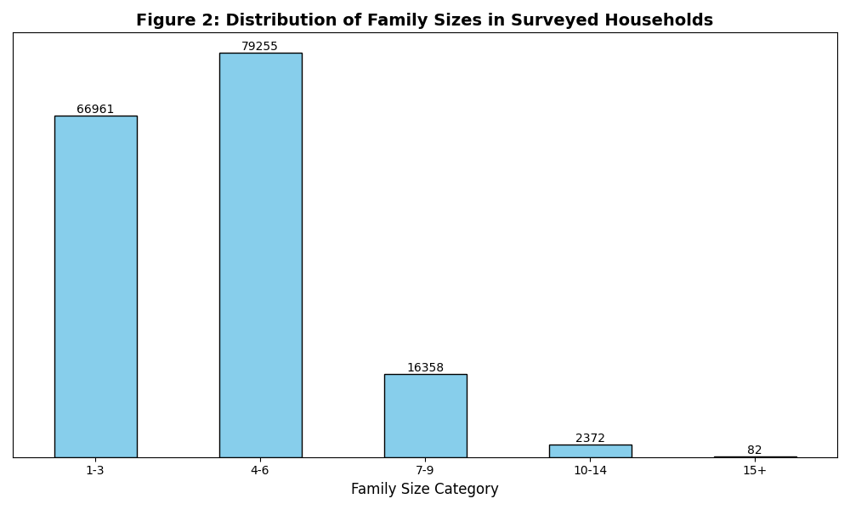

Figure 2 displays the distribution of family sizes within surveyed households, highlighting patterns of household composition across the dataset:

* **Prevalence of Smaller Families:** The majority of households fall within the 1-3 and 4-6 family size categories, indicating that smaller family sizes are predominant.
* **Decline in Larger Family Sizes:** Households with 7-9 family members are considerably fewer, and as family size increases to 10-14 or 15+, the number of households decreases significantly.

These observations suggest that larger family sizes are relatively uncommon in the surveyed population. This trend may reflect broader demographic patterns, including urbanization, economic constraints, or shifting cultural norms regarding family size.

### 3.2. Family Size and Economic Indicators

### Average Household Income by Region

### 

Figure 3 illustrates the disparities in average household income across regions in the Philippines, highlighting significant regional variations:

* **National Capital Region (NCR):** This region records the highest average household income, exceeding PHP 400,000. This is likely due to the concentration of economic activity, government offices, and multinational corporations.
* **Calabarzon and Ilocos Region:** These regions show relatively high average incomes, likely attributed to their proximity to major urban centers and industrial hubs.
* **Caraga and Autonomous Region in Muslim Mindanao (ARMM):** These regions report the lowest average household incomes, reflecting limited economic opportunities, infrastructure development, and socio-political challenges.

These findings underscore the economic disparities across regions and have the following implications:

1. **Regional Disparities:** Regions like NCR significantly outpace others in household income, highlighting economic concentration in urban areas.
2. **Policy Interventions:** Regions with lower incomes, such as ARMM and Caraga, may benefit from targeted interventions like infrastructure development, skills training, and support for small enterprises.
3. **Future Research:** Further investigation is needed to understand the drivers of income disparities and their impact on household well-being.

Average Household Expenditures by Region

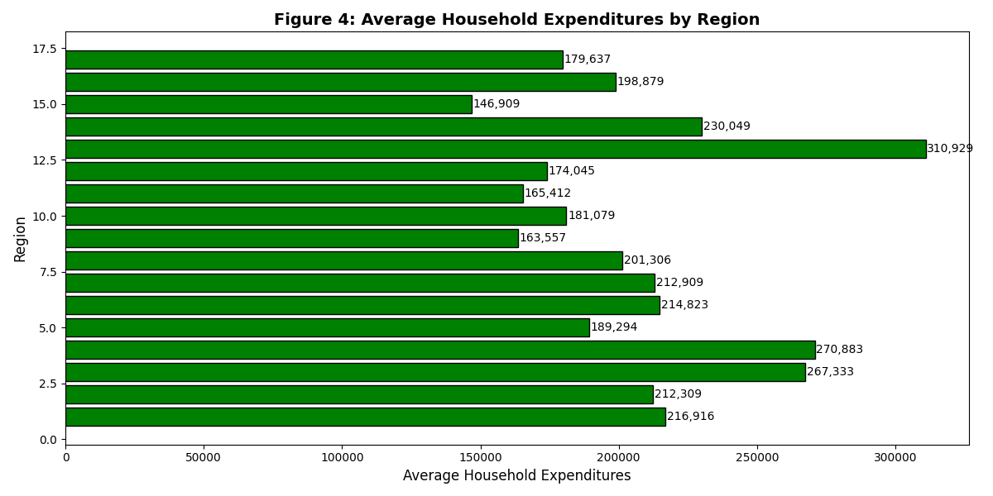

Figure 4 provides insights into regional disparities in household spending, illustrating patterns that closely mirror income trends:

* **National Capital Region (NCR):** Households in NCR exhibit the highest average expenditures, exceeding PHP 300,000. This is likely influenced by urban lifestyles, higher income levels, and access to diverse goods and services.
* **Calabarzon and Central Luzon:** These regions report relatively high expenditures, potentially due to their economic activity and proximity to major urban centers.
* **Caraga and ARMM:** These regions display the lowest average expenditures, reflecting their lower income levels, limited access to goods and services, and differing consumption priorities.

The observations suggest that spending patterns are strongly tied to regional income disparities, with implications for both policymakers and businesses:

1. **Economic Development:** Disparities in expenditures highlight the need for equitable economic development to improve household spending capacity in lower-income regions.
2. **Market Strategies:** Businesses can tailor their strategies to align with regional spending behaviors, focusing on affordable products and services in lower-income areas.
3. **Policy Focus:** Government initiatives aimed at increasing household purchasing power in less affluent regions could foster economic growth and improve living standards.

### 3.3. Correlation Analysis

### Correlation Matrix of Family Size, Income, Expenditures, and Assets

### 

Figure 5 provides a comprehensive view of the relationships between family size, income, expenditures, and asset ownership:

* **Positive Correlations:**
  + **Family Size and Household Income/Expenditures:** Larger families tend to report higher household income and expenditures, indicating increased financial demands.
  + **Household Income and Expenditures:** The strongest correlation observed, affirming that higher-income households typically spend more.
  + **Income and Asset Ownership:** Assets such as refrigerators, washing machines, and cellular phones positively correlate with income, suggesting that wealthier households are more likely to own these items.
  + **Expenditures and Asset Ownership:** Similar patterns emerge, with higher spenders more likely to own multiple assets.
* **Negative Correlations:**
  + **Family Size and Per Capita Income:** A weak negative relationship suggests that while larger families may have higher total income, income per individual decreases.
* **Other Observations:**
  + Asset ownership variables, such as owning cars and refrigerators, exhibit moderate correlations, indicating shared consumption patterns among wealthier households.

These correlations emphasize the interconnectedness of family size, economic resources, and material well-being, underscoring the need for nuanced policy responses to address disparities.

### Relationship Between Family Size and Household Income

### 

Figure 6 illustrates the relationship between family size and total household income, depicted as a scatter plot with a regression line. The plot reveals a weak positive correlation between family size and household income, suggesting a modest upward trend as family size increases.

#### **Key Observations**

1. **Positive Correlation:**  
   Although weak, the positive correlation indicates that larger families tend to report higher total household incomes. This may reflect the increased income-generating capacity of larger households, where multiple members contribute to the household income.
2. **Wide Variability:**  
   The scatter of data points around the regression line shows considerable variation in income levels for households of similar sizes. This highlights that family size alone is not a strong determinant of household income, with other factors—such as education, employment type, and regional economic conditions—playing significant roles.
3. **Outliers:**  
   A few households deviate markedly from the general trend. For example:
   * Some larger families report exceptionally low incomes, potentially indicating underemployment or limited income opportunities.
   * Conversely, some smaller households have disproportionately high incomes, likely due to higher-paying occupations or fewer dependents.

#### **Implications**

The observed weak positive relationship between family size and household income underscores the complex interplay of factors influencing household finances. While larger family sizes might enhance income potential through additional earners, the added financial burden can dilute per capita income. This finding suggests the following considerations:

1. **Policy Focus:**  
   Interventions targeting income generation should account for family size while addressing other determinants like skill development and employment opportunities.
2. **Further Analysis:**  
   Future studies should explore how variables such as education levels, job types, and regional economic disparities mediate the relationship between family size and household income.

### Relationship Between Family Size and Household Expenditures

### 

Figure 7 presents a scatter plot showing the relationship between family size and total household expenditures, with a regression line illustrating the overall trend. The plot reveals a clear positive relationship, indicating that household expenditures generally increase as family size grows.

#### Key Observations

1. **Positive Correlation:**  
   The positive trend shown in the scatter plot suggests that larger families tend to have higher total household expenditures. This reflects the increased financial demands of accommodating additional household members, such as food, education, and other essentials.
2. **Variability:**  
   Despite the positive trend, there is significant scatter around the regression line. This indicates that household spending is influenced by multiple factors beyond family size, such as income levels, consumption patterns, and regional cost-of-living differences.
3. **Outliers:**  
   A small number of data points deviate significantly from the general trend. These include:
   * Households with large family sizes but unexpectedly low expenditures, possibly reflecting economic constraints or different spending priorities.
   * Households with smaller family sizes but unusually high expenditures, potentially due to higher income levels or lifestyle choices.

#### Implications

The relationship between family size and household expenditures underscores the role of family size in shaping household spending patterns. However, the observed variability and presence of outliers highlight the need to consider other influencing factors. These findings have important implications for policymakers and researchers:

1. **Policy Insights:**  
   Larger families may require targeted financial assistance to meet their spending needs, especially in lower-income regions.
2. **Future Research:**  
   Further studies should investigate how income, regional disparities, and cultural differences mediate the relationship between family size and household expenditures, providing a more nuanced understanding of household spending dynamics.

### Family Size vs. Per Capita Income

### 

Figure 8 illustrates the relationship between family size and per capita income in the Philippines. The bar graph shows the average per capita income across households grouped by family size, highlighting key trends and disparities.

#### Key Observations

1. **Income Disparities Across Family Sizes:**  
   Households with smaller family sizes, particularly those with 1–3 or 4–7 members, report significantly higher per capita incomes. In contrast, larger families experience lower per capita incomes, reflecting the financial challenges of distributing income among a greater number of individuals.
2. **Decreasing Trend with Larger Family Sizes:**  
   A consistent downward trend is evident, where average per capita income decreases as family size increases. This indicates that larger families often struggle to maintain a comparable standard of living for individual members, likely due to the higher resource demands associated with larger households.
3. **Income Inequality within Family Size Groups:**  
   The variation in per capita income within each family size group underscores the existence of income inequality. This suggests that factors such as education, employment type, geographic location, and access to opportunities significantly influence income levels, irrespective of family size.

#### Implications

The observed relationship between family size and per capita income carries several important implications:

1. **Economic Challenges for Larger Families:**  
   Larger households may require targeted policy interventions to mitigate the economic strain. These could include support for affordable housing, education subsidies, childcare services, and nutrition programs.
2. **Addressing Regional and Structural Disparities:**  
   Policymakers should consider addressing structural disparities that exacerbate income inequality. Strategies such as improving access to quality education, creating sustainable job opportunities, and fostering regional economic development can have far-reaching benefits.
3. **Holistic Approach to Family Well-being:**  
   Beyond financial support, programs aimed at empowering families—such as skills training, family planning, and access to healthcare—can enhance their socioeconomic resilience and ensure equitable opportunities for all household members.

### 3.4. Access to Basic Services

### Household Water Supply by Family Size

Figure 9 presents a detailed visualization of the relationship between family size and the primary sources of household water supply. The stacked bar chart effectively illustrates how different water sources are distributed across various family size categories.

**Key Observations:**

* **Dominance of Piped Water Supply:** Piped water supply emerges as the most common source across all family sizes, though its prevalence varies. Smaller families (1–3 members) tend to have greater access to piped water, reflecting more consistent infrastructure coverage in urban or suburban areas.
* **Family Size and Water Source Variation:** Larger families (10 or more members) exhibit a distinct shift toward using alternative water sources such as wells, rivers, or rainwater harvesting. This trend suggests that, as family size increases, access to piped water becomes less prevalent, potentially due to infrastructure limitations or geographical challenges in rural regions.
* **Diversity in Water Sources:** The chart underscores the varied reliance on alternative water sources, particularly among larger families. This diversity highlights potential challenges in securing a consistent and safe water supply, especially in rural or underserved areas, where reliance on non-piped sources may be more pronounced.

### Toilet Facilities by Family Size

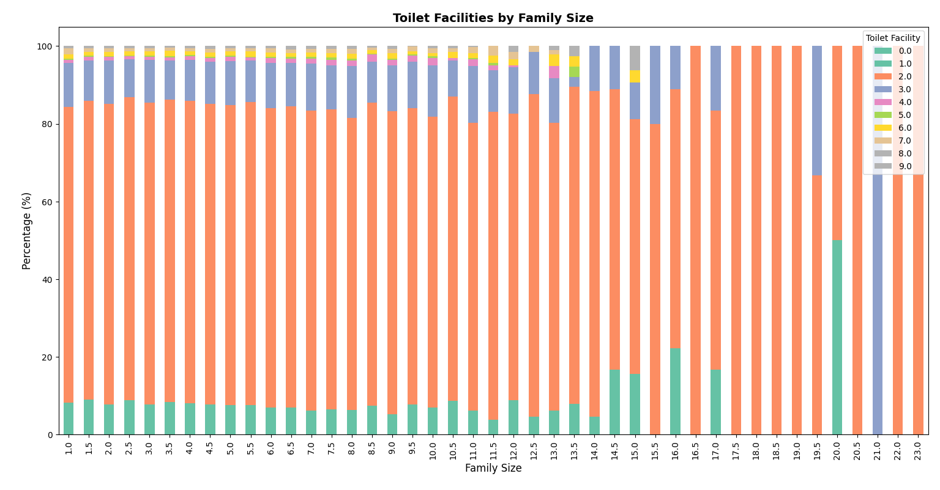  
Figure 10 provides a visual representation of the relationship between family size and the types of toilet facilities used in households. The stacked bar chart illustrates the distribution of toilet facilities across different family size categories, revealing trends in access to sanitation.

**Key Observations**

* **Prevalence of Flush Toilets:** Flush toilets are the most common type of toilet facility across all family sizes, although their prevalence varies slightly between different family size categories. Smaller families (1–3 members) exhibit a higher proportion of households with flush toilets.
* **Family Size and Toilet Facility Access:** As family size increases, the proportion of households with flush toilets gradually decreases, while there is a corresponding increase in the use of alternative facilities such as pit latrines and septic tanks. This suggests that larger families may have less access to modern flush toilets, possibly due to higher demands on infrastructure or more rural settings.
* **Variation in Toilet Facilities:** The chart highlights the increasing diversity of toilet facilities used by households, especially in larger families. This suggests that access to adequate sanitation facilities may be more challenging in larger households, particularly in rural or underserved areas.
* **Toilet Access with Increasing Family Size:** A notable trend is that larger families tend to have more toilet facilities. For families with 10 or more members, the majority of households have access to at least two toilets. Conversely, smaller families (1–5 members) are more likely to have access to fewer toilets, with a noticeable decrease in the proportion of households with just one toilet as family size grows. For families with between 12 and 15 members, the percentage of households with two or more toilets approaches or exceeds 90%.

### 3.5. Housing Conditions and Asset Ownership

### Average Housing Floor Area by Family Size

### 

Figure 11 presents a bar chart that illustrates the relationship between family size and average housing floor area. The chart provides insights into how housing space varies across different family sizes.

**Key Observations**

* **Variation in Floor Area:** The chart highlights considerable variation in average floor area across different family sizes. Some family sizes are associated with significantly larger average floor areas, while others show more modest spaces.
* **Lack of a Clear Trend:** There is no discernible linear relationship between family size and housing floor area. The data points are dispersed, indicating that factors beyond family size, such as income level, geographical location, and housing type, likely play a significant role in determining the size of dwellings.
* **Potential for Overcrowding:** Larger families, in particular, appear to have relatively smaller average floor areas compared to smaller families. This suggests the potential for overcrowding, where these households may face challenges in terms of space and adequate living conditions, possibly due to limitations in housing supply or affordability.

### Average Number of Bedrooms by Family Size

### 

Figure 12 presents a bar chart illustrating the relationship between family size and the average number of bedrooms in households. This visualization provides insight into whether larger families have access to adequate living spaces in terms of bedroom availability.

**Key Observations**

* **Variation in Bedroom Numbers:** The chart reveals significant variation in the average number of bedrooms across different family sizes. Some family sizes have notably more bedrooms, while others show fewer, reflecting disparities in living space allocation.
* **No Clear Linear Trend:** There is no clear linear relationship between family size and the number of bedrooms. The data points are widely scattered, suggesting that factors beyond family size—such as income level, housing type, and geographic location—are likely influencing the number of bedrooms in households.
* **Potential Overcrowding Risks:** Larger families, in particular, seem to have a lower average number of bedrooms, which could suggest overcrowding. These households may face challenges in terms of adequate living space, highlighting potential issues with housing adequacy, especially in areas where housing supply is limited or unaffordable.

### Asset Ownership by Family Size

### 

Figure 13 presents a heatmap illustrating the percentage of households owning various assets across different family size categories. This visualization provides insight into the relationship between family size and patterns of asset ownership.

**Key Observations**

* **Increasing Ownership with Family Size:** The heatmap reveals a general trend of increasing asset ownership as family size grows. This is particularly evident for items like refrigerators, washing machines, and televisions, which see higher ownership rates in larger families.
* **Asset Ownership Disparities:** Significant disparities in asset ownership are observed across family sizes. Larger families tend to own a broader range of assets, including cars, air conditioners, and personal computers, which are less common in smaller households. This suggests that larger families may have greater financial resources or a higher demand for certain assets.
* **Household Essentials:** Items such as radios, televisions, and refrigerators/freezers are widely owned across all family sizes, reflecting their status as essential household items.
* **Luxury and Non-Essential Items:** Luxury items, such as cars, air conditioners, and personal computers, are notably less common in smaller families, indicating that these assets are often considered non-essential or represent higher financial investment. Their ownership tends to rise with family size, potentially reflecting a higher disposable income or more diverse household needs.
* **Technological Shifts:** The decline in ownership of landline or wireless telephones as family size increases may reflect a shift toward more portable communication technology, such as mobile phones, which are more commonly owned across all family sizes.

### 3.6. Regional Disparities

### Regional Variation in Per Capita Income

### 

Figure 14 presents a choropleth map illustrating regional disparities in per capita income across the Philippines. The map uses color intensity to depict income levels, with darker shades indicating higher per capita income.

**Key Observations**

* **Regional Disparities:** The map highlights significant regional disparities in per capita income. Regions such as the National Capital Region (NCR) and CALABARZON are notably higher in income compared to other regions.
* **High-Income Regions:** The National Capital Region (NCR) has the highest per capita income at ₱118,744, followed by CALABARZON, with a per capita income of ₱93,205. These regions are characterized by greater economic development, higher urbanization, and better access to resources.
* **Low-Income Regions:** In contrast, regions like CARAGA (₱73,727) and MIMAROPA (₱41,631) have significantly lower per capita income. This disparity points to potential economic challenges in these areas, which may require targeted interventions to improve infrastructure, employment opportunities, and access to essential services.
* **Income Range Across Regions:** The map provides a broad range of per capita incomes, from ₱41,630.65 in the BARMM (Bangsamoro Autonomous Region in Muslim Mindanao) to ₱118,744.02 in the CAR (Cordillera Administrative Region). These income disparities underscore the need for region-specific economic policies to address income inequality.

**Important Notes:**

* These figures represent average per capita income, and individual income levels within each region can vary widely.
* The observed regional variations may be influenced by factors such as industry concentration, economic development strategies, infrastructure, and access to natural resources.
* The map serves as a snapshot of income disparities and provides valuable insights into regional economic conditions. Ongoing monitoring and targeted analysis are essential to understand the root causes of these disparities and to design effective strategies for sustainable economic development.

### Regional Comparison of Family Size

Figure 15 presents a bar chart that visually compares the average family size across different regions in the Philippines. This chart highlights regional variations in household composition, providing insights into the diverse family structures across the country.

**Key Observations**

* **Regional Disparities:** The chart reveals notable regional disparities in average family size, with some regions having substantially larger families compared to others. This variation suggests that regional factors, such as socioeconomic conditions, cultural practices, and access to resources, play a role in shaping family structures.
* **Larger Families:** Regions like CARAGA, SOCCSKSARGEN, and BARMM stand out with relatively larger average family sizes. These regions may have higher fertility rates, cultural preferences for larger families, or extended family living arrangements, which contribute to their larger household sizes.
* **Smaller Families:** In contrast, regions such as NCR, MIMAROPA, and CALABARZON show smaller average family sizes. This trend is likely influenced by urbanization, where smaller living spaces and changing social norms, including higher education and career opportunities, contribute to fewer children per household.

**Implications**

* The data emphasizes the significant variation in family structures across regions in the Philippines. These regional differences have important implications for policymakers and planners, as areas with larger families may face distinct challenges in terms of resource allocation, education, healthcare, and housing.
* Understanding the factors that influence family size—such as fertility rates, urbanization, and cultural norms—can offer valuable insights into demographic trends. Such knowledge is crucial for addressing the specific needs of families in different regions and formulating targeted interventions that support both social and economic development.

### 3.7. Regression Analysis

**Regression Coefficients for the Impact of Family Size on Socioeconomic Outcomes**

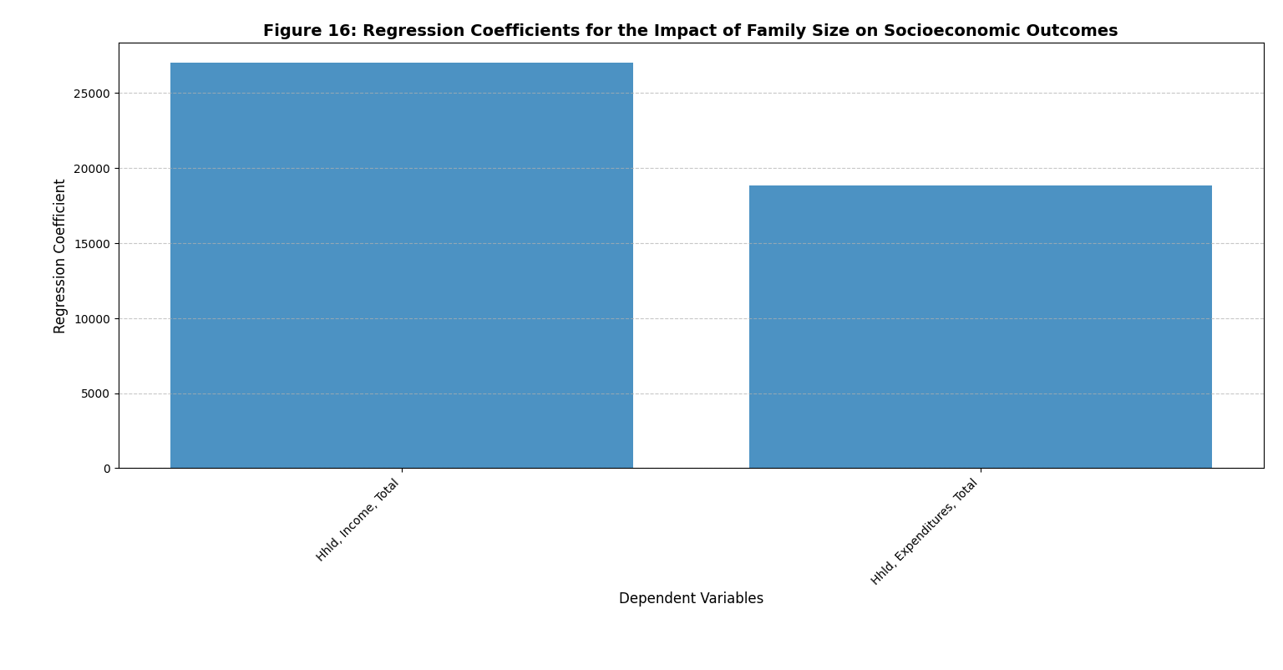

**Figure 16: Regression Coefficients for the Impact of Family Size on Socioeconomic Outcomes**

Figure 16 presents a bar chart illustrating the regression coefficients for the impact of family size on household income and expenditures. These coefficients quantify the strength and direction of the relationship between family size and two key socioeconomic outcomes: income and spending.

**Key Observations**

* **Positive Relationship:** The positive regression coefficients for both household income and expenditures indicate a clear positive association between family size and these outcomes. Larger families tend to have higher incomes and greater expenditures compared to smaller households, reflecting a general trend that more people in a household are associated with more income and spending.
* **Differential Impact:** The coefficient for household income is notably larger than that for household expenditures, suggesting that family size has a stronger influence on income levels than on spending. This could be due to factors such as economies of scale in larger households, where more family members contribute to income generation, or the increased labor force participation often seen in larger families.

**Limitations and Considerations**

* **Correlation vs. Causation:** It is important to note that the chart shows a correlation, not a causal relationship, between family size and income/expenditures. While the data suggests an association, other factors—such as education, occupation, and geographic location—could also influence these outcomes, potentially confounding the results.
* **Limited Scope:** The chart focuses solely on income and expenditures, but a more comprehensive analysis would include additional socioeconomic indicators such as health, education, and housing conditions. These factors may provide a more holistic view of how family size impacts overall well-being.
* **Contextual Factors:** The relationship between family size and socioeconomic outcomes can be influenced by contextual factors, including cultural norms, economic conditions, and government policies. These factors should be considered when interpreting the results and designing policies.

**Implications**

* The findings suggest that family size can significantly affect household economic well-being, with larger families generally experiencing higher income and expenditures. Policymakers and researchers should take these relationships into account when designing interventions aimed at improving family welfare. For example, policies that provide targeted support to larger families—such as child allowances, subsidized childcare, or affordable housing programs—could help alleviate the economic challenges associated with raising larger families.

**Predicted vs. Actual Household Income from Regression Model**

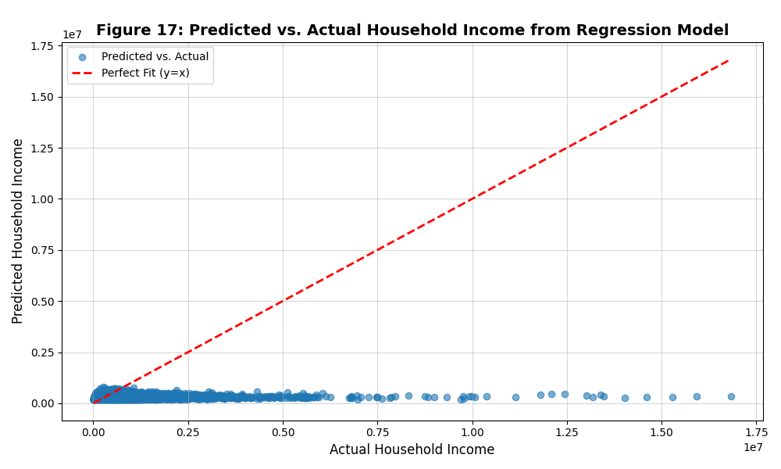

Figure 17 presents a scatter plot that compares predicted and actual household income values derived from a regression model. Each data point represents a household, with the x-axis displaying actual household income and the y-axis showing the predicted values. The red dashed line represents a perfect fit, where the predicted and actual income values are equal.

**Key Observations**

* **Scattered Distribution:** The data points are widely dispersed around the perfect fit line, suggesting a significant deviation between predicted and actual household income. This pattern indicates that the model has limited accuracy in predicting household income and does not fully capture the underlying complexities.
* **Underprediction:** A majority of the data points lie below the perfect fit line, indicating that the model tends to consistently underpredict household income. This suggests that the model may fail to account for key factors influencing income levels, leading to systematic underestimation.
* **Clustering:** There is a noticeable concentration of data points around lower income values, suggesting that the model performs better for households with lower incomes. Its predictive power seems to weaken as household income increases, with the model struggling to accurately predict income in higher brackets.
* **Outliers:** While most of the data points are clustered near the line, a few outliers show significant deviations between predicted and actual income values. These outliers highlight cases where the model's predictions are particularly inaccurate.

**Model Performance Metrics**

* **R-squared:** The R-squared value of 0.027 indicates that the model explains only a very small proportion of the variation in household income. This low value suggests that other factors, not captured by the model, have a significant influence on household income.
* **Mean Absolute Error (MAE):** With an MAE of 172,050.53, the model's predictions deviate by an average of ₱172,050.53 from the actual household income values, further indicating its limited accuracy.
* **Root Mean Squared Error (RMSE):** The RMSE of 327,293.03 reflects the average magnitude of errors in the predictions, reinforcing the conclusion that the model has substantial predictive limitations.

The scatter plot in Figure 17 illustrates that the regression model faces significant challenges in accurately predicting household income. The underprediction, scattered distribution of data points, and clustering at lower income levels suggest that the model fails to capture the full range of factors influencing household income, particularly for higher-income households. The model’s performance metrics, including low R-squared and high MAE and RMSE values, indicate that the model's predictive power is weak and that it requires refinement or the inclusion of additional variables to improve its accuracy.

### 4. ****Discussion****

This study examines the relationship between family size and various socioeconomic outcomes in the Philippines, with a particular focus on regional disparities. The findings reveal significant variations across regions, with family size influencing factors such as household income, expenditures, access to basic services, and asset ownership. By analyzing these relationships, we can better understand the complex dynamics that shape socioeconomic well-being in the country.

**Regional Disparities in Family Size and Socioeconomic Outcomes**  
One of the most striking findings of this study is the significant regional variability in family size and socioeconomic indicators. Larger family sizes were predominantly observed in regions like **CARAGA**, **SOCCSKSARGEN**, and **BARMM**, where income levels tend to be lower, and access to essential services is more limited. In contrast, regions such as **NCR**, **CALABARZON**, and **MIMAROPA** display smaller average family sizes and higher average incomes, suggesting that urbanization, better access to services, and economic development contribute to these differences.

The positive relationship between family size and both **income** and **expenditures** underscores the financial demands that larger households face. While larger families often report higher total income, the **per capita income** remains lower for them due to the distribution of resources among more individuals. This is a key observation that highlights the potential economic strain on larger families, despite their higher overall income. These findings align with existing literature that suggests larger families may have more income-generating members but struggle with more significant financial demands and limited resources.

However, the **regression analysis** reveals the complexities of this relationship. While a positive correlation exists between family size and household income/expenditures, the model's low **R-squared** value (0.027) suggests that other unaccounted factors, such as education, occupation, and regional economic conditions, play a crucial role in determining household income and spending. The underperformance of the regression model, indicated by significant underprediction and high error metrics (MAE of ₱172,050.53 and RMSE of ₱327,293.03), emphasizes the need for further refinement in the modeling process.

**Impact of Family Size on Access to Basic Services**  
The analysis also sheds light on how family size affects access to basic services such as **water supply** and **toilet facilities**. Smaller families tend to have better access to piped water and flush toilets, often associated with urbanized regions where infrastructure is more developed. In contrast, larger families, particularly those with 10+ members, are more likely to rely on alternative sources like wells or rivers, indicating infrastructure gaps in rural areas. This disparity in access to safe water and sanitation underscores the need for targeted infrastructure development in rural and underdeveloped regions to improve living conditions for larger families.

**Housing Conditions and Asset Ownership**  
The findings related to **housing conditions** and **asset ownership** suggest that family size plays a role in determining the availability of housing space and assets. While no clear relationship was found between family size and **housing floor area** or **number of bedrooms**, the data points to potential overcrowding in larger households, which may face challenges in securing adequate living space. On the other hand, larger families tend to own more **luxury items** such as refrigerators and cars, indicating a higher financial capacity to acquire such assets despite the potential strain on household resources.

The **asset ownership** trends also reveal a shift in ownership patterns, with larger families often owning more household items like washing machines and refrigerators, which are essential for daily living. This finding may reflect both the greater financial resources available to larger households and their higher consumption needs.

**Correlation between Family Size and Socioeconomic Indicators**  
The **correlation analysis** further supports the notion that family size is intricately linked to household income, expenditures, and asset ownership. Larger families tend to have higher total income and expenditure levels, but these relationships are not linear, as income per capita decreases with family size. This trend highlights the financial challenges larger families face in allocating resources across a larger number of individuals. The weak negative correlation between **family size** and **per capita income** suggests that while larger families may have more income in total, the per capita financial burden is higher, limiting the individual economic opportunities available to each member.

The **positive correlations** between asset ownership and household income point to the broader economic landscape in which family size operates. Families with higher incomes are better able to accumulate assets, providing greater economic security. However, the role of **education**, **employment opportunities**, and **regional economic conditions** in shaping these outcomes should not be overlooked. Future research should explore how these factors interact with family size to influence socioeconomic outcomes.

**Policy Implications and Recommendations**  
The results of this study suggest several important implications for policymakers. First, **targeted economic interventions** are necessary to address the disparities between regions with larger and smaller family sizes. Areas with larger families, particularly those in **CARAGA**, **SOCCSKSARGEN**, and **BARMM**, require focused efforts to improve access to education, healthcare, and infrastructure. Policies that support **family planning** initiatives, **affordable housing**, and **child allowances** can help alleviate the financial strain on larger families, contributing to improved socioeconomic well-being.

Additionally, policymakers should prioritize investments in **basic services** such as water supply and sanitation, particularly in rural regions, to ensure equitable access to essential resources. These investments can improve health outcomes, reduce inequality, and enhance the overall quality of life for families of all sizes.

The study also underscores the need for a **comprehensive approach** to poverty alleviation and social protection. Measures that address income inequality, improve employment opportunities, and provide social services are essential for reducing disparities related to family size and regional differences. A multi-faceted approach that integrates economic, social, and infrastructural development will be critical for fostering greater equity and improving living standards across the Philippines.

### 5. ****Conclusion****

This study highlights the complex relationship between family size and socioeconomic outcomes in the Philippines. By analyzing regional variations and employing a variety of statistical and visualization techniques, we have shown that family size is a significant factor influencing household income, expenditures, access to basic services, and asset ownership. However, the regression analysis indicates that other factors, such as education, occupation, and regional economic conditions, also play a crucial role in shaping these outcomes.

The findings emphasize the need for region-specific policies that address the unique challenges faced by households of different sizes. Policymakers must consider the financial strain on larger families and the disparities in access to services and resources when designing interventions. Furthermore, the study calls for improved data collection, particularly in regions with fewer households sampled, to ensure that regional disparities are adequately represented in future research and policy development.

Ultimately, addressing the socioeconomic challenges associated with family size requires a holistic and inclusive approach that integrates economic, social, and infrastructural strategies. By doing so, the Philippines can move closer to achieving greater social equity and improved quality of life for all its citizens.

## References

1. Philippine Statistics Authority. (2023). Family Income and Expenditure Survey 2023. Retrieved from <https://psa.gov.ph>.
2. World Bank. (2022). World Development Indicators: Philippines. Retrieved from <https://data.worldbank.org>.
3. National Economic and Development Authority. (2022). Philippine Development Plan 2023-2028. Retrieved from <https://neda.gov.ph>.
4. UNICEF Philippines. (2022). Access to Basic Services: Challenges and Opportunities. Retrieved from https://unicef.org/philippines.
5. Asian Development Bank. (2021). Poverty and Inequality in the Philippines. Retrieved from <https://adb.org>.