

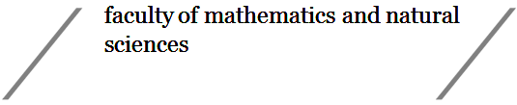
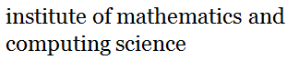
Short programming project - Computing Science

Course code: WBCS15002
Credits (EC): 5 points (140 hours, 14 hours/week)

1. General information

Project title: Google play crawler

Student name and signature: Job Heersink

Student number: s3364321

Date: 06-12-2019
First supervisor (name + signature): F.F.M. Mohsen
Second supervisor (name + signature):

2. Project description:
The aim of this project is to create a crawler for the Google Play store to get app details and download the apk file. It should be able to collect the contextual data from the playstore. Like description, name, popularity, distributors ect., but not necessarily reviews. The crawler should also be able to download the apk file from the playstore and store the data on a database. The crawler should be able to successfully visit, read and download all available data from the page. It should be able to deal with server waiting time and be able to scan apps in different categories, or lists, which must can be specified. It should be able to run for hours or days without supervision.

Several problems that the project targets:
Making the program read a single page.
Making the program be able to crawl through the playstore.
Making the program able to download apk files and store them.
Making the program able to crawl through different specified categories.
Making the program run without supervision.
3. Methodology and timeline:
The plan is to modify an existing crawler and make it work. In the sense that the program is able to successfully gather data from the playstore and download the apk file of any app publicly available.
If the existing crawler doesn’t work on the most recent version of the playstore, then the crawler must be changed to be able to read the new format. The coding language that is going to be used is either Java or Python, depending on the available libraries for crawlers. Libraries like scrapy (https://scrapy.org/) [python] or crawler4j (https://github.com/yasserg/crawler4j) [java] can be used in this project.

Tentative time-line (Gantt chart with Work Packages (WP) and Milestones (M) for overlapping intervals shortly explained in a list)

1. research
choosing programming language
research existing libraries
looking at other opportunity’s
literature research
making a choice.
2. making it work for 1 page
making the crawler be able to read one page
store that information
download the apk
3. making it crawl through the playstore
making the crawler be able to read several pages.
Download the data and apk as well.
Making the crawler be able to scan different specified categories.
4. testing
testing the crawler and make it run for a few hours.
5. downloading a sample
downloading a sample of a large amount of apps plus data from the playstore.

