
Job Seeker
Readme-Document

Project Overview
In today’s digital era, most of the companies still lean towards the old system for hiring and websites that share information inefficiently. Job Seeker is a web application to make it easier the process the job employment by connecting the job seeker and job givers in only intuitive environment.
System offers function for registration, job posting, searching and applying, it saves the clear separation of the role between users.
Deployed by using ASP.NET CORE MVC, C#, Entity Framework, SQL Server, project seeks to modernize the requirement way in Albania and more.

Main Objectives
- To create a web application platform for publishing and application job.
- To securely and clearly separate the work roles (Job Seeker and Employer).
- To implement the management of job advertisements.
- To create a modern Interface, friendly and generally for the user.
- To secure containable betterment by following methodology Agile(scrum).

Category | Tools & Frameworks
Frontend | HTML5, CSS3, Bootstrap
Backend | ASP.NET Core MVC, C#
Database | SQL Server, Entity Framework
Version control | Git, GitHub
Documentation | Markdown, Diagrams UM

- System Architecture Overview
The system is divided into 3 main levels:
    - Frontend (View Layer): HTML, CSS, Bootstrap for the user Interface.
    - Backend (Controller & Model): ASP.NET MVC and C# used for business logic.
    - Database Layer: SQL Server used for data storage (user, work, applications)

Main characteristics
- 👥 Entrance with separate roles: Job givers & job seekers have unique panels.
- 📝 Job Management: Job giver can publish and modify and delete job publication.
- 🔍 Job searching: Job seeker can filter and apply for job position.
- 🔔 Notifications: Notifications signaling about new job offerings or the state of applications.
- 🧠 Agent (in Plan): Recommendations base in ai for job lists or candidates.
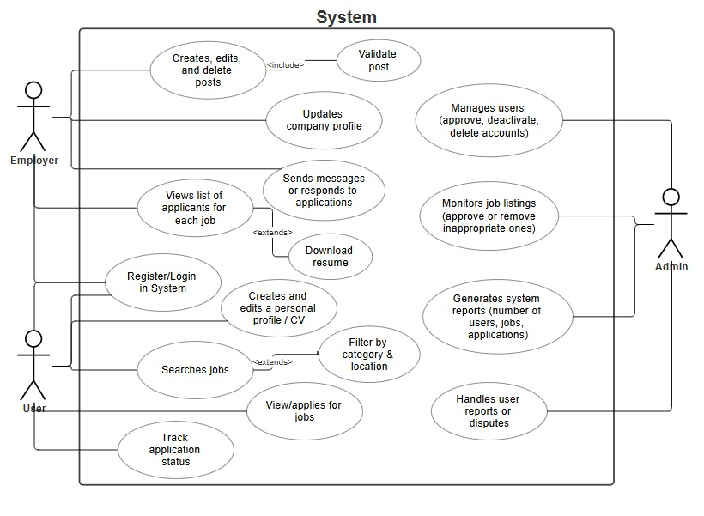

- Software Development Approach
The “Job seeker” Project will follow the “Agile (Scrum)” model, for it is the best method for the development of web-based systems whom are tested often and allow continuous adaptation for feedback. This model, hence secures the continuous cooperation between tam members and allows the division of labor in short sprints.
The advantages of this method are:
- The integration of real-time feedback for the user and professor.
- Making necessary changes without damaging the general structure.
- The increase of cooperation within the team by using regular meetings (daily stand-ups).
- The handing of functional periodical versions, which displays the current progress of the project.
In the end of every cycle, the result will bring us a stable, tested and optimized product for the needs of the users – be it jobseekers or employers. This method guarantees the perpetual evolution of the application “Job Seeker”.
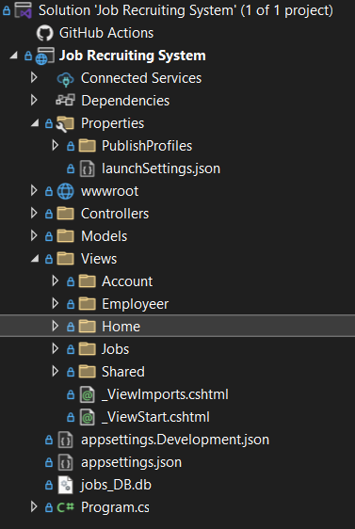

/Controllers → MVC controllers handling logic
/Models → Database entities (User, Job, Application)
/Views → Frontend pages (.cshtml)
/wwwroot → Static files (CSS, JS, Images)
/Migrations → Database migrations via Entity Framework
/docs → UML diagrams, reports, and manuals
README.md → This file

📄 Authors
ID | Name | Role
040623018 | Ruben Gjata | Product Owner
040623051 | Baçe Xhindi | Product Owner

🏁 License
This project was created for educational purposes for the course Software Engineering – Fall 2025 of the University of New York Tirana.
All rights reserved © 2025 Job Seeker Team.

