**Guide to Mastering JavaScript**

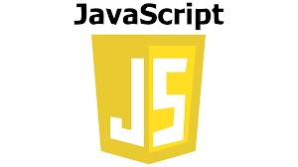

Table of Contents

Chapter 1: Introduction to JavaScript 4

Chapter 2: Variables 6

Chapter 3: Arrays 8

Chapter 4: Objects 10

Chapter 4: Arithmetic Operators 12

Learning Objectives 12

What Are Arithmetic Operators? 12

🧪 Assignment 13

❓ Quiz 14

📌 Summary 14

Chapter 5: Conditional Statements 15

Learning Objectives 15

What Are Conditional Statements? 15

⚖️ Comparison Operators 16

🧠 Logical Operators 17

Examples 17

Assignment 17

❓ Quiz 18

📌 Summary 18

Chapter 6: Loops 19

Learning Objectives 19

🔁 What Are Loops? 19

💡 Loop Control Statements 20

Examples 20

Assignment 21

❓ Quiz 21

📌 Summary 21

Chapter 7: Functions 22

Chapter 8: Async/Await 24

Chapter 9: DOM Manipulation 26

Chapter 11: OOP 30

🧒 Real-Life Analogy: 30

🔹 1. Class & Object 30

🔹 2. Encapsulation 31

🔹 3. Abstraction 31

🔹 5. Polymorphism 32

🛠️ 3. Activities for Practice 33

📝 Summary Sheet 34

Chapter 12: Final Quiz & Practical 35

Appendices 38

# Chapter 1: Introduction to JavaScript

**Learning Objectives**

By the end of this chapter, you will be able to:

- Understand what JavaScript is and its role in web development.

- Differentiate between HTML, CSS, and JavaScript.

- Recognize where JavaScript can run (client-side vs server-side).

- Grasp why JavaScript is essential for modern websites.

**What is JavaScript?**

JavaScript is a high-level, interpreted scripting language that enables developers to create dynamic and interactive content on websites. Unlike HTML (which structures content) and CSS (which styles it), JavaScript adds behavior—making pages respond to user actions like clicks, hovers, or form submissions.

Initially designed to run only in web browsers, JavaScript now powers both front-end and back-end applications thanks to environments like Node.js.

**Why Use JavaScript?**

* Runs in the Browser

You don't need any special software beyond a browser to execute JavaScript. It runs directly in the client’s browser, making it fast and accessible.

* Enables Client-Side Interactivity

JavaScript allows immediate interaction without waiting for server responses. For example:

- Form validation before submission

- Dynamic updates to page content

- Interactive animations

* Versatile Language

With frameworks like React, Angular, Vue.js for front-end, and Node.js for backend, JavaScript powers full-stack development.

**Real-World Applications**

- Web apps (Google Maps, Gmail)

- Mobile apps (React Native)

- Server-side apps (Node.js)

- Games (Canvas-based or WebGL)

- Chatbots and AI tools

**Summary**

JavaScript is essential for modern web development. It transforms static HTML/CSS pages into rich, interactive experiences. Whether you're building a simple website or a complex application, JavaScript is a must-know tool.

**Further Reading**

- [MDN Web Docs - JavaScript Basics](<https://developer.mozilla.org/en-US/docs/Web/JavaScript/Guide> )

- [W3Schools JavaScript Tutorial]( <https://www.w3schools.com/js/> )

# Chapter 2: Variables

**Learning Objectives**

After completing this chapter, you will be able to:

- Understand variable declaration using `**var**`, `**let**`, and `**const**`.

- Know the differences between scope types.

- Choose the right keyword based on use case.

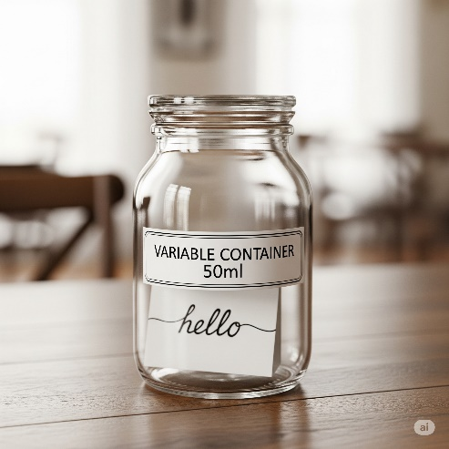 **Concepts**

Variables are containers for storing data values.

In JavaScript, variables are declared using three keywords:

🔹 `var`

- Function-scoped

- Can be redeclared and updated

- Not recommended due to hoisting issues and outdated scoping behavior

🔹 `let`

- Block-scoped (`{}` defines block scope)

- Can be updated but not redeclared in the same scope

- Ideal for variables that change over time

🔹 `const`

- Block-scoped

- Cannot be reassigned once declared

- Best for constants like API keys, configuration settings, etc.

Examples

let name = "Alice";

const age = 25;

name = "Bob"; // Valid

age = 30; // Error: Assignment to constant variable

Hands-On Assignment

1. Declare a student's name, age, and course using `let` and `const`.

2. Try reassigning a `const` value and observe the error.

Sample Solution:

let studentName = "John Doe";

const enrollmentYear = 2024;

enrollmentYear = 2025; // TypeError: Assignment to constant

**Quiz**

Q: Which keyword prevents variable reassignment?

A: `const`

Q: What is the scope of `let`?

A: Block scope

**Summary**

Understanding how to declare and manage variables is crucial. Always choose `const` for immutability and `let` when changes are expected. Avoid `var` due to outdated scoping rules.

# Chapter 3: Arrays

**Learning Objectives**

Upon completion, you will be able to:

- Create and manipulate arrays.

- Use common array methods like `.push()`, `.pop()`, `.slice()`, and `.filter()`.

- Store multiple values efficiently.

**Concepts**

An array is a collection of elements stored in a single variable. Elements are accessed by their index (starting from 0).

Arrays are mutable and allow duplicate values.

Examples

let fruits = ["apple", "banana", "orange"];

fruits.push("grape"); // Adds to the end

fruits.pop(); // Removes from the end

console.log(fruits); // ["apple", "banana"]

**Assignment**

1. Create a list of 5 countries.

2. Use `.slice()` to get the first two items.

3. Use `.filter()` to find countries starting with 'U'.

**Solution:**

let countries = ["USA", "India", "Ukraine", "Brazil", "Canada"];

let firstTwo = countries.slice(0, 2); // ["USA", "India"]

let startsWithU = countries.filter(c => c.startsWith('U')); // ["USA", "Ukraine"]

**Quiz**

Q: What does `.push()` do?

A: Adds an element to the end of the array.

Q: How to get a sub-array?

A: Use `.slice(start, end)`.

**Summary**

Arrays are fundamental for managing collections of data. Knowing how to add, remove, and filter elements makes working with lists much more efficient.

# Chapter 4: Objects

**Learning Objectives**

After this chapter, you will be able to:

- Create and access JavaScript objects.

- Understand key-value pair structure.

- Use object destructuring.

**Concepts**

Objects store key-value pairs. Keys are strings (or Symbols), and values can be any valid JavaScript type.

Objects can represent entities like users, products, settings, etc.

Access properties using:

- Dot notation: `object.key`

- Bracket notation: `object["key"]`

**Examples**

let user = { name: "John", age: 30 };

console.log(user.name); // John

console.log(user["age"]); // 30

**Assignment**

1. Create an object representing a student with name, age, course, and grade.

2. Destructure to extract name and age.

**Solution**:

let student = {

name: "Alice",

age: 22,

course: "Computer Science",

grade: "A"

};

let { name, age } = student;

console.log(name, age); // Alice 22

**Quiz**

Q: How do you access the value of the key `name` in an object?

A: `object.name` or `object["name"]`

Q: What is object destructuring?

A: Extracting values from objects into variables.

**Summary**

Objects are powerful for modeling real-life entities. Understanding how to access and destructure them helps write cleaner and more readable code.

# ****Chapter 4: Arithmetic Operators****

### Learning Objectives

By the end of this chapter, you will be able to:

* Understand basic arithmetic operators in JavaScript.
* Use operators to perform calculations.
* Apply increment/decrement operations effectively.

### What Are Arithmetic Operators?

Arithmetic operators are used to perform mathematical operations on numbers (literals or variables).

| **Operator** | **Description** | **Example** |
| --- | --- | --- |
| **+** | Addition | **5 + 3**→**8** |
| **-** | Subtraction | **10 - 4**→**6** |
| **\*** | Multiplication | **3 * 5**→**15** |
| **/** | Division | **10 / 2**→**5** |
| **%** | Modulus (remainder) | **10 % 3**→**1** |
| **\*\*** | Exponentiation | **2 ** 3**→**8** |
| **++** | Increment | **let x = 5; x++**→**6** |
| **--** | Decrement | **let y = 5; y--**→**4** |

Note: The **+** operator can also concatenate strings.

console.log("Hello" + " World"); // Hello World

console.log("5" + 2); // 52 (string)

Examples

let a = 10;

let b = 3;

console.log(a + b); // 13

console.log(a - b); // 7

console.log(a * b); // 30

console.log(a / b); // 3.333...

console.log(a % b); // 1

console.log(a ** b); // 1000

#### **Increment/Decrement**

let count = 5;

count++; // 6

console.log(count);

let score = 10;

score--; // 9

console.log(score);

### 🧪 Assignment

1. Calculate the area of a rectangle with width 10 and height 5.
2. Find the remainder when dividing 27 by 5.
3. Use exponentiation to calculate 3 to the power of 4.

**Solution:**

// Area of rectangle

let width = 10;

let height = 5;

let area = width * height;

console.log(area); // 50

// Remainder

console.log(27 % 5); // 2

// Power

console.log(3 ** 4); // 81

### ❓ Quiz

**Q:** What is the result of **10 % 3**?  
**A: 1**

**Q:** Which operator is used for exponentiation?  
**A: \*\***

**Q:** What does **++x** do?  
**A:** Increments **x** by 1 before using its value.

### 📌 Summary

Arithmetic operators allow you to perform math operations like addition, subtraction, multiplication, and more. Understanding how they work is crucial for any JavaScript developer.

# ****Chapter 5: Conditional Statements****

### Learning Objectives

After completing this chapter, you will be able to:

* Use **if**, **else if**, and **else** statements.
* Evaluate conditions using comparison operators.
* Implement logical operators to combine conditions.

### What Are Conditional Statements?

Conditional statements control the flow of your program based on certain conditions.

#### Basic Syntax

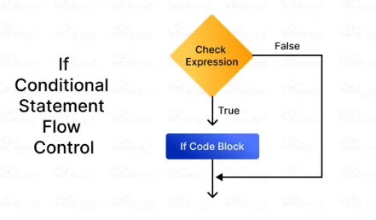

if (condition) {

// code to run if condition is true

} else if (anotherCondition) {

// code if another condition is true

} else {

// fallback code if none are true

}

### ⚖️ Comparison Operators

| **Operator** | **Meaning** | **Example** |
| --- | --- | --- |
| **==** | Equal to | **5 == '5'**→ true |
| **===** | Strict equal | **5 === '5'**→ false |
| **!=** | Not equal | **5 != 3**→ true |
| **!==** | Strict not equal | **5 !== '5'**→ true |
| **>** | Greater than | **10 > 5**→ true |
| **<** | Less than | **2 < 4**→ true |
| **>=** | Greater/equal | **5 >= 5**→ true |
| **<=** | Less/equal | **3 <= 5**→ true |

### 🧠 Logical Operators

Used to combine multiple conditions:

| **Operator** | **Meaning** | **Example** |
| --- | --- | --- |
| **&&** | AND | **(age > 18 && age < 60)** |
| **!** | NOT | **!(age < 18)**→ is adult? |

### Examples

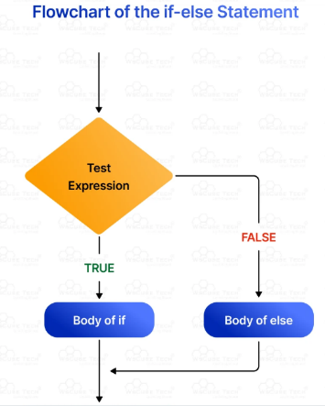let age = 20;

if (age >= 18) {

console.log("You are an adult.");

} else {

console.log("You are a minor.");

}

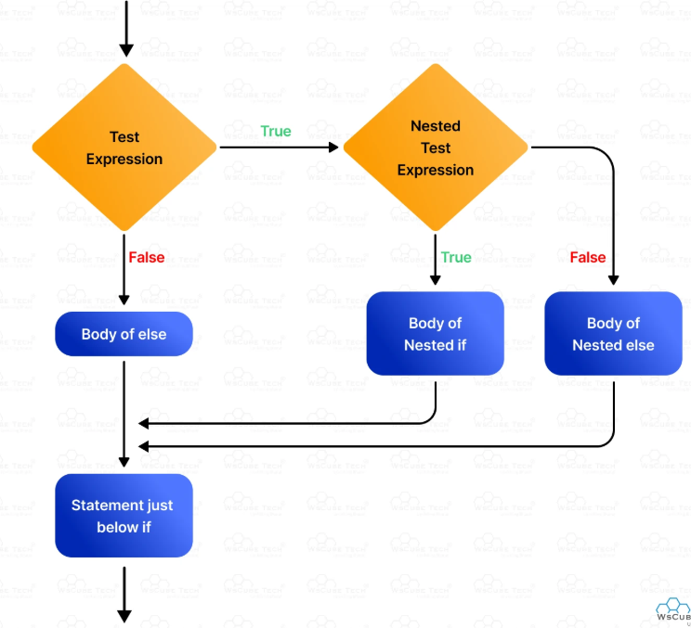

let grade = 85;

if (grade >= 90) {

console.log("A");

} else if (grade >= 80) {

console.log("B");

} else {

console.log("C or below");

}

### Assignment

Write a program that:

* Takes a number input.
* Checks if it is positive, negative, or zero.
* Logs the appropriate message.

**Solution**

let num = prompt("Enter a number:");

if (num > 0) {

console.log("Positive");

} else if (num < 0) {

console.log("Negative");

} else {

console.log("Zero");

}

### ❓ Quiz

**Q:** What does **===** check for?  
**A:** Value and type equality

**Q:** What is the output of **!(true && false)**?  
**A: true**

**Q:** When would you use **else if**?  
**A:** For checking additional conditions after the first one fails.

### 📌 Summary

Conditional statements give your programs decision-making capabilities. They are essential for controlling the logic and behavior of your code.

# ****Chapter 6: Loops****

### Learning Objectives

After this chapter, you will be able to:

* Use **for**, **while**, and **do...while** loops.
* Iterate over arrays and repeat actions efficiently.
* Break or skip loop iterations when needed.

### 🔁 What Are Loops?

Loops allow you to execute a block of code repeatedly until a condition is met.

#### 1. for Loop

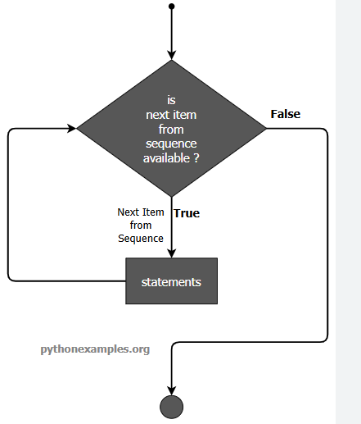

for (initialization; condition; update) {

// code to run

}

**Example:**

for (let i = 1; i <= 5; i++) {

console.log(i);

}

#### 2. while Loop

while (condition) {

// code to run

}

**Example:**

let i = 1;

while (i <= 5) {

console.log(i);

i++;

}

#### 3. do...while Loop

Runs at least once even if condition is false.

do {

// code to run

} while (condition);

**Example:**

let j = 1;

do {

console.log(j);

j++;

} while (j <= 5);

### 💡 Loop Control Statements

* **break**: Exits the loop early
* **continue**: Skips current iteration and continues

**Example:**

for (let i = 1; i <= 10; i++) {

if (i === 5) continue;

if (i === 8) break;

console.log(i);

}

// Output: 1 2 3 4 6 7

### Examples

Loop through an array:

let fruits = ["apple", "banana", "orange"];

for (let i = 0; i < fruits.length; i++) {

console.log(fruits[i]);

}

### Assignment

Create a loop that:

* Prints numbers from 1 to 20.
* Replaces multiples of 3 with “Fizz”.
* Replaces multiples of 5 with “Buzz”.
* Replaces multiples of both 3 and 5 with “FizzBuzz”.

**Solution:**

for (let i = 1; i <= 20; i++) {

if (i % 3 === 0 && i % 5 === 0) {

console.log("FizzBuzz");

} else if (i % 3 === 0) {

console.log("Fizz");

} else if (i % 5 === 0) {

console.log("Buzz");

} else {

console.log(i);

}

}

### ❓ Quiz

**Q:** Which loop runs at least once?  
**A: do...while**

**Q:** How do you stop a loop early?  
**A:** Use **break**

**Q:** What is the difference between **for** and **while** loops?  
**A: for** is better for known iterations; **while** for unknown.

### 📌 Summary

Loops are powerful tools for repeating tasks efficiently. Whether you're iterating through data or performing repeated actions, loops make your code concise and effective

# Chapter 7: Functions

**Learning Objectives**

At the end of this chapter, you will be able to:

- Define and call functions.

- Differentiate between function types: regular, arrow, anonymous.

- Use functions effectively in programs.

Types of Functions

🔹 Regular Functions

Declared with the `function` keyword.

function greet(name) {

console.log (`Hello, ${name}`);

}

🔹 Arrow Functions

Introduced in ES6, concise syntax, no `this` binding.

const greet = name => console.log (`Hello, ${name}`);

🔹 Anonymous Functions

Functions without names, often used as callbacks.

setTimeout(function() {

console.log("Timeout!");

}, 1000);

Assignment

Write a function that calculate the square of a number.

function square(n) {

return n * n;

}

// Using arrow function

const square = n => n * n;

Quiz

Q: What is the difference between regular and arrow functions?

A: Arrow functions do not have their own `this` context.

Q: Can functions be passed as arguments?

A: Yes, they are first-class citizens in JavaScript.

**Summary**

Functions are reusable blocks of logic. Choosing between function types depends on context, especially when dealing with `this` binding and conciseness.

# Chapter 8: Async/Await

**Learning Objectives**

After this chapter, you will be able to:

- Handle asynchronous operations using `async/await`.

- Fetch data from APIs.

- Improve readability of asynchronous code.

**Concepts**

JavaScript uses Promises to handle async operations. `async/await` provides a cleaner way to work with promises.

- `**async**` marks a function as asynchronous.

- `**await**` pauses execution until a promise resolves.

Examples

async function fetchJoke() {

let response = await fetch("https://api.chucknorris.io/jokes/random");

let data = await response.json();

console.log(data.value);

}

fetchJoke();

**Assignment**

Fetch a joke from `https://official-joke-api.appspot.com/random_joke` and log it.

**Solution**

async function getRandomJoke() {

const res = await fetch("https://official-joke-api.appspot.com/random_joke");

const data = await res.json();

console.log(`${data.setup} — ${data.punchline}`);

}

getRandomJoke();

**Quiz**

Q: What is the use of `await`?

A: It waits for a Promise to resolve.

Q: What is returned from an `async` function?

A: A Promise.

**Summary**

Async/await simplifies asynchronous programming by making code look synchronous. It enhances readability and reduces callback complexity.

# Chapter 9: DOM Manipulation

**Learning Objectives**

By the end of this chapter, you will be able to:

- Select and modify HTML elements using JavaScript.

- Attach event listeners to buttons and inputs.

- Dynamically update content on a webpage.

**Concepts**

The Document Object Model (DOM) represents the structure of a webpage as a tree. JavaScript can access and modify the DOM to dynamically update content.

Examples

<button id="btn">Click Me</button>

<p id="msg"></p>

<script>

document.getElementById("btn").addEventListener("click", () => {

document.getElementById("msg").innerText = "Clicked!";

});

</script>

Assignment

Create an input and button. On clicking the button, display the input value below.

Solution:

<input type="text" id="userInput">

<button id="showBtn">Show</button>

<p id="output"></p>

<script>

document.getElementById("showBtn").addEventListener("click", () => {

let value = document.getElementById("userInput").value;

document.getElementById("output").innerText = "You entered: " + value;

});

</script>

**Quiz**

Q: How do you get an element by ID?

A: `document.getElementById("id")`

Q: What is an event listener?

A: A function that runs when a specific event occurs (e.g., click, hover).

**Summary**

DOM manipulation is essential for creating interactive websites. With JavaScript, you can dynamically control HTML content, styles, and behavior.

**Chapter 10: Array Methods**

**Learning Objectives**

After this chapter, you will be able to:

- Use advanced array methods like `.map()`, `.filter()`, and `.find()`.

- Transform and process arrays efficiently.

- Write clean functional-style code.

**Common Array Methods**

🔹 `.map()`

Transforms each item in the array and returns a new array.

let nums = [1, 2, 3];

let doubled = nums.map(n => n * 2); // [2, 4, 6]

🔹 `.filter()`

Returns a new array containing only elements that pass a condition.

let even = nums.filter(n => n % 2 === 0); // [2]

🔹 `.find()`

Returns the first element that matches a condition.

let firstLarge = nums.find(n => n > 1); // 2

**Assignment**

Use `.map()` to convert an array of prices to include 20% tax.

Solution:

let prices = [100, 200, 300];

let taxedPrices = prices.map(price => price * 1.2);

console.log(taxedPrices); // [120, 240, 360]

Quiz

Q: What does `.filter()` return?

A: A new array with elements that meet the condition.

Q: Which method modifies original array?

A: None of these methods modify the original array.

**Summary**

Array methods like `map`, `filter`, and `find` make processing arrays easier and more expressive. They help avoid traditional loops and promote functional programming practices.

# Chapter 11: OOP

**Object-Oriented Programming (OOP)** is like organizing your code by grouping data and actions together into "objects" — just like real-life things!

### 🧒 Real-Life Analogy:

| **Real-Life Object** | **Data (What it has)** | **Actions (What it does)** |
| --- | --- | --- |
| Car | Color, Model, Year | Start, Stop, Drive |
| Dog | Name, Breed, Age | Bark, Eat, Sleep |
| Student | Name, Grade | Study, Take Test |

### 🔹 1. Class & Object

* **Class** : A blueprint or template.
* **Object** : A real thing made from the blueprint.

class Dog {

constructor(name, breed) {

this.name = name;

this.breed = breed;

}

bark() {

console.log(`${this.name} says: Woof!`);

}

}

// Create objects

let dog1 = new Dog("Buddy", "Golden Retriever");

let dog2 = new Dog("Max", "Poodle");

dog1.bark(); // Buddy says: Woof!

dog2.bark(); // Max says: Woof!

🎯 Activity: Create a **Car** class with color, model, and method like **drive(), hoot()**.

### 🔹 2. Encapsulation

Keep related data and functions inside one class. Protect data from bad values.

class Person {

constructor(name, age) {

this.name = name;

this._age = age; // act private

}

get age() {

return this._age;

}

set age(newAge) {

if (newAge > 0) this._age = newAge;

}

}

🎯 Activity: Try changing age to a negative number and see what happens.

### 🔹 3. Abstraction

Hide complex details. Users only need to know how to use something, not how it works.

class CoffeeMachine {

#startEngine() {

console.log("Heating water...");

}

brew() {

console.log("Starting coffee...");

this.#startEngine();

console.log("Coffee is ready!");

}

}

🎯 Analogy: When you press “brew” on a machine, you don’t need to know how the engine works.

🔹 4. Inheritance

One class can inherit properties and methods from another.

class Animal {

eat() {

console.log("Animal is eating.");

}

}

class Cat extends Animal {

meow() {

console.log("Meow!");

}

}

let whiskers = new Cat();

jerry.eat(); // Inherited

jerry.meow(); // Own method

🎯 Analogy: Like inheriting traits from your parents — kids get some features automatically.

### 🔹 5. Polymorphism

Same method name, different behaviors.

class Shape {

area() {

return 0;

}

}

class Square extends Shape {

area() {

return this.side * this.side;

}

}

class Circle extends Shape {

area() {

return Math.PI * this.radius ** 2;

}

}

🎯 Analogy: Different types of calculators do math differently but have same buttons.

## 🛠️ 3. Activities for Practice

| **Activity** | **Description** |
| --- | --- |
| 🐾 Build a Pet Simulator | Create classes for**Dog**,**Cat**, etc., with properties and methods |
| 🚗 Car Race Game | Use OOP to track speed, position, and collisions |
| 📚 Library System | Create**Book**,**User**, and**Library**classes |
| 💬 Chat App Profile | Create**User**class with name, status, messages, etc. |

**📖 4. Visual Learning Tools**

* A **class diagram**

+-------------------+

| Person |

+-------------------+

| - name |

| - _age |

+-------------------+

| + getName() |

| + setName() |

| + greet() |

+-------------------+

Or use tools like:

* [draw.io](https://www.draw.io/) – free diagram tool

## 📝 Summary Sheet

| **Term** | **Meaning** | **Example** |
| --- | --- | --- |
| Class | Blueprint for creating objects | **class Dog** |
| Object | Instance of a class | **let myDog = new Dog()** |
| Constructor | Sets up initial data | **constructor(name, age)** |
| Encapsulation | Group data and behavior | Keeping variables and functions together |
| Abstraction | Hide complexity | Only show necessary parts |
| Inheritance | Reuse code | **class Cat extends Animal** |
| Polymorphism | Same method, different results | **.area()**behaves differently per shape |

# Chapter 12: Final Quiz & Practical

**Learning Objectives**

By the end of this chapter, you will be able to:

- Apply all concepts learned throughout the course.

- Build a small practical app.

- Test knowledge through a final quiz.

**Practical Project**

Build a simple product manager app that:

- Accepts user input for a product name.

- Stores it in an array.

- Filters products that start with a given letter.

- Displays results using DOM manipulation.

**Code:**

<input type="text" id="productInput" placeholder="Enter product name">

<button id="addBtn">Add Product</button>

<input type="text" id="filterInput" placeholder="Filter by letter">

<ul id="productList"></ul>

<script>

let products = [];

document.getElementById("addBtn").addEventListener("click", () => {

let name = document.getElementById("productInput").value;

if (name) products.push(name);

displayProducts();

});

function displayProducts(arr = products) {

let html = arr.map(p => `<li>${p}</li>`).join("");

document.getElementById("productList").innerHTML = html;

}

document.getElementById("filterInput").addEventListener("input", () => {

let letter = document.getElementById("filterInput").value.toLowerCase();

let filtered = products.filter(p => p.toLowerCase().startsWith(letter));

displayProducts(filtered);

});

</script>

Final Quiz

1. What is `const` used for?

2. How does `async/await` improve code readability?

3. What is the use of `.map()`?

Solutions

1. Declares variables that can’t be reassigned.

2. Avoids chaining `.then()` and makes asynchronous code readable.

3. Transforms elements in an array and returns a new array.

# Appendices

**Appendix A: Glossary**

- Function: A reusable block of code.

- Scope: Context where variables exist.

- Promise: Represents eventual completion of an async operation.

- DOM: Document Object Model – interface for HTML documents.

**Appendix B: Tools & Editors**

- VS Code

- Node.js

**Appendix C: Debugging Tips**

- Use `console.log()` to inspect values.

- Set breakpoints in DevTools.

- Read error messages carefully.