Assignment 2

Dai Li dl37@rice.edu

Yuxiang Sun ys24@rice.edu

**Problem 1**

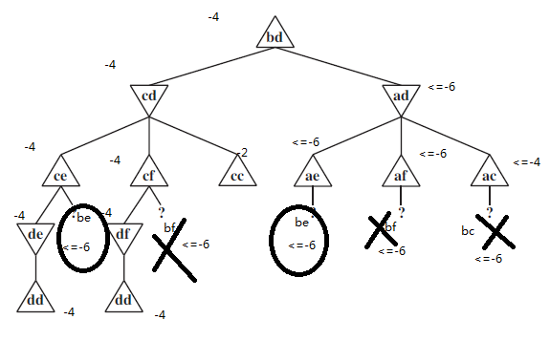

Applying a Minimax approach, problem (a)(b)(c)(e) are labeled in the above graph.

(d)

The shortest-path length can give the minimum steps for capturing, thus providing an upper bound for the values of an internal node. It is based on an assumption of good pursuer and bad evader.

(f)

For a tree that has no loop and is finite, the pursuer will win the game. Because the pursuer can always enter the subtree containing the evader. The evader could either go down to the leaf or go up to the root. By either way, it will finally be caught.

**Problem 2**

(a)



In the above graph, root node has value 50 when Expectimax search is used, which is larger than 10 when minimax search is used.

(b)

It is impossible. Because the expectimax search always return a larger value in rival node than minimax search, resulting in larger value at max layer for the player. Minimax assumes perfect rival, and will always have smaller value than expectimax search.

(c)

If player 2 is moves optimally, player 1 should use minimax search.

(d)

If player 2 moves randomly, player 1 should use expectimax search.

(e)

First use a tree where player 1 plays randomly and player 2 plays optimally. Record choices made by player 2 at each node. Then replace player 1 with optimal playing and maximize the value from the choices made by player 2.

**Problem 3**

**Problem 4**

1. Impossible in a max only tree. Because we want to find the maximum value in a layer, but we never know whether the next value is larger.
2. Impossible. Because we still could not know whether the next node will be larger.
3. Possible if a known node has value 1.
4. Possible if for a previous subtree, all nodes has value 1.
5. Highest probability first, if the values are bounded, then the subtree can have a smaller bound. If values are not bounded, then it has no influence.