Project Proposal

Contents

Project Goals 2

Project Objectives 2

Project Specifications 3

Target Language Platform 3

Project Tasks 4

Requirement Modeling 5

Process Modeling: 5

Homepage: 5

Result Page: 5

Library: 6

About Page: 7

Wireframe 7

Home Page 7

Resources 8

Project work 8

ER Diagram 10

Project Milestone 10

Project Deliverables 11

Assumption of the project 11

Project Risk 12

Conclusion 12

References 13

# Project Goals

The main goal of this project is to develop the WEBAPI based movie search engine and library

# Project Objectives

* Develop the create, update, delete and read system
* To get the full information of the movie through API

# Project Specifications

1. **Secure Login and Registration**

Login and registration must be secured in order to protect an author’s privacy.

In this project, the login and registration processes have been secured by encryption methods.

1. **Word editing capabilities**

Authors can collaborate on projects and edit documents from their profile. This makes editing or even documenting notes from scratch quite easy.

1. **Editor will provide output in PDF**

The system converts documents into PDF by using services like Overleaf. PDF as we know is quite convenient form of document; the project yields the output in PDF.

1. **Instant Messaging**

Apart from letting you collaborate with other authors, the platform also features instant messaging by the virtue of which you can chat with people in real time. This direct communication makes things easier.

1. **Printing Jobs**

You won’t need to download or have the documents in your hard disk in order to print them. The platform has a built in system for letting authors do the print job at one click.

# Target Language Platform

**1. C#**

C# is a general purpose programming language developed by Microsoft. It is a multi paradigm language (functional, object oriented, etc.)

The web application was developed using C# frameworks.

2. **SQLite**

SQLite is a *server-less* database available for free to use. It offers full CRUD functionality and is an efficient and quick way to create, read, update or delete entries from a database.

The version used in the Movie Library application is 3.

3. **API Integration**

Movie Library search feature primarily depends upon open source movie database API provided by [themoviedb.org](http://themoviedb.org).

Integration of API involves handling HTTP requests, their response, etc.

4. **JSON**

JSON is a kind of file format that contains human readable text-based data. It stands for JavaScript Object Notation. However, contrary to its name, many programming languages have libraries for parsing JSON. In this project, Newtonsoft.Json.Linq library has been used to parse and collect information from the API response.

5. **Visual Studio 2017**

Visual Studio is an IDE designed, developed and maintained by Microsoft. It provides hands on support for web app development with C#

# Project Tasks

|  |  |  |  |
| --- | --- | --- | --- |
| Planning | 5 Days | 02/03/2019 | 07/03/2019 |
| Execution | 10 Days | 08/03/2019 | 18/03/2019 |
| Monitoring | 2 Days | 20/03/2019 | 22/03/2019 |
| Control | 6 Days | 25/03/2019 | 31/03/2019 |
| Closing | 4 Days | 03/04/2019 | 07/04/2019 |

# Requirement Modeling

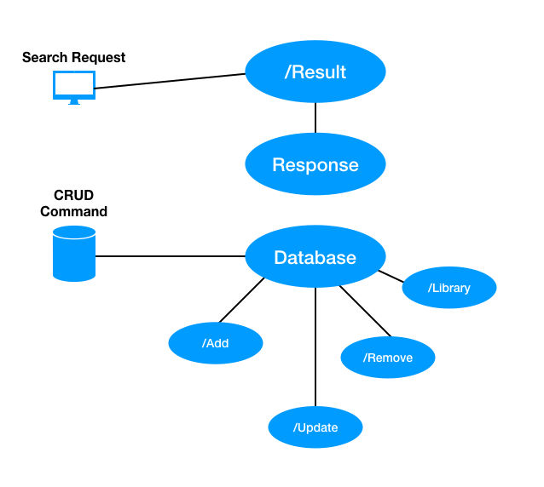

# Process Modeling:

## Homepage:

## Result Page:

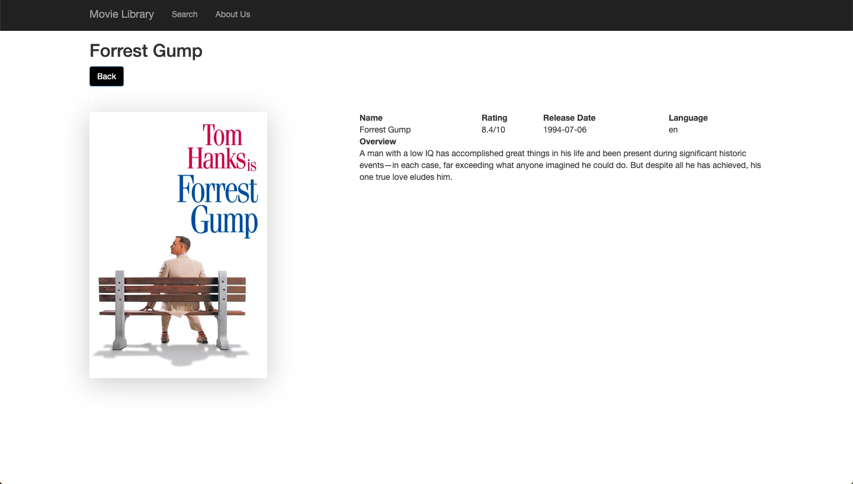

## Library:

## About Page:

# Wireframe

It is also known as a page schematic or screen blueprint that is used by the firm for the better management of the websites as well as it can also be determined that the use of wireframe is also better for the firm to arranging elements for the websites to run it in a effective manner.

Home Page

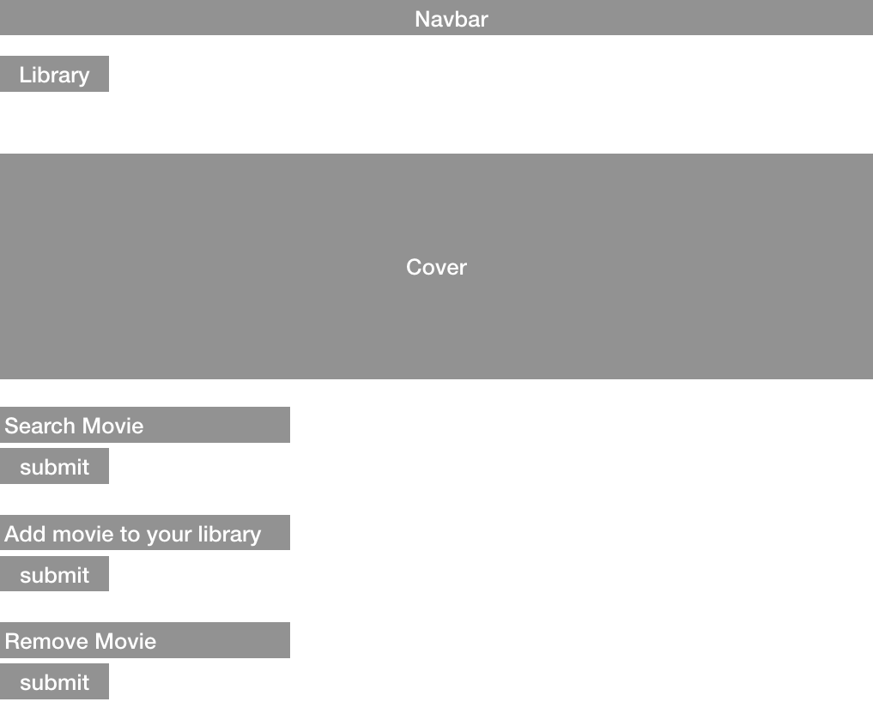

# Resources

There will be different sources that will be used by the firm to manage the project and to accomplish this project on time. In this, some major resources are human resource, internet connection, financial institution, IT department, etc. These all will be helpful for the firm and the project manage to complete the project and to have a good base of the design (Fleming, and Koppelman, 2016).

# Project work

|  |  |  |  |  |
| --- | --- | --- | --- | --- |
| **NO** | **MILESTONE** | **TASKS** | **DESCRIPTION** | **MEMBERS RESPONSIBLE** |
| 1 | Checking the all initiating project | Manage the team and handle the Meeting | Initial Meeting with the all stakeholders of the firm | Team Members |
| 2 | Kick the all meeting | Manage the all requirements | Client, Team Members |
| 3 | Technologies research | Manage the technology adoption | Team Members |
| 4 | Documentation of the project proposal | Define the all possible solution | Team Members |
| 5 | Project Proposal Presentation | Propose solution | Team Members |
| 6 | Initial Project Planning | Analysis of scope | Check the all requirements | Team Members |
| 7 | Project of the all Tasks and manage the Milestones | Creation of tasks and milestones | Team Members |
| 8 | Gantt chart the schedule of the project | Visual representation creation | Team Members |
| 9 | Risk Analysis and Management | Risk creation | Team Members |
| 10 | Project Execution and Development | Requirement Software Analysis | Technologies determination | Team Members |
| 11 | Project Planning | Planning of the project | Team Members |
| 12 | Software Front-end Design | Check the front end process | Team Members |
| 13 | Software Back-end Design | Check the back-end process | Team Members |
| 14 | Software Database Design | Manage the database Architecture | Team Members |
| 15 | Software Front-end Development | Web design and front end design | Team Members |
| 16 | Software Back-end Development | Back end functionalities | Team Members |
| 17 | Software Database Development | Development and maintenance | Team Members |
| 18 | Unit Testing | Testing | Team Members |
| 19 | Integration Testing | Documentation of testing | Team Members |
| 20 | User Acceptance Testing | System testing | Team Members |
| 21 | Documentation of the Software Project | Software documentation | Team Members |
| 22 | Progress Presentation | Check the all progress report | Team Members |
| 23 | Deployment and Documentation | User Manual | Manage the user manual | Team Members |
| 24 | User Training | Training and development | Team Members |
| 25 | Project Closure | Post Access | Meeting and manage the all business | Team Members |
| 26 | Final Project Presentation | Manage with college | Team Members |
| 27 | Turnover of the Software | Turnover of the software to the client | Team Members |

# ER Diagram

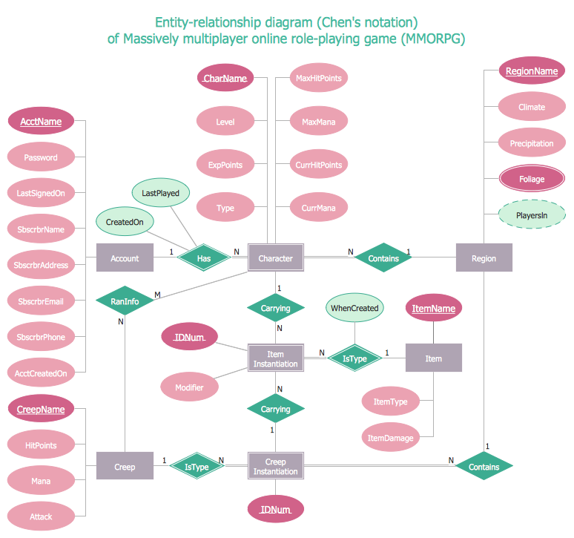

# Project Milestone

The milestone of the project defines the success of the project. In the concern of this project, below is the milestone of the project.

* Complete the needed of the programming
* Complete the programming
* Check the error and debug
* Risk management and the fix the all errors
* Complete the project
* Check the all requirement (Walker, 2015)
* Run the project successfully

# Project Deliverables

Below are the deliverables of the project

|  |  |
| --- | --- |
| Deliverable | Description |
| Project Proposal Documentation | All requirement include |
| Project Proposal Presentation | Panel presentation |
| TOTAL | |
| Software Project | Include GUI, and the testing of the all functions . |
| Software Project Documentation | Analysis, design, and implementation. |
| Progress Presentation | Check the all requirements |
| TOTAL | |
| User Manual | Graphical user interface. |
| Final Presentation | Checking and managing the all process |
| TOTAL | |

# Assumption of the project

However, this project will be successful but at the same time, there are also some assumptions that can be occurred and can affect the project also. In this, the one of the major assumption that can be occurred is the lack of coding, error in the programming, issue of the time and the cost, project failure due to incomplete the requirement, etc. There can be the issue for the project to make successful and to handle the all project also (Walker, 2015).

# Project Risk

* Project scope and duration wrong estimated
* Project delays may cause due to some dependent tasks
* Project must have exceptional security
* Not proper working of the functions
* Conflicts among team members

# Conclusion

This project will get the success and there are different milestones that are to be completed in this project, although there are some issues in terms of project failure that can be occurred and can affect the project but the better management of the task will be effective.

# References

Kerzner, H. and Kerzner, H.R., 2017. *Project management: a systems approach to planning, scheduling, and controlling*. John Wiley & Sons.

Schwalbe, K., 2015. *Information technology project management*. Cengage Learning.

Fleming, Q.W. and Koppelman, J.M., 2016, December. Earned value project management. Project Management Institute.

Walker, A., 2015. *Project management in construction*. John Wiley & Sons.