**Weather App**

1: Main Activity: In this page, there is a search button to search the name of the place. Moreover, there is About Developer button where we can check the role of developers those contributed in this project.

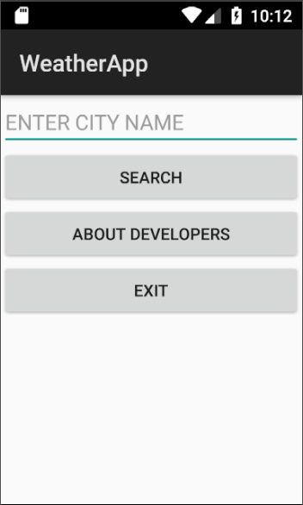

2:Weather Activity: This page shows the weather informtion of the searched area.

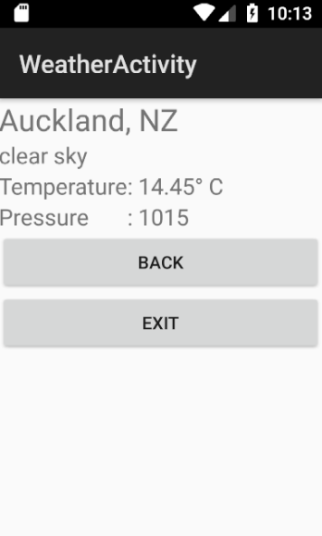

**3: About Developers :** This page shows the roles of developers to make this application.

