**Weather App**

The Weather App is an application to search the weather information of any area. In this app we can see weather condition, pressure and temperature.

**Wireframes**

**Main Activity`**

**Developer Activities:**

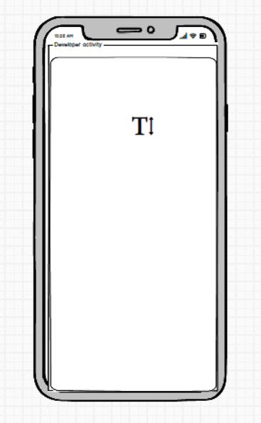

**Weather Activity**

