**Visit:** [www.apachefriends.org/download.html](http://www.apachefriends.org/download.html)

Integer is a type of number with no decimal value (no value after point). The size of this Integer depends on:

1. Compiler (The back-end program that converts programming language into machine understandable language)
2. Interpreter (The programming language processor, that translates a program line by line to complete an action)
3. Platform (Windows / Linux / Mac; Operating System has 32 Bit, or 64 Bit version)
4. Language (PHP / ASP / JSP; Language also has 32 Bit Built, or 64 Bit Built)

**32-bit Builds of PHP Language supports Integer value (on 32 Bit or 64 Bit Windows):**

From -2147483648 To 2147483647

**64-bit Builds of PHP Language supports Integer value (on Linux):**

From -9223372036854775808 To 9223372036854775807

<?php

**print** **PHP_INT_MAX**;

?>

PHP_INT_SIZE is a Built-In Constant that shows the Maximum Size of Integer Value on your on your Platform (PHP) on your Machine (PC/Server).

**Code:**

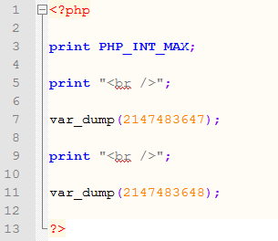

**Result:**

