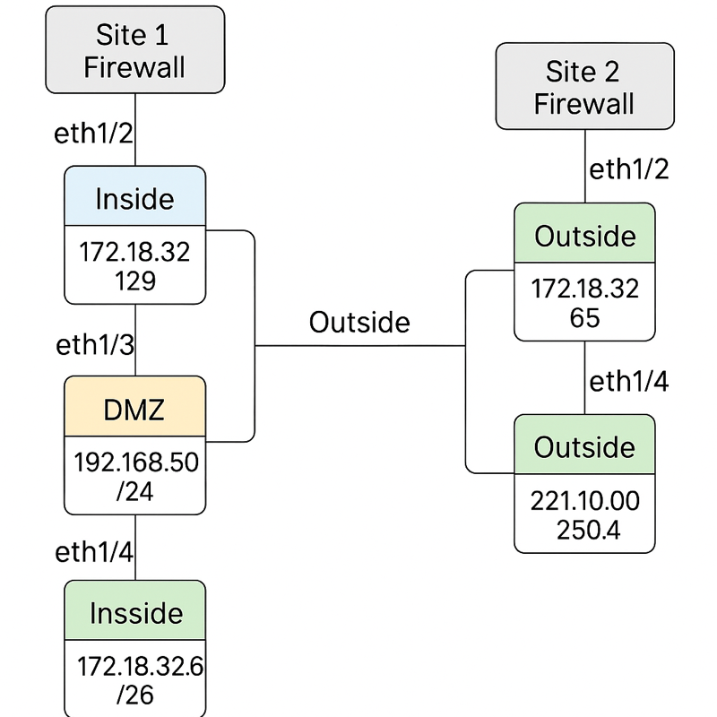
Requirements Summary:
This document outlines the business and security requirements for the configuration of two Palo Alto Firewalls across Site 1 and Site 2. It is intended as a functional specification for technicians implementing the design.
- Site 1 Firewall must have a DMZ configured on ethernet1/3 with IP 192.168.50.1/24.
- A web server is hosted in the DMZ at 192.168.50.10 and must be accessible via HTTP from the internet using destination NAT to 221.100.250.36.
- Site 2 does not require a DMZ zone.
- Site 1 inside network uses 172.18.32.128/28 on ethernet1/2 with IP 172.18.32.129.
- Site 2 inside network uses 172.18.32.64/26 on ethernet1/2 with IP 172.18.32.65.
- Outside interfaces for Site 1 and Site 2 are 221.100.250.36 and 221.100.250.44 respectively.
- A site-to-site IPSec VPN tunnel must be established between Site 1 and Site 2 firewalls.
- URL filtering must be enabled to block access to shopping websites.
- Only DNS, HTTP, and HTTPS services are allowed from internal users to the internet.
- Ping should be allowed to ethernet1/2 via management profile, but SSH and HTTPS should not be.
- The management interface must allow HTTPS, SSH, and Ping access.
- A local user admin must be created with full admin privileges for firewall access.
- Inside clients should access the internet via Source NAT using the firewall’s outside interface.
- Security policies must include App-ID filtering to control application access.
- Site 2 should be able to access the web server in Site 1 DMZ via HTTP but not via ping.
Test/Validation Plan Table:
Function | Device | Test Command | Expected Result
Internet Access | Site 1 Client | ping 8.8.8.8 or browser test | Success
Internet Access | Site 2 Client | ping 8.8.8.8 or browser test | Success
DMZ Access | Site 2 Client | Access http://221.100.250.36 | Success
DMZ Ping Block | Site 2 Client | ping 192.168.50.10 | Fails
VPN Tunnel | Site 1 to Site 2 | ping 172.18.32.66 | Success
VPN Tunnel | Site 2 to Site 1 | ping 172.18.32.130 | Success
Blocked Website | Any Client | Access amazon.com | Blocked
Allowed Website | Any Client | Access cisco.com | Success
Admin Login | Firewall | Login with jobayer_admin | Success
Security Policy Hit Count | Firewall | View under Policies > Hit Count | Non-zero
NAT Policy | Firewall | View NAT policy hit count | Non-zero

