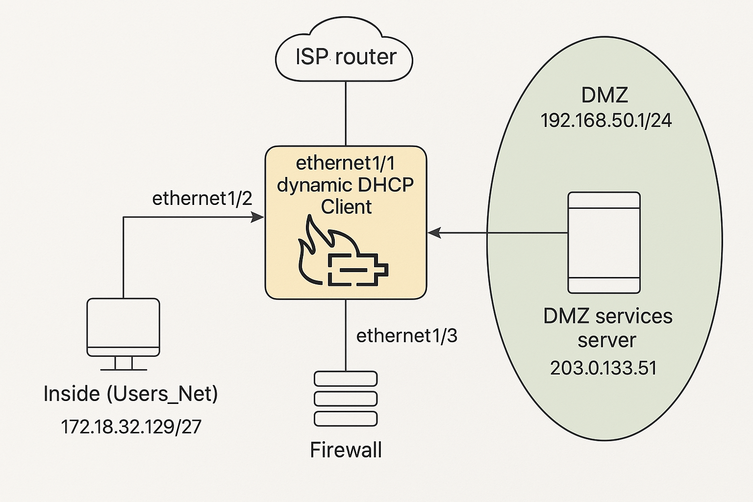

IP Address Table:
Interface | Zone | IP Address | Description
Ethernet1/1 | Internet | DHCP(203.0.113.0/24) | Public/Outside Interface
Ethernet1/2 | Users_Net | 172.18.32.129/27 | Internal/Client Network
Ethernet1/3 | DMZ | 192.168.50.1/24 | DMZ Gateway for Web Server

Business Requirements:
The network has three zones—Inside (Users_Net), DMZ, and Internet. Inside users have limited internet access, restricted to trusted domains like *.cisco.com and *.paloaltonetworks.com, enforced via address objects and URL filtering. Sites like Google and YouTube also any others are explicitly blocked. The DMZ hosts a public web server, accessible only via HTTP from the Internet, with ICMP and other protocols blocked. All traffic passes securely through the firewall using configured NAT and security policies.

Test & Validation Table:
Test | Expected Result | Pass/Fail
Client pings 8.8.8.8 | Successful ping | ✅
Client does nslookup cisco.com | Returns IP | ✅
Client opens cisco.com | Loads page | ✅
Client tries google.com | Blocked | ✅
Curl from vRouter to 203.0.113.100 | Returns DMZ page | ✅
Ping from vRouter to 203.0.113.100 | Fails(blocked) | ✅
HTTPS to DMZ | Blocked | ✅
DNS from firewall | Works(resolved) | ✅

