Configuring GlobalProtect VPN on Palo Alto Firewall
Jobayer Bhuiyan

Purpose:
The purpose of this lab is to configure and test GlobalProtect VPN on a Palo Alto firewall. The lab includes creating and applying certificates, configuring the GlobalProtect Portal and Gateway, creating security policies, NAT rules, and verifying VPN tunnel connectivity from an external client.
Logical Drawing:

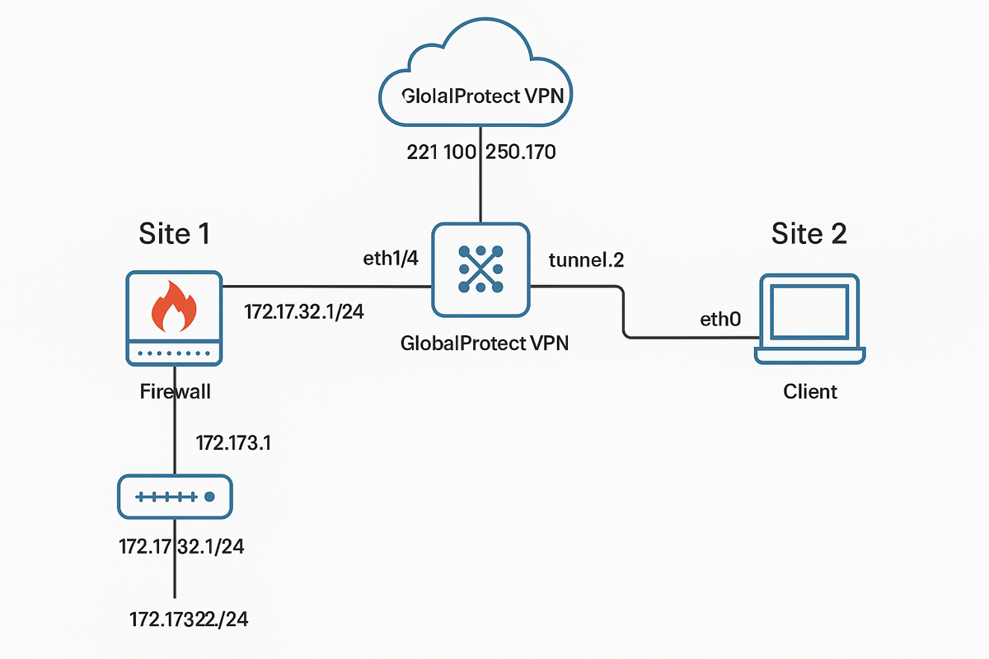
Address Table:
Device | Interface | IP Address
Site 1 Firewall | ethernet1/2 (inside) | 172.17.32.1/24
Site 1 Firewall | ethernet1/4 (outside) | 221.100.250.170
Site 1 Firewall | Management | 192.168.1.x/24
Site 1 Tunnel Interface | tunnel.2 | No IP
Site 2 Client | eth0 | Dynamic (192.168.1.x)

Procedures:
- Configure Management Interface:
  - Set management IP, DNS, and permitted IP addresses.
- Configure Interfaces:
  - ethernet1/2 assigned to Inside zone.
  - ethernet1/4 assigned to Outside zone.
- Set Up Security Zones:
  - Created zones: Inside, Outside, gpVPN (for VPN clients).
- Create NAT Policies:
  - Inside-to-Outside NAT.
  - gpVPN-to-Outside NAT.
- Create Security Policies:
  - Allow Inside to Outside.
  - Allow gpVPN to Inside.
  - Allow gpVPN to Outside.

- Generate Certificates:
  - Created RootCert (CA certificate).
  - Created Server Certificate (Common Name: 221.100.250.170).
  - Created SSL/TLS Service Profile using Server Certificate.
- Create Authentication Profile:
  - Configured local authentication profile using the Local User Database.
- Create Local User:
  - Created user testme with password Pa$$w0rd.
- Configure Tunnel Interface:
  - Created Tunnel.2, assigned it to gpVPN zone.
- Configure GlobalProtect Portal:
  - Set external interface and IP.
  - Used SSL/TLS Profile.
  - Set authentication with local user database.
  - Set Trusted Root CA to RootCert.
- Configure GlobalProtect Gateway:
  - Set external interface and IP.
  - Enabled tunnel mode.
  - Selected Tunnel.2 as tunnel interface.
  - Used SSL/TLS Profile.
- Test VPN Connection from Site 2:
  - Reached Portal web page via browser.
  - Installed GlobalProtect Agent.
  - Attempted VPN connection (failed certificate verification on Linux client).
  - Ping attempted to internal Site 1 IP.

Verification/Troubleshooting:
Test | Command/Action | Expected Result | Actual Result
Access Portal | Browser https://221.100.250.170 | Reach GlobalProtect Portal page | ✅ Successful
Install GlobalProtect | tar -xzf, dpkg -i | Agent installed | ✅ Successful
Connect to VPN | GlobalProtect UI | Connection established | ⚠️ Certificate trust failed on Linux client
Ping Internal IP | ping 172.17.32.20 | Receive ping replies | ⚠️ Ping failed without full tunnel
Troubleshooting Notes:
- Issue: Certificate not trusted by Linux GlobalProtect client.
- Impact: VPN tunnel could not fully establish, causing ping failure.
- Workaround: Would require importing RootCert manually into Linux trusted store.
- Lab Conclusion: Connection procedures completed; functional verification partially achieved.

GlobalProtect portal was reachable and agent was installed. VPN connection failed due to certificate trust issue on Linux. Ping to 172.17.32.20 was unsuccessful because VPN tunnel could not fully establish.

