Controlling Access to Network Resources with User-ID
Jobayer Bhuiyan

Purpose:
The purpose of this lab is to configure User-ID technology on a Palo Alto Networks firewall to control access to internet applications based on user identity and group membership in the newly created Acquisition security zone.

Logical Drawing:
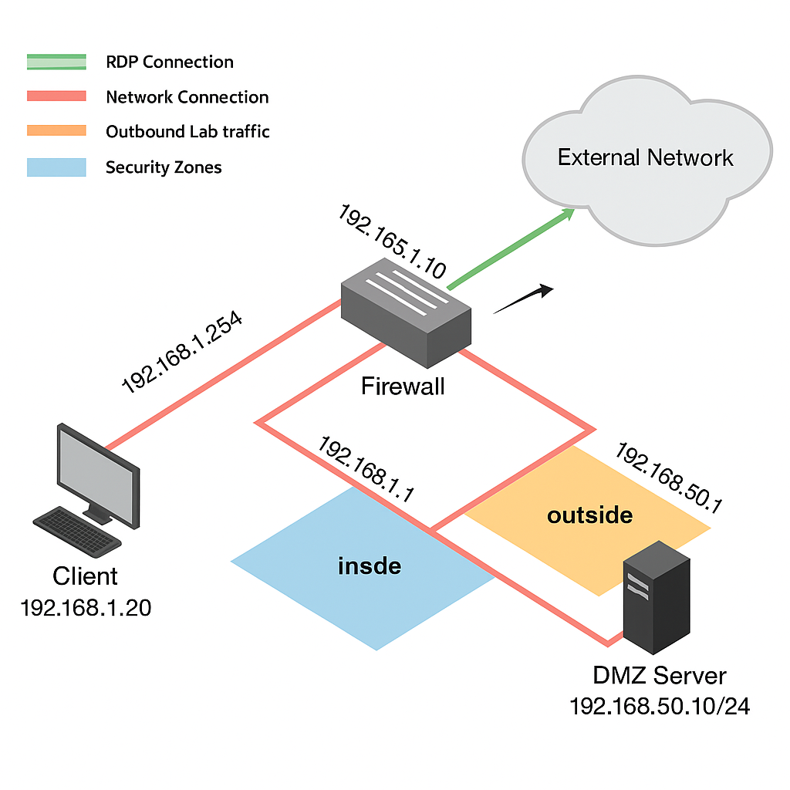

Address Table:

Device Name | Interface | IP Address
Client | - | 192.168.1.20/24
Firewall Mgmt | Management | 192.168.1.254/24
Firewall vRouter | Inside / Ethernet1/2 | 192.168.1.1/24
DMZ Server | DMZ | 192.168.50.10/24

Procedures:
- Log in to the Client PC using the credentials lab-user / Pal0Alt0!.
- Access the Firewall Web Interface by browsing to https://192.168.1.254 and logging in as admin / Pal0Alt0!.
- Load and Commit Baseline Configuration:
  - Navigate to Device > Setup > Operations.
  - Load edu-210-11.0a-11.xml snapshot.
  - Commit the configuration.
- Examine Current Security Policy:
  - Review Policies > Security > Acquisition-Allow-All rule settings:
    - Source Zone: Acquisition
    - Destination Zone: any
    - Application: any
    - Action: allow
  - Reset rule hit counters for all rules.
- Verify Application Groups:
  - Go to Objects > Application Groups and verify:
    - Allowed-Corp-Apps: (dns, web-browsing, ssl)
    - Allowed-Mktg-Apps: (facebook-base, instagram-base, twitter-base, etc.)
- Generate Traffic:
  - Open Remmina and connect to Server-Extranet.
  - Navigate to /home/paloalto42/pcaps92019/app.pcaps/.
  - Run the script: ./Appgenerator-2.sh.
- Monitor Traffic Logs:
  - Go to Monitor > Logs > Traffic.
  - Add Source User column.

- Enable User-ID on Acquisition Zone:
  - Navigate to Network > Zones.
  - Edit the Acquisition zone and enable User Identification.
- Modify Acquisition-Allow-All Rule:
  - Rename it to Allow-Corp-Apps.
  - Set Description: Allows only approved apps for Acquisition users.
  - Set Application to Allowed-Corp-Apps.
- Create Marketing Apps Rule:
  - Add a new rule Allow-Mktg-Apps.
  - Source Zone: Acquisition.
  - (If Source User “marketing” group unavailable, leave empty or add individual users.)
  - Application: Allowed-Mktg-Apps.
  - Action: Allow.
- Create Deny Rule:
  - Add a new rule Deny-All-Others.
  - Source Zone: Acquisition.
  - Application: any.
  - Action: Deny.
- Commit Changes:
  - Click Commit to save all policy changes.
- Regenerate Traffic:
  - Re-run ./Appgenerator-2.sh on the Extranet-Server.
- Examine User-ID Logs:
  - Check Monitor > Logs > User-ID.
  - SSH into Firewall-A using Remmina and run:
show user ip-user-mapping all
- Analyze Firewall Traffic Log:
  - Apply filters for apps: youtube-base, dns, facebook-base, instagram-base.
  - Answer lab questions and take screenshots.
- Clean Up:
  - Clear any Traffic log filters.
  - Close Remmina connections.
  - Close the browser window.

Verification/Troubleshooting:
- Verification:
  - Check Traffic Logs to verify that:
    - Approved corporate apps (dns, web-browsing, ssl) are allowed.
    - Social media apps (facebook-base, instagram-base) are allowed for Marketing users only.
    - All other applications are denied.
  - Use CLI command:
show user ip-user-mapping all
to verify user-to-IP mappings
- Troubleshooting:
  - If User-ID mappings do not appear, ensure User Identification is enabled on the Acquisition zone.
  - If traffic hits incorrect rules, verify correct Source User or Application Group assignments in policy rules.
  - Re-run Appgenerator script if Traffic Logs are empty.

