Lab 10: Blocking Unknown Threats with WildFire
Jobayer Bhuiyan

Purpose:
The purpose of this lab is to configure a Palo Alto firewall to send unknown files to the WildFire cloud for analysis, helping to identify and block zero-day threats.

Logical Drawing:
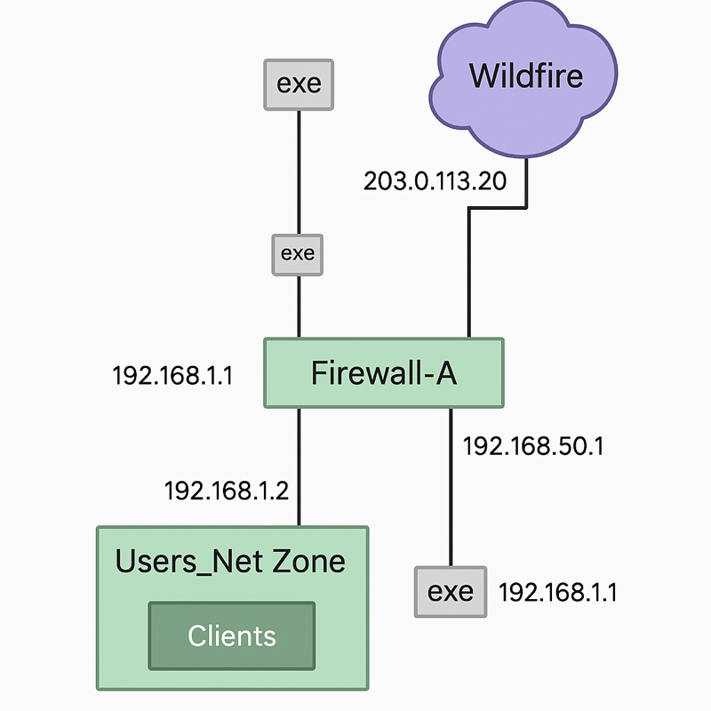

Address Table:
Device | Interface | IP Address
Client | Ethernet | 192.168.1.20/24
DMZ Server | Ethernet | 192.168.50.10/24
Firewall | Management | 192.168.1.254/24
vRouter | Ethernet | 192.168.1.10/24
Procedures:
- Login to Client and Firewall:
  - Client login: lab-user / Pal0Alt0!
  - Firewall login: admin / Pal0Alt0!
- Load Baseline Configuration:
  - Navigate to Device > Setup > Operations.
  - Load named configuration snapshot edu-210-11.0a-10.xml.
  - Commit the changes.
- Create WildFire Analysis Profile:
  - Go to Objects > Security Profiles > WildFire Analysis.
  - Click Add, name the profile Corp-WF.
  - Under Profile Settings, add "All_Files" profile (applications: any, file types: any, direction: both, analysis: public-cloud).
- Modify Security Profile Group:
  - Go to Objects > Security Profile Groups.
  - Edit Corp-Profiles-Group, select WildFire Profile Corp-WF.
  - Set all other profiles to None.
- Update WildFire Settings:
  - Navigate to Device > Setup > WildFire.
  - Edit General Settings, check "Report Benign Files" and "Report Grayware Files".
- Commit Configuration Again:
  - Click Commit to apply the new security settings.
- Test WildFire Upload:
  - On the client, use Firefox to download http://192.168.50.80/wildfire-test-pe-file.exe.
  - Save the file.
- Verify WildFire Upload:
  - On the firewall CLI, run: debug wildfire upload-log show.
  - Confirm that the file was uploaded.
- Examine WildFire Analysis:
  - Go to Monitor > Logs > WildFire Submissions.
  - Review the verdict and download the detailed PDF analysis.

Verification/Troubleshooting:
- Verified that the file "wildfire-test-pe-file.exe" was uploaded successfully.
- WildFire Submissions showed a malicious verdict.
- Confirmed WildFire report details via downloaded PDF.
- If the file did not show up, troubleshooting included checking network access and WildFire configuration settings.

Lab 12: Using Decryption to Block Threats in Encrypted Traffic
Jobayer Bhuiyan

Purpose:
The purpose of this lab is to configure SSL Forward Proxy Decryption on a Palo Alto firewall to inspect outbound HTTPS traffic and block threats hidden in encrypted connections.

Logical Drawing:
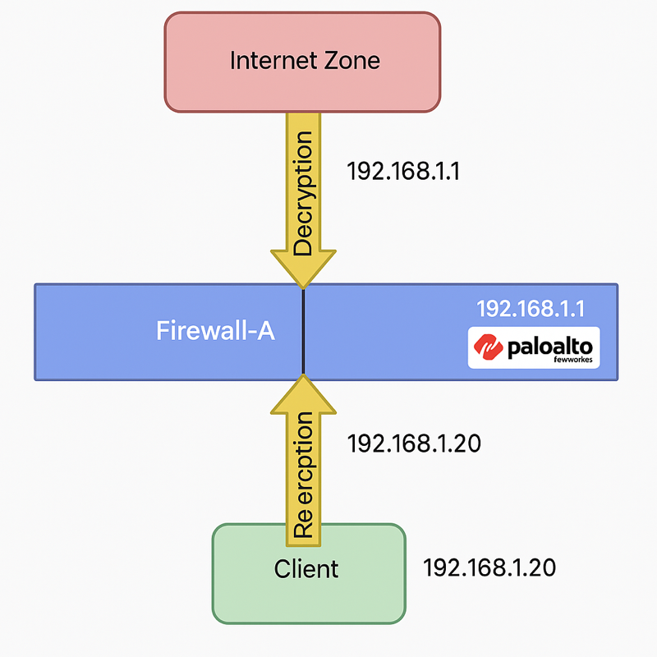
Address Table:
Device | Interface | IP Address
Client | Ethernet | 192.168.1.20/24
DMZ Server | Ethernet | 192.168.50.10/24
Firewall | Management | 192.168.1.254/24
vRouter | Ethernet | 192.168.1.10/24

Procedures:
- Login to Client and Firewall:
  - Client login: lab-user / Pal0Alt0!
  - Firewall login: admin / Pal0Alt0!
- Load Baseline Configuration:
  - Navigate to Device > Setup > Operations.
  - Load named configuration snapshot edu-210-11.0a-12.xml.
  - Commit the changes.
- Test Connection Without Decryption:
  - Access http://192.168.50.80/eicar.com and https://www.eicar.org.
  - Note firewall blocks or certificate warnings.
- Create Trusted Certificate:
  - Device > Certificate Management > Certificates > Generate.
  - Certificate Name: trusted-cert, Common Name: 192.168.1.1, check Certificate Authority.
  - Set as Forward Trust Certificate.

- Create Untrusted Certificate:
  - Generate new Certificate Name: untrusted-cert, Common Name: DO NOT TRUST, check Certificate Authority.
  - Set as Forward Untrust Certificate.
- Create Decryption Policy:
  - Policies > Decryption > Add.
  - Name: Decrypt_User_Traffic.
  - Source Zone: Users_Net, Destination Zone: Internet.
  - Action: Decrypt, Type: SSL Forward Proxy, Profile: default.
- Commit Configuration:
  - Click Commit to apply settings.
- Export and Import Trusted Certificate into Firefox:
  - Export trusted-cert without private key.
  - Import into Firefox > Settings > Certificates > Authorities.
- Test Decryption:
  - Access https://www.bing.com.
  - Verify the certificate Issuer is 192.168.1.1.
- Test Firewall Block for Untrusted Certificate:
  - Access https://www.eicar.org.
  - Connection error expected (due to untrusted cert).
- Verify Decryption Logs:
  - Monitor > Logs > Decryption.
  - Confirm traffic decryption using Decrypt_User_Traffic policy.

Verification/Troubleshooting:
- Verified browser certificate issuer changed to firewall's trusted cert.
- Verified HTTPS inspection through decryption logs.
- Verified block page or secure connection errors on untrusted SSL sites.
- Troubleshooting included checking imported certificates and decryption policy match conditions.

