Locating Valuable Information Using Logs and Reports
Jobayer Bhuiyan

Purpose:

The purpose of this lab is to explore how to locate valuable network and threat-related information using the Palo Alto firewall's monitoring tools such as the Dashboard, ACC (Application Command Center), and log views for Threats, URL Filtering, and Data Filtering.
Diagram:
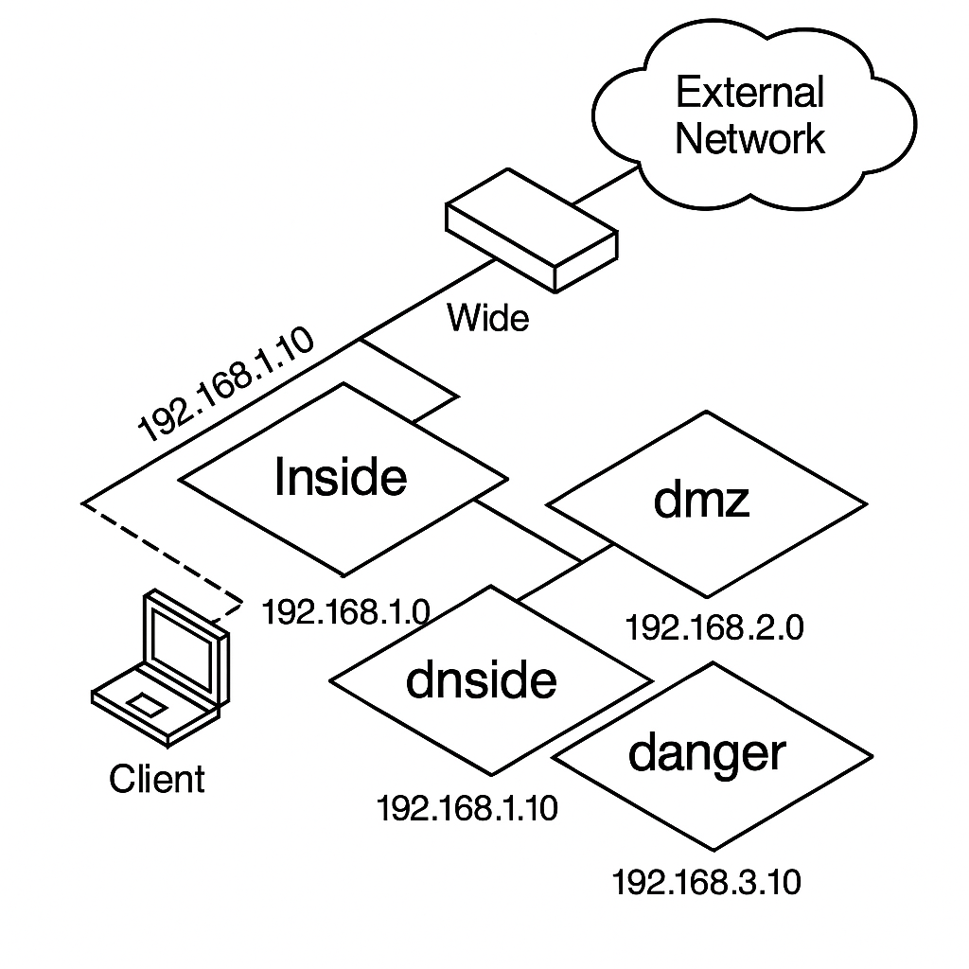
Address Table:

Device Name | Interface | Address
Client | - | 192.168.1.20
DMZ Server | - | 192.168.50.10
Firewall | MGMT | 192.168.1.254
Firewall | Ethernet1/1 (Outside) | 203.0.113.20
Firewall | Ethernet1/2 (Inside) | 192.168.1.1
Firewall | Ethernet1/3 (DMZ) | 192.168.50.1

Procedures:

- Generate Traffic
  - Open Remmina on the client machine.
  - Connect to Server-Extranet.
  - Run the script:
  - cd ~
  - chmod +x UsingLogs-V1.sh
./UsingLogs-V1.sh
  - Let it run for 5-7 minutes.
- Login to the Firewall Web Interface
  - Open Firefox on the client.
  - Visit: https://192.168.1.254
  - Login as: admin / Pal0Alt0!

- View Logs
  - Navigate to Monitor > Logs > Threat
    - Apply filter: receive_time geq '2025/04/29 08:15:00'
    - Take a screenshot of the first 10 entries.
  - Navigate to Monitor > Logs > URL Filtering
    - Apply same time filter.
    - Screenshot top 10 entries (even if none appear).
  - Navigate to Monitor > Logs > Data Filtering
    - Apply same time filter.
    - Screenshot top 10 entries (even if none appear).

Verification / Troubleshooting:

- Verify Logs are Populated:
  - Check that running the traffic script results in visible logs in Threat, URL Filtering, and Data Filtering logs.
- If Logs are Empty:
  - Ensure the traffic script (UsingLogs-V1.sh) is still running or was run recently.
  - Re-apply the correct timestamp filter (receive_time geq with proper date/time).
- Browser Won't Connect to Firewall:
  - Confirm client has network access.
  - Retry URL or refresh after a few seconds.
  - Ensure the firewall has finished initializing.

