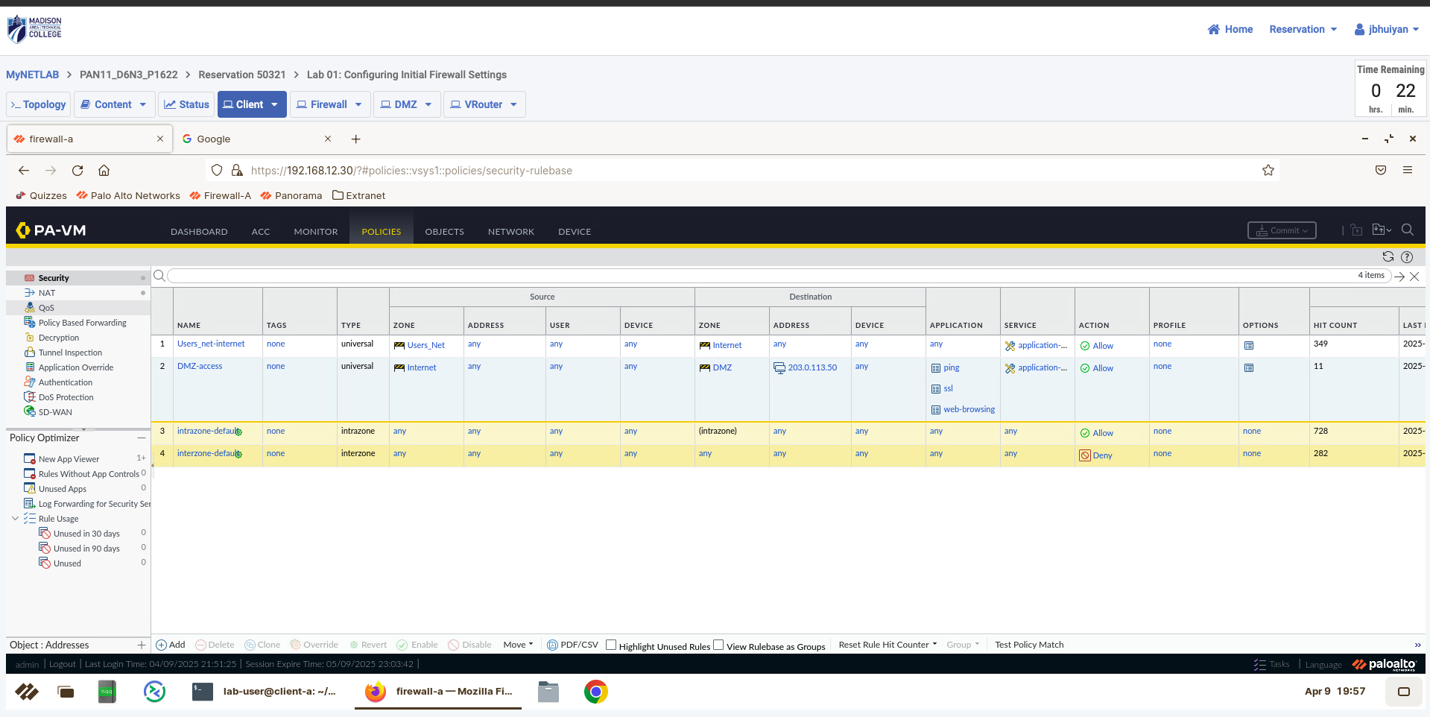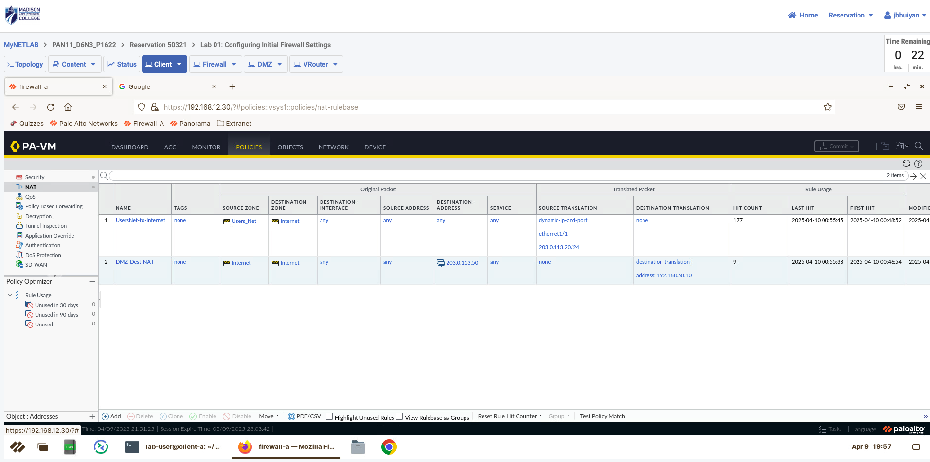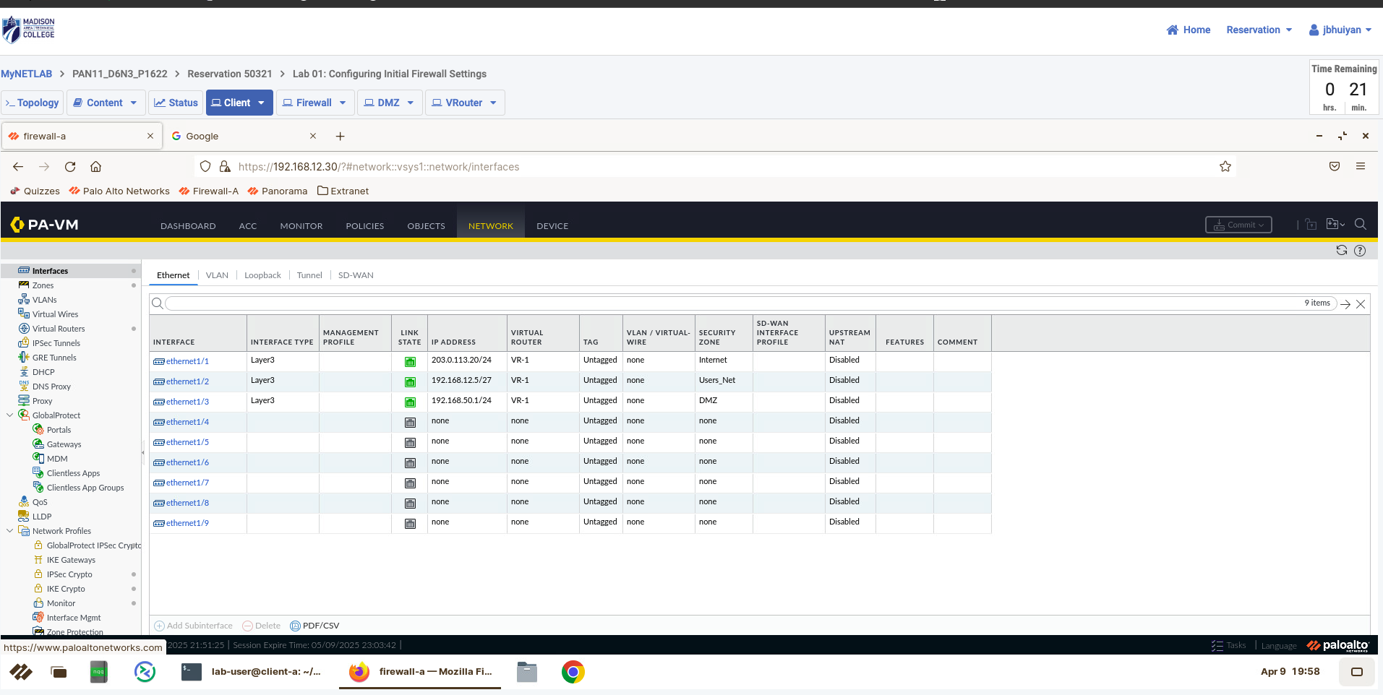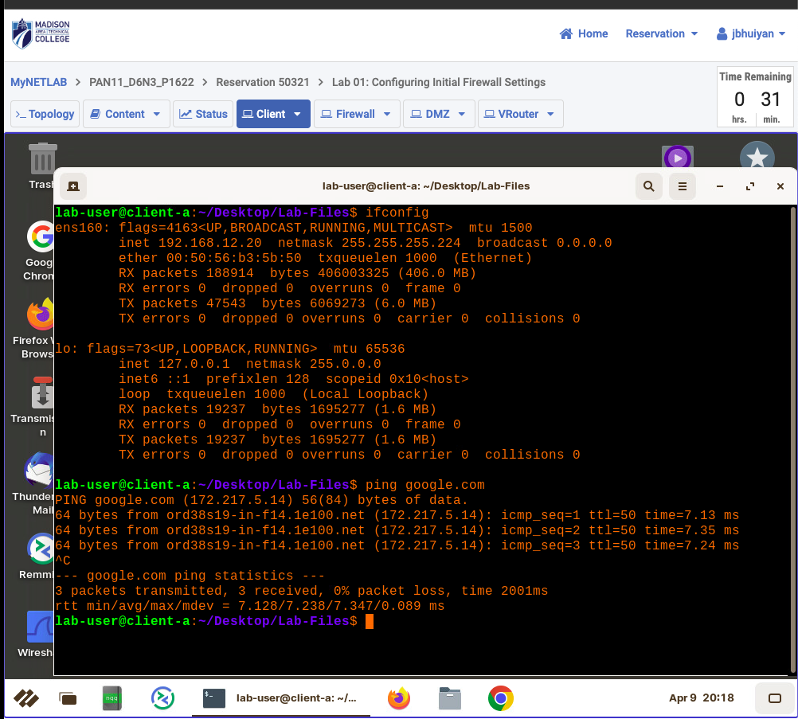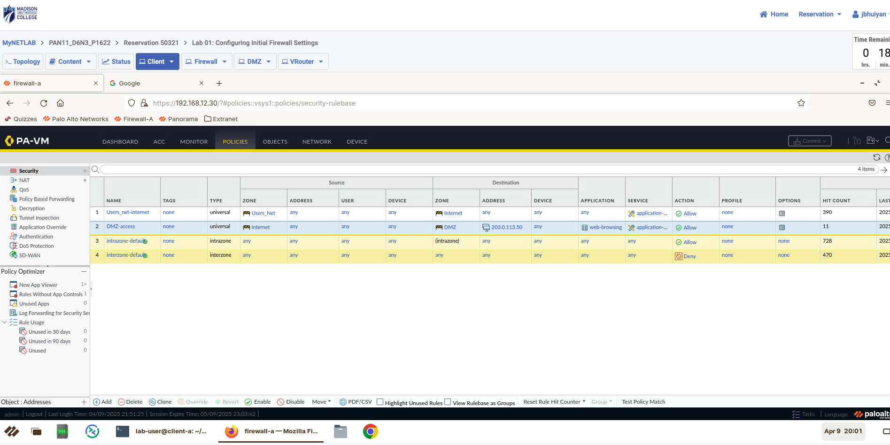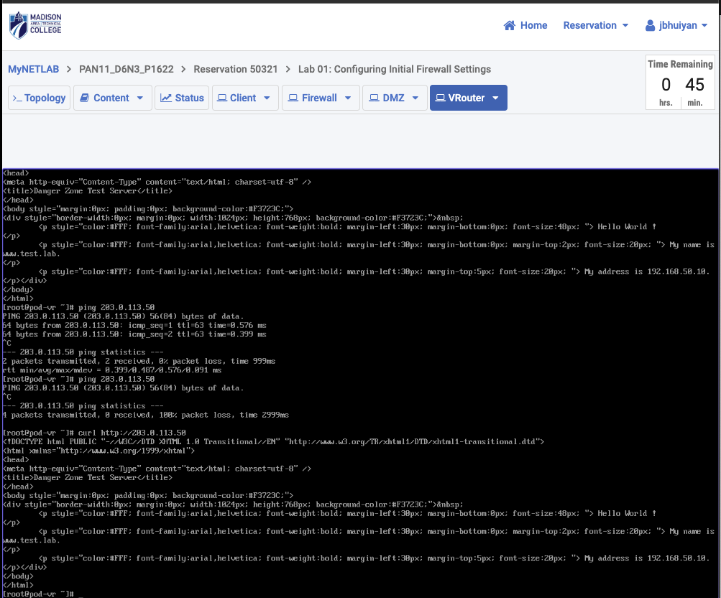

Troubleshooting and Testing Steps:
First, I confirmed that my client machine (192.168.12.20) had Internet access by opening a browser and visiting some websites.
I pinged the DMZ server (203.0.113.50) from the Internet side to make sure ICMP was allowed, and it worked when the ping application was included in the rule.
I used the curl command to access the DMZ server’s web page and got a full HTML response, which confirmed that HTTP traffic was getting through.
To double-check security, I tried accessing services like FTP and SSH, which failed showing that my rule was correctly blocking everything except what’s allowed.
Finally, I reviewed the traffic logs in the Palo Alto firewall to confirm that only ping, web-browsing, and ssl traffic was being allowed, and other attempts were dropped

