Lab 3: Managing Firewall Administrator Accounts
Name: Jobayer Bhuiyan
Purpose Statement
This lab introduces the configuration and testing of multiple administrator authentication methods on a Palo Alto Networks Firewall. It covers Local Database, LDAP, and RADIUS authentication, as well as the creation of Authentication Profiles and Sequences for managing firewall admin access.
Logical Network Drawing
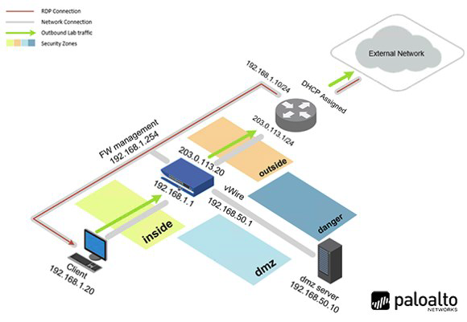

IP Address Table
Device | Interface | IP Address | Notes
Client | N/A | 192.168.1.20 | Lab-user login
DMZ Server | N/A | 192.168.50.10 | LDAP/RADIUS host
Firewall | Management | 192.168.1.254 | GUI Access
vRouter | Management | 192.168.1.10 | Root Access

Step-by-Step Procedures
- Apply a Baseline Configuration
  - Login to the Client (lab-user/Pal0Alt0!).
  - Access the firewall at https://192.168.1.254 (admin/Pal0Alt0!).
  - Navigate to Device > Setup > Operations > Load named configuration snapshot.
  - Load edu-210-11.0a-03.xml and commit the changes.
- Create Local Authentication
  - Go to Device > Authentication Profile > Add
  - Name: Local-Database, Type: Local Database
  - Under Advanced > Allow List: Add all
  - Save and Commit
- Create a Local User Account
  - Navigate to Device > Local User Database > Users
  - Add user adminBob, Password: Pal0Alt0!
  - Save and Commit
- Create Local Administrator
  - Go to Device > Administrators > Add
  - Name: adminBob, Auth Profile: Local-Database
  - Save and Commit
- Test Local Authentication
  - Log out and log in as adminBob
  - Navigate to Monitor > Logs > System
  - Confirm successful login (Screenshot 1)
- Configure LDAP Authentication
  - Go to Device > Server Profiles > LDAP > Add
  - Name: LDAP Server Profile, Server: 192.168.50.89, Port: 389
  - Base DN: dc=panw,dc=lab, Bind DN: cn=admin,dc=panw,dc=lab, Password: Pal0Alt0!
  - Disable SSL requirement
  - Go to Authentication Profile, create LDAP Auth, link it to LDAP Server Profile
  - Add user adminSally in Administrators with LDAP Auth profile
  - Commit changes
- Test LDAP Authentication
  - Log out and log in as adminSally
  - Check system logs for LDAP success (Screenshot 2)
- Configure RADIUS Authentication
  - Go to Device > Server Profiles > RADIUS > Add
  - Name: RADIUS Server Profile, Server: 192.168.50.150, Port: 1812
  - Protocol: CHAP, Secret: Pal0Alt0!
  - Go to Authentication Profile, create RADIUS Auth, link it to RADIUS Server Profile
  - Add user adminHelga in Administrators with RADIUS Auth profile
  - Commit changes
- Test RADIUS Authentication
  - Log out and log in as adminHelga
  - Verify in logs that RADIUS authentication was successful (Screenshot 3)
- Create Authentication Sequence
  - Navigate to Device > Authentication Sequence > Add
  - Name: LDAP then RADIUS, Order: LDAP Auth -> RADIUS Auth
  - Commit configuration

Troubleshooting Section
Step | Device | What to Check | Expected Result
5 | Firewall | Logs for adminBob  Login | Success via Local-Database
7 | Firewall | Logs for adminSally login | Success via LDAP Auth Profile
9 | Firewall | Logs for adminHelga  login | Commit Completes successfully
Any | Firewall | Commit changes after any config | Commit completes successfully
Any | Firewall | Connection to LDAP/RADIUS server | No timeout or auth errors in log

