VPN Lab Documentation
Jobayer Bhuiyan

Purpose:
The purpose of this lab was to configure a Site-to-Site VPN between Site 1 (P1720) and Site 2 (P1728) using Palo Alto firewalls. This VPN ensures secure communication between two remote networks, allowing devices from Site 1 and Site 2 to communicate with each other while maintaining internet access.

Diagram:
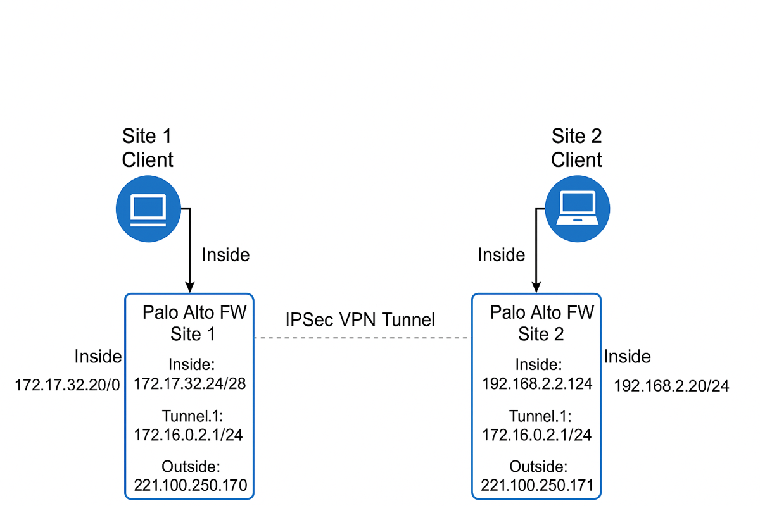
Procedures:
Site 1 (P1720):
- Client IP: 172.17.32.20/28
- Firewall Inside IP (eth1/2): 172.17.32.24/28
- Firewall Outside IP (eth1/4): 221.100.250.170/24
- Management IP: 172.17.32.30/28
- Tunnel Interface IP: 172.16.0.1/24
Site 2 (P1728):
- Client IP: 192.168.2.20/24
- Firewall Inside IP (eth1/2): 192.168.2.1/24
- Firewall Outside IP (eth1/4): 221.100.250.171/24
- Management IP: 192.168.2.254/24
- Tunnel Interface IP: 172.16.0.2/24
Firewall Zones:
- Inside
- Outside
- VPN

Step-by-Step Procedures:

- Interface Configuration:
  - Assigned IP addresses to Ethernet1/2 (Inside) and Ethernet1/4 (Outside) on both firewalls.
  - Created a Tunnel.1 interface, assigned it to VPN zone, and configured tunnel IPs.
- NAT Policies:
  - Configured source NAT for Inside-to-Outside traffic to allow internet access.
- Security Policies:
  - Created policies:
    - Inside-to-Internet (Inside -> Outside)
    - Inside-to-VPN (Inside -> VPN)
    - VPN-to-Inside (VPN -> Inside)

- IKE Gateway Configuration:
  - Site 1 Local IP: 221.100.250.170
  - Site 1 Peer IP: 221.100.250.171
  - Site 2 Local IP: 221.100.250.171
  - Site 2 Peer IP: 221.100.250.170
  - Used pre-shared key for authentication.
- IPSec Tunnel Configuration:
  - Configured IPSec tunnels on both firewalls.
  - Set up Proxy IDs:
    - Site 1 Local: 172.17.32.16/28, Remote: 192.168.2.0/24
    - Site 2 Local: 192.168.2.0/24, Remote: 172.17.32.16/28
- Static Routes:
  - Site 1: Route to 192.168.2.0/24 via tunnel.1
  - Site 2: Route to 172.17.32.16/28 via tunnel.1
- Management Interface Configuration:
  - Site 1 Management IP: 172.17.32.30/28 with permitted IPs 172.17.32.16/28
  - Site 2 Management IP: 192.168.2.254/24 with permitted IPs 192.168.2.0/24
- Commit and Save Configuration:
  - Saved named snapshots and committed all changes on both sites.

Testing Results:

- Ping Success:
  - Site 1 Client successfully pinged Site 2 Client (192.168.2.20).
  - Site 2 Client successfully pinged Site 1 Client (172.17.32.20).
- Tunnel Status:
  - Both IPSec Tunnels showed green/up status.
- Traffic Logs:
  - Allowed traffic observed between Inside and VPN zones.
  - Internet traffic allowed from Inside to Outside.

Conclusion:

The Site-to-Site VPN was successfully established between Site 1 and Site 2. Both sites achieved secure communication over the VPN tunnel and maintained internet access through correct NAT and security policy configurations. All testing, including ping and traffic monitoring, confirmed the correct setup and operation of the VPN.

