Security Policy
Objective: The objective of this lab is to set up two sites to test out security policies for access to applications and services on the Internet and to a DMZ
Instructions: Complete the steps below. Submit documentation in the format outlined in Documentation Requirements, any answers to questions, and requested screenshots to Blackboard.

Topology:
Device/Int | Address
Site 1 Eth1/4 (outside) | DHCP assigned on 221.100.250.0 /24 net
Site 1 Eth 1/2 (inside) | 192.168.1.1 /24
Site 1 Management | 192.168.1.254
Site 1 Eth 1/3 (dmz) | 192.168.50.1 /24
Site 1 Inside Client | 192.168.1.20 /24
Site 1 DMZ Server | 192.168.50.10 /24
Site 2 Eth1/4 (outside) | DHCP assigned on 221.100.250.0 /24 net
Site 2 Eth 1/2 (inside) | 192.168.1.1 /24
Site 2 Management | 192.168.1.254
Site 2 Eth 1/3 (dmz) | 192.168.50.1 /24
Site 2 Inside Client | 192.168.1.20 /24
Site 2 DMZ Server | 192.168.50.10 /24

*****Note that the addresses at the sites can be the same because they are hidden behind a NAT interface.
You will reserve two Palo Alto Nodes from the following class/pods. Note that the class is different than the one you normally schedule pods from:
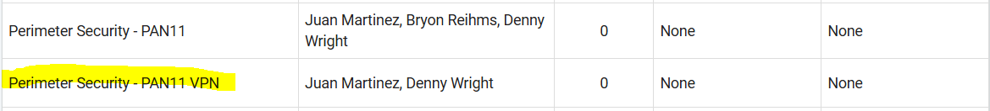
When reserving the pods, it is important to reserve the pods on the same Dell Node. The Dell Node is indicated by the highlighted Nx, shown below. Note the one on the far left is Dell Node 1. If you do not schedule the reservations on the same Dell Node, they will not be able to communicate with each other. There are four Dell Nodes, and if you scroll the reservation screen to the right, you should be able find another open pod on your node.

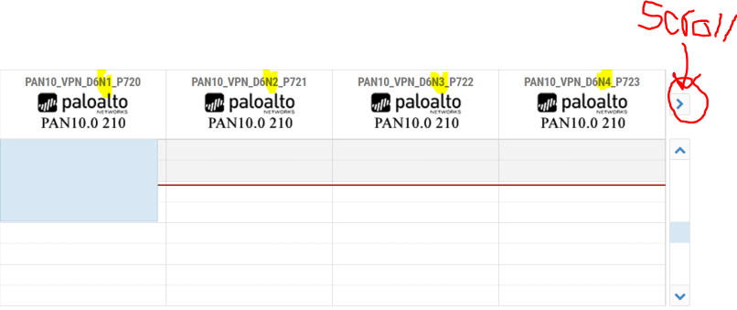
Notice that Both of my reservations below are on Dell Node 1:
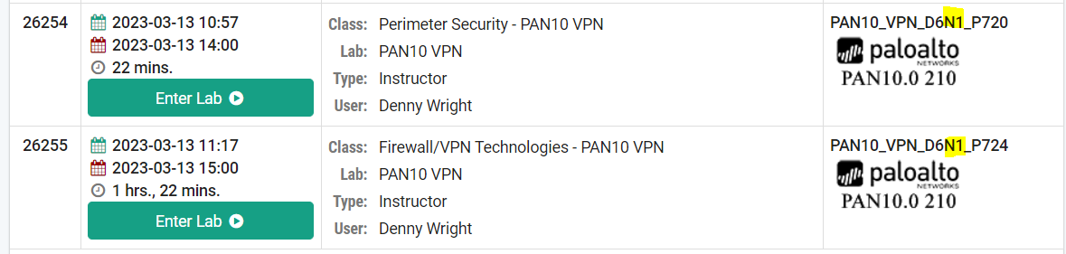
Both Sites will have the same default configuration, shown below:

Materials:
- NetLabs+
Complete the following:
- Schedule two pods on the same Dell Node
- Do the following to Site 1
  - Load Named Config 4 and Commit
  - Create a new virtual router and name it something.
  - Create your security zones, DMZ, Users Net, and Internet
  - Configure your interfaces as shown in the table above, note that Eth1/4 is your new Internet-facing interface. Eth1/1 will not be used in this configuration. Also, remember to add your interfaces to the correct zone and virtual router
  - Add your default route to your virtual router. Note the new interface and ISP address used in this scenario
  - Configure Source NAT (PAT) for Users Net to Internet
  - Configure a Security policy for Users Net to Internet

  - Commit these changes and test that you can browse the Internet before continuing. Submit a screenshot of a successful browse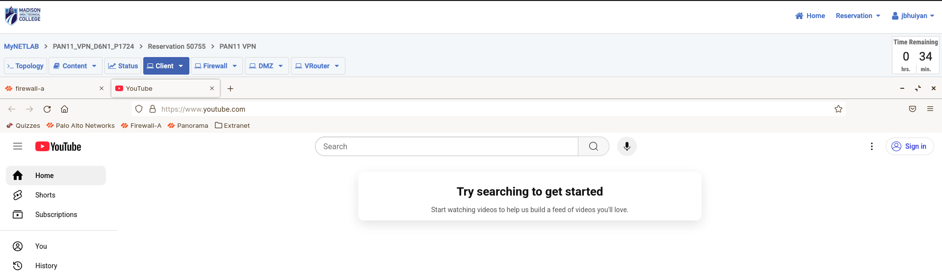
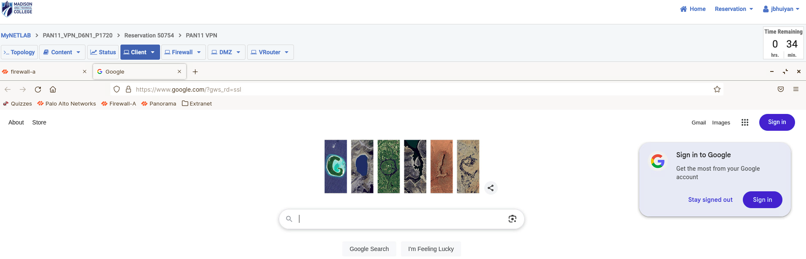

- If everything works, repeat the above for Site 2
- You now have two working sites. Now you are going to set up your DMZ server at site 2 so that Site 1 (and the rest of the world if you were on your enterprise edge) can access it. You are going to lock it down so that the outside world can only open web pages. You will do this by configuring the following on Site 2:
  - On Site 2, Set up a Destination NAT policy that maps traffic going from the outside zone to the DMZ zone and maps the outside address of 221.100.250.x to 192.168.50.10. The x is computed by substituting a “1” for the “17” in your pod number:
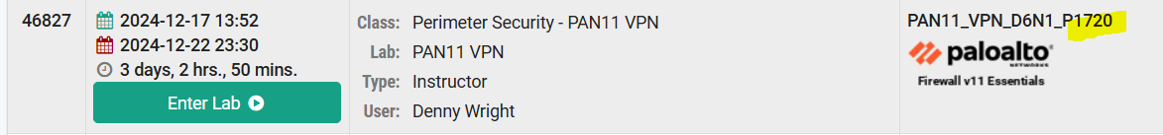
  - The 1720, highlighted above would become 120 in the 4th octet or 221.100.250.120. So in my example, I map that address to 192.168.50.10 with a Destination (Static) NAT policy
  - Create a security policy for traffic going from outside to the DMZ. Allow only web-browsing:
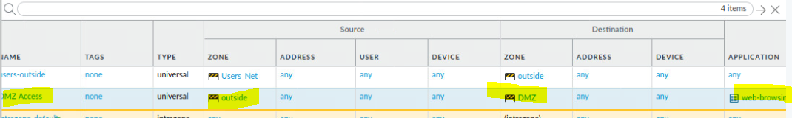
  - Commit the changes
- Now go to Site 1, and try to browse to the 221.100.250.x address on Site 2’s DMZ, configured above. Be sure to use HTTP. HTTPs is not configured on our DMZ servers. It should work. Try going to a Terminal prompt and pinging the address. It should fail. This is because your security policy, using App ID only allows this protocol to your website. This prevents exploit attacks on other resources that may be on the DMZ server. Submit Screenshots of both your tests above and of your security policy.
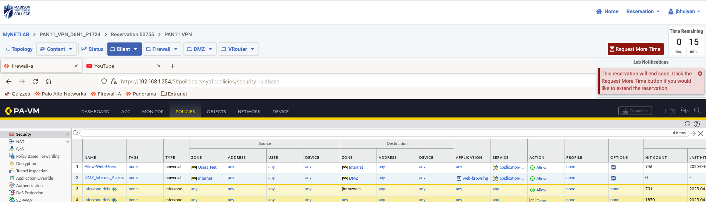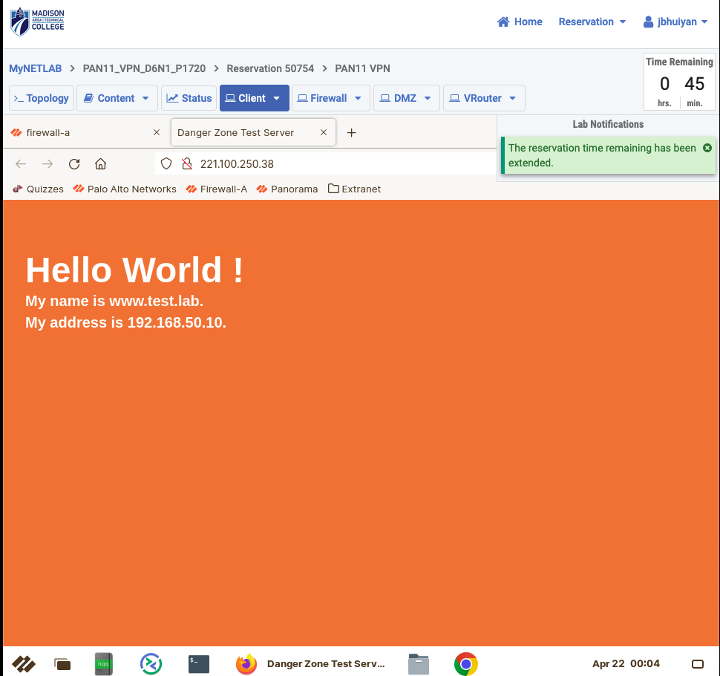
- Now that you have locked down your DMZ at Site 2, you want to lock down your users at Site 1 to ensure that they don’t access applications on the Internet that they shouldn’t be accessing. You are going to lock them down to web browsing, and DNS for looking up names.
- On Site 1, configure the Security Policy for Internet access with the following settings:
  - Under the Application section, Add SSL and web-browsing. SSL is HTTPs
  - Add a new Security Policy for DNS as a security policy. Be sure to configure your source and destination zones to be Users_Net and Internet. *****IMPORTANT READ: For many reasons, some technical and some administrative, it is often better to have your security policies allow one protocol family per policy. Since the first policy uses App ID to allow only HTTP and HTTPs, non-application traffic, it makes your configuration more flexible for future changes to have your DNS policy be separate.
  - Commit your changes
  - Try to browse to NPR.org from Site 1. Get a screenshot, this should work.
  - Now try to open google.com. What do you think happened?
It failed because Google’s traffic is tagged with the google‑base App‑ID, which your current web‑browsing/ssl policy doesn’t include.
  - Google, and many other sites have an app signature (remember App-ID). To be able to get this to work, you have to add google-base as an Application, in addition to SSL and web-browsing. Try this and see if it works. Submit a screenshot of your Security policy and a successful Google page.

  - You need to add the Facebook app as well if you want to be able to get to Facebook. ****IMPORTANT READ: There are many sites that require APP ID signatures that won’t work with generic SSL and Web-Browsing. That’s because the deep packet inspection feature of APP ID will recognize that these sites are doing additional tasks not found in standard browsing.
  - Let’s assume that you want to limit your users to web browsing any site, but they can only use the https service. You can do the following:
    - Keep your DNS policy
    - Remove the Applications to remove App-ID inspection
    - Add the following services in the service tab:
    - Commit and test Google, Facebook, and other sites. This works because the services only verify ports. ***IMPORTANT READ: That means that they are only verifying that the layer four ports are the expected ports. They are not inspecting for expected behavior of these protocols. That doesn’t mean that this is an insecure setup. It’s not as secure as using APP-ID, but it can be used to lock down incoming or outgoing protocols, and can be a way to add a layer to your security configuration, while remaining flexible. Submit screenshots of the policy and your successful browse. 