Configuring Security Policies and NAT on Palo Alto Firewalls for Internet & DMZ Access
Jobayer Bhuiyan
Purpose:
The purpose of this lab is to configure two Palo Alto firewall sites to enforce security policies for Internet access and DMZ hosting. Site 1 is locked down to HTTP, HTTPS, and DNS. Site 2 hosts a DMZ web server accessible only via HTTP from the Internet and Site 1, using Destination NAT and hairpin NAT.
Logical Diagram: 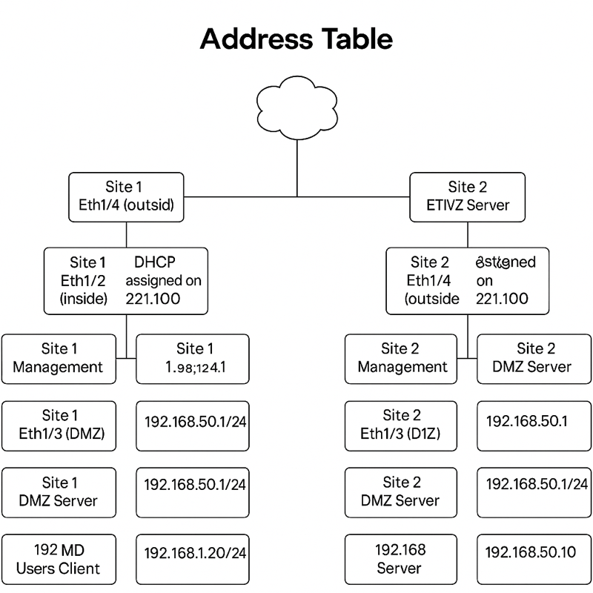

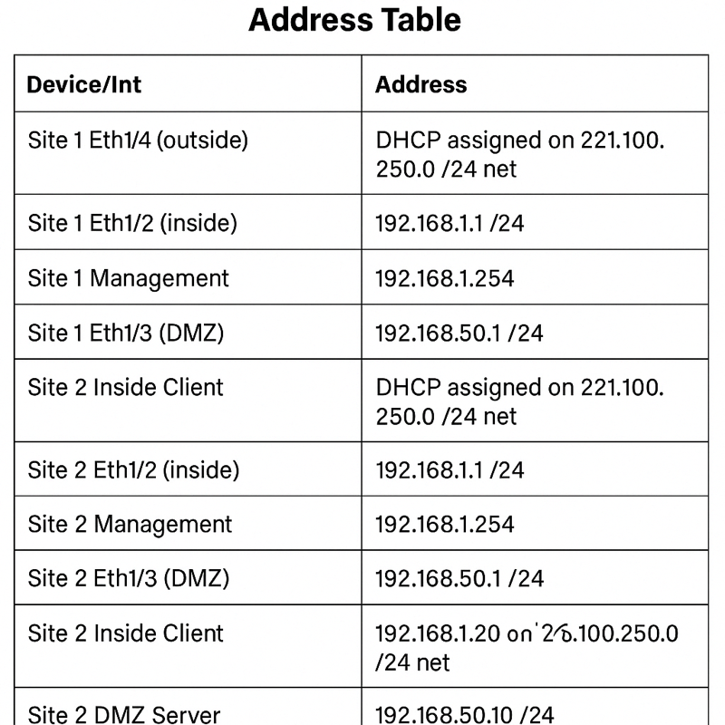

Procedures:
- Create a Virtual Router (Name: VR-Site1)
- Create Security Zones (Users_Net, DMZ, Internet)
- Assign Interfaces
  - ethernet1/2 → Users_Net
  - ethernet1/3 → DMZ
  - ethernet1/4 → Internet
- Add Default Route (Static Route 0.0.0.0/0 via ethernet1/4)
- Configure Source NAT
  - NAT Policy: SNAT-Users-Internet
  - Source Zone: Users_Net
  - Translation: Interface Address (ethernet1/4)
- Allow HTTP/HTTPS
  - Security Policy: Web-and-SSL
  - Applications: web-browsing, ssl
- Allow DNS
  - Security Policy: Allow-DNS
  - Application: dns
- Destination NAT for DMZ
  - NAT Policy: DNAT-to-DMZ
  - Translated: 192.168.50.10
- Allow Internet→DMZ HTTP
  - Security Policy: DMZ_Internet_Access
  - Application: web-browsing
- Hairpin NAT for Site 1 Clients
  - NAT Policy: Hairpin-DNAT-to-DMZ
  - Source Zone: Users_Net
  - Translated: 192.168.50.10
- Allow Users_Net→DMZ HTTP
  - Security Policy: Allow-Users-to-DMZ
  - Application: web-browsing
- Add App-ID for Google/Facebook
  - Add: google-base, facebook-base to Web-and-SSL rule
- (Optional) HTTPS Only Service Rule
  - Application: any
  - Service: service-https
Verification/Troubleshooting:
- Internet Browsing: http://example.com → success
- NPR Test: http://npr.org → success
- Google Test: Initial fail, success after adding google-base
- Facebook Test: success after adding facebook-base
- DMZ HTTP: http://221.100.250.38 → success
- Ping DMZ: ping -c4 221.100.250.124 → 100% loss
- SNAT Verification: SNAT-Users-Internet rule hit count >0
- DNAT Verification: DNAT-to-DMZ rule hit count >0
- Hairpin NAT: Hairpin-DNAT-to-DMZ rule hit count >0

