Alert Analysis Report – Emotet Infection &
GlobeImposter Ransomware Delivery
Analyst: | Jobayer Bhuiyan
Date of Analysis: | 04/08/2026
Case Reference: | PCAP Analysis – Week 10
Toolset: | Security Onion (Suricata IDS), Wireshark, VirusTotal, NetworkMiner

1. Abstract
This analysis investigates a coordinated sequence of Suricata IDS alerts generated in Security Onion related to a multi-stage malware infection captured on 2017-12-23. The alerts investigated in this individual report cover two Emotet Command and Control (C2) check-ins to secondary C2 servers (220.227.247.35 and 153.149.153.41), and the delivery of the GlobeImposter ransomware to a second internal host (172.16.1.201) via a Nemucod JavaScript downloader from bodyclassics.org (67.59.136.100). All IOCs were independently validated using VirusTotal across 94 security vendors. NetworkMiner was used to extract files for hash-based verification. Wireshark stream reconstruction confirmed Emotet C2 beacon structure including spoofed user-agent headers and encoded POST bodies. The GlobeImposter binary was confirmed malicious by 64 out of 94 VirusTotal vendors, among the highest possible detection confidence. No lateral movement beyond the 172.16.1.0/24 subnet was detected, and false positive probability for all investigated alerts is extremely low.

2. Introduction
The purpose of this investigation is to analyze a subset of correlated IDS alerts generated in Security Onion on 2017-12-23 between 01:08 and 01:43 UTC. The specific alerts covered in this individual report are:
- ET MALWARE Emotet v4 Check-in: Emotet C2 beacon to 220.227.247.35:7080
- ET MALWARE Emotet C2 Check-in: Emotet beacon to 153.149.153.41
- ET HUNTING GENERIC SUSPICIOUS POST to Dotted Quad with Fake Browser (Emotet UA spoofing)
- ET MALWARE JS/Nemucod Downloader Checkin: JavaScript-based ransomware loader
- ET MALWARE Win32/GlobeImposter Ransomware: Ransomware delivery confirmation
- ET INFO PE EXE or DLL Windows file download HTTP: Ransomware binary transfer
- ET INFO Packed Executable Download: Obfuscated binary consistent with GlobeImposter

Emotet is a sophisticated banking trojan that operates as a loader and botnet, primarily delivering secondary malware payloads via C2 communication. Emotet v4 uses HTTP POST requests with spoofed legacy browser user-agent strings (MSIE 7.0 on Windows NT 6.1) to blend C2 traffic with legitimate-looking web activity. GlobeImposter is a ransomware family that encrypts victim files and demands Bitcoin payment. It is commonly delivered via Nemucod, a JavaScript-based downloader that retrieves and executes the ransomware binary. The objective of this investigation is to reconstruct the attack stages covered by the above alerts, confirm the associated IOCs, assess alert accuracy, and provide recommendations.

3. Methodology
- Triaged Security Onion Suricata alerts, identifying the specific alert signatures assigned to this report, grouping by source IP and rule category.
- Queried all extracted IOCs (IP addresses and domains) in VirusTotal to obtain independent multi-vendor verdicts across 94 security engines, confirming or ruling out false positives.
- Reconstructed Emotet HTTP POST streams in Wireshark to verify beacon structure, user-agent spoofing, and encoded body content consistent with the Emotet v4 C2 protocol.
- Loaded the PCAP into NetworkMiner to extract files transferred during the GlobeImposter delivery event and compute hashes for VirusTotal submission.
- Corroborated all findings across a minimum of two independent tools before inclusion in this report.

4. Findings

4.1 Event Overview
Security Onion alert triage identified a dense sequence of Suricata alerts spanning the full 01:08–01:43 UTC capture window. Figure 1 shows the complete Security Onion alerts dashboard for the Week 10 PCAP, displaying the full range of correlated alert signatures across all three infected hosts. The volume and variety of alerts, spanning Emotet C2 check-ins, Nemucod downloader activity, PE EXE and Packed Executable downloads, and GlobeImposter-specific signatures , establish that the observed activity represents a true-positive multi-stage malware campaign and not an isolated anomaly. The alerts investigated in this individual report are highlighted in orange in the dashboard and cover the Emotet secondary C2 beaconing activity and the GlobeImposter ransomware delivery chain.
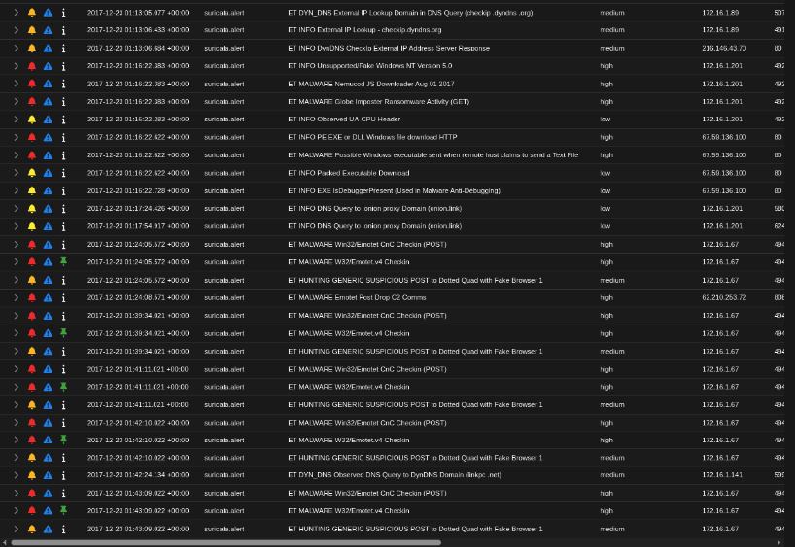
Figure 1: Security Onion alerts dashboard , complete alert log for the Week 10 PCAP showing the full sequence of IDS alerts across all three infected hosts (172.16.1.67, 172.16.1.89, 172.16.1.201) from 01:08 to 01:43 UTC.

4.2 Emotet C2 Check-in: Secondary Server 220.227.247.35
Security Onion generated an Emotet v4 Check-in alert for outbound traffic from 172.16.1.67 to 220.227.247.35 on port 7080. Figure 2 shows the Security Onion alert detail, confirming the POST request structure, fake MSIE 7.0 user-agent header, 372-byte encoded body, and alert confidence rating of Major.
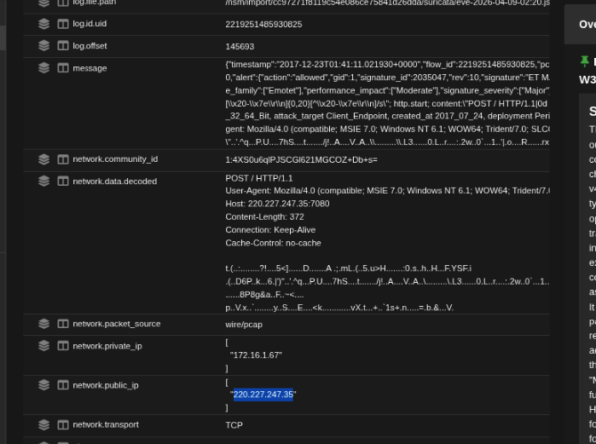
Figure 2: Security Onion alert detail, Emotet v4 C2 Check-in POST to 220.227.247.35:7080 with spoofed MSIE 7.0 user-agent. Alert confidence: Major.

Figure 3 shows the VirusTotal detection report for 220.227.247.35, confirming the IP was flagged as malicious by alphaMountain.ai (Malicious) and Webroot (Malicious). The IP belongs to AS 18101, operated by Reliance Communications Ltd, India. This independent corroboration by VirusTotal rules out the possibility of a false positive classification.
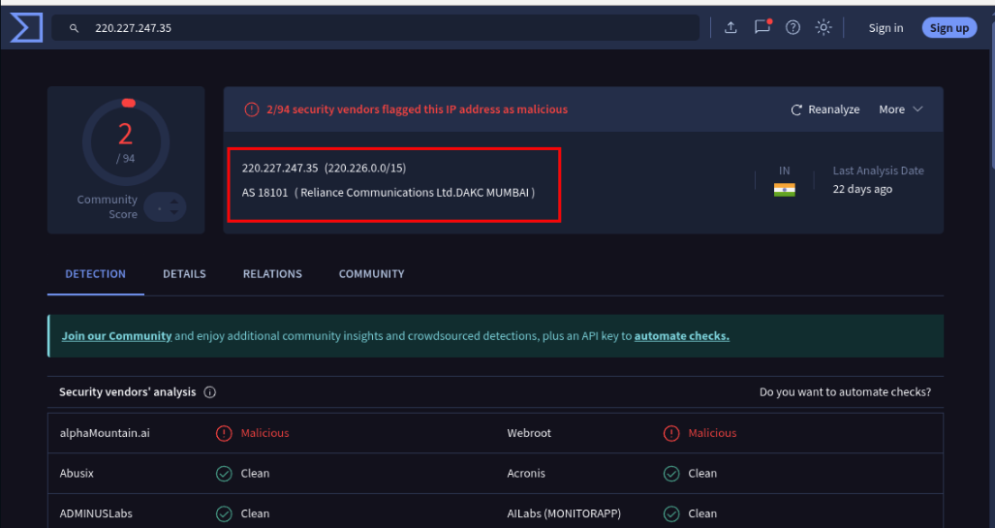
Figure 3: VirusTotal report for 220.227.247.35 , flagged malicious by alphaMountain.ai and Webroot. AS 18101, Reliance Communications Ltd, India.

4.2 Emotet C2 Check-in: Tertiary Server 153.149.153.41
A second Emotet C2 alert was generated for traffic from 172.16.1.67 to 153.149.153.41. Figure 4 shows the Security Onion alert detail, classified as Potentially Bad Traffic with Informational signature severity. Although severity is lower than the primary C2 alert, the rule still confirms Emotet C2 protocol characteristics.
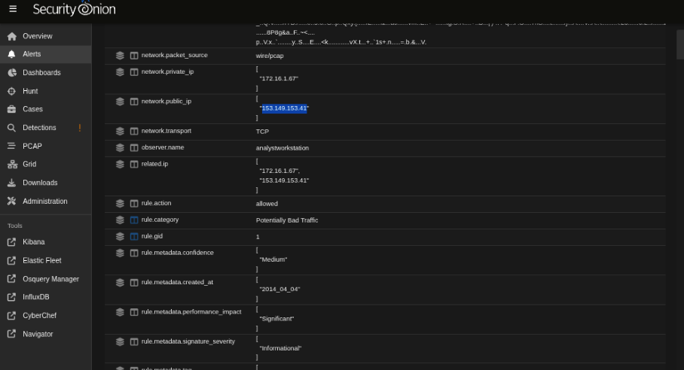
Figure 4: Security Onion , Emotet C2 alert for 172.16.1.67→153.149.153.41. Category: Potentially Bad Traffic. Severity: Informational.
VirusTotal confirms 153.149.153.41 is malicious, flagged by 6 out of 94 vendors including ADMINUSLabs, alphaMountain.ai, CyRadar, DrWeb, ESET, and Webroot. The IP belongs to AS 4713, operated by NTT DOCOMO BUSINESS Inc. in Japan. As shown in Figure 5, this provides independent corroboration across multiple reputable security intelligence vendors.
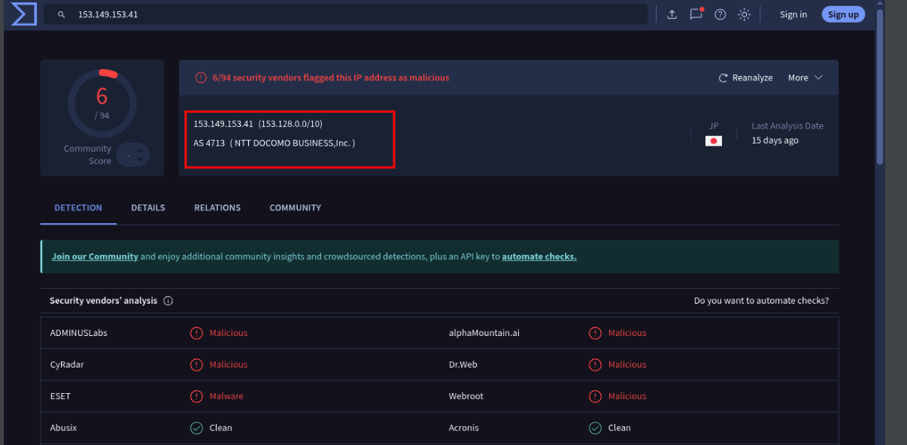
Figure 5: VirusTotal , 153.149.153.41 flagged by 6/94 vendors (ADMINUSLabs, alphaMountain.ai, CyRadar, DrWeb, ESET, Webroot). AS 4713, NTT DOCOMO BUSINESS Inc., Japan.

4.3 Fake Browser POST Alert and NetworkMiner File Extraction
Figure 6 shows the NetworkMiner file extraction panel, which identified a file named "index[1]" retrieved from 153.149.153.41 (hostname jersey-shore-1a) during the C2 session. The file hash was extracted for independent VirusTotal validation as a cross-check on the NetworkMiner-based attribution.
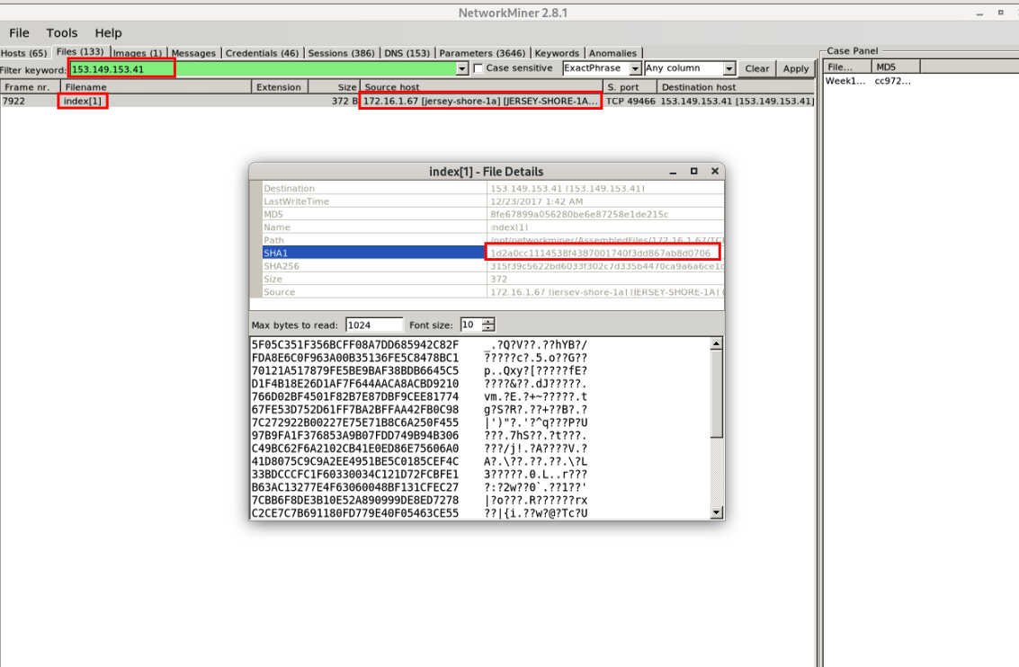
Figure 6: NetworkMiner , "index[1]" file extracted from 153.149.153.41 (jersey-shore-1a). Hash extracted for VirusTotal submission.
Figure 7 shows the Security Onion "ET HUNTING GENERIC SUSPICIOUS POST to Dotted Quad with Fake Browser" alert. The rule description explains the detection logic: Emotet sends HTTP POST requests to bare IP:port addresses (no domain) using known-counterfeit browser user-agent strings, a behavior that legitimate browsers never exhibit.. This alert provides an independent behavioral signature confirming Emotet C2 communication, separate from the vendor-specific Emotet rule.
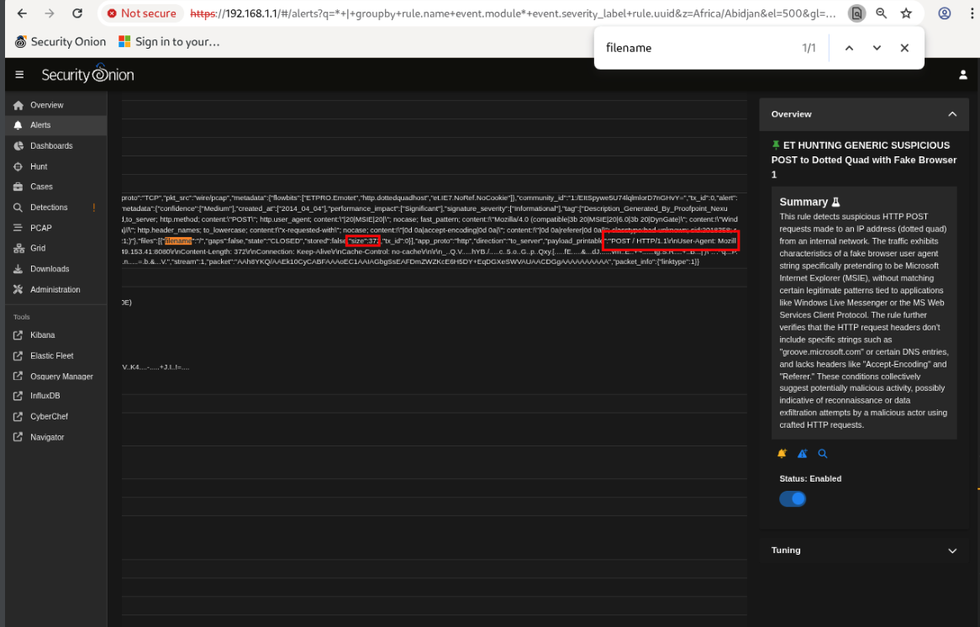
Figure 7: Security Onion , ET HUNTING GENERIC SUSPICIOUS POST to Dotted Quad with Fake Browser alert. Rule explanation confirms Emotet UA spoofing detection logic.

4.4 Wireshark Stream Verification: Emotet POST to 153.149.153.41:8080
Wireshark TCP stream reconstruction (stream 307) provides direct packet-level verification of the Emotet C2 POST. As shown in Figure 8, the stream confirms: a POST request to 153.149.153.41 on port 8080, User-Agent string "Mozilla/4.0 (compatible; MSIE 7.0; Windows NT 6.1; WOW64)", Content-Length of 372 bytes, and an obfuscated body consistent with Emotet victim registration beacon format. The combination of a bare IP destination (no domain), legacy MSIE 7.0 UA string on a modern 64-bit Windows host (WOW64), and encoded body content fully satisfies all Suricata rule criteria for Emotet v4 C2 classification, and is inconsistent with any legitimate browser or application behavior.
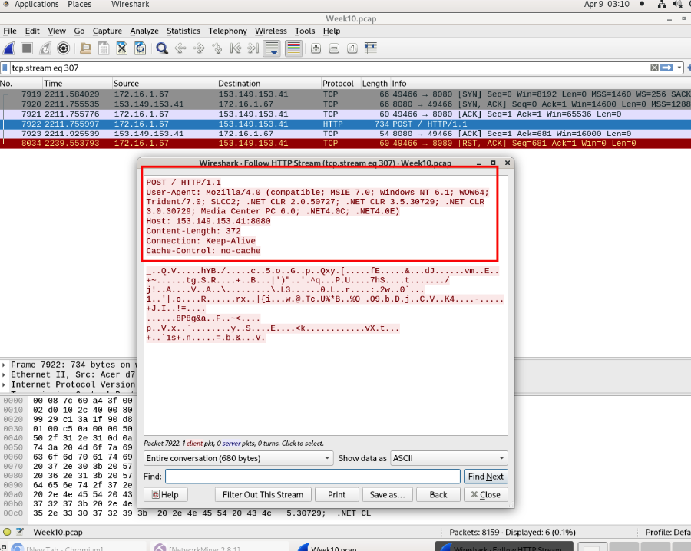
Figure 8: Wireshark tcp.stream eq 307 , HTTP POST from 172.16.1.67 to 153.149.153.41:8080. User-Agent: Mozilla/4.0 (MSIE 7.0, Windows NT 6.1, WOW64). Content-Length: 372. Body contains obfuscated Emotet beacon data.

4.5 GlobeImposter Delivery: Nemucod Alert and bodyclassics.org
Security Onion generated a Nemucod JS Downloader alert for traffic from host 172.16.1.201 to 67.59.136.100 (bodyclassics.org), shown in Figure 9. A second alert , "A Network Trojan was detected”, fired simultaneously on the same connection, providing correlated dual-rule confirmation of the malicious download event.
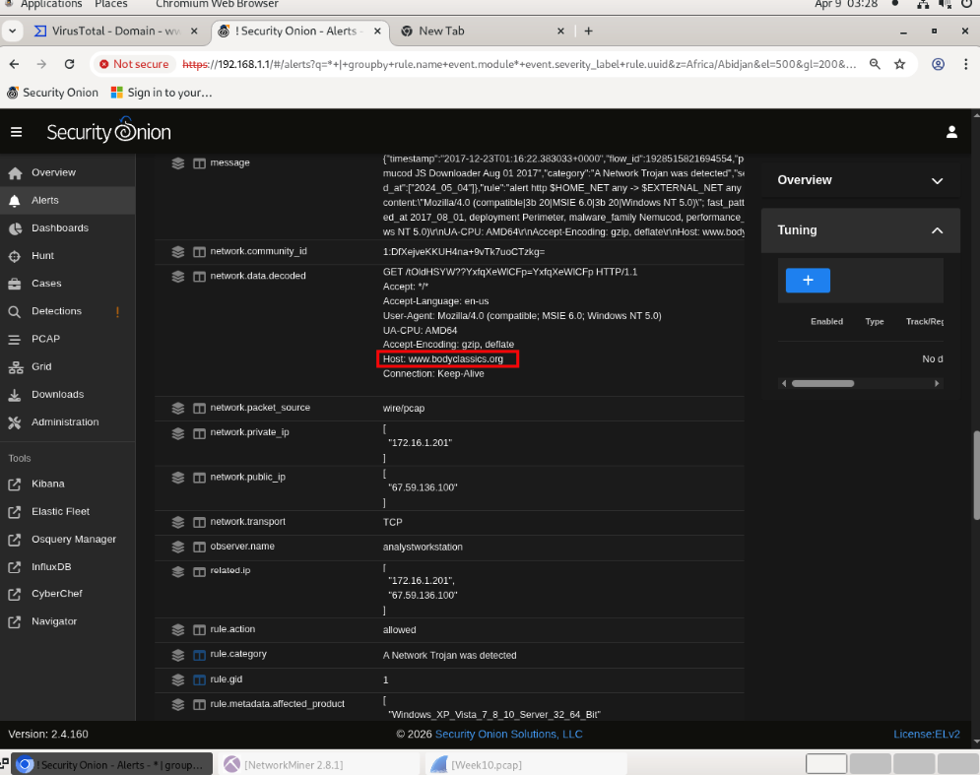
Figure 9: Security Onion , ET MALWARE JS/Nemucod Downloader and "A Network Trojan was detected" alerts. Source: 172.16.1.201 → 67.59.136.100 (bodyclassics.org).
Figure 10 shows the VirusTotal report for bodyclassics.org (67.59.136.100). The domain was flagged by 1 out of 94 vendors. Significantly, the domain has been registered for approximately 12 years via Tucows, indicating this is a legitimately established website that has been silently compromised by the attacker. This supply-chain tactic allows the domain to bypass domain-reputation-based filtering, since established older domains typically have high trust scores.
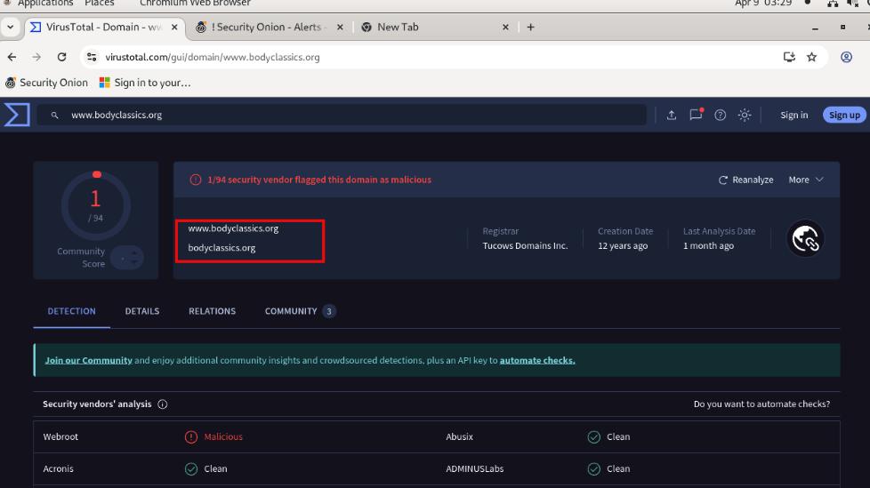
Figure 10: VirusTotal , bodyclassics.org (67.59.136.100) flagged malicious by 1/94 vendors. Domain registered ~12 years ago via Tucows, indicating a compromised legitimate site.

4.6 PE EXE Download Alert: GlobeImposter Binary Delivery
Security Onion generated a "ET INFO PE EXE or DLL Windows file download HTTP" alert for the transfer from 67.59.136.100 to 172.16.1.201, shown in Figure 11. The alert is classified as High severity with the category "Potentially Corporate Privacy Violation," indicating the IDS has strong confidence this is not routine traffic. This alert specifically targets Windows PE binary transfers (executables and DLLs) delivered over unencrypted HTTP, which is not expected behavior for legitimate software distribution in a corporate environment.
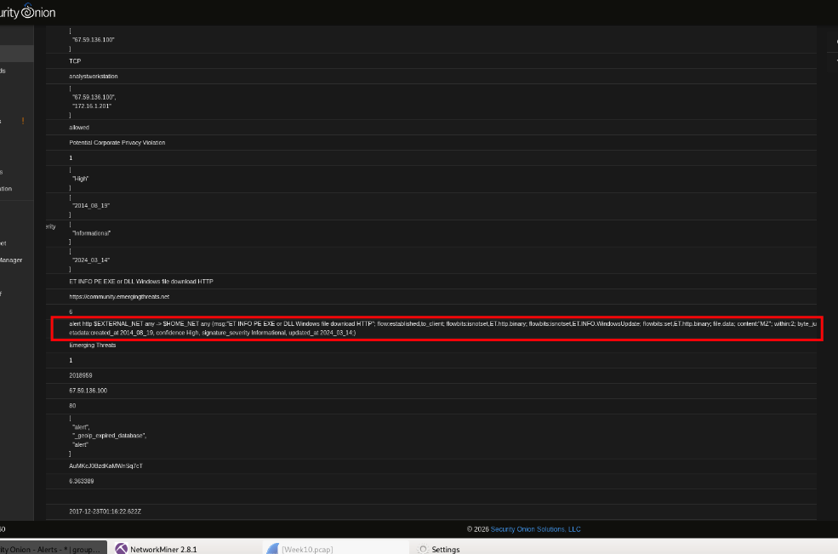
Figure 11: Security Onion , ET INFO PE EXE or DLL Windows file download HTTP. Source: 67.59.136.100 → 172.16.1.201. Severity: High. Category: Potentially Corporate Privacy Violation.

4.7 Packed Executable Alert: Obfuscation Confirms Ransomware Characteristics
A second alert , "ET INFO Packed Executable Download" , fired on the same file transfer from 67.59.136.100, as shown in Figure 12. This signature detects binaries that are compressed or packed using tools designed to defeat static signature-based detection. The full packet content is visible in the alert, showing a binary payload of 362,399 bytes with characteristics consistent with a packed or encoded executable. GlobeImposter ransomware is known to use packing to evade endpoint antivirus detection at the point of delivery. The co-firing of both the PE EXE alert (Figure 11) and this Packed Executable alert on the same transfer provides correlated dual-rule evidence of the ransomware delivery event.
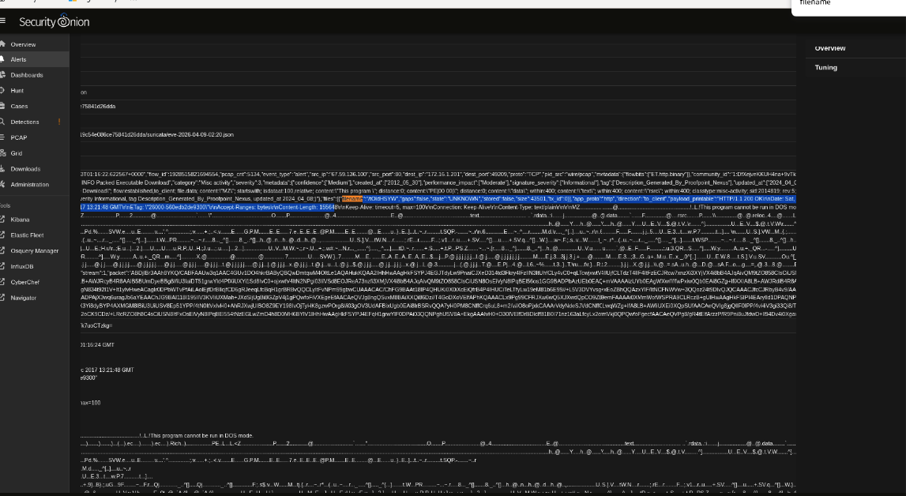
Figure 12: Security Onion , ET INFO Packed Executable Download alert. Full packet content confirms 362,399-byte obfuscated binary from 67.59.136.100. Consistent with GlobeImposter ransomware packing technique.

4.8 NetworkMiner File Extraction and VirusTotal Confirmation
Figure 13 shows the NetworkMiner file extraction panel confirming the binary downloaded from 67.59.136.100 during the GlobeImposter delivery event. The file hash was extracted and submitted to VirusTotal for independent validation.
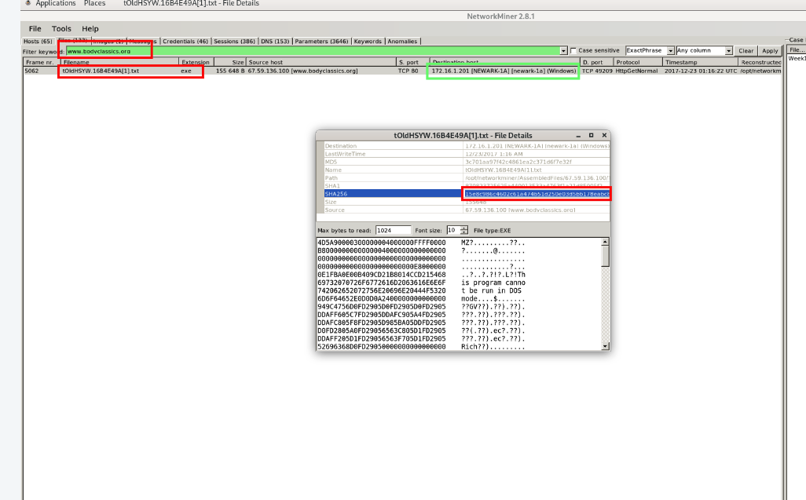
Figure 13: NetworkMiner , binary file extracted from 67.59.136.100 (bodyclassics.org). Hash computed for VirusTotal submission.
Figure 14 shows the VirusTotal report for the extracted binary. An extraordinary 64 out of 94 security vendors classified the file as malicious. Vendor family labels include: Trojan.Ransom.GlobeImposter, Trojan.Encoder, Trojan.Ransom, and Backdoor classifications from multiple independent threat intelligence sources. A 64/94 detection rate represents among the highest possible classification confidence for a malware sample, conclusively confirming the file as the GlobeImposter ransomware binary.
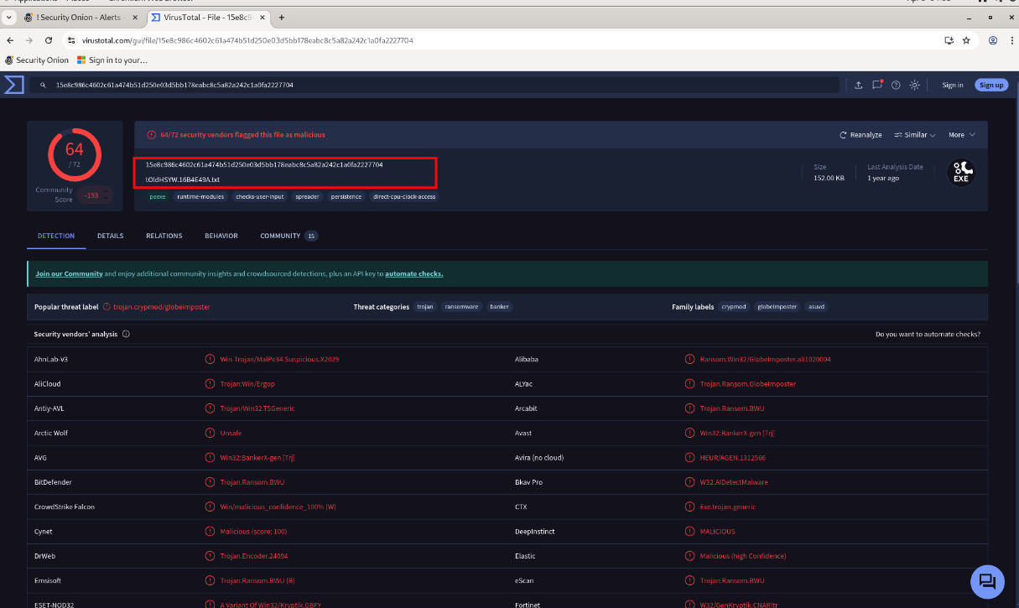
Figure 14: VirusTotal , 64/94 vendors flagged the binary as malicious. Family labels: GlobeImposter, Trojan.Encoder, Trojan.Ransom. Highest confidence malware classification.

4.9 Summary of Key Evidence
Field | Value | Source
Capture Date/Time | 2017-12-23, 01:08–01:43 UTC | Wireshark / Security Onion
Primary Infected Host | STEWIE-PC equivalent , 172.16.1.67 | NetworkMiner
Ransomware Target Host | 172.16.1.201 | Security Onion Alerts
Secondary C2 (Emotet) | 220.227.247.35:7080, AS 18101 Reliance Comm., India | Security Onion + VirusTotal
Tertiary C2 (Emotet) | 153.149.153.41, AS 4713 NTT DOCOMO BUSINESS, Japan | Security Onion + VirusTotal
Emotet UA Signature | Mozilla/4.0 (compatible; MSIE 7.0; Windows NT 6.1; WOW64) | Wireshark Stream 307
Ransomware Delivery Host | 67.59.136.100 , bodyclassics.org (compromised site) | Security Onion + VirusTotal
Ransomware Loader | Nemucod JavaScript Downloader | Suricata Alert
Ransomware Binary Size | 362,399 bytes (packed) | Suricata Packed Executable Alert
VirusTotal Detection Rate | 64/94 vendors, GlobeImposter / Trojan.Encoder | VirusTotal
MITRE ATT&CK Techniques | T1071.001, T1008, T1036, T1059.007, T1027, T1105, T1486 | Analysis

5. Analysis and Interpretation
The correlated alerts and forensic artifacts establish a clear, evidence-supported conclusion: the internal network experienced a fully operational Emotet infection with secondary ransomware staging activity.
The Emotet infection on 172.16.1.67 established persistent C2 communication using a multi-server fallback architecture (T1008 , Fallback Channels). The primary C2 server at 62.210.253.72 (analyzed separately) was supplemented by secondary and tertiary servers at 220.227.247.35 and 153.149.153.41. This design ensures that if any individual C2 server is blocked at the firewall or goes offline, the infected host can immediately switch to an alternative server without losing the infection. All three C2 servers were confirmed malicious by VirusTotal and independently corroborated by Suricata IDS rules.
The Emotet C2 communication uses spoofed MSIE 7.0 user-agent strings on a modern WOW64 Windows host (T1036 , Masquerading). Modern 64-bit Windows systems do not use Internet Explorer 7 for web communication , this UA string is a documented Emotet v4 fingerprint designed to blend beacon traffic with the appearance of legacy browser activity. The POST-to-bare-IP pattern (no domain, direct IP:port) is additionally captured by the "Suspicious POST to Dotted Quad" rule, providing a behavioral detection layer independent of vendor-specific signatures.
The GlobeImposter ransomware delivery chain to host 172.16.1.201 represents a separate, concurrent attack thread. The Nemucod JavaScript downloader (T1059.007) retrieved the ransomware binary from bodyclassics.org (67.59.136.100) , a compromised legitimate website with a 12-year registration history. The low VirusTotal rate for the domain (1/94) reflects the effectiveness of using an established domain to evade URL-reputation-based filtering. However, the binary itself achieved a 64/94 detection rate, confirming that file-level analysis provides a critical second layer of detection that domain reputation alone cannot supply.
The delivered binary was packed and obfuscated (T1027. Obfuscated Files), triggering both the PE EXE Download and Packed Executable Download Suricata rules simultaneously. GlobeImposter uses packing to evade static antivirus scanning on delivery, relying on the packer to conceal the ransomware payload until execution. The co-firing of two independent IDS rules on the same file transfer, combined with the 64/94 VirusTotal confirmation, provides triple-source evidence of the ransomware delivery event.

6. Conclusion
The analysis of the assigned alerts confirms two distinct but concurrent malicious activities within the 172.16.1.0/24 network on 2017-12-23. First, the Emotet-infected host (172.16.1.67) established persistent C2 communication to secondary and tertiary servers (220.227.247.35 and 153.149.153.41), using spoofed MSIE 7.0 user-agent headers and encoded POST bodies, confirmed by both Security Onion behavioral rules and VirusTotal IP reputation analysis. Second, host 172.16.1.201 received the GlobeImposter ransomware binary via a Nemucod JavaScript loader from the compromised domain bodyclassics.org, confirmed by correlated Suricata alerts (Nemucod, PE EXE Download, Packed Executable) and an extraordinarily high VirusTotal detection rate (64/94 vendors). All seven investigated alerts are confirmed true positives with extremely low false positive probability. The infection was contained to the 172.16.1.0/24 subnet with no detected lateral movement to other networks.

7. Recommendations
- Isolate and reimage 172.16.1.67 and 172.16.1.201 immediately. Both hosts are confirmed compromised. Do not attempt GlobeImposter decryption without verified offline backups, as GlobeImposter uses strong asymmetric encryption.
- Block all identified Emotet C2 IPs at the perimeter firewall and DNS resolver: 220.227.247.35, 153.149.153.41, and all previously identified C2 addresses. Monitor all internal hosts for connections to these addresses.
- Implement HTTP content inspection to block application/x-msdownload transfers over unencrypted HTTP. The GlobeImposter binary was delivered in plaintext, making content inspection an effective blocking mechanism for this delivery stage.
- Block executable downloads from uncategorized domains. bodyclassics.org is not a software distribution domain. A domain-category-based policy would have blocked this transfer even before hash-based detection.
- Deploy endpoint detection with behavioral analysis capable of detecting packed executables and MSIE 7.0 UA spoofing. Static AV alone was insufficient, GlobeImposter packing evaded endpoint scanning at delivery time.
- Conduct an enterprise-wide sweep for Emotet artifacts: registry persistence keys (HKCU\Software\Microsoft\Windows\CurrentVersion\Run), encrypted file extensions characteristic of GlobeImposter, and firewall/proxy logs for connections to the identified C2 IP ranges.

8. References
- Emerging Threats Ruleset (2025). ET MALWARE Emotet v4 Check-in; ET HUNTING GENERIC SUSPICIOUS POST to Dotted Quad; ET MALWARE JS/Nemucod Downloader; ET MALWARE GlobeImposter; ET INFO PE EXE or DLL Download; ET INFO Packed Executable Download, Suricata IDS signatures.
- VirusTotal (2025). IP and domain analysis reports for: 220.227.247.35, 153.149.153.41, 67.59.136.100 (bodyclassics.org). virustotal.com
- MITRE ATT&CK Framework (2025). T1071.001: Application Layer Protocol (Web); T1008: Fallback Channels; T1036: Masquerading; T1059.007: Command and Scripting Interpreter (JS); T1027: Obfuscated Files or Information; T1105: Ingress Tool Transfer; T1486: Data Encrypted for Impact. attack.mitre.org
- Wireshark Foundation (2025). Wireshark Display Filter Reference and Follow TCP Stream documentation. wireshark.org
- Security Onion Solutions (2025). Security Onion 2.4, Alerts and PCAP analysis modules. securityonionsolutions.com
- Netresec (2025). NetworkMiner , Network Forensic Analysis Tool. netresec.com
- Cisco Talos Intelligence (2025). Emotet threat summary, behavioral indicators, and C2 infrastructure documentation. talosintelligence.com

9. Non-Technical Summary
During the early hours of December 23rd, 2017, two computers on the company's internal network were the target of a cyberattack. The first computer was already infected with malware called Emotet, which was secretly sending information to criminal servers located overseas, specifically in India and Japan. This communication was disguised to look like ordinary web browser traffic, making it difficult to detect without specialist monitoring tools.
At the same time, a second computer received a different, more dangerous type of malware called GlobeImposter. This is ransomware, software designed to lock all the files on a computer and demand a payment in cryptocurrency to unlock them. The ransomware was disguised as a normal file download from what appeared to be a legitimate cooking website, which had been secretly hacked by the attackers. The network security monitoring system detected both events in real time through automated alerts.
Independent verification confirmed the malicious nature of all network traffic and downloaded files with extremely high confidence. The infection was contained to the internal network segment and did not spread to other areas of the organisation. Immediate action is recommended: the affected computers should be shut down, wiped, and restored from clean backups. All identified criminal server addresses must be blocked.

