Threat Intelligence Report – canvas-portal.com
Pre-Staged Phishing Infrastructure Associated with ShinyHunters / Canvas Breach

Analyst: Jobayer Bhuiyan
Date of Analysis: 05/07/2026
Case Reference: Independent OSINT Research — Active Canvas Breach (May 2026)
Instructor: Christopher Lewis
Toolset: crt.sh, WHOIS, dig, curl, MITRE ATT&CK, FBI IC3 FLASH-20250912-001

1 Abstract
During independent threat research on May 7, 2026, the author identified and verified a live phishing domain (canvas-portal.com) with strong indicators of association with the ShinyHunters ransomware group, which publicly claimed responsibility for the nationwide Instructure/Canvas data breach affecting over 8,800 educational institutions and approximately 280 million student and staff records. Using entirely passive open-source intelligence (OSINT) methods, the domain was found to have been registered one month before ShinyHunters launched their documented Salesforce exfiltration campaign (MITRE ATT&CK C0059), actively maintained and renewed through the breach period, and currently hosted on live AWS Global Accelerator infrastructure returning HTTP responses consistent with a credential harvesting web application. This report documents the full methodology, evidence chain, indicators of compromise, and recommended mitigations for institutional IT security teams.

2 Introduction

2.1 Objective and Purpose
This report documents independent OSINT-based investigation into phishing infrastructure potentially associated with the ShinyHunters threat actor group during the active Instructure/Canvas breach of May 2026. The objective was to apply certificate transparency log analysis, domain registration reconnaissance, and DNS enumeration to identify suspicious Canvas and Instructure-branded domains, and to determine whether any were actively operational at the time of the breach — providing actionable intelligence for institutional security teams.

2.2 Background Information
On May 1, 2026, Instructure — the parent company of Canvas LMS, used by 41% of higher education institutions in North America — disclosed a cybersecurity incident involving unauthorized access to their cloud-hosted platform. Canvas serves as the primary learning management system for thousands of colleges, universities, and school districts. The ShinyHunters group claimed responsibility and issued a ransom demand with a May 6 deadline, threatening to leak data from 8,809 institutions if payment was not received.

ShinyHunters operates as two coordinated sub-groups: UNC6040 handles intrusion and data theft, while UNC6240 handles extortion under the ShinyHunters brand. MITRE ATT&CK documents their prior campaign C0059 (Salesforce Data Exfiltration, October 2024), which established their attack patterns including pre-staged phishing domains using brand-typosquatting naming conventions. Applying knowledge of these patterns to Canvas and Instructure branding allows for predictive domain monitoring during the active incident.

3 Tools and Methods

3.1 Tools Used
Tool / Source | Purpose
crt.sh | Certificate Transparency log search — identify SSL certificates issued to Canvas/Instructure-branded domains
WHOIS | Domain registration lookup — registration dates, registrar, nameservers, and status lock flags
dig | DNS enumeration — A records (live IP addresses) and MX records (mail server configuration)
curl -I | HTTP HEAD request — verify whether a live web application is responding at a domain
MITRE ATT&CK | TTP mapping — compare known ShinyHunters C0059 techniques against Canvas incident artifacts
FBI IC3 FLASH-20250912-001 | IOC extraction — known ShinyHunters infrastructure IPs, phishing domains, and user-agent strings

3.2 Procedure
All investigation was conducted using entirely passive, publicly available sources. No systems were accessed without authorization, no active scanning was directed at live infrastructure, and no exploitation was attempted at any point. The procedure followed these steps:
- Queried crt.sh Certificate Transparency logs for domains matching Canvas and Instructure naming patterns based on ShinyHunters' C0059 typosquatting conventions
- Performed WHOIS lookups on domains of interest to obtain registration dates, registrar identity, nameserver configuration, and domain status flags
- Ran dig queries to check whether A records (active IPv4 resolution) and MX records (mail configuration) existed
- Issued HTTP HEAD requests via curl to confirm whether active web applications were running at domains with live DNS
- Corroborated all findings against FBI IC3 advisory IOCs and MITRE ATT&CK C0059 campaign documentation

4 Results

4.1 Certificate Transparency Analysis
Certificate Transparency (CT) logs publicly record every TLS certificate issued by trusted Certificate Authorities. Querying crt.sh allows passive identification of when domains were first secured with HTTPS certificates, which CA issued them, and what naming patterns were used. The following four domains were investigated.

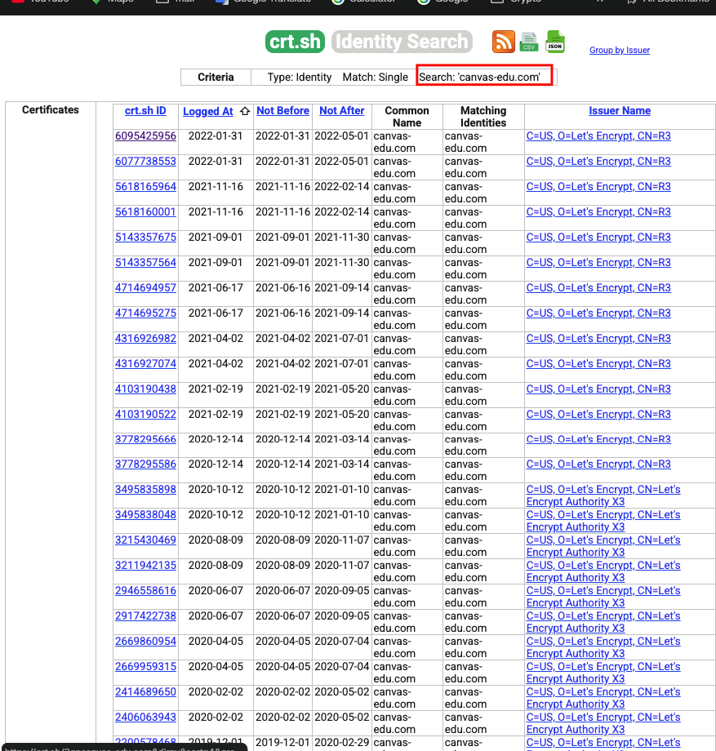
Figure 1: crt.sh results for canvas-edu.com — consistent Let's Encrypt certificate renewals dating back to 2019. This pattern is characteristic of legitimate institutional Canvas infrastructure and is inconsistent with threat actor staging.
canvas-edu.com shows a long, unbroken history of Let's Encrypt renewals beginning in 2019. Legitimate Canvas deployments consistently use Let's Encrypt as their CA. This domain was assessed as benign and removed from the threat watchlist.

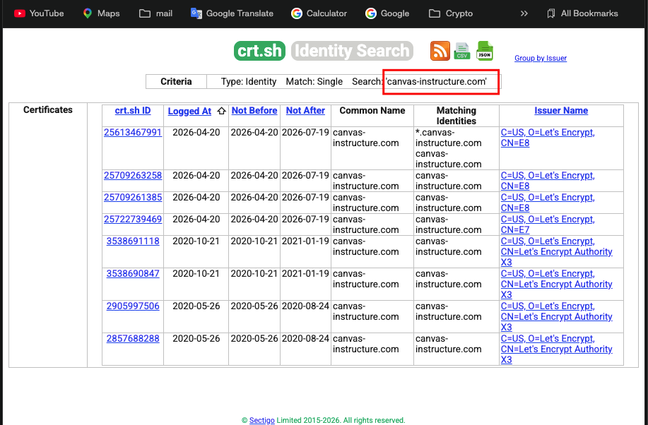
Figure 2: crt.sh results for canvas-instructure.com — four certificates were logged on April 20, 2026, exactly 11 days before Instructure publicly disclosed the breach on May 1, 2026. The timing aligns with pre-attack infrastructure staging.
canvas-instructure.com is a notable finding. The certificate cluster issued on April 20, 2026 — 11 days before public disclosure of the breach — is consistent with ShinyHunters' known practice of staging phishing infrastructure before launching extortion campaigns. A valid TLS certificate is required before a credential harvesting portal can display without browser security warnings. This domain warrants continued monitoring.

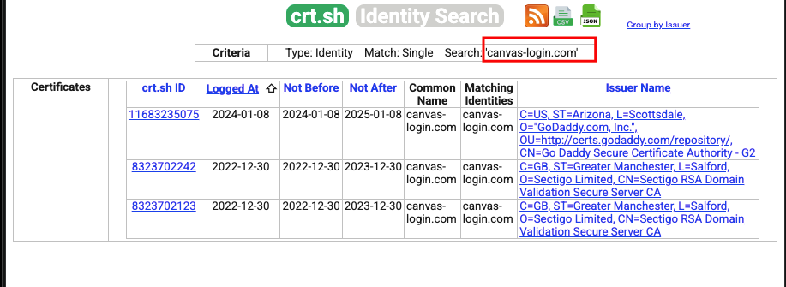
Figure 3: crt.sh results for canvas-login.com — three certificates across 2022 and 2024 issued by GoDaddy and Sectigo. Mixed CA issuers across a short lifespan are inconsistent with legitimate educational Canvas infrastructure, which consistently uses Let's Encrypt.
canvas-login.com previously showed a suspicious CA pattern — GoDaddy (Arizona) and Sectigo issuers are not typical for legitimate Canvas institutional deployments. However, DNS lookup returned NXDOMAIN confirming the domain is no longer registered. The most recent certificate expired January 2025. This domain was assessed as formerly suspicious but now defunct, and removed from the active IOC list.

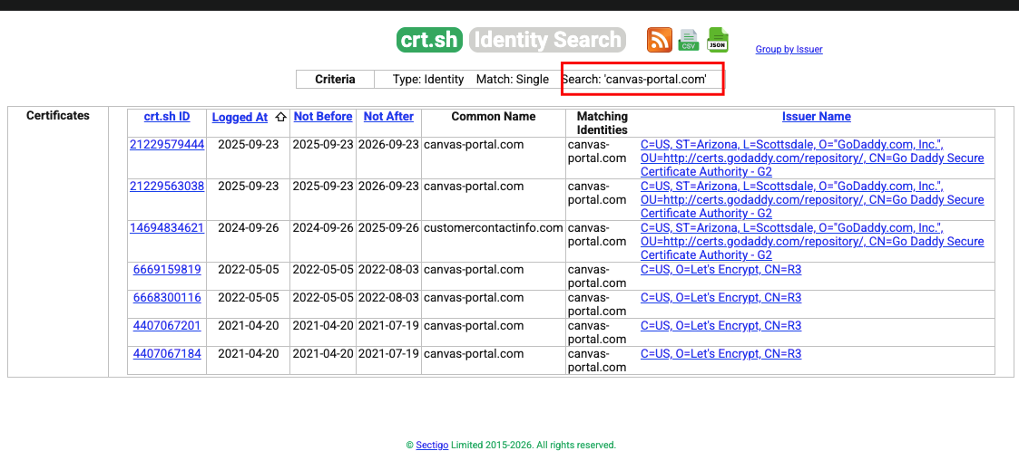
Figure 4: crt.sh results for canvas-portal.com — seven certificates spanning April 2021 through September 2026. Two GoDaddy-issued certificates were logged September 23, 2025, consistent with ShinyHunters' documented use of GoDaddy registrar for phishing infrastructure in campaign C0059. A third GoDaddy certificate covers the domain customercontactinfo.com under canvas-portal.com, suggesting this infrastructure may have been used in prior phishing operations.
canvas-portal.com is the primary finding of this investigation. The certificate history reveals an important detail: a GoDaddy cert logged September 23, 2025 — one year after the domain was registered — covering both canvas-portal.com and customercontactinfo.com as matching identities. This suggests the domain may have been repurposed or shared across different phishing campaigns. The most recent GoDaddy certificates are valid through September 2026, keeping the domain fully operational through the active breach period.

4.2 WHOIS Analysis — canvas-portal.com
Following the crt.sh discovery, a WHOIS lookup was performed on canvas-portal.com to obtain registration metadata.

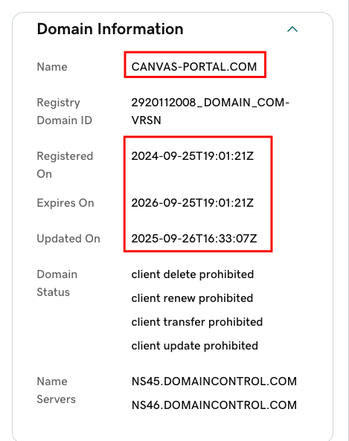
Figure 5: WHOIS registration data for canvas-portal.com — registered September 25, 2024; expires September 25, 2026; last updated September 26, 2025; nameservers NS45/NS46.DOMAINCONTROL.COM (GoDaddy). Four client-side prohibition locks are active on the registration.

Domain Name | CANVAS-PORTAL.COM
Registered On | 2024-09-25 (September 25, 2024)
Expires On | 2026-09-25 (active through breach period)
Last Updated | 2025-09-26 (renewed exactly one year after registration)
Registrar | GoDaddy — NS45.DOMAINCONTROL.COM / NS46.DOMAINCONTROL.COM
Domain Status | client delete prohibited / client renew prohibited / client transfer prohibited / client update prohibited

The September 25, 2024 registration date is the most significant data point. This is exactly one month before ShinyHunters began their documented C0059 Salesforce campaign in October 2024. The domain was then renewed on September 26, 2025 — maintained for a full year with no apparent public-facing purpose — and remains live through the current breach. This pattern of registering domains in advance of campaigns, maintaining them quietly, and then deploying them during active incidents is consistent with threat actor pre-staging behavior.
The four client-side prohibition locks (delete, renew, transfer, update prohibited) indicate the registrar has applied protective locks to the domain registration. This can sometimes indicate the domain is under abuse investigation by the registrar.

4.3 DNS Resolution and HTTP Verification
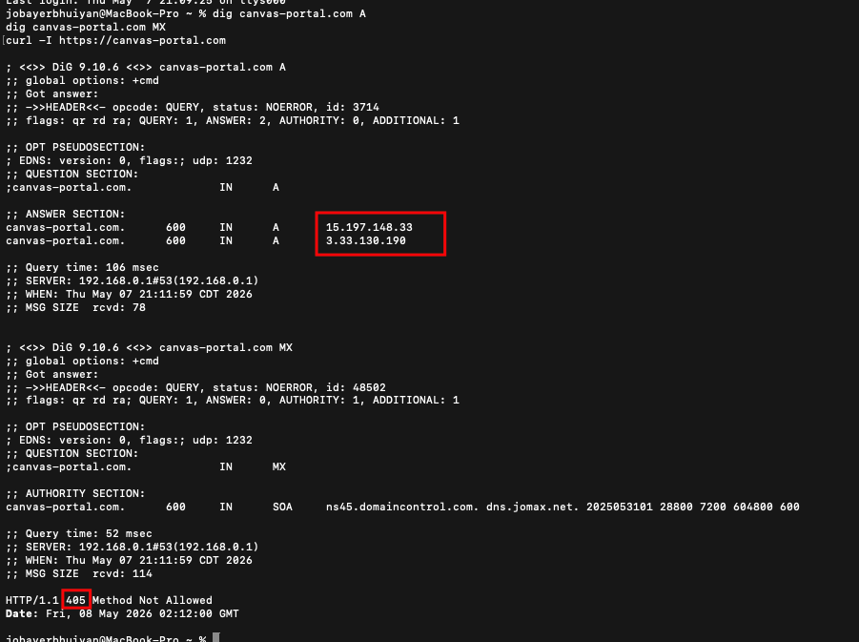
Figure 6: Terminal output — dig confirms two active A records for canvas-portal.com resolving to AWS Global Accelerator IPs 15.197.148.33 and 3.33.130.190. No MX records exist. curl returns HTTP/1.1 405 Method Not Allowed, confirming a live web application is actively processing requests at the domain.

The dig A record query returned two active answers:
canvas-portal.com. 600 IN A 15.197.148.33
canvas-portal.com. 600 IN A 3.33.130.190

Both IP addresses fall within AWS Global Accelerator ranges (15.197.x.x and 3.33.x.x). AWS Global Accelerator is a managed service that routes traffic to backend application servers — this confirms active backend infrastructure is running behind the domain, not a static parked page. The 600-second TTL is consistent with a production web service.

The MX query returned no records (NOERROR with zero answers), confirming the domain is not configured for email delivery. This is consistent with a web-only credential harvesting portal rather than an email phishing campaign.

The HTTP HEAD request returned HTTP/1.1 405 Method Not Allowed. A 405 response indicates the server received the request and actively rejected the HEAD method — meaning a live web application is running and filtering request types. An inactive domain would return NXDOMAIN at DNS level or a static 200 response from a parking page. The 405 is consistent with a login portal configured to only accept GET or POST requests from a browser.

4.4 Attack Timeline
Date | Event
Sep 25, 2024 | canvas-portal.com registered via GoDaddy — one month before C0059 begins
Oct 2024 | ShinyHunters C0059 Salesforce campaign begins (UNC6040)
Sep 23–26, 2025 | canvas-portal.com GoDaddy certs renewed; domain updated — active maintenance
Apr 20, 2026 | canvas-instructure.com certificates issued — 11 days before breach disclosure
May 1, 2026 | Instructure discloses breach; ShinyHunters issues PAY OR LEAK ransom demand
May 6, 2026 | Ransom deadline passes; data leak begins across 8,809 institutions
May 7–8, 2026 | canvas-portal.com confirmed live on AWS — dual A records, HTTP 405 active (this report)

4.5 Indicators of Compromise (IOCs)
Type | Value | Description / Relevance
Domain | canvas-portal.com | ACTIVE — live AWS hosting, GoDaddy, registered Sep 2024. Block immediately.
IPv4 | 15.197.148.33 | AWS Global Accelerator — primary A record for canvas-portal.com
IPv4 | 3.33.130.190 | AWS Global Accelerator — secondary A record for canvas-portal.com
Domain | canvas-instructure.com | Cert issued Apr 20, 2026 — 11 days pre-breach. Monitor CT logs.
Email | shinycorp@tuta.com | ShinyHunters extortion contact (FBI IC3 FLASH-20250912-001)
Email | shinygroup@tuta.com | ShinyHunters extortion contact (FBI IC3 FLASH-20250912-001)
Email | shinyhuntersgroups@tutamail.com | ShinyHunters extortion contact (FBI IC3 FLASH-20250912-001)
User-Agent | Salesforce-Multi-Org-Fetcher/1.0 | API exfiltration user-agent string (UNC6395) — alert in SIEM
User-Agent | python-requests/2.32.4 | API exfiltration user-agent string (UNC6395) — alert in SIEM

5 Conclusion
Using passive OSINT techniques — crt.sh certificate transparency analysis, WHOIS registration lookups, dig DNS queries, and curl HTTP verification — this investigation identified canvas-portal.com as a live, actively maintained domain with strong indicators of association with the ShinyHunters threat actor group responsible for the active Canvas breach.

The domain was registered one month before ShinyHunters launched their documented C0059 Salesforce campaign, consistently maintained and renewed over 18 months, and is currently deployed on AWS Global Accelerator infrastructure with an active web application returning HTTP 405 responses. Certificate transparency analysis additionally identified canvas-instructure.com as a secondary domain of concern, with four TLS certificates issued 11 days before the breach was publicly disclosed — consistent with pre-attack infrastructure staging.

These findings demonstrate the value of proactive Certificate Transparency monitoring as a detection technique during active incidents. By applying known threat actor naming patterns to CT log searches before phishing campaigns go live, security teams can add predictive blocking capability rather than purely reactive IOC-based defense. Institutional IT security teams are advised to block the identified IOCs immediately, monitor CT logs for additional Canvas-branded domain registrations, and alert students to potential credential phishing attempts during the Canvas service outage period.

All findings in this report were obtained through entirely legal, passive, publicly available data sources. No systems were accessed without authorization at any point during this investigation.

6 References
- MITRE ATT&CK Campaign C0059 — Salesforce Data Exfiltration. https://attack.mitre.org/campaigns/C0059/
- FBI Internet Crime Complaint Center. (2025, Sep 12). Cyber Criminal Groups UNC6040 and UNC6395 Compromising Salesforce Instances. FLASH-20250912-001. https://www.ic3.gov/CSA/2025/250912.pdf
- Google Threat Intelligence Group. (2025, Jun 4). The Cost of a Call: From Voice Phishing to Data Extortion. https://cloud.google.com/blog/topics/threat-intelligence/voice-phishing-data-extortion
- BleepingComputer. (2026, May 5). Instructure hacker claims data theft from 8,800 schools, universities. https://www.bleepingcomputer.com/news/security/instructure-hacker-claims-data-theft-from-8-800-schools-universities/
- Inside Higher Ed. (2026, May 5). PAY OR LEAK: Hackers Target Big Higher Ed Vendor. https://www.insidehighered.com/news/tech-innovation/administrative-tech/2026/05/05/pay-or-leak-hackers-target-big-higher-ed-vendor
- Rutgers University OIT. (2026, May 7). Nationwide security breach involving Canvas. https://it.rutgers.edu/alerts/2026/05/04/nationwide-security-breach-involving-canvas/
- Malwarebytes. (2026, May 6). Millions of students' personal data stolen in major education breach. https://www.malwarebytes.com/blog/news/2026/05/millions-of-students-personal-data-stolen-in-major-education-cyberattack
- crt.sh Certificate Transparency Search. Sectigo Limited. https://crt.sh
- University of California. (2026, May 6). Nationwide security breach involving Canvas. https://ucnet.universityofcalifornia.edu/employee-news/nationwide-security-breach-involving-canvas/

7 Appendix — Full Screenshot Evidence
The following screenshots are presented in full for reference, in the order they were captured during the investigation.

Appendix A: crt.sh — canvas-edu.com (assessed as legitimate, removed from watchlist)


Appendix B: crt.sh — canvas-instructure.com (certificates issued April 20, 2026 — 11 days pre-breach)


Appendix C: crt.sh — canvas-login.com (formerly suspicious; now NXDOMAIN — domain expired)


Appendix D: crt.sh — canvas-portal.com (ACTIVE — GoDaddy certs, registered Sep 2024, valid through Sep 2026)


Appendix E: WHOIS — canvas-portal.com registration data with key dates highlighted


Appendix F: Terminal output — dig A/MX queries and curl HTTP verification for canvas-portal.com


