NetworkMiner Threat Hunt Report
NF_W3_Jobayer_A1 | Student: Jobayer Bhuiyan | Course Lab: [Lab-ThreatHunt] NetworkMiner
Investigative objective: Analyze two packet captures in NetworkMiner, identify the local network infrastructure, and document any threat-hunting evidence such as anomalous protocol behavior, suspicious sessions, or indicators of a network-based attack.

Introduction
This report analyzes the two packet captures provided in the lab, network1.pcap and network2.pcap. The investigation focuses on four goals: reconstruct the private network layout, identify domain and DNS infrastructure, identify probable gateway behavior, and review NetworkMiner evidence for suspicious or adversarial activity. Consistent with the lab instructions, each section provides the answer first and then the evidence that supports that answer. Where an infrastructure role is inferred rather than directly labeled by the tool, the inference is stated cautiously and tied to the screenshot evidence.

1. Network 1 (network1.pcap)
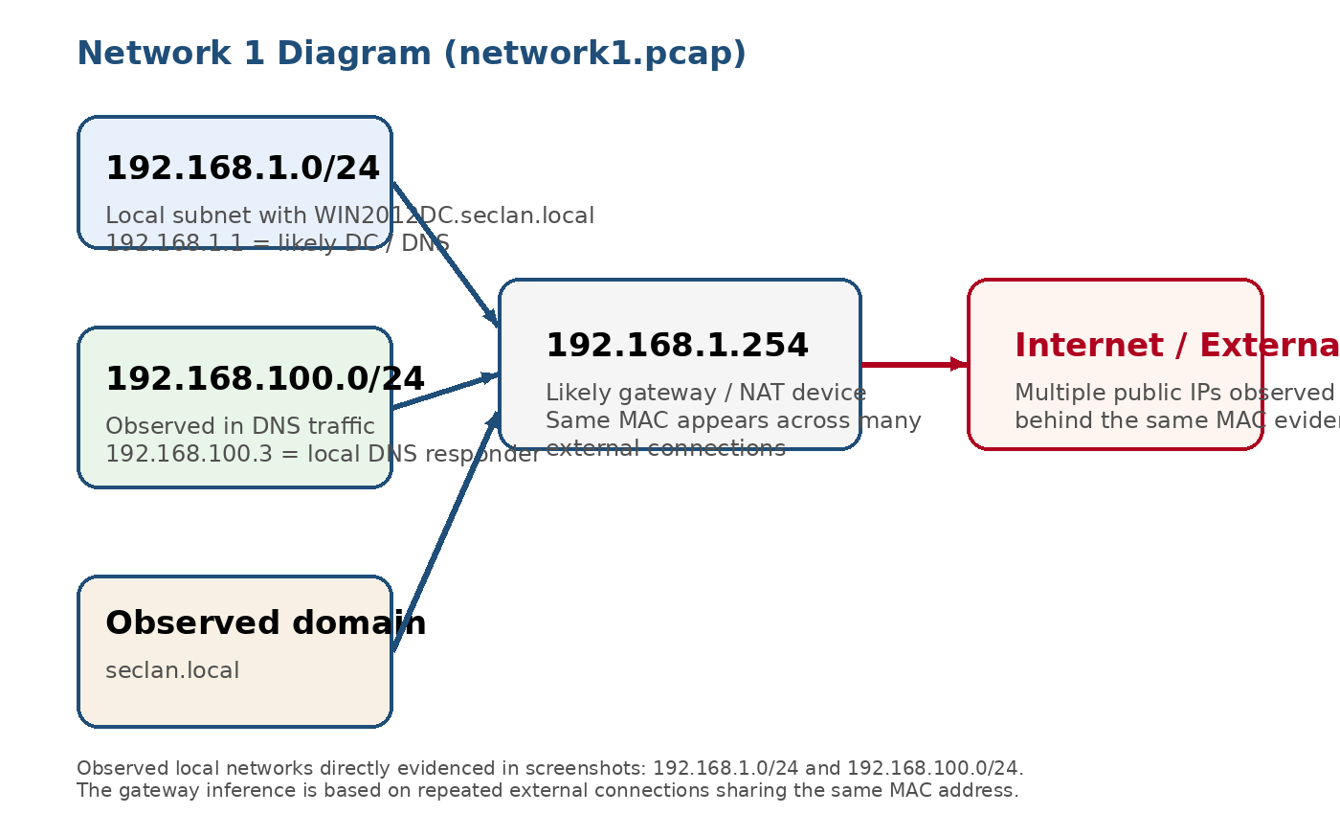
Figure 1. Network 1 diagram based on the local subnets, DNS activity, domain evidence, and gateway/NAT behavior visible in the screenshots.
Required heading | Finding and explanation
1.1 Local networks (private IPs) | 192.168.1.0/24 and 192.168.100.0/24 were directly observed in the DNS and host evidence. The lab note indicates an additional local network exists in the capture, but the provided screenshots directly evidence these two private subnets.
1.2 Local domain names used | seclan.local, including the host WIN2012DC.seclan.local.
1.3 Domain Controller (if present) | WIN2012DC.seclan.local at 192.168.1.1 is the strongest candidate for a Domain Controller because it appears as a named internal Windows host and is associated with DNS responses for the local domain.
1.4 Local DNS servers | 192.168.1.1 and 192.168.100.3 were observed handling DNS traffic on port 53. 8.8.8.8 also appears as an external resolver, but it is not a local DNS server.
1.5 LAN segment gateway IP (or IPs) | 192.168.1.254 is the most likely gateway / NAT device for the 192.168.1.0/24 segment because many external destinations appear beneath the same MAC address on that host.

1.6 Evidence and interpretation
The DNS screenshots below establish the local domain name, the likely internal DNS servers, and the presence of Windows hosts communicating inside the 192.168.1.0/24 environment.
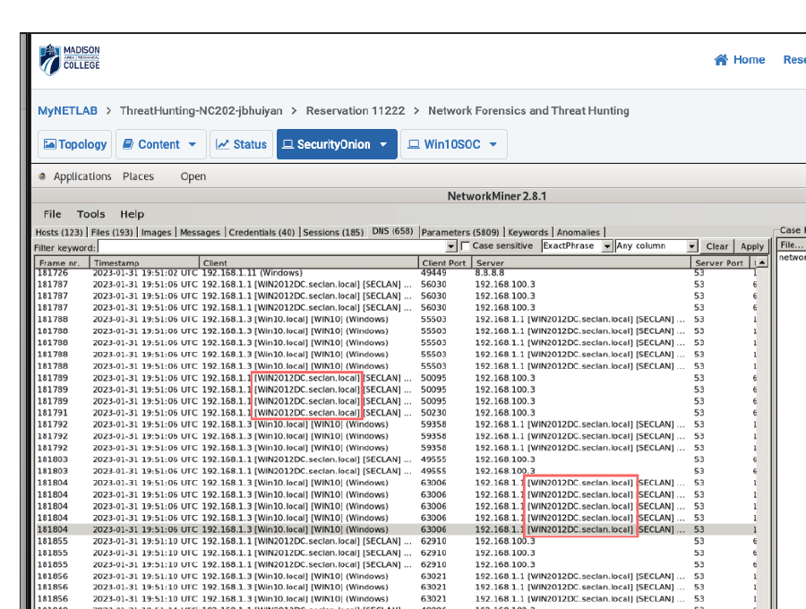
Figure 2. DNS evidence for Network 1 showing internal queries involving 192.168.1.1, 192.168.100.3, and the local host WIN2012DC.seclan.local.
Interpretation: The repeated appearance of WIN2012DC.seclan.local and port 53 traffic supports the conclusion that 192.168.1.1 is acting as internal DNS infrastructure and is also the strongest Domain Controller candidate in the capture. The separate appearance of 192.168.100.3 in the DNS view shows that a second internal resolver is active on the 192.168.100.0/24 subnet.
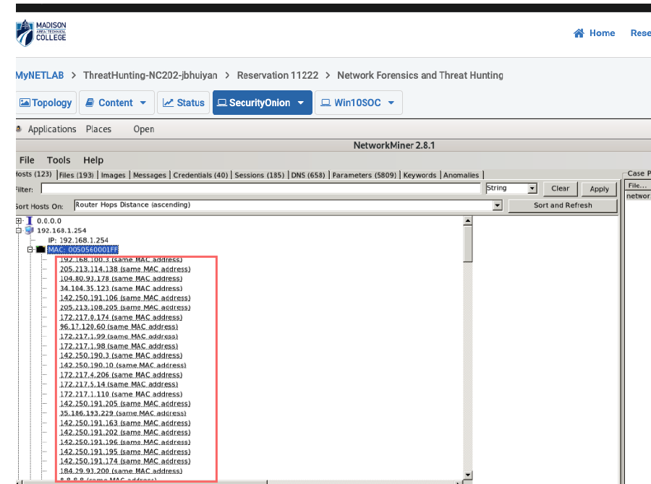
Figure 3. Host evidence for Network 1 showing 192.168.1.254 with many external connections that share the same MAC address, which is consistent with router / NAT behavior.
Interpretation: A single host presenting many external IP relationships under one MAC is a common sign of a routed or NAT-translated edge device rather than a normal endpoint. That is why 192.168.1.254 is documented here as the most likely LAN gateway. This is an inference grounded in the host inventory evidence and is consistent with firewall / gateway behavior described in forensic and network monitoring guidance (Scarfone & Hoffman, 2009).

1.7 Threat-hunting notes
The screenshots supplied for Network 1 primarily support infrastructure reconstruction rather than deep behavioral pivoting. Based on the visible evidence, no confirmed malicious sessions, suspicious files, or credential leakage are directly shown for this packet capture. However, the capture still supports useful hunting observations: the internal domain infrastructure is active, the gateway appears to be performing NAT, and the environment shows a Windows-centric internal network. Because no anomalies, credential artifacts, or suspicious session screenshots were supplied for Network 1, the correct analytic conclusion is that the evidence is currently inconclusive for adversary activity rather than definitively benign. That distinction reflects good threat-hunting discipline.

2. Network 2 (network2.pcap)
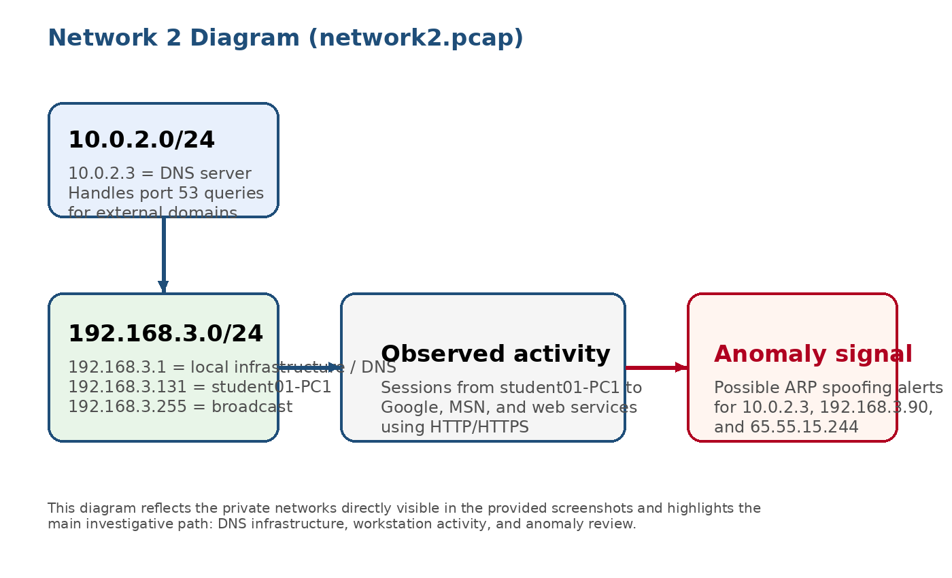
Figure 4. Network 2 diagram showing the observed private subnets, DNS roles, workstation activity, and the anomaly path used for threat hunting.
Required heading | Finding and explanation
2.1 Local networks (private IPs) | 10.0.2.0/24 and 192.168.3.0/24 were directly observed in the screenshots. The broadcast address 192.168.3.255 further supports the 192.168.3.0/24 subnet interpretation.
2.2 Local domain names used | No internal Active Directory style domain was directly confirmed in the provided evidence. The visible host naming is student01-PC1 rather than a domain-qualified internal hostname.
2.3 Domain Controller (if present) | Not identified from the provided screenshots.
2.4 Local DNS servers | 10.0.2.3 and 192.168.3.1 were observed serving DNS traffic on port 53.
2.5 LAN segment gateway IP (or IPs) | A gateway is not directly confirmed in the supplied Network 2 screenshots. 192.168.3.1 appears to be an infrastructure node and may also provide gateway functions, but that role cannot be confirmed solely from the current evidence set.

2.6 Evidence and interpretation
The following screenshots provide direct evidence for the DNS infrastructure, threat-hunting anomalies, and outbound session behavior visible in Network 2.
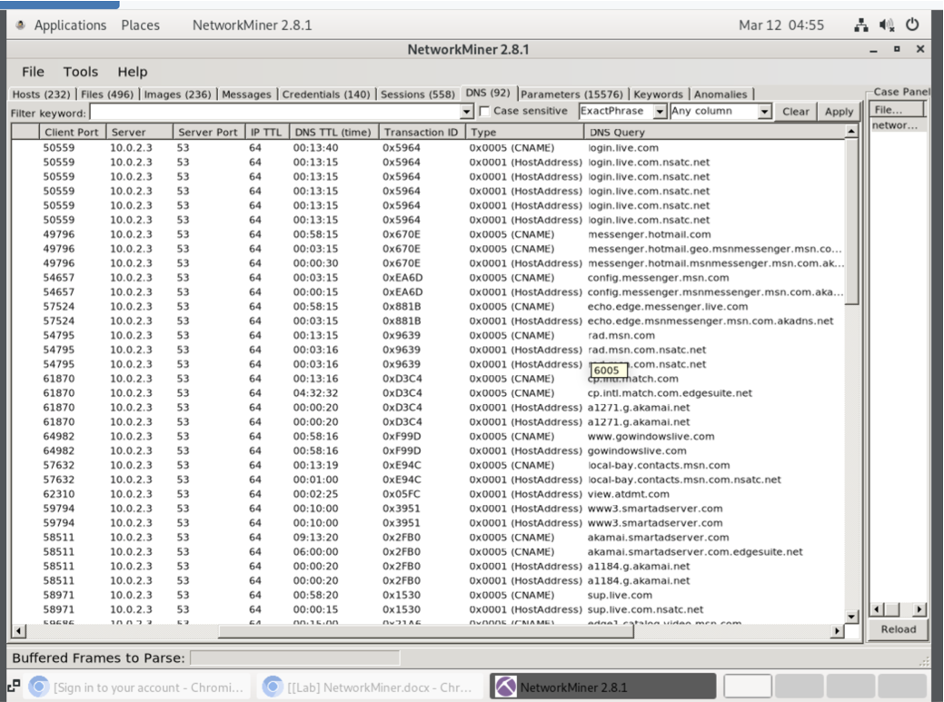
Figure 5. DNS tab showing 10.0.2.3 handling port 53 queries for external domains such as login.live.com, messenger.hotmail.com, and rad.msn.com.
Interpretation: The repeated appearance of 10.0.2.3 in the server column on port 53 strongly supports the conclusion that it functions as a DNS server for the 10.0.2.0/24 network. This is classic DNS resolver behavior and helps establish infrastructure roles before deeper behavioral hunting begins.
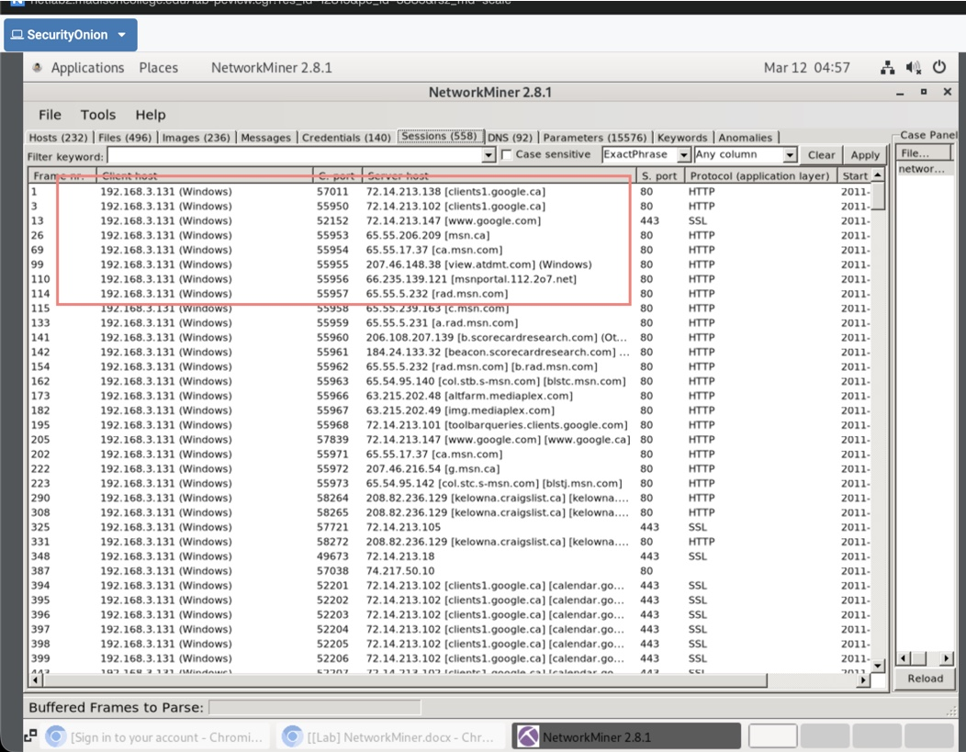
Figure 6. Sessions tab showing 192.168.3.131 (student01-PC1) communicating with multiple external hosts over standard web ports 80 and 443.
Interpretation: These sessions largely resemble user-driven web activity because the destinations include Google, MSN, and normal content-delivery style services over HTTP and HTTPS. By itself, that pattern does not confirm compromise. In threat hunting, the significance comes from comparing these sessions against the anomalies and any unexpected infrastructure changes.
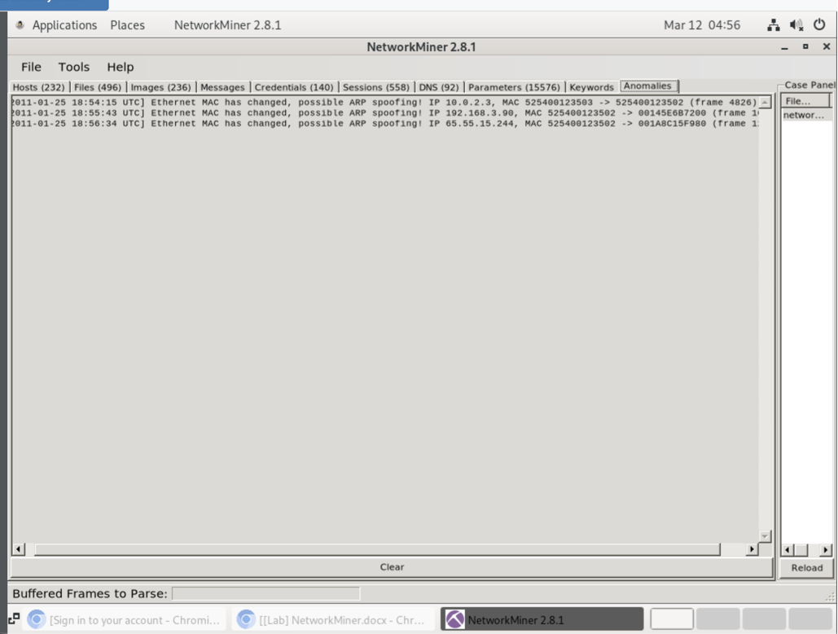
Figure 7. Anomalies tab showing Ethernet MAC changes and possible ARP spoofing alerts involving 10.0.2.3, 192.168.3.90, and 65.55.15.244.
Interpretation: These anomaly messages are the strongest threat-hunting indicators in the supplied evidence. ARP spoofing is a technique attackers can use to intercept or redirect traffic on a LAN by poisoning IP-to-MAC relationships. Because NetworkMiner specifically reports MAC changes and possible ARP spoofing, these alerts should be treated as suspicious and worthy of escalation or additional packet-level validation (Bejtlich, 2013).

2.7 Threat-hunting analysis
Network 2 contains the clearest adversary-related evidence in the provided screenshots. The DNS view shows ordinary name-resolution behavior, and the sessions view mostly reflects standard browsing from student01-PC1. The anomalies view, however, introduces a materially different signal: multiple MAC changes tied to named IP addresses and explicitly labeled by NetworkMiner as possible ARP spoofing. In a threat-hunting context, that combination matters because it suggests an attempt to manipulate Layer 2 identity on the local network while endpoints continue their normal web activity. A cautious but defensible conclusion is that Network 2 shows suspicious network-based attack indicators consistent with ARP spoofing, while the exact attacker host and impact would require validation through full packet review, ARP table reconstruction, or corroboration from endpoint logs.

3. Conclusion
Across the two packet captures, the supplied screenshots support solid infrastructure reconstruction and limited but meaningful threat-hunting conclusions. Network 1 shows a Windows-oriented internal environment using the seclan.local domain, with 192.168.1.1 as the strongest Domain Controller / DNS candidate and 192.168.1.254 as the most likely gateway or NAT device. Network 2 shows two private subnets, identifiable DNS infrastructure, a user workstation generating mostly normal web traffic, and anomaly evidence consistent with possible ARP spoofing. The most defensible overall assessment is that Network 1 is primarily an infrastructure-mapping case from the supplied evidence, while Network 2 contains suspicious behavior that should be investigated as a potential network-based attack.

References
Bejtlich, R. (2013). The Practice of Network Security Monitoring. No Starch Press.
Casey, E. (2011). Digital Evidence and Computer Crime (3rd ed.). Academic Press.
Scarfone, K., & Hoffman, P. (2009). Guidelines on Firewalls and Firewall Policy. National Institute of Standards and Technology (NIST Special Publication 800-41).

