Community-Powered Multi-Agent Disaster Response System for Bangladesh

Background
Bangladesh faces recurring disasters-including floods, cyclones, fires, and building collapses-that regularly disrupt communication networks and overwhelm emergency services. During these events, responders often lack timely, verified, and geolocated information from affected areas, which leads to delayed rescue operations, duplicated efforts, and inefficient resource allocation. These issues are well documented across disaster operations research, which highlights that poor coordination and incomplete situational awareness significantly reduce the effectiveness of emergency response (Altay & Green, 2006; Balcik et al., 2010).
The emergence of crisis informatics has shown that citizen-generated data-such as microblogs, social media posts, and mobile reports-can meaningfully enhance situational awareness during crises (Palen & Anderson, 2016). Studies demonstrate that citizen contributions often appear faster and in greater volume than official reports (Vieweg et al., 2010), and multimodal datasets like CrisisMMD illustrate how image–text data from citizens capture on-ground disaster conditions (Alam et al., 2018). Systems such as AIDR automate the classification of large-scale crisis data, enabling timely extraction of actionable information (Imran et al., 2014). CrisisLex further supports crisis communication by providing lexicons that filter disaster-relevant content (Olteanu et al., 2014).
However, these systems face important limitations. Misinformation spreads rapidly during disasters, often faster than verified reports (Vosoughi et al., 2018). Furthermore, most existing platforms depend on stable internet connectivity and centralized infrastructures, which makes them fragile in contexts like Bangladesh where communication networks commonly degrade during severe disasters.
Parallel research in multi-agent systems offers promising approaches to overcome these challenges. Foundational frameworks such as the Contract Net Protocol (Smith, 1980) and market-based coordination methods (Kalra & Martinoli, 2005) demonstrate that distributed agents can allocate tasks autonomously and efficiently. Distributed Constraint Optimization (DCOP) techniques allow agents to cooperate under partial information, uncertainty, and limited communication (Modi et al., 2005; Farinelli et al., 2008; Fioretto et al., 2018). Multi-agent solutions have been successfully applied to search-and-rescue tasks, robotic coordination, and environmental exploration (Drew, 2021; Zlot et al., 2006).
Although many studies highlight the value of crowdsourced data and decentralized coordination, a combined system that collects structured citizen reports, verifies them automatically, and coordinates multi-agent responders in low-connectivity environments remains largely unexplored. Existing research addresses these components separately but rarely integrates them into a unified architecture designed for real-world deployment in disaster-prone regions.
Given Bangladesh’s high vulnerability to communication breakdowns during disasters, there is a critical need for a system capable of (1) ingesting citizen reports, (2) verifying authenticity, (3) filtering duplicates, and (4) assigning responder teams through decentralized multi-agent coordination-even when networks are partially degraded. Addressing this gap has the potential to significantly improve real-time situational awareness, accelerate response operations, and strengthen public safety.

Problem Statement:
Effective disaster response in Bangladesh is hindered by the lack of a unified, resilient platform for collecting, verifying, and coordinating responses to citizen-reported incidents. Current channels depend on centralized infrastructures that often fail during large-scale emergencies, leading to information bottlenecks, inconsistent situational awareness, and delayed rescue efforts. Although crowdsourced data provides valuable real-time insights (Vieweg et al., 2010; Alam et al., 2018), misinformation and unverified reports remain major challenges (Vosoughi et al., 2018). Existing automated systems such as AIDR classify crisis-related messages but do not offer decentralized coordination for field teams or operation under degraded networks (Imran et al., 2014).
At the same time, multi-agent coordination research demonstrates effective distributed decision-making (Smith, 1980; Kalra & Martinoli, 2005; Farinelli et al., 2008), yet these methods are not integrated into citizen–responder disaster workflows in Bangladesh. As a result, there is no system capable of combining real-time citizen reporting, automated verification, and distributed resource coordination into a single operational platform.
The core problem, therefore, is the absence of a scalable, multi-agent, low-connectivity disaster response system that can transform crowdsourced information into verified insights and coordinated responder actions in real time. This problem affects emergency responders, public institutions, and citizens and represents a critical gap in both research and practice.

Research Aim:
To develop a decentralized multi-agent disaster response system that integrates citizen reporting, automated verification, and responder coordination suitable for degraded network environments in Bangladesh.

Objectives:
- Design a decentralized system architecture integrating reporting, verification, and coordination agents for real-time disaster response.
- Develop a citizen-facing reporting interface (PWA) capable of capturing structured text, images, and geolocation data under low-bandwidth conditions.
- Implement an automated verification component that evaluates the credibility and similarity of citizen reports using linguistic, spatial, and cross-report features.
- Construct a multi-agent coordination mechanism that assigns responder teams through distributed decision-making suitable for intermittent connectivity.
- Build backend data services for geospatial processing, report ingestion, deduplication, and event synchronization during network degradation.

Research Questions:
Main Research Questions
How can a decentralized multi-agent system integrate citizen reporting, automated verification, and responder coordination to improve disaster response under degraded network conditions in Bangladesh?
Sub-research Questions:
- What types of citizen-generated information are essential for real-time disaster reporting, and how can they be captured effectively under low-connectivity conditions?
- What verification techniques can automatically assess the credibility, similarity, and spatial relevance of citizen reports during disasters?
- What multi-agent coordination mechanisms are suitable for assigning and routing responder teams when communication reliability is limited?
- Under what conditions does a decentralized system outperform centralized approaches in terms of responsiveness, coordination efficiency, and resilience?
- What system design choices (e.g., offline-first architecture, message queues, distributed decision protocols) best support operation during network degradation?
- How can the integrated system be evaluated to determine its effectiveness, usability, and operational robustness in realistic disaster scenarios?

Literature Review
Recent research in crisis informatics highlights the growing importance of citizen-generated data in understanding and responding to disasters. Alam, Ofli, and Imran (2018) addressed the lack of multimodal datasets for crisis analysis by introducing CrisisMMD, a large, annotated collection of text and image data from real disasters. This dataset was created to support machine learning models that aim to classify, filter, and interpret crisis-related content. The authors demonstrated that multimodal models outperform text-only approaches in detecting damage severity and humanitarian categories, emphasizing the potential of structured citizen inputs for situational awareness. Their work shows that visual and textual cues shared by citizens can meaningfully enrich emergency response systems, which is directly relevant for the report ingestion and verification components of this project.
Building on the importance of citizen data, Imran et al. (2014) introduced AIDR, a real-time artificial intelligence framework designed to classify large volumes of social media messages during disasters. Their research tackled the problem of information overload on platforms like Twitter, where responders often struggle to filter out irrelevant or misleading posts. The authors developed a supervised machine learning pipeline that could automatically categorize crisis messages into actionable and non-actionable classes. The results showed that automated classifiers significantly reduce manual screening effort and improve response timeliness. However, AIDR remains dependent on centralized infrastructures and does not incorporate distributed coordination, exposing a gap that motivates the development of decentralized architectures in the present study.
The quality and reliability of citizen-generated data have also been widely discussed. Wiegmann et al. (2020) examined how social media influences disaster response effectiveness and found that although public posts can accelerate situational awareness, they simultaneously increase the spread of misinformation. Their study demonstrated that responders face challenges in verifying the accuracy of online reports, which can lead to misallocated resources or delayed interventions. These findings underline the necessity of automated verification mechanisms-such as credibility scoring, similarity clustering, and spatial correlation-which are essential features of the system being developed in this research. Similarly, the findings by Vosoughi et al. (2018), although earlier, reinforce how quickly false information propagates during crises, further supporting the need for robust verification layers.
Parallel to crisis informatics research, significant progress has been made in multi-agent systems and decentralized coordination. Drew (2021) analyzed multi-agent frameworks for search and rescue operations, highlighting the limitations of centralized control when communication becomes unreliable-a condition common in large-scale disasters. The study emphasized that multi-agent approaches provide better scalability, resilience, and fault tolerance, enabling autonomous coordination even when individual communication channels fail. Results showed that distributed agents outperform centralized algorithms in dynamic, uncertain environments, reinforcing the relevance of multi-agent coordination for responder assignment in this project.
Complementing this perspective, Fioretto, Pontelli, and Yeoh (2018) presented a comprehensive survey of Distributed Constraint Optimization Problems (DCOPs), which form the theoretical foundation of many multi-agent coordination techniques. Their work identified key challenges in distributed decision-making, such as communication limits, partial observability, and dynamic environments. The authors evaluated widely used algorithms including Max-Sum and ADOPT, demonstrating their effectiveness in decentralized optimization tasks such as routing, task allocation, and resource sharing. These results validate the use of DCOP-inspired mechanisms in disaster response systems where communication networks may be degraded.
Humanitarian mapping research also provides insights relevant to geospatial decision support. Herfort et al. (2021) studied the evolution of volunteer-driven crisis mapping within the OpenStreetMap (OSM) community, focusing on how crowdsourced geospatial updates support humanitarian organizations during emergencies. The authors showed that community-based mapping efforts significantly improve the completeness and accuracy of geographic data in disaster-prone areas. They also found that volunteer contributions surge rapidly during major crises, providing updated maps that enhance navigation, damage assessment, and logistics planning. Their results demonstrate the value of integrating geospatial intelligence into disaster response platforms, especially those relying on citizen inputs.
Finally, recent work on hybrid human–AI systems further supports the need for verification and human oversight. Zhou et al. (2024) introduced HSAP, a human-in-the-loop platform for social media–based situational awareness. Their research addressed the difficulty of fully automating crisis data analysis due to ambiguity and misinformation. By combining AI classifiers with expert review, the system achieved higher accuracy and reliability than fully automated pipelines. The study confirms that combining automated processing with selective human validation produces more trustworthy information-an approach that aligns closely with incorporating operator oversight in the proposed system.
Taken together, these research studies highlight three consistent themes: (1) citizen-generated data is essential for rapid situational awareness but requires verification to ensure reliability; (2) centralized systems struggle under network stress, while multi-agent coordination offers resilience and scalability; and (3) geospatial intelligence and hybrid human–AI workflows significantly enhance disaster response effectiveness. These findings confirm the relevance of integrating multimodal reporting, automated verification, and decentralized coordination into a unified multi-agent disaster response system designed for Bangladesh’s real-world constraints.

Methodology
This study follows a design science research methodology (DSRM), which is widely used in computing and information systems to guide the development of innovative technological artifacts. The project aims to design and develop a decentralized multi-agent disaster response system integrating citizen reporting, automated verification, and responder coordination suitable for degraded network environments. The methodology is structured around iterative design, development, evaluation, and refinement cycles.

Research Approach
The research adopts a design-oriented, mixed-method approach, combining:
- Design Science Research (DSR) for constructing the system’s architecture and multi-agent components.
- Engineering-based development for the implementation of the PWA, backend pipelines, and coordination agents.
- Experimentation and scenario-based evaluation for testing verification accuracy, network resilience, and coordination efficiency.
This approach is suitable because the study’s goal is to create a functional software artifact that addresses a practical, real-world problem while being grounded in scientific knowledge from crisis informatics, distributed AI, and human–computer interaction.
Research Strategy
The research strategy incorporates three complementary strategies:
1. System Development Strategy (Core Strategy)
Used to design and build the multi-agent system, including reporting, verification, and coordination modules.
2. Experiment-Based Strategy
Used to evaluate:
- verification accuracy of the agent,
- system performance under degraded network scenarios,
- coordination efficiency of the assignment algorithm.

3. Case-Based Simulation Strategy
Disaster scenarios (flood, building collapse, urban fire) are simulated to test:
- flow of citizen reports,
- agent decisions,
- responder assignment.
This hybrid strategy ensures both scientific rigor and practical validation.

System Design and Architecture
Use Case Diagram:
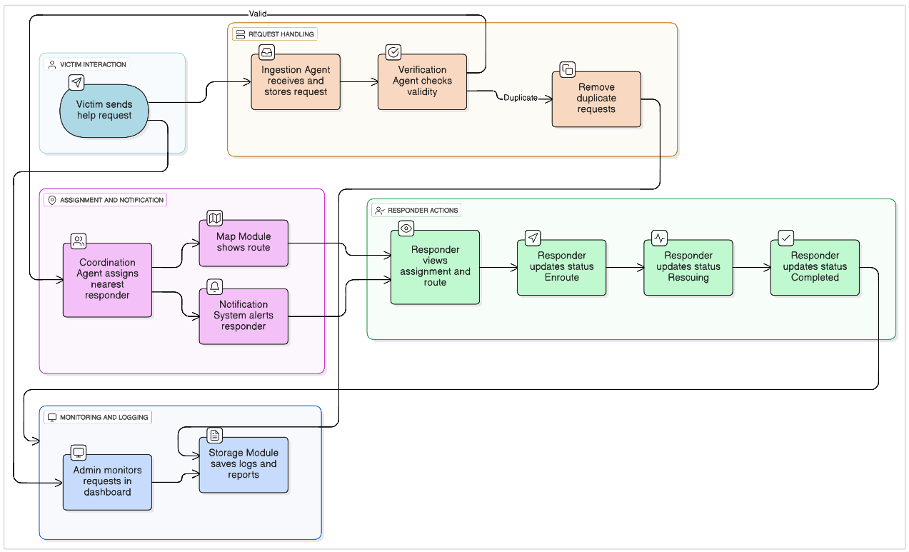
System Architecture Diagram
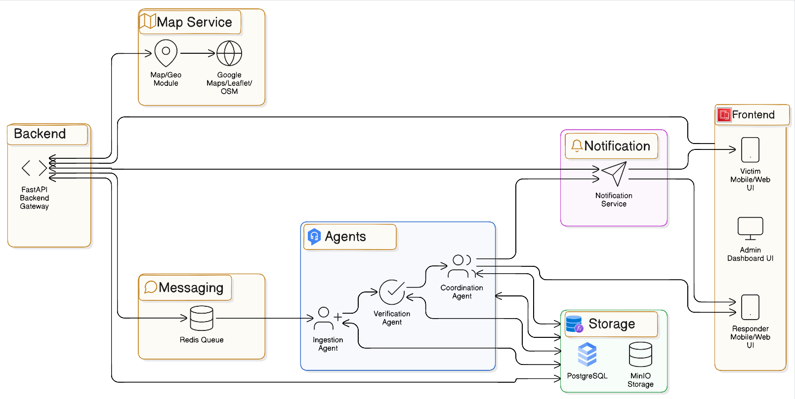

UML Class Diagram:

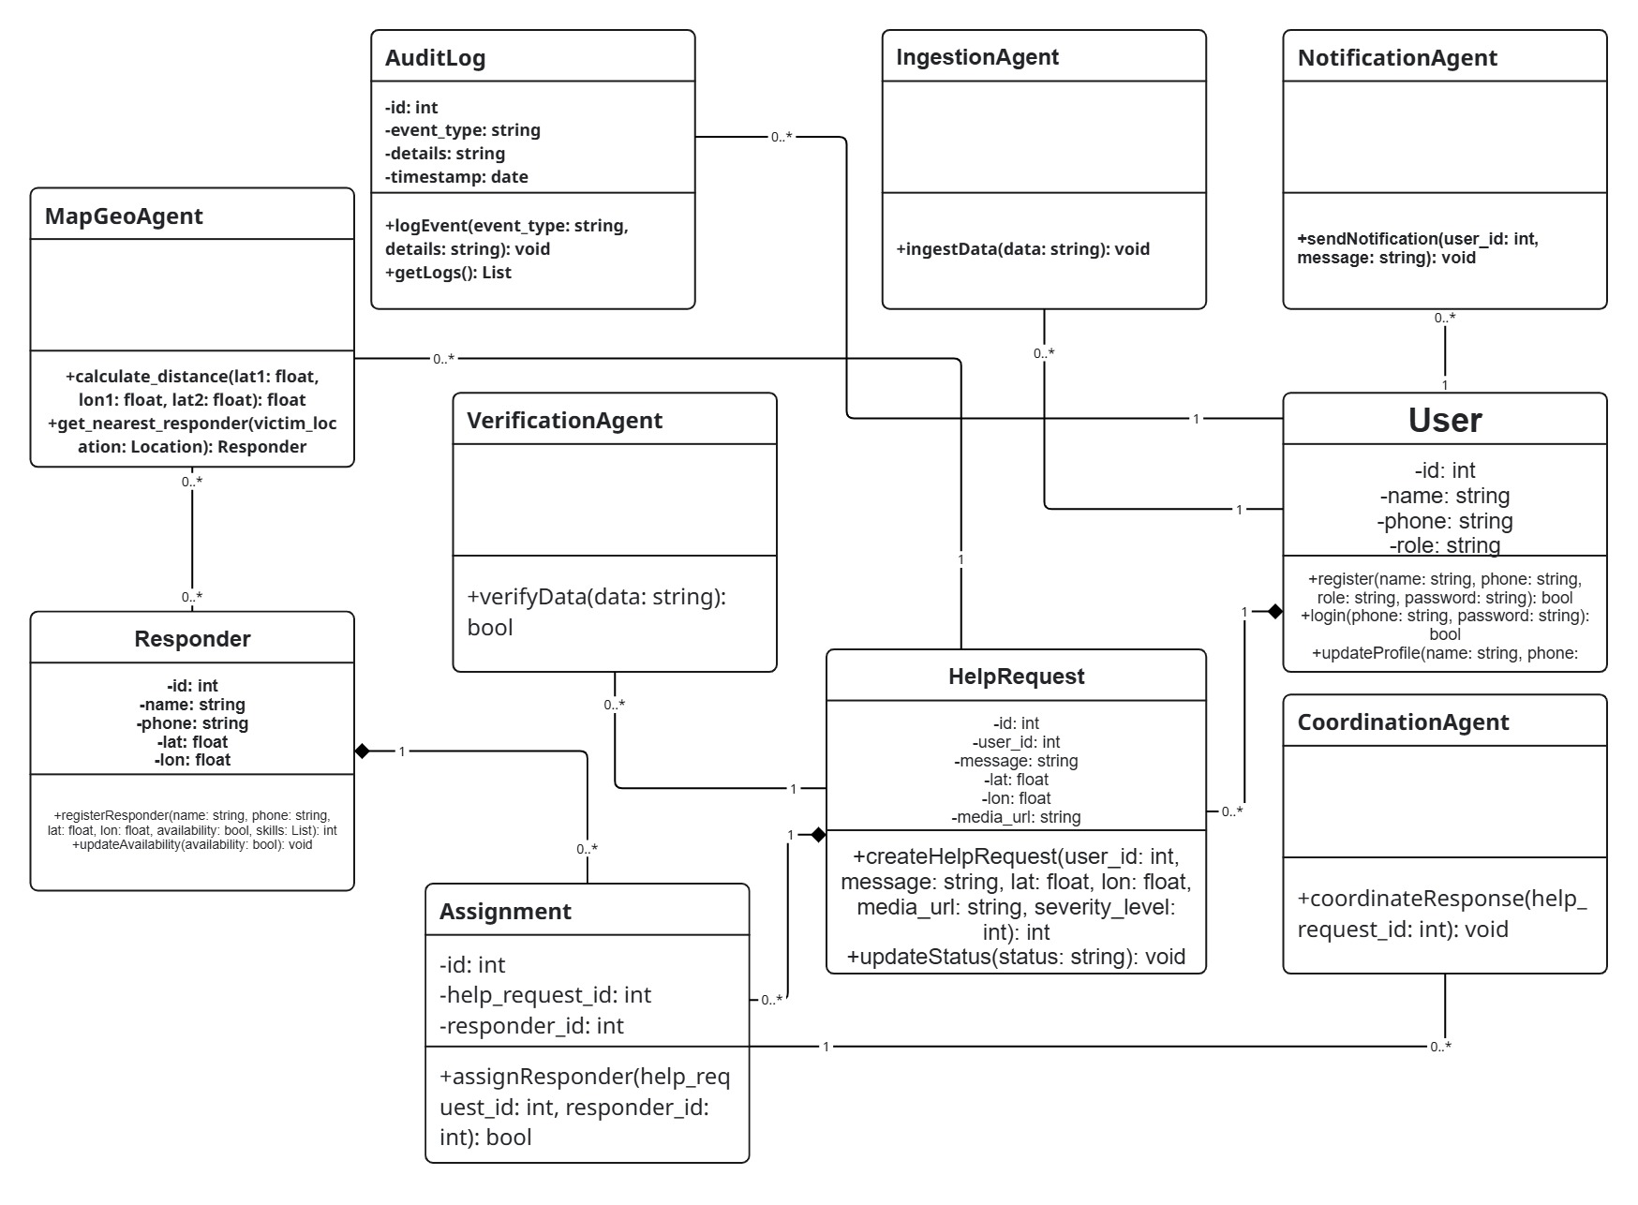

System Flowchart:

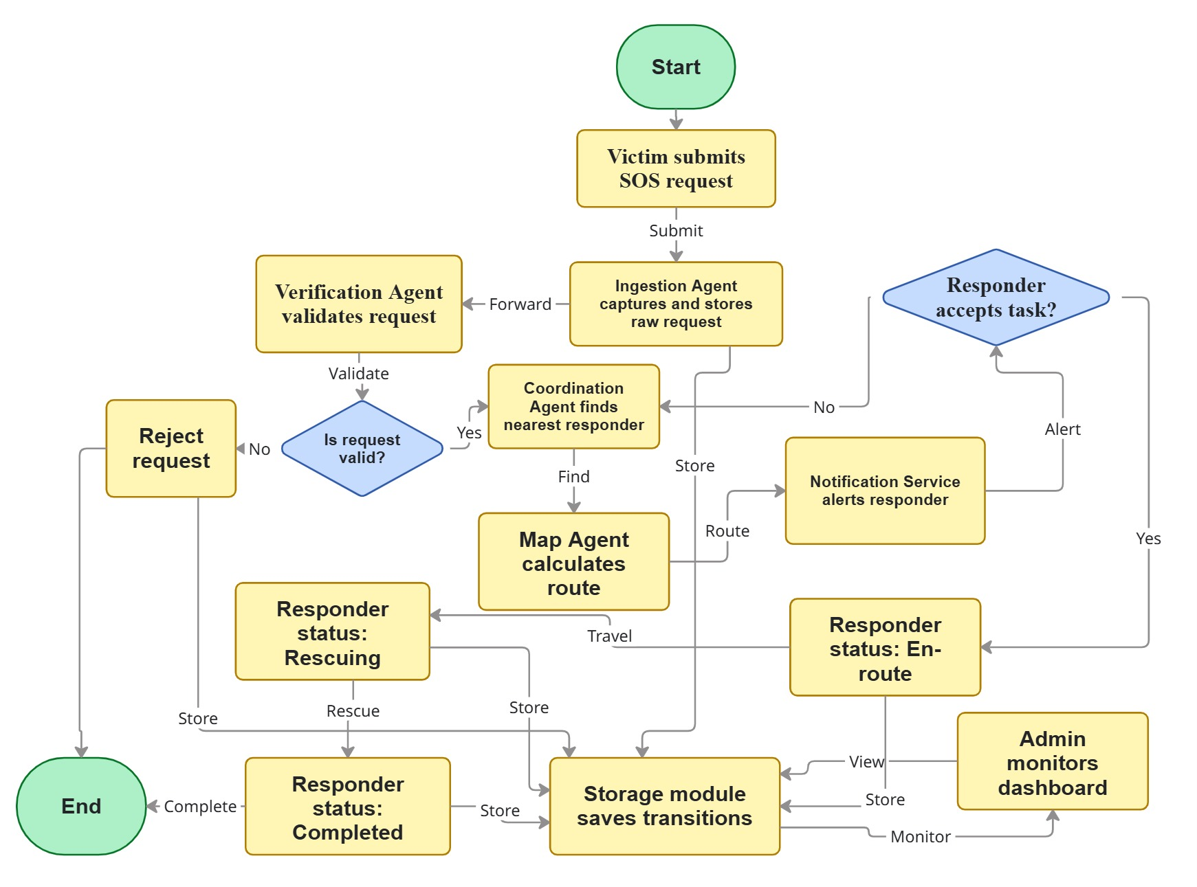

Ingestion Agent Flowchart:

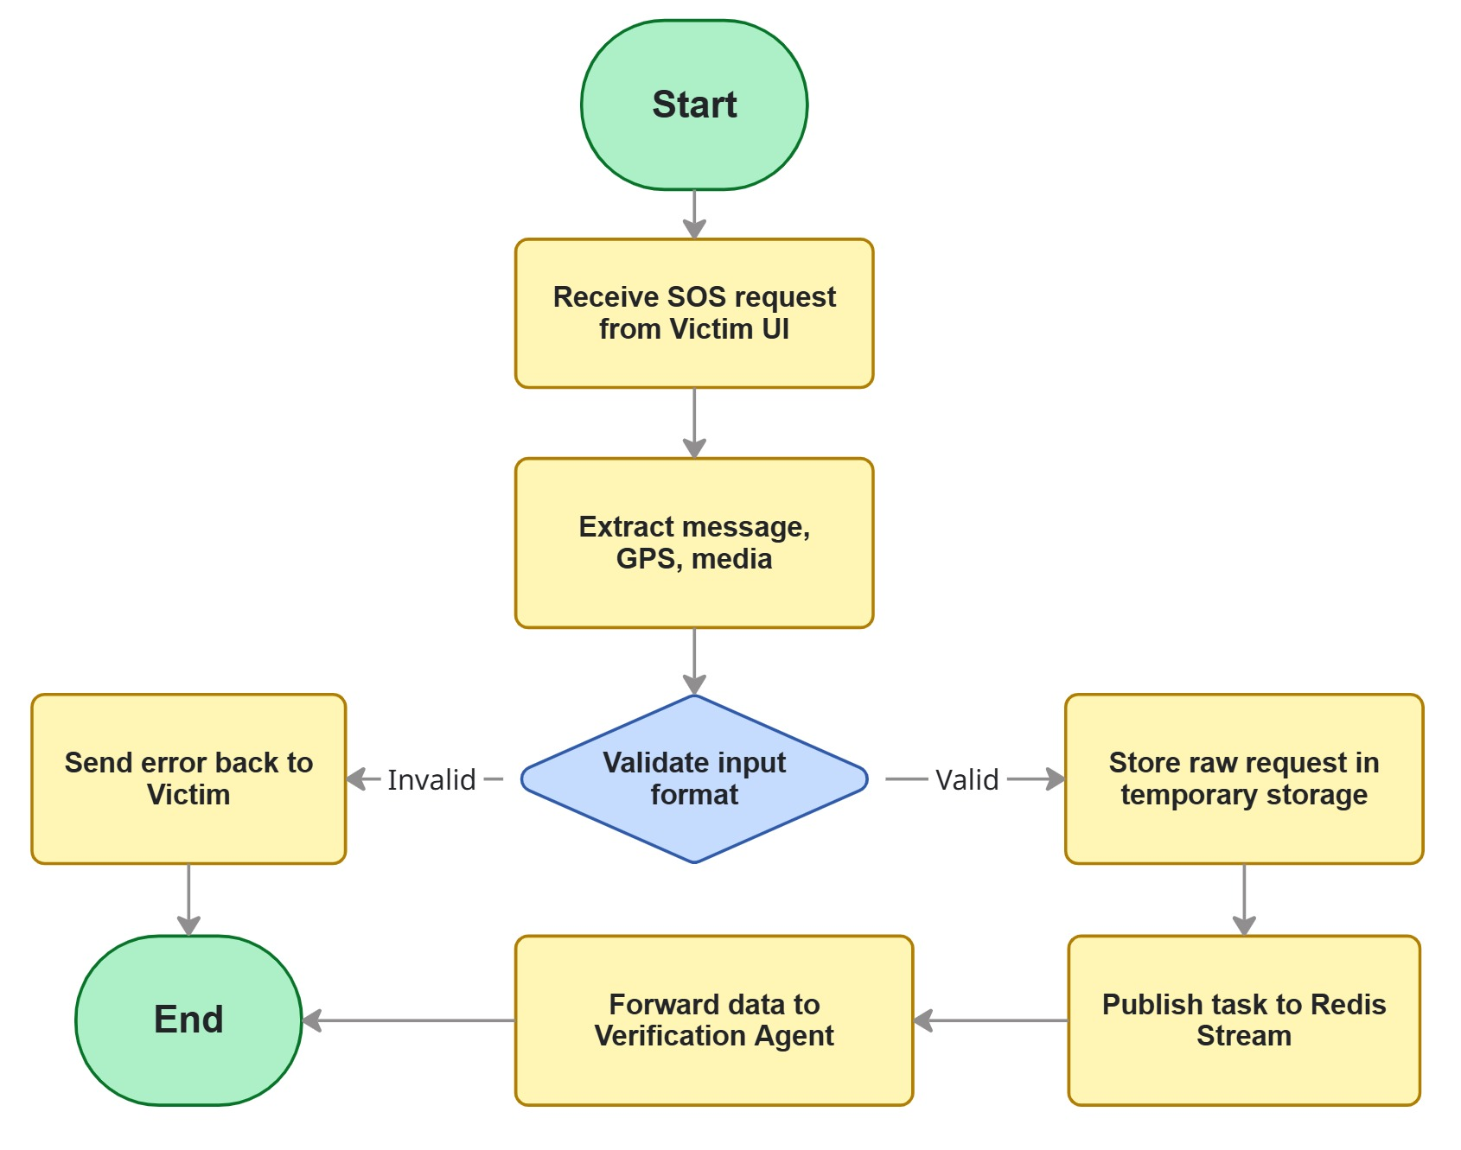

Verification Agent Flowchart:

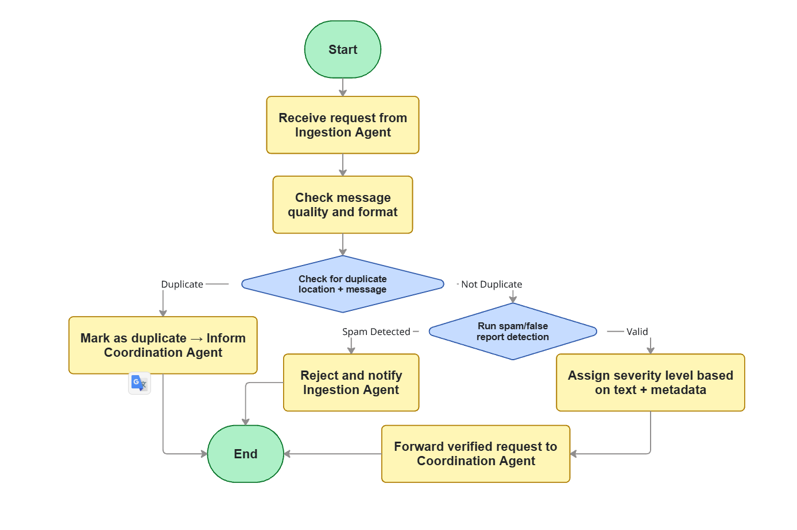

Co-ordination Agent Flowchart:

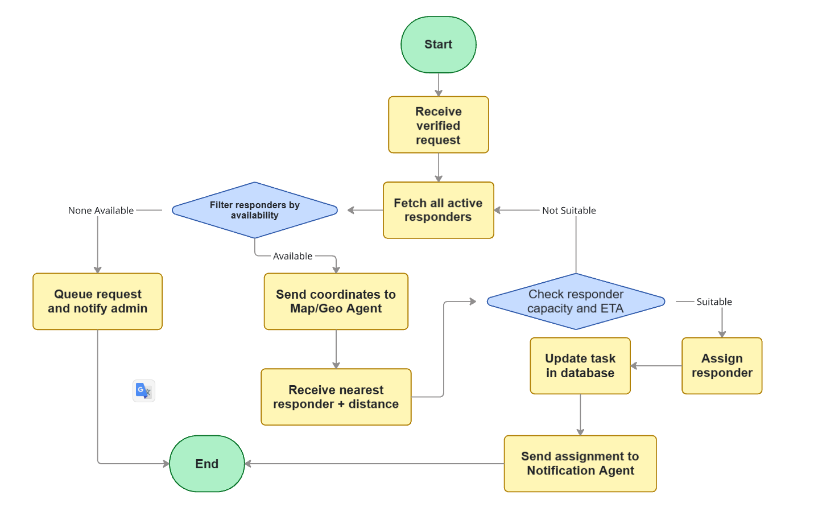

Map / Geo Agent:

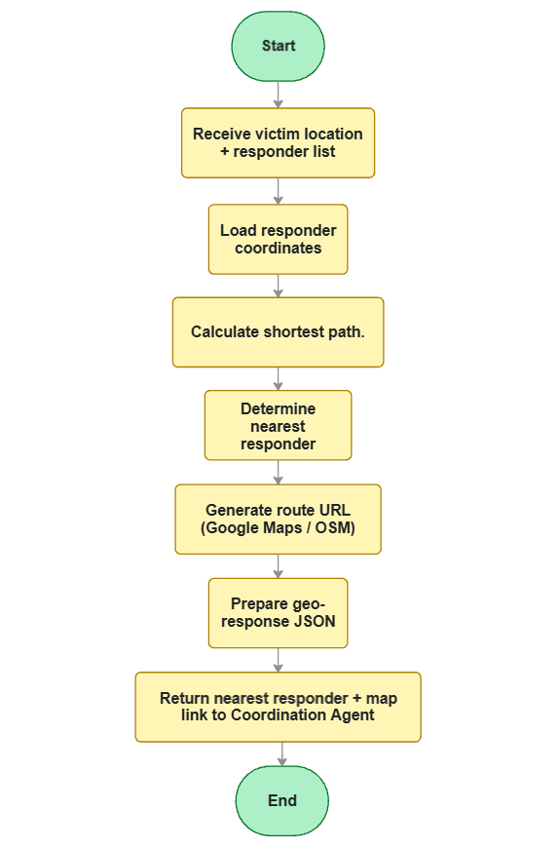

Ingestion Agent Sequence Diagram:
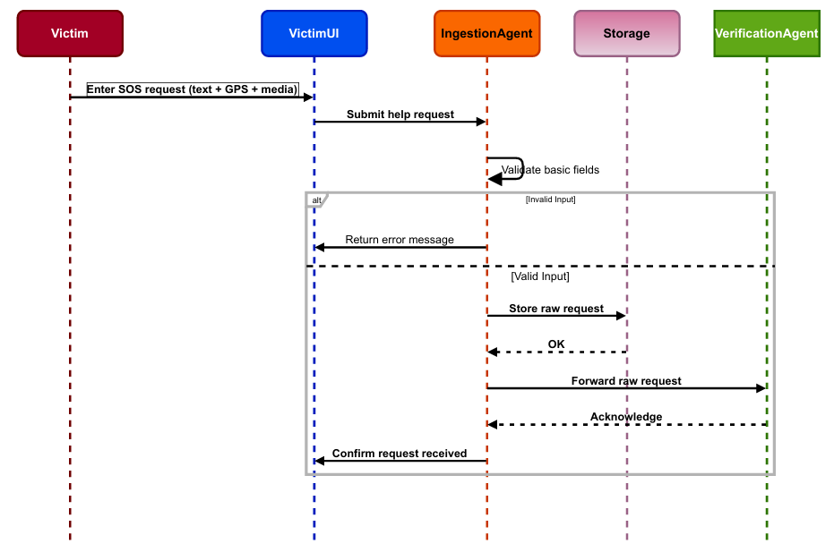

Verification Agent Sequence Diagram::
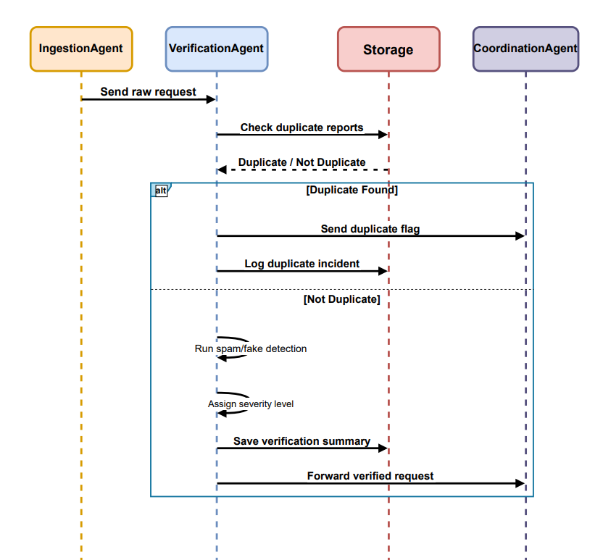

Co-ordination Agent Sequence Diagram:
