AFRICAN LEADERSHIP UNIVERSITY
BSc Software Engineering
Project Proposal and Software Requirements Specification
MansaPay
A Blockchain Remittance Platform for Affordable Cross-Border Money Transfers in Africa
Author
Alieu O. Jobe
Organisation
African Leadership University (ALU), Kigali, Rwanda
Facilitator
Emmanuel Annor
Date Created
22nd June 2026

Table of Contents
PART A: Project Proposal
1. Mission Description
2. Problem Statement
3. Hypothesis of the Solution
4. Software Development Model

PART B: Software Requirements Specification
Chapter 1: Introduction (Purpose, Scope, System Overview)
Chapter 4: Functional Requirements
Chapter 5: Non-Functional Requirements

Appendix B: UML Diagrams (Software Architecture Design)
B.1 Use Case Diagram (Behavioral)
B.2 Class Diagram (Structural)
B.3 Sequence Diagram (Behavioral)
B.4 Deployment Diagram (Structural)

References

List of Figures
Figure 1: Cost of Sending US$200 to Sub-Saharan Africa vs Global Targets
Figure 2: MansaPay High-Level System Architecture
Figure 3: End-to-End Transaction Flow
Figure 4: Use Case Diagram (overview, Chapter 4)
Figure 5: Agile Scrum Sprint Roadmap
Figure B1: Use Case Diagram (detailed, Appendix B)
Figure B2: Class Diagram
Figure B3: Sequence Diagram (Send Money flow)
Figure B4: Deployment Diagram

PART A: PROJECT PROPOSAL

1. Mission Description
I am on a mission to use blockchain technology to widen financial inclusion and create economic opportunity for people across Africa. The continent still records the highest financial exclusion rate in the world, and some of the most expensive money transfer corridors anywhere on the planet. My work focuses on building software systems that let ordinary people, especially those outside the formal banking system, send money, receive money, save value, and prove their financial identity at a fraction of the current cost.
What pulls me toward this mission is personal. I am from The Gambia, where remittances make up more than 20 percent of national GDP. I have watched family members lose meaningful chunks of money just to send funds home from Europe or the United States. Blockchain offers a clean way around the layers of intermediaries that keep those costs high. The bigger picture is simple: if we fix the payment rails, everything else becomes possible. Savings, credit, insurance, and small business growth all sit on top of being able to move money cheaply and prove who you are.
Within Africa specifically, the relevance is sharp. Sub-Saharan Africa receives an estimated 56 billion US dollars in formal remittances each year, but pays the highest fees in the world to do so. Around 350 million adults in the region still do not have a bank account. If I can help build a system that drops the cost of sending 200 dollars from close to 9 percent down to under 3 percent, that money stays in households where it matters most. That is the change I want my work to make.

2. Problem Statement
The problem I am tackling is the high cost and slow speed of cross-border money transfers into and within Sub-Saharan Africa, combined with the deep financial exclusion that locks hundreds of millions of adults out of the formal financial system.
The numbers are uncomfortable. According to the United Nations Department of Economic and Social Affairs, in the first quarter of 2025 the average cost of sending 200 US dollars to Sub-Saharan Africa was close to 9 percent, well above the global average of 6.4 percent and far above the Sustainable Development Goal target of 3 percent (UN DESA, 2025). A 2025 paper presented at the South African Reserve Bank Cross-Border Payments Conference confirmed this, reporting an average cost of 8.78 percent for the same transaction, against a global average of 6.49 percent (SARB, 2025). The gap of around 2 percentage points sounds small in isolation, but applied to the continent's annual remittance flow, it costs African families billions of dollars every year. Figure 1 below puts those numbers side by side.
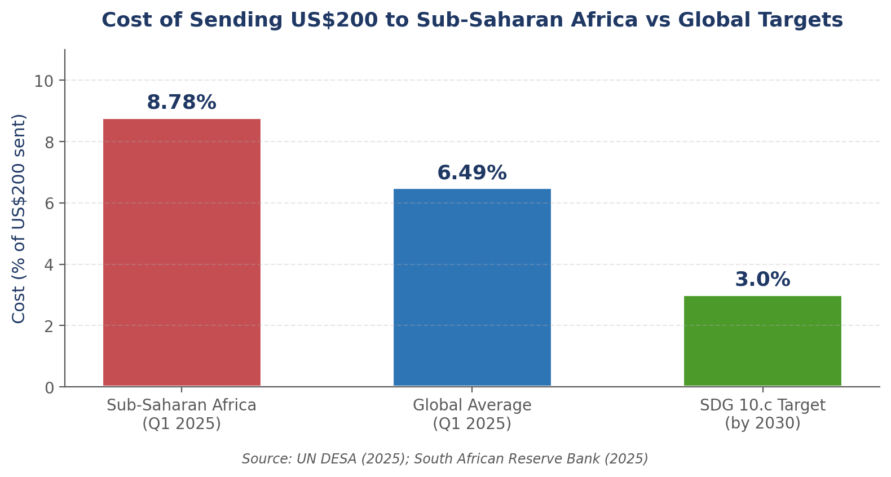
Figure 1: Cost of sending US$200 to Sub-Saharan Africa vs global benchmarks (Q1 2025).
Financial exclusion makes the picture worse. The World Bank's Global Findex reports that roughly 350 million adults in Sub-Saharan Africa do not hold a bank account, and around 105 million of them lack the formal identification required to open one under standard Know-Your-Customer rules (World Bank, 2025). Approximately 90 percent of all financial transactions in Africa are still done in cash (MobiBank, 2025).
The downstream effects show up everywhere:
- Migrant workers pay too much to send money home, which reduces the actual support reaching their families.
- Recipients in rural areas often travel hours to reach a cash-out point, paying transport costs on top of the transfer fees.
- Small and medium enterprises lose competitiveness because cross-border payments inside Africa can take three to five days to settle.
- Adults without formal identification cannot access basic savings, credit, or insurance, even when they have steady income.
Sector: This problem sits in the Financial Technology (FinTech) sector, specifically at the intersection of cross-border payments, digital identity, and financial inclusion.

3. Hypothesis of the Solution
If we build a mobile-first remittance platform powered by the Stellar blockchain, paired with stablecoin rails and local mobile money cash-out points, then we can reduce the cost of sending 200 US dollars between African countries from the current average of around 8.78 percent to under 3 percent within twelve months of pilot launch, while serving users who do not currently hold a traditional bank account.
In plainer language: blockchain settlement removes most of the middlemen that drive up remittance fees. The Stellar network in particular was designed for cross-border value transfer. It settles transactions in three to five seconds and charges fractions of a US cent per transfer. By using stablecoins like USDC on Stellar, and connecting to existing licensed anchors (such as Flutterwave and Yellow Card) that bridge crypto and local mobile money, we can offer a service that feels like Mobile Money but settles like the Internet.
The name of the proposed system is MansaPay. The name is drawn from Mansa Musa, the 14th-century West African ruler whose wealth and trade networks reshaped global commerce. The brand carries a message: Africa has been a centre of trade and value before, and it can be again.

SMART Check on the Concept
- Specific: A blockchain-based remittance and digital wallet platform called MansaPay, focused on Africa-to-Africa and diaspora-to-Africa transfers using the Stellar network.
- Measurable: Reduce the cost of a 200 dollar transfer to under 3 percent. Settlement time under 10 seconds. Onboard at least 500 pilot users across The Gambia, Senegal, and Rwanda within 6 months of MVP launch.
- Achievable: The Stellar SDK is open-source and well-documented. Anchor partners already operate on the network. A solo developer can ship an MVP that covers one corridor within an academic semester.
- Realistic: The first version focuses on the Senegal-Gambia corridor, which is small, regulated, and one where I have local contacts for user research. The wider rollout sits in a later phase of the roadmap.
- Timely: The project aligns with the African Continental Free Trade Area push for cheaper cross-border payments, and with the United Nations Sustainable Development Goal 10.c, which targets remittance costs below 3 percent by 2030.

4. Software Development Model

Selected Model: Agile (Scrum-inspired)
Agile is the right fit for MansaPay for three honest reasons.
First, requirements will shift. I am working with a young technology stack (the Stellar SDK, anchor APIs, mobile money integrations) where what looks possible on day one often changes by day thirty. A waterfall approach would lock me into a frozen specification that reality would quickly invalidate. Agile lets me re-plan at the end of every sprint.
Second, this project needs user feedback early. The whole point of MansaPay is to serve real people in real corridors. Building the entire system in one long stretch and then discovering that users in Banjul prefer USSD over a smartphone app would be a disaster. Short sprints with usability checkpoints reduce that risk significantly.
Third, the project breaks down cleanly into vertical slices. Sending money, receiving money, KYC, wallet creation, and cash-out can each be designed, built, and tested as independent user stories. That fits Scrum's backlog-driven workflow perfectly.

Description of the Agile Scrum Model
Scrum is an Agile framework that organises work into short, time-boxed iterations called sprints (typically two to four weeks long). Each sprint produces a working increment of software. The team plans at the start of a sprint, holds short daily stand-ups, demonstrates the result at the end of the sprint (sprint review), and reflects on the process (sprint retrospective). Work is captured as user stories on a product backlog, prioritised by the product owner, and pulled into each sprint based on team velocity.

How Scrum Will Be Applied to MansaPay
Scrum Element | How It Applies to MansaPay
Sprint Length | Two weeks per sprint.
Product Backlog | All user stories captured in GitHub Projects, prioritised by user value and technical dependency.
Sprint Planning | Held on the first Monday of each sprint. Stories are selected to fit the realistic velocity of a solo developer.
Daily Stand-up | A 15-minute self-check-in each weekday morning, logged in a personal development journal.
Sprint Review | Live demo of the working increment to at least two real test users at the end of every sprint.
Sprint Retrospective | Honest reflection on what worked, what stuck, and what to change in the next sprint.
Definition of Done | Code reviewed, unit tests passing, deployed to a staging environment, and manually tested against the acceptance criteria.

Project Sprint Roadmap
The high-level sprint plan from kick-off to pilot is shown in Figure 5 and the table below. Each sprint produces a working slice of MansaPay.
Sprint | Weeks | Sprint Goal
Sprint 1 | Weeks 1 to 2 | Lock down requirements, conduct user interviews with 5 diaspora senders and 5 Gambian recipients, set up the GitHub repository with branch protection and continuous integration.
Sprint 2 | Weeks 3 to 4 | Build the authentication system and KYC flow using JWT tokens and the Smile Identity API.
Sprint 3 | Weeks 5 to 6 | Create automatic Stellar wallet provisioning on signup, secure key storage, and a balance display screen.
Sprint 4 | Weeks 7 to 8 | Implement send and receive flows with the USDC stablecoin on the Stellar testnet.
Sprint 5 | Weeks 9 to 10 | Integrate fiat on-ramp and off-ramp through a Stellar anchor partner.
Sprint 6 | Weeks 11 to 12 | Run a closed pilot with real users on testnet, build the transaction history dashboard, fix bugs.
Sprint 7 | Weeks 13 to 14 | Move the platform to mainnet for the pilot corridor, add monitoring, write the final report.
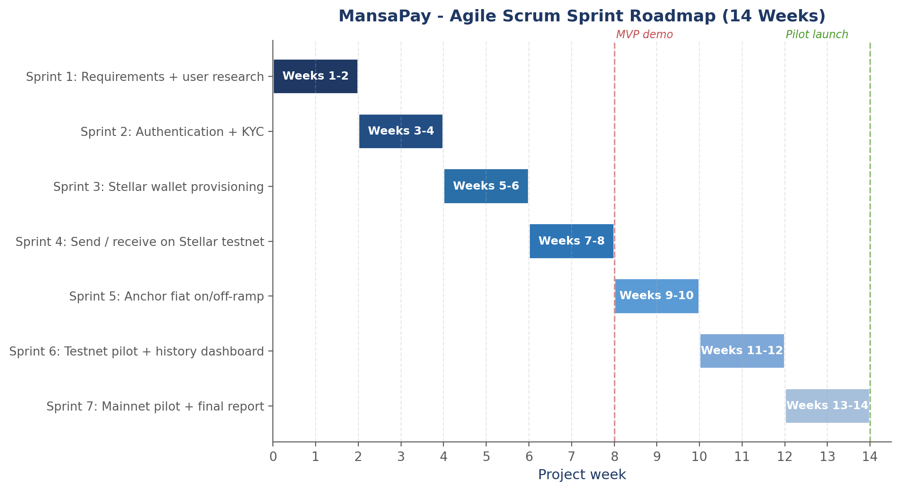
Figure 5: Agile Scrum sprint roadmap over 14 weeks, with MVP demo and pilot launch milestones.

PART B: SOFTWARE REQUIREMENTS SPECIFICATION

Chapter 1: Introduction

1.1 Purpose
This Software Requirements Specification (SRS) sets out what MansaPay must do and how well it must do it. The document is written for three audiences: the author, who will build the system; the academic facilitator, who will assess it; and any future contributors who join the project after the initial MVP is delivered. It captures both functional behaviour (what the system does) and non-functional quality attributes (how the system performs, scales, and stays secure).
Anyone reading this document should be able to answer three questions when they finish. What problem is the system solving? What features must it have to count as complete? And what quality standards must it meet to be safe and useful in production?

1.2 Scope
MansaPay is a web and mobile application that lets users send and receive money across African borders using blockchain settlement. The system delivers the following capabilities:
- Account creation and identity verification, with support for either government-issued ID or a community-vouched alternative for users who lack formal documents.
- Automatic provisioning of a non-custodial Stellar wallet for every verified user, where the user controls the private key.
- Holding balances in USDC stablecoin and local-currency tokens issued by licensed Stellar anchors.
- Sending and receiving money across African borders in under ten seconds at a fee target of under 3 percent of the transfer value.
- Converting between digital balances and local cash through mobile money operators (MTN Mobile Money, Orange Money, Wave) via anchor partners.
- A complete, exportable transaction history with on-chain proof for every transfer.
The pilot scope is limited to two corridors: Senegal-Gambia and Rwanda-DRC. Outside the MVP, the following are explicitly out of scope: lending and credit products, investment instruments, support for non-Stellar blockchains, and full bank-grade compliance for jurisdictions outside the pilot countries.

1.3 System Overview
MansaPay sits between the user and the Stellar blockchain. Users interact through a clean web or mobile front end. The platform handles identity verification, wallet management, transaction signing, and the bridging of digital assets to local cash through licensed anchor partners. Off-chain user data (KYC records, transaction metadata, user preferences) lives in a PostgreSQL database that the development team controls directly. On-chain settlement happens on the Stellar network, so user funds remain in their own control even if the MansaPay back-end is temporarily unavailable.
The high-level architecture is built in five layers, as shown in Figure 2.
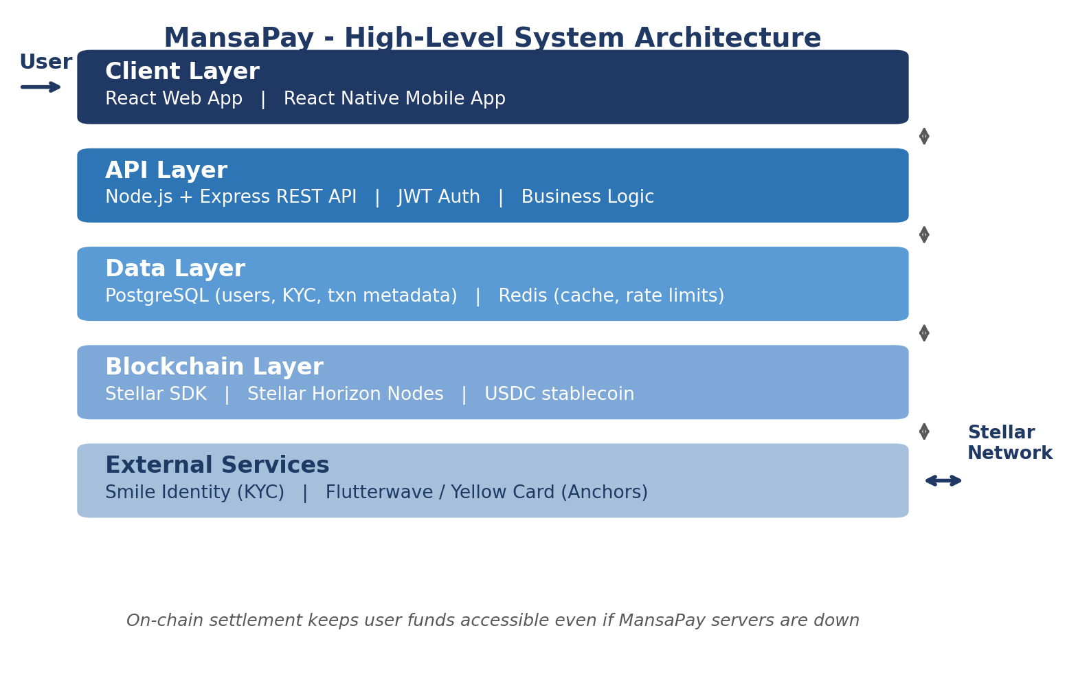
Figure 2: MansaPay five-layer system architecture.
- Client Layer: A React web application and a React Native mobile application. Users interact with these directly.
- API Layer: A Node.js (Express) REST API that handles authentication, business logic, and the orchestration of blockchain calls.
- Data Layer: PostgreSQL stores user accounts, KYC status, and transaction metadata. Redis handles session caching and rate limiting.
- Blockchain Layer: The Stellar SDK communicates with Stellar Horizon nodes to submit transactions, fetch balances, and watch for incoming payments.
- External Services Layer: Smile Identity provides KYC verification. Stellar anchors such as Flutterwave or Yellow Card bridge between USDC and local mobile money.
This separation matters. It keeps user data inside controlled infrastructure, while pushing the actual movement of value onto a transparent and auditable blockchain. If the MansaPay back-end goes down, the user's funds are still safe on Stellar and can be accessed through any other Stellar wallet.
To make the architecture concrete, Figure 3 walks through a single end-to-end transaction from a sender in Senegal to a recipient in The Gambia. The whole flow is designed to finish within ten seconds and cost under 3 percent of the transfer value.
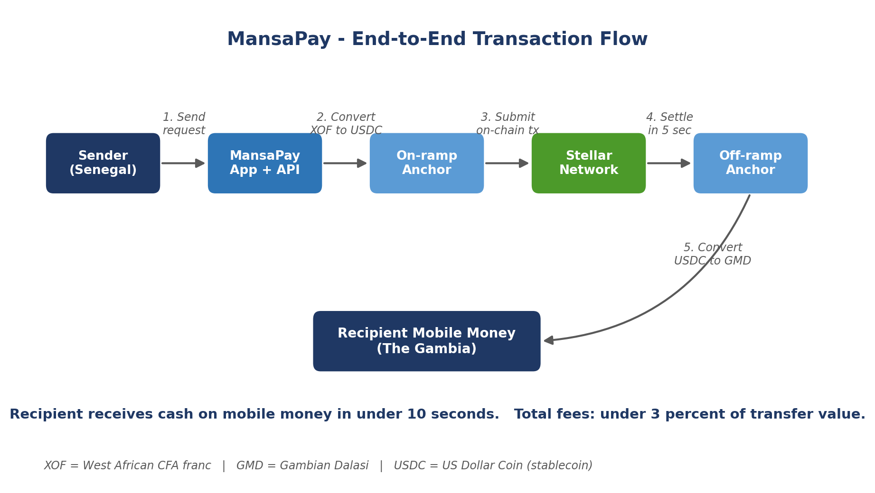
Figure 3: End-to-end transaction flow from sender to recipient, using Stellar settlement and licensed anchors for fiat conversion.

Chapter 4: Functional Requirements
Functional requirements describe what the system must do. Each requirement has a unique identifier for traceability across the design, implementation, and testing phases. Priority is rated High (must have for MVP), Medium (should have for MVP), or Low (nice to have).
Figure 4 summarises the main actors and the use cases each one can trigger. A more detailed version of this diagram with include and extend relationships appears in Appendix B as Figure B1.
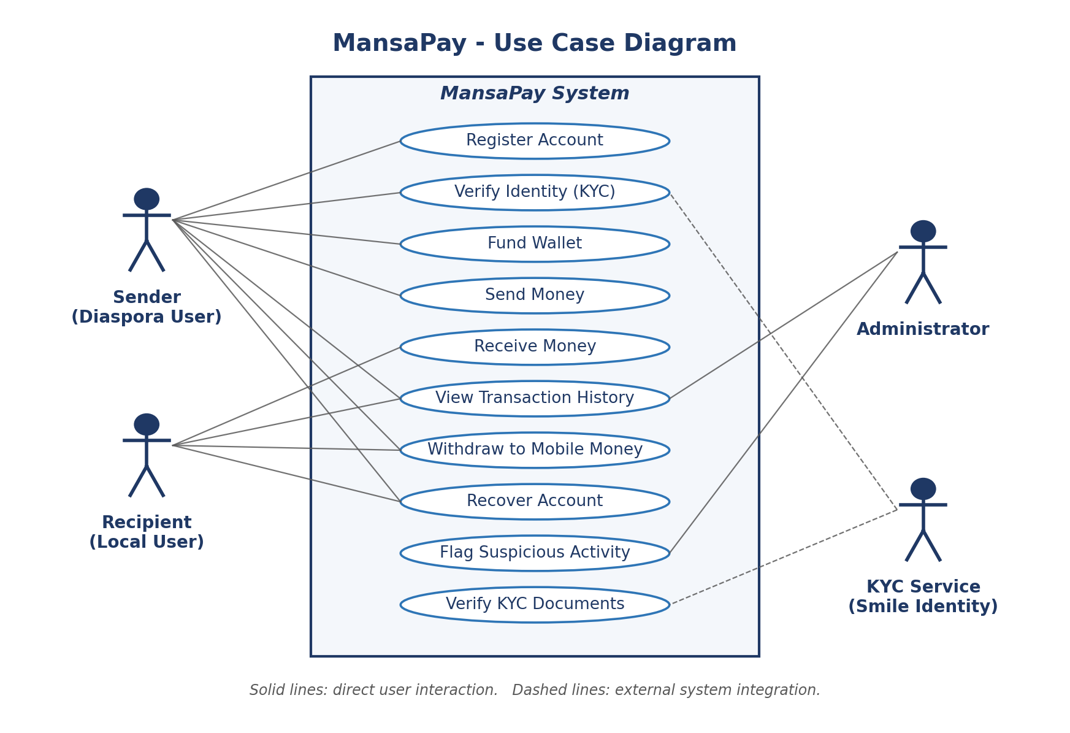
Figure 4: Use case diagram (overview) showing the four main actors and their interactions with the MansaPay system.
ID | Requirement | Priority
FR-01 | The system shall allow a new user to register an account using a phone number, a verified email address, and a chosen password. | High
FR-02 | The system shall verify the user's identity through the Smile Identity API, accepting either a national ID document or a community-vouched alternative proof for users without formal identification. | High
FR-03 | On successful KYC verification, the system shall automatically create a Stellar wallet for the user and store the public key in the database, while encrypting the secret key at rest using a key derived from the user's password. | High
FR-04 | The system shall allow a verified user to fund their MansaPay wallet from a local mobile money account through a connected Stellar anchor partner. | High
FR-05 | The system shall allow a user to send a specified amount of money to another user, identified by phone number or MansaPay username, with settlement on the Stellar network. | High
FR-06 | The system shall display the real-time exchange rate between the sender's local currency, USDC, and the recipient's local currency before the user confirms a transaction. | High
FR-07 | The system shall send an SMS notification and an in-app push notification to the recipient when funds have settled in their wallet. | Medium
FR-08 | The system shall allow a user to withdraw funds to their mobile money account through a connected anchor partner, with the final settlement amount displayed before confirmation. | High
FR-09 | The system shall provide a transaction history view showing every send, receive, deposit, and withdrawal, with timestamps, fees paid, and the on-chain transaction hash for each transfer. | Medium
FR-10 | The system shall allow an administrator to flag a suspicious transaction for compliance review and freeze a user account when required by anti-money-laundering rules. | High
FR-11 | The system shall allow a user to recover account access using a multi-factor recovery flow combining an SMS code and a security question, without exposing the underlying wallet secret key. | High
FR-12 | The system shall maintain an immutable audit log of every API request and on-chain transaction, accessible only to administrators with the relevant permissions. | Medium

Chapter 5: Non-Functional Requirements
Non-functional requirements describe how well the system must perform. They cover the quality attributes that turn a feature-complete system into a trustworthy one. Each requirement has a measurable target so success is not left to opinion.
ID | Category | Requirement | Target
NFR-01 | Performance | The system shall complete an in-app send transaction from confirmation to on-chain settlement within ten seconds under normal Stellar network load. | Under 10 seconds
NFR-02 | Scalability | The system shall support 10,000 concurrent active users on a single backend instance and scale horizontally through container replication on Docker and Kubernetes. | 10,000 concurrent users
NFR-03 | Security | The system shall hash user passwords with bcrypt using at least 12 salt rounds, and shall encrypt all wallet secret keys at rest using AES-256. | bcrypt 12+ / AES-256
NFR-04 | Availability | The system shall maintain at least 99.5 percent uptime measured monthly, excluding scheduled maintenance windows announced 48 hours in advance. | 99.5 percent uptime
NFR-05 | Usability | A first-time user shall be able to complete account registration, identity verification, and a first transfer within eight minutes, measured during user acceptance testing. | Under 8 minutes
NFR-06 | Reliability | The system shall recover from any single component failure (database node, API server, or anchor connection) without data loss, supported by nightly automated backups and graceful service degradation. | Zero data loss
NFR-07 | Maintainability | The codebase shall maintain at least 70 percent unit test coverage and follow the Airbnb JavaScript style guide enforced through ESLint in the continuous integration pipeline. | 70 percent coverage
NFR-08 | Compliance | The system shall meet the KYC and anti-money-laundering requirements of the Central Bank of The Gambia and the National Bank of Rwanda for the pilot phase, and shall generate audit-ready compliance reports on demand. | Pilot country regulations
NFR-09 | Portability | The mobile application shall run on Android 9 and above, covering at least 85 percent of active Android devices in the target markets according to GSMA data. | Android 9 and above
NFR-10 | Accessibility | The user interface shall meet WCAG 2.1 Level AA standards, including screen reader support, keyboard navigation, and a minimum text contrast ratio of 4.5 to 1. | WCAG 2.1 Level AA

APPENDIX B
UML Diagrams: Software Architecture Design
This appendix presents four UML 2.5 diagrams that model the software architecture of MansaPay from different angles. Two of the diagrams are behavioural (Use Case and Sequence) and two are structural (Class and Deployment). Together they describe who interacts with the system, how the domain objects relate to each other, how a transaction unfolds over time, and where every piece of software actually runs.
Each section below states the type of diagram, lists the elements that appear in it, and walks through the relationships in the order a reader should follow them.
The four diagrams included in this appendix are summarised in the table below.
Section | Diagram Type | Purpose
B.1 | Use Case Diagram (Behavioural) | Shows the actors who use MansaPay and the services they invoke, including extend and include dependencies between use cases.
B.2 | Class Diagram (Structural) | Shows the static structure of the domain: the classes, their attributes and operations, and the associations, generalisations, and compositions between them.
B.3 | Sequence Diagram (Behavioural) | Shows the time-ordered exchange of messages between objects during a single cross-border Send Money transaction, including failure handling.
B.4 | Deployment Diagram (Structural) | Shows the physical and logical infrastructure: the devices, execution environments, containers, artifacts, and external systems that host MansaPay.

B.1 Use Case Diagram (Behavioural)
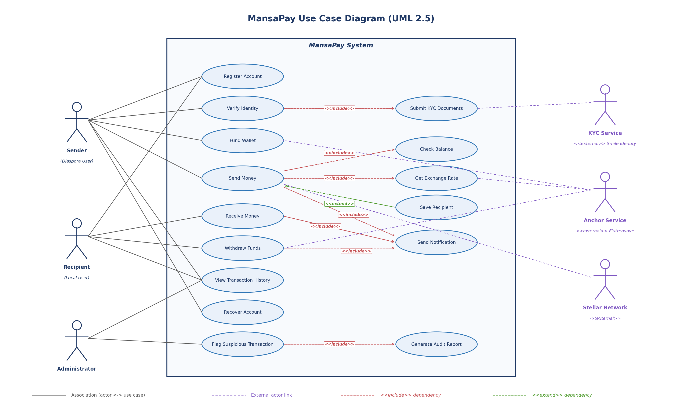
Figure B1: Detailed use case diagram showing primary and secondary use cases with include and extend dependencies.

Diagram Type and Purpose
This is a UML use case diagram. It captures the system from the outside-in perspective: who uses MansaPay (the actors), what they want to achieve (the use cases), and how those use cases depend on each other. It is the most useful diagram for non-technical stakeholders because it answers "who does what with this software" without requiring any knowledge of how the code is structured.

Elements in the Diagram
Actors
- Sender (Diaspora User): a primary human actor. Triggers most of the value-creating use cases.
- Recipient (Local User): a primary human actor based in the destination country. Can receive money and convert it to local cash.
- Administrator: a secondary human actor. Performs compliance and oversight operations.
- KYC Service (Smile Identity): an external system actor that verifies identity documents. Shown in purple with the <<external>> stereotype because it is outside the MansaPay boundary.
- Anchor Service (Flutterwave): an external system actor that converts between digital assets and local fiat through mobile money.
- Stellar Network: an external system actor that settles transactions on-chain.
Use Cases (Primary)
- Register Account, Verify Identity, Fund Wallet, Send Money, Receive Money, Withdraw Funds, View Transaction History, Recover Account, and Flag Suspicious Transaction. These are the headline things MansaPay actors do.
Use Cases (Secondary)
- Submit KYC Documents, Check Balance, Get Exchange Rate, Save Recipient, Send Notification, and Generate Audit Report. These are sub-behaviours that are either always required by a primary use case (include) or optionally extend it under certain conditions (extend).

Relationships and Notation
- Association (solid line): connects an actor to a use case to show that the actor initiates or participates in that behaviour. For example, Sender to Send Money.
- External actor link (dashed purple line): connects an external system actor to the use cases it participates in. For example, the Anchor Service is involved in Fund Wallet and Withdraw Funds.
- <<include>> dependency (dashed red arrow): the base use case must always execute the included use case. Verify Identity always includes Submit KYC Documents. Send Money always includes Check Balance, Get Exchange Rate, and Send Notification.
- <<extend>> dependency (dashed green arrow): the extending use case is optional. Save Recipient extends Send Money: it only fires when the sender wants to keep the recipient's details for future transfers.

Reading the Diagram (Narrative Flow)
A new user joins MansaPay through Register Account. Before any money moves, they trigger Verify Identity, which includes Submit KYC Documents. Those documents are handed to the Smile Identity external service, which approves or rejects.
Once verified, the Sender Funds the Wallet by depositing local currency through the Anchor Service. To Send Money, three sub-behaviours always happen: Check Balance (do they have enough), Get Exchange Rate (from the Anchor), and Send Notification (the recipient must be told). If they choose to save the recipient's contact, the optional Save Recipient extension fires.
On the receiving side, the Recipient triggers Receive Money (which also includes Send Notification) and can Withdraw Funds to their local mobile money account through the Anchor. The Stellar Network external actor participates in Send Money because it actually settles the transfer.
Finally, the Administrator can Flag Suspicious Transaction, which always includes Generate Audit Report so a paper trail is kept. The Administrator can also View Transaction History across all users for compliance review.

B.2 Class Diagram (Structural)
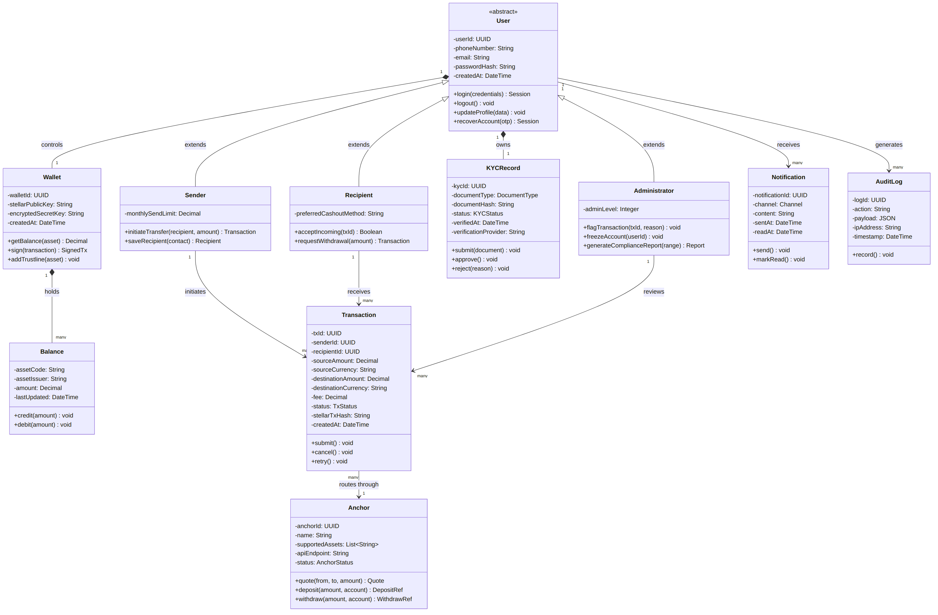
Figure B2: Class diagram showing the domain model, attributes, operations, and relationships.

Diagram Type and Purpose
This is a UML class diagram. It models the static structure of the MansaPay domain: the data the system holds, the operations that can be performed on that data, and how the different kinds of objects relate to each other. A class diagram is the foundation for the database schema, the API resource model, and the object-oriented code that the team will eventually write.

Elements in the Diagram
Classes
- User: abstract base class for everyone with an account. Holds identity attributes (userId, phoneNumber, email, passwordHash) and the common operations (login, logout, updateProfile, recoverAccount).
- Sender, Recipient, Administrator: three concrete subclasses of User. Each adds attributes and operations specific to its role. For example, Sender adds monthlySendLimit and initiateTransfer; Administrator adds adminLevel and flagTransaction.
- KYCRecord: holds the identity verification state for a user (documentType, status, verifiedAt). Operations include submit, approve, and reject.
- Wallet: the user's Stellar wallet. Stores stellarPublicKey and the encryptedSecretKey. Operations include getBalance, sign, and addTrustline.
- Balance: a per-asset amount held in a wallet. One wallet can have many balances, one for each currency or stablecoin the user holds.
- Transaction: a single transfer. Records both the source and destination amounts and currencies, the fee, the status, and the on-chain Stellar transaction hash. Operations include submit, cancel, and retry.
- Anchor: a third-party fiat bridge such as Flutterwave or Yellow Card. Stores the name, supported assets, and API endpoint. Operations include quote, deposit, and withdraw.
- Notification: an SMS, email, or push message sent to a user. Tracks channel, content, sentAt, and readAt.
- AuditLog: an immutable record of every meaningful action in the system. Required for regulatory compliance.

Relationships and Notation
- Generalisation (hollow triangle, labelled "extends"): Sender, Recipient, and Administrator all extend User. They inherit User's attributes and operations and add their own. This is classic object-oriented inheritance.
- Composition (filled diamond, labelled "owns" or "controls" or "holds"): the diamond is on the side of the whole. A User owns a KYCRecord and controls a Wallet. A Wallet holds many Balances. Composition means the part cannot exist without the whole; delete the User and the KYCRecord and Wallet go with them.
- Association (plain line with multiplicity labels): a Sender initiates many Transactions; a Recipient receives many Transactions. Each Transaction routes through one Anchor. A User receives many Notifications and generates many AuditLog entries.
- Multiplicities (1, many): the numbers at the ends of each line state how many objects can be on each side. "1" and "many" follow standard UML cardinality notation.

Visibility Markers
Inside each class, attribute and operation names start with either a minus sign or a plus sign. A minus sign means private (only the class itself can access it) and a plus sign means public (callable from outside). Private attributes like passwordHash and encryptedSecretKey are critical for security; if those were public, any other class could read sensitive data.

Why This Structure Matters
The class diagram makes three architectural decisions explicit. First, splitting User into Sender, Recipient, and Administrator means each role can carry its own business rules without polluting a single bloated User class. Second, modelling Wallet and KYCRecord as compositions of User keeps user identity, identity verification, and on-chain assets tightly bound, which is what regulators expect for a money-transfer service. Third, modelling Anchor as its own class lets MansaPay swap or add anchor partners (Flutterwave, Yellow Card, MoneyGram) without rewriting the Transaction logic, because every anchor exposes the same operations (quote, deposit, withdraw).

B.3 Sequence Diagram (Behavioural)
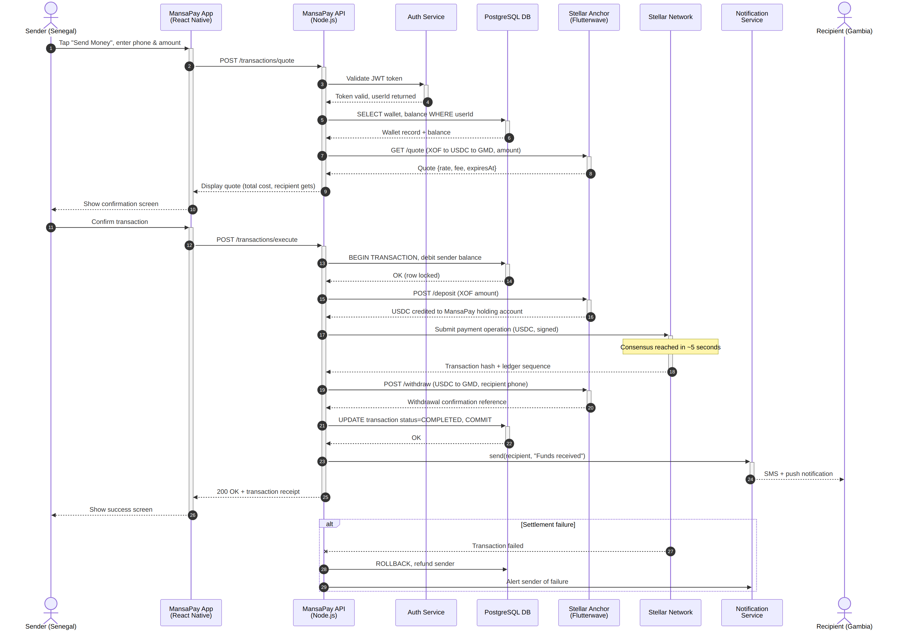
Figure B3: Sequence diagram of a complete cross-border Send Money transaction with failure handling.

Diagram Type and Purpose
This is a UML sequence diagram. It shows how multiple objects collaborate over time to fulfil one scenario, in this case a Sender in Senegal sending money to a Recipient in The Gambia. Sequence diagrams are the most useful way to verify that the design works end-to-end before writing any code. They expose race conditions, missing return values, and forgotten failure paths.

Elements in the Diagram
Participants (Lifelines)
- Sender (Senegal): the human actor who initiates the transfer.
- MansaPay App (React Native): the client application running on the sender's phone.
- MansaPay API (Node.js): the backend service that orchestrates the transaction.
- Auth Service: a focused module that validates JWT tokens and returns the user identity.
- PostgreSQL DB: the off-chain database that holds user data, wallet records, and transaction metadata.
- Stellar Anchor (Flutterwave): the external fiat bridge.
- Stellar Network: the public blockchain that settles the transfer.
- Notification Service: a separate worker that delivers SMS and push notifications.
- Recipient (Gambia): the human actor on the receiving end.
Notation
- Lifelines (vertical dashed lines): each participant has its own vertical line representing its existence over time. Time flows downward.
- Activation bars (thin rectangles on lifelines): show when a participant is busy processing a message.
- Synchronous messages (solid arrows): the sender waits for a response. Most messages in this diagram are synchronous because each step depends on the previous one.
- Return messages (dashed arrows): the reply that closes a synchronous call.
- Combined fragment alt: the box at the bottom showing what happens if Stellar settlement fails. The system rolls back the database and alerts the sender.
- Note: the yellow box near Stellar marks an important constraint (consensus typically reached within five seconds).

Reading the Diagram (Step by Step)
Steps 1 through 10 cover the quote phase. The sender opens the app and enters the amount. The app calls POST /transactions/quote on the API. The API verifies the JWT through the Auth Service, reads the wallet and balance from PostgreSQL, and asks the Anchor for an FX quote covering Senegalese CFA to USDC to Gambian Dalasi. The quote is returned to the app and shown to the sender.
Steps 11 through 22 cover the actual execution. The sender confirms the transaction. The API opens a database transaction and debits the sender's balance (with row-level locking so two concurrent sends cannot double-spend). The API tells the Anchor to deposit USDC into MansaPay's holding account, then submits a Stellar payment operation. Once Stellar reaches consensus (typically five seconds), the API instructs the Anchor to withdraw to the recipient's mobile money account, updates the database to mark the transaction COMPLETED, and commits.
Steps 23 through 26 cover the notification and acknowledgement. The API hands a job to the Notification Service, which sends an SMS and push notification to the recipient. The API returns a 200 OK to the app, which shows the sender a success screen.

Failure Handling (the alt Fragment)
If Stellar fails to settle the transaction for any reason (network split, insufficient signer weight, asset trustline missing), the diagram shows the alt fragment kicking in. The API rolls back the database transaction (refunding the sender), and the Notification Service alerts the sender that the transfer did not complete. No money is lost. This kind of explicit failure path is what separates a careful design from a hopeful one.

Why This Sequence Matters
The Send Money flow is the heart of MansaPay. Walking through it with a sequence diagram catches three classes of bug before they reach code. First, missing quote refresh: rates expire, so if the user takes too long to confirm, the API needs to re-quote (this is why the Quote object has an expiresAt field in the class diagram). Second, partial failure: the alt fragment forces the design to commit to a clear rollback strategy if Stellar fails mid-flight. Third, idempotency: every external call (deposit, submit, withdraw) needs an idempotency key so a network retry never causes a double-charge.

B.4 Deployment Diagram (Structural)
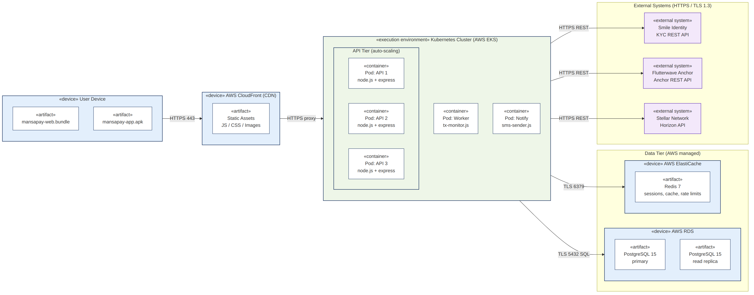
Figure B4: Deployment diagram showing devices, execution environments, artifacts, and external systems.

Diagram Type and Purpose
This is a UML deployment diagram. Where the class diagram showed the logical design and the architecture diagram in Chapter 1 showed the layered structure, the deployment diagram answers a more concrete question: where does every piece of software actually live, and how do those locations talk to each other? This is what the DevOps engineer needs to read before provisioning infrastructure on AWS.

Elements in the Diagram
Nodes (UML cubes) and Stereotypes
- <<device>>: a physical or virtual host that runs software. User Device, AWS CloudFront, AWS RDS, and AWS ElastiCache are all devices.
- <<execution environment>>: a runtime container that hosts other artifacts. The Kubernetes Cluster on AWS EKS is the execution environment for all MansaPay backend services.
- <<container>>: a Kubernetes pod running a single artifact. The diagram shows three replicated API pods, one Worker pod (for background transaction monitoring), and one Notify pod (for outbound SMS).
- <<external system>>: a third-party service that MansaPay depends on but does not host. Smile Identity, Flutterwave Anchor, and Stellar Network all fall into this category.
Artifacts (rectangles with the dog-eared corner)
- mansapay-web.bundle and mansapay-app.apk: the compiled client applications that live on the user's device.
- Static Assets: the JS, CSS, and images served by CloudFront.
- node.js + express artifacts inside each API pod: the deployed backend code.
- tx-monitor.js: the worker that watches the Stellar Network for incoming payments.
- sms-sender.js: the notification worker.
- PostgreSQL 15 (primary and read replica): the relational database artifacts.
- Redis 7: the in-memory cache artifact.
- KYC REST API, Anchor REST API, Horizon API: the external service interfaces MansaPay talks to.

Communication Paths
Every line between nodes is labelled with the protocol used. This matters because security and performance are determined by these choices.
- User Device to CloudFront: HTTPS 443 (TLS 1.3) for serving static assets and proxying API calls.
- CloudFront to Kubernetes: HTTPS reverse proxy. CloudFront terminates TLS and forwards to the cluster.
- Kubernetes to AWS RDS: TLS 5432 (the encrypted PostgreSQL wire protocol) for all SQL traffic.
- Kubernetes to AWS ElastiCache: TLS 6379 for Redis traffic.
- Kubernetes to Smile Identity, Flutterwave, Stellar Horizon: all HTTPS REST with TLS 1.3.

Reading the Diagram (Left to Right)
On the far left, the User Device holds both the web bundle and the mobile APK. The user interacts only with these. When they make an API call, the request travels over HTTPS to AWS CloudFront, which serves cached static assets and proxies API traffic onward to the Kubernetes cluster.
In the centre, the Kubernetes Cluster on AWS EKS is the home of all MansaPay backend code. The cluster contains three API pods that auto-scale based on CPU load, a Worker pod for background transaction monitoring, and a Notify pod for SMS delivery. Kubernetes handles failover and rolling deployments.
On the right, two AWS managed data stores (RDS for PostgreSQL and ElastiCache for Redis) provide persistence and caching. The three external systems (Smile Identity, Flutterwave Anchor, Stellar Network) sit outside the MansaPay boundary entirely. They are reached only through their public APIs.

Why This Topology Matters
Three architectural commitments are baked into this diagram.
First, statelessness. The API pods hold no session state in memory. All session data lives in Redis, so any pod can serve any request. This is what makes horizontal scaling possible.
Second, data durability. PostgreSQL runs with a primary plus a read replica, and AWS RDS handles automated backups and point-in-time recovery. For a money-transfer service, losing a single transaction record is unacceptable.
Third, controlled external dependencies. Every external service (Smile Identity, Flutterwave, Stellar) is shown explicitly with a clear protocol. If any of them goes down, the system can detect it and degrade gracefully. For example, if the Anchor is unreachable, new transactions are rejected with a clear error rather than getting stuck in an unknown state.

B.5 How the Four Diagrams Fit Together
Each of the four diagrams in this appendix answers a different question about MansaPay, and together they describe the system completely enough for someone new to the project to start building it.
Diagram | Question it Answers | Maps to Which Other Artefacts
B1 Use Case | Who interacts with MansaPay and what services do they invoke? | Drives the API endpoint list (FR-01 through FR-12 in Chapter 4).
B2 Class | What are the domain objects, and how are they related? | Drives the PostgreSQL schema and the API resource models.
B3 Sequence | How does the Send Money use case unfold step by step? | Drives the API route logic, the database transactions, and the error-handling code.
B4 Deployment | Where does every artifact run, and how do they talk? | Drives the Kubernetes manifests, the Terraform infrastructure code, and the security review.

A diagram that does not connect back to code or infrastructure is decoration. These four were chosen because each one drives a concrete artefact later in the development lifecycle.

References
MobiBank. (2025). What 350 Million Unbanked Africans Actually Need From a Bank. Retrieved from https://www.mobibank.fi/what-350-million-unbanked-africans-actually-need-from-a-bank/
Object Management Group (OMG). (2017). OMG Unified Modeling Language Version 2.5.1. Retrieved from https://www.omg.org/spec/UML/2.5.1/
South African Reserve Bank (SARB). (2025). Understanding Cost Patterns in Remittance Corridors of Sub-Saharan Africa. SARB Cross-Border Payments Conference. Retrieved from https://www.resbank.co.za/content/dam/sarb/what-we-do/payments-and-settlements/cross-border-payments-conference/documents/paper-cost-patterns-remittance.pdf
Tralac Trade Law Centre. (2023). Remittance costs: challenges for intra-Africa transfers. Retrieved from https://www.tralac.org/blog/article/15942-remittance-costs-challenges-for-intra-africa-transfers.html
United Nations Department of Economic and Social Affairs (UN DESA). (2025). World Economic Situation and Prospects, November 2025 Briefing No. 196. Retrieved from https://policy.desa.un.org/publications/world-economic-situation-and-prospects-november-2025-briefing-no-196
World Bank. (2024). Migration and Development Brief. World Bank Group, Washington, DC.
World Bank. (2025). Global Findex Database 2025. World Bank Group, Washington, DC.

