1. Update the package manager and install GPG and wget.

sudo apt update && sudo apt install gpg wget

2. Download the keyring.

wget -O- https://apt.releases.hashicorp.com/gpg | sudo gpg --dearmor -o /usr/share/keyrings/hashicorp-archive-keyring.gpg

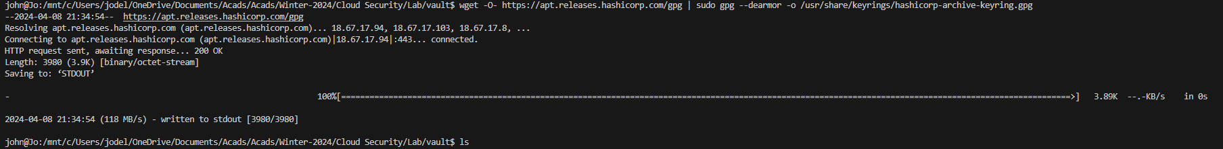

3. Verify the keyring.

gpg --no-default-keyring --keyring /usr/share/keyrings/hashicorp-archive-keyring.gpg –fingerprint

4. Add the HashiCorp repository.

echo "deb [arch=$(dpkg --print-architecture) signed-by=/usr/share/keyrings/hashicorp-archive-keyring.gpg] https://apt.releases.hashicorp.com $(lsb_release -cs) main" | sudo tee /etc/apt/sources.list.d/hashicorp.list



5. Install Vault.

sudo apt update && sudo apt install vault

6. Verifying the Installation

vault

7. Start Vault: This is used to start the Vault server.

vault server -dev -dev-listen-address="0.0.0.0:8200"

8. Enable kv Secret Engine and Create Vault

vault secrets enable -path=secret kv

9. Enable AppRole Authentication

vault auth enable approle

10. Create a Policy

vault policy write terraform - <<EOF

path "secret/data/*" {

capabilities = ["create", "read", "update", "delete", "list"]

}

EOF

11. Create an AppRole

vault write auth/approle/role/terraform \

secret_id_ttl=10m \

token_num_uses=10 \

token_ttl=20m \

token_max_ttl=30m \

secret_id_num_uses=40 \

token_policies=terraform

12. Generate Role ID

vault read auth/approle/role/terraform/role-id



13. Generate Secret ID

vault write -f auth/approle/role/terraform/secret-id

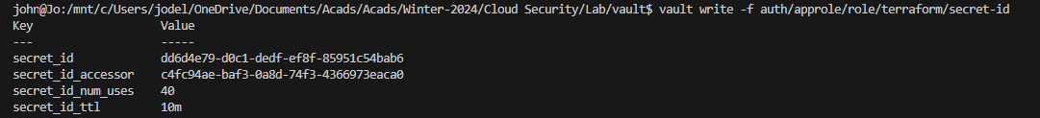

14. Terraform Configuration files:  
main.tf

Vars.tf

15. terraform init

16. terraform apply

17. terraform state list | nl

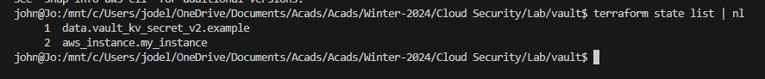

AWS Console Management:

