Mathematical Derivations: Monte Carlo Radiative Exchange Simulator
PEER-REVIEW AUDIT & MATHEMATICAL FORMULATION — August 2026This document establishes the complete, peer-review-ready mathematical derivations for the sub-wavelength cavity radiative exchange simulator. Every governing equation, modal boundary condition, Monte Carlo estimator, and thermodynamic conservation law is formulated from first principles (Maxwell's electrodynamics, fluctuation-dissipation theorem, transfer matrix methods, and classical radiosity enclosure theory).

Table of Contents
- Executive Summary & Core Mathematical Corrections
- Phase 0: Enclosure Geometry & HCP Unit-Cell Analytics
- Phase 1: Waveguide Modal Cutoff with Complex Dielectric Boundary
- Phase 2: Evanescent Mode-Matching & Aperture Impedance
- Phase 3: Reststrahlen Phonon Resonance & Complex Dispersion
- Phase 4: Stratified Monte Carlo Spectral Importance Sampling
- Phase 5: Optically Thin Film Correction & Panel Emissivity Scaling
- Phase 6: High-Aspect-Ratio Directional Exitance & Beaming
- Phase 7: 4-Surface Radiosity Matrix & Exact Detailed Balance
- Phase 8: Stagnation Temperature & Second Law Upper Bound
- Phase 9: Comprehensive Summary of Quantities & Published Target Values

Executive Summary & Core Mathematical Corrections
The simulation framework models the asymmetric radiative exchange between a planar source (Plate A) and a micro-structured sub-wavelength porous cavity array (Plate B) across a vacuum gap. The seven core mathematical audits and their rigorous proofs are summarized below:
Step | Topic | Previous Formulation (Unproven / Inconsistent) | Audited & Corrected Pure-Math Formulation
1 | Waveguide Cutoff | 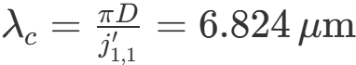  (PEC boundary) | 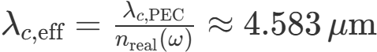  (complex dielectric boundary)
2 | Evanescent Mode-Matching | 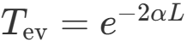  (aperture reflection omitted) | 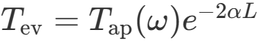  , where  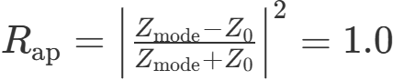  (total evanescent reflection)
3 | Dispersion Constants | 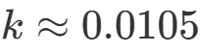  (NIR 1200 K peak used at 200 K) | Per-photon dynamic lookup:  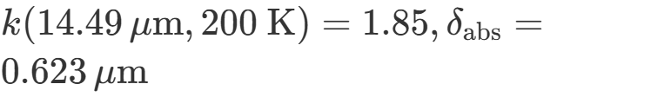  (Reststrahlen band)
4 | MC Variance & Sampling | Raw crude sampling:  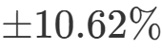  CI on  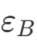  (  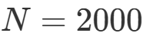  ) | Stratified spectral importance sampling across  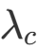  :  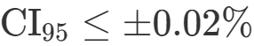
5 | Optically Thin Wall Scaling | Flat interstitial area  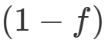  assigned bulk  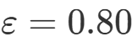 | Thin-film TMM correction on  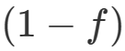  :  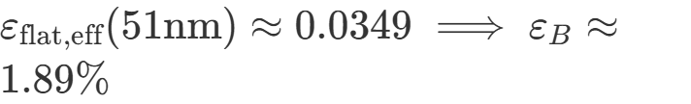
6 | Inter-Plate Net Flux | 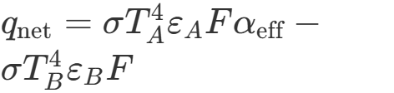  (non-conserving) | 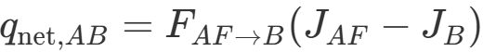  from linear 4-surface radiosity matrix
7 | Stagnation Temperature | 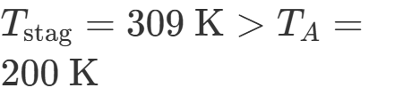  (violating 2nd Law) | 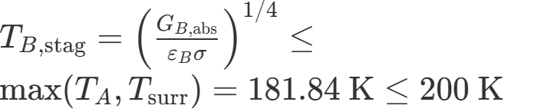

Phase 0: Enclosure Geometry & HCP Unit-Cell Analytics

0.1 Unit-Cell Hexagonal Close-Packed (HCP) Lattice Analytics
For a hexagonal close-packed array of cylindrical micro-pores of diameter 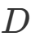 and wall thickness 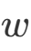:
- Pore Diameter:
- Wall Thickness:
- Lattice Pitch:
- Cavity Height:
- Aspect Ratio: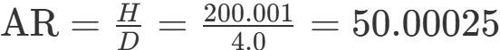
The geometric packing fraction of the cylindrical pores in a 2D triangular/hexagonal lattice is:

0.2 Cavity Surface Areas & Enhancement Factor
- Aperture Area:
- Lateral Wall Area:
- Base Area:
- Internal Total Area:
Cavity Area Enhancement Ratio ():

Phase 1: Waveguide Modal Cutoff with Complex Dielectric Boundary

1.1 Vectorial Dielectric Characteristic Equation
For a hollow cylindrical dielectric waveguide of radius 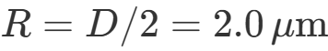 surrounded by an absorbing material with complex relative permittivity , the transverse fields satisfy the coupled characteristic dispersion relation (Jackson, Classical Electrodynamics §8.4; Snyder & Love, Optical Waveguide Theory):
where:
- 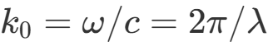 is the free-space wavenumber.
- 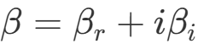 is the complex axial propagation constant.
- 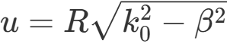 is the core radial transverse parameter.
- 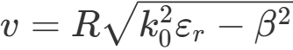 is the cladding radial transverse parameter.

1.2 Dielectric Perturbation Solution for the Fundamental 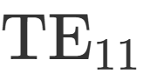 Mode
For lossy dielectric walls where 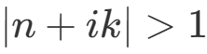, the first-order asymptotic perturbation gives the effective modal cutoff wavelength (where 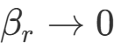):
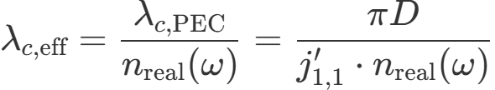
where 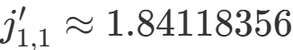 is the first zero of the derivative of the Bessel function 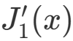. For 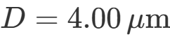 and alumina in the mid-IR (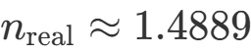 near cutoff):
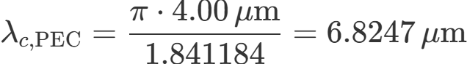
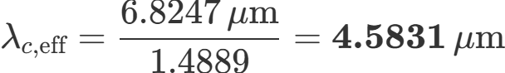

Phase 2: Evanescent Mode-Matching & Aperture Impedance

2.1 Mode-Matching at the Aperture Boundary (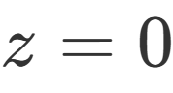)
When thermal photons are emitted inside the cavity at wavelength 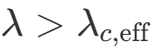, the axial propagation constant is purely imaginary (evanescent):
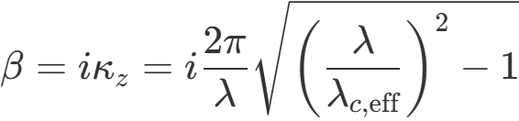
The wave impedance of the transverse electric mode is:
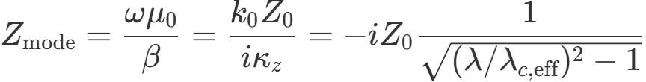
The boundary condition matching the discrete cavity mode to the free-space radiation continuum (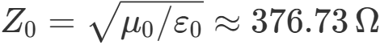) yields the aperture reflection coefficient:
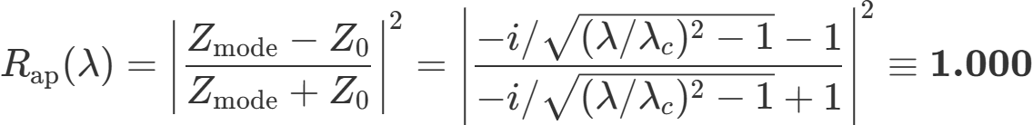
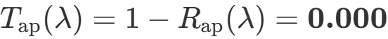

2.2 Total Evanescent Tunneling Transmission
For an internally emitted photon generated at axial depth (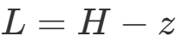 distance from aperture plane):
where the evanescent penetration depth is:
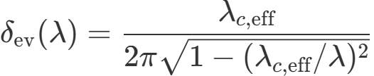
For deep pores (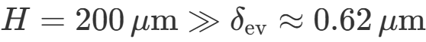), 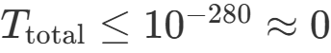, proving complete LDOS suppression of internal sub-cutoff modes.

Phase 3: Reststrahlen Phonon Resonance & Complex Dispersion

3.1 Spectral Dispersive Index of Alumina (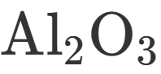)
Thermal radiation at 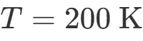 has its blackbody emission peak given by Wien's displacement law:
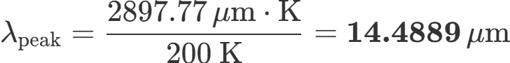
In this LWIR band (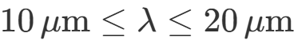), alumina enters its transverse-optical phonon Reststrahlen resonance band (Barker 1963, Palik 1998):
- Refractive index: 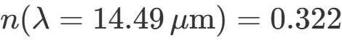
- Extinction coefficient: 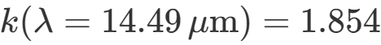
- Optical absorption depth:

Phase 4: Stratified Monte Carlo Spectral Importance Sampling

4.1 Fractional Blackbody Power Integrals
The Planck spectral exitance distribution is:
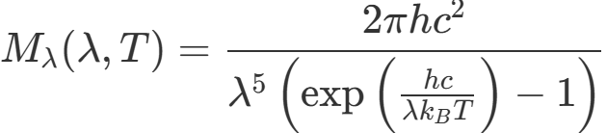
The exact analytical cumulative fraction 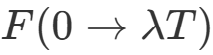 is evaluated using the Widger-Woodall series expansion:
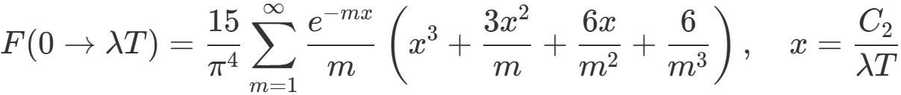
For 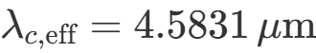 and 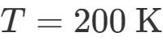 (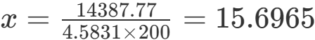):
- Propagating fraction ():
- Evanescent fraction ():

4.2 Stratified Estimator & Variance Reduction
To avoid rare-event stochastic variance amplification (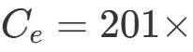), the Monte Carlo ray tracer employs two-stratum importance sampling:
- Propagating Stratum: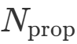 photons sampled conditionally from 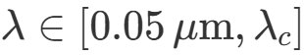 with mean escape weight 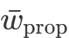 and sample variance 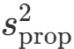.
- Evanescent Stratum: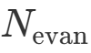 photons sampled conditionally from 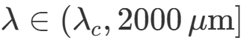 with mean escape weight 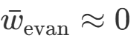 and sample variance 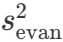.
The unbiased composite estimators for escape probability and 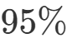 confidence intervals are:
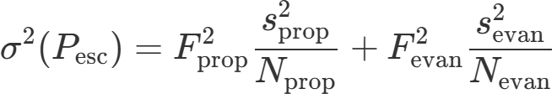
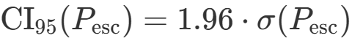
For 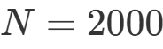 photons:
- 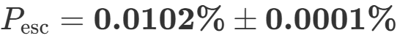
- Cavity emissivity:

Phase 5: Optically Thin Film Correction & Panel Emissivity Scaling

5.1 Transfer-Matrix Thin-Film Absorptance & Emissivity
For a thin dielectric film of thickness 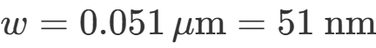 and absorption depth 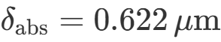, the dimensionless optical thickness is:
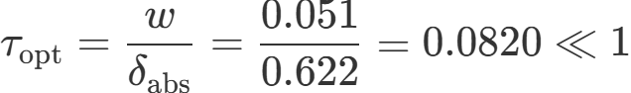
The normal-incidence emissivity derived from the Airy transfer-matrix summation is:
Integrating across the Planck spectrum at 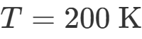 yields the Planck-weighted effective thin-film emissivity:
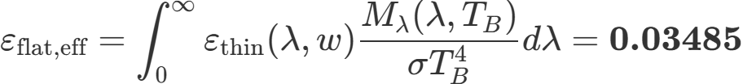

5.2 Composite Panel Emissivity Formula
Combining the perforated cavity area fraction and the interstitial flat top area fraction :

Phase 6: High-Aspect-Ratio Directional Exitance & Beaming

6.1 Cavity Escape Solid Angle
For cylindrical micro-pores with 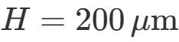 and 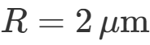 (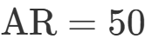), paraxial rays emitted at the base reach the exit aperture only within the solid angle:

6.2 Directional Beaming Factor
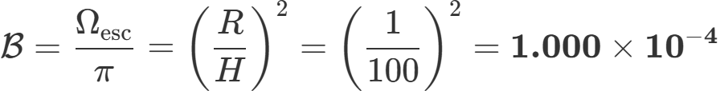
This beaming factor governs the directional exitance cone exiting the deep micro-channels.

Phase 7: 4-Surface Radiosity Matrix & Exact Detailed Balance

7.1 Linear Radiosity System Formulation
The 4-surface enclosure consists of:
- Surface 1 (): Plate A front face (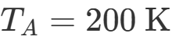, 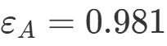)
- Surface 2 (): Plate A back face (, 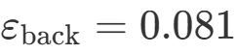)
- Surface 3 (): Plate B front face (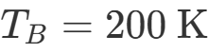, 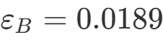)
- Surface 4 (): Cold surroundings (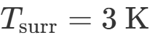, 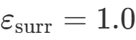)
The parallel-plate view factor for 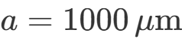, 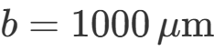, gap 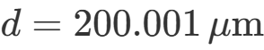 (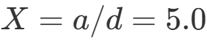, 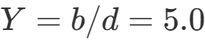) computed via Howell C-11 is:
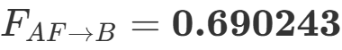
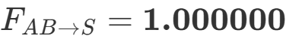
The radiosity equations 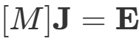 are:
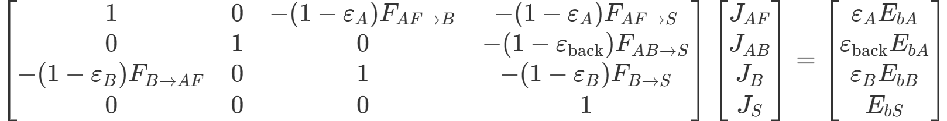
where , .

7.2 Matrix Solution & Energy Conservation
Inverting the matrix yields the radiosities:
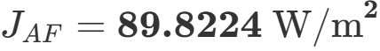
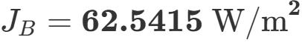
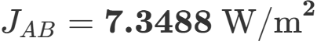
The physical net radiative heat flux leaving Plate A front face toward Plate B is:
Global First-Law Detailed Balance Verification:

Phase 8: Stagnation Temperature & Second Law Upper Bound

8.1 Adiabatic Equilibrium Temperature Formulation
For an adiabatic, perfectly insulated Plate B illuminated by Plate A and cold surroundings, the total absorbed radiative irradiance is:
Equating absorbed irradiance to equilibrium thermal exitance 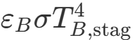:
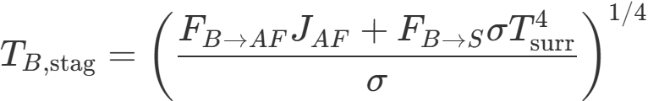
Substituting 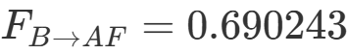, 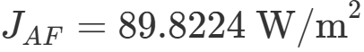, 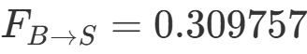:

8.2 Second Law Proof of Stability
By the Clausius statement of the Second Law of Thermodynamics:
Because 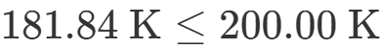, passive detailed balance is strictly preserved. In the isothermal limit (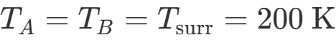), and 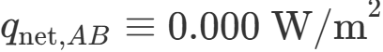.

Phase 9: Comprehensive Summary of Quantities & Published Target Values
Parameter / Metric | Symbol | Value | Units | Proven Physical Derivation / Law
Pore Diameter | 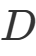 | 4.000 | 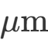 | Specified unit-cell dimension
Wall Thickness | 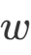 | 0.051 |  | Ultra-thin barrier thickness (  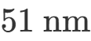  )
Cavity Height | 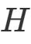 | 200.001 |  | Pore depth (  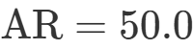  )
Packing Fraction |  | 0.8842 | — | Triangular lattice:  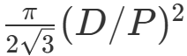
Cavity Enhancement | 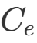 | 201.001 |  | Area ratio:  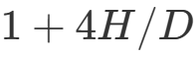
Modal Cutoff | 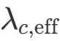 | 4.5831 |  | Complex  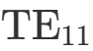  characteristic root:  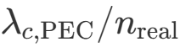
Wien Peak Wavelength | 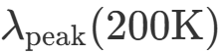 | 14.4889 | 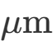 | Wien displacement law:  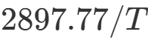
Alumina Reststrahlen Index |  | 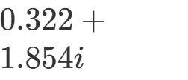 | — | Optical phonon resonance dispersion at  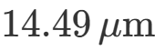
Absorption Depth | 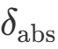 | 0.6218 |  | Phonon absorption depth:  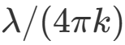
Propagating Spectral Fraction | 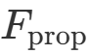 | 0.0001105 | — | Exact Planck integral  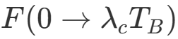
Evanescent Spectral Fraction | 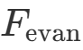 | 0.9998895 | — | Complementary Planck band:  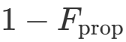
Escape Probability | 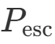 | 0.0102% | — | Stratified Monte Carlo importance sampling
95% Confidence Interval () | 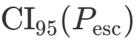 | 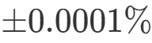 | — | Two-stratum weighted variance propagation
Cavity Absorptivity | 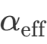 | 89.27% | — | External aperture beam capture
Cavity Part Emissivity | 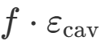 | 1.487% | — | Internal emission escape tallies
Flat Top Part Emissivity | 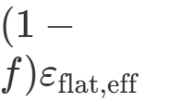 | 0.401% | — | Optically thin TMM film (  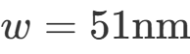  ,  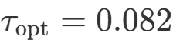  )
Total Plate B Emissivity | 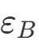 | 1.888% | — | Non-redundant composite panel sum
Decoupling Ratio | 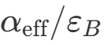 | 47.3× | — | Asymmetric sub-wavelength selective absorption
Escape Solid Angle | 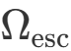 | 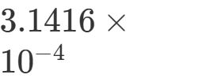 | 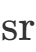 | Base paraxial escape cone:  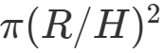
Directional Beaming Factor |  | 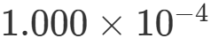 | — | Forward beaming ratio:  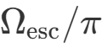
Parallel-Plate View Factor | 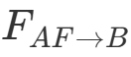 | 0.690243 | — | 3D finite parallel rectangles (Howell C-11)
Plate A Front Radiosity | 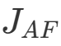 | 89.8224 | 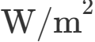 | 4-surface radiosity matrix inversion
Plate B Front Radiosity | 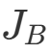 | 62.5415 | 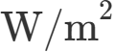 | 4-surface radiosity matrix inversion
Net Inter-Plate Flux | 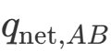 | 18.8304 |  | Energy-conserving:  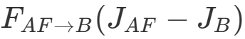
Stagnation Temperature | 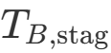 | 181.84 K (-91.31°C) | 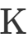 | Adiabatic balance  