Water, Earth, Fire, Air
Master All Four Elements

Team 21
Revision | Description
A1 | 9.14.2014 Started the Document, Edited Properties – Laura Owczarski
A2 | 9.14.2014 Updated Scope, Abbreviations, Test Procedures, Block Diagrams –Laura Owczarski
A3 | 9.14.2014 Added diagrams – Ken Ackerman
A4 | 9.14.2014 Updated Test Procedures – Mahdi Inaya
A5 | 9.14.2014 Added diagrams, Updated hardware block descriptions, proofreading – Joseph Jarriel
B1 | 10.15.2014 Fixes based on comments, updated Section 3 to include motors block –Laura Owczarski
B2 | 10.15.2014 Added pictures, hardware notes, and testing notes – Joseph Jarriel
B3 | 10.15.2014 Updated diagrams, added software notes – Ken Ackerman
B4 | 10.15.2014 Added Motors Block section and Motor diagrams – Mahdi Inaya
B5 | 10.16.2014 Fixed formatting – Ken Ackerman / Mahdi Inaya
C1 | 10.26.2014 Added Release Date, LCD acronym, code flow charts – Laura Owczarski
C2 | 10.26.2014 Emitters & Detectors Block and Verification, Thumb Wheel Block, Figures – Mahdi Inaya
C3 | 10.26.2014 Flowchart and Software added – Ken Ackerman
C4 | 10.26.2014 Flowcharts and Software added – Joseph Jarriel
C5 | 11.13.2014 Added content to Software Section – Laura Owczarski
C6 | 11.14.2014 Added content to Overview and Hardware Sections – Mahdi Inaya
C7 | 11.14.2014 Fixed Flowcharts – Ken Ackerman
D1 | 11.14.2014 Added content to Testing and Software – Laura Owczarski
D2 | 11.14.2014 Added content to Overview and Hardware Sections – Mahdi Inaya
D3 | 11.14.2014 Added Flowcharts for Serial.c and Edited flowcart for main.c – Ken Ackerman
E1 | 11.28.2014 Added GPS block diagrams and hardware description – Laura Owczarski
E2 | 12.1.2014 Added Testing and Software sections for GPS and black line course –Laura Owczarski
E3 | 12.3.2014 Adding power analysis – Mahdi Inaya
E4 | 12.3.2014 Added flowcharts and software – Ken Ackerman
E5 | 12.4.2014 Added conclusion –Laura Owczarski

Table of Contents
1. Scope 4
2. Abbreviations 4
3. Overview 4
3.1. User Interface Block 5
3.2. Power System Block 5
3.3. Processer Block 5
3.4. Control Board Block 6
3.5. Motors Block 6
3.6. IR Emitter and Detectors Block 6
3.7. Serial Communications Block 7
3.8. GPS Block 7
4. Hardware 7
4.1. User Interface Block 7
4.1.1 LEDs 7
4.1.2 LCD 8
4.1.3 Switches 8
4.1.4 Thumb Wheel (Potentiometer) Block 9
4.2. Power System Block 9
4.2.1 Power Supply 9
4.2.2 Power Switch 9
4.2.3 Buck Boost Converter 9
4.3. Processor Block 10
4.4. Control Board Block 10
4.5. Motors Block 11
4.6. IR Emitter and Detectors Block 12
4.7. Serial Communications Block 14
4.8. GPS Block 14
5. Power Analysis 15
6. Test Process 15
6.1. Power System Verification 15
6.2. LCD Verification 15
6.3. Motor Verification 15
6.4. IR Emitter and Detector Verification 16
6.5. Serial Communication Verification 16
6.6. GPS Verification 16
6.7. Black Line Course Verification 16
7. Software 16
8. Flow Chart 18
8.1. main.c Blocks 18
8.2. interrupt.c Blocks 19
8.2.1 Timer0_A0_ISR() 19
8.2.2 switch_interrupt() 20
8.2.3 ADC10_ISR() 21
8.3. Ports.c 21
8.3.1 Init_Ports() 21
8.4. Drive.c 22
9. Software Listing 24
9.1. main.c 24
9.2. interrupts.c 28
9.3. ports.c 40
9.4. init.c 58
9.5. drive.c 59
10. Conclusion 64

Table of Figures

Figure 1: System Block diagram 4
Figure 2: User Interface Block 5
Figure 3: Power System Block 5
Figure 4: Processor Block 5
Figure 5: Control Board Block 6
Figure 6: Motors Block 6
Figure 7: IR Emitter and Detectors Block 6
Figure 8: Serial Communications – Receive, Ground, Transmit Pins 7
Figure 9: GPS Block 7
Figure 10: LED Nets 7
Figure 11: LCD 8
Figure 12: Switches 8
Figure 13: Thumb Wheel (Potentiometer) 9
Figure 14: Buck Boost Converter Diagram 9
Figure 15: MSP-EXP430FR5739 10
Figure 16: Power System Interface 10
Figure 17: Right Motor H-Bridge 11
Figure 18: Left Motor H-Bridge 11
Figure 19: Motor Schematic 12
Figure 20: Right Detector 12
Figure 21: Left Detector 13
Figure 22: Emitter 13
Figure 23: Serial Communications six pin header 14
Figure 24: GPS connector and U3 14
Figure 25: Power Analysis 15

Scope
This document describes the systems, hardware, software and test procedures used to create a robotic vehicle that can be programmed to follow a path either by using a sensor or GPS coordinates.
As of Project #1 we have put together the power system and soldered the connecting pins to attach the control board to the MSP-EXP430FR5739 experimenter board.

Abbreviations
Abbreviation Definition
FRAM Ferroelectric Random-Access Memory
LED Light Emitting Diode
MSP-EXP430FR5739 The model number of the TI Experimenter board used
GPS Global Positioning System
LCD Liquid Crystal Display
IR Infrared

Overview
The system currently consists of a control board hooked up to a processor and a power system. The system also has a simple user interface. The power system, processor and the control board all contribute to the control of the motors.
User Interface

Processor

Power System

Control Board

Motors

Emitters/ Detectors

Serial Communication
GPS

Figure 1: System Block diagram

User Interface Block
The user interface block contains the LED lights that light up in response to code being run on the processor. These LEDs serve to give information to the user about what is happening in the system. We have also installed an LCD screen onto our control board that will be written to using our processor to indicate possible actions and actions being performed. The FRAM board also includes two switches connected to Port 4 which can be used to take manual user input.
User Interface
LEDs

LCD

Switches

Figure 2: User Interface Block

Power System Block
The power system block contains a power supply, a switch to turn the system on, and a buck boost converter circuit to regulate the voltage. The power system is allowing our system to run on battery power. (4AA Batteries.)
Power System
Power Supply

Power Switch

Buck Boost Converter

Figure 3: Power System Block

Processer Block
The processor block contains the FRAM processor board. The FRAM board is constructed by Texas Instruments MSP430FR5739 board uses a 16 bit RISC architecture microcontroller. This device can support up to 24Mhz clock rate when supplied a voltage between 2V to 3.6V.
Processor
FRAM board

Figure 4: Processor Block

Control Board Block
The control board block contains the circuitry interfacing the MSP-EXP430 with the power system, the LCD, and the H-bridge for motor control.
Figure 5: Control Board Block
Control Board

Power System
Interface

Motor H Bridge

LCD Interface

Motors Block
The motors block contains the left and right motors that can each go forward or reverse, as well as the full H-Bridge which allows the car to be made to go forward or reverse.

Motors

Left Motor

H - Bridge

Right Motor

Figure 6: Motors Block

IR Emitter and Detectors Block
The IR Emitter and Detectors allows us to navigate through terrain while following a black line. This values read from the detectors are analog values. The FRAM board includes an ADC converter to allow the reading to be digitally monitored.
IR

Left Detector

Emitter

Right Detector

Figure 7: IR Emitter and Detectors Block

Serial Communications Block
The Control Board includes 2-3 pin headers that allows transmitting and receiving information. The FRAM board includes transmit and receive buffers to allow communication. The transmit and receive buffers only hold 8 bits at a time. The transmit and receive buffers can be read synchronously through polling or asynchronously through interrupts.
Serial Communications

Receive

Ground

Transmit

Figure 8: Serial Communications – Receive, Ground, Transmit Pins

GPS Block
The GPS block includes the GPS itself, which is attached to the control board with a connecting cable that connects to the J11 connector. U3 is a level shifter that allows the 1.8V GPS outputs to be translated into 3.3V inputs for the processor.
GPS System

J11 connector and cable

GPS

U3
level shifter

Figure 9: GPS Block

Hardware

User Interface Block

LEDs
The LEDs are connected to the nets of Port Pins J.0 (GPS PWR), J.1 (GPS_RESET), J.2 (GPS_PWRCNTL), J.3 (GPS_PWRCHK), 3.4 (R_FORWARD), 3.5 (R_REVERSE), 3.6 (L_FORWARD) and 3.7 (L_REVERSE). When any of these signals are on the LEDs will turn on as well.
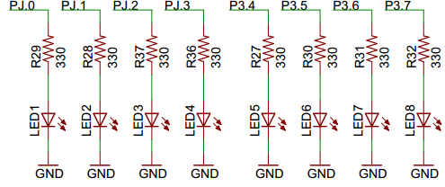
Figure 10: LED Nets

LCD
We are using an EA DOGM162 LCD. We have two lines of text to display our current operation conditions or expose options to the user. The LCD is able to display 2 separate lines of text with 16 character spaces for each line. The LCD only displays ASCII characters. The LCD is written to by software LCD commands.
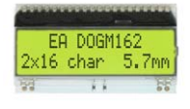
Figure 11: LCD

Switches
Our experimenter’s board includes two switches attached to Port 4 Pins 1 and 2. We can manually observe the voltage at these pins when configured for GPIO, or assign interrupt service routines to handle switch events. These switches metallic clicker switches create vibrations when pressed. This phenomenon must be adapted to through software manipulations.

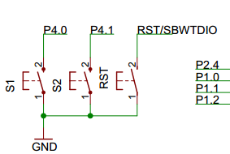
Figure 12: Switches

Thumb Wheel (Potentiometer) Block
The 20kΩ thumb wheel is included in our circuit to allow a new method of cycling through our menu.
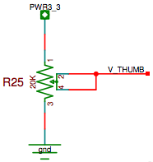

Figure 13: Thumb Wheel (Potentiometer)

Power System Block

Power Supply
Power Supply will come from either 4 AA batteries connected in parallel or through the Microcontroller’s USB input.

Power Switch
The control board/buck boost assembly will have a switch that toggles power from the AA batteries on and off. This switch will have no effect on the supplied USB power.

Buck Boost Converter
We will keep the power supplied from our 4 AA batteries at the preferred 3.3V by using a Buck-Boost converter to step the voltage provided up or down as needed. The schematic for the buck-boost converter is shown below.

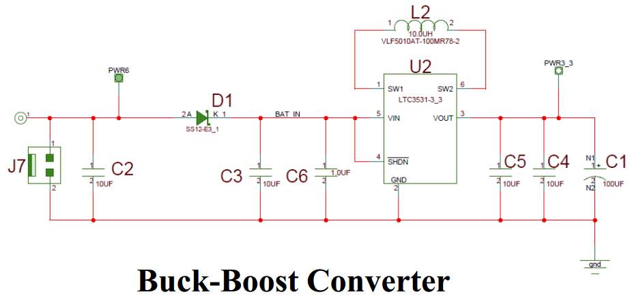
Figure 14: Buck Boost Converter Diagram

Processor Block
MSP-EXP430FR5739 processor

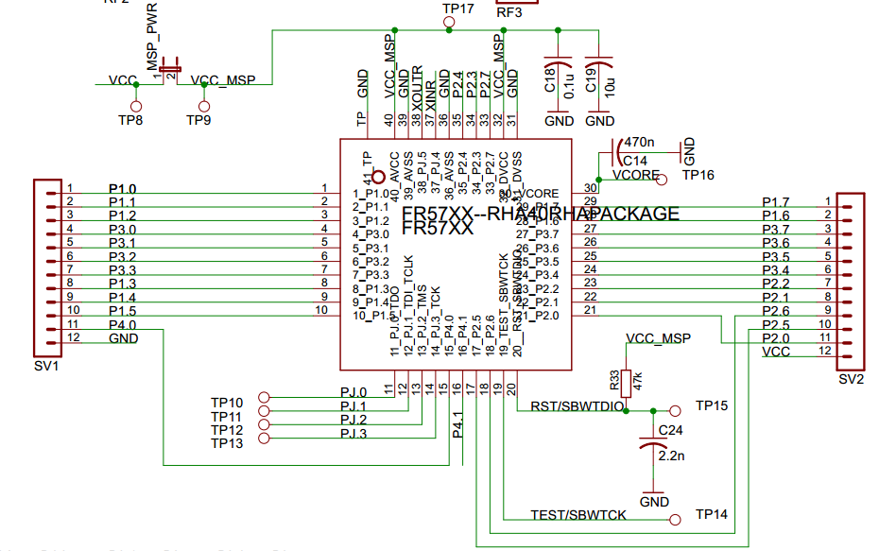
Figure 15: MSP-EXP430FR5739

Control Board Block
The control board includes the interface circuitry between the power system, the motor control H-bridge, the LCD screen, and the processor.
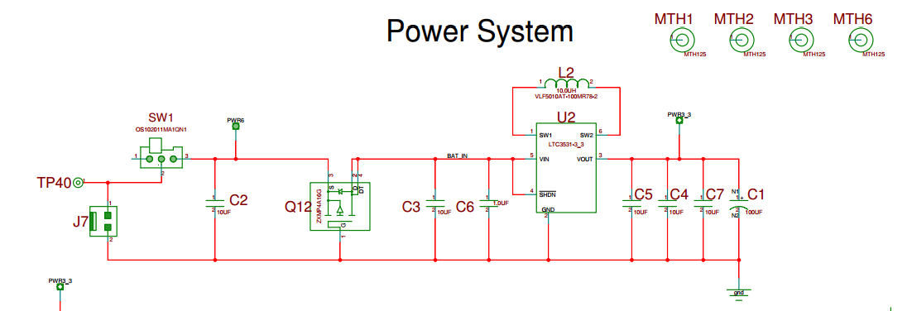
Figure 16: Power System Interface

Motors Block
The H-Bridges are the used to control the motors.
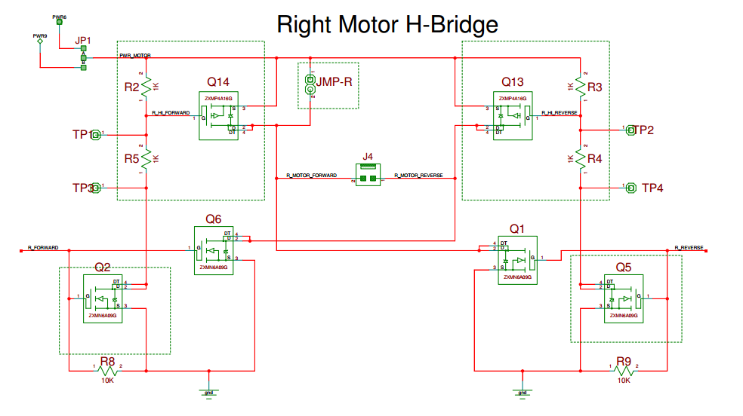
Figure 17: Right Motor H-Bridge

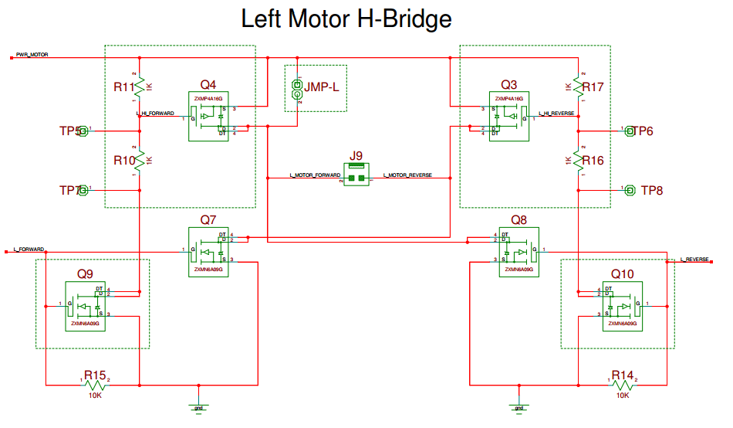
Figure 18: Left Motor H-Bridge
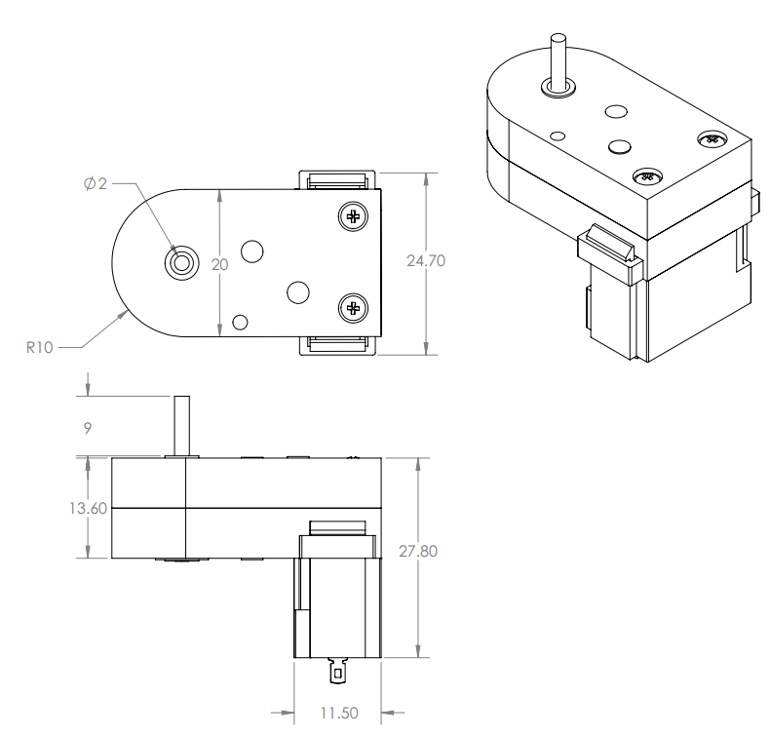
Figure 19: Motor Schematic

IR Emitter and Detectors Block
These circuits, along with the proper software algorithms, allow our cars to detect and follow a black line. One IR emitter and two IR detectors were used.

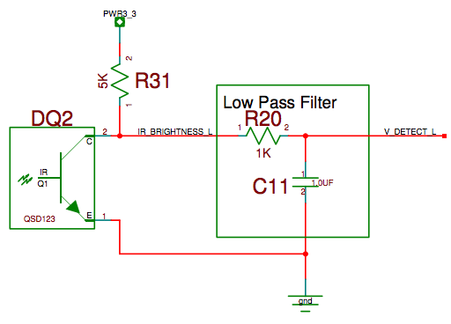
Figure 20: Right Detector
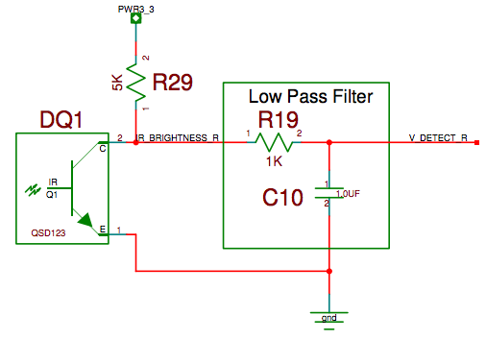
Figure 21: Left Detector


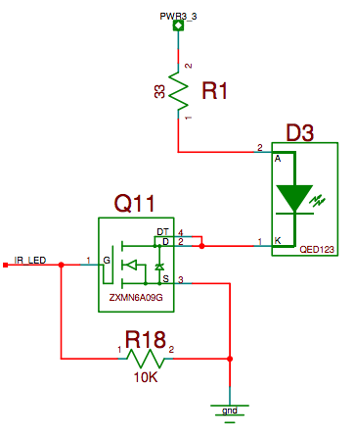
Figure 22: Emitter

Serial Communications Block
A six-pin header is soldered onto the board in order to activate the transmit and receive serial communication functions. The receiving pin is the circle and the transmitting pin is the square. While the middle pin is the ground pins. The system sends and receives 8 bits at a time. (LSB first (default)).
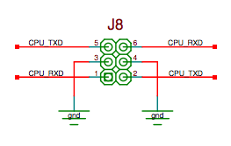
Figure 23: Serial Communications six pin header

GPS Block
The GPS connector J11 is soldered to the control board so that the GPS can communicate with the processor. The GPS is connected to J11 using a ribbon cable. The GPS signals are transmitted to the processor at 1.8V, so they need to be translated to 3.3V signals using the U3 level shifter, which is a NLSX4373 from ON Semiconductor.
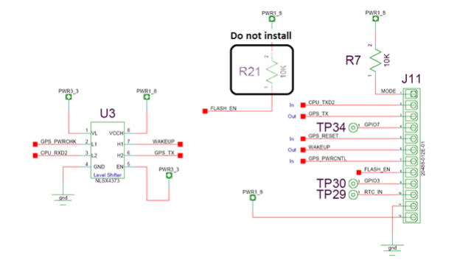
Figure 24: GPS connector and U3

Power Analysis
The system uses 4AA batteries that are connected in series. The batteries provide 6 volts to the system but all 6 volts are not needed. Our system requires only 3.3 volts. The ample voltage is regulated by the buck boost converter. We have assumed that our Buck-Boost Converter is 91% efficient. In Figure 25, we have calculated the estimates of our systems power analysis. We have assumed that the car will be used 30 minutes per day. We have also shown the effect on amount of days depending on which parts of the car are being used. For example, the FRAM board will be used many less days if the system is consistently using the Motors than if the system is only using the FRAM Experiment Board.
Configuration | Current (A) | Max Operation (Days)
FRAM Experiment Board | 0.051 | 116
FRAM Board with Detectors | 0.074 | 50
FRAM Board with Motors | 0.270 | 18
Figure 25: Power Analysis

Test Process
The testing for this product was done in stages with each of the deliverable dates for sections of the project. They are as follows:

Power System Verification
The power system was tested during assembly and after the system was constructed completely. Soldering of each component was checked visually under a magnifying glass for cold solder joints. The switch was tested with a multimeter for continuity when the switch was flipped to the “on” position.
The buck boost converter circuit U2 was tested after installation with a multimeter for shorts, and it was verified that only pins 4 and 5 were shorted together. The 3.3V circuit was tested with a voltmeter and the battery pack connected. When the switch was flipped to the “on” position it was verified that the 3.3V circuit was immediately producing a voltage difference of approximately 3.3V between the test pads for the circuit.
The 1.8V circuit was tested with a voltmeter and the battery pack connected. When the switch was flipped to the “on” position it was verified that the 1.8V circuit was immediately producing a voltage difference of approximately 1.8V between the test pads for the circuit.
Once the connecting pins were installed the voltages were tested again and verified to be the same as before, and then the FRAM board was connected to the control board. The battery pack was connected and the switch was flipped to the “on” position, and it was verified that the LED lights lit up the same way they did when the homework 1 code was loaded into the FRAM board initially.

LCD Verification
The LCD is already configured to run with timerB0 by a precompiled object file provided to us. At assembly, the LCD’s solder points were all carefully visually inspected before the display was tested.
After installation, the LCD was tested using its provided library function calls to ensure that it can write and erase both lines, as well as toggle its backlight on and off. Using the preconfigured timerB0 helped ensure that we satisfied the LCD’s timer requirements as well.

Motor Verification
The H-bridge for motor control was tested incrementally with a multimeter during installation. The FRAM board’s output LEDs also helped us verify that the correct signals were being delivered.
After installation, we test both the H-bridge and motors by ensuring that the signals R_FORWARD, L_FORWARD, R_REVERSE, and L_REVERSE produce the corresponding actions in the car’s assembled motors.

IR Emitter and Detector Verification
After following the necessary installation steps, the IR Emitter was tested by using a camera phone that does not have an IR filter. While the emitter only provides a dim light, it is still noticeable through the use of the camera phone. To test if the detectors were working properly, we used our IAR watch windows; specifically we used the Left_Detect and Right_Detect variables. We saw that if the Detectors were not connected correctly, that regardless of a black line being present, the readings stayed at a high value of 1024, which is the highest possible reading from the given ten bit ADC. When the detectors were connected and working correctly, if a detector was near a black line that our detect values showed to be high and if there was no black line near by that we read values that were closer to zero. Placement of our detectors showed to be an important validation factor for our system. Using black straws to cover our detectors helped in providing more consistent values, as well.

Serial Communication Verification
After installing the 6 pin header J8 and setting the baud rate to 4800 in the code, the baud rate was tested with an oscilloscope. The amount of time to transmit 10 symbols was measured on the oscilloscope, and then divided by 10. One divided by that value is the baud rate. It was verified that the baud rate was 4800, and if it was off by a significant amount, some changes in the code were required.

GPS Verification
It was important to make sure that the baud rate was 4800 so the processor could properly receive GPS transmissions, so that was retested to make sure it was exactly 4800 using the same test as in section 6.5. The GPS was also tested to see if it was transmitting properly and receiving signals by looking in the code debug menu at the receive buffer to make sure that it was being filled with transmissions.

Black Line Course Verification
The test process for the black line course involved further testing of the IR emitters and detectors as in section 6.4. The black line course itself was tested by allowing the car to run the course, verifying it followed the line correctly and measuring the amount of time it took before it would need to turn around. This testing involved a lot of runs and adjustment of the code to account for variations in the detectors and the motors.

Software
Currently the car is running a “while loop operating system.” The main thread begins by running through the initialization sequence and then continues into an infinite while loop that holds the main thread in anticipation of different system interrupts. When an interrupt occurs the main thread is paused and the interrupt thread begins. This interrupt thread runs through the appropriate interrupt service routine. These interrupt service routines update variables that are used to inform the while loop operating system that the interrupts have occurred the necessary actions must be taken. After the interrupt service routine has completed the main thread returns where it was paused and continues running.
The initialization sequence in main includes initializing the ports, clocks, timers, LCD, and other initial conditions for the system. The ports are initialized as such: port 1 pins 0-2 control the IR emitters and detectors, pin 3 is used for the thumb wheel, and pins 4-7 control LCD functions. Port 2 pins are used for serial communication. Port 3 pins 0-2 control the x y and z axes for the accelerometer, pin 3 controls the LCD backlight, and pins 4-7 control the motors forward and reverse. Port 4 pins are used for the switches. Port J pins control the GPS.
While the main loop is running a few interrupts can occur. The first is a timer interrupt, which increments a timer counter every time it interrupts. A switch interrupt will occur if a switch is pressed, and a debounce event will trigger for that switch. While the ADC is sampling, every time the ADC converts a value an interrupt is triggered and the converted value is stored.
For Project 5, the car will wait until a switch is pressed. When the switch is pressed, the IR detectors are turned on and the ADC begins converting values from the detectors. When the switch is pressed again, the value of the ADC is stored as the ambient light value. Then when the switch is pressed again, the IR Emitter is turned on and the ADC begins converting values from the detectors again. A switch press stores this as the value of the emitter and detectors on white. A repeat of this process stores the value of the emitter and detectors on black. Then with another switch press the car will begin moving forward, and the detectors and emitters are turned on while the ADC converts values again. When the ADC value converted matches what the detectors were when on a black line, the car will reverse until it detects a black line again. During this time a timer variable increments to measure the length of time between the two black lines. Then when the black line is detected, the car moves forward for half of the time measured and stops. Then it spins clockwise and counterclockwise for a set amount of time.
For Project 6, when a switch is pressed on a car, the car displays a 1 on the LCD and begins transmitting that value to a partner’s car. When a transmission is received the program increments the received value, displays it on the LCD and transmits the new value. This will continue until the incremented value reaches 64535 after which it resets to 0. When a switch is pressed again it restarts by transmitting a 1 and displays it on the LCD. The baud rate for transmission and receiving is set to 4800.

For Project 7, the GPS is powered on and initialized on a timer so the initialization happens properly. When the GPS is initializing, the LCD displays the steps in the initialization process, and when it is done initializing the LCD displays that the GPS is initialized. Then the GPS is ready to receive information from the satellites. While the GPS waits for a valid satellite signal, the LCD displays ??? in place of where the latitude and longitude data would go. When a valid signal is received, the LCD displays the latitude and direction on the first line, and the longitude and direction on the second line. The GPS continually receives and transmits location data to the processor, and the LCD updates regularly to display the current location.

For Project 8, the car waits until a switch is pressed. Switch 1 will scroll through the menu options while switch 2 selects that option. The menu options are calibration of the detectors on white or on black, and then a drive option. When calibrating on white or black the left and right detectors take individual readings and are saved in the code. When the car is calibrated, drive should be selected. The car will begin following the black line and a timer will start, and when the timer counts to the set value for that car it will turn around and follow the line back the other direction. This timer is set so that the car makes one circuit of the track before turning around. The car follows the black line by detecting if the detector value on one side goes below a certain threshold for black, which it then knows is off the line. Then it corrects its trajectory by turning back towards the line and checking for it again. When it gets back to the line it resumes checking to see if it is going off the line.

Flow Chart

main.c Blocks

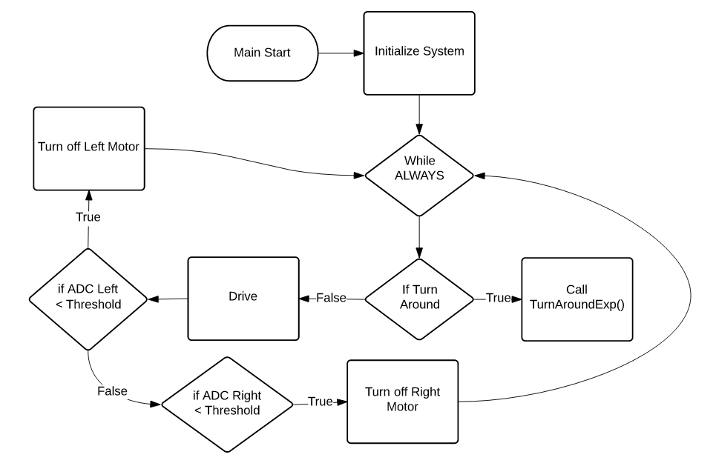

interrupt.c Blocks

Timer0_A0_ISR()
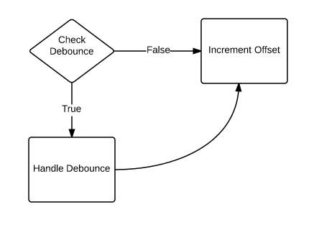

switch_interrupt()
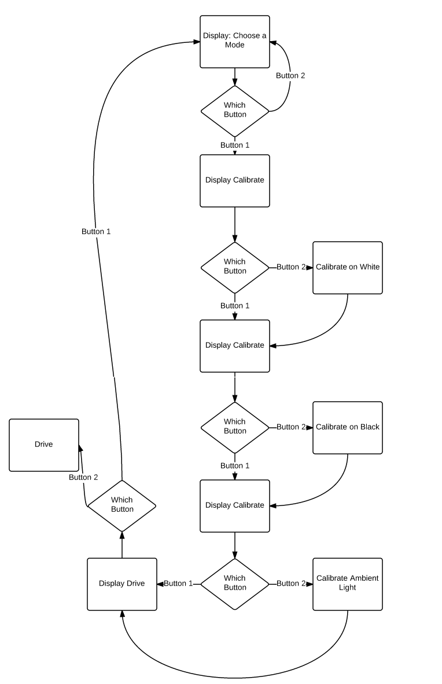

ADC10_ISR()
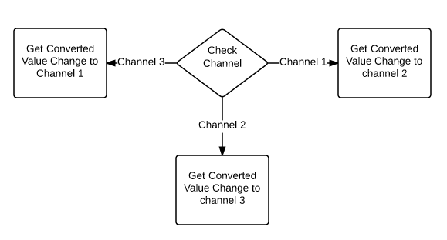

Ports.c

Init_Ports()
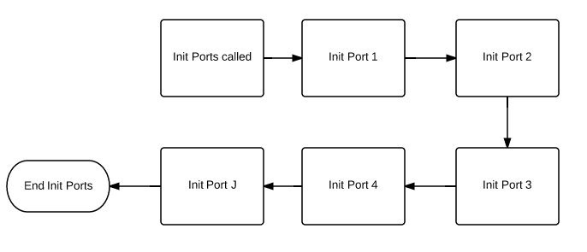

Drive.c
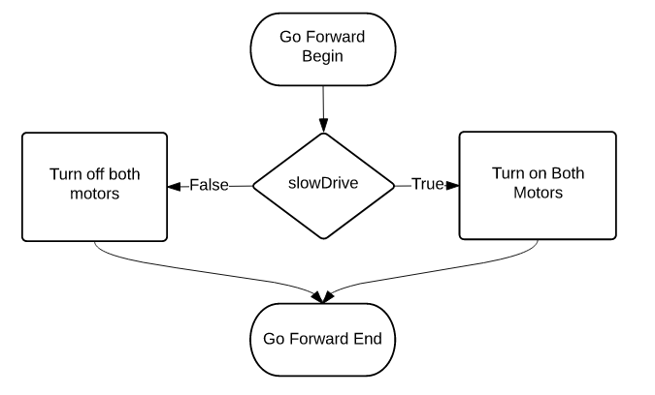

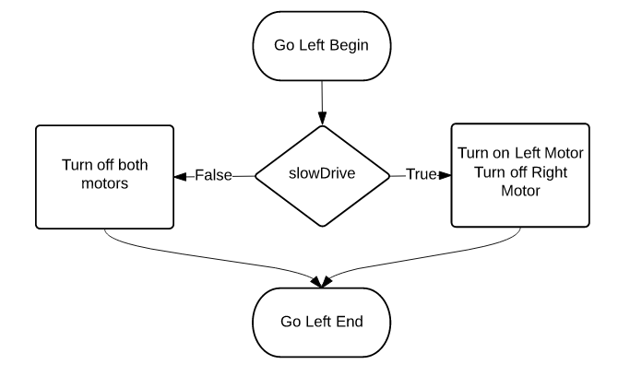

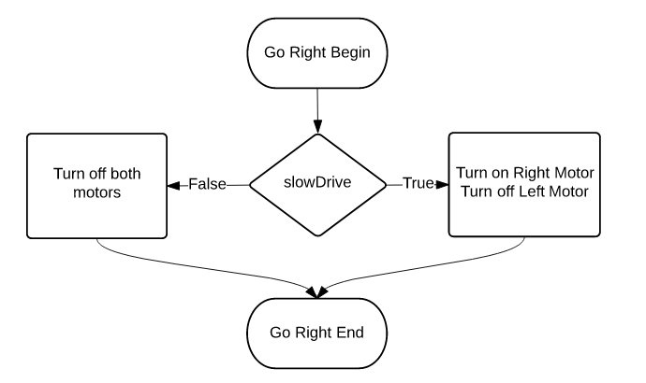
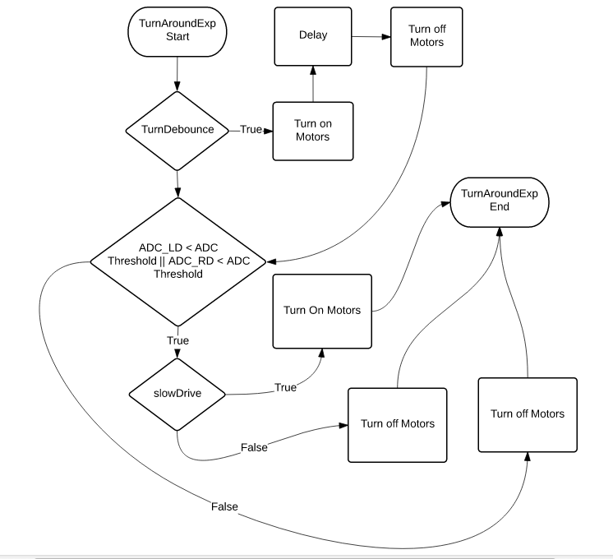

Software Listing

main.c
//===========================================================================
// File Name : main.c
//
// Description: The main, 'while' operating system
//
// Author: Joseph Jarriel
// Date: Sep 2014
// Compiler: Built with IAR Embedded Workbench (6.10.5)
// Globals: volatile unsigned int Time_Sequence, volatile char one_time,
// volatile unsigned int five_msec_count, char *display_NCSU, char *display_HW3
// Functions: main
//===========================================================================

#include "msp430.h"
#include "functions.h"
#include "macros.h"

volatile unsigned int Time_Sequence;
volatile char one_time;
volatile unsigned int five_msec_count;
volatile unsigned int startTimer = RESET;

volatile unsigned int goFor = RESET;

volatile unsigned int slowDrive = RESET;

unsigned int driving = RESET;
unsigned int reverse = RESET;
unsigned int startHalf = RESET;
unsigned int halfTimer = RESET;

char *display_NCSU;
char *display_HW3;

volatile char goingRight = RESET;
volatile char goingLeft = RESET;
volatile int waitCount = RESET;

void main(void){
//===========================================================================
// Function name: main
//
// Description: The main function. Our 'while' OS
//
// Passed : no variables passed
// Locals: no variables declared
// Returned: no values returned
// Globals: Time_Sequence, one_time, five_msec_count
// Calls: Init_Ports, Init_Clocks, Init_Conditions, Init_Timers, Init_LEDs,
// Init_LCD, five_msec_sleep, Switch_Process
//
// Author: Joseph Jarriel
// Date: Sep 2014
// Compiler: Built with IAR Embedded Workbench Version (6.10.5)
//===========================================================================
Init_Ports(); // Initialize Ports
Init_ADC();
Init_Clocks(); // Initialize Clock System
Init_Conditions();
PJOUT |= LED1; // Turn LED 1 on to indicate boot
Time_Sequence = RESET; //
Init_Timers(); // Initialize Timers
five_msec_sleep(SLEEP_50); // 250 msec delay for the clock to settle
Init_LCD(); // Initialize LCD
five_msec_sleep(SLEEP_75); // 375 msec delay for the clock to settle
Init_LEDs(); // Initialize LEDs
display_NCSU = " Callibrate ";
display_HW3 = " IR Em Off ";

five_msec_sleep(SLEEP_10);
lcd_out("Make Selection",LCD_LINE_1); // 16 characters max between quotes - line 1

//------------------------------------------------------------------------------
// Begining of the "While" Operating System
//------------------------------------------------------------------------------
ADC_Process();

while(ALWAYS) { // Can the Operating system run

//Turn car around when timer expires
if ((turnAround && drive))
{
turnAroundExp();
}
else{
//start up car when button 2 is pressed on drive menu
if ((drive) && ~(driving))
{
driving = START;
}
if (driving)
{

//Go forward
if ((ADC_LD > (LED_Black_LD-ledOffset)) && (ADC_RD > (LED_Black_RD-ledOffset)))
{
goForward();
}
//Go left
else if ((ADC_RD > (LED_Black_RD-ledOffset)))
{
goLeft();
}
//Go right
else if ((ADC_LD > (LED_Black_LD-ledOffset)))
{
goRight();
}

//If you lose the line, continue in the direction you were already going
else
{
if (goingLeft)
{
goLeft();

}

else if (goingRight)
{
goRight();
}
}
}
}
}
}

interrupts.c
//===========================================================================
// File Name : functions.h
//
// Description: function declarations
//
// Author: Joseph Jarriel
// Date: Sep 2014
// Compiler: Built with IAR Embedded Workbench (6.10.5)
// Globals: None
// Functions: None defined
//===========================================================================

#include "functions.h"
#include "macros.h"
#include "msp430.h"

volatile unsigned int isDebounce;
volatile unsigned int bounceCount;
volatile unsigned int switchPress;

volatile unsigned int drive = RESET;

volatile unsigned int LED_White_LD;
volatile unsigned int LED_Black_LD;
volatile unsigned int LED_White_RD;
volatile unsigned int LED_Black_RD;

volatile unsigned int butt1 = -START;
volatile unsigned int butt2 = RESET;

volatile unsigned int turnAroundCount = RESET;

char nib1;
char nib2;
char nib3;
char nib4;

char* outP;

char *display_One;

#pragma vector=PORT4_VECTOR

__interrupt void switch_interrupt(void) {
//===========================================================================
// ISR name: switch_interrupt
//
// Description: This ISR handles switch events
//
// Passed : no variables passed
// Locals: no variables declared
// Returned: no values returned
// Globals: switchPress, isDebounce, bounceCount
// Calls: lcd_out, lcd_clear
//
// Author: Joseph Jarriel
// Date: Sep 2014
// Compiler: Built with IAR Embedded Workbench Version (6.10.5)
// ==========================================================================
// Switch 1
if (P4IFG & SW1) {
// Set a variable to identify the switch has been pressed.
switchPress = START;
// Set a variable to identify the switch is being debounced.
isDebounce = START;
// Reset the count required of the debounce.
bounceCount = RESET;
// Disable the Switch Interrupt.
P4IE &= ~SW1; // P4.0 SW1 interrupt Disabled
P4IE &= ~SW2; // P4.0 SW2 interrupt Disabled
// Clear any current timer interrupt.
P4IFG &= ~SW1; // P4 IFG SW1 cleared
P4IFG &= ~SW2; // P4 IFG SW2 cleared
PJOUT |= LED1; // Toggle LED 1 on to indicate boot ISR working

switch(butt1)
{

//Tell user to press butt2 to callibrate black
case -START:
lcd_clear();
lcd_out(" Calibrate", LCD_LINE_1);
lcd_out("LED Black",LCD_LINE_2);
butt1++;

//Tell user to press butt2 to callibrate white
case RESET:
lcd_clear();
lcd_out(" Calibrate", LCD_LINE_1);
lcd_out("LED White",LCD_LINE_2);
butt1++;
//P1OUT |= IR_LED;
break;

//Tell user to press butt2 to callibrate black
case START:
lcd_clear();
lcd_out(" Calibrate", LCD_LINE_1);
lcd_out("LED Black",LCD_LINE_2);
butt1++;
//P1OUT &= ~IR_LED;
break;

//Tell user to press butt2 to drive
case SECOND:
lcd_clear();
lcd_out(" Drive", LCD_LINE_1);
butt1 = RESET;
break;

default: break;
}
}
// Switch 2
if (P4IFG & SW2) {
//lcd_clear();
//lcd_out(" Switch 2", LCD_LINE_1);
// Set a variable to identify the switch has been pressed.
switchPress = START;
// Set a variable to identify the switch is being debounced.
isDebounce = START;
// Reset the count required of the debounce.
bounceCount = RESET;
// Disable the Switch Interrupt.
P4IE &= ~SW2; // P4.0 SW2 interrupt Disabled
P4IE &= ~SW1; // P4.0 SW1 interrupt Disabled
// Clear any current timer interrupt.
P4IFG &= ~SW2; // P4 IFG SW2 cleared
P4IFG &= ~SW1; // P4 IFG SW1 cleared
PJOUT |= LED1; // Toggle LED 1 on to indicate boot ISR working

switch(butt1)
{
case 1:

switch(butt2)
{
case RESET:
//On first press, read Left detector on white

LED_White_LD = ADC_LD;

nib1 = (mask1&ADC_LD);
if (nib1 < TENTH) nib1 = nib1 + numMask;
else nib1 = nib1 + alphaMask;

nib2 = (mask2&ADC_LD)>>FOURTH;
if (nib2 < TENTH) nib2 = nib2 + numMask;
else nib2 = nib2 + alphaMask;

nib3 = (mask3&ADC_LD)>>EIGHTH;
nib3 = nib3 + numMask;

nib4 = CLEAR_REG + numMask;

display_One=" ";
display_One[EIGHTH]=nib4;
display_One[NINTH]=nib3;
display_One[TENTH]=nib2;
display_One[ELEVENTH]=nib1;

lcd_clear();
lcd_out(display_One, LCD_LINE_1);
lcd_out("Left Detector",LCD_LINE_2);
butt2++;

break;

case 1:
//On second press, read Right detector on white

LED_White_RD = ADC_RD;

nib1 = (mask1&ADC_RD);
if (nib1 < TENTH) nib1 = nib1 + numMask;
else nib1 = nib1 + alphaMask;

nib2 = (mask2&ADC_RD)>>FOURTH;
if (nib2 < TENTH) nib2 = nib2 + numMask;
else nib2 = nib2 + alphaMask;

nib3 = (mask3&ADC_RD)>>EIGHTH;
nib3 = nib3 + numMask;

nib4 = CLEAR_REG + numMask;

display_One=" ";
display_One[EIGHTH]=nib4;
display_One[NINTH]=nib3;
display_One[TENTH]=nib2;
display_One[ELEVENTH]=nib1;

lcd_clear();
lcd_out(display_One, LCD_LINE_1);
lcd_out("Right Detector",LCD_LINE_2);
butt2 = RESET;

break;

default: break;
}

break;

case SECOND:

switch(butt2)
{
case RESET:
//On first press, read Left detector on black
LED_Black_LD = ADC_LD;

nib1 = (mask1&ADC_LD);
if (nib1 < TENTH) nib1 = nib1 + numMask;
else nib1 = nib1 + alphaMask;

nib2 = (mask2&ADC_LD)>>FOURTH;
if (nib2 < TENTH) nib2 = nib2 + numMask;
else nib2 = nib2 + alphaMask;

nib3 = (mask3&ADC_LD)>>EIGHTH;
nib3 = nib3 + numMask;

nib4 = CLEAR_REG + alphaMask;

display_One=" ";
display_One[EIGHTH]=nib4;
display_One[NINTH]=nib3;
display_One[TENTH]=nib2;
display_One[ELEVENTH]=nib1;

lcd_clear();
lcd_out(display_One, LCD_LINE_1);
lcd_out("Left Detector",LCD_LINE_2);
butt2++;
break;

case START:
//On second press, read Right detector on black
LED_Black_RD = ADC_RD;

nib1 = (mask1&ADC_RD);
if (nib1 < TENTH) nib1 = nib1 + numMask;
else nib1 = nib1 + alphaMask;

nib2 = (mask2&ADC_RD)>>FOURTH;
if (nib2 < TENTH) nib2 = nib2 + numMask;
else nib2 = nib2 + alphaMask;

nib3 = (mask3&ADC_RD)>>EIGHTH;
nib3 = nib3 + numMask;

nib4 = CLEAR_REG + numMask;

display_One=" ";
display_One[EIGHTH]=nib4;
display_One[NINTH]=nib3;
display_One[TENTH]=nib2;
display_One[ELEVENTH]=nib1;

lcd_clear();
lcd_out(display_One, LCD_LINE_1);
lcd_out("Right Detector",LCD_LINE_2);
butt2 = RESET;
break;

default: break;
}

break;

case RESET:
//Drive car when butt2 is pressed on drive menu

drive = START;
turnAroundCount = RESET;

break;

default: break;
}
nib1 = nib1;
}
}

//===========================================================================
// File Name : interrupts_adc.c
//
// Description: function declarations
//
// Author: Joseph Jarriel
// Date: Sep 2014
// Compiler: Built with IAR Embedded Workbench (6.10.5)
// Globals: None
// Functions: None defined
//===========================================================================

#include "msp430.h"
#include "functions.h"
#include "macros.h"

volatile unsigned int ADC_Thumb = -START;
volatile unsigned int ADC_RD = -START;
volatile unsigned int ADC_LD = -START;
volatile unsigned int chan = START;

#pragma vector=ADC10_VECTOR
__interrupt void ADC10_ISR(void){

//===========================================================================
// ISR name: adc interrupt
//
// Description: This ISR handles adc
//
// Passed : no variables passed
// Locals: no variables declared
// Returned: no values returned
// Globals: switchPress, isDebounce, bounceCount
// Calls: lcd_out, lcd_clear
//
// Author: Joseph Jarriel
// Date: Sep 2014
// Compiler: Built with IAR Embedded Workbench Version (6.10.5)
// ==========================================================================
switch(__even_in_range(ADC10IV,TWELVTH)) {
case RESET: break; // No interrupt
case SECOND: break; // conversion result overflow
case FOURTH: break; // conversion time overflow
case SIXTH: break; // ADC10HI
case EIGHTH: break; // ADC10LO
case TENTH: break; // ADC10IN
case TWELVTH:
//ADC_Thumb = ADC10MEM0; // Channel A3

switch(chan)
{
case RESET:
ADC_Thumb = ADC10MEM0;

ADC10CTL0 &= ~ADC10ENC;
ADC10CTL0 &= ~ADC10SC;
ADC10MCTL0 &= ~ADC10INCH_3;
ADC10MCTL0 |= ADC10INCH_0;
ADC10CTL0 |= ADC10ENC;
ADC10CTL0 |= ADC10SC;
chan++;
break;
case START:
ADC_LD = ADC10MEM0;

ADC10CTL0 &= ~ADC10ENC;
ADC10CTL0 &= ~ADC10SC;
ADC10MCTL0 &= ~ADC10INCH_0;
ADC10MCTL0 |= ADC10INCH_1;
ADC10CTL0 |= ADC10ENC;
ADC10CTL0 |= ADC10SC;
chan++;
break;
case SECOND:
ADC_RD = ADC10MEM0;

ADC10CTL0 &= ~ADC10ENC;
ADC10CTL0 &= ~ADC10SC;
ADC10MCTL0 &= ~ADC10INCH_1;
ADC10MCTL0 |= ADC10INCH_3;
ADC10CTL0 |= ADC10ENC;
ADC10CTL0 |= ADC10SC;
chan=RESET;
break;
default: break;
}
break;
default: break;
}
}

//chan 1 is R det
//chan 2 is L det

//===========================================================================
// File Name : interrupts_timers.c
//
// Description: timer interrupts
//
// Author: Joseph Jarriel
// Date: Sep 2014
// Compiler: Built with IAR Embedded Workbench (6.10.5)
// Globals: None
// Functions: Timer0_A0_ISR
//===========================================================================

#include "msp430.h"
#include "functions.h"
#include "macros.h"

int lcdCount = RESET;
int incr = 0;

volatile unsigned int fMCount = RESET;
volatile unsigned int timerCount = 0;

volatile unsigned int turnAround = 0;
volatile unsigned int turnTime = 0;
//******************************************************************************
//------------------------------------------------------------------------------
// TimerA0 0 Interrupt handler
#pragma vector = TIMER0_A0_VECTOR
__interrupt void Timer0_A0_ISR(void){
//===========================================================================
// ISR name: Timer0_A0_ISR
//
// Description: This ISR handles the A0 timer
//
// Passed : no variables passed
// Locals: no variables declared
// Returned: no values returned
// Globals: fMCount, TA0CCR0
// Calls: void Init_Timer_B2(void)
//
// Author: Joseph Jarriel
// Date: Sep 2014
// Compiler: Built with IAR Embedded Workbench Version (6.10.5)
// ==========================================================================

//Mahdi - 50 sec @ 5
//Joe - 32 sec @ 3 - 6800
//Laura - 32 sec @ 3 - 6800
//Ken - 50 sec @ 5
fMCount = ~fMCount;
incr++;
turnAroundCount++;

//Turn car around when timeToTurn is reached
if ((drive) && (turnAroundCount > timeToTurn))
{
turnAround = START;
turnAroundCount = RESET;
}
//This determines how long motors are on vs off
// ie, it controls the car's speed.
//we're using different values depending on the car's wheel size
slowDrive = RESET;
//5 works
//3 is good for my car
if (incr == THIRD)
{
slowDrive = START;
incr = RESET;
}

//Handle debouncing
if (isDebounce)
{
if (bounceCount > bounceCountFin)
{
//Clear
P4IFG &= ~SW1; // P4 IFG SW1 cleared
P4IFG &= ~SW2; // P4 IFG SW2 cleared
// Start / Enable Interrupt
P4IE |= SW1; // P4.0 SW1 interrupt Enabled
P4IE |= SW2; // P4.0 SW2 interrupt enabled

isDebounce = RESET;
bounceCount = RESET;

//lcd_clear();
//lcd_out(" Done Debouncing", LCD_LINE_1);

PJOUT &= ~LED1; // Turn off debounce LED
}
else
{
bounceCount++;
}
}

if (startTimer) timerCount++;
TA0CCR0 += FIVE_MSEC_OFFSET; // Add Offset to TACCR0
}
//------------------------------------------------------------------------------

ports.c
//===========================================================================
// File Name : ports.c
//
// Description: This file contains the Initialization for all port pins
// All bit masks are #defined in "macros.h"
//
// Author: Joseph Jarriel
// Date: Sep 2014
// Compiler: Built with IAR Embedded Workbench (6.10.5)
// Globals: No globals defined in this file
// Functions: Init_Ports, Init_Ports1, Init_Ports2, Init_Ports3, Init_Ports2,
// Init_PortsJ
//===========================================================================

#include "msp430.h"
#include "functions.h"
#include "macros.h"

void Init_Ports1(void)
//===========================================================================
// Function name: Init_Ports1
//
// Description: Init all pins on port 1
//
// Passed : no variables passed
// Locals: no variables declared
// Returned: no values returned
// Globals: no globals modified
// Calls: none
//
// Various options for Pin 0
// SEL0 SEL1 DIR
// 0 0 I:0 O:1 - *General-purpose digital I/O with port interrupt and wake up from LPMx.5
// 0 1 0 - TA0 CCR1 capture: CCI1A input
// 0 1 1 - TA0 CCR1 compare: Out1
// 1 0 0 - External DMA trigger
// 1 0 1 - RTC clock calibration output
// 1 1 X - Analog input A0 - ADC, Comparator_D input CD0, Vref- External applied reference
//
// Various options for Pin 1
// SEL0 SEL1 DIR
// 0 0 I:0 0:1 - *General-purpose digital I/O with port interrupt and wake up from LPMx.5
// 0 1 0 - TA0 CCR2 capture: CCI2A input,
// 0 1 1 - TA0 CCR2 compare: Out2
// 1 0 0 - TA1 input clock
// 1 0 1 - Comparator_D output
// 1 1 X - Analog input A1 - ADC, Comparator_D input CD1, Input for an external reference voltage to the ADC
//
// Various options for Pin 2
// SEL0 SEL1 DIR
// 0 0 I:0 O:1 - *General-purpose digital I/O with port interrupt and wake up from LPMx.5
// 0 1 0 - TA1 CCR1 capture: CCI1A input
// 0 1 1 - TA1 CCR1 compare: Out1
// 1 0 0 - TA0 input clock
// 1 0 1 - Comparator_D output
// 1 1 X - Analog input A2 - ADC, Comparator_D input CD2
//
// Various options for Pin 3
// SEL0 SEL1 DIR
// 0 0 I:0 O:1 - *General-purpose digital I/O with port interrupt and wake up from LPMx.5
// 0 1 0 - TA1 CCR2 capture: CCI2A input
// 0 1 1 - TA1 CCR2 compare: Out2
// 1 0 X - Slave transmit enable - eUSCI_B0 SPI mode
// 1 1 X - Analog input A3 - ADC, Comparator_D input CD3
//
// Various options for Pin 4
// SEL0 SEL1 DIR
// 0 0 I:0 O:1 - *General-purpose digital I/O with port interrupt and wake up from LPMx.5
// 0 1 0 - TB0 CCR1 capture: CCI1A input
// 0 1 1 - TB0 CCR1 compare: Out1
// 1 0 X - Slave transmit enable - eUSCI_A0 SPI mode
//
// Various options for Pin 5
// SEL0 SEL1 DIR
// 0 0 I:0 O:1 - *General-purpose digital I/O with port interrupt and wake up from LPMx.5
// 0 1 0 - TB0 CCl2A
// 0 1 1 - TB0.2
// 1 0 X - UCA0CLK
// 1 1 X - A5/CD5
//
// Various options for Pin 6
// SEL0 SEL1 DIR
// 0 0 I:0 O:1 - *General-purpose digital I/O with port interrupt and wake up from LPMx.5
// 0 1 0 - TB1.CCl1A
// 0 1 1 - TB1.1
// 1 0 X - UCB0SIM0
// 1 1 0 - TA0.CCI0A
// 1 1 1 - TA0.0
//
// Various options for Pin 7
// SEL0 SEL1 DIR
// 0 0 I:0 O:1 - *General-purpose digital I/O with port interrupt and wake up from LPMx.5
// 0 1 0 - TB1.CCI2A
// 0 1 1 - TB1.2
// 1 0 X - UCB0SOMI
// 1 1 0 - TA1.CCI0A
// 1 1 1 - TA1.0
//
// Pins:
// P10 - V Detect Right
// - ADC, Out=0
// P11 - V Detect Left
// - ADC, Out=0
// P12 - IR LED
// - Output, Out=0
// P13 - V Thumb
// - ADC, Out=1
// P14 - SPI_CS_LCD
// - Output, Out=1
// P15 - RESET LCD
// - Output, Out=1
// P16 - SPI SIMO
// - UCB0SIMO, Out=0
// P17 - RS LCD
// - Output, Out=1
//
// Author: Joseph Jarriel
// Date: Sep 2014
// Compiler: Built with IAR Embedded Workbench Version: (6.10.5)
//===========================================================================
{

P1SELC = CLEAR_REG; // Default to I/0
P1DIR = DIR_INPUT; // Default to input

P1SEL0 |= V_DETECT_R; // 1 V_DETECT_R selected
P1SEL1 |= V_DETECT_R; // 1 V_DETECT_R selected

P1SEL0 |= V_DETECT_L; // 1 V_DETECT_L selected
P1SEL1 |= V_DETECT_L; // 1 V_DETECT_L selected

P1SEL0 &= ~SPI_SIMO; // 0 SIMO_B selected
P1SEL1 |= SPI_SIMO; // 1 SIMO_B selected
// P1SEL0 &= ~SOMI_B; // 0 SOMI_B is unused on the LCD
// P1SEL1 |= SOMI_B; // 1 SOMI_B is unused on the LCD

P1OUT &= ~IR_LED; // 0 P1 IR_LED Port Pin set low
P1DIR |= IR_LED; // 1 Set P1 IR_LED direction to output
P1OUT |= IR_LED;

P1SEL0 |= V_THUMB; // 1 V_THUMB selected
P1SEL1 |= V_THUMB; // 1 V_THUMB selected

P1OUT |= SPI_CS_LCD; // 1 P1 SPI_CS_LCD Port Pin set high
P1DIR |= SPI_CS_LCD; // 1 Set SPI_CS_LCD output direction
P1REN |= SPI_CS_LCD; // 1 Enable pullup resistor

P1OUT &= ~RESET_LCD; // 0 P1 SPI_CS_LCD Port Pin set low
P1DIR |= RESET_LCD; // 1 Set RESET_LCD output direction
P1REN |= RESET_LCD; // 1 Enable pullup resistor

// P1DIR &= ~SOMI_B; // SOMI_B is unused on the LCD
P1DIR |= SPI_SIMO; // 1 SIMO_B set to Output
P1REN |= SPI_SIMO; // 1 Enable pullup resistor

P1OUT |= RS_LCD; // 1 P1 RS_LCD Port Pin set high
P1DIR |= RS_LCD; // 1 Set RS_LCD output direction
P1REN |= RS_LCD; // 1 Enable pullup resistor
}

void Init_Ports2(void)
//===========================================================================
// Function name: Init_Ports2
//
// Description: Init all pins on port 2
//
// Passed : no variables passed
// Locals: no variables declared
// Returned: no values returned
// Globals: no globals modified
// Calls: none
//
// Various options for Pin 0
// SEL0 SEL1 DIR
// 0 0 I:0 O:1 - *General-purpose digital I/O with port interrupt and wake up from LPMx.5
// 0 1 0 - TB2.CCI0A
// 0 1 1 - TB2.0
// 1 0 X - UCA0TXD
// 1 1 0 - TB0CLK
// 1 1 1 - ACLK
//
// Various options for Pin 1
// SEL0 SEL1 DIR
// 0 0 I:0 0:1 - *General-purpose digital I/O with port interrupt and wake up from LPMx.5
// 0 1 0 - TB2.CCl1A,
// 0 1 1 - TB2.1
// 1 0 X - UCA0RXD
// 1 1 0 - TB0.CC10A
// 1 1 1 - TB0.0
//
// Various options for Pin 2
// SEL0 SEL1 DIR
// 0 0 I:0 O:1 - *General-purpose digital I/O with port interrupt and wake up from LPMx.5
// 0 1 0 - TB2.CCl2A
// 0 1 1 - TB2.2
// 1 0 X - UCB0CLK
// 1 1 0 - TB1.CCl0A
// 1 1 1 - TB1.0
//
// Various options for Pin 3
// SEL0 SEL1 DIR
// 0 0 I:0 O:1 - *General-purpose digital I/O with port interrupt and wake up from LPMx.5
// 0 1 0 - TA0.CCl0B
// 0 1 1 - TA0.0
// 1 0 X - UCA1STE
// 1 1 X - A6/CD10
//
// Various options for Pin 4
// SEL0 SEL1 DIR
// 0 0 I:0 O:1 - *General-purpose digital I/O with port interrupt and wake up from LPMx.5
// 0 1 0 - TA1.CCl0B
// 0 1 1 - TA1.0
// 1 0 X - UCA1CLK
// 1 1 X - A6/CD11
//
// Various options for Pin 5
// SEL0 SEL1 DIR
// 0 0 I:0 O:1 - *General-purpose digital I/O with port interrupt and wake up from LPMx.5
// 0 1 0 - TB0.CCIOB
// 0 1 1 - TB0.0
// 1 0 X - UCA1TXD
//
// Various options for Pin 6
// SEL0 SEL1 DIR
// 0 0 I:0 O:1 - *General-purpose digital I/O with port interrupt and wake up from LPMx.5
// 0 1 0 - TB1.CCl0B
// 0 1 1 - TB1.0
// 1 0 X - UCA1RXD
//
// Various options for Pin 7
// SEL0 SEL1 DIR
// 0 0 I:0 O:1 - *General-purpose digital I/O with port interrupt and wake up from LPMx.5
//
// Pins:
// P20 - USB TXD
// - UCA0TXD, Out=0
// P21 - USB RXD
// - UCA0RXD, Out=0
// P22 - SPI_SCK
// - UCB0CLK, Out=0
// P23 - Unused
// - Input, no pull up/down
// P24 - Unused
// - Input, no pull up/down
// P25 - CPU TXD
// - UCA1TXD, Out=0
// P26 - CPU RXD
// - UCA1RXD, Out=0
// P27 - Unknown
// - Input, no pull up/down
//
// Author: Joseph Jarriel
// Date: Sep 2014
// Compiler: Built with IAR Embedded Workbench Version: (6.10.5)
//===========================================================================
{
P2SELC = CLEAR_REG; // Default to I/0
P2DIR = DIR_INPUT; // Default to input

P2SEL1 |= USB_TXD;
P2SEL0 &= ~USB_TXD;
//P2DIR
P2OUT &= ~USB_TXD;

P2SEL1 |= USB_RXD;
P2SEL0 &= ~USB_RXD;
//P2DIR
P2OUT &= ~USB_RXD;

P2SEL1 |= SPI_SCK;
P2SEL0 &= ~SPI_SCK;
//P2DIR
P2OUT |= SPI_SCK;
P2REN |= SPI_SCK;

P2DIR &= ~P_2_3;

P2DIR &= ~P_2_4;

P2SEL1 |= CPU_TXD;
P2SEL0 &= ~CPU_TXD;
//P2DIR
P2OUT &= ~CPU_TXD;

P2SEL1 |= CPU_RXD;
P2SEL0 &= ~CPU_RXD;
//P2DIR
P2OUT &= ~CPU_RXD;

P2DIR &= ~P_2_7;
}

void Init_Ports3(void)
//===========================================================================
// Function name: Init_Ports3
//
// Description: Init all pins on port 3
//
// Passed : no variables passed
// Locals: no variables declared
// Returned: no values returned
// Globals: no globals modified
// Calls: none
//
// Various options for Pin 0
// SEL0 SEL1 DIR
// 0 0 I:0 O:1 - *General-purpose digital I/O with port interrupt and wake up from LPMx.5
// 1 1 X - A12/CD12
//
// Various options for Pin 1
// SEL0 SEL1 DIR
// 0 0 I:0 0:1 - *General-purpose digital I/O with port interrupt and wake up from LPMx.5
// 1 1 X - A13/CD13
//
// Various options for Pin 2
// SEL0 SEL1 DIR
// 0 0 I:0 O:1 - *General-purpose digital I/O with port interrupt and wake up from LPMx.5
// 1 1 X - A14/CD14
//
// Various options for Pin 3
// SEL0 SEL1 DIR
// 0 0 I:0 O:1 - *General-purpose digital I/O with port interrupt and wake up from LPMx.5
// 1 1 X - A15/CD15
//
// Various options for Pin 4
// SEL0 SEL1 DIR
// 0 0 I:0 O:1 - *General-purpose digital I/O with port interrupt and wake up from LPMx.5
// 0 1 0 - TB1.CCl1B
// 0 1 1 - TB1.1
// 1 1 0 - TB2CLK
// 1 1 1 - SMCLK
//
// Various options for Pin 5
// SEL0 SEL1 DIR
// 0 0 I:0 O:1 - *General-purpose digital I/O with port interrupt and wake up from LPMx.5
// 0 1 0 - TB1.CCl2B
// 0 1 1 - TB1.2
// 1 1 1 - CDOUT
//
// Various options for Pin 6
// SEL0 SEL1 DIR
// 0 0 I:0 O:1 - *General-purpose digital I/O with port interrupt and wake up from LPMx.5
// 0 1 0 - TB2.CCl1B
// 0 1 1 - TB2.1
// 1 1 0 - TB1CLK
//
// Various options for Pin 7
// SEL0 SEL1 DIR
// 0 0 I:0 O:1 - *General-purpose digital I/O with port interrupt and wake up from LPMx.5
// 0 1 0 - TB2.CCl2B
// 0 1 1 - TB2.2
//
// Pins:
// P30 - Var X
// - Input, no pull-up/down res
// P31 - Var Y
// - Input, no pull-up/down resistor
// P32 - Var Z
// - Input, no pull-up/down resistor
// P33 - LED_BACKLITE
// - Output, Initialized to 1
// P34 - R Forward
// - Output, Initialzied to 0
// P35 - R Reverse
// - Output, Initialized to 0
// P36 - L Forward
// - Output, Initialized to 0
// P37 - L Reverse
// - Output, Initialized to 0
//
// Author: Joseph Jarriel
// Date: Sep 2014
// Compiler: Built with IAR Embedded Workbench Version: (6.10.5)
//===========================================================================
{
P3SELC = CLEAR_REG; // Default to I/0
P3DIR = DIR_INPUT; // Default to input

P3OUT &= ~VAR_X;
P3OUT &= ~VAR_Y;
P3OUT &= ~VAR_Z;

P3DIR |= LCD_BACKLITE;
P3OUT |= LCD_BACKLITE;

P3DIR |= R_FORWARD;
P3OUT &= ~R_FORWARD;

P3DIR |= R_REVERSE;
P3OUT &= ~R_REVERSE;

P3DIR |= L_FORWARD;
P3OUT &= ~L_FORWARD;

P3DIR |= L_REVERSE;
P3OUT &= ~L_REVERSE;
}

void Init_Ports4(void)
{
//===========================================================================
// Function name: Init_Ports4
//
// Description: Init all pins on port 4
//
// Passed : no variables passed
// Locals: no variables declared
// Returned: no values returned
// Globals: no globals modified
// Calls: none
//
// Various options for Pin 0
// SEL0 SEL1 DIR
// 0 0 I:0 O:1 - *General-purpose digital I/O with port interrupt and wake up from LPMx.5
// 0 1 0 - TB2.CCI0B
// 0 1 1 - TB2.0
//
// Various options for Pin 1
// SEL0 SEL1 DIR
// 0 0 I:0 0:1 - *General-purpose digital I/O with port interrupt and wake up from LPMx.5
//
// Pins:
// P40 - Switch 1
// - Input, pull-up resistor
// P41 - Switch 2
// - Input, pull-up resistor
//
// Author: Joseph Jarriel
// Date: Sep 2014
// Compiler: Built with IAR Embedded Workbench Version: (6.10.5)
//===========================================================================
P4SELC = CLEAR_REG; // Default all to I/0
P4DIR = DIR_INPUT; // Default all to input

//Init switch 1
P4DIR &= ~SW1;
P4OUT |= SW1;
P4REN |= SW1;

//Init switch 2
P4DIR &= ~SW2;
P4OUT |= SW2;
P4REN |= SW2;

// Configure the interrupt
P4IES |= SW1; // P4.0 Hi/Lo edge interrupt
P4IES |= SW2; // P4.0 Hi/Lo edge interrupt
P4IFG &= ~SW1; // P4 IFG SW1 cleared
P4IFG &= ~SW2; // P4 IFG SW2 cleared
// Start / Enable Interrupt
P4IE |= SW1; // P4.0 SW1 interrupt Enabled
P4IE |= SW2; // P4.0 SW2 interrupt enabled

}

void Init_PortsJ(void)
//===========================================================================
// Function name: Init_PortsJ
//
// Description: Init all pins on port J
//
// Passed : no variables passed
// Locals: no variables declared
// Returned: no values returned
// Globals: no globals modified
// Calls: none
//
// Various options for Pin 0
// SEL0 SEL1 DIR
// 0 0 I:0 O:1 - *General-purpose digital I/O with port interrupt and wake up from LPMx.5
// 0 1 0 - TA0 CCR1 capture: CCI1A input
// 0 1 1 - TA0 CCR1 compare: Out1
// 1 0 0 - External DMA trigger
// 1 0 1 - RTC clock calibration output
// 1 1 X - Analog input A0 - ADC, Comparator_D input CD0, Vref- External applied reference
//
// Various options for Pin 1
// SEL0 SEL1 DIR
// 0 0 I:0 0:1 - *General-purpose digital I/O with port interrupt and wake up from LPMx.5
// 0 1 0 - TA0 CCR2 capture: CCI2A input,
// 0 1 1 - TA0 CCR2 compare: Out2
// 1 0 0 - TA1 input clock
// 1 0 1 - Comparator_D output
// 1 1 X - Analog input A1 - ADC, Comparator_D input CD1, Input for an external reference voltage to
//
// Various options for Pin 2
// SEL0 SEL1 DIR
// 0 0 I:0 O:1 - *General-purpose digital I/O with port interrupt and wake up from LPMx.5
// 0 1 0 - TA1 CCR1 capture: CCI1A input
// 0 1 1 - TA1 CCR1 compare: Out1
// 1 0 0 - TA0 input clock
// 1 0 1 - Comparator_D output
// 1 1 X - Analog input A2 - ADC, Comparator_D input CD2
//
// Various options for Pin 3
// SEL0 SEL1 DIR
// 0 0 I:0 O:1 - *General-purpose digital I/O with port interrupt and wake up from LPMx.5
// 0 1 0 - TA1 CCR2 capture: CCI2A input
// 0 1 1 - TA1 CCR2 compare: Out2
// 1 0 X - Slave transmit enable - eUSCI_B0 SPI mode
// 1 1 X - Analog input A3 - ADC, Comparator_D input CD3
//
// Various options for Pin 4
// SEL0 SEL1 DIR
// 0 0 I:0 O:1 - *General-purpose digital I/O with port interrupt and wake up from LPMx.5
// 0 1 0 - TB0 CCR1 capture: CCI1A input
// 0 1 1 - TB0 CCR1 compare: Out1
// 1 0 X - Slave transmit enable - eUSCI_A0 SPI mode
//
// Pins:
// PJ0 - GPS Power
// - Output, initially 0
// PJ1 - GPS Reset
// - Output, initially 0
// PJ2 - GPS Power Control
// - Output, initially 0
// PJ3 GPS Power Check
// - Input, no pull up/down Res
//
// Author: Joseph Jarriel
// Date: Sep 2014
// Compiler: Built with IAR Embedded Workbench Version: (6.10.5)
//===========================================================================
{
PJSELC = CLEAR_REG; // Default to I/0
PJDIR = DIR_INPUT; // Default to input

PJDIR |= GPS_PWR; //Select GPS Power
PJOUT &= ~GPS_PWR;

PJDIR |= GPS_RESET; //Select GPS Reset
PJOUT &= ~GPS_RESET;

PJDIR |= GPS_PWRCNTL; //Select GPS Power Control
PJOUT &= ~GPS_PWRCNTL;

PJDIR &= ~GPS_PWRCHK; //Select GPS Power Check
PJREN &= ~GPS_PWRCHK;

//Will go to init_ADC
//ADC10CTL0 = RESET_STATE; // Clear ADC10CTL0
ADC10CTL0 = 0x00; // Clear ADC10CTL0
ADC10CTL0 |= ADC10SHT_2; // 16 ADC clocks
ADC10CTL0 &= ~ADC10MSC; // Single Sequence
ADC10CTL0 |= ADC10ON; // ADC ON - Core Enabled
//ADC10CTL1 = RESET_STATE; // Clear ADC10CTL1
ADC10CTL1 = 0x00; // Clear ADC10CTL1
ADC10CTL1 |= ADC10SHS_0; // ADC10SC bit
ADC10CTL1 |= ADC10SHP; // SAMPCON signal sourced from sampling timer
ADC10CTL1 &= ~ADC10ISSH; // The sample-input signal is not inverted.
ADC10CTL1 |= ADC10DIV_0; // ADC10_B clock divider – Divide by 1.
ADC10CTL1 |= ADC10SSEL_0; // MODCLK
ADC10CTL1 |= ADC10CONSEQ_0; // Single-channel, single-conversion
//ADC10CTL1 |= 1; // sequence-of-channels, single-conversion
//ADC10CTL2 = RESET_STATE; // Clear ADC10CTL2
ADC10CTL2 = 0x00; // Clear ADC10CTL2
ADC10CTL2 |= ADC10DIV_0; // Pre-divide by 1
ADC10CTL2 |= ADC10RES; // 10-bit resolution
ADC10CTL2 &= ~ADC10DF; // Binary unsigned
ADC10CTL2 &= ~ADC10SR; // supports up to approximately 200 ksps

//ADC10MCTL0 = RESET_STATE; // Clear ADC10MCTL0
ADC10MCTL0 = 0x00; // Clear ADC10MCTL0
ADC10MCTL0 |= ADC10SREF_0; // V(R+) = AVCC and V(R-) = AVSS

//ADC10MCTL0 |= ADC10INCH_0; // Channel A1
//ADC10MCTL0 |= ADC10INCH_1; // Channel A2
ADC10MCTL0 |= ADC10INCH_0; // Channel A3 Thumb Wheel

ADC10IE |= ADC10IE0; // Enable ADC conversion complete interrupt
}

// ADC10 interrupt service routine
// ADC_Right_Detector; // A00 ADC10INCH_0 - P1.0
// ADC_Left_Detector; // A01 ADC10INCH_1 - P1.1
// ADC_Thumb; // A03 ADC10INCH_3 - P1.3
// ADC_Temp; // A10 ADC10INCH_10 – Temperature REF module
// ADC_Bat; // A11 ADC10INCH_11 - Internal

volatile unsigned int ADC_Thumb = -1;
volatile unsigned int ADC_RD = -1;
volatile unsigned int ADC_LD = -1;
volatile unsigned int chan = 1;

#pragma vector=ADC10_VECTOR
__interrupt void ADC10_ISR(void){
switch(__even_in_range(ADC10IV,12)) {
case 0: break; // No interrupt
case 2: break; // conversion result overflow
case 4: break; // conversion time overflow
case 6: break; // ADC10HI
case 8: break; // ADC10LO
case 10: break; // ADC10IN
case 12:
//ADC_Thumb = ADC10MEM0; // Channel A3

switch(chan)
{
case 0:
ADC_Thumb = ADC10MEM0;

ADC10CTL0 &= ~ADC10ENC;
ADC10CTL0 &= ~ADC10SC;
ADC10MCTL0 &= ~ADC10INCH_3;
ADC10MCTL0 |= ADC10INCH_0;
ADC10CTL0 |= ADC10ENC;
ADC10CTL0 |= ADC10SC;
chan++;
break;
case 1:
ADC_LD = ADC10MEM0;

ADC10CTL0 &= ~ADC10ENC;
ADC10CTL0 &= ~ADC10SC;
ADC10MCTL0 &= ~ADC10INCH_0;
ADC10MCTL0 |= ADC10INCH_1;
ADC10CTL0 |= ADC10ENC;
ADC10CTL0 |= ADC10SC;
chan++;
break;
case 2:
ADC_RD = ADC10MEM0;

ADC10CTL0 &= ~ADC10ENC;
ADC10CTL0 &= ~ADC10SC;
ADC10MCTL0 &= ~ADC10INCH_1;
ADC10MCTL0 |= ADC10INCH_3;
ADC10CTL0 |= ADC10ENC;
ADC10CTL0 |= ADC10SC;
chan=0;
break;
default: break;
}
break;
default: break;
}
}

//chan 1 is R det
//chan 2 is L det

void ADC_Process(void){
while (ADC10CTL1 & BUSY); // Wait if ADC10 core is active
ADC10CTL0 |= ADC10ENC + ADC10SC; // Sampling and conversion start
//chan = chan;
//newFM(100);
}

void Init_Ports(void)
//===========================================================================
// Function name: Init_Ports
//
// Description: Call init functions for each port
//
// Passed : no variables passed
// Locals: no variables declared
// Returned: no values returned
// Globals: none
// Calls: void Init_Ports1(void), void Init_Ports2(void), void Init_Ports3(void)
// void Init_Ports4(void), void Init_PortsJ(void)
//
// Author: Joseph Jarriel
// Date: Sep 2014
// Compiler: Built with IAR Embedded Workbench Version: (6.10.5)
//===========================================================================
{

Init_Ports1();
Init_Ports2();
Init_Ports3();
Init_Ports4();
Init_PortsJ();

}

init.c
//===========================================================================
// File Name : init.c
//
// Description: Set up initial conditions
//
// Author: Joseph Jarriel
// Date: Sep 2014
// Compiler: Built with IAR Embedded Workbench (6.10.5)
// Globals: No globals defined in this file
// Functions: Init_Conditions
//===========================================================================

#include "functions.h"
#include "macros.h"

void Init_Conditions(void){
//===========================================================================
// Function name: Init_Conditions
//
// Description: Set up intiial conditions
//
// Passed : no variables passed
// Locals: no variables declared
// Returned: no values returned
// Globals: None
// Calls: enable_interrupts
//
// Author: Joseph Jarriel
// Date: Sep 2014
// Compiler: Built with IAR Embedded Workbench Version (6.10.5)
// ==========================================================================
//------------------------------------------------------------------------------
// Initializations Configurations
//------------------------------------------------------------------------------
// Interrupts are disabled by default, enable them.
enable_interrupts();

//------------------------------------------------------------------------------
}

drive.c
//===========================================================================
// File Name : drive.c
//
// Description: The code for oreintation changes
//
// Author: Joseph Jarriel
// Date: Sep 2014
// Compiler: Built with IAR Embedded Workbench (6.10.5)
// Globals: volatile unsigned int Time_Sequence, volatile char one_time,
// volatile unsigned int five_msec_count, char *display_NCSU, char *display_HW3
// Functions: goLeft, goRight, turnAround
//===========================================================================
#include "msp430.h"
#include "functions.h"
#include "macros.h"

unsigned int L_Dir = L_FORWARD;
unsigned int R_Dir = R_FORWARD;

volatile unsigned int turnDebounce = START;

void goLeft()
//===========================================================================
// Function name: goLeft
//
// Description: Go left
//
// Passed : no variables passed
// Locals: no variables declared
// Returned: no values returned
// Globals: Time_Sequence, one_time, five_msec_count
// Calls:
//
// Author: Joseph Jarriel
// Date: Sep 2014
// Compiler: Built with IAR Embedded Workbench Version (6.10.5)
//===========================================================================
{

if (slowDrive)
{
P3OUT |= L_Dir;
P3OUT &= ~R_Dir;
}
else
{
P3OUT &= ~L_FORWARD;
P3OUT &= ~R_FORWARD;
P3OUT &= ~L_REVERSE;
P3OUT &= ~R_REVERSE;
}
goingLeft = START;
}

void goForward()
//===========================================================================
// Function name: goForward
//
// Description: Drive car forward
//
// Passed : no variables passed
// Locals: no variables declared
// Returned: no values returned
// Globals: Time_Sequence, one_time, five_msec_count
// Calls:
//
// Author: Joseph Jarriel
// Date: Sep 2014
// Compiler: Built with IAR Embedded Workbench Version (6.10.5)
//===========================================================================
{
if (slowDrive)
{
P3OUT |= L_Dir;
P3OUT |= R_Dir;
}
else
{
P3OUT &= ~L_Dir;
P3OUT &= ~R_Dir;
}
goingLeft = RESET;
goingRight = RESET;
}

void goRight()
//===========================================================================
// Function name: goRight
//
// Description: Turn the car around
//
// Passed : no variables passed
// Locals: no variables declared
// Returned: no values returned
// Globals: Time_Sequence, one_time, five_msec_count
// Calls:
//
// Author: Joseph Jarriel
// Date: Sep 2014
// Compiler: Built with IAR Embedded Workbench Version (6.10.5)
//===========================================================================
{
if (slowDrive)
{
P3OUT &= ~L_Dir;
P3OUT |= R_Dir;
}
else
{
P3OUT &= ~L_Dir;
P3OUT &= ~R_Dir;
}
goingRight = START;

}

void turnAroundExp()
//===========================================================================
// Function name: turnAroundExp
//
// Description: movements for turning around
//
// Passed : no variables passed
// Locals: no variables declared
// Returned: no values returned
// Globals: Time_Sequence, one_time, five_msec_count
// Calls:
//
// Author: Joseph Jarriel
// Date: Sep 2014
// Compiler: Built with IAR Embedded Workbench Version (6.10.5)
//===========================================================================
{

if (turnDebounce)
{
newFM(FIFTH);
P3OUT |= R_FORWARD;
P3OUT |= L_REVERSE;
newFM(ledOffset - TENTH);
P3OUT &= ~L_FORWARD;
P3OUT &= ~R_FORWARD;
P3OUT &= ~L_REVERSE;
P3OUT &= ~R_REVERSE;
newFM(FIFTH);
turnDebounce = RESET;
}
if (((ADC_LD < (LED_Black_LD-ledOffset)) && (ADC_RD < (LED_Black_RD-ledOffset))))
{
if (slowDrive)
{
P3OUT |= R_FORWARD;
P3OUT &= ~L_FORWARD;
P3OUT |= L_REVERSE;
}
else
{
P3OUT &= ~L_FORWARD;
P3OUT &= ~R_FORWARD;
P3OUT &= ~L_REVERSE;
P3OUT &= ~R_REVERSE;
}
}
else
{
P3OUT &= ~L_FORWARD;
P3OUT &= ~R_FORWARD;
P3OUT &= ~L_REVERSE;
P3OUT &= ~R_REVERSE;
turnAround = RESET;
drive = RESET;
}
}

Conclusion
Over the course of this semester while working on this project we learned a lot about working with embedded systems. We learned how to solder surface mount components, how to write code that directly modified processor pin configurations, how to write code with logical structure, how to write code that met a standard, how to comment code so that others could use it, how to debug code and hardware bugs, and how to figure out the power use of a system. We also learned how to write documentation for a product and how to work with a team that had members with vastly different schedules.
We had to learn to adjust our code to different variations in each of our cars’ hardware as well. Each of our motors had slightly different speeds, and all of our detectors gave different values while looking at the same black line.
Overall, we learned that there is an incredible amount of effort that goes into making a product like this car. There are a lot of different parts that go into making a system, and a lot of man hours put into making all of them. But we also learned that creating a cool product feels worth all of the time we put into making it.

