Software Design Document

for

College Event Management App

Prepared by:

Jobin Don Benny

Abin S Varghese

Francies Sunny

Bibin Mathew

Mentor:

Prof. Sarju S

Table of Contents

Table of Contents ii

1. System Analysis 1

1.1 Software Specification 1

2. System Design 2

2.1 Database Design 2

2.2 UML model Diagrams 2

2.3 UI Design 2

**SYSTEM ANALYSIS**

### Software specification

We require different software and technologies to make this application work efficiently. It is very important to select the appropriate software so that the software works properly and reliably.

|  |  |
| --- | --- |
| OS | Android |
| Front-end | Flutter |
| Back-end | Firebase |

**Introduction to the frontend and backend**

### Frontend tool: Flutter

Flutter is a simple and high-performance framework based on Dart language, that provides high performance by rendering the UI directly in the operating system’s canvas rather than through the native framework.

It also offers many ready-to-use widgets (UI) to create a modern application. These widgets are optimized for mobile environments and designing the application using widgets is as simple as designing HTML.

**Backend tool: Firebase**

Firebase is a product of Google which helps developers to build, manage, and grow their apps easily. It helps developers to build their apps faster and in a more secure way. No programming is required on the firebase side which makes it easy to use its features more efficiently. It provides services to android, iOS, web, and unity. It provides cloud storage. It uses NoSQL for the database for the storage of data.

Google Firebase offers many features that pitch it as the go-to backend development tool for web and mobile apps. It reduces development workload and time. And it's a perfect prototyping tool. Firebase is simple, lightweight, friendly, and industrially recognized.

**SYSTEM DESIGN**

### DATABASE DESIGN

Database design is the process of producing a detailed data model of a database. This logical data model contains all the needed logical and physical design choices and physical storage parameters needed to generate a design in a data definition language, which can then be used to create a database. A fully attributed data model contains detailed attributes for each entry.

The objectives of database design are:

* Data integration
* Data integrity
* Data independence

Several degrees of normalization has to be applied during the process of table design. The major aim of the process of normalization is to reduce data redundancy and prevent losing data integrity. Redundancy refers to the unwanted and unnecessary repetition of data.

### ER DIAGRAM

### 

**TABLES**

The tables used in this project are given below.

**Table Name: User**

|  |  |  |  |  |  |  |  |
| --- | --- | --- | --- | --- | --- | --- | --- |
| User_id | U_Name | Gender | DOB | Email_id | Phone_No. | Collage_id | Password |

**Table Name: Event**

|  |  |  |  |
| --- | --- | --- | --- |
| Event_id | E_Name | Date_Of_Event | Amount |

**Table Name: Participants**

|  |  |  |  |  |
| --- | --- | --- | --- | --- |
| Participant_id | U_id | U_Name | E_Name | E_id |

**Table Name: Payment**

|  |  |  |  |  |
| --- | --- | --- | --- | --- |
| User_id | U_Name | Payment_id | Date_Of_Pay | Status |

**Table Name: Admin**

|  |  |  |
| --- | --- | --- |
| Admin_id | A_Name | Password |

**Table Name: Volunteer**

|  |  |  |  |  |  |
| --- | --- | --- | --- | --- | --- |
| Volunteer_id | User_id | U_Name | Event_id | E_Name | Password |

**Table Name: Organisation**

|  |  |
| --- | --- |
| Org_id | O_Name |

1. **UML MODEL DIAGRAMS**

UML Model Diagram is ideal for software developers and program managers who need to illustrate and interpret software application relationships, actions, and connections using the Unified Modelling Language (UML) notation.

It includes UML use case diagram, UML activity diagram, UML sequence diagram, UML collaboration diagram etc.

**USE CASE DIAGRAM**

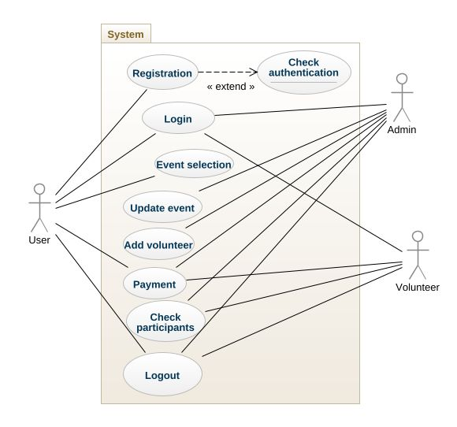

**SEQUENCE DIAGRAM**

**For Admin:**

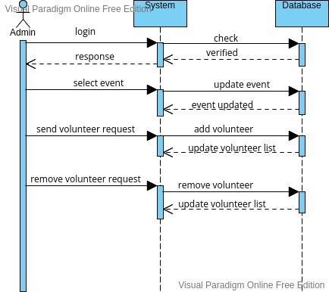

**For user:**

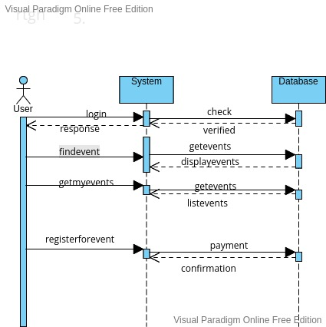

**For volunteer:**

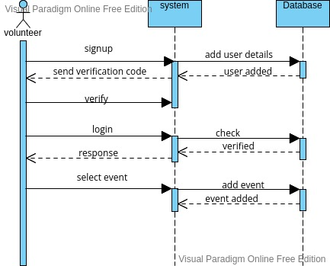

**ACTIVITY DIAGRAM**

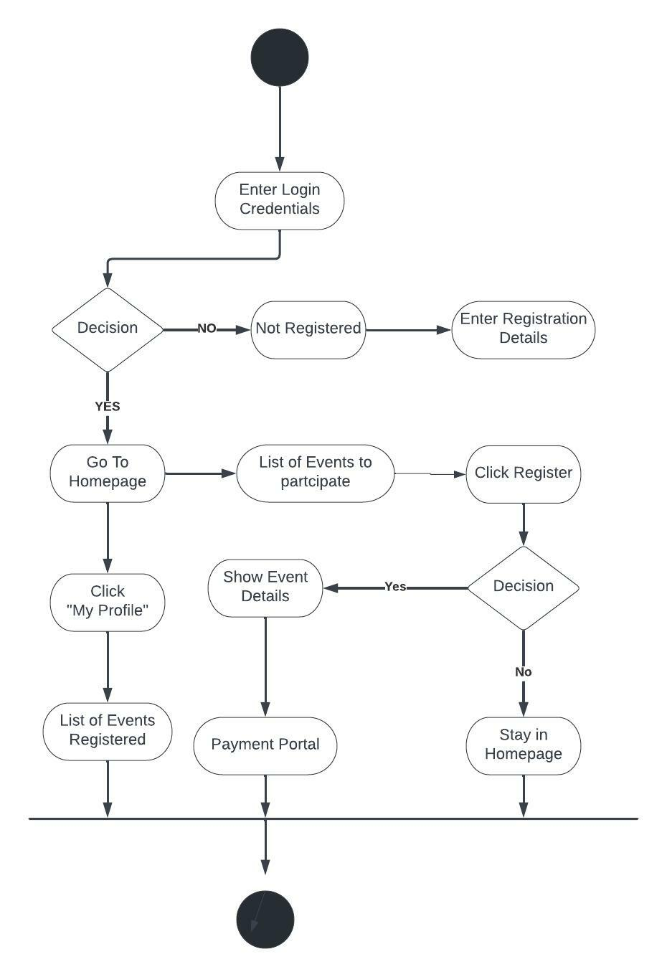



1. **PRODUCT UI**

**Login and Sign-up**

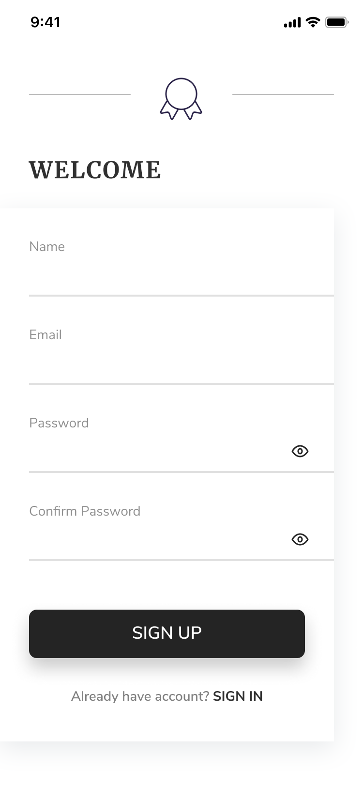**:**

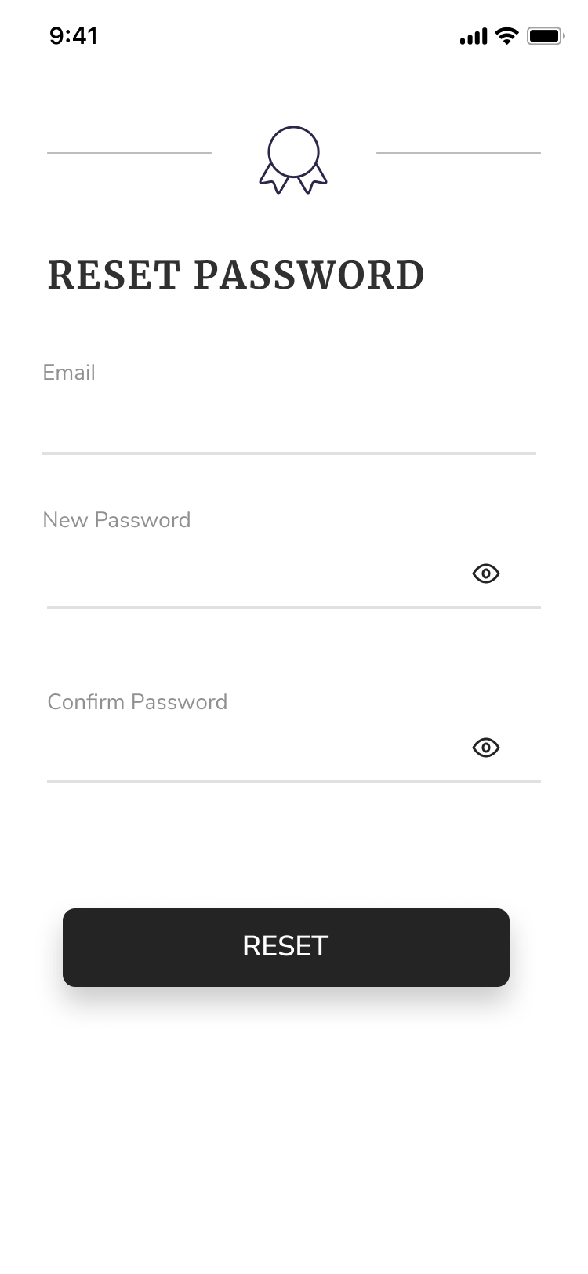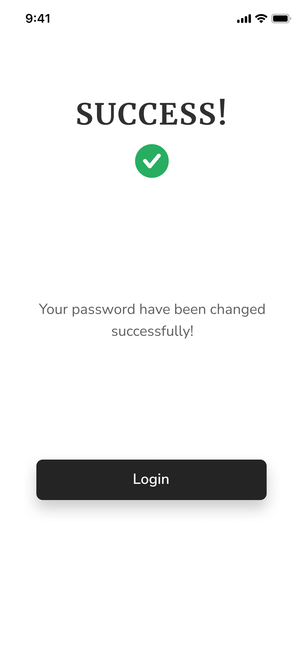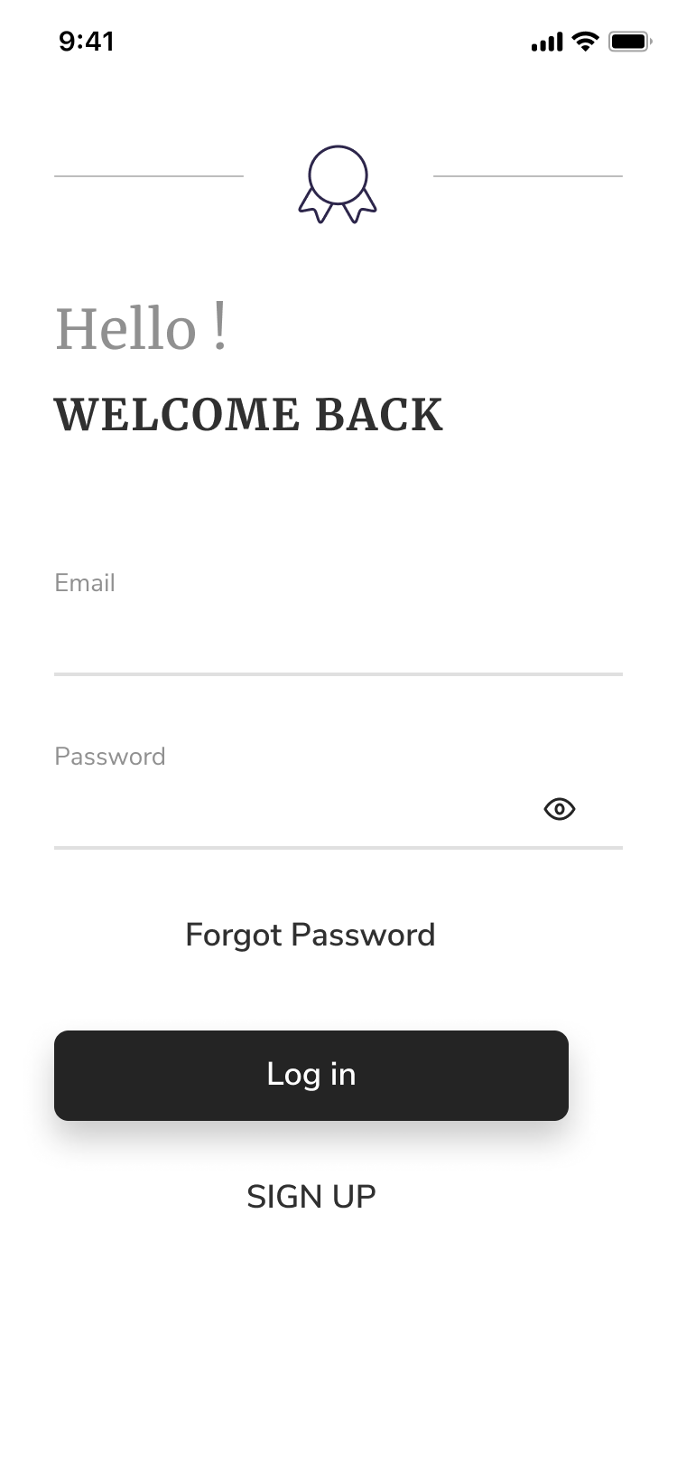

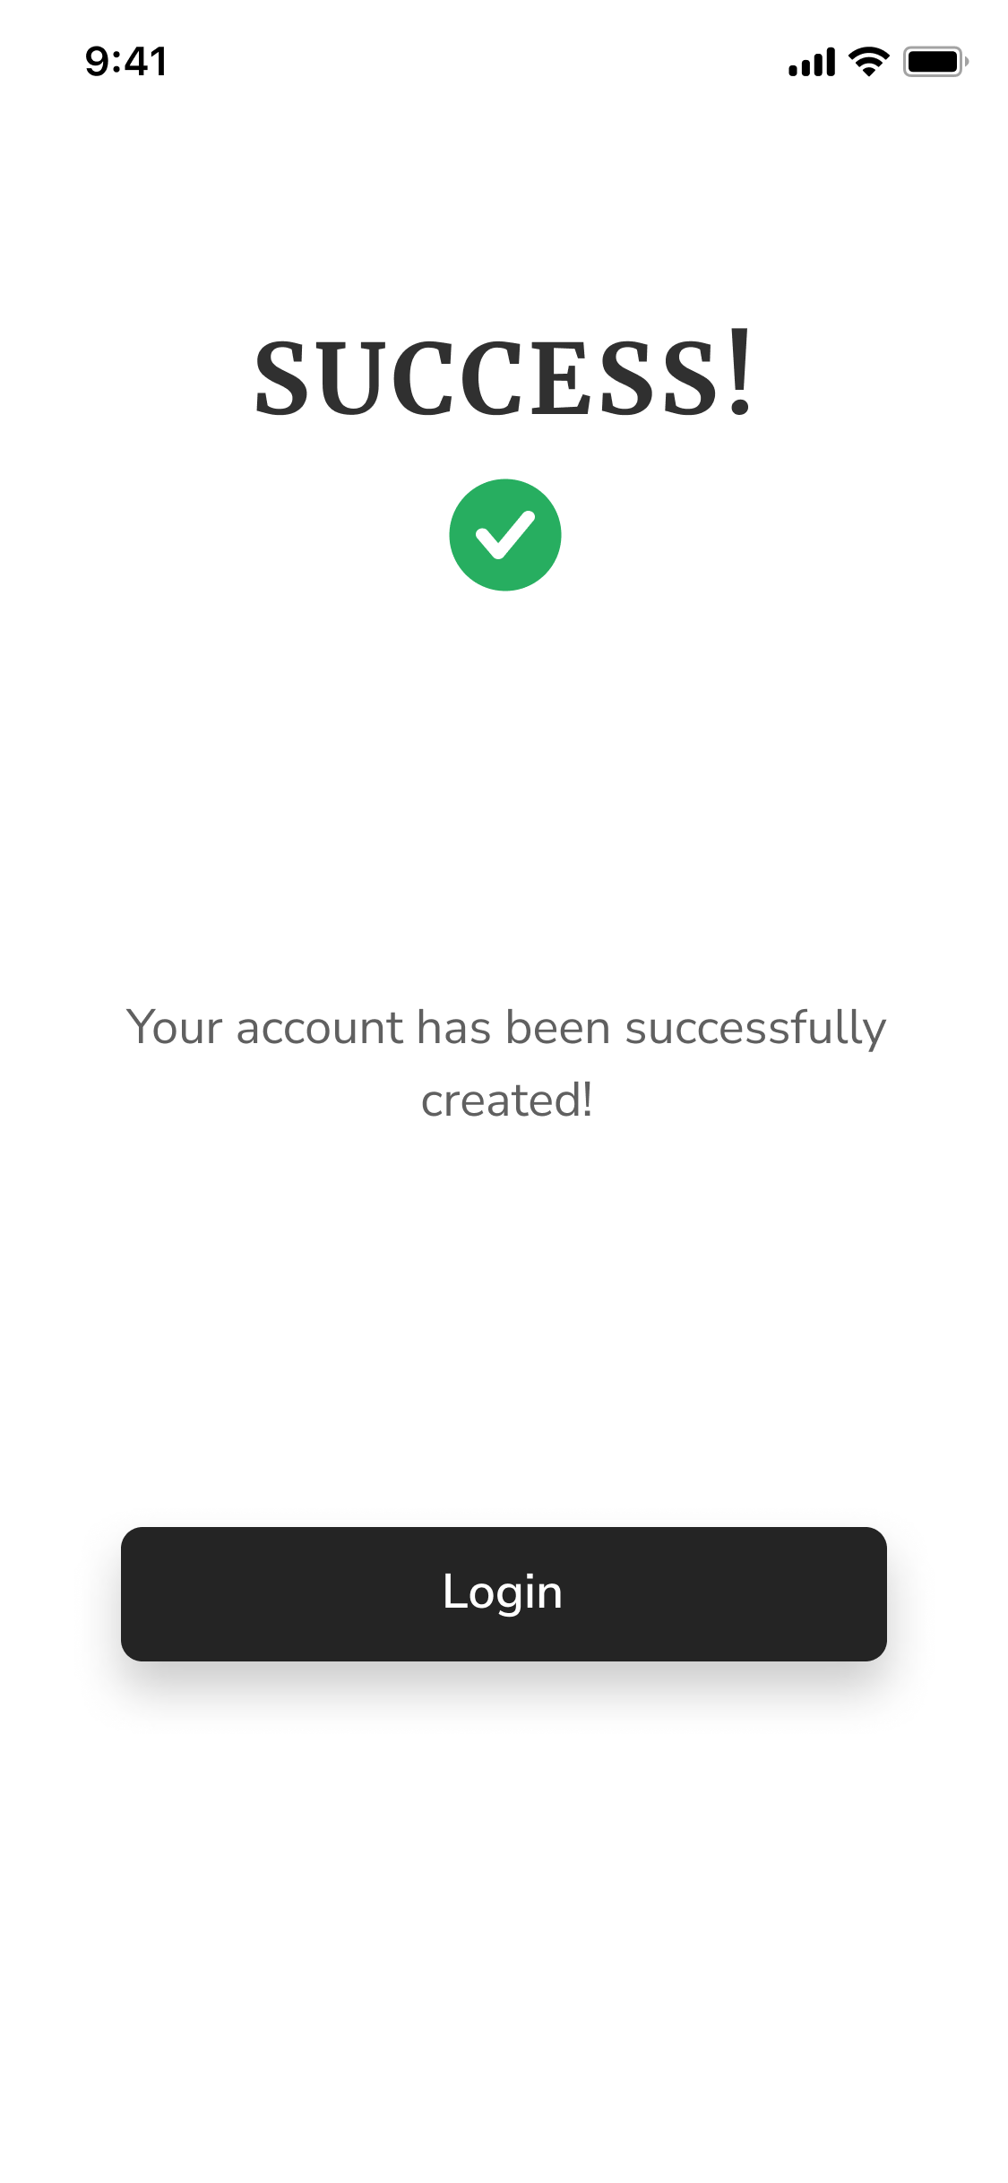

**Home**

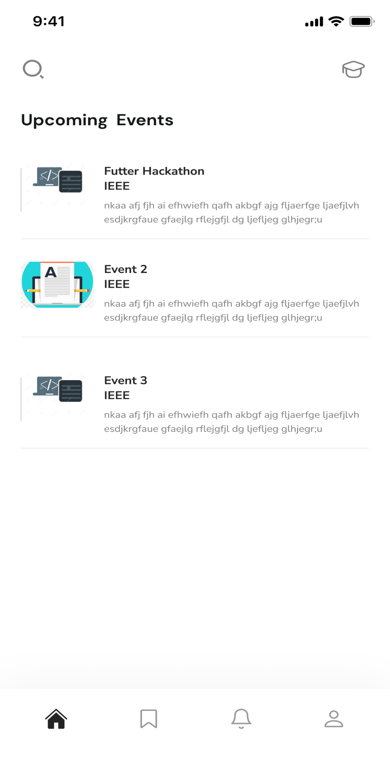

**Event page and Registration**

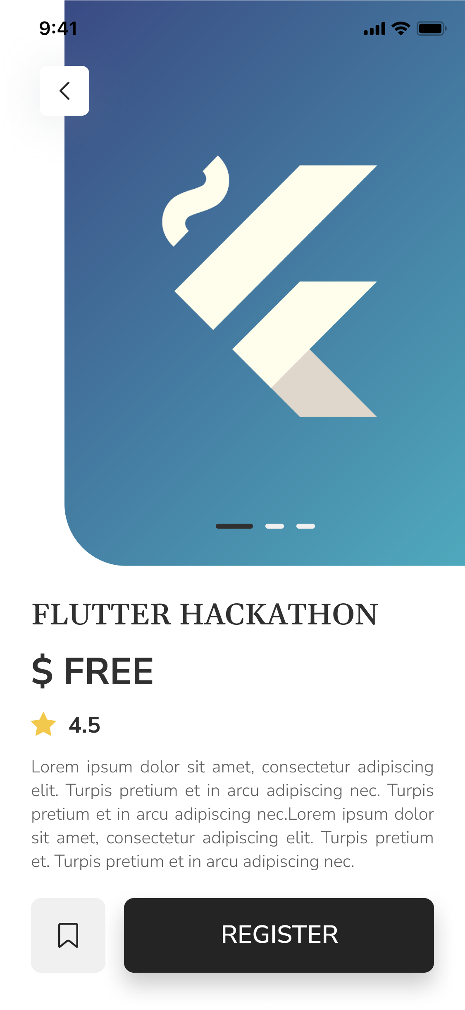

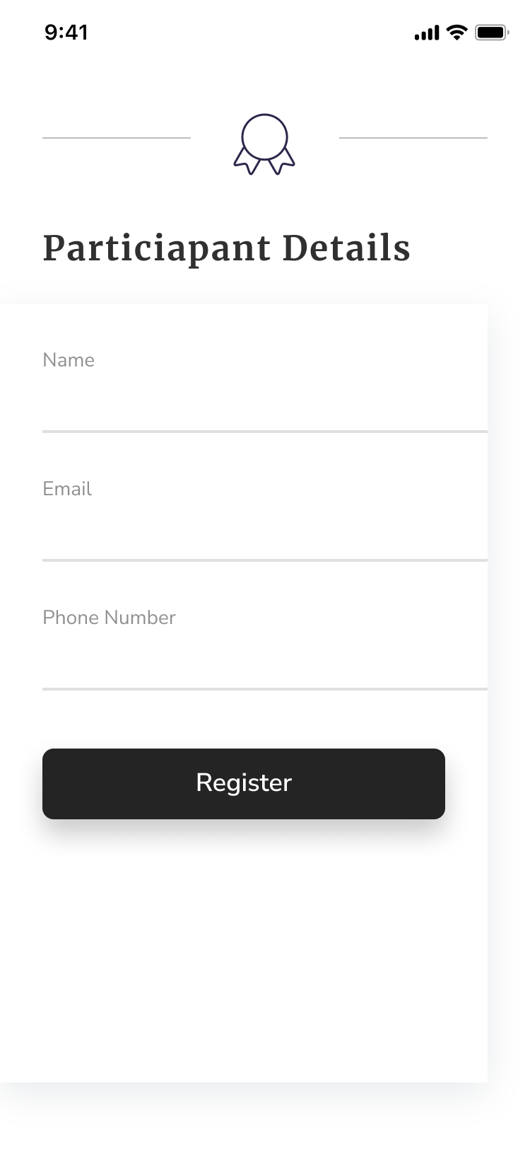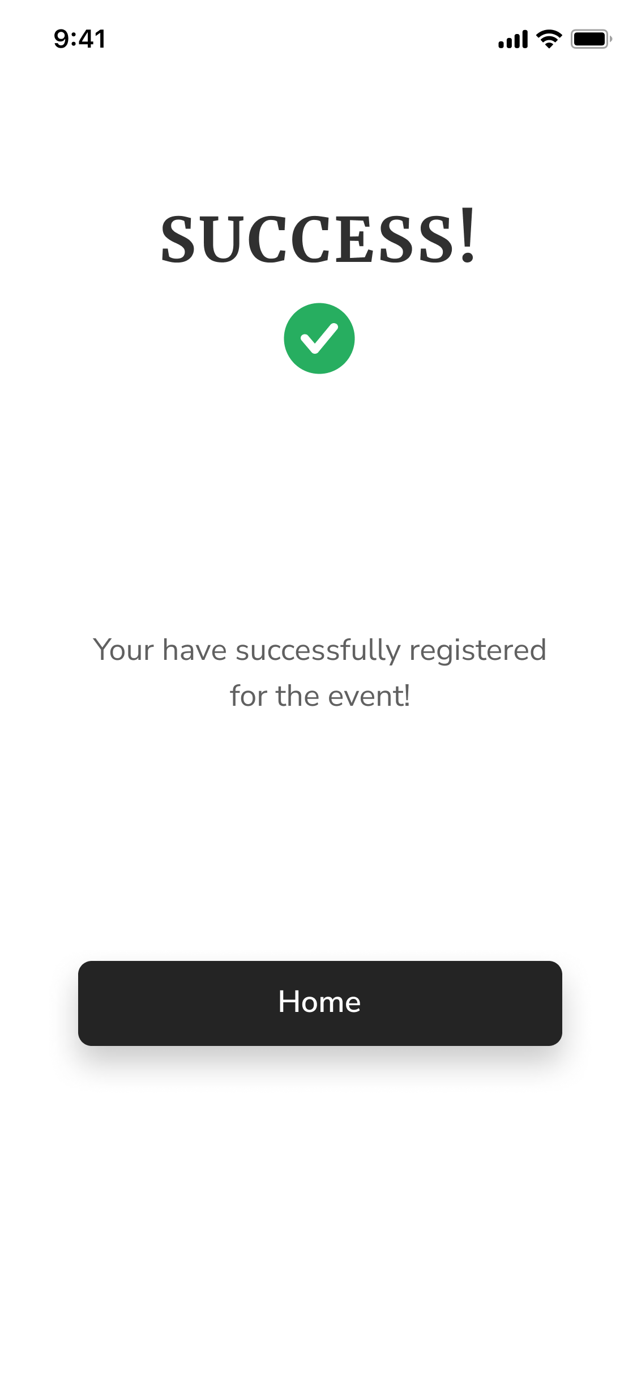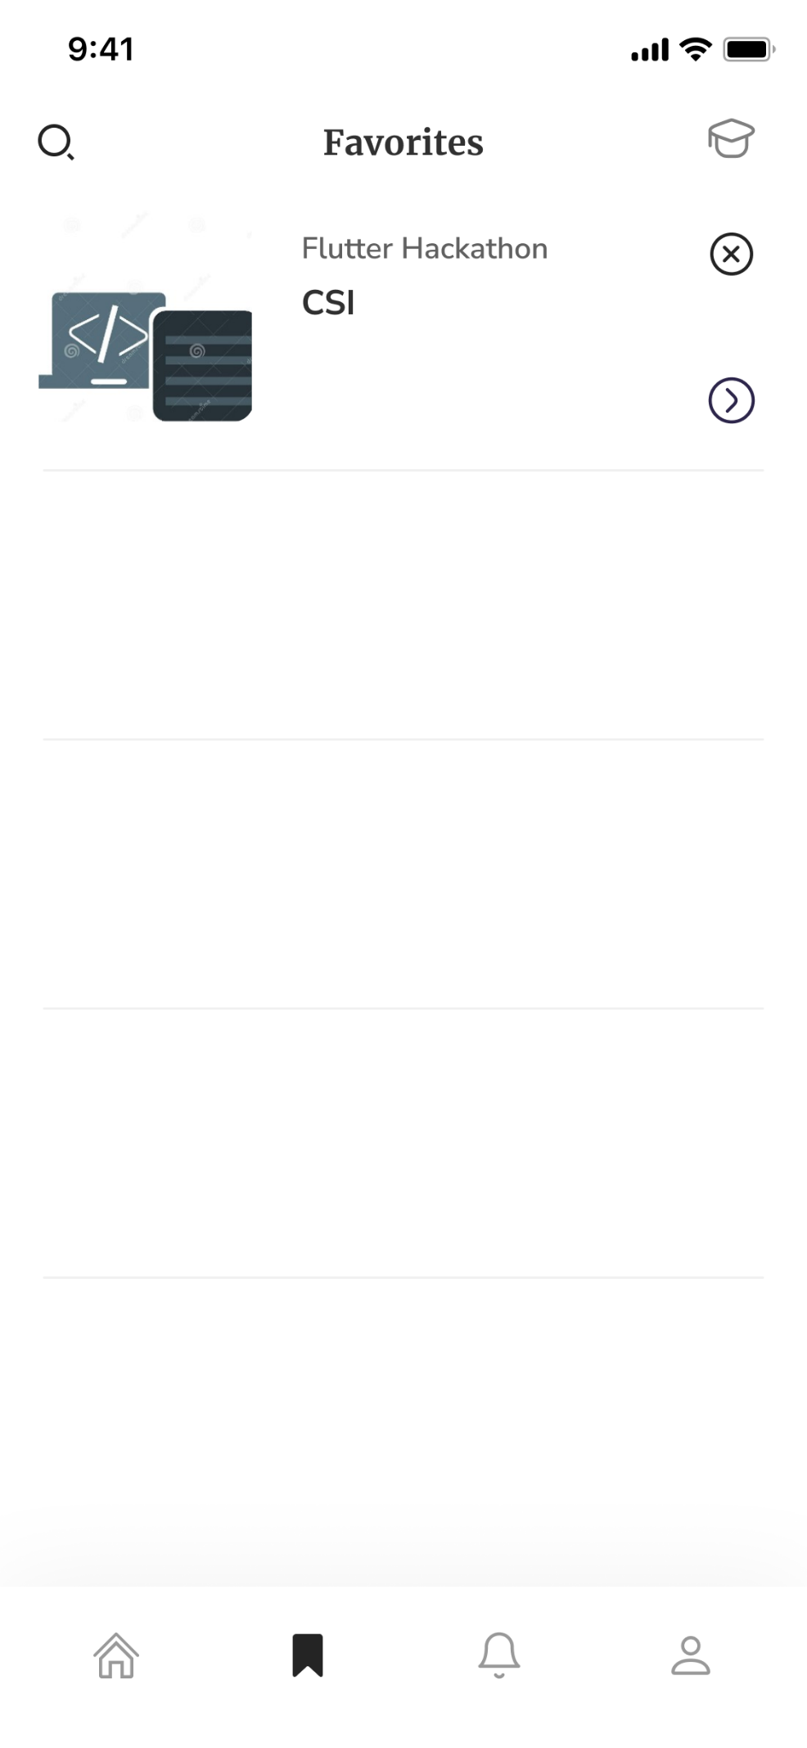

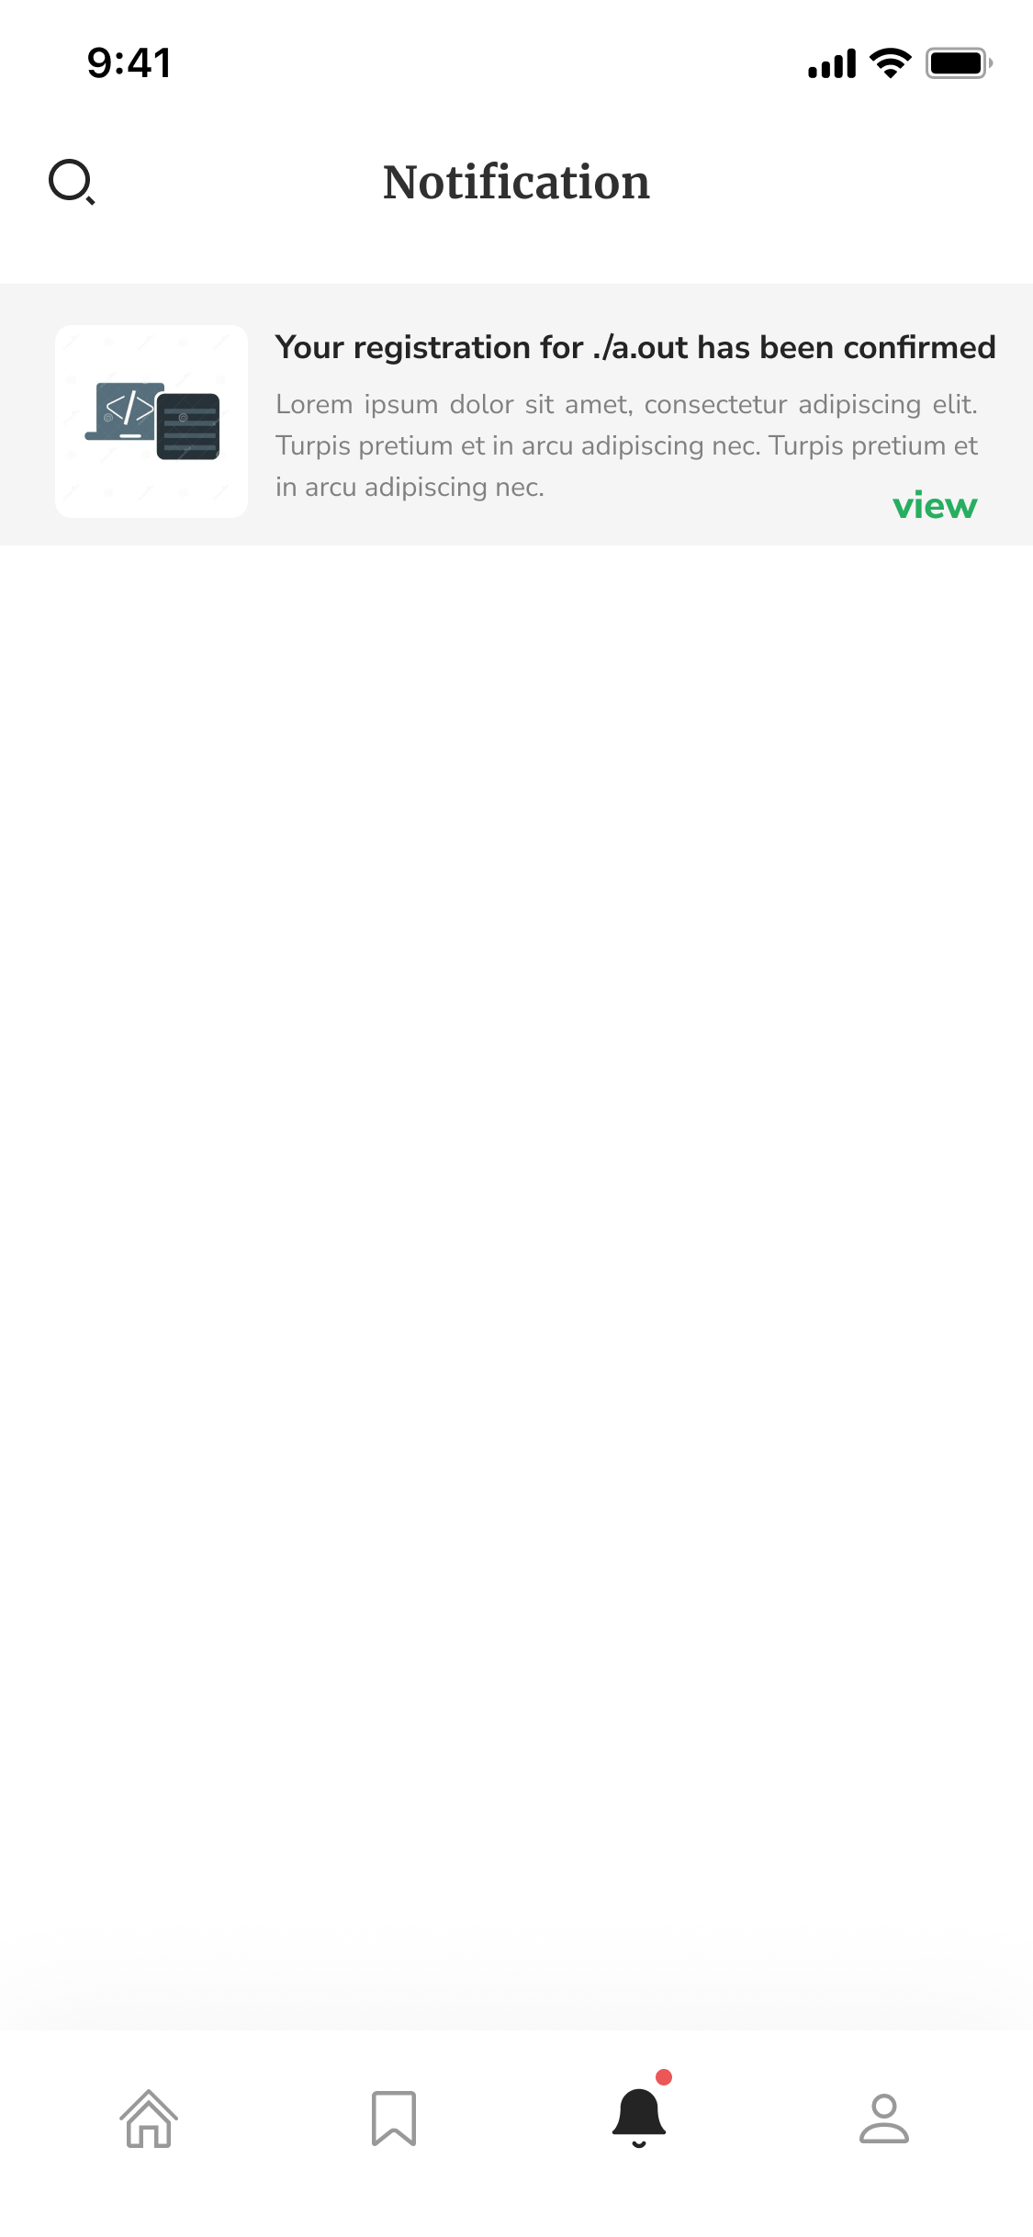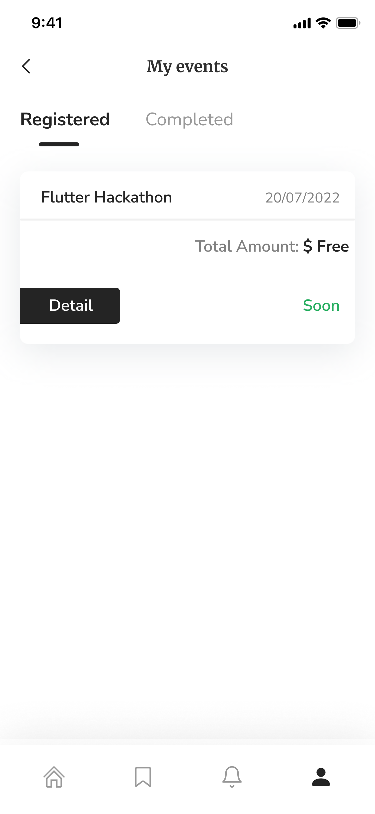

**Profile and Settings**

