**MONGODB-PHP CONNECTION**

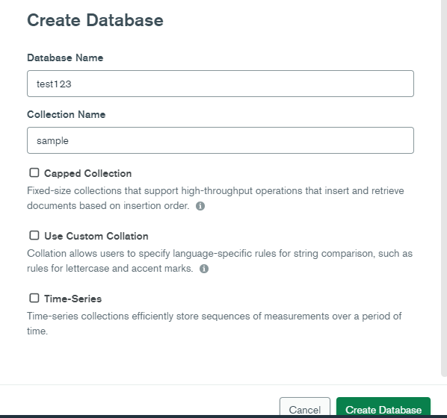

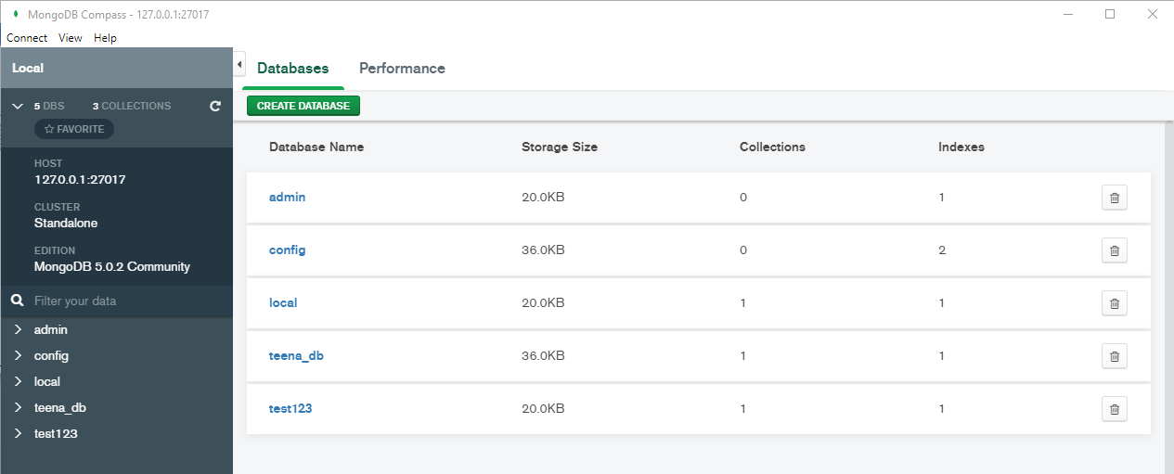

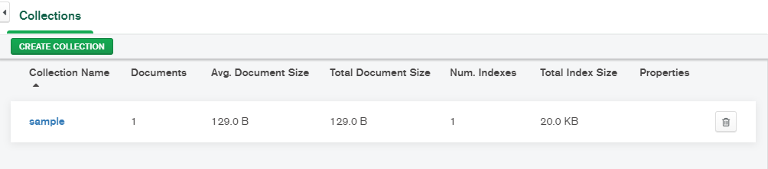

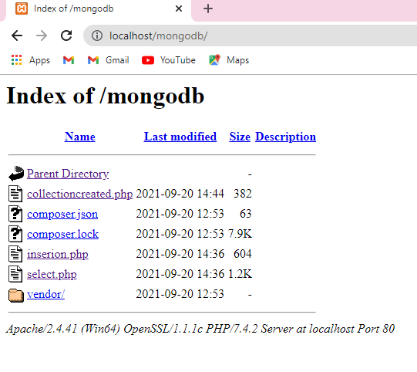

**Connectioncreated.php**

<?php

require 'vendor/autoload.php';

$m = new MongoDB\Client("mongodb://localhost:127.0.0.1:27017");

// connect to mongodb

echo "Connection to database successfully";

// select a database

$db = $m->test123;

echo "Database admin selected";

$collection = $db->createCollection("sample");

echo "Collection created succsessfully";

?>

output

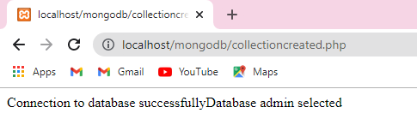

**Insertion.php**

<?php

// connect to mongodb

require 'vendor/autoload.php';

$m = new MongoDB\Client("mongodb://localhost:27017");

echo "Connection to database successfully";

$db = $m->test123;

echo "Database mydb selected";

$collection = $db->sample;

echo "Collection selected succsessfully";

$document = array(

"title" => "class",

"description" => "students",

"likes" => 1000,

"url" => "http://www.apple.com/mongodb/",

"by" => "apple"

);

$collection->insertOne($document);

echo "Document inserted successfully";

?>

**Output**

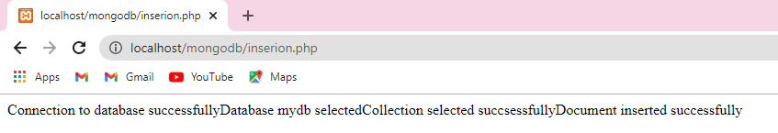

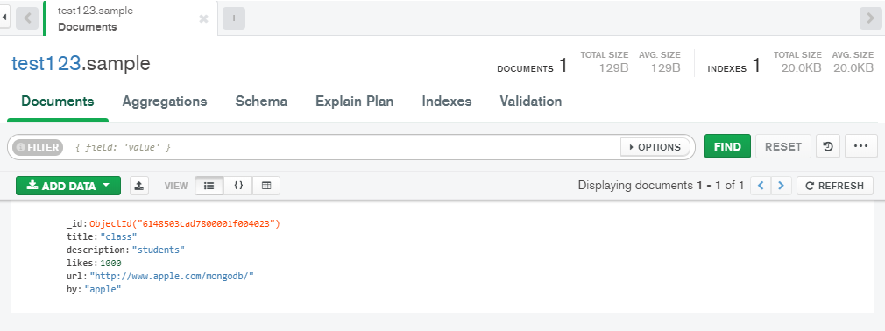

**Select.php**

<?php

require 'vendor/autoload.php';

$server = new MongoDB\Client("mongodb://localhost:27017/test");

$data = "<table style='border:1px solid red;";

$data .= "border-collapse:collapse' border='1px'>";

$data .= "<thead>";

$data .= "<tr>";

$data .= "<th>title</th>";

$data .= "<th>description</th>";

$data .= "<th>likes</th>";

$data .= "<th>url</th>";

$data .= "<th>by</th>";

$data .= "</tr>";

$data .= "</thead>";

$data .= "<tbody>";

try{

$db = $server->test123;

$collection = $db->sample;

$cursor = $collection->find();

foreach($cursor as $document){

$data .= "<tr>";

$data .= "<td>" . $document["title"] . "</td>";

$data .= "<td>" . $document["description"]."</td>";

$data .= "<td>" . $document["likes"]."</td>";

$data .= "<td>" . $document["url"]."</td>";

$data .= "<td>" . $document["by"]."</td>";

$data .= "</tr>";

}

$data .= "</tbody>";

$data .= "</table>";

echo $data;

}catch(MongoException $mongoException){

print $mongoException;

exit;

}

