**MINI PROJECT**

**DOCUMENT**

**Jobin Joseph**

**S3 RMCA**

**Roll no:01**

**ABSTRACT**

The aim of this project is to make a **Vehicle Sharing Service Application.** The online vehicle Sharingsystem is a web-based application to provide us with a simple riding platform between the vehicle owner and a user. The vehicle owner can post a travel destination prior to the travel date and if anyone is interested to travel in the same location, he/she can contact the vehicle owner and book the ride with an amount specified by the owner. Personal ride booking and sharing services allow customers to arrange transportation quickly and at a reasonable amount. This application typically uses a GPS technology to match a customer’s location with the nearest available vehicle. This project consists of a website and its mobile app.

**Proposed System**

* The online Vehicle SharingService system connects vehicle owners to people in their vicinity who needs a vehicle.
* A platform as a link between supply and demand is provided creating a new mobility service.
* The ride fare is fixed by the vehicle owner within the range of kilometres travelled and will even take care of all administrative issues.

**MODULES**

**ADMIN**

* **Login:**

Admin can able to login to admin panel. And admin can configure and change settings of application.

* **Verify users:**

Admin can able to verify user with government id proof which is uploaded by user during registration.

* **Manage users:**

Admin can add or remove users. And also admin can block and monitor registered users.

* **Customer support:**

24/7 customer support is provided. Customer support is provided through phone, chat or email.

**USER**

* **Register:**

User can register with a valid email, phone number, username, password, any government id proof and other personal details.

* **OTP Verification:**

Users phone number and email is verified using OTP.

* **Login:**

User can login into the account using username and password which is set during the registration.

* **Update profile:**

User can edit and update profile after login.

* **Add vehicle details:**

User can add vehicle details such as vehicle type (car, bike, jeep etc), model, number of seats etc.

* **Post travel details:**

The vehicle owner can post a travel destination prior to the travel. The owner must also post the details of travel such as date, time and amount.

* **Search:**

user can search vehicles by location for ride. Search filters includes vehicle type, model , riding price etc.

* **Notification:**

vehicle owner gets notification if any user book the ride.

* **Payment:**

User can choose online payment or COD.

* **Feedback**

User can feedback and rate their experience.

**Table Design**

Tbl_registration

|  |  |  |  |
| --- | --- | --- | --- |
| Field | Datatype | Constraint | Description |
| Uid | INT | Primary key | User id |
| Name | VARCHAR | Not null | User name |
| email | VARCHAR | Not null | User email |
| gender | VARCHAR | Not null | gender |
| DOB | DATE | Not null | DOB |
| image | VARCHAR | Not null | Image path |
| Gov_id_No | Varchar | Not null | Verification |
| Phone no | INT | Not null | Phone no |
| User_Type | INT | Not null | User type |

Tbl_login

|  |  |  |  |
| --- | --- | --- | --- |
| Field | Datatype | Constraint | Description |
| Login_id | INT | Primary key | Login id |
| Uid | INT | Foreign Key | Reference |
| username | Varchar | Not null | Username |
| Password | Varchar | Not null | password |
| Status | INT | Not null | User Status |

Tbl_addVehicle

|  |  |  |  |
| --- | --- | --- | --- |
| Field | Datatype | Constraint | Description |
| Vid | INT | Primary Key | Vehicle id |
| Login_id | INT | Foreign Key | Login id |
| Model | VARCHAR | Not null | Vehicle model |
| Type | VARCHAR | Not null | Type |
| Build Year | VARCHAR | Not null | Build Year |
| No_of_seats | INT | Not null | No_of_seats |
| Vehicle_no | INT | Not null | Vehicle_no |
| Image | Varchar | Not null | Image path |

Tbl_Travel_Details

|  |  |  |  |
| --- | --- | --- | --- |
| Field | Datatype | Constraint | Description |
| Travel_id | INT | Primary key | Travel id |
| Vid | INT | Foreign Key | vid |
| Date | Date | Not null | Date |
| Time | VARCHAR | Not null | Time |
| From | VARCHAR | Not null | From |
| To | VARCHAR | Not null | To |
| Amount | INT | Not null | Amount |

Tbl_booking details

|  |  |  |  |
| --- | --- | --- | --- |
| Field | Datatype | Constraints | Description |
| Bid | INT | Primary Key | Bid |
| Uid | INT | Foreign Key | Uid |
| Travel_id | INT | Foreign Key | travelid |
| Payment status | INT | Not null | Payment Status |

Tbl_payment details

|  |  |  |  |
| --- | --- | --- | --- |
| Field | Datatype | Constraints | Description |
| Payment_id | INT | Primary Key | Payment id |
| Login_id | INT | Foreign Key | Login id |
| Travel_id | INT | Foreign Key | travelid |
| Payment status | INT | Not null | Payment Status |

Tbl_Feedback

|  |  |  |  |
| --- | --- | --- | --- |
| Field | Datatype | Constraints | Description |
| Feedback_id | INT | Primary Key | Feedback id |
| Login_id | INT | Foreign Key | Log id |
| Feedback | Varchar | Not null | Feedback |

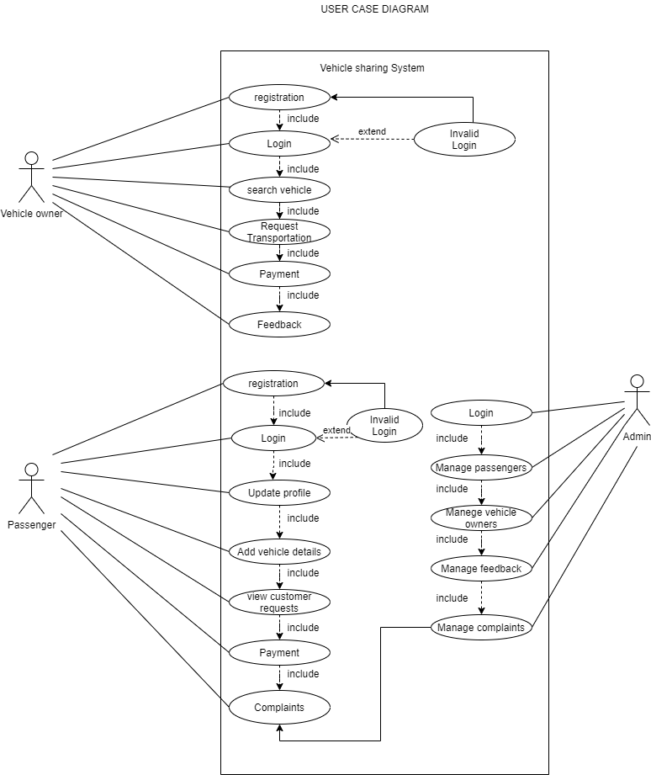

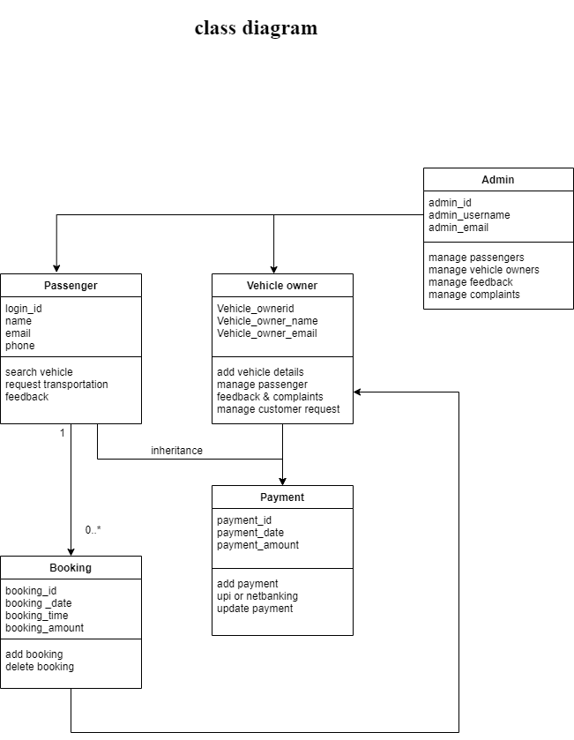

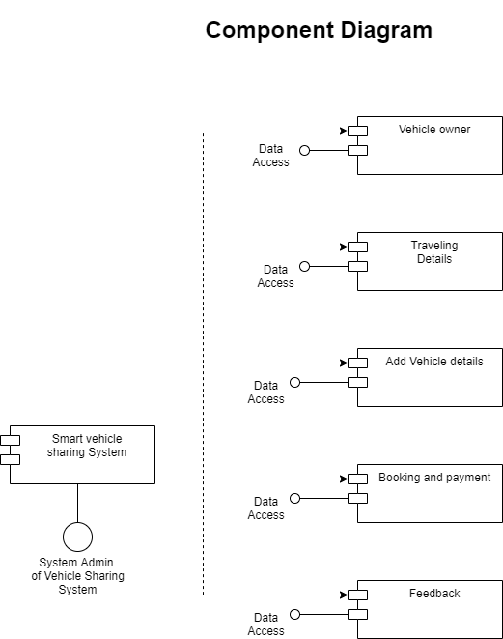

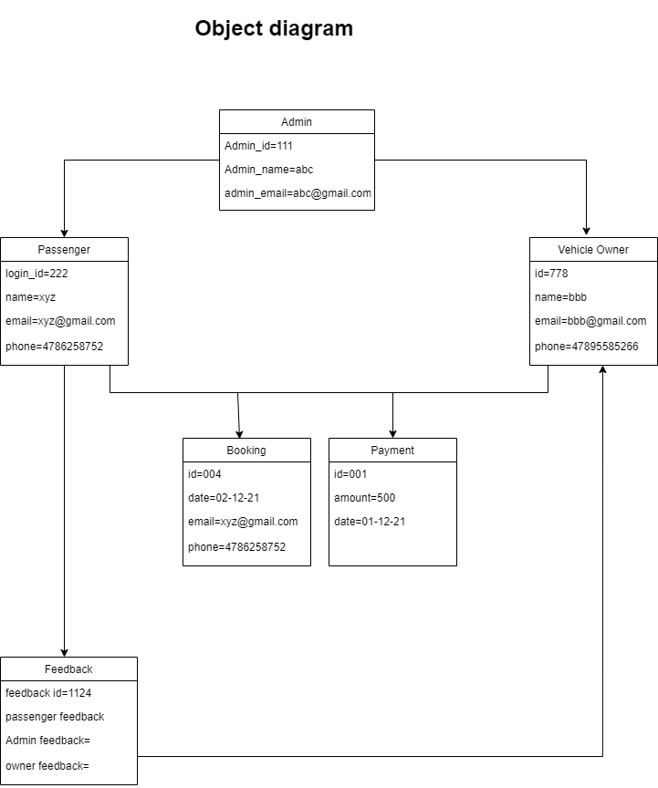

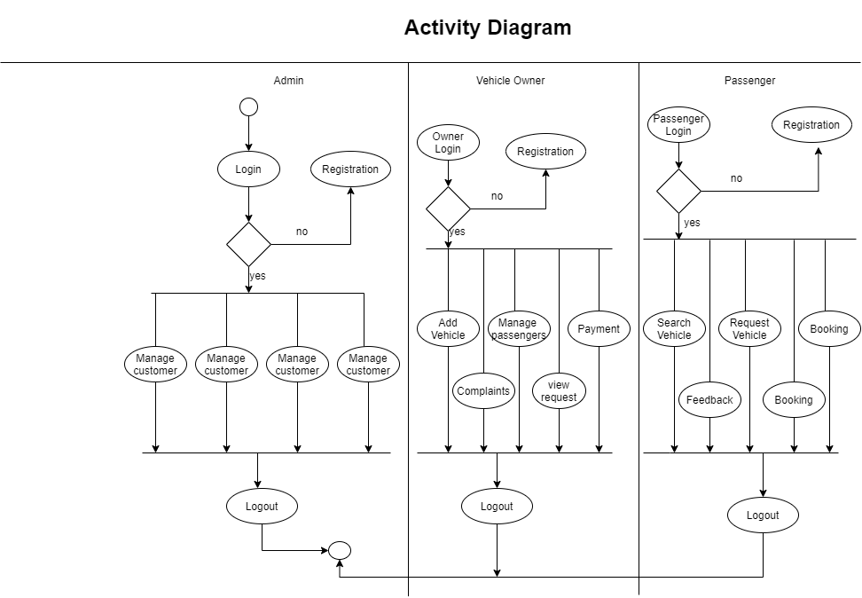

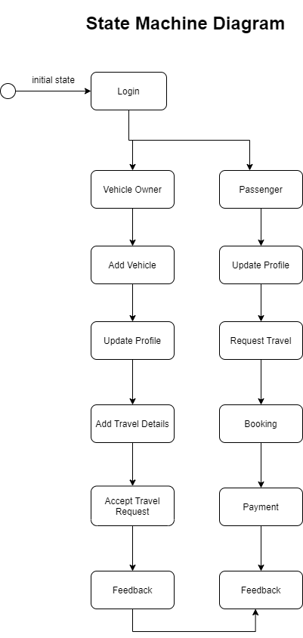

**Deployement Diagram**

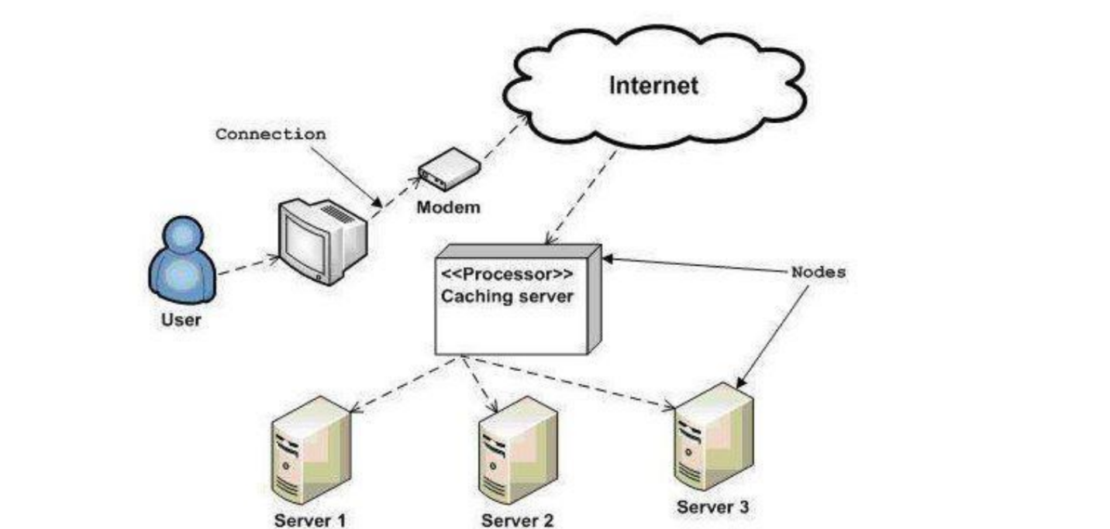

**Prototype**

