**Water Quality Analysis Project**

*Phase-1 Report*

*Submitted by*

*Bhuvanaradja.T-2021115021*

*Cheran. D– 2021115022*

*Deepakraj CN-2021115024*

*Dhanushkumar S - 2021115026*

*Vinoth kumar .R-2021115334*

*Jobson Charles.J-2021115303*

***In partial fulfilment for the award of the degree***

**Of**

**BACHELOR OF TECHNOLOGY**

**In**

**INFORMATION TECHNOLOGY**



**DEPARTMENT OF INFORMATION SCIENCE AND TECHNOLOGY**

**COLLEGE OF ENGINEERING GUINDY**

**ANNA UNIVERSITY, CHENNAI 600025**

**September 2023**

**Content**

| **S.no** | **Topics** | **Page no** |
| --- | --- | --- |
| 1. | Introduction |  |
| 2. | Problem definition |  |
| 3. | Design thinking |  |
|  |  |  |
|  |  |  |
|  |  |  |
|  |  |  |

**Introduction**

Water, as the elixir of life, plays a central role in sustaining ecosystems, human health, and societal well-being. Its quality profoundly impacts both the environment and the communities that depend on it. This report encapsulates the culmination of our dedicated efforts in the "Water Quality Analysis Project." Through meticulous data collection, rigorous analysis, and a commitment to environmental stewardship, we embarked on a journey to assess, understand, and improve water quality in chennai .The significance of water quality analysis cannot be overstated in today's world, where rapid urbanization, industrialization, and changing climate patterns challenge the integrity of our water resources. Our project was born out of a shared responsibility to safeguard this vital resource.

**2.Problem definition**

Water quality degradation is a pressing concern in Chennai. Our region's water bodies, including rivers, lakes, and groundwater, face a myriad of challenges that threaten their overall health and suitability for various purposes. The specific problems that necessitate this water quality analysis project are as follows:

**1. Pollution from Multiple Sources:**

The waters in our region are susceptible to pollution from various sources, including industrial discharge, agricultural runoff, urban development, and natural processes. These pollutants encompass a wide range of contaminants, from heavy metals to nutrient-rich agricultural runoff, and pose a significant threat to water quality.

**2. Health Risks to Communities:**

Poor water quality directly impacts the health and well-being of communities that rely on these water sources for drinking, irrigation, and recreation. Waterborne diseases, often linked to contamination, pose a serious risk to public health, and the availability of safe drinking water is not guaranteed in all areas.

**3. Ecological Degradation:**

Declining water quality has detrimental effects on aquatic ecosystems. It can lead to the loss of biodiversity, harm aquatic life, and disrupt the delicate balance of these ecosystems. The long-term health of our region's natural environment is at risk.

**4. Sustainable Resource Management:**

Sustainable management of our water resources is essential to meet current and future demands. Without effective water quality management, we face challenges in maintaining a sustainable balance between water supply, agriculture, industrial needs, and environmental preservation.

**5. Regulatory Compliance:**

Regulatory agencies have set standards for water quality that must be met to protect human health and the environment. Ensuring compliance with these standards is essential to avoid legal repercussions and maintain a healthy environment.

It is evident that a comprehensive analysis of water quality in our region is imperative. This project seeks to address the identified issues by collecting and analyzing data, understanding the sources of pollution, evaluating health risks, assessing ecological impacts, and developing sustainable solutions.

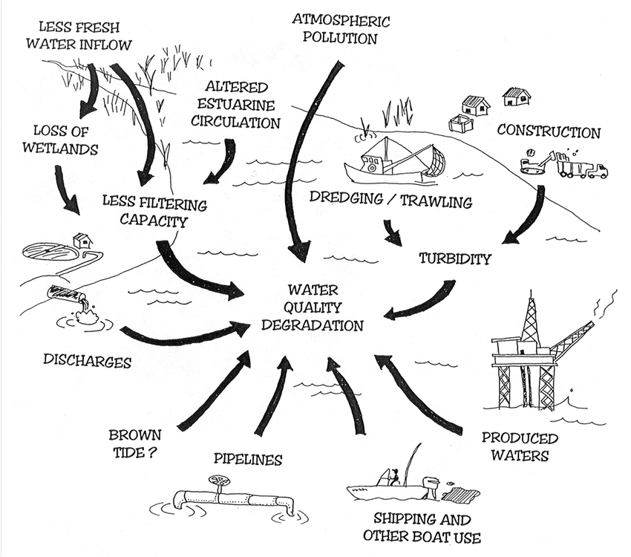

**3.Design and Thinking**

There are several experiment should be done to check quality of the water.Here we should Design a proper machine to check all these experiements are.

**Experimental Procedures**

**1.Temperature** was measured at the time of sample collection with a good mercury filled Celsius thermometer, having a scale marked for every 0.1°C .

**2.pH** was measured within 2 hr of sample collection because the pH of the sample can change due to carbon dioxide from the air dissolving in the sample water. A Systronics pH meter of 0.01 readability was used for the measurement of pH.

**3. Electrical conductivity(EC)** was measured with Systronicsconductivity meter. 0.01M KCl solution was used as the standard reference solution.

**4.In the total hardness determination**, the water samples were first buffered to a pH of 10.0 with ammonia buffer and 2 or 3 drops EBT indicator was added. The indicator reacts with calcium and magnesium ions to yield a wine red coloured complex. As EDTA is added, it combines with free calcium and magnesium ions in the sample to produce

EDTA – calcium and EDTA – magnesium complexes. When all free ions are used up, EDTA begins to break the red metal–indicator complex and combines with the free calcium and magnesium ions. Then the colour of the solution changes from wine red to pale blue.

Hardness as mg CaCO3 = A x B x mol.wt. of CaCO3 x 1000/vol. of sample

where A = Volume of EDTA consumed (ml) ; mol.wt. of CaCO3=100 ;

B = concentration of EDTA

Two titration method was adopted to determine the concentration of calcium and magnesium ions in water. One method measures the concentration of calcium ions alone and the second measures the total hardness. The concentration of magnesium ions was calculated as the difference between the two test results .

**5. Calcium**- Water samples were buffered to a pH of 12-13 with sodium hydroxide buffer for the determination of calcium hardness. At a pH of 12.0, magnesium precipitates out so that it will not interfere in the titration. Eriochrome Black T indicator was added to the solution and EDTA was then added as a titrant. Disodium EDTA combines with the free calcium ions to produce an EDTA – calcium complex.

Calculation :

Ca as CaCO3(mg/L) = A x B x mol.wt. of CaCO3 x 1000/vol. of sample

where A = ml of EDTA consumed ; mol.wt. of CaCO3=100

B = EDTA concentration

Calcium as Ca(mg/l)= 0.4 x Ca as CaCO3(mg/l)

**6. Magnesium** was determined as the difference between total hardness and calcium as CaCO3.

Mg (mg/ l) = (Total hardness (as CaCO3mg / l) – Calcium hardness (as mg CaCO3/l)) x 0.243

**7.Alkalinity** was determined by acid – base titration method. 20.0 ml of the sample was taken in a 250.0 ml conical flask and titrated with standard 0.1N sulphuric acid by using phenolphthalein and methyl orange indicators. Phenolphthalein alkalinity registered total hydroxide and one half of the carbonate present in the sample. Methyl orange was used to determine total alkalinity.

Total alkalinity , mg CaCO3/ l = AxBx50,000/vol of sample

where A = Volume of acid consumed (ml) with methyl orange as indicator

B = Normality of standard acid solution

Carbonate as CO32-( mg/l) = Phenolphthalein alkalinity(as mg CaCO3) x 1.2

Bicarbonate as HCO3-( mg/l) = (Total alkalinity - 2 x phenolp. alk.) x 1.22

**8.Chloride** was determined by argentometric method. 1.0ml of 5% potassium chromate solution was added to 20.0ml of the sample and titrated with standard 0.014N AgNO3 solution till the colour changed to reddish brown.

mg Cl-/l = (A-B) x N x 35450/vol. of sample

Where A = vol. of AgNO3 consumed for sample

B = vol of AgNO3consumed for blank

N = normality of AgNO3

**9. Nitrate** (UV Spectrophotometric screening method) Nitrate - N was determined spectrophotometrically using Systronics UV-Vis.

spectrophotometre with potassium nitrate standard solutions.

Stock nitrate solution

0.7218g of potassium nitrate dried in an oven at 105°C for 24hr was dissolved in water and diluted to 1.0l (1.0ml = 100μg NO3 – N). This solution could be stored up to 6 months by adding 2.0ml CHCl3/l. Stock nitrate solution was diluted with water to form NO3-calibration standards in the range of 0 to 7mg NO3-- N/l as intermediate nitrate solutions. 1.0ml 0.1M HCl solution was added to 50.0ml clear sample and blank and mixed thoroughly. NO3 – standards were treated in the same manner as samples. Absorbance was measured at 220nm and 275nm due to NO3 – N and organic nitrogen respectively against a blank solution. Twice the absorbance at 270nm was subtracted from the absorbance at 220nm and a calibration curve was drawn by plotting absorbance against concentration. NO3 - N and organic N concentrations of the samples were also determined in the same manner and NO3 – N conc. of the samples was obtained directly from the standard calibration curve .

**10.Potassium (Flame Photometric method)** Potassium concentration in mg/l was determined using standard KCl solution. Stock potassium chloride solution was prepared by dissolving 1.907g of potassium chloride dried in an oven at 110°C in water and diluted to 1.0l (1.0ml = 1mg K+). Intermediate potassium chloride solution was prepared by diluting 100.0ml stock potassium chloride solution to 1l with distilled water. From this intermediate solution 5.0 to 100.0ppm standard solutions were prepared and inserted into the flame to calibrate the instrument. After calibration the concentration of potassium was obtained by insertingthe samples into the flame.

K+in ppm = concentration of sample in ppm x dilution factor

Dilution factor = vol of sample + vol of water/vol of sample

**10.Biochemical Oxygen Demand (BOD**): BOD was also determinedtitrimetrically by adopting in toto the procedure adopted for the measurement DO but only after incubation for five days at 200C. BOD was then calculated on the basis of oxygen depleted when compared to DO before incubation.

**11. Chemical Oxygen Demand (COD):** Chemical Oxygen Demand measures the ability of hot chromic acid solution to oxidize organic matter present in the sample.