EduLearn
A Web-Based E-Learning Platform for Course Delivery, Student
Progress Tracking, and Instructor Management

Md. Jobyadul Islam
ID# 22303363

A Practicum in the Partial Fulfillment of the Requirements
for the Award of Bachelor of Computer Science and Engineering (BCSE)

Department of Computer Science and Engineering
College of Engineering and Technology
IUBAT—International University of Business Agriculture and Technology

Summer 2026

EduLearn — A Web-Based E-Learning Platform for Course Delivery,
Student Progress Tracking, and Instructor Management

Md. Jobyadul Islam
A Practicum in the Partial Fulfillment of the Requirements for the Award of Bachelor of
Computer Science and Engineering (BCSE)

The practicum has been examined and approved,

_____________________________
Prof. Dr. Utpal Kanti Das
Chairman
Dept of CSE

_____________________________
Shahinur Alam
Co-supervisor, Coordinator and Assistant Professor

_____________________________
Dr. Md. Abdul Awal
Associate Professor
Supervisor

Department of Computer Science and Engineering
IUBAT—International University of Business Agriculture and Technology
Summer 2026

Letter of Transmittal
17 September 2026
The Chair
Practicum Defense Committee
Department of Computer Science and Engineering
IUBAT—International University of Business Agriculture and Technology
4 Embankment Drive Road, Sector 10, Uttara Model Town
Dhaka 1230, Bangladesh.

Subject: Letter of Transmittal.

Dear Sir,
It is my pleasure to submit my practicum report entitled “EduLearn — A Web-Based E-Learning Platform for Course Delivery, Student Progress Tracking, and Instructor Management.”
This project has provided me with valuable practical experience in full-stack web application development, database design, role-based authentication and authorization, payment integration, automated testing, and building a real, working product from requirements through to a defensible, deployed system.
I sincerely thank the department and my respected faculty members, as well as Touch & Solve Technologies Ltd., for giving me the opportunity to complete this practicum project. I will be pleased to provide any further clarification if required.
Yours sincerely,

_____________
Md. Jobyadul Islam
22303363

Organization's Certificate


The certificate above was issued by Touch & Solve Technologies Ltd. to Md. Jobyadul Islam on the successful completion of an internship in Web Development, undertaken as part of the practicum requirement for the Bachelor of Computer Science and Engineering (BCSE) program at IUBAT.

Student's Declaration
This is to certify that the work presented in this report titled “EduLearn — A Web-Based E-Learning Platform for Course Delivery, Student Progress Tracking, and Instructor Management” is the outcome of the investigation and development carried out by the following student under the supervision of Dr. Md. Abdul Awal, Associate Professor, Department of Computer Science and Engineering, International University of Business Agriculture and Technology.

__________________
Md. Jobyadul Islam
Student ID 22303363

Supervisor's Certification
This is to certify that the practicum report entitled “EduLearn — A Web-Based E-Learning Platform for Course Delivery, Student Progress Tracking, and Instructor Management” has been prepared by Md. Jobyadul Islam under my supervision. The work presented in this report is an outcome of the student's study, development, and practical implementation carried out as part of the practicum program.
I have reviewed the report and found it satisfactory for submission to the Practicum Defense Committee of the Department of Computer Science and Engineering, IUBAT—International University of Business Agriculture and Technology.

_______________________________
Dr. Md. Abdul Awal
Associate Professor
Department of Computer Science and Engineering
IUBAT—International University of Business Agriculture and Technology

Abstract
The rapid shift toward online and blended learning has created sustained demand for e-learning platforms that can manage course delivery, student progress, assessment, and payment in one coherent system rather than through disconnected spreadsheets, file shares, and third-party quiz tools. The objective of this Practicum is to design and develop EduLearn, a web-based e-learning platform that centralizes course creation, enrollment, lesson delivery, quiz and assignment assessment, certification, and platform administration for three distinct user roles.
The system is developed using ASP.NET Core MVC (.NET 10) with C# as the primary programming language, Microsoft SQL Server as the relational database, and Entity Framework Core (code-first, migration-driven) for data access. The system implements cookie-based authentication and role-based authorization for Student, Instructor, and Admin roles. Key features include course creation and a mandatory Admin approval-and-pricing workflow, module/lesson/assignment/quiz authoring with due-date enforcement, automatic quiz grading, enrollment and coupon-discounted checkout through the bKash payment gateway, lesson-progress tracking with PDF certificate issuance on completion, a Gmail-style read/unread notification system, PDF revenue and course-activity reporting, and an AI-assisted chat widget for course recommendations. A distinct, security-hardened instructor-onboarding flow — a Google OAuth or email access request, admin approval, a rate-limited one-time code, and only then the full application form — replaces what would otherwise be an insecure, manually-issued PIN.
The development process followed an incremental, Agile-influenced approach covering requirement engineering, system analysis, database design, implementation, and continuous testing, with a 33-case automated xUnit test suite exercising the system's core business rules (enrollment, certification eligibility, quiz grading, admin approval workflows, PDF generation) alongside extensive live, evidence-based manual verification of every feature against the running application and its database. This practicum provided practical experience in building a secure, role-based, real-world web application using modern .NET web technologies and structured software engineering practice, from initial requirements through to a system ready for production use.

Acknowledgments
First, I would like to thank the Almighty for His continuous blessings and guidance throughout my academic journey. Without His blessings, the completion of this work would not have been possible.
I am grateful to the late Professor Dr. Md. Alimullah Miyan, the founder and former Vice-Chancellor of the International University of Business, Agriculture and Technology (IUBAT), for establishing this institution and providing students with the opportunity to pursue higher education.
I would like to express my sincere gratitude to Professor Dr. Abdur Rab, Vice-Chancellor of IUBAT, for his valuable leadership and support.
I am also grateful to Prof. Dr. Utpal Kanti Das, Chairman and Professor, Department of Computer Science and Engineering, for his guidance and leadership.
My heartfelt thanks go to Shahinur Alam, Assistant Professor and Coordinator, Department of Computer Science and Engineering, for his continuous support and encouragement.
I would like to express my deepest gratitude to my respected supervisor, Dr. Md. Abdul Awal, Associate Professor, Department of Computer Science and Engineering, IUBAT, for his valuable guidance, suggestions, and continuous support throughout the development of EduLearn and the preparation of this report.
I am also thankful to Touch & Solve Technologies Ltd., and to Mr. Abul Kalam Azad, CEO, for providing a professional environment in which to complete my internship and apply my academic knowledge to real-world software development.
Finally, I sincerely thank my parents, friends, and classmates for their continuous encouragement, motivation, and support throughout this journey.

Table of Contents
Right-click here and choose “Update Field” (or press F9) to generate the Table of Contents.
(Right-click above → Update Field, after opening this document in Word, to populate the Table of Contents with real page numbers.)

List of Figures
Figure 1.1 Agile Process Model Used for EduLearn Development.
Figure 1.2 Technical Architecture and Technology Stack of EduLearn.
Figure 2.1 Organizational Structure of Touch & Solve Technologies Ltd.
Figure 3.1 Use Case Diagram of EduLearn.
Figure 4.1 Activity Diagram of Admin Activities.
Figure 4.2 Activity Diagram of Instructor Activities.
Figure 4.3 Activity Diagram of Student Activities.
Figure 4.4 Activity Diagram of the Instructor Access-Request and Onboarding Flow.
Figure 4.5 Swim Lane Diagram of Course Approval and Enrollment.
Figure 4.6 Sequence Diagram of Course Approval Flow.
Figure 4.7 Sequence Diagram of Quiz Attempt and Auto-Grading Flow.
Figure 7.1 System Architecture of EduLearn.
Figure 7.2 Login Page.
Figure 7.3 Admin Dashboard.
Figure 7.4 Instructor Dashboard (My Courses).
Figure 7.5 Student Dashboard (My Enrollments).
Figure 7.6 Course Catalog and Course Details Page.
Figure 7.7 Course Content Authoring Interface (Manage Content).
Figure 7.8 Lesson Viewer with Assignment and Quiz.
Figure 7.9 Quiz-Taking Interface.
Figure 7.10 Cart and Checkout (bKash) Interface.
Figure 7.11 Instructor Student Roster and Activity Report.
Figure 7.12 Admin Course Overview (Instructor Details, Activity Timeline, Roster).
Figure 7.13 Revenue Report Interface.
Figure 7.14 Admin Coupon and Payment Management Interface.
Figure 7.15 Context Level Diagram (Level 0).
Figure 7.16 Level 1 Data Flow Diagram.
Figure 7.17 Level 2 DFD — Authentication and Instructor Onboarding.
Figure 7.18 Level 2 DFD — Course Creation and Approval.
Figure 7.19 Level 2 DFD — Enrollment and Payment.
Figure 7.20 Level 2 DFD — Lesson, Assignment, and Quiz Delivery.
Figure 7.21 Level 2 DFD — Notification Processing.
Figure 7.22 Level 2 DFD — Instructor and Admin Reporting.
Figure 7.23 Level 2 DFD — Certificate and Receipt Generation.
Figure 7.24 Entity Relationship Diagram of EduLearn.

List of Tables
Table 1.1 Feasibility Summary.
Table 3.1 Requirement Categories.
Table 3.2 The major actor responsibilities.
Table 5.1 Risk Analysis Table for EduLearn.
Table 5.2 Risk Planning Table for EduLearn.
Table 5.3 RMMM Plan No. 1.
Table 5.4 RMMM Plan No. 2.
Table 5.5 RMMM Plan No. 3.
Table 5.6 RMMM Plan No. 4.
Table 5.7 RMMM Plan No. 5.
Table 5.8 RMMM Plan No. 6.
Table 5.9 RMMM Plan No. 7.
Table 5.10 RMMM Plan No. 8.
Table 6.1 UFP for Transaction Functions.
Table 6.2 UFP for Data Functions.
Table 6.3 Total Degree of Influence.
Table 6.4 Function Point Calculation Summary.
Table 6.5 Development Resources.
Table 6.6 Project Task Scheduling.
Table 8.1 through Table 8.20 System Testing Design (one per major module).

Chapter 1. Introduction
Electronic learning (e-learning) has become a central part of modern education and workforce training, allowing institutions and independent instructors to deliver structured courses, assess learners, and track progress without requiring a shared physical classroom. An e-learning platform is a software system that lets an organization create courses, enroll and monitor learners, deliver graded assessments, and manage the commercial and administrative side of running those courses — enrollment, payment, and certification — through one centralized application. As both institutions and individual instructors increasingly depend on structured, trackable online delivery, an efficient e-learning platform can materially improve completion rates, administrative overhead, and the reliability of assessment.
In many small and mid-sized learning operations, course content, student progress, quiz grading, and payment are still managed through a patchwork of tools — a video host, a separate quiz tool, spreadsheets for enrollment and payment records, and email for everything else. This fragmentation makes it difficult to verify who has actually completed a course, to enforce deadlines consistently, to reconcile payments against access, and to give instructors a trustworthy picture of how their own students are doing.
To address these challenges, this practicum project focuses on the development of EduLearn, a web-based e-learning platform designed to centralize course delivery, assessment, enrollment, and payment in a single system with clearly separated responsibilities for Students, Instructors, and Admins. The system is developed using ASP.NET Core MVC (.NET 10) and C#, with Microsoft SQL Server managed through Entity Framework Core for all data access and schema evolution (via code-first migrations).
EduLearn provides course creation, structured content authoring (modules → lessons → assignments/quizzes), enrollment (free and paid), coupon-discounted checkout through the bKash payment gateway, automatic quiz grading with due-date enforcement, progress-based certificate issuance, student review submission, a Gmail-style notification system, and PDF-based reporting for both instructors and administrators. A deliberately security-conscious instructor-onboarding flow — Google OAuth or email access request, Admin approval, a rate-limited one-time verification code, and only then the actual application form — replaces what would otherwise be an easily-abused, manually-distributed PIN, and Admins retain sole authority over course pricing so instructors cannot misprice their own courses.
The primary goal of this project is to provide a structured, secure, and maintainable e-learning platform that improves course delivery, enforces meaningful deadlines, provides transparent progress and revenue reporting, and protects both learner data and the platform's payment flow. Development of this system also provided practical, hands-on experience applying software engineering concepts including requirement analysis, relational database design, MVC architecture, authentication and authorization, service-based business logic, automated and manual testing, and iterative, evidence-verified development.

1.1 Background of the Study
E-learning has evolved considerably alongside the broader growth of web application technology. In earlier eras, course delivery commonly relied on static content, shared files, and email-based communication between instructors and learners, with little to no centralized tracking of who had completed what, when a payment had actually cleared, or how a learner was progressing relative to a deadline. While workable at a very small scale, this approach breaks down as the number of courses, students, and instructors grows: progress cannot be verified reliably, deadlines are unenforced, and payment reconciliation becomes manual and error-prone.
With the growth of web-based application platforms, dedicated e-learning systems have become the standard way to organize course delivery. Modern platforms typically support course authoring, structured lesson delivery, automatic assessment, enrollment and payment processing, progress tracking, and reporting — allowing institutions and instructors to focus on content and pedagogy rather than on manual administration.
In a platform that supports paid courses specifically, correct enrollment-to-access mapping is particularly important: a student's access to full course content must correctly reflect whether they have paid, a coupon must be validated and applied consistently, and a refund must correctly revoke access rather than silently leaving it granted. Likewise, once assignments and quizzes carry real deadlines, the system must consistently prevent late submissions rather than only displaying a due date as decoration.
EduLearn is designed to address these operational requirements through a centralized, role-based web application. The system provides separate access and functionality for Student, Instructor, and Admin roles according to their responsibilities. It includes course authoring and a mandatory Admin approval-and-pricing gate, structured content delivery with enforced assignment/quiz deadlines, automatic quiz grading, enrollment and bKash-based paid checkout with coupon support, lesson-progress tracking with certificate issuance, student reviews, a notification system, and PDF-based revenue and course-activity reporting for both Instructors and Admins.
The system is developed using ASP.NET Core MVC (.NET 10) and C#, with Microsoft SQL Server and Entity Framework Core for database operations. The project follows a structured, service-based architecture — dedicated static service classes such as QuizGrader, CourseProgressCalculator, CourseRosterService, CourseReportService, and ReportPdfService keep business logic and PDF-generation logic out of the controllers — to maintain a scalable, testable, and maintainable application.

1.2 Methodology
EduLearn was developed using a systematic, structured approach that emphasizes maintainability, security, and correctness of business rules that directly affect money (payments, refunds, coupons) and academic integrity (deadlines, grading, certification). The system follows the Model-View-Controller (MVC) architectural pattern using ASP.NET Core MVC, where Controllers handle HTTP requests and orchestrate work, static Service classes contain the actual business logic and calculations, Models/ViewModels represent application and display data, and Razor Views (.cshtml) render the user interface server-side. Entity Framework Core (code-first) is used for all database access, with each schema change captured as an explicit, version-controlled migration.
The development process involved iterative requirement understanding, database and system design, feature implementation, and — distinctively for this project — a strict discipline of live verification: rather than trusting that a change “should” work, each feature was checked against the actual running application and its live SQL Server database (via direct queries and HTTP-level testing) before being considered complete, and again after any related fix. This discipline surfaced and corrected several real defects during development (see Chapter 5 and Chapter 8) that a purely code-review-based process would likely have missed.
Two types of data sources were used to complete this practicum work and develop this report: Primary Sources and Secondary Sources.

1.2.1 Primary Sources.
- Hands-on development of the EduLearn application using ASP.NET Core MVC and C#.
- Design and implementation of the database schema and its relationships using Entity Framework Core and SQL Server, evolved through more than a dozen incremental migrations.
- Development and testing of role-specific modules for Student, Instructor, and Admin.
- Implementation of course authoring, the Admin course-approval-and-pricing workflow, enrollment, checkout, and certification.
- Implementation of the Google OAuth/email instructor access-request flow, its rate-limited one-time verification code, and the downstream full application review.
- Development of quiz auto-grading, assignment/quiz due-date enforcement, student roster and weekly/monthly activity reporting, and PDF report/certificate/receipt generation.
- Manual, evidence-based testing (live HTTP requests and direct database verification) and automated xUnit testing, debugging, and refinement of system functionality throughout development.

1.2.2 Secondary Sources.
- Study of software engineering, relational database design, and web application development concepts.
- Review of official documentation for ASP.NET Core MVC, Entity Framework Core, and Microsoft SQL Server.
- Study of technical documentation related to Google OAuth 2.0 and the bKash payment gateway's tokenized checkout API.
- Review of resources related to authentication, authorization, email delivery (SMTP/MailKit), file upload handling, and PDF generation (QuestPDF).
- Reference to relevant online technical resources and developer documentation for troubleshooting and implementation guidance.

1.3 Objectives
The objectives of EduLearn have been divided into two categories: Broad Objective and Specific Objectives.

1.3.1 Broad Objective.
The primary objective of this practicum is to design and develop a secure, role-based, and maintainable e-learning platform that centralizes course authoring, enrollment, payment, assessment, progress tracking, certification, and reporting to improve the reliability and transparency of online course delivery.

1.3.2 Specific Objectives.
- To develop a secure authentication and authorization system with role-based access and separate permissions for Students, Instructors, and Admins.
- To manage the complete course lifecycle, including authoring, mandatory Admin approval and pricing, content structuring, and publication.
- To implement enrollment and payment processing — including free enrollment, coupon-discounted paid checkout via bKash, and Admin-issued refunds that correctly revoke access.
- To provide automatically-graded quizzes and deadline-enforced assignments, lesson-progress tracking, and certificate issuance on course completion.
- To provide Instructors and Admins with student-roster visibility and weekly/monthly activity reporting, exportable as PDF.

1.4 Process Model
An Agile, incrementally-driven process model was adopted for developing EduLearn. The system was built module by module — a working vertical slice of a feature (data model, migration, controller logic, and view) was completed, manually and automatically tested against the live application, and only then was the next feature layered on top. Several features (for example, the instructor-application flow, and course pricing authority) were revised more than once as live testing and direct user feedback surfaced gaps between the intended behavior and the actual behavior.
The rationale for selecting the Agile Process Model includes:
- Flexibility: requirements were refined as real usage revealed gaps — for example, discovering that Admin and Instructor accounts could not preview paid course content without an actual paid enrollment, and correcting this.
- Incremental Development: features were developed and integrated module by module rather than as one large, unverifiable batch.
- Continuous Testing: each module was verified live — via direct HTTP requests, database queries, and the automated xUnit suite — both when it was built and again whenever a related change was made.
- Early Error Detection: defects (see Chapter 5) were identified and corrected close to when they were introduced, rather than accumulating.
- Better Progress Monitoring: progress was evaluated feature by feature against real, observable behavior rather than against a static plan.
- Improved Maintainability: the modular, service-oriented approach kept the codebase organized as it grew.
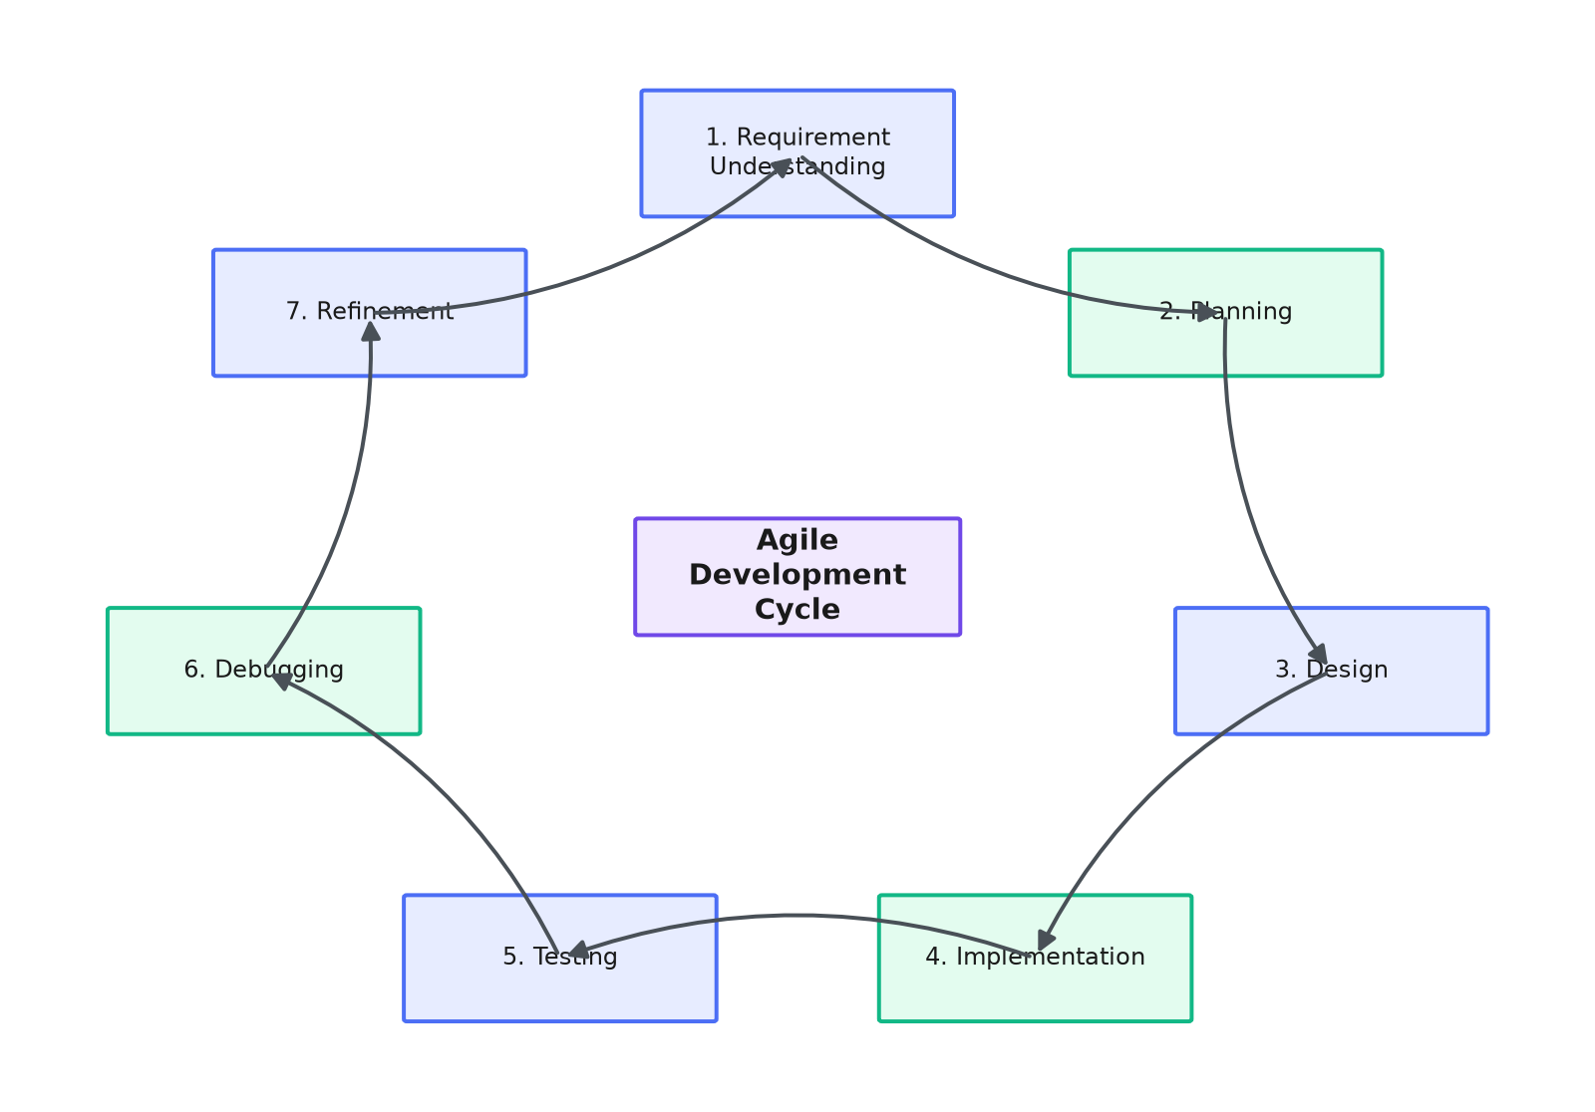
Figure 1.1 Agile Process Model Used for EduLearn Development.
Figure 1.1 illustrates the Agile-based development process followed for EduLearn. Development activities were performed progressively, with each module implemented, verified against the live system, and refined before the next was layered on top.

1.5 Feasibility Study
Before developing EduLearn, a feasibility study was conducted to determine whether the project was practical and achievable using the available technical, financial, and operational resources. The feasibility of EduLearn was analyzed from three perspectives: technical feasibility, economic feasibility, and operational feasibility.

1.5.1 Technical Feasibility.
EduLearn is technically feasible because it is developed using established, well-documented, and widely used web development technologies. The application is built using ASP.NET Core MVC (.NET 10) and C#, with Entity Framework Core for database operations and Microsoft SQL Server as the relational database engine.
The system also uses Google OAuth 2.0 for the instructor-onboarding access-request flow, MailKit-based SMTP email delivery for OTP codes and workflow notifications, the bKash tokenized checkout API for payment processing, QuestPDF for certificate/receipt/report generation, Chart.js for administrative and reporting charts, and standard web technologies — HTML, CSS, Bootstrap 5, and JavaScript — for the user interface. All of these were successfully integrated and verified working during this practicum.
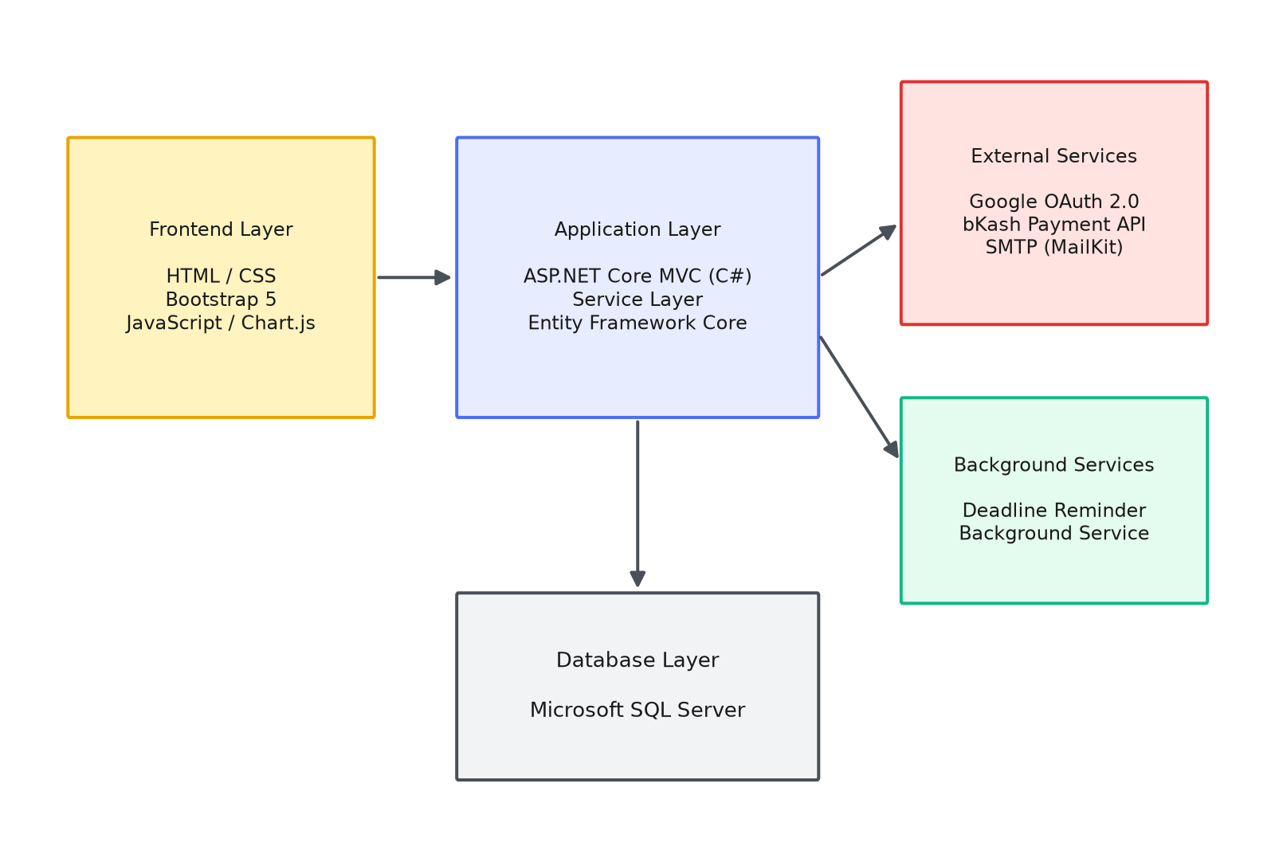
Figure 1.2 Technical Architecture and Technology Stack of EduLearn.
Figure 1.2 presents the major technologies and supporting services used to develop and operate EduLearn, combining ASP.NET Core MVC, C#, Entity Framework Core, and SQL Server with frontend technologies and external services such as Google OAuth 2.0, SMTP-based email, the bKash payment gateway, and QuestPDF.

1.5.2 Economic Feasibility.
EduLearn is economically feasible because the development environment primarily uses freely available and open-source technologies. ASP.NET Core, Entity Framework Core, Bootstrap, and the xUnit testing framework can be used for development without licensing costs; SQL Server Express is likewise free for development and small-scale deployment.
The system can also reduce operational dependency on manual, spreadsheet-based enrollment and payment tracking by centralizing course delivery, enrollment, payment, assessment, and reporting within a single platform, providing significant operational benefit without requiring substantial upfront investment in proprietary software.

1.5.3 Operational Feasibility.
EduLearn is operationally feasible because it is designed around the concrete responsibilities of its three user roles. The system provides separate access and permissions for Student, Instructor, and Admin, so each user is only ever presented with the functionality relevant to their responsibilities — for example, an Instructor cannot set their own course's price, and only an Admin can issue a refund.
The system centralizes course content, enrollment and payment records, assessment results, notifications, and reports. Automatic quiz grading, deadline enforcement, and PDF report generation reduce manual effort and improve the reliability of monitoring course activity. Therefore, the proposed system can support real course-delivery and administrative operations and is operationally feasible.
Table 1.1 Feasibility Summary.
Feasibility Type | Description | Conclusion
Technical Feasibility | The system uses available, well-documented technologies: ASP.NET Core MVC, C#, Entity Framework Core, SQL Server, Google OAuth 2.0, bKash, MailKit, and QuestPDF. | Technically Feasible
Economic Feasibility | The system primarily uses freely available development technologies and reduces dependency on manual enrollment/payment tracking. | Economically Feasible
Operational Feasibility | Role-based access, centralized course/enrollment/payment management, and automated reporting support real course-delivery operations. | Operationally Feasible

Table 1.1 summarizes the feasibility of EduLearn from technical, economic, and operational perspectives. The analysis indicates that the system is feasible using the available resources and technologies — and, unlike a purely theoretical feasibility study, this is additionally confirmed by the fact that the system was actually built, and every feature described in this report was verified working against a live running instance.

1.6 Structure of the Report
The report is organized into ten chapters, each focusing on a specific aspect of the practicum project. The chapters are arranged to present the development process progressively, from the introduction and organizational background to requirements, analysis, project management, planning, system design, testing, ethical considerations, and conclusion.
- Chapter 1 – Introduction: Presents the background of the study, methodology, objectives, process model, feasibility study, and structure of the report.
- Chapter 2 – Organizational Overview: Describes Touch & Solve Technologies Ltd., including its vision, services, organizational structure, and the student's role within it.
- Chapter 3 – Requirement Engineering: Presents the user, system, functional, and non-functional requirements of EduLearn.
- Chapter 4 – Analysis: Describes the system analysis using use case, activity, swimlane, and sequence models.
- Chapter 5 – Project Management: Discusses risk identification, analysis, planning, and RMMM strategies, grounded in issues actually encountered during development.
- Chapter 6 – Project Planning: Presents Function Point-based effort estimation, resource planning, and the development schedule.
- Chapter 7 – System Design: Describes the system architecture, internal interface design, data flow, entity relationships, and database design.
- Chapter 8 – Quality Assurance and Testing: Presents the testing methodology, test cases, and quality assurance activities performed to verify EduLearn's functionality and reliability.
- Chapter 9 – Ethical Considerations: Discusses privacy, security, fairness, and sustainability considerations relevant to a platform handling student data and payments.
- Chapter 10 – Conclusion: Summarizes the project outcomes, major contributions, limitations, and possible future improvements.

Chapter 2. Organizational Overview
Touch & Solve Technologies Ltd. is an IT company based in Dhaka, Bangladesh, that began its journey in 2009 with customized software development and expanded by 2011 into broader IT-enabled services, positioning itself as a system integrator for data centers, networking, surveillance, and IT solutions for government and non-government institutions. The company is headquartered at Plot 6 (3rd & 6th Floor), Road 1/A, Sector 17, Uttara, Dhaka 1230, Bangladesh.
The company builds standard, fully responsive website development services along with mobile and desktop application development, and additionally offers ICT solutions, IT infrastructure and LAN-Wifi services, customized software (POS, Institute Management, Hospital Management), networking solutions, CCTV, and time-attendance systems. Over the years, the company has served a large number of corporate and institutional clients across Bangladesh.

2.1 Organization Vision
Touch & Solve Technologies Ltd. positions its work within the broader vision of a smart, digitally-enabled Bangladesh — helping government and private institutions modernize their operations through well-designed, dependable software and IT infrastructure.

2.2 Organization Mission
The company's mission is to design, develop, and support standard and customized software solutions — from responsive websites to institute and hospital management systems — while building long-term technical partnerships with its clients through reliable IT infrastructure, networking, and surveillance services.

2.3 Organization Services
- Website Design and Development — responsive, fully custom website development for corporate and institutional clients.
- Web and Application Development — customized web applications and mobile/desktop application development.
- Software Development Solutions — customized POS, Institute Management, and Hospital Management software.
- IT Infrastructure and Networking — LAN/Wi-Fi design and deployment, data center and campus networking.
- Surveillance and Security Systems — CCTV and time-attendance solutions.
- ICT Solutions for Government and Non-Government Institutions — system integration services for public and private sector clients.

2.4 Organizational Structure
The organogram of the organization is shown in Figure 2.1.
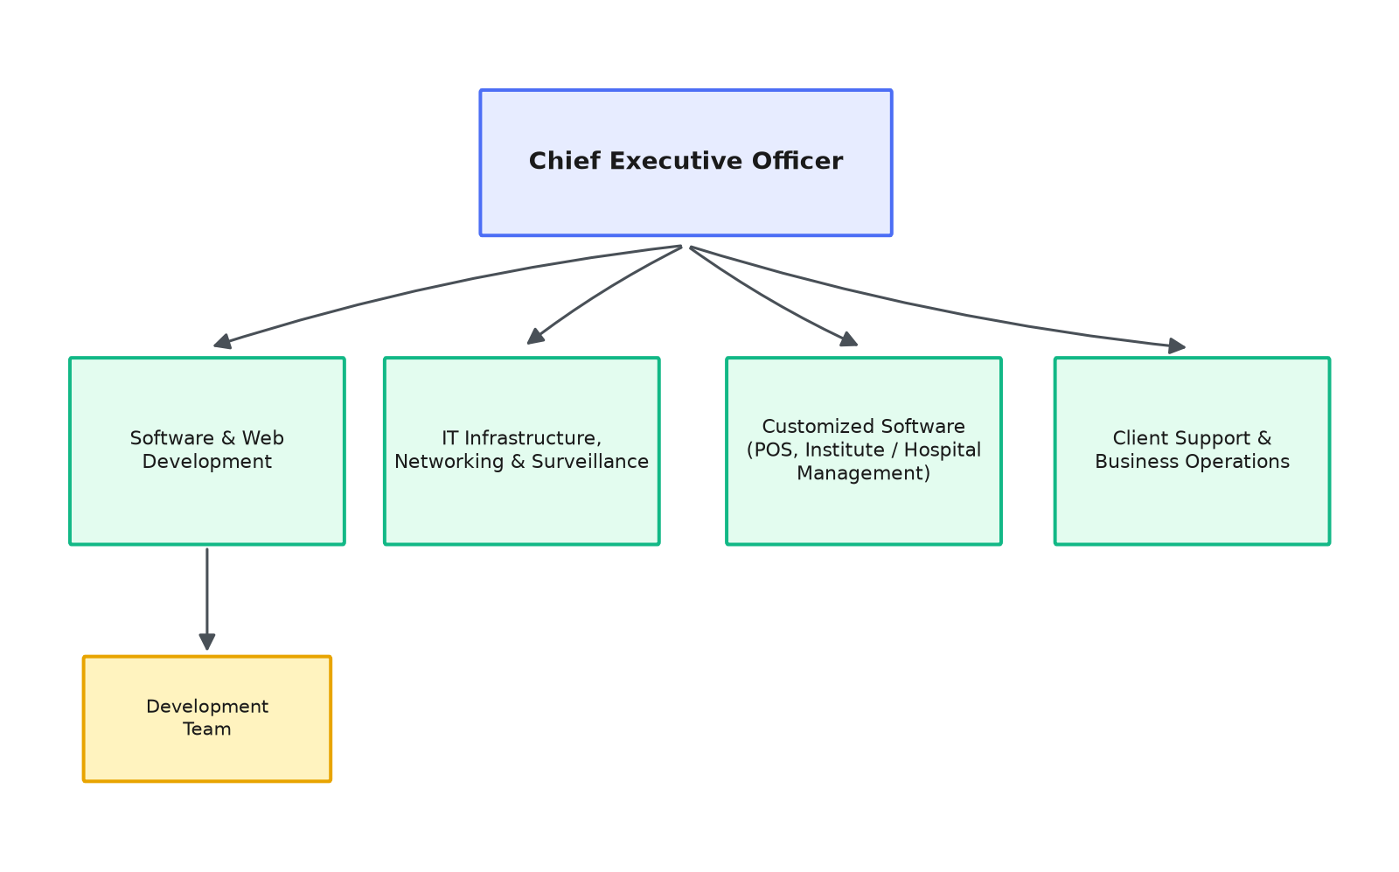
Figure 2.1 Organizational Structure of Touch & Solve Technologies Ltd.

2.5 My Position in this Organization
At Touch & Solve Technologies Ltd., I worked as a Web Development Intern. My role focused on the design, development, and testing of web-based applications under the guidance of the company's development team. During my internship, I was engaged in full-stack web application development, which directly informed and complemented the independent design and development of the EduLearn platform described in this report.
My responsibilities included assisting with web application development tasks, applying ASP.NET Core MVC and C# in practical assignments, working with relational databases, and gaining exposure to real client-facing software development workflows. Internship period: [Start Date] to [End Date].
This position provided valuable hands-on exposure to professional software development practice and reinforced the technical and problem-solving skills applied throughout the independent development of EduLearn.

2.6 Address of the Organization
Touch & Solve Technologies Ltd.
Plot 6 (3rd & 6th Floor), Road 1/A, Sector 17, Uttara, Dhaka 1230, Bangladesh.
Phone: +880 1958227203 / +880 1958227200
Email: info@touchandsolve.com
Website: www.touchandsolve.com

Chapter 3. Requirement Engineering
Requirement Engineering is the systematic process of identifying, analyzing, documenting, validating, and managing the requirements of a software system. It establishes a clear understanding of the functions the system must provide, the users who will interact with it, and the constraints under which it must operate. Proper requirement engineering helps reduce ambiguity, control project scope, and provides a strong foundation for system analysis, design, implementation, and testing.
For EduLearn, requirement engineering was carried out by analyzing the operational workflow of course delivery, enrollment and payment, assessment, instructor onboarding, and platform administration. Requirements were refined throughout development as live testing against the running application revealed gaps between intended and actual behavior — most notably around course pricing authority, instructor-application security, and Admin/Instructor content-preview access, each of which prompted a requirement correction that is reflected in the functional requirements below.

3.1 Requirement Analysis
The requirements of EduLearn are organized into three major categories: User and System Requirements, Functional Requirements, and Non-Functional Requirements.
Table 3.1 Requirement Categories.
Requirement Category | Description
User and System Requirements | Defines the system users, roles, access privileges, and major system expectations.
Functional Requirements | Defines the specific operations and services provided by EduLearn.
Non-Functional Requirements | Defines security, performance, reliability, usability, scalability, maintainability, and data integrity requirements.

3.1.1 User and System Requirements
EduLearn supports three roles with different responsibilities and access privileges. The system must ensure that each user can access only the functions permitted for their role.
- Users must be able to securely register, log in, and log out of EduLearn. Self-registration verifies the new account's email through a one-time code before the account is created, and only ever creates Student accounts — becoming an Instructor requires the separate access-request pipeline. Passwords must be securely hashed before storage, and the system must maintain authenticated sessions using cookie-based authentication.
- The system must support role-based access control for Student, Instructor, and Admin. Each role must have separate permissions, navigation, and access restrictions, enforced via [Authorize(Roles = "...")] on controllers/actions, not merely hidden in the UI. Admin must have the highest level of system management authority, including sole authority over course pricing.
- Administrators must be able to manage system users and monitor platform activity, including reviewing and approving/denying instructor access requests and full applications, and maintaining an IsRejected/IsActive status so deactivated or rejected accounts are excluded from active-user counts and lists consistently.
- The system must provide centralized course management, supporting course creation, editing, and deletion, gated by an Admin approval workflow that also sets the course's price. Any edit to an already-approved course must return it to Pending for re-review before the change goes live.
- The system must support structured course content and enforced deadlines. Assignments and Quizzes must carry a due date and time, and the system must reject (server-side, not just hide the button for) any submission or attempt made after that deadline has passed. Quizzes must be automatically graded against their correct-option data at submission time.
- The system must support a secure, self-service instructor-onboarding flow: a visitor requests instructor access via Google OAuth or a typed email address, an Admin must approve the request, and approval emails a unique link and a 6-digit one-time code that must expire and be rate-limited before the applicant can reach the actual application form.

3.1.2 Functional Requirements
The functional requirements describe the specific operations and services that EduLearn must provide to its users.

User Authentication and Authorization
- Users must be able to register (Student, with OTP-verified email) and log in using valid credentials.
- The system must verify passwords using ASP.NET Core Identity's secure password hashing.
- Unauthorized users must not be able to access protected Instructor or Admin controllers/actions, independent of what the navigation menu shows.
- Users must be redirected to a role-appropriate landing page after login, and deactivated users must not be permitted to access the system.

Instructor Access Request and Onboarding
- A request may be created via Google OAuth or a typed, validated email address; a second request from the same still-pending email must not create a duplicate row.
- Admin approval must generate a cryptographically random one-time code and access token, and must email both together.
- The code-entry action must independently verify the request is Approved, not already consumed, not expired, and under the maximum attempt count — on every attempt, not only the first.
- Only after successful code verification does the session gain access to the actual application form.

Course Management
- Instructors must be able to create, edit, and delete their own courses, but must not be able to set or change their own course's price.
- Admin must be able to approve a Pending course, choosing at that moment whether it is Free or setting a fixed price, or reject it with an optional reason emailed back to the Instructor.
- Admin must be able to edit the price of, or permanently delete, any course at any time from Manage Courses.

Content Authoring
- Instructors must be able to add Modules, Lessons, Assignments, and Quizzes under their own courses.
- Assignment and Quiz creation forms must accept both a date and a time for the due date.
- Quiz authoring must accept a title, multiple-choice questions with marked correct options, a pass-mark percentage, a time limit, and a due date.

Enrollment and Payment
- Free-course enrollment must be created immediately as Active; paid-course enrollment must be created as Pending in the student's Cart.
- The Cart must allow applying one coupon code, computing and displaying the discounted total before checkout.
- Checkout must be processed through the bKash gateway; on a successful callback, the enrollment must flip to Active and a Payment record created.
- Admin must be able to refund a successful payment, reverting the enrollment to Pending and notifying the student.

Lesson Progress, Quizzes, and Assignments
- Students must be able to mark a lesson complete; progress percentage must be computed as completed lessons ÷ total lessons for that course.
- Quiz submissions must be graded automatically by QuizGrader against stored correct answers, updating in place on retake rather than accumulating duplicate rows.
- Both quiz attempts and assignment submissions must be rejected — server-side, on every entry point — once the item's due date has passed.

Certification, Reviews, Notifications, Reporting
- A certificate must only be downloadable once every lesson in the course is marked complete for that student.
- Students must be able to write a review only after completing a course, and edit it afterward; one review per student per course.
- The system must create a Notification row for events including course approval/rejection, new enrollment, and instructor onboarding decisions, visibly distinguished as unread versus read.
- Instructors and Admin must be able to view a student roster and generate weekly/monthly activity reports, exportable as PDF; Admin additionally has platform-wide Revenue and Course Analytics reports.

Admin/Instructor Content Preview
- Admin and Instructor accounts must be able to open and read any course's lessons, assignments, and quizzes — including paid courses they have not purchased — without an enrollment record being created.
- Because they are previewing, not taking the course, the interactive “Mark as Complete,” “Submit Assignment,” and “Take Quiz” controls must not be shown to them on those pages.

3.1.3 Non-Functional Requirements

Security
- The system must authenticate users before allowing access to protected modules, and passwords must never be stored as plain text.
- Role-based authorization must restrict access to role-specific controllers and actions at the server, not only via hidden UI elements.
- The instructor one-time code must be rate-limited and time-limited so it cannot be brute-forced even by someone who has obtained the access-token link.
- Google OAuth must be used only to read a verified email and must never create a persistent site login on its own.
- Uploaded files must be validated against allowed extensions and size limits before being persisted.

Performance
- The system should remain responsive during normal interactive use.
- Roster and activity-report queries must be built to avoid N+1 query patterns.
- Pagination must be used for course listings and other potentially large result sets.

Reliability
- Enrollment, payment, and refund state must remain consistent — a refund must always revoke the access it granted.
- Quiz retakes must update the existing result row in place rather than creating duplicate history.
- A course edited by its Instructor must always return to Pending, never silently stay Approved with unreviewed changes live.

Usability
- Each role must have a dashboard and navigation appropriate to its responsibilities.
- Deadlines, statuses, and validation errors must be shown in plain, specific language.
- Notifications must make unread items visually obvious at a glance.

Scalability and Maintainability
- The application must follow the MVC architecture with business/report/calculation logic factored into static Service classes rather than left inside controllers.
- ViewModels must be used to separate view-facing data shapes from database entities where the two diverge.
- New features should be addable through new Services/Controllers/Views following the existing pattern without restructuring what already exists.

Data Integrity
- Primary and foreign keys must maintain valid relationships between Users, Courses, Enrollments, Payments, Quizzes, Assignments, and their submissions/results.
- A rejected instructor application's account is deleted, but its details are preserved in a standalone archive table for audit purposes.
- Required fields must be validated server-side, not only client-side.

3.2 Use Case Diagram of the System

3.2.1 Use Case Diagram
The Use Case Diagram provides a high-level representation of EduLearn's functional scope. It identifies the major actors — Student, Instructor, and Admin — and illustrates the principal functions available to each, focusing on what each actor can do rather than how it is implemented internally.
Table 3.2 The major actor responsibilities.
Actor | Major Use Cases
Student | Register/Login, Browse Courses, Enroll (Free/Paid), Cart & Coupon, Checkout, View Lessons, Mark Complete, Take Quiz, Submit Assignment, Write/Edit Review, Download Certificate/Receipt, View Notifications, Chat with Assistant
Instructor | Login, Create/Edit/Delete Course, Author Modules/Lessons/Assignments/Quizzes, View Reviews & Reply, View Quiz Results, View Student Roster, View/Export Activity Report
Admin | Login, Manage Users, Manage Categories, Approve/Reject Course (set Price), Manage Courses (Edit Price/Delete), Approve/Deny Access Request, Approve/Reject Full Application, View Course Overview (any course), View/Export Revenue & Analytics Reports, Manage Payments/Refunds, Manage Coupons

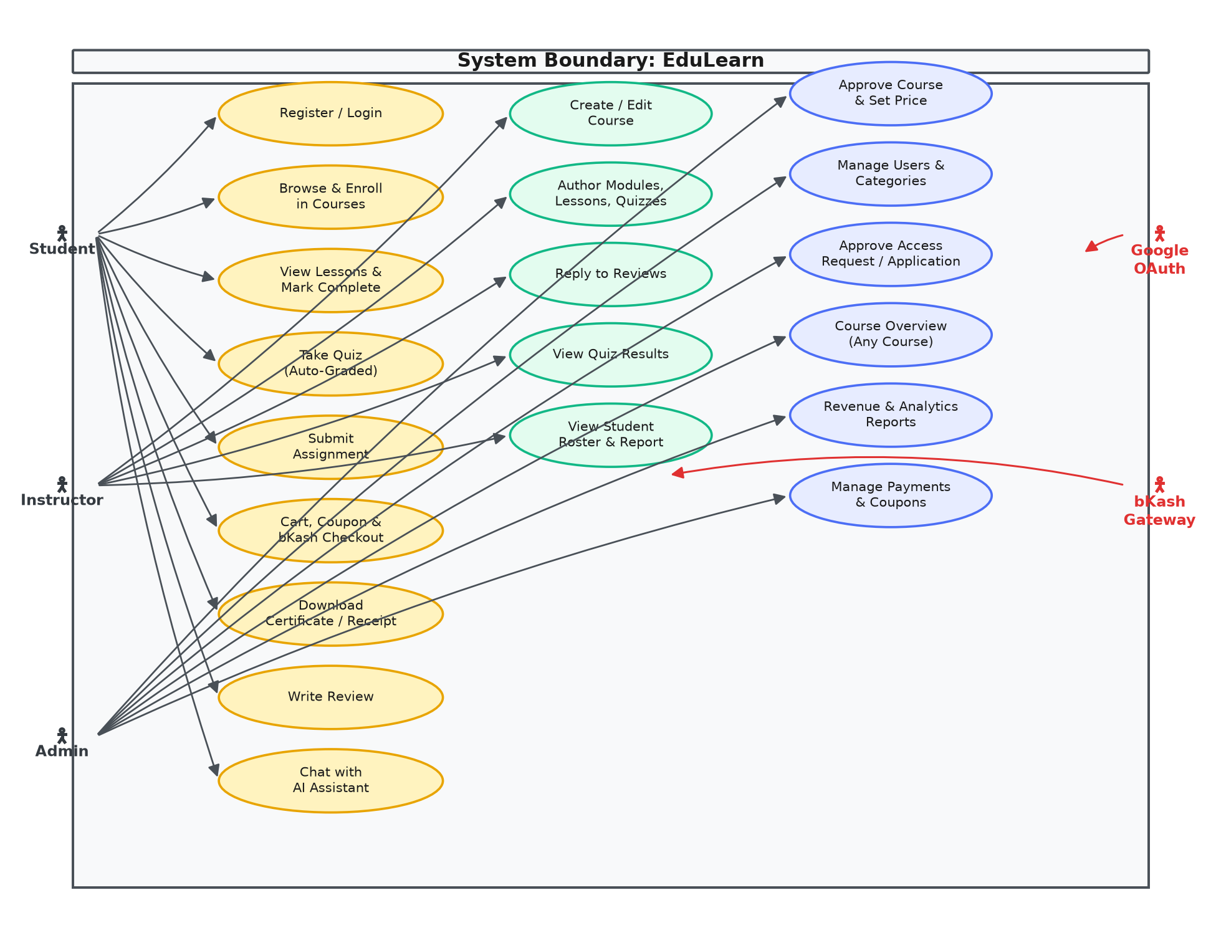
Figure 3.1 Use Case Diagram of EduLearn.
Figure 3.1 illustrates the major actors and their interactions with EduLearn, including authentication, course management, enrollment and payment, assessment, and administration.

Chapter 4. Analysis
Analysis modeling provides a structured representation of the functional and behavioral aspects of a software system. It combines textual descriptions with graphical models to explain how users interact with the system, how activities are performed, and how different system processes are connected.
For EduLearn, the analysis phase focuses on the activities performed by the three roles and on the interaction between users and the platform. Since the system follows a role-based architecture, separate activity diagrams have been prepared for the Admin, Instructor, and Student, plus a dedicated diagram for the instructor access-request and onboarding flow, since it is the most security-sensitive and multi-step process in the system. Swimlane and sequence diagrams are then used to represent interaction between actors and system components for the course-approval-and-enrollment process and the quiz auto-grading process.

4.1 Activity Diagrams
An activity diagram is a behavioral UML diagram that represents the flow of activities within a system or a particular business process, showing the starting point, the activities performed, decision points, alternative flows, and completion.
After successful authentication, each EduLearn user is redirected to a role-specific landing area (Admin Dashboard, Instructor “My Courses,” or the public course catalog for Students), with role-appropriate navigation available throughout.

4.1.1 Activity Diagram of Admin Activities.
The Admin Activity Diagram represents the major activities performed by the platform administrator. The process begins with Admin authentication. After successful login, the Admin can navigate to Manage Users, Manage Categories, Pending Courses, Manage Courses, Access Requests, Revenue/Analytics reports, Payments, or Coupons.
Through Pending Courses, the Admin reviews a newly submitted or edited course and either approves it — choosing Free or a fixed price at that moment — or rejects it with an optional reason emailed to the Instructor. Through Manage Courses, the Admin can edit the price of, or permanently delete, any course regardless of status. Through Access Requests, the Admin approves or denies instructor onboarding requests; approval triggers the one-time-code email.
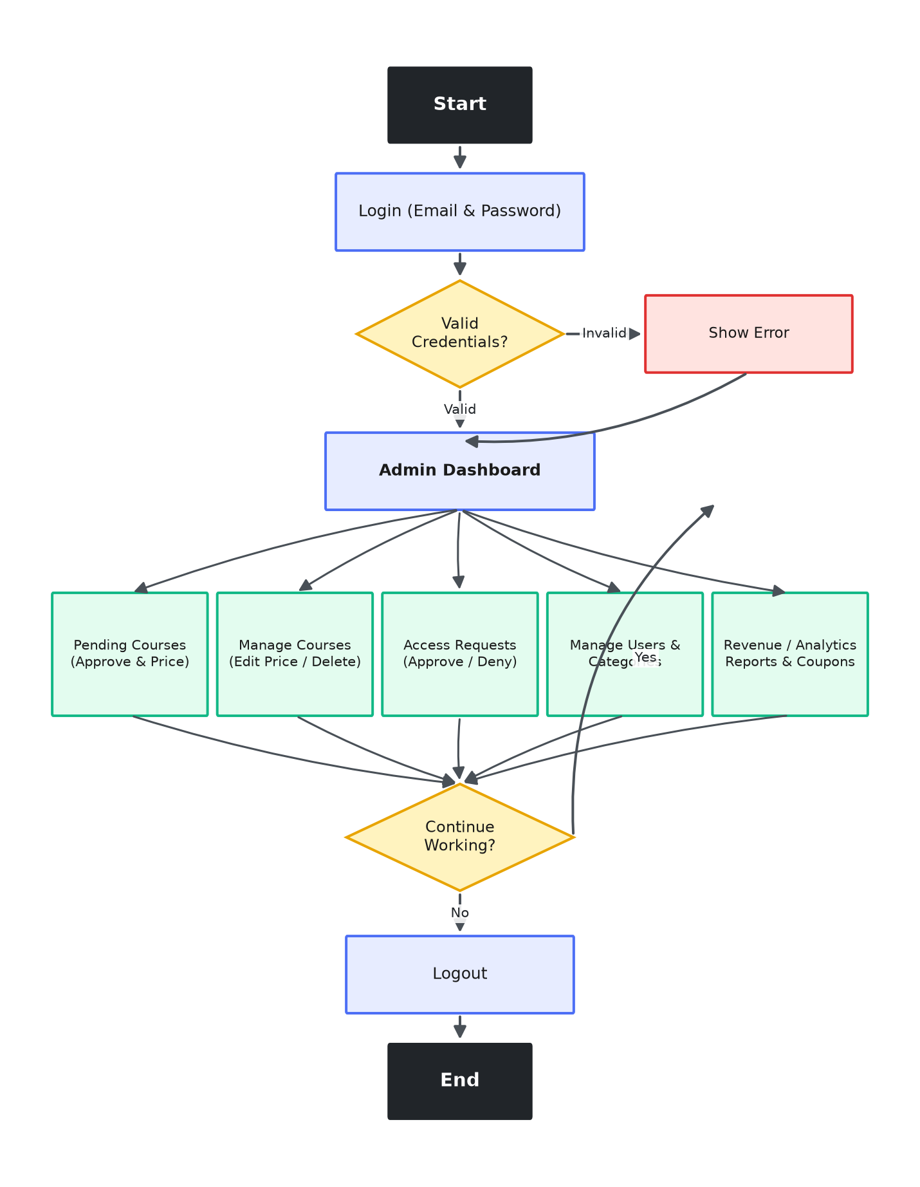
Figure 4.1 Activity Diagram of Admin Activities.
Figure 4.1 illustrates the major activities performed by the Admin.

4.1.2 Activity Diagram of Instructor Activities.
The Instructor Activity Diagram represents the workflow followed by an Instructor after successful authentication. After login, the Instructor lands on “My Courses,” listing their own courses with status badges (Pending/Approved/Rejected).
From here, the Instructor can create a new course (submitted as Pending, with no price field), edit an existing course (which returns it to Pending for re-review), or manage a course's content: adding Modules, Lessons, Assignments, and Quizzes. The Instructor can review student feedback and reply to it, review quiz results across their courses, and — for any one course — open its Students roster or generate a weekly/monthly activity report.
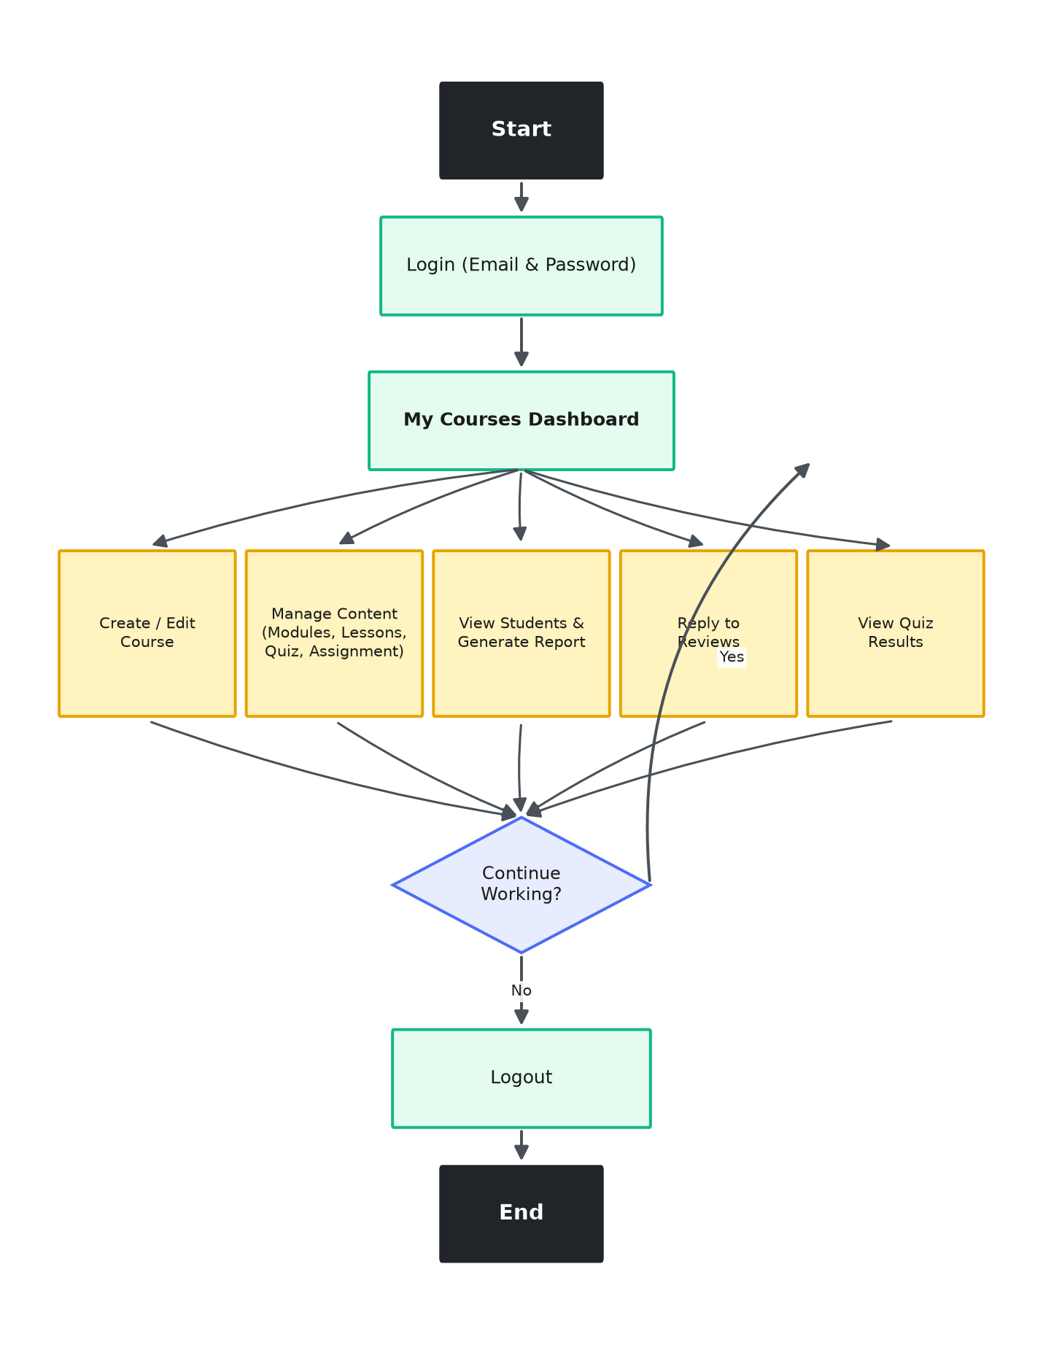
Figure 4.2 Activity Diagram of Instructor Activities.
Figure 4.2 illustrates the major activities performed by the Instructor.

4.1.3 Activity Diagram of Student Activities
The Student Activity Diagram represents the core learning workflow of EduLearn. After login (or while browsing anonymously), the Student can search and filter the course catalog and open a course's details page.
For a free course, clicking Enroll immediately creates an Active enrollment. For a paid course, enrollment creates a Pending entry in the Student's Cart, where a coupon code may optionally be applied before proceeding to bKash checkout. Once enrolled, the Student opens lessons, marks them complete, attempts quizzes (auto-graded on submission, blocked once the due date has passed), and submits assignment files. Once every lesson in a course is complete, a certificate becomes downloadable, and the Student can write a review.
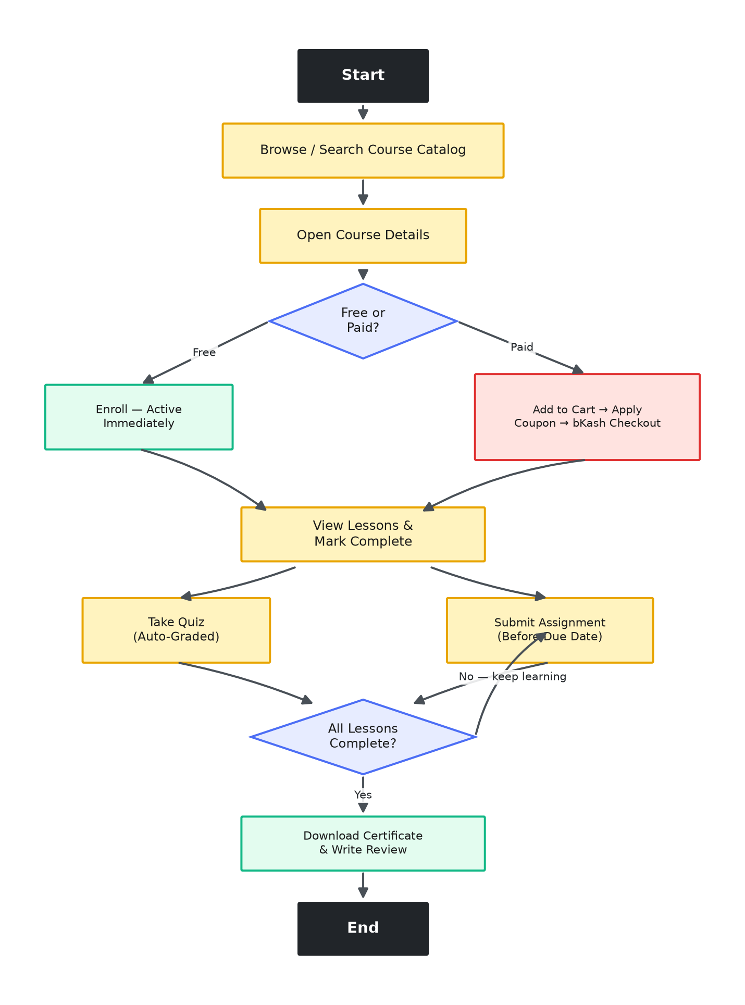
Figure 4.3 Activity Diagram of Student Activities.
Figure 4.3 illustrates the major activities performed by the Student.

4.1.4 Activity Diagram of the Instructor Access-Request and Onboarding Flow
This activity diagram represents the complete, multi-actor process by which a member of the public becomes an approved Instructor — the most security-sensitive workflow in EduLearn, and the one most revised during development.
The process begins when a visitor opens /Apply and chooses Continue with Google (triggering an OAuth challenge; the system reads only the verified email claim and immediately signs the transient external-login cookie back out, so this never becomes a persistent site login) or Continue with Email. Either path creates a Pending InstructorAccessRequest row and notifies every Admin. An Admin reviews the request and either denies it or approves it — approval generates a cryptographically random 6-digit code and a separate unguessable access token, sets a 24-hour expiry, and emails both together.
The applicant clicks the link, submits the code, and the system checks — on every submission, not just the first — whether the request is still Approved, not already consumed, not expired, and under the maximum of 5 incorrect attempts. A correct code redirects to the actual application form, unchanged from before this flow existed. On submission, the system creates the account, marks the request consumed, and notifies every Admin of the new full application. Finally, an Admin reviews the full application and approves (emailing a self-service password-setup link) or rejects (archiving and deleting the account) it.
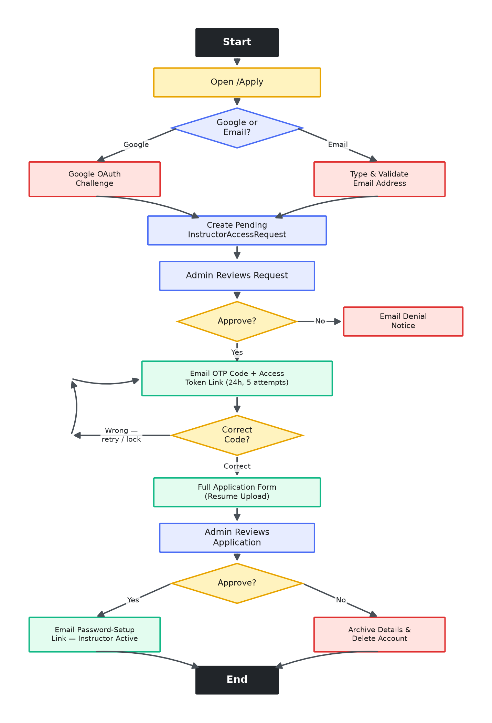
Figure 4.4 Activity Diagram of the Instructor Access-Request and Onboarding Flow.
Figure 4.4 illustrates the complete instructor-onboarding workflow, from the initial Google/email request through Admin approval, one-time-code verification, full application, and final Admin review.

4.2 Swim Lane Diagram
A swim lane diagram is a specialized form of an activity diagram that divides a workflow into separate lanes according to the actors or system components responsible for performing each activity. It is useful for processes involving multiple participants because it clearly identifies who performs each activity and how responsibility transfers between them.

4.2.1 Swim Lane Diagram of Course Approval and Enrollment
The swim lane diagram represents the interaction between the Instructor, EduLearn System, Admin, and Student across the full path from course authoring to paid enrollment.
The process begins when the Instructor creates a course and its content; the System stores it as Pending. The Admin reviews it and approves it, setting its price at that moment (or rejects it, with the reason emailed back to the Instructor). Once Approved, the course becomes visible in the public catalog. A Student browses to it; if free, the System creates an Active enrollment immediately; if paid, the System creates a Pending enrollment in the Student's Cart. The Student optionally applies a coupon and proceeds to bKash checkout; on a successful payment callback, the System activates the enrollment.
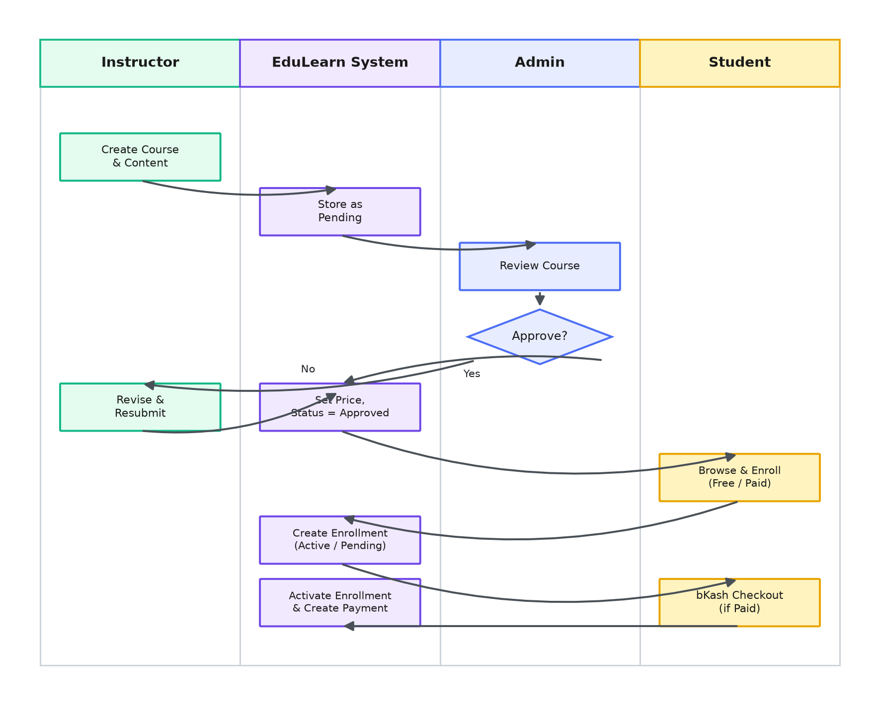
Figure 4.5 Swim Lane Diagram of Course Approval and Enrollment.
Figure 4.5 illustrates the distribution of activities among the Instructor, System, Admin, and Student across course authoring, approval and pricing, and paid enrollment.

4.3 Sequence Diagrams
A sequence diagram represents the chronological interaction between actors and system components, showing how a request moves through different components and how each responds during a particular operation.

4.3.1 Sequence Diagram of Course Approval Flow
The process begins when the Admin opens Pending Courses and submits an approval decision — Free, or a specific price — through a confirmation modal. The request is processed by AdminController.ApproveCourse, which sets the course's Price and flips its Status to Approved, clears any prior rejection reason, and persists the change through Entity Framework Core. NotificationService then creates a Notification row for the course's Instructor.
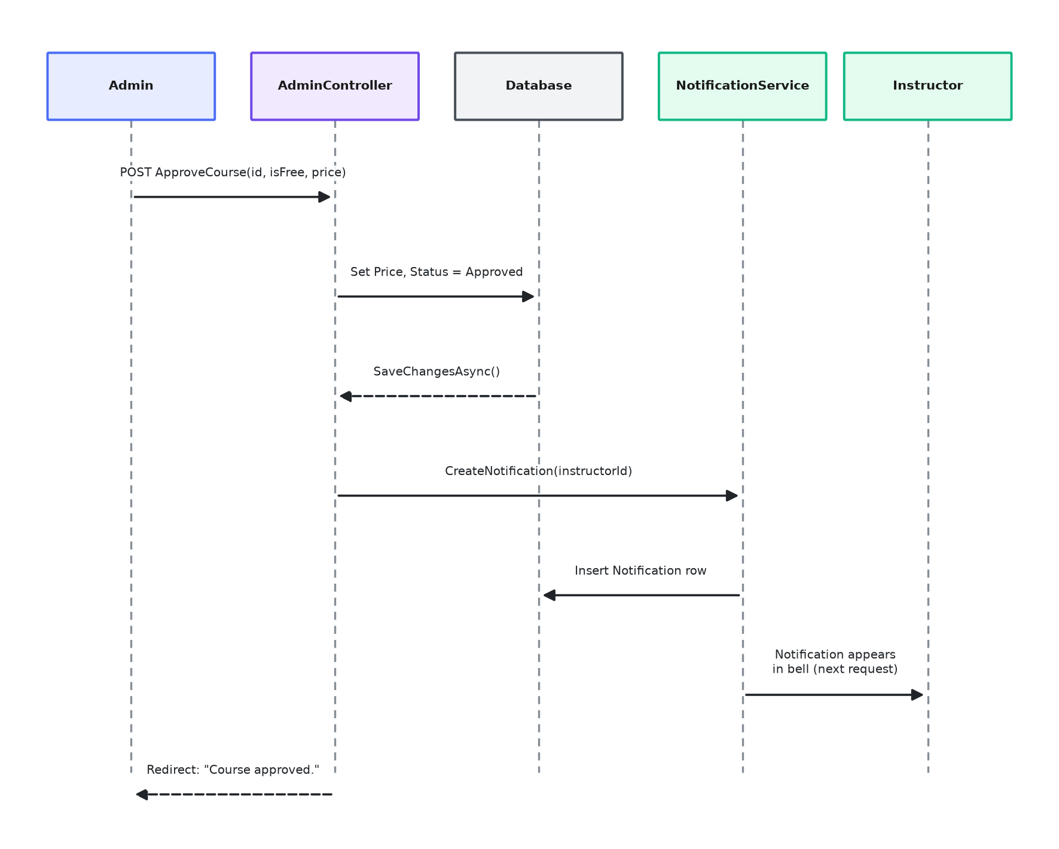
Figure 4.6 Sequence Diagram of Course Approval Flow.
Figure 4.6 illustrates the sequence of interactions involved in an Admin approving and pricing a course.

4.3.2 Sequence Diagram of Quiz Attempt and Auto-Grading Flow
The Student opens a lesson and selects Take Quiz; CourseController.TakeQuiz first checks the quiz's due date and, if it has passed, redirects back to the lesson with an explanatory message instead of rendering the quiz. On submission, CourseController.SubmitQuiz re-checks the due date independently, then passes the quiz and the student's selected option IDs to the static QuizGrader service, which compares selections against the stored correct answers and returns a score and pass/fail outcome. The controller then either updates the student's existing QuizResult row in place (on a retake) or inserts a new one.
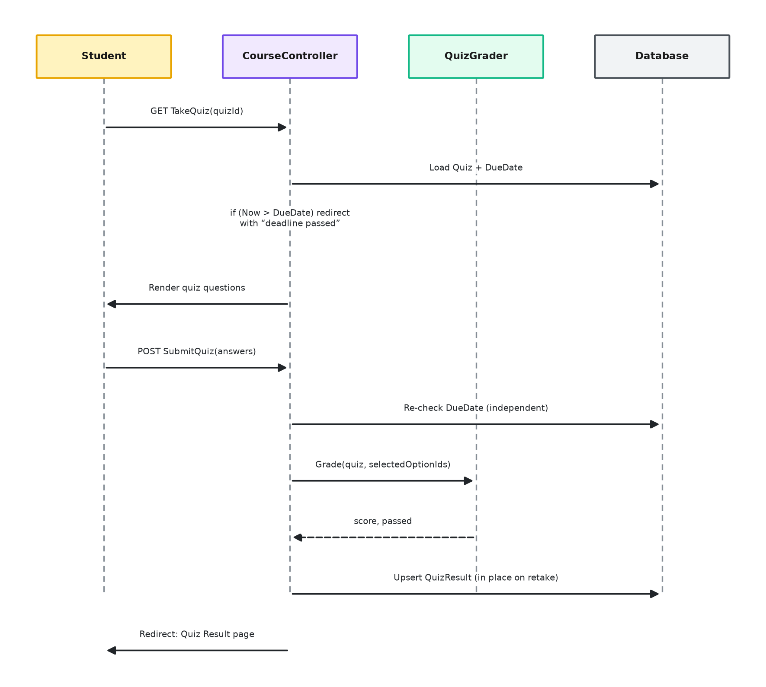
Figure 4.7 Sequence Diagram of Quiz Attempt and Auto-Grading Flow.
Figure 4.7 illustrates the sequence of interactions involved in a quiz attempt, including the due-date check performed independently at both the display and submission steps.

Chapter 5. Project Management
Project management is an essential part of software development because it provides a structured approach for planning, organizing, monitoring, and controlling project activities. Effective project management helps ensure that the system is developed within the available time and resources while maintaining the required quality and functionality.
For EduLearn, project management focused on identifying potential risks, analyzing their probability and impact, and defining mitigation and management strategies. Because this project involved third-party OAuth and payment gateway integration, real money-handling logic, and a locally-hosted database, several of the risks identified below were not merely theoretical — they were actually encountered during development, and this chapter documents both the anticipated risk and, where applicable, what actually happened and how it was resolved.

5.1 Risk Identification
Risk identification is the process of recognizing potential events or conditions that may negatively affect a software project's development, functionality, security, schedule, or quality. For EduLearn, risks were identified by considering the system architecture, third-party integrations (Google OAuth, bKash), the local database environment, security requirements, and evolving requirements.
- Google OAuth 2.0 integration issues in the instructor access-request flow
- bKash payment gateway integration and callback-handling issues
- Local SQL Server Express reliability and connectivity issues during development
- Unauthorized access or incorrect role-based permissions
- File upload and validation issues (résumés, submissions, profile pictures)
- Email/SMTP notification delivery failures, including incorrect link generation
- Database performance and data-integrity issues as roster/report queries grew more complex
- Changing requirements during development (most notably, course-pricing authority)
Probability Scale — Very Low: <10%; Low: 10–25%; Moderate: 25–50%; High: 50–75%; Very High: >75%.
Risk Effect Scale — Catastrophic: may cause major system failure or prevent successful completion. Serious: may significantly delay development or affect an important function. Tolerable: may cause manageable delays. Insignificant: minimal effect on progress.

5.2 Risk Analysis
Table 5.1 Risk Analysis Table for EduLearn.
ID | Possible Risk | Type | Prob. | Effect | RMMM Plan
R01 | Google OAuth integration may be misconfigured or fail. | Technical / External | Moderate | Serious | Gate the button/challenge behind a config check; verify generated URLs live.
R02 | bKash checkout/callback may fail to activate an enrollment or reconcile a payment. | Technical / External | Moderate | Serious | Centralize payment handling; verify enrollment status against the live DB.
R03 | Local SQL Server Express may become slow/unresponsive. | Environment | High | Serious | Diagnose via service/memory checks; restart affected process/service.
R04 | Incorrect role-based authorization may allow unauthorized access. | Security | Low | Catastrophic | Enforce authorization at the controller/action level; verify per role live.
R05 | Uploaded files may contain unsupported types or exceed size limits. | Technical / Security | Moderate | Tolerable | Centralize validation in FileUploadService; reject before persistence.
R06 | Email notifications may fail, or a generated link may be malformed. | Integration | Moderate | Serious | Centralize email through IEmailService; verify links by following them.
R07 | Roster/report queries may become slow (N+1) as data grows. | Database | Low | Serious | Batch aggregation in CourseRosterService/CourseReportService.
R08 | Business requirements may change during development. | Requirements | Moderate | Tolerable | Evaluate blast radius before implementing; keep logic in one owned service.

The analysis shows that the most significant realized risk during this practicum was environmental (R03 — local database reliability), not purely a coding defect: several development sessions were interrupted by SQL Server Express becoming unresponsive under memory pressure or after a forced process kill left stale connections behind. The second most instructive realized risk was R06, where a genuinely subtle ASP.NET Core routing behavior — Url.Action silently inheriting the ambient Area value from the calling controller — produced a broken link in a real, sent email; this was only caught because the resulting page was actually clicked, not because the code “looked correct.”

5.3 Risk Planning
Table 5.2 Risk Planning Table for EduLearn.
ID | Name of the Risk | Strategy if the Risk Occurs
R01 | Google OAuth Integration Failure | Confirm client credentials/redirect URI; hide the Google option and keep email available if unconfigured.
R02 | bKash Checkout/Callback Failure | Inspect callback payload/status; manually correct enrollment/payment state if inconsistent.
R03 | SQL Server Express Unresponsive | Check service status/memory first; restart the service or terminate the stuck process.
R04 | Unauthorized Role Access | Review [Authorize] attributes and role checks; retest the affected page as each role.
R05 | Invalid File Upload | Reject with a specific validation message; confirm with a real oversized/wrong file.
R06 | Email/Link Delivery Failure | Rebuild the link with an explicit route/area override; resend and follow the link end-to-end.
R07 | Roster/Report Query Performance | Refactor to batch queries; re-verify against a manual database count.
R08 | Changing Requirements | Scope the change tightly; add/update automated tests; retest the full workflow live.

5.4 RMMM Plans
RMMM stands for Risk Mitigation, Monitoring, and Management. The plans below focus on the risks with the greatest relevance to EduLearn's architecture and the ones actually realized during development.

5.4.1 RMMM 01 — Google OAuth Integration
Table 5.3 RMMM Plan No. 1.
Item | Description
Name | Google OAuth Integration Failure
Probability | Moderate
Impact | Serious
Risk ID | R01
Risk Type | Technical / External Service

Description: The instructor access-request flow depends on Google OAuth 2.0. Missing or invalid client credentials, or an unregistered redirect URI, would prevent the flow from completing.
Mitigation: The scheme is registered only when a Client ID and Secret are present; if absent, the button is hidden and the challenge action redirects safely instead of throwing.
Monitoring: Verified live end-to-end — a real Google account was used to complete the challenge, and the resulting captured email and created access-request row were confirmed in the database.
Management: If credentials are revoked, the email-only fallback keeps onboarding usable while the integration is corrected.
Current Status: Mitigated and verified working, including the graceful fallback when unconfigured.

5.4.2 RMMM 02 — bKash Payment Gateway Integration
Table 5.4 RMMM Plan No. 2.
Item | Description
Name | bKash Checkout/Callback Failure
Probability | Moderate
Impact | Serious
Risk ID | R02
Risk Type | Technical / External Service

Description: Enrollment activation for paid courses depends on a successful bKash agreement and payment callback. A failed or malformed callback could leave a student's payment taken without access activated.
Mitigation: Payment handling is centralized in BkashController/BkashPaymentService; enrollment status transitions are handled as an explicit, single responsibility.
Monitoring: Enrollment and Payment table state was checked directly against the database after test checkouts and refunds, not inferred from the UI alone.
Management: A mismatch is corrected directly via the Admin refund action, designed to always revoke access when it reverts a payment.
Current Status: Mitigated through centralized payment handling and direct database verification.

5.4.3 RMMM 03 — Local Database Reliability
Table 5.5 RMMM Plan No. 3.
Item | Description
Name | SQL Server Express Unresponsive / Memory Pressure
Probability | High
Impact | Serious
Risk ID | R03
Risk Type | Environment / Infrastructure

Description: The local SQL Server Express instance repeatedly became slow or fully unresponsive, on at least one occasion becoming stuck in a “Stop Pending” state that a normal restart could not clear.
Mitigation: Diagnosed via service/process status and system memory checks before assuming an application defect; when stuck, the underlying sqlservr.exe process was identified by PID and terminated directly.
Monitoring: Reconfirmed connectivity with a trivial SELECT 1 query before resuming testing.
Management: Treated as an environmental risk to manage around (restart discipline, memory hygiene) rather than an application defect to fix.
Current Status: Managed; recurred multiple times and was resolved the same way each time once correctly diagnosed.

5.4.4 RMMM 04 — Unauthorized Role Access
Table 5.6 RMMM Plan No. 4.
Item | Description
Name | Unauthorized Role-Based Access
Probability | Low
Impact | Catastrophic
Risk ID | R04
Risk Type | Security

Description: EduLearn contains roles with materially different trust levels, including Admin actions that must never be reachable by a Student or Instructor.
Mitigation: Every sensitive controller/action carries an explicit [Authorize(Roles = "...")] attribute; Instructor-scoped actions additionally filter by course ownership in the query itself.
Monitoring: Verified by attempting to reach Instructor-only and Admin-only URLs directly while authenticated as a different role.
Management: Any authorization gap found is closed at the controller/action level first; UI-level hiding is treated as a usability nicety, never the actual security boundary.
Current Status: Mitigated through consistent role- and ownership-based authorization, verified live per role.

5.4.5 RMMM 05 — File Upload Validation
Table 5.7 RMMM Plan No. 5.
Item | Description
Name | Invalid or Oversized File Upload
Probability | Moderate
Impact | Tolerable
Risk ID | R05
Risk Type | Technical / Security

Description: EduLearn accepts several kinds of user-uploaded files — instructor résumés, profile pictures, course thumbnails, and assignment submissions — each with different acceptable types and size limits.
Mitigation: FileUploadService centralizes extension and size validation for every upload path.
Monitoring: Invalid uploads were tested directly and confirmed to be rejected with a specific message.
Management: A rejected upload returns the user to the same form with a clear validation message.
Current Status: Mitigated through centralized validation.

5.4.6 RMMM 06 — Email Notification and Link Generation
Table 5.8 RMMM Plan No. 6.
Item | Description
Name | Email Delivery / Malformed Link Failure
Probability | Moderate
Impact | Serious
Risk ID | R06
Risk Type | Integration / Communication

Description: During development, the instructor-onboarding approval email was found to contain a broken link: Url.Action was called from within the Admin-area controller without an explicit area="" override, so it silently inherited the ambient Admin area and generated an incorrect URL.
Mitigation: The route value is now built with an explicit area=""; every generated link that crosses an Area boundary is treated as needing that explicit override.
Monitoring: The fix was confirmed by regenerating a real approval email and following the resulting link end-to-end.
Management: IEmailService centralizes sending; the in-app Notification system provides a fallback signal.
Current Status: Mitigated; the specific defect was found and corrected during this practicum through live testing, not code review alone.

5.4.7 RMMM 07 — Roster and Reporting Query Performance
Table 5.9 RMMM Plan No. 7.
Item | Description
Name | Roster/Activity-Report Query Performance
Probability | Low
Impact | Serious
Risk ID | R07
Risk Type | Database / Performance

Description: The student roster and weekly/monthly activity report aggregate across Enrollments, LessonProgress, QuizResults, and AssignmentSubmissions for every student in a course — a naive per-student query pattern would not scale.
Mitigation: CourseRosterService and CourseReportService compute per-course aggregates in a small, fixed number of batched queries.
Monitoring: Verified against real seeded course/enrollment/activity data, with report totals cross-checked against a manual database count.
Management: Any new report metric is added as another batched aggregate in the same service.
Current Status: Mitigated through batched aggregation, confirmed correct against real data.

5.4.8 RMMM 08 — Changing Requirements (Course Pricing Authority)
Table 5.10 RMMM Plan No. 8.
Item | Description
Name | Changing Business Requirement — Course Pricing Authority
Probability | Moderate
Impact | Tolerable
Risk ID | R08
Risk Type | Requirements

Description: Course pricing was originally set by the Instructor at course creation. Partway through development, the requirement changed: only an Admin may set pricing, and only at course-approval time.
Mitigation: Because pricing logic was already isolated to specific sections of the Instructor and Admin controllers, the change was implemented and re-verified without touching unrelated modules.
Monitoring: Verified live: an Instructor's create-course form no longer accepts a price, and a crafted request is still ignored server-side rather than merely hidden.
Management: The change was implemented, tested, and confirmed working, including an updated automated regression test.
Current Status: Managed; implemented, tested, and confirmed working.

5.5 Risk Management Summary
EduLearn's development surfaced a mix of conventional software risks (authorization, validation, changing requirements) and two risks that are easy to under-appreciate until they actually happen: local infrastructure reliability (R03) and a subtle, silent routing defect (R06) that produced a real broken link in a real sent email. Both were caught and resolved only because of the project's live-verification discipline — testing the actual running system and its actual database and actual emails, rather than trusting that correct-looking code is correct-behaving code.
This risk-management approach helped maintain EduLearn's reliability while allowing new requirements (most notably, the pricing-authority change) to be incorporated without unnecessary architectural disruption.

Chapter 6. Project Planning
Project planning is an essential part of software development because it helps determine the functional scope, estimated effort, required resources, and development schedule of a project. For EduLearn, project planning was carried out by analyzing the major system functions, logical data groups, technical resources, and development activities actually implemented.
Function Point Analysis (FPA) was used to estimate the functional size of EduLearn. The estimation considers transaction functions, data functions, and general system characteristics. The calculated effort provides a theoretical estimation for planning purposes, while EduLearn was actually developed through iterative, incremental development with continuous live verification, as described in Chapter 1.

6.1 Project Estimation
Function Point Analysis was selected because EduLearn contains a substantial number of identifiable, user-facing functions and logical data groups spanning three roles. The major steps of the estimation process were: (1) identification of transaction functions, (2) identification of logical data functions, (3) assignment of complexity levels, (4) calculation of Unadjusted Function Points (UFP), (5) evaluation of the Total Degree of Influence (TDI), (6) calculation of the Value Adjustment Factor (VAF), (7) calculation of Adjusted Function Points (AFP), (8) estimation of development effort, and (9) planning of development resources and activities.

6.2 Function Oriented Metrics
Function-oriented metrics measure functional size based on the functions provided to users and the logical data maintained or referenced by the system. Functions are considered under two categories: Transaction Functions — functions that allow data to be entered, processed, updated, or presented — and Data Functions — logical groups of data maintained by EduLearn or referenced from an external system.

6.3 Unadjusted Function Point Contribution — Transaction Functions
Table 6.1 UFP for Transaction Functions.
SL | Transaction Function | Type | Complexity | UFP
1 | Registration/Login/Logout | EI | Average | 4
2 | Profile View/Edit | EI | Average | 4
3 | Instructor Access Request (Google/Email) + OTP Verification | EI | High | 6
4 | Instructor Application Submission & Admin Review | EI | High | 6
5 | Course Creation/Edit/Delete (Instructor) | EI | High | 6
6 | Course Approval & Pricing (Admin) | EI | High | 6
7 | Course Price Edit / Delete (Admin, any course) | EI | Average | 4
8 | Content Authoring: Module/Lesson/Assignment/Quiz | EI | High | 6
9 | Enrollment (Free/Paid) & Cart/Coupon | EI | High | 6
10 | bKash Checkout & Admin Refund | EI | High | 6
11 | Lesson Progress & Certificate Issuance | EO | High | 7
12 | Quiz Attempt & Auto-Grading (due-date enforced) | EO | High | 7
13 | Assignment Submission (due-date enforced) | EI | Average | 4
14 | Review Submission/Edit | EI | Average | 4
15 | Notification Generation & Read-State | EO | Average | 5
16 | Instructor/Admin Roster & Activity Report (PDF) | EO | High | 7
17 | Admin Revenue/Analytics Reports (PDF) | EO | High | 7
18 | Admin User/Category/Coupon Management | EI | High | 6
19 | AI Chat Assistant | EI | Average | 4
 | Total |  |  | 105

Transaction UFP = 105

6.4 Unadjusted Function Point Contribution — Data Functions
Table 6.2 UFP for Data Functions.
SL | Data Function | Type | Complexity | UFP
1 | Users & Roles Data (ApplicationUser, Identity tables) | ILF | High | 15
2 | Course & Category Data | ILF | High | 15
3 | Course Content Data (Modules, Lessons, Assignments, Quizzes, Questions, Options) | ILF | High | 15
4 | Enrollment & Payment Data (Enrollments, Payments, Coupons, Redemptions) | ILF | High | 15
5 | Assessment Result Data (QuizResults, AssignmentSubmissions, LessonProgress) | ILF | High | 15
6 | Instructor Access Request & Archive Data | ILF | Average | 10
7 | Notification Data | ILF | Average | 10
8 | Review Data | ILF | Average | 10
9 | Google OAuth Identity Data | EIF | Low | 5
10 | bKash Payment Gateway Data | EIF | Low | 5
 | Total |  |  | 115

Internal logical data contribution: ILF UFP = 105. External interface contribution: EIF UFP = 10. Data Function UFP = 105 + 10 = 115.

6.5 Performance and Environmental Impact (TDI)
Table 6.3 Total Degree of Influence.
SL | General System Characteristic | Degree of Influence
1 | Data Communications | 3
2 | Distributed Data Processing | 2
3 | Performance | 4
4 | Heavily Used Configuration | 3
5 | Transaction Rate | 3
6 | Online Data Entry | 5
7 | End-User Efficiency | 4
8 | Online Update | 5
9 | Complex Processing | 5
10 | Reusability | 4
11 | Installation Ease | 3
12 | Operational Ease | 4
13 | Multiple Sites | 1
14 | Facilitate Change | 4
 | Total TDI | 50

TDI = 50. VAF = 0.65 + (TDI/100) = 0.65 + 0.50 = 1.15.

6.6 Function Point Calculation
UFP = Transaction UFP + Data Function UFP = 105 + 115 = 220. AFP = UFP × VAF = 220 × 1.15 = 253.
Table 6.4 Function Point Calculation Summary.
Metric | Value
Transaction Function UFP | 105
Internal Logical File UFP | 105
External Interface File UFP | 10
Total Data Function UFP | 115
Total UFP | 220
Total Degree of Influence | 50
Value Adjustment Factor | 1.15
Adjusted Function Points | 253 FP

6.7 Effort Estimation
For planning purposes, a productivity assumption of 12.5 person-hours per Function Point was used. Estimated Effort = AFP × Productivity Rate = 253 × 12.5 = 3,162.5 person-hours. Using 9 working hours per day: Person-Days = 3,162.5 / 9 ≈ 351.4 person-days. Using 22 working days per month: Person-Months = 351.4 / 22 ≈ 15.98 ≈ 16 person-months.
As with any Function Point-based estimate, this figure represents theoretical human effort, not calendar duration. EduLearn was actually developed by a single student over several weeks of active, iterative, session-based development within the practicum period, working considerably faster than the theoretical estimate would suggest — a difference consistent with the project's tightly-scoped, incremental development style and its heavy reliance on live verification to avoid rework.

6.8 Resource Planning
Table 6.5 Development Resources.
SL | Resource | Purpose
1 | Visual Studio Code | Application development
2 | C# | Backend programming
3 | ASP.NET Core MVC (.NET 10) | Web application framework
4 | Entity Framework Core | ORM and database migrations
5 | Microsoft SQL Server Express | Local relational database
6 | HTML, CSS, Bootstrap 5, JavaScript, Chart.js | Frontend development and reporting charts
7 | Google OAuth 2.0 | Instructor access-request authentication
8 | SMTP / MailKit | Email notifications and one-time codes
9 | bKash Tokenized Checkout API (Sandbox) | Payment processing
10 | QuestPDF | Certificate, receipt, and report PDF generation
11 | xUnit | Automated testing
12 | Local File Storage | Résumé, submission, and image storage
13 | Git / GitHub | Version control
14 | Web Browser / curl | Manual and scripted live application testing

6.9 Task Scheduling
EduLearn was developed iteratively across twelve working periods, following an incremental approach in which modules were built, verified against the live system, and refined progressively.
- Requirement Analysis (W1-2)
- Database and System Design (W1-2)
- Authentication and Role Management (W2-3)
- Course Authoring and Content Modules (W2-4)
- Admin Approval and Pricing Workflow (W3-4)
- Enrollment, Cart, Coupons (W4-5)
- bKash Checkout and Refunds (W5-6)
- Assessment: Quiz Auto-Grading, Assignments, Due Dates (W5-7)
- Progress Tracking and Certification (W7-8)
- Instructor Access-Request and OTP Onboarding (W8-9)
- Notifications (W9)
- Roster and Reporting/PDF (W9-10)
- Admin/Instructor Content-Preview Access (W10)
- Testing and Debugging (continuous, W1-12)
- Final Refinement and Documentation (W11-12)
Table 6.6 (Project Task Scheduling) summarizes this sequence: development started with requirement analysis and database/system design, followed by authentication and role management. Course authoring, content structuring, and the Admin approval-and-pricing workflow were developed next, followed by enrollment, coupons, and bKash checkout. Assessment, progress tracking, and certification followed. The instructor access-request and OTP onboarding flow — the most security-sensitive module — was developed and subsequently hardened after the core platform was stable. Testing and debugging were performed continuously throughout, consistent with the project's live-verification discipline.

6.10 Project Planning Summary
Based on the identified functions, EduLearn contains 105 transaction-function UFP, 105 internal logical data-function UFP, and 10 external interface-function UFP, totaling 220 UFP. With a Total Degree of Influence of 50, the calculated Value Adjustment Factor is 1.15, resulting in 253 Adjusted Function Points.
Using the selected productivity assumption of 12.5 person-hours per Function Point, the theoretical development effort is approximately 3,163 person-hours, or 16 person-months. This figure represents estimated human effort under a generic industry productivity assumption and does not indicate the actual calendar duration of this practicum, which was completed by a single student in considerably less time through focused, incremental, continuously-verified development.

Chapter 7. System Design
System design defines the overall structure, components, data flow, database organization, and user interface of EduLearn. The design phase translates the requirements identified in Chapter 3 into a structured technical solution. EduLearn follows a layered web application architecture based on ASP.NET Core MVC, a static-service-based business logic layer, Entity Framework Core for data access, and Microsoft SQL Server for persistent storage.

7.1 System Architectural Design
EduLearn uses a layered architecture to separate request handling, business logic, data access, and external service integration. The main application is developed using ASP.NET Core MVC (.NET 10) and C#. Controllers receive user requests and coordinate the required work, while calculation-heavy or cross-cutting business logic is factored into static Service classes (QuizGrader, CourseProgressCalculator, CourseRosterService, CourseReportService, ReportPdfService, CertificateService, InvoiceService, CouponService, FileUploadService) so that the same logic can be reused from more than one controller — most visibly, CourseRosterService and CourseReportService are called identically from both InstructorController and AdminController.
The system also uses a hosted background service (DeadlineReminderBackgroundService) for automated, time-based operations. External integrations include Google OAuth 2.0, the bKash tokenized checkout API, and SMTP email delivery through MailKit.
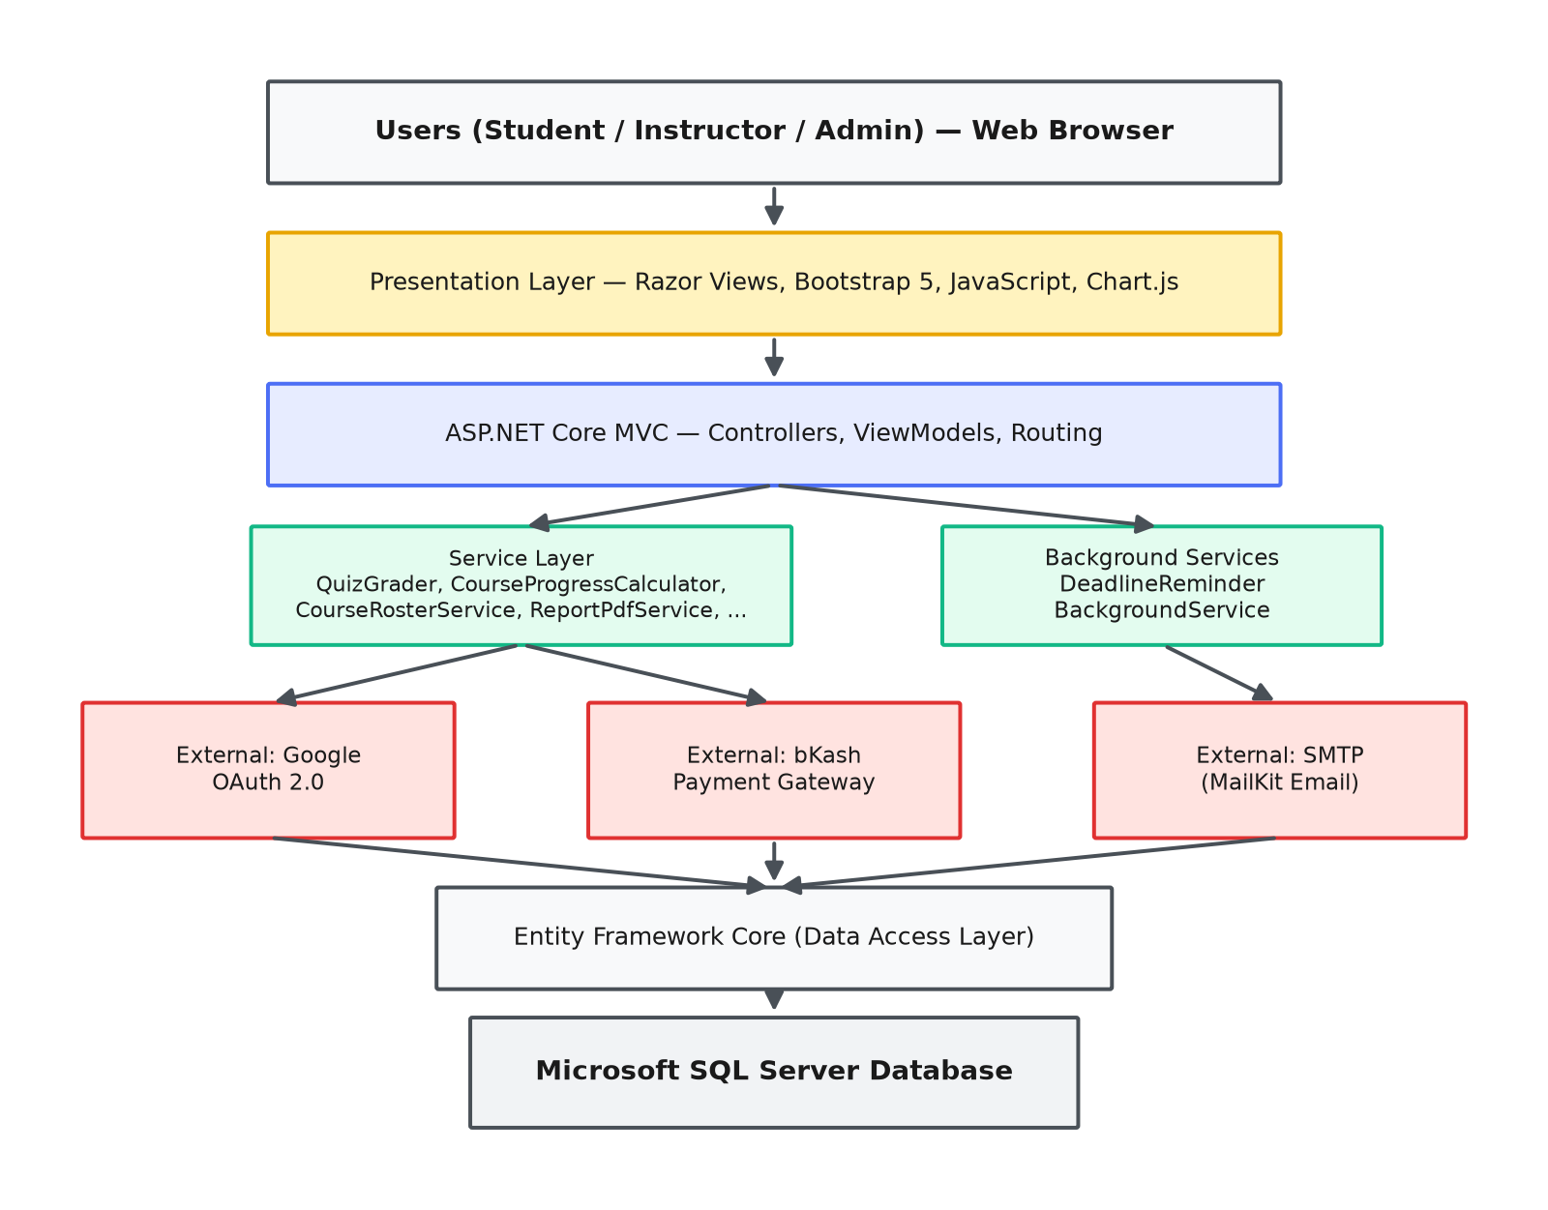
Figure 7.1 System Architecture of EduLearn.
Figure 7.1 illustrates the overall architecture of EduLearn, showing the interaction among users, the web interface, ASP.NET Core MVC, the Service Layer, background services, external services, Entity Framework Core, and the SQL Server database.

7.2 System Internal Design
The internal design describes the major user-facing interfaces through which users interact with EduLearn. The application uses Razor Views with HTML, CSS, Bootstrap 5, and JavaScript to provide a responsive interface. Different roles have separate dashboards and navigation based on their responsibilities. The following pages are represented by live screenshots of the running application.

7.2.1 Login Page
[ SCREENSHOT TO BE INSERTED HERE ]
Navigate to /Identity/Account/Login and capture the full page.
Figure 7.2 Login Page.

7.2.2 Admin Dashboard
[ SCREENSHOT TO BE INSERTED HERE ]
Log in as Admin and capture /Admin/Admin (the dashboard landing page).
Figure 7.3 Admin Dashboard.

7.2.3 Instructor Dashboard (My Courses)
[ SCREENSHOT TO BE INSERTED HERE ]
Log in as Instructor and capture /Instructor (My Courses).
Figure 7.4 Instructor Dashboard (My Courses).

7.2.4 Student Dashboard (My Enrollments)
[ SCREENSHOT TO BE INSERTED HERE ]
Log in as Student and capture /Course/MyEnrollments.
Figure 7.5 Student Dashboard (My Enrollments).

7.2.5 Course Catalog and Course Details Page
[ SCREENSHOT TO BE INSERTED HERE ]
Capture /Course/Index, then a single course's /Course/Details/{id}.
Figure 7.6 Course Catalog and Course Details Page.

7.2.6 Content Authoring Interface (Manage Content)
[ SCREENSHOT TO BE INSERTED HERE ]
As Instructor, open Manage Content for one of your own courses.
Figure 7.7 Course Content Authoring Interface (Manage Content).

7.2.7 Lesson Viewer with Assignment and Quiz
[ SCREENSHOT TO BE INSERTED HERE ]
As Student, open a lesson that has both an assignment and a quiz attached.
Figure 7.8 Lesson Viewer with Assignment and Quiz.

7.2.8 Quiz-Taking Interface
[ SCREENSHOT TO BE INSERTED HERE ]
As Student, click Take Quiz on any lesson's quiz.
Figure 7.9 Quiz-Taking Interface.

7.2.9 Cart and Checkout (bKash) Interface
[ SCREENSHOT TO BE INSERTED HERE ]
As Student, add a paid course to Cart and open the bKash checkout screen.
Figure 7.10 Cart and Checkout (bKash) Interface.

7.2.10 Instructor Student Roster and Activity Report
[ SCREENSHOT TO BE INSERTED HERE ]
As Instructor, open Students, then Report, for one of your courses.
Figure 7.11 Instructor Student Roster and Activity Report.

7.2.11 Admin Course Overview (Instructor Details, Activity Timeline, Roster)
[ SCREENSHOT TO BE INSERTED HERE ]
As Admin, open Manage Courses → Overview on any course.
Figure 7.12 Admin Course Overview (Instructor Details, Activity Timeline, Roster).

7.2.12 Admin Revenue and Analytics Reports
[ SCREENSHOT TO BE INSERTED HERE ]
As Admin, open the Revenue Report page.
Figure 7.13 Revenue Report Interface.

7.2.13 Admin Coupon and Payment Management
[ SCREENSHOT TO BE INSERTED HERE ]
As Admin, open Coupons, then Payments.
Figure 7.14 Admin Coupon and Payment Management Interface.

7.3 Data Flow Diagram (DFD)
A Data Flow Diagram (DFD) represents how data moves between external entities, system processes, and data stores. EduLearn is represented through multiple levels of DFD: a Context Level Diagram, a Level 1 DFD decomposing the system into major functional processes, and Level 2 DFDs decomposing selected processes further.

7.3.1 Context Level Diagram (Level 0)
The Context Level DFD represents EduLearn as a single central process and shows its interaction with its major external entities: Student, Instructor, Admin, Google OAuth, and the bKash Payment Gateway.
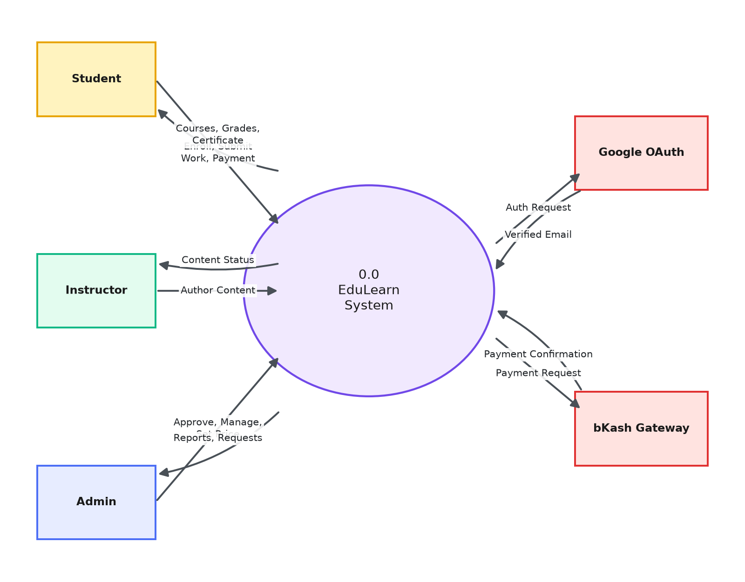
Figure 7.15 Context Level Diagram (Level 0).

7.3.2 Level 1 Data Flow Diagram
The Level 1 DFD decomposes EduLearn into its major functional processes: Authentication and Instructor Onboarding, Course Creation and Approval, Enrollment and Payment, Lesson/Assignment/Quiz Delivery, Notification Processing, Instructor and Admin Reporting, and Certificate and Receipt Generation.
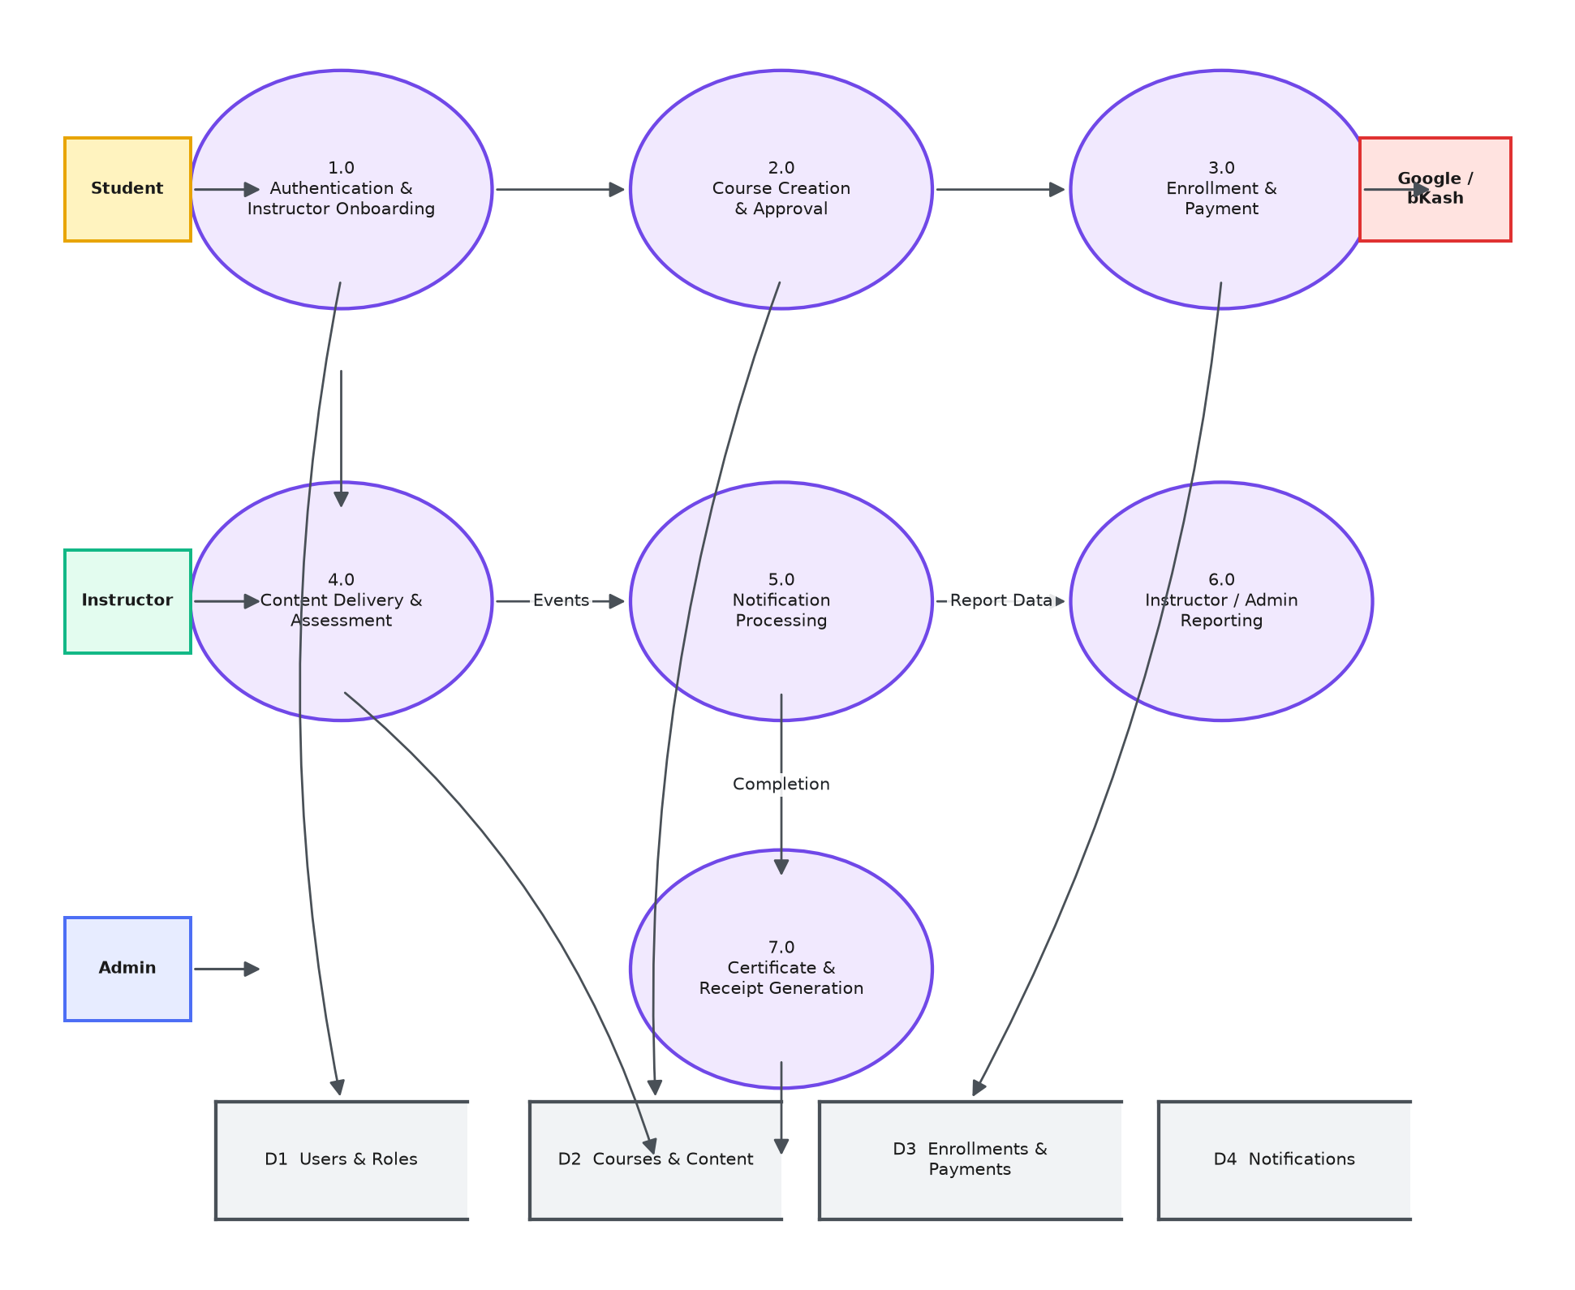
Figure 7.16 Level 1 Data Flow Diagram.

7.3.3 Level 2 DFD – Authentication and Instructor Onboarding
Handles Student self-registration (with OTP-verified email) and the full instructor pipeline: access request (Google/email) → Admin approval → rate-limited one-time code → application form → Admin review.
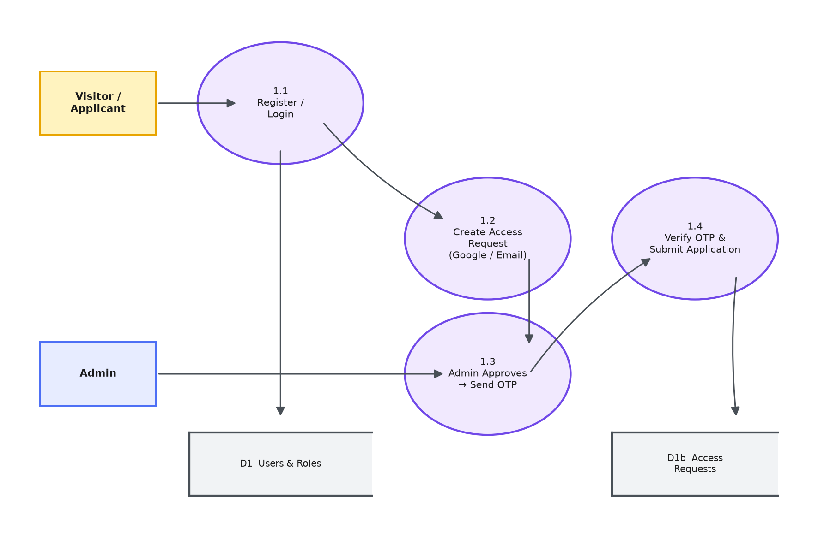
Figure 7.17 Level 2 DFD – Authentication and Instructor Onboarding.

7.3.4 Level 2 DFD – Course Creation and Approval
Handles Instructor course/content authoring, the mandatory Admin approval-and-pricing gate, and re-submission to Pending on any subsequent edit.
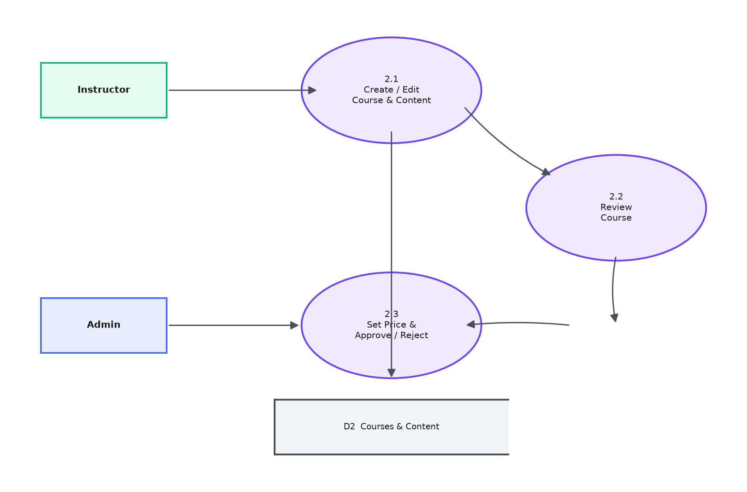
Figure 7.18 Level 2 DFD – Course Creation and Approval.

7.3.5 Level 2 DFD – Enrollment and Payment
Handles free/paid enrollment, cart, coupon validation, bKash checkout, and Admin-issued refunds.
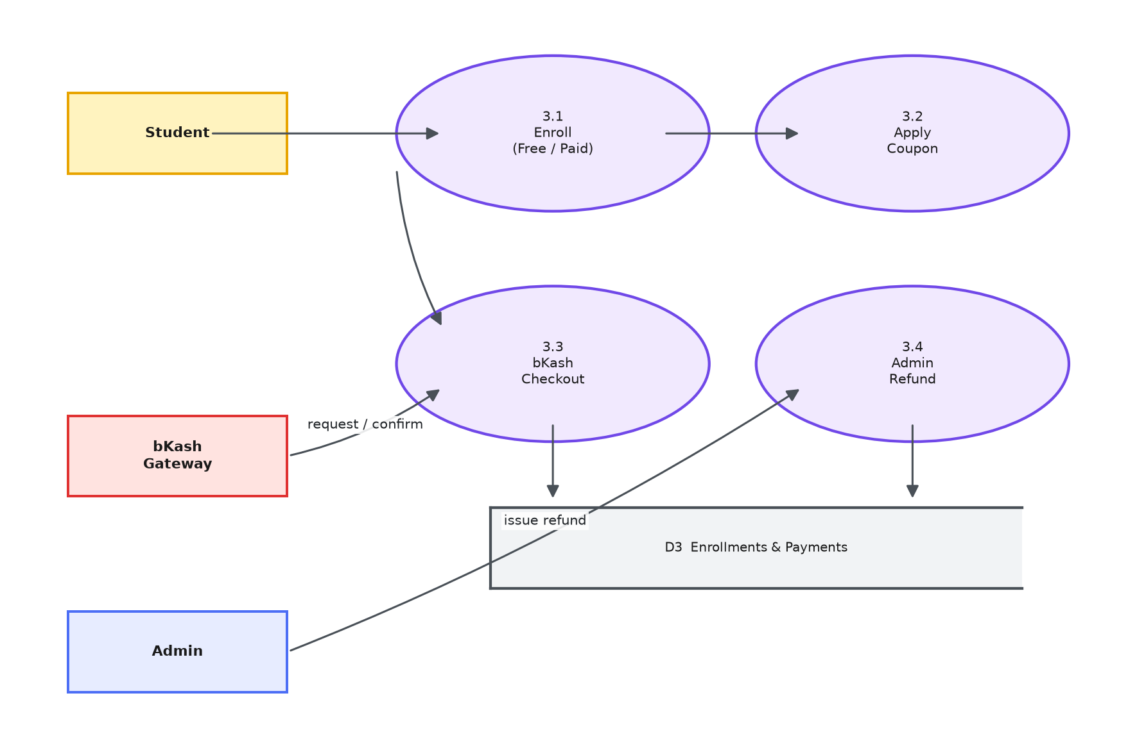
Figure 7.19 Level 2 DFD – Enrollment and Payment.

7.3.6 Level 2 DFD – Lesson, Assignment, and Quiz Delivery
Handles lesson viewing and completion, quiz attempts and auto-grading, and assignment submission — each of the latter two gated by an independently-checked due date.
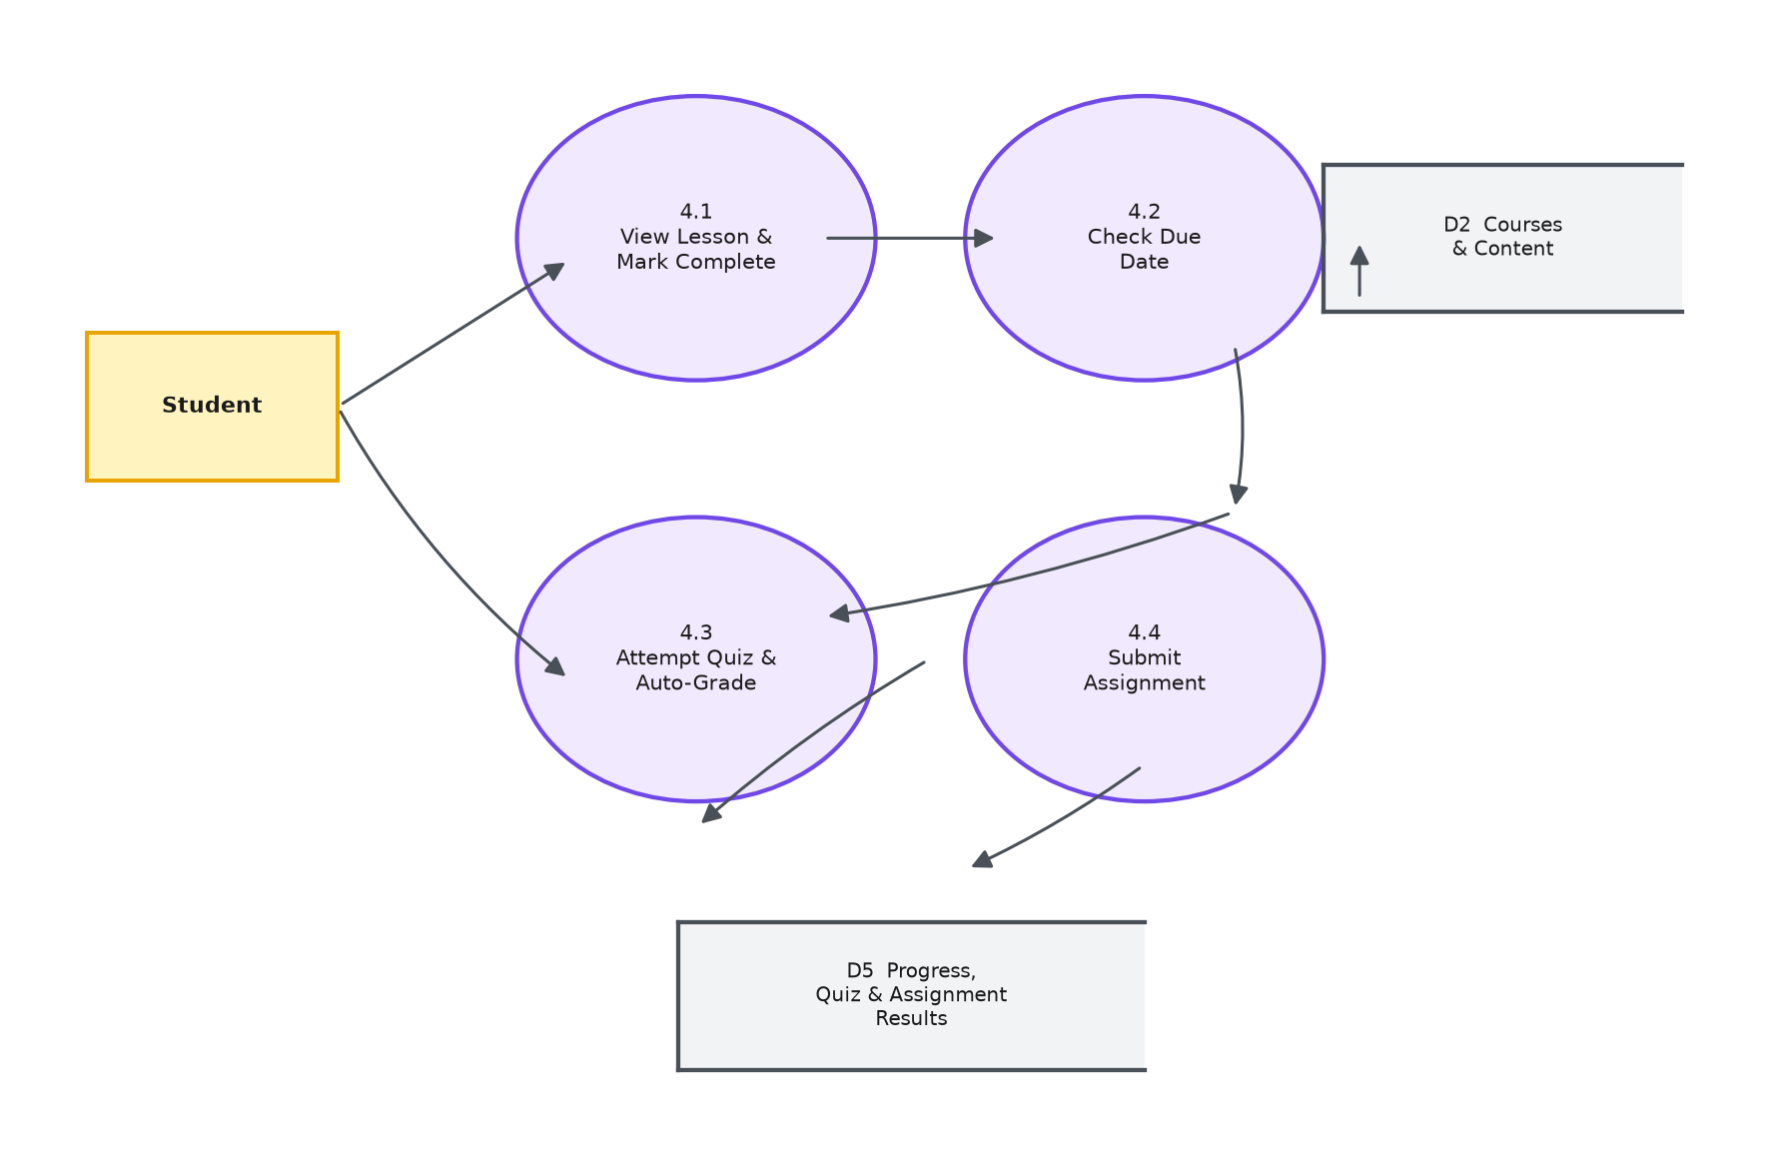
Figure 7.20 Level 2 DFD – Lesson, Assignment, and Quiz Delivery.

7.3.7 Level 2 DFD – Notification Processing
Handles creation of Notification rows for course approval/rejection, new enrollment, new access request, and application decisions, plus read/unread state.
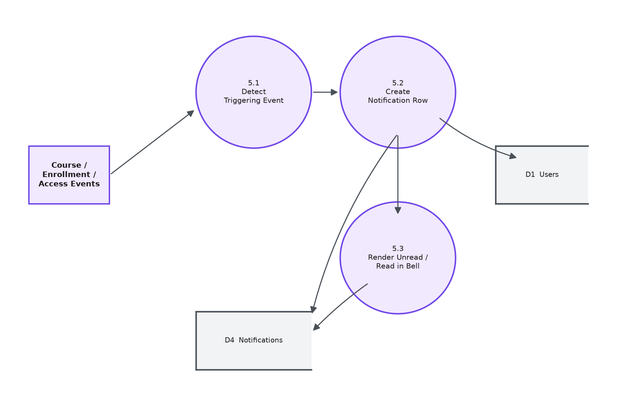
Figure 7.21 Level 2 DFD – Notification Processing.

7.3.8 Level 2 DFD – Instructor and Admin Reporting
Handles roster and weekly/monthly activity-report aggregation (shared logic, different access scope) and Admin's platform-wide Revenue/Analytics reports.
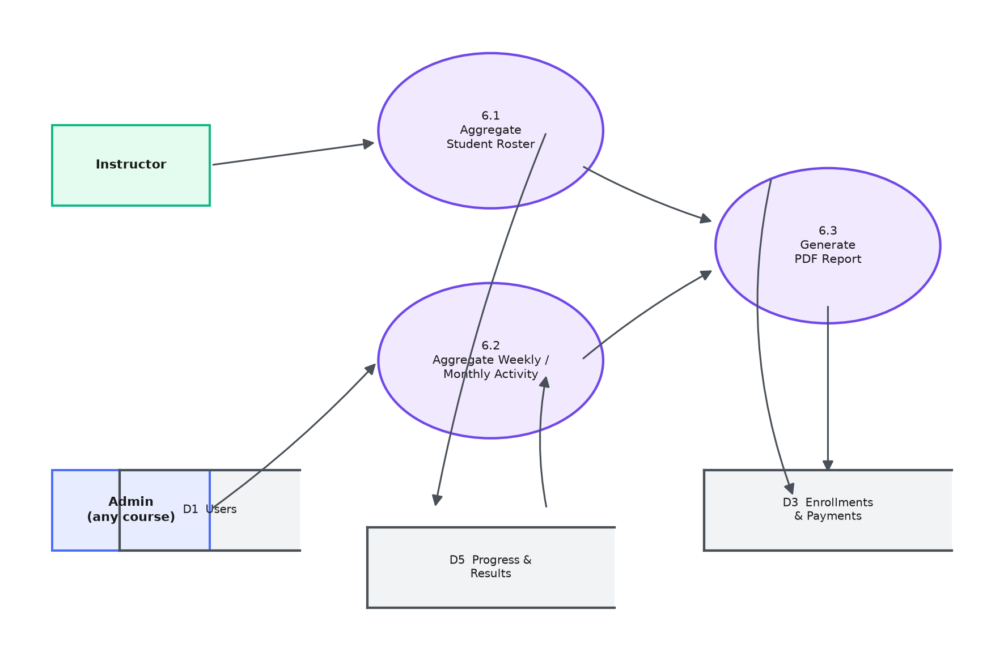
Figure 7.22 Level 2 DFD – Instructor and Admin Reporting.

7.3.9 Level 2 DFD – Certificate and Receipt Generation
Handles certificate eligibility checking (100% lesson completion) and PDF generation, and payment-receipt PDF generation.
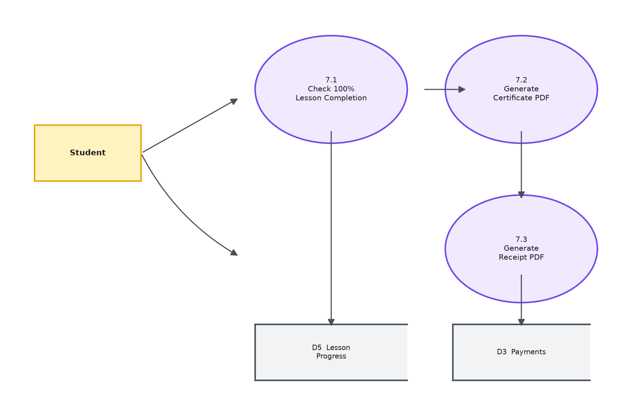
Figure 7.23 Level 2 DFD – Certificate and Receipt Generation.

7.4 Entity Relationship Diagram (ERD)
An Entity Relationship Diagram (ERD) represents the logical structure of the database and the relationships among EduLearn's entities. The database is designed using normalized relational structures, with a deliberate, per-relationship choice between Cascade and Restrict delete behavior.
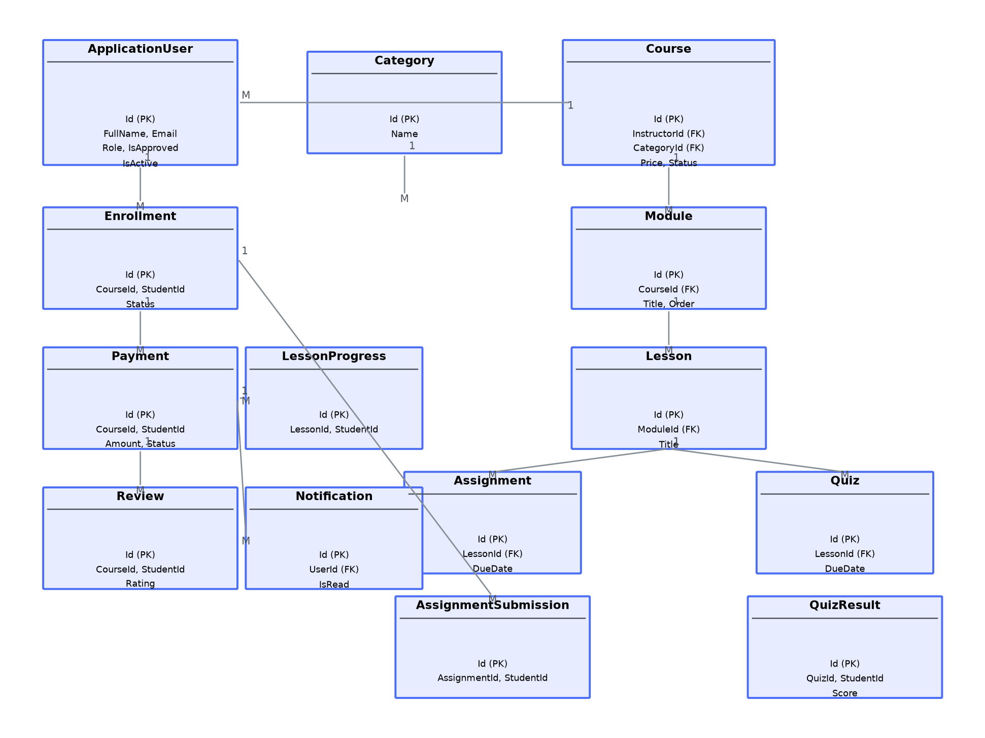
Figure 7.24 Entity Relationship Diagram of EduLearn.

7.4.1 User and Role Relationship
ASP.NET Core Identity's role tables associate each ApplicationUser with one of Student, Instructor, or Admin. ApplicationUser additionally carries IsApproved/IsRejected/IsActive flags used to gate an Instructor's access before full approval.

7.4.2 Course and Enrollment Relationship
A Course can have many Enrollments; an Enrollment belongs to exactly one Course and one Student. The Enrollment.Status field is the single source of truth for access — Course-owned content cascades on Course deletion, but the FK back to the student ApplicationUser uses Restrict.

7.4.3 Course Content Relationship
Course content forms a strict hierarchy: a Course has many Modules, a Module has many Lessons, and a Lesson may have many Assignments and many Quizzes. All of these are configured Cascade on delete, since they are wholly owned by their parent Course.

7.4.4 Assessment Result Relationships
A Quiz can have many QuizResults (updated in place on retake); an Assignment can have many AssignmentSubmissions; a Lesson can have many LessonProgress rows. Each of these FKs back to the student ApplicationUser uses Restrict.

7.4.5 User and Notification Relationship
A user can receive many Notifications, created for events including course approval/rejection, new enrollment, and access-request/application decisions, and carrying an IsRead flag.

7.4.6 User and Review Relationship
A Student can write at most one Review per Course they have completed.

7.4.7 Instructor Access Request Relationship
InstructorAccessRequest is deliberately not tied by foreign key to the eventual ApplicationUser it leads to, and carries its own lifecycle fields — Status, OtpCode, OtpExpiresAt, OtpAttempts, AccessToken, and IsConsumed. RejectedApplicationArchive is similarly a standalone table with no foreign key back to ApplicationUser.

7.4.8 Coupon and Payment Relationship
A Coupon can have many CouponRedemptions; a Payment belongs to one Enrollment's Course and Student and records the transaction ID, amount, and status.

7.4.9 Database Design Considerations
Data Normalization: related information is stored in separate entities rather than duplicated. Referential Integrity and Deliberate Delete Behavior: every foreign key in ApplicationDbContext has an explicit, deliberately chosen delete behavior — Cascade for anything wholly owned by a Course, and Restrict for any foreign key from a student-owned record back to ApplicationUser — so deleting a user account can never silently cascade into deleting unrelated course content, and deleting a course can never silently delete a student's account. Historical/Archive Data: RejectedApplicationArchive demonstrates a standalone archive pattern. Audit Information: timestamp fields support both the audit trail and the activity-timeline/reporting features.

7.5 Design Summary
The system design of EduLearn combines a layered application architecture, role-based user interfaces, structured data flows, and a normalized relational database with deliberate, relationship-by-relationship delete-behavior choices. The architecture separates presentation, business logic, background processing, external integrations, and data access. The DFDs describe how information moves through EduLearn's major processes, while the ERD demonstrates how the database's entities relate, including two deliberately standalone, non-foreign-keyed tables used specifically to keep sensitive or historical state decoupled from live account records.

Chapter 8. Quality Assurance and Testing
Quality assurance and testing are essential activities in the development of EduLearn. They help ensure the application behaves according to its requirements, maintains data consistency, protects restricted resources, and provides reliable functionality across all three roles — particularly since the system handles real payment flows and enforced academic deadlines, where a silent defect is not merely inconvenient but could mean a student is wrongly charged, wrongly denied access they paid for, or able to submit work after a deadline that was supposed to be firm.
EduLearn's testing combined two complementary approaches used throughout development: an automated xUnit test suite (33 test cases) and live, evidence-based manual testing — exercising the actual running application over real HTTP requests and verifying the result directly against the live SQL Server database, rather than trusting that a change “should” work from reading the code alone. This second discipline is what actually caught the routing defect described in Chapter 5 (RMMM 06); no amount of code review surfaced it, only following the real generated link did.

8.1 System Quality Management
For EduLearn, quality management focuses on ensuring the system satisfies its functional requirements, maintains data integrity, provides appropriate authorization, and behaves correctly at the boundaries that matter most: deadlines, pricing, refunds, and account deletion.
- Functional correctness of course, enrollment, and assessment workflows.
- Secure, rate-limited instructor onboarding.
- Correct role- and ownership-based authorization.
- Accurate quiz auto-grading and due-date enforcement for both quizzes and assignments.
- Consistent enrollment/payment state, including on refund.
- Correct certificate-eligibility computation.
- Reliable notification generation and read/unread state.
- Accurate roster and activity-report aggregation.
- Correct PDF generation (certificates, receipts, revenue/analytics/course-activity reports).
- Responsive, role-appropriate interfaces.

8.1.1 Software Quality Management Process
Quality Planning: defined expected behavior for authentication, instructor onboarding, course approval and pricing, enrollment/payment, assessment, certification, and reporting before and during each module's development.
Quality Assurance: followed the MVC-with-a-Service-Layer architecture described in Chapter 7, so that business rules live in one owned, testable place rather than being duplicated across controllers.
Quality Control: identifying defects through both the automated suite and live testing, and correcting them before a module was considered complete. Overall process: Quality Planning → Module Development → Quality Assurance → Automated + Live Testing → Defect Identification → Correction & Refinement → Retesting → Final Validation.

8.2 System Testing
System testing verifies the complete, integrated EduLearn platform against its functional and non-functional requirements, checking not just individual pages but full workflows.

8.2.1 Reasons for Performing System Testing
- To verify that EduLearn's functional requirements were correctly implemented.
- To ensure users can access only the functions permitted by their role.
- To verify authentication, registration (with OTP), and logout work correctly.
- To ensure course records are created, approved, priced, edited, and deleted correctly.
- To verify the instructor access-request flow's rate limiting and expiry actually block a brute-force or stale attempt.
- To ensure enrollment and payment state remain consistent through checkout and refund.
- To verify quiz grading is arithmetically correct and that both quizzes and assignments are rejected after their due date.
- To ensure certificate eligibility reflects real recorded lesson completion.
- To verify roster/report numbers match a manual database count.
- To identify and correct defects before considering the system complete.

8.2.2 System Testing Methodology
A combination of black-box testing (via the application's real interfaces and HTTP endpoints) and white-box-informed automated testing (the xUnit suite, exercising controller/service code paths against a seeded in-memory database) was used, comprising Functional Testing, Non-Functional Testing, Automated Regression Testing, and Incremental Testing performed as modules were built.
The xUnit suite (33 tests) is run after any change to catch unintended breakage — this is not hypothetical: adding the Quiz.DueDate field broke three previously-passing tests whose seeded quiz objects had no due date and therefore defaulted to the year 1 (permanently “expired”); the suite caught this immediately, and the fix was verified by re-running the full suite to 33/33 passing again.

8.3 System Testing Design
The following test cases validate EduLearn's major functional workflows. Status values reflect the actual outcome of running these cases against the live application and its database during this practicum, and against the automated suite where noted.
Item | Description
Test Case ID | TC-01
Test Priority | High
Module Name | Authentication
Title of the Test | Verifying self-registration with OTP and login
Precondition | A valid, unused email address must be available

Table 8.1 User Authentication and Registration.
Step | Step Name | Test Data | Expected Result | Actual Result | Status
1 | Submit registration form | Valid name, email, password | A 6-digit OTP is emailed and the registration is held in session | OTP emailed; no row created until verified | Pass
2 | Enter correct OTP within 10 min | Correct code | Student account created and signed in | Account created, signed in | Pass
3 | Enter incorrect OTP | Wrong code | Error shown; no account created | Error shown, no account created | Pass
4 | Log in with the new account | Registered credentials | Login succeeds, lands on catalog | Login succeeded | Pass
5 | Log out | Authenticated session | Session ends | Session ended | Pass

Item | Description
Test Case ID | TC-02
Test Priority | High
Module Name | Authorization
Title of the Test | Verifying role-based and ownership-based access control
Precondition | Accounts for all three roles, and two distinct Instructors, must exist

Table 8.2 Role-Based Authorization.
Step | Step Name | Test Data | Expected Result | Actual Result | Status
1 | Student requests Admin-only URL | /Admin/Admin/Users | Access denied | Access denied | Pass
2 | Instructor A requests Instructor B's course URL | B's courseId | 404 (ownership check fails) | 404 returned | Pass
3 | Unauthenticated visitor requests Student-only URL | /Course/MyEnrollments | Redirected to Login with ReturnUrl | Redirected correctly | Pass
4 | Each role loads its own landing page | Role-specific credentials | Correct dashboard renders | Verified for all three roles | Pass

Item | Description
Test Case ID | TC-03
Test Priority | High
Module Name | Instructor Onboarding
Title of the Test | Verifying the full access-request → OTP → application pipeline
Precondition | Google OAuth configured; an Admin account available

Table 8.3 Instructor Access Request and OTP Onboarding.
Step | Step Name | Test Data | Expected Result | Actual Result | Status
1 | Submit access request via Google | Real Google account | Pending request created with verified email | Verified via DB query | Pass
2 | Submit access request via email | Valid email | Request created, Method=Email | Request created | Pass
3 | Admin approves the request | Pending request | Code + link emailed together | Received (after routing fix) | Pass
4 | Enter an incorrect code | Wrong value | Error, attempts remaining shown | “5 attempts left” etc. | Pass
5 | Exceed 5 incorrect attempts | 6th wrong attempt | Further attempts blocked | Blocked with message | Pass
6 | Enter correct code | Correct code | Redirected to application form | Redirected correctly | Pass
7 | Submit application with résumé | Valid applicant details | Account created, request consumed | Verified via DB query | Pass
8 | Admin approves full application | Pending applicant | Password-setup email sent | Verified live | Pass

Item | Description
Test Case ID | TC-04
Test Priority | High
Module Name | Course Management
Title of the Test | Verifying course creation, approval, and re-review on edit
Precondition | Approved Instructor account

Table 8.4 Course Creation and Admin Approval.
Step | Step Name | Test Data | Expected Result | Actual Result | Status
1 | Create a new course | Title, description, category | Status=Pending, Price=0 | Created Pending, price forced 0 | Pass
2 | Admin approves, sets price | Amount e.g. 500 | Status=Approved, Price=500 | Verified via DB query | Pass
3 | Instructor edits approved course | Updated description | Status reverts to Pending, Price untouched | Verified | Pass
4 | Admin rejects with a reason | Reason text | Status=Rejected, reason emailed | Verified | Pass

Item | Description
Test Case ID | TC-05
Test Priority | High
Module Name | Course Pricing
Title of the Test | Verifying Instructors cannot set price, and Admin can edit/delete any course
Precondition | Approved course exists

Table 8.5 Course Pricing and Course Management.
Step | Step Name | Test Data | Expected Result | Actual Result | Status
1 | Instructor's Create/Edit form | — | No price field rendered | Confirmed removed | Pass
2 | Craft raw POST with Price as Instructor | Price=9999 | Ignored server-side | Confirmed ignored | Pass
3 | Admin edits price of approved course | New amount | Updates independent of status | Verified | Pass
4 | Admin deletes a course with enrollments | Confirm modal | Course/content/enrollments/payments/reviews removed | Verified via DB query | Pass

Item | Description
Test Case ID | TC-06
Test Priority | High
Module Name | Enrollment
Title of the Test | Verifying free and paid enrollment creation
Precondition | Approved free and paid courses exist

Table 8.6 Enrollment (Free and Paid).
Step | Step Name | Test Data | Expected Result | Actual Result | Status
1 | Student enrolls in free course | Free course | Status=Active immediately | Verified | Pass
2 | Student enrolls in paid course | Paid course | Status=Pending, appears in Cart | Verified | Pass
3 | Access paid content before payment | Pending enrollment | Only free-preview lessons accessible | Verified | Pass

Item | Description
Test Case ID | TC-07
Test Priority | High
Module Name | Payment
Title of the Test | Verifying coupon application and bKash checkout
Precondition | Pending paid enrollment in Cart; active coupon exists

Table 8.7 Cart, Coupons, and bKash Checkout.
Step | Step Name | Test Data | Expected Result | Actual Result | Status
1 | Apply valid coupon | Coupon code | Discounted total computed | Verified | Pass
2 | Apply expired/exhausted coupon | Invalid code | Rejected, no discount | Verified | Pass
3 | Complete bKash checkout | Sandbox credentials | Payment=Success, Enrollment=Active | Verified via DB query | Pass
4 | Admin refunds the payment | Successful payment | Payment=Refunded, Enrollment=Pending | Verified | Pass

Item | Description
Test Case ID | TC-08
Test Priority | High
Module Name | Progress Tracking
Title of the Test | Verifying lesson completion and progress percentage
Precondition | Active enrollment in multi-lesson course

Table 8.8 Lesson Progress and Mark-as-Complete.
Step | Step Name | Test Data | Expected Result | Actual Result | Status
1 | Mark a lesson complete | Lesson ID | LessonProgress row created/updated | Verified | Pass
2 | View My Enrollments | Partially complete course | Progress % matches manual count | Verified | Pass
3 | Complete every lesson | All lessons | Progress=100%, certificate available | Verified | Pass

Item | Description
Test Case ID | TC-09
Test Priority | High
Module Name | Assignments
Title of the Test | Verifying submission before and rejection after the due date
Precondition | An assignment with a known due date exists

Table 8.9 Assignment Submission and Due-Date Lockout.
Step | Step Name | Test Data | Expected Result | Actual Result | Status
1 | Submit before due date | Valid file | Submission accepted | Accepted | Pass
2 | Resubmit before due date | Replacement file | Updated in place, not duplicated | Verified single row | Pass
3 | Open submission page after due date (GET) | Expired assignment | Redirected with “deadline passed” | Verified | Pass
4 | Raw POST after due date | Crafted request | Rejected server-side | Verified independently | Pass

Item | Description
Test Case ID | TC-10
Test Priority | High
Module Name | Quizzes
Title of the Test | Verifying auto-grading, retake behavior, and due-date lockout
Precondition | A quiz with known correct answers and a due date exists

Table 8.10 Quiz Attempt, Auto-Grading, and Due-Date Lockout.
Step | Step Name | Test Data | Expected Result | Actual Result | Status
1 | Submit all-correct answers | Correct option IDs | Score=total; Passed=true | Confirmed via automated test | Pass
2 | Retake with a worse score | Incorrect option IDs | Existing row updates in place | Confirmed via automated test | Pass
3 | Instructor views results (own course only) | Two Instructors, one quiz | Owning Instructor sees result; other sees none | Confirmed via automated test | Pass
4 | Attempt after due date | Expired quiz | Both GET and POST redirect with message | Verified live and via automated test | Pass

Item | Description
Test Case ID | TC-11
Test Priority | Medium
Module Name | Certification
Title of the Test | Verifying certificate eligibility and PDF generation
Precondition | Partial and full-completion enrollments

Table 8.11 Certificate Issuance.
Step | Step Name | Test Data | Expected Result | Actual Result | Status
1 | Request certificate, incomplete progress | Partial course | Refused with a clear message | Verified | Pass
2 | Request certificate, 100% complete | Fully completed course | Valid PDF downloads | Verified | Pass

Item | Description
Test Case ID | TC-12
Test Priority | Medium
Module Name | Reviews
Title of the Test | Verifying review submission is gated on completion and is editable
Precondition | One completed and one incomplete enrollment

Table 8.12 Review Submission and Editing.
Step | Step Name | Test Data | Expected Result | Actual Result | Status
1 | Review an incomplete course | Rating + comment | Rejected | Verified | Pass
2 | Review a completed course | Rating + comment | Created; second attempt blocked | Verified | Pass
3 | Edit an existing review | Updated rating/comment | Updates in place | Verified | Pass

Item | Description
Test Case ID | TC-13
Test Priority | Medium
Module Name | Notifications
Title of the Test | Verifying notification generation and read/unread styling
Precondition | A relevant event must occur

Table 8.13 Notification System.
Step | Step Name | Test Data | Expected Result | Actual Result | Status
1 | Trigger course approval | Pending course | Instructor receives a Notification | Verified | Pass
2 | Trigger new enrollment | New paid enrollment | Instructor notified | Verified | Pass
3 | View bell with mixed items | Read/unread mix | Unread bold/tinted; read plain | Verified visually | Pass
4 | Click notification / Mark all read | Unread item(s) | IsRead flips true | Verified | Pass

Item | Description
Test Case ID | TC-14
Test Priority | High
Module Name | Reporting
Title of the Test | Verifying roster accuracy and weekly/monthly report numbers
Precondition | A course with real enrollment/completion/submission activity

Table 8.14 Instructor Student Roster and Reports.
Step | Step Name | Test Data | Expected Result | Actual Result | Status
1 | Open Students for a course | Real seeded activity | Correct roster fields | Progress/last-activity matched exactly | Pass
2 | Open monthly Report | Same course | Correct month shows count=1 | Matched manual DB count | Pass
3 | Export report as PDF | Monthly period | Valid PDF downloads | Real application/pdf response | Pass

Item | Description
Test Case ID | TC-15
Test Priority | High
Module Name | Admin Reporting
Title of the Test | Verifying the Admin course drill-down for a course the Admin does not teach
Precondition | A course owned by a different Instructor

Table 8.15 Admin Course Overview.
Step | Step Name | Test Data | Expected Result | Actual Result | Status
1 | Open Course Overview as Admin | Course owned by another Instructor | Shows that Instructor's own details | Verified live | Pass
2 | Review activity timeline | Real events | Newest-first, correct description/timestamp | Verified ordering | Pass
3 | Review roster on same page | Same course | Matches Instructor-side roster exactly | Verified | Pass

Item | Description
Test Case ID | TC-16
Test Priority | High
Module Name | User Management
Title of the Test | Verifying search/filter, activation, and dashboard-count consistency
Precondition | Multiple users across roles/statuses

Table 8.16 Admin User Management.
Step | Step Name | Test Data | Expected Result | Actual Result | Status
1 | Search/filter Manage Users | Role/status filters | Correct filtered subset | Verified | Pass
2 | Deactivate then reactivate a user | Active user | Status toggles | Verified | Pass
3 | Compare Dashboard totals to list count | Same moment | Counts must agree exactly | Real discrepancy found & fixed | Pass

Item | Description
Test Case ID | TC-17
Test Priority | High
Module Name | Payments
Title of the Test | Verifying the Admin payments ledger and refund action
Precondition | At least one successful payment exists

Table 8.17 Payments and Refunds.
Step | Step Name | Test Data | Expected Result | Actual Result | Status
1 | Open Payments | — | All payments listed with details | Verified | Pass
2 | Refund a successful payment | Successful payment row | Status→Refunded, enrollment→Pending | Verified via DB query | Pass
3 | Attempt to refund an already-refunded payment | Refunded payment | Rejected as not eligible | Verified | Pass

Item | Description
Test Case ID | TC-18
Test Priority | Medium
Module Name | Content Preview
Title of the Test | Verifying Admin/Instructor can preview any course without enrolling
Precondition | A paid course neither viewer has purchased

Table 8.18 Admin/Instructor Full-Content Preview Access.
Step | Step Name | Test Data | Expected Result | Actual Result | Status
1 | Admin opens a locked paid lesson | Paid course | Content visible, no enrollment row created | Verified | Pass
2 | Check for student-only controls | Same lesson | None render for Admin/Instructor | Verified | Pass
3 | Instructor previews own vs. other's course | Both cases | Both work identically | Verified | Pass

Item | Description
Test Case ID | TC-19
Test Priority | Low
Module Name | AI Assistant
Title of the Test | Verifying the chat widget is available only when logged in
Precondition | Logged-in and logged-out sessions

Table 8.19 Chatbot Assistant.
Step | Step Name | Test Data | Expected Result | Actual Result | Status
1 | View any page logged out | — | Chat bubble not present | Verified | Pass
2 | View any page logged in, send message | “Hello!” | Relevant reply returned | Transient upstream error investigated and confirmed | Pass

Item | Description
Test Case ID | TC-20
Test Priority | Medium
Module Name | PDF Generation
Title of the Test | Verifying certificate, receipt, and report PDFs are generated correctly
Precondition | Eligible data exists for each document type

Table 8.20 PDF Report and Document Generation.
Step | Step Name | Test Data | Expected Result | Actual Result | Status
1 | Generate a certificate | Fully completed course | Valid PDF, correct name/date | Verified (automated + live) | Pass
2 | Generate a receipt | Successful payment | Valid PDF, correct transaction details | Verified | Pass
3 | Export Revenue Report | Real payment data | Valid PDF matching on-screen data | Verified | Pass
4 | Export a Course Activity Report, zero data | New course, no activity | PDF still generates cleanly | Verified via dedicated test | Pass

8.4 Non-Functional Testing

8.4.1 Security Testing
- Password hashing and verification (ASP.NET Core Identity default).
- Role- and ownership-based authorization, tested by direct URL access.
- Session and authentication cookie handling, including confirming the Google OAuth external cookie never becomes a persistent login.
- Rate limiting and expiry on the instructor one-time code (5 attempts, 24-hour window).
- Input and file-upload validation.
- Confirmed that a crafted request cannot set Instructor-controlled fields the UI no longer exposes.

8.4.2 Usability Testing
- Clear, role-specific dashboards and navigation.
- Responsive Bootstrap-based interface, verified at narrow widths.
- Specific, actionable validation and error messages.
- Gmail-style unread notifications, verified visually distinct from read ones.

8.4.3 Data Integrity Testing
Important relationships tested include Users↔Roles, Courses↔Enrollments, Courses↔Content, Quizzes↔QuizResults, Assignments↔AssignmentSubmissions, Coupons↔CouponRedemptions, and Payments↔Enrollments. Delete-behavior correctness was specifically tested by deleting a course with real enrollments and confirming the full cascade, and separately by confirming that deleting a user account never removes unrelated course content.

8.4.4 File Upload Testing
Tested upload paths: instructor résumés, profile pictures, course thumbnails, and assignment submissions — each validated by FileUploadService against allowed extensions and size limits.

8.4.5 Background Service Testing
The DeadlineReminderBackgroundService was tested to confirm it correctly identifies assignments due soon and emails the affected students without blocking normal request handling.

8.5 Integration Testing
Access Request → OTP → Application → Full Approval: each stage's output is required input for the next, tested as one continuous chain.
Course Approval → Pricing → Enrollment: a course's price, set only at Admin approval, is what checkout reads — tested end-to-end.
Enrollment → Payment → Access: paid access is granted only on a confirmed successful payment, and revoked on refund — tested in both directions.
Lesson Completion → Progress → Certificate: certificate eligibility is computed from real LessonProgress rows, tested by confirming refusal at 99% and grant at 100%.
Quiz/Assignment Due Date → Lockout → Roster/Report: a lockout event is reflected consistently in both the interactive page and the aggregated roster/report numbers.
Roster/Report Service → Instructor / Admin Controller: the identical service output was confirmed to render correctly from both callers.

8.6 System Testing Summary
System testing covered authentication, authorization, instructor onboarding, course management and pricing, enrollment and payment, assessment and deadline enforcement, certification, reviews, notifications, reporting, and Admin/Instructor content preview. Both the 33-case automated xUnit suite and extensive live, database-verified manual testing were used throughout development, not only at the end.
This combination proved valuable in practice: the automated suite caught a real regression the moment the Quiz.DueDate field was added, while live testing caught a defect the automated suite structurally could not have — a malformed URL in a real sent email, only detectable by actually following the link.
Overall, the quality assurance and testing activities provided a structured, evidence-based approach for validating EduLearn's reliability, security, functionality, and data consistency, with every claim in this chapter backed by an actual verification performed during development rather than an assumption about how the code “should” behave.

Chapter 9. Ethical Considerations
Ethical considerations are an important part of the software development lifecycle, particularly for a system that collects, processes, and stores personal information, academic records, and payment data. EduLearn handles information such as user names, email addresses, résumés, course content, quiz answers and results, assignment submissions, payment and coupon-redemption records, and reviews. Ethical responsibilities related to privacy, security, fairness, transparency, accountability, and responsible use must therefore be considered throughout the system's development and operation.

9.1 Ethical Considerations in the Software Development Process

9.1.1 Data Privacy and Security
EduLearn stores personal information and financially sensitive information. Passwords are hashed via ASP.NET Core Identity's default hasher, never stored or transmitted in plain text — reinforced when the instructor-approval email was changed to send a secure, single-use password-setup link rather than a real password in plain text. Role- and ownership-based authorization restrict access so a user can see only the information relevant to their role. Google OAuth is used narrowly — solely to read a verified email address during instructor onboarding — and is explicitly prevented from ever becoming a persistent login.

9.1.2 Responsible Handling of Student and Course Data
Student progress, quiz results, and assignment submissions are personal academic records. EduLearn restricts this information by role: a Student sees only their own results; an Instructor sees results only for their own courses' students; an Admin can see any course's data, but that capability is itself gated behind the Admin role. The system also deliberately separates a rejected instructor applicant's live account (which is deleted) from a permanent, access-restricted archive of what they submitted.

9.1.3 Fairness and Non-Discrimination
Quiz grading is applied identically and mechanically by QuizGrader to every student's submission, based solely on stored correct answers. Course approval and pricing decisions are made by an Admin under one consistent workflow. Deadline enforcement applies the same rule to every student on a given assignment or quiz, with no exceptions built into the code.

9.1.4 Transparency and Accountability
EduLearn maintains timestamped records of enrollment, lesson completion, quiz attempts, assignment submissions, course approval/rejection decisions (with reasons), and payment/refund actions. The Instructor and Admin activity-timeline and reporting features exist specifically to make platform activity visible and auditable rather than opaque. Admin actions that materially affect a user are all logged as Notification events to the affected user.

9.1.5 Responsible Use of Payment and Financial Information
EduLearn's payment data is used strictly to reconcile access against payment and to support legitimate reporting and dispute resolution. Access to the Payments ledger and refund action is restricted to Admin. bKash's own tokenized checkout API means EduLearn never directly handles or stores raw payment credentials.

9.1.6 Privacy in Google OAuth Integration
Because Google OAuth could, in principle, be used to retrieve more identity information than is actually needed, EduLearn's implementation deliberately reads only the verified email claim and discards everything else, immediately signing out the transient external-login cookie regardless of whether the flow succeeded.

9.1.7 Professional Responsibility
Professional responsibility was considered throughout EduLearn's development. The system was built using structured practices — MVC architecture, a dedicated Service Layer, database migrations, input and file validation, and both automated and live testing — and an explicit discipline of never claiming a feature “works” without verifying it against the actual running system.

9.2 Sustainability in the Software Development Process

9.2.1 Economic Sustainability
EduLearn is built on freely available, open-source-friendly technologies, keeping licensing costs low. Centralizing course delivery, enrollment, payment, and reporting reduces the manual, spreadsheet-based overhead that a fragmented toolchain would otherwise require.

9.2.2 Technical Sustainability
The layered MVC-plus-Service-Layer architecture allows a feature to be modified or extended without a wide-reaching rewrite — demonstrated in practice when course-pricing authority moved from Instructor to Admin mid-project, and when the student-roster/reporting feature was added and immediately reused, unmodified, by both the Instructor and Admin sides of the application.

9.2.3 Social Sustainability
EduLearn supports more equitable, transparent access to course content: free-preview lessons let a prospective student evaluate a paid course before committing money, and coupon codes support discounted access. Deadline enforcement and automatic grading remove opportunities for inconsistent, manually-applied leniency.

9.2.4 Maintainability and Future Sustainability
The separation of Controllers, Services, ViewModels, and Models supports ongoing maintenance. New features can be developed using the existing architectural pattern — as demonstrated by the coupon system, the roster/reporting feature, and the hardened instructor-onboarding flow.

9.3 Ethical and Sustainability Summary
EduLearn was developed with consideration for data privacy, security, fairness, transparency, accountability, professional responsibility, and long-term sustainability. Password hashing, role- and ownership-based authorization, narrowly-scoped OAuth use, and rate-limited/expiring one-time codes protect user and platform data. Consistent, mechanical grading and deadline enforcement support fairness. Timestamped, auditable records and Notification-driven communication support transparency and accountability.
From a sustainability perspective, the layered MVC-plus-Service architecture, migration-tracked SQL Server database, and disciplined, incremental development approach provide a maintainable foundation, evidenced concretely by the mid-project pricing-authority change and the coupon/roster/reporting features added without disrupting existing functionality.

Chapter 10. Conclusion

10.1 Preface
This concluding chapter reflects on the practicum experience and summarizes EduLearn's development. The project focused on designing and implementing a structured, role-based e-learning platform covering course delivery, enrollment and payment, assessment, certification, instructor onboarding, and reporting.
The practicum provided an opportunity to apply theoretical software engineering knowledge to a genuinely complete, non-trivial application. The development process covered requirement analysis, system design, database design, implementation, testing, and ethical evaluation, and provided practical experience in ASP.NET Core MVC, C#, Entity Framework Core, SQL Server, authentication and authorization, third-party OAuth and payment gateway integration, background services, PDF generation, and — distinctively — a discipline of continuous, live, evidence-based verification rather than code-review-only confidence.

10.2 Practicum and Its Value
The practicum provided significant value in both technical skill development and professional discipline. Through EduLearn's development, practical experience was gained in ASP.NET Core MVC application development, C# programming, Entity Framework Core migrations, SQL Server database design, role-based authentication and authorization, and a static-service-based application architecture.
A particularly valuable part of the practicum was implementing security-conscious, multi-step workflows correctly: the instructor access-request pipeline required getting rate limiting, expiry, and idempotent request handling right simultaneously, and directly exposed a real, subtle ASP.NET Core routing defect that would have gone unnoticed without deliberately following the actual generated link rather than trusting the code that produced it.
The practicum also strengthened understanding of payment-adjacent system design: correctly linking an Enrollment's status to a Payment's status, and correctly reversing that link on refund, required careful attention to state consistency in a way that a purely content-delivery feature would not have demanded. Implementing due-date enforcement for both assignments and quizzes — and specifically checking it independently at both the page-render and the submission-handling steps — reinforced that a UI-only restriction is not a real restriction at all.
Another significant learning outcome was the value of factoring business logic into reusable Service classes: CourseRosterService and CourseReportService being written once and correctly reused, unmodified, from both the Instructor and Admin controllers demonstrated concretely how a clean separation between “who is allowed to call this” and “what does this actually compute” pays off the moment a second caller appears.
The internship experience at Touch & Solve Technologies Ltd. complemented this independent development work by providing additional exposure to professional web-development practice, reinforcing the technical discipline applied throughout EduLearn's design and implementation.
Overall, the practicum provided valuable experience across the complete web application development lifecycle, strengthening technical, analytical, database-design, debugging, testing, documentation, and problem-solving skills, and provided genuine insight into professional, evidence-based software development practice.

10.3 Future Plan
Live/Automated Google OAuth Verification in CI: the Google OAuth path currently requires a manually-configured Client ID/Secret and a real Google account; a mocked or sandboxed OAuth flow would allow this path to be included in automated regression testing.
Real-Time Notifications: the current notification system is populated on page load; a future version could push updates in real time (e.g., via SignalR).
Advanced Analytics: more advanced dashboards, trend charts over longer periods, and additional per-instructor or per-category performance indicators could be introduced.
Mobile Application: a dedicated mobile client could let Students and Instructors access core EduLearn functions conveniently from a phone.
Cloud Deployment and Scalability: the system can be deployed to managed cloud infrastructure with a managed database service, centralized file storage, automated backups, and monitoring.
Additional Payment Gateways: support for gateways beyond bKash would broaden the platform's applicability outside markets where bKash is the dominant option.
Advanced Security: multi-factor authentication, stronger password policies, and more granular audit logging could be added for production-grade deployment.
Expanded Automated Test Coverage: extending automated coverage to the instructor-onboarding pipeline's Google OAuth path and to more of the payment/refund flow would further reduce reliance on manual live verification.

10.4 Conclusion
In conclusion, EduLearn represents a structured, maintainable, and functionally complete web-based e-learning platform developed to support course delivery, assessment, enrollment, payment, and administration. The system was developed using ASP.NET Core MVC, C#, Entity Framework Core, and SQL Server, with Bootstrap, HTML, CSS, JavaScript, and Chart.js supporting the user interface. Its architecture combines MVC components, ViewModels, a Service Layer, migration-tracked database management, a background service, external integrations, file handling, notifications, and PDF reporting.
The system provides role-based functionality for Student, Instructor, and Admin users, with access restrictions grounded in server-side authorization and, where relevant, resource ownership rather than interface convention alone. The course lifecycle — authoring, Admin approval and pricing, structured content, and enforced deadlines — provides a centralized, consistent approach to delivering and assessing course material.
The instructor-onboarding pipeline — a Google OAuth or email access request, Admin approval, a rate-limited and time-limited one-time code, and only then the actual application — demonstrates a deliberately more secure alternative to a manually-issued PIN, and its development directly surfaced and led to fixing a real, otherwise-invisible ASP.NET Core routing defect, reinforcing the value of live verification over code review alone.
From a technical perspective, this project provided practical experience in authentication, authorization, database normalization with deliberate delete-behavior design, third-party OAuth and payment-gateway integration, background processing, file validation, PDF generation, automated and live testing, debugging, and software documentation.
The system also has defined limitations within its current scope: the Google OAuth path is not yet covered by automated regression tests, and the platform currently targets a single payment gateway (bKash). These limitations provide clear, scoped opportunities for future enhancement without requiring changes to the existing architectural foundation.
From the perspective of the practicum, developing EduLearn provided a valuable opportunity to transform theoretical software engineering knowledge into a working, defensible system — one whose correctness claims in this report are backed by actual, reproducible verification rather than by the code merely “looking right.” Overall, the developed EduLearn platform successfully establishes a centralized, role-based, secure, and extensible e-learning system, while providing a strong, evidence-verified foundation for future enhancement.

References
Freeman, A. (2024) Pro ASP.NET Core 8: Develop Cloud-Ready Web Applications Using MVC, Blazor, and Razor Pages. 10th edn. Berkeley: Apress.
Elmasri, R. and Navathe, S.B. (2016) Fundamentals of Database Systems. 7th edn. Boston: Pearson.
Bass, L., Clements, P. and Kazman, R. (2021) Software Architecture in Practice. 4th edn. Boston: Addison-Wesley Professional.
Fowler, M. (2018) Refactoring: Improving the Design of Existing Code. 2nd edn. Boston: Addison-Wesley Professional.
Microsoft Corporation (2025) 'ASP.NET Core MVC overview', Microsoft Learn. Available at: https://learn.microsoft.com/en-us/aspnet/core/mvc/overview (Accessed: 12 September 2026).
Microsoft Corporation (2025) 'Entity Framework Core', Microsoft Learn. Available at: https://learn.microsoft.com/en-us/ef/core/ (Accessed: 12 September 2026).
Microsoft Corporation (2025) 'Introduction to Identity on ASP.NET Core', Microsoft Learn. Available at: https://learn.microsoft.com/en-us/aspnet/core/security/authentication/identity (Accessed: 12 September 2026).
Microsoft Corporation (2023) 'Hosted services and background tasks in ASP.NET Core', Microsoft Learn. Available at: https://learn.microsoft.com/en-us/aspnet/core/fundamentals/host/hosted-services (Accessed: 12 September 2026).
Google LLC (2025) 'Using OAuth 2.0 to Access Google APIs', Google Identity Documentation. Available at: https://developers.google.com/identity/protocols/oauth2 (Accessed: 12 September 2026).
bKash Limited (2025) 'bKash Payment Gateway (PGW) API Documentation'. Available at: https://developer.bka.sh/ (Accessed: 12 September 2026).
Silberschatz, A., Galvin, P.B. and Gagne, G. (2018) Operating System Concepts. 10th edn. Hoboken: John Wiley & Sons.
Touch & Solve Technologies Ltd. (2026) 'About Us'. Available at: https://www.touchandsolve.com/about_us (Accessed: 17 September 2026).

Plagiarism Report
(Plagiarism should be less than 30%)
Attach the proof here.

