PC客户端构建发布流程

构建地址：<https://ci.yy.com/jenkins2/job/OFCamera/>

构建后包体查询地址：[\\repo.yy.com\dwbuild\client\OFCamera\OFCamera](file:///\\repo.yy.com\dwbuild\client\OFCamera\OFCamera)

发布地址：<https://ci.yy.com/jenkins2/job/client_pre_release/>

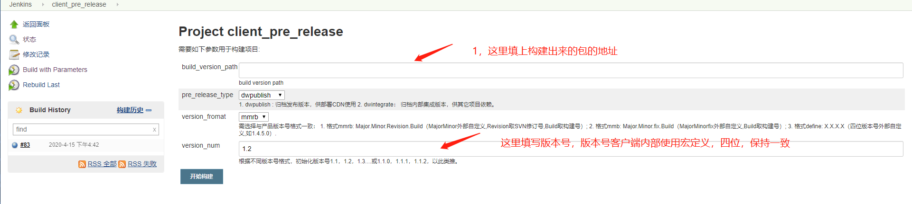

发布包查询地址：[\\repo.yy.com\dwpublish\client\OFCamera](file:///\\repo.yy.com\dwpublish\client\OFCamera)