**LAPORAN PENGERJAAN UJI KOMPETENSI KEJURUAN SMK MAHARDHIKA BATUJAJAR**

**TAHUN PELAJARAN 2022-2023**

KOMPETENSI KEAHLIAN : Rekayasa Perangkat Lunak

KELAS : XII RPL 1

NAMA LENGKAP : Jodi Joy Yoga

PAKET SOAL : P3

JENIS APLIKASI : WEB

ALOKASI WAKTU : 24 Jam

1. **PEJADWALAN KEGIATAN**

Danchartt Pemantapan

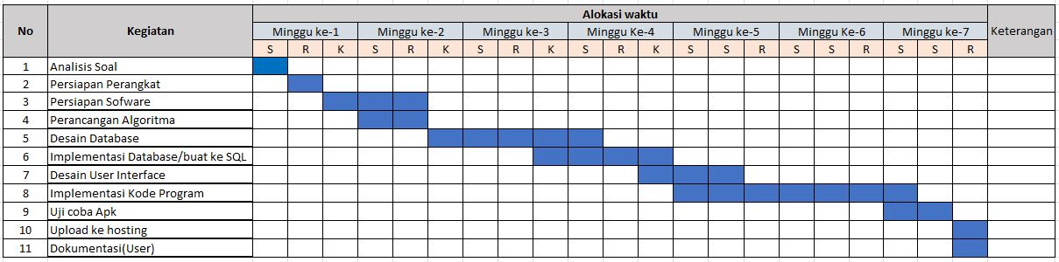

1. **PERSIAPAN PERANGKAT KERAS**
2. Spesifikasi Komputer

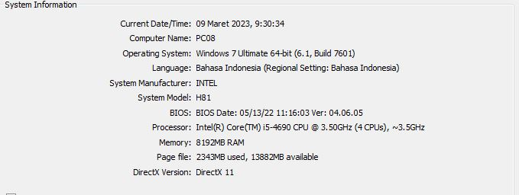

1. **PERSIAPAN PERANGKAT LUNAK**

|  |  |  |
| --- | --- | --- |
| 1. Window 7 64-bit | d. Balsamiq | g. Astah Profesional |
| 1. Visual Studio Code | e. Chrome | h. Ms Word |
| 1. XAMPP | f. Notepad | i. Ms Excel |

1. **PERANCANGAN ALGORITMA APLIKASI**
2. Activity diagram proses login Aplikasi pengeloaan Laundry (“bisa diakses oleh Admin, kasir dan Owner).

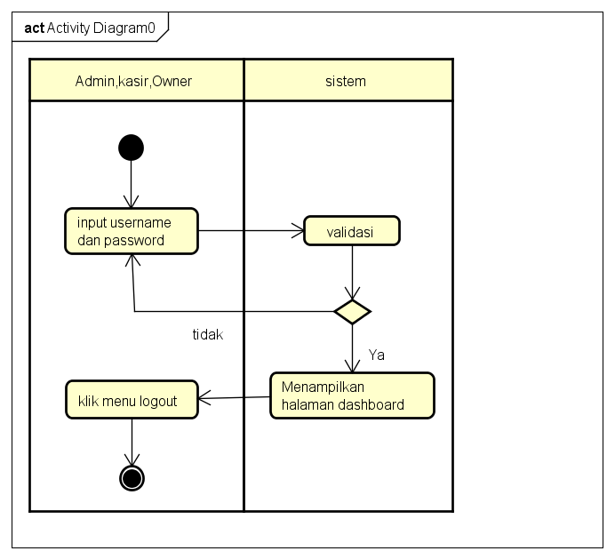

1. Activity Diagram proses cetak Laporan Aplikasi pengeloaan Laundry (“bisa diakses oleh Admin, kasir dan Owner).

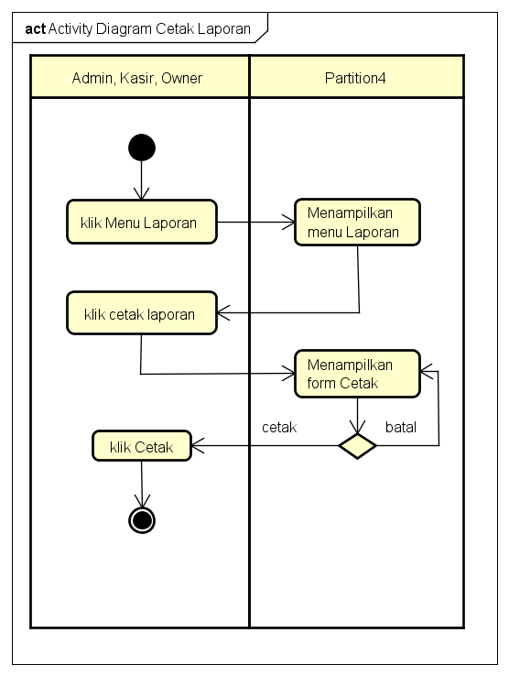

1. Activity Diagram proses CRUD paket.(Admin).

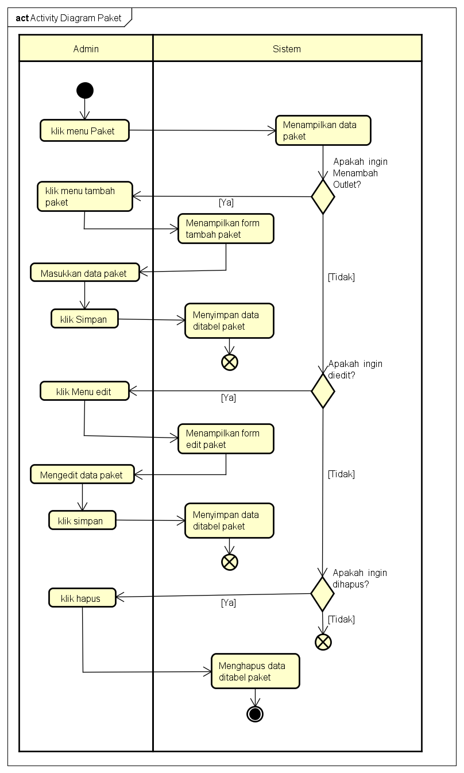

1. Activity Diagram Transaksi (Admin dan Kasir)

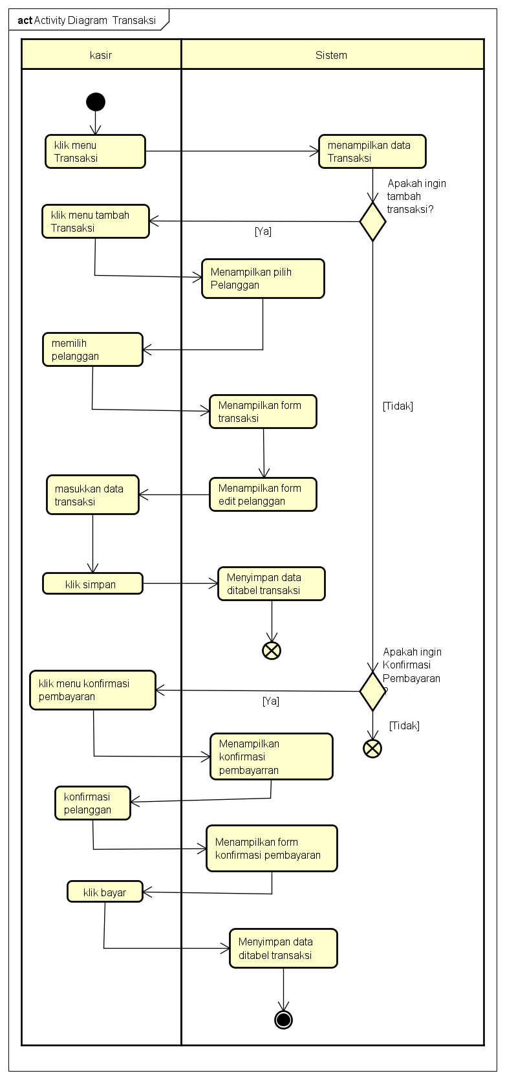

1. Activity Diagaram Proses cetak Struk (Admin dan Kasir).

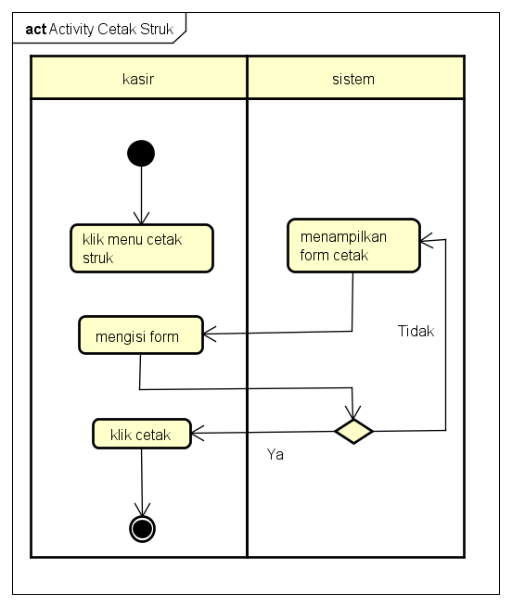

1. **PERANCANGAN DESAIN BASIS DATA**
2. Class Diagram Aplikasi Pengelolaan Laundry

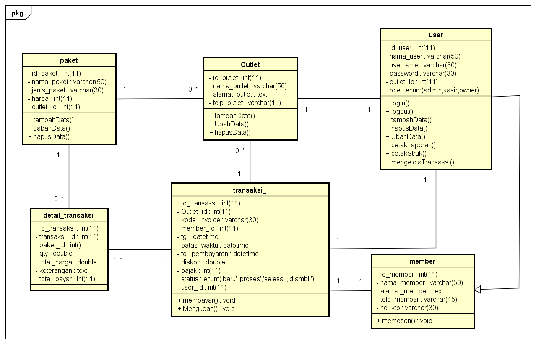

1. Data Flow Diagram Aplikasi Pengeloaan Laundry

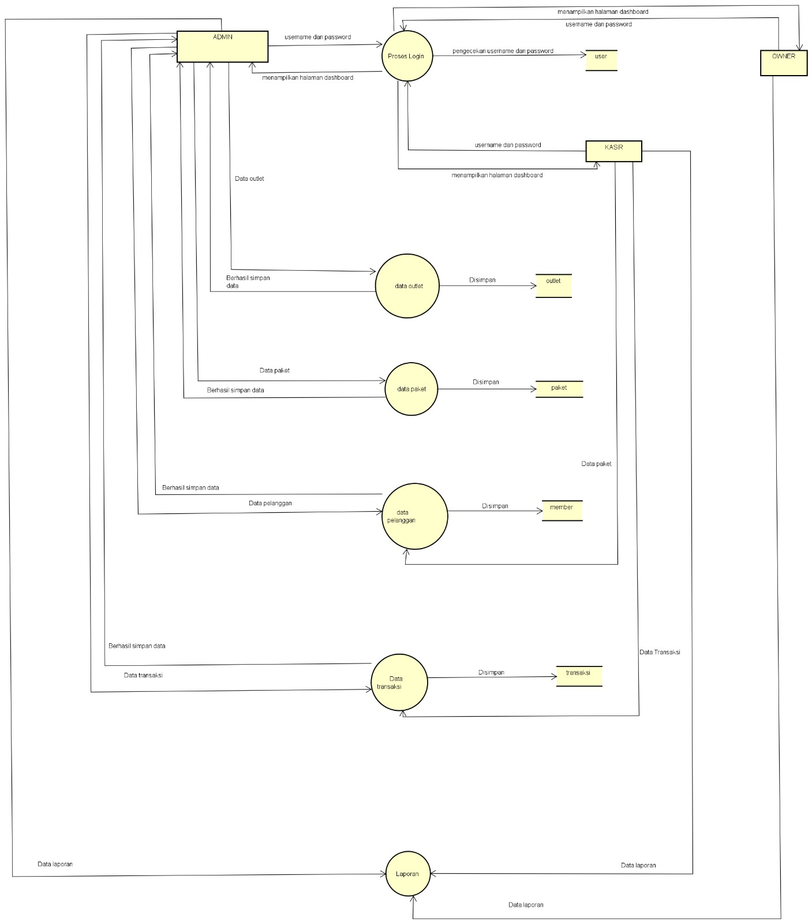

1. **DUMMY DATA**

|  |  |  |  |  |  |
| --- | --- | --- | --- | --- | --- |
| **Id_user** | **Nama_user** | **username** | **password** | **outlet_id** | **role** |
| 01 | Uzumaki Naruto | Naruto | 1sds223 | 25 | Admin |
| 02 | Uciha Sasuke | Sasuke | 23sds23 | 26 | Kasir |
| 03 | Haruno Sakura | Sakura | 23dw34 | 27 | Owner |
| 04 | Nara Shikamaru | Shikamaru | 234d1sd | 28 | Admin |
| 05 | Akimichi Choji | Choji | 34242ds | 29 | Kasir |
| 06 | Yamanaka Ino | Ino | 42321sd | 30 | Owner |

1. Tabel User
2. Tabel Member

|  |  |  |  |  |  |
| --- | --- | --- | --- | --- | --- |
| **Id_member** | **Nama_member** | **Alamat_member** | **jk** | **Tlp_member** | **No_ktp** |
| 01 | Luffy | Rancaekek | L | 0202323232 | 23232132 |
| 02 | Zoro | Cibiru | L | 0932212323 | 23232139 |
| 03 | Sanji | Cimerang | L | 0988782382 | 23234433 |
| 04 | Nami | Cihanjuang | P | 0239232223 | 32324444 |
| 05 | Usop | Ciamis | L | 0892323232 | 24434334 |
| 06 | Chopper | Cileben | L | 0872321321 | 53343433 |

1. Tabel Paket

|  |  |  |  |  |
| --- | --- | --- | --- | --- |
| **Id_paket** | **Jenis_paket** | **Nama_paket** | **harga** | **Outlet_id** |
| 01 | kaos | Paket cuci kering | Rp.15000 | 02 |
| 02 | selimut | Paket cuci angi | Rp.17000 | 03 |
| 03 | Bed cover | Paket Setrika wangi | Rp.20000 | 04 |
| 04 | Kaos | Paket Premium | Rp. 25000 | 05 |
| 05 | Selimut | Paket komplit | Rp. 27.000 | 06 |
| 06 | Bed cover | Paket 1 hari | Rp. 30.000 | 07 |

1. Tabel Outlet

|  |  |  |  |
| --- | --- | --- | --- |
| **Id_outlet** | **Nama_outlet** | **Alamat_outlet** | **Telp_outlet** |
| 01 | Outlet Baduy | Cimerang | 08944232424 |
| 02 | Outlet Barokah | Cibintung | 09784343344 |
| 03 | Outlet Jaya | Citunjung | 08934344343 |
| 04 | Outlet Banjay | Cihanjuang | 08324343434 |
| 05 | Outlet Balangsak | Cililin | 08374343445 |
| 06 | Outlet Bahaha | Ciawi | 08473343434 |

1. **PEMBUATAN BASIS DATA (MySQL Code)**
2. Tabel user

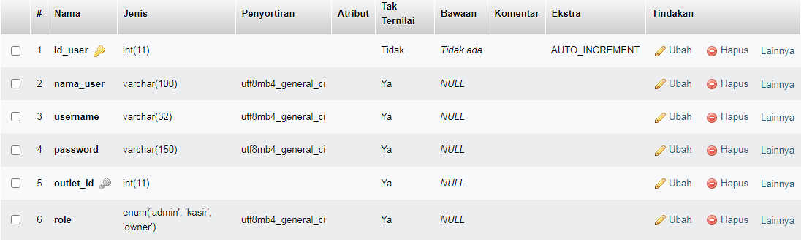

1. Tabel Transaksi

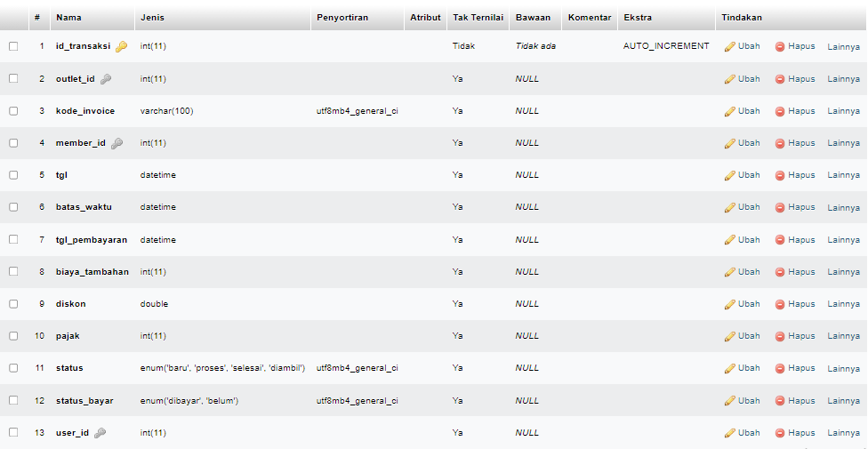

1. Tabel Paket

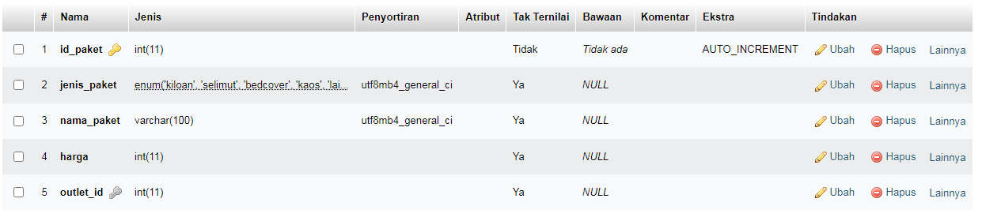

1. Tabel Outlet

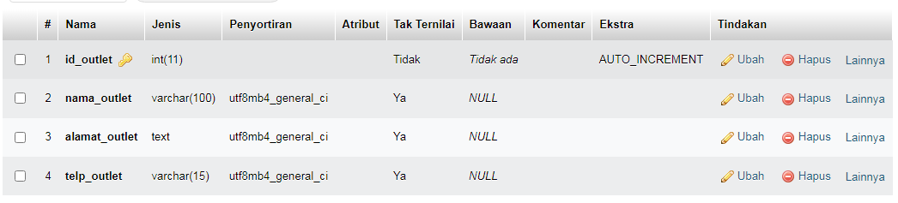

1. Tabel Member

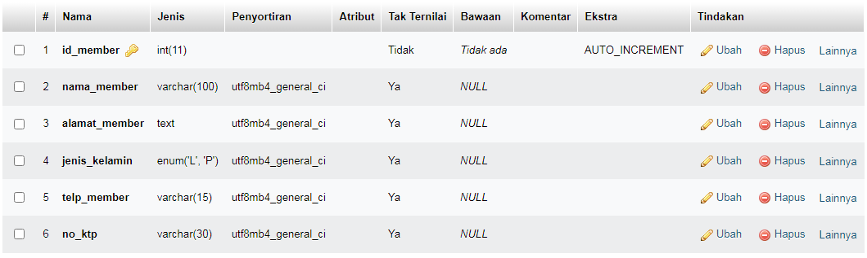

1. Tabel Detail Transaksi

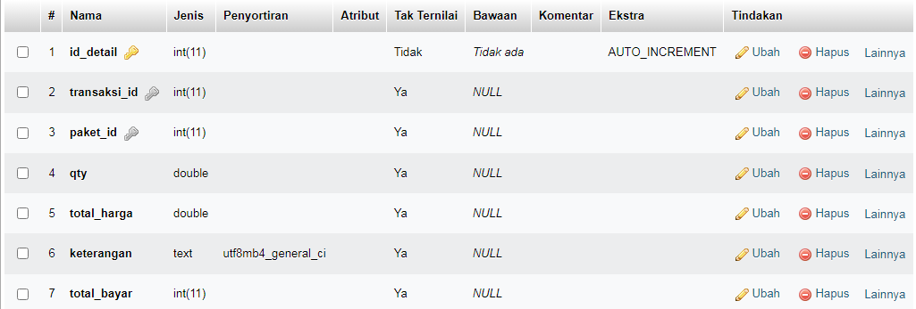

1. **PERANCANGAN TAMPILAN ANTARMUKA (UI) WEB**
2. Use case diagram Aplikasi pengelolaan Laundry

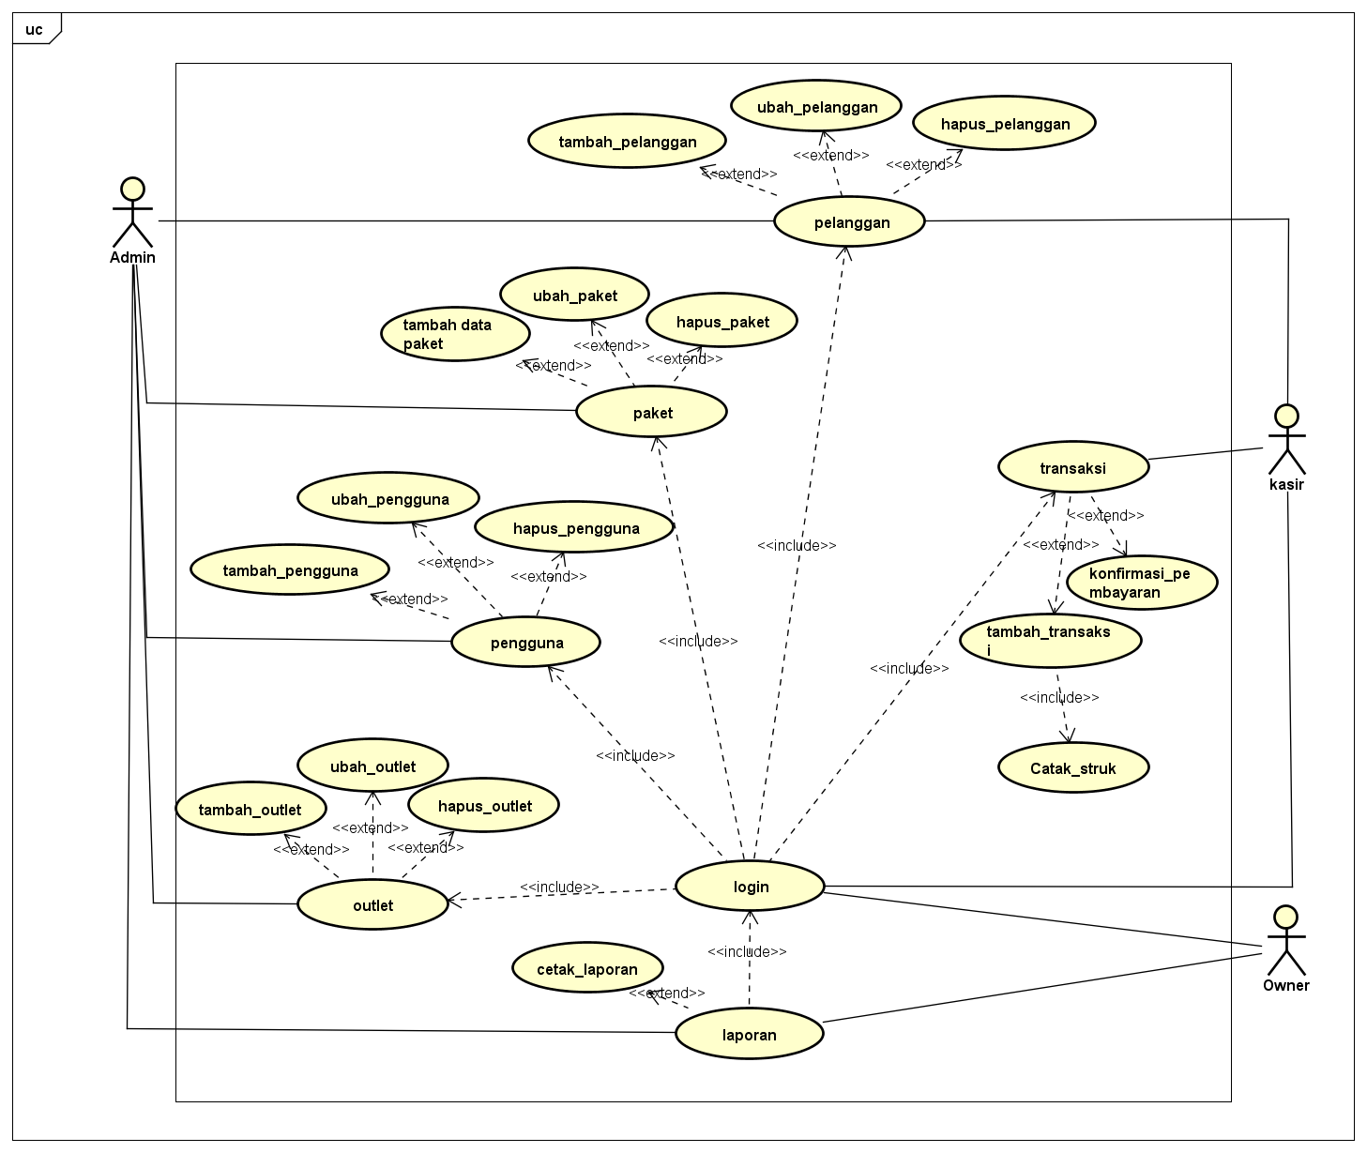

1. Mockup Web pengelolaan Laundry
2. Tampilan login (admin, kasir, owner)

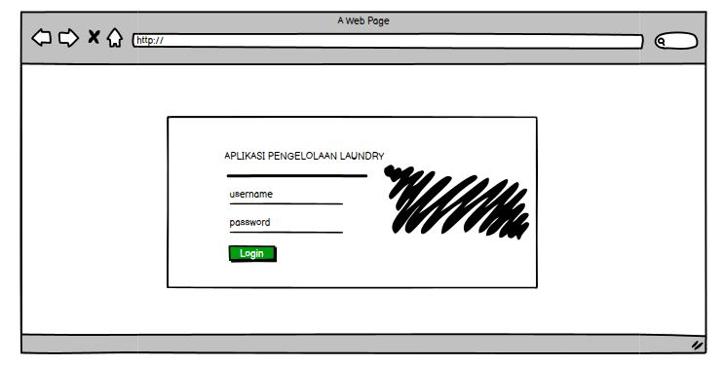

1. Tampilan dashboard (admin, kasir, owner)

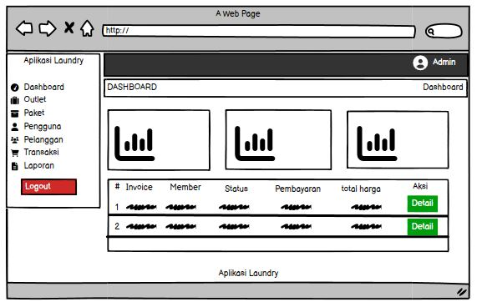

1. Tampilan Outlet (Admin)

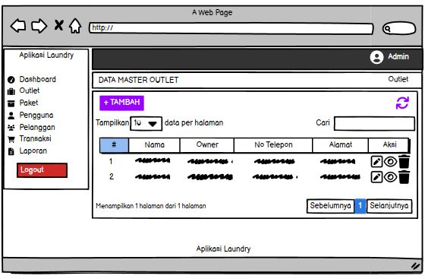

1. Tampilan Tambah data Outlet. (Admin)

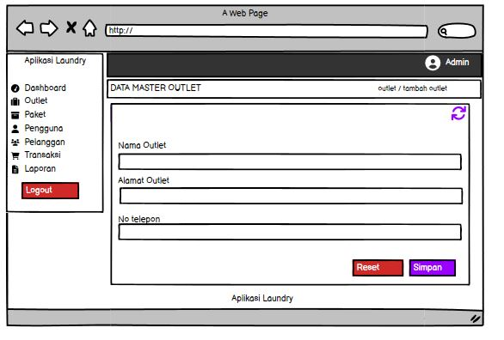

1. Tampilan Ubah data oulet (Admin)

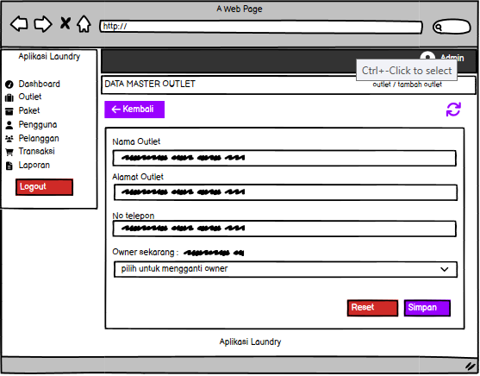

1. Tampilan data Paket (Admin)

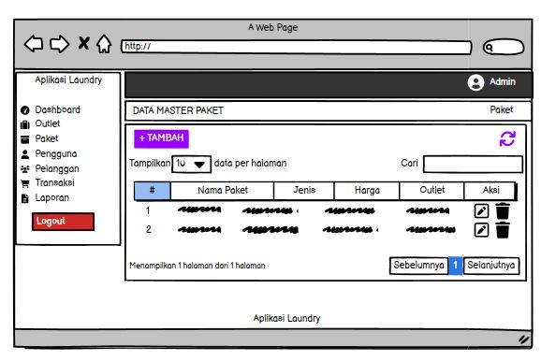

1. Tampilan Tambah data Paket (Admin)

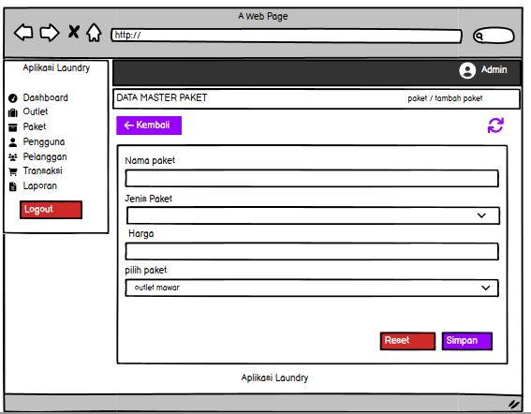

1. Tampian Ubah data Paket (Admin)

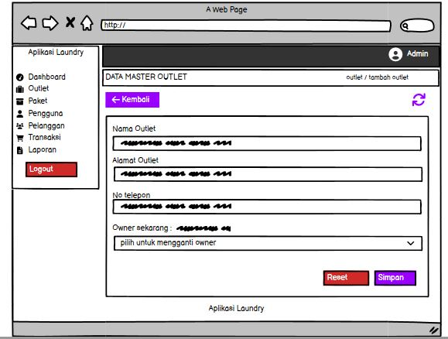

1. Tampilan data Pengguna (Admin)

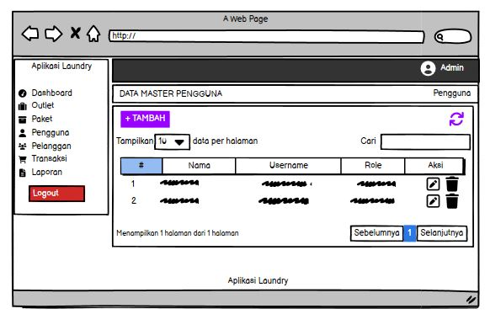

1. Tampilan Tambah data Pengguna (Admin)

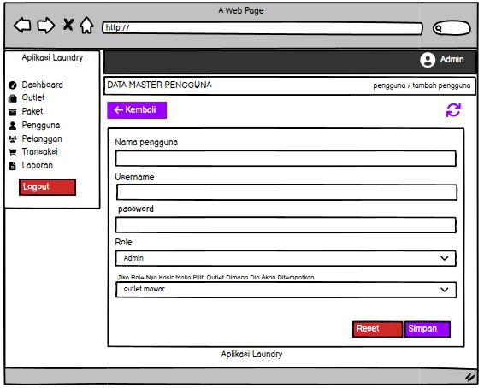

1. Tampilan Ubah data Pengguna (Admin)

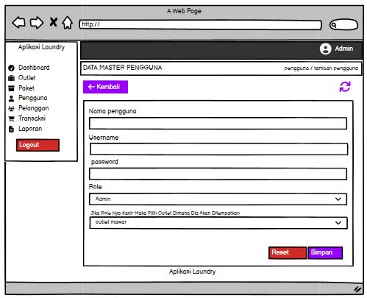

1. Tampilan data Pelanggan (Admin, Kasir)

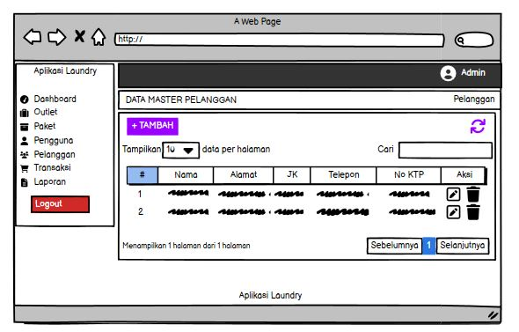

1. Tampilan tambah data Pelanggan

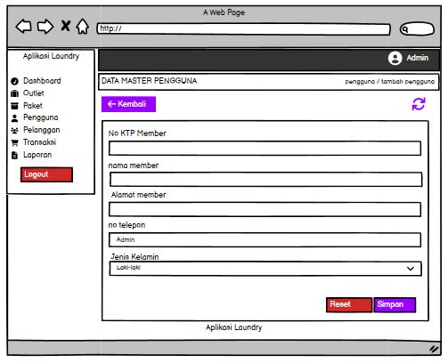

1. Tampilan ubah data Pelanggan

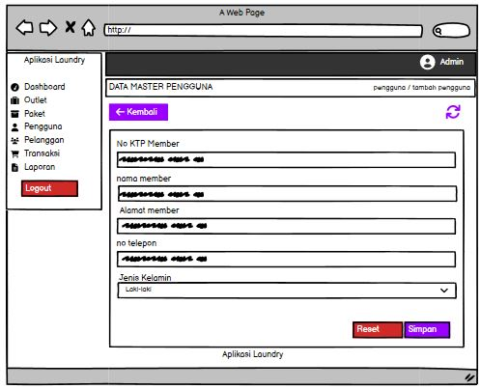

1. Tampilan Menu Laporan (Admin, Kasir, Owner)

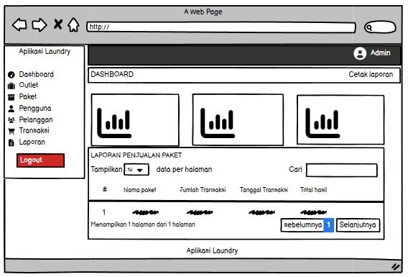

1. Tampilan data Transaksi (Admin, Kasir)

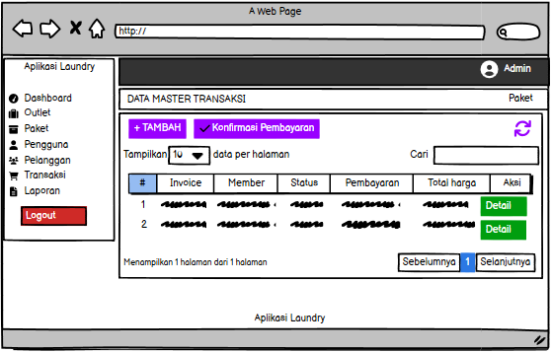

1. Tampilan pilih data member/pelanggan(Admin, Kasir)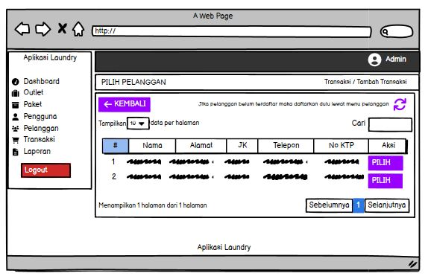
2. Tampilan form konfirmasi Pembayaran (Admin, kasir)

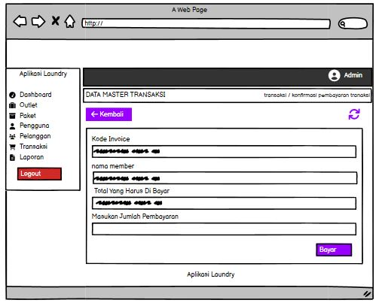

1. Tampilan form tambah data Transaksi(Admin, Kasir)

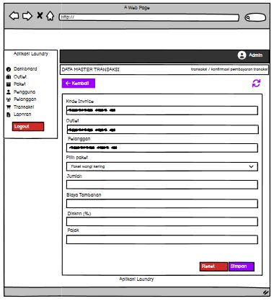

1. Tampilan Pembayaran Telah dibayar (Admin, Kasir)

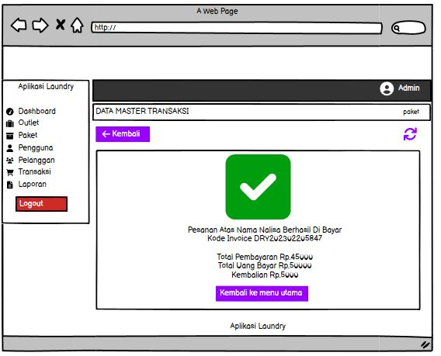

1. **PEMBUATAN STRUKTUR WEB (HTML)**
2. **PEMBUATAN STYLE WEB (CSS)**

* Diabawah ini merupakan kode css mempercantik from login “login.css”

|  |
| --- |
| * {margin: 0;  padding: 0;  box-sizing: border-box;  font-family:'Gill Sans', 'Gill Sans MT', Calibri, 'Trebuchet MS', sans-serif;  }body { display: flex;  justify-content: center;  align-items: center;  min-height: 100vh;  background-image: url("../../assets/plugins/images/woods.jpg");  color: #3a4b60;  background-size: cover;}.container {  width: 100%;  display: flex;  max-width: 850px;  backdrop-filter: blur(5px);  background-color: rgba(255,255,255,0.7);  border-radius: 15px;  box-shadow: 0 10px 15px rgba(237, 242, 241, 0.25);  border: 1px solid rgba(0,0,0,.125);}.login {  width: 400px;}form {  width: 300px;  margin: 60px auto;}h1 {  margin: 20px;  text-align: center;  font-weight: bolder;  color: #3a4b60;  text-transform: uppercase;}hr {  border-top: 2px solid #3a4b60}.right img {  width: 450px;  height: 100%;  border-top-right-radius: 15px;  border-bottom-right-radius: 15px;}button {  border: none;  outline: none;  padding: 8px;  width: 300px;  height: 45px;  color: #fff;  font-size: 16px;  cursor: pointer;  margin-top: 20px;  border-radius: 5px;  background: #3a4b60;}button:hover {  background: rgba(214, 86, 64, 1);}form .row{  height: 45px;  margin-bottom: 15px;  position: relative; } form .row input{  height: 100%;  width: 100%;  outline: none;  background: rgba(237, 242, 241, 0.2);  padding-left: 60px;  border-radius: 5px;  border: 1px solid #3a4b60;  font-size: 16px;  transition: all 0.3s ease;  }  form .row input:focus{  border-color: rgba(0,0,0,.125);  background: #fff;  color: #3a4b60;  box-shadow: inset 0px 0px 2px 2px rgba(237, 242, 241, 0.25);  }  form .row input::placeholder{  color: #3a4b60;  }  form .row i{  position: absolute;  width: 47px;  height: 100%;  color: #fff;  font-size: 18px;  background: #3a4b60;  border: 1px solid #3a4b60;  border-radius: 5px 0 0 5px;  display: flex;  align-items: center;  justify-content: center;  }  @media (max-width: 880px) {  .container {  width: 100%;  max-width: 750px;  margin-left: 20px;  margin-right: 20px;  }  form {  width: 300px;  margin: 20px auto;  }  .login {  width: 400px;  padding: 20px;  }  button {  width: 100%;  }  .right img {  width: 100%;  height: 100%;  }  } |

1. **Pembuatan Kode Web (PHP/JS)**
2. File index.html atau halaman dashboard

|  |
| --- |
| <?php  $title = 'dashboard';  require 'functions.php';  require 'layout_header.php';  $jTransaksi = ambilsatubaris($conn,'SELECT COUNT(id_transaksi) as jumlahtransaksi FROM transaksi');  $jPelanggan = ambilsatubaris($conn,'SELECT COUNT(id_member) as jumlahmember FROM member');  $joutlet = ambilsatubaris($conn,'SELECT COUNT(id_outlet) as jumlahoutlet FROM outlet');  $query = "SELECT transaksi.*,member.nama_member , detail_transaksi.total_harga FROM transaksi INNER JOIN member ON member.id_member = transaksi.member_id INNER JOIN detail_transaksi ON detail_transaksi.transaksi_id = transaksi.id_transaksi ORDER BY transaksi.id_transaksi DESC LIMIT 10";  $data = ambildata($conn,$query);  ?>  <div class="container-fluid">  <div class="row bg-title">  <div class="col-lg-3 col-md-4 col-sm-4 col-xs-12">  <h4 class="page-title">Dashboard</h4> </div>  </div>  <div class="row">  <div class="col-lg-4 col-sm-6 col-xs-12">  <div class="white-box analytics-info">  <h3 class="box-title">Oulet</h3>  <ul class="list-inline two-part">  <li>  <div id="sparklinedash"></div>  </li>  <li class="text-right"><i class="ti-arrow-up text-success"></i> <span class="counter text-success"><?= $joutlet['jumlahoutlet'] ?></span></li>  </ul>  </div>  </div>  <div class="col-lg-4 col-sm-6 col-xs-12">  <div class="white-box analytics-info">  <h3 class="box-title">Pelanggan</h3>  <ul class="list-inline two-part">  <li>  <div id="sparklinedash2"></div>  </li>  <li class="text-right"><i class="ti-arrow-up text-purple"></i> <span class="counter text-purple"><?= $jPelanggan['jumlahmember'] ?></span></li>  </ul>  </div>  </div>  <div class="col-lg-4 col-sm-6 col-xs-12">  <div class="white-box analytics-info">  <h3 class="box-title">Transaksi</h3>  <ul class="list-inline two-part">  <li>  <div id="sparklinedash3"></div>  </li>  <li class="text-right"><i class="ti-arrow-up text-info"></i> <span class="counter text-info"><?= $jTransaksi['jumlahtransaksi'] ?></span></li>  </ul>  </div>  </div>  </div>  <div class="row">  <div class="col-md-12 col-lg-12 col-sm-12">  <div class="white-box">  <h3 class="box-title">10 Transaksi Terbaru</h3>  <div class="table-responsive">  <table class="table ">  <thead>  <tr>  <th>#</th>  <th>Invoice</th>  <th>Member</th>  <th>Status</th>  <th>Pemabayaran</th>  <th>Total Harga</th>  <th width="15%">Aksi</th>  </tr>  </thead>  <tbody>  <?php $no=1; foreach($data as $transaksi): ?>  <tr>  <td><?= $no++ ?></td>  <td><?= $transaksi['kode_invoice'] ?></td>  <td><?= $transaksi['nama_member'] ?></td>  <td><?= $transaksi['status'] ?></td>  <td><?= $transaksi['status_bayar'] ?></td>  <td><?= $transaksi['total_harga'] ?></td>  <td align="center">  <a href="transaksi_detail.php?id=<?= $transaksi['id_transaksi']; ?>" data-toggle="tooltip" data-placement="bottom" title="Edit" class="btn btn-success btn-block">Detail</a>  </td>  </tr>  <?php endforeach; ?>  </tbody>  </table>  </div>  </div>  </div>  </div>  </div>  <?php  require 'layout_footer.php';  ?> |

1. Create data Outlet, kode untuk menambahkan data Outlet “create_outlet.php”

|  |
| --- |
| <?php  $title = 'outlet';  require'functions.php';  if(isset($_POST['btn-simpan'])){  $nama = stripslashes($_POST['nama_outlet']);  $alamat = stripslashes($_POST['alamat_outlet']);  $telp = stripslashes($_POST['telp_outlet']);  $query = "INSERT INTO outlet (nama_outlet,alamat_outlet,telp_outlet) values ('$nama','$alamat','$telp')";  $execute = bisa($conn,$query);  if($execute == 1){  $success = 'true';  $title = 'Berhasil';  $message = 'Berhasil Simpan Data';  $type = 'success';  header('location: outlet.php?crud='.$success.'&msg='.$message.'&type='.$type.'&title='.$title);  }else{  echo "Gagal Tambah Data";  }  }  require'layout_header.php';  ?>  <div class="container-fluid">  <div class="row bg-title">  <div class="col-lg-3 col-md-4 col-sm-4 col-xs-12">  <h4 class="page-title">Data Master Outlet</h4> </div>  <div class="col-lg-9 col-sm-8 col-md-8 col-xs-12">  <ol class="breadcrumb">  <li><a href="outlet.php">Outlet</a></li>  <li><a href="#">Tambah Outlet</a></li>  </ol>  </div>  <!-- /.col-lg-12 -->  </div>  <div class="row">  <div class="col-md-12 col-lg-12 col-sm-12 col-xs-12">  <div class="white-box">  <div class="row">  <div class="col-md-6">  <a href="javascript:void(0)" onclick="window.history.back();" class="btn btn-primary box-title"><i class="fa fa-arrow-left fa-fw"></i> Kembali</a>  </div>  <div class="col-md-6 text-right">  <button id="btn-refresh" class="btn btn-primary box-title text-right" title="Refresh Data"><i class="fa fa-refresh" id="ic-refresh"></i></button>  </div>  </div>  </div>  </div>  </div>  <div class="row">  <div class="col-md-12 col-lg-12 col-sm-12 col-xs-12">  <div class="white-box">  <form method="post" action="">  <div class="form-group">  <label>Nama Outlet</label>  <input type="text" name="nama_outlet" class="form-control">  </div>  <div class="form-group">  <label>Alamat Outlet</label>  <textarea name="alamat_outlet" class="form-control"></textarea>  </div>  <div class="form-group">  <label>Nomor Telepon</label>  <input type="text" name="telp_outlet" class="form-control">  </div>  <div class="text-right">  <button type="reset" class="btn btn-danger">Reset</button>  <button type="submit" name="btn-simpan" class="btn btn-primary">Simpan</button>  </div>  </form>  </div>  </div>  </div>  </div>  <?php  require'layout_footer.php';  ?> |

1. Read Outlet kode ini digunakan untuk melihat data outlet “read_pengguna.php”

|  |
| --- |
| <?php  $title = 'outlet';  require 'functions.php';  require 'layout_header.php';  $query = 'SELECT outlet.*, user.nama_user FROM outlet LEFT JOIN user ON user.outlet_id = outlet.id_outlet';  $data = ambildata($conn,$query);  ?>  <div class="container-fluid">  <div class="row bg-title">  <div class="col-lg-3 col-md-4 col-sm-4 col-xs-12">  <h4 class="page-title">Data Master Outlet</h4> </div>  <!-- /.col-lg-12 -->  </div>  <div class="row">  <div class="col-md-12 col-lg-12 col-sm-12 col-xs-12">  <div class="white-box">  <div class="row">  <div class="col-md-6">  <a href="outlet_tambah.php" class="btn btn-primary box-title"><i class="fa fa-plus fa-fw"></i> Tambah</a>  </div>  <div class="col-md-6 text-right">  <button id="btn-refresh" class="btn btn-primary box-title text-right" title="Refresh Data"><i class="fa fa-refresh" id="ic-refresh"></i></button>  </div>  </div>  <div class="table-responsive">  <table class="table table-bordered thead-dark" id="table">  <thead class="thead-dark">  <tr>  <th>#</th>  <th>Nama</th>  <th>Owner</th>  <th>No Telepon</th>  <th>Alamat</th>  <th>Aksi</th>  </tr>  </thead>  <tbody>  <?php foreach($data as $outlet): ?>  <tr>  <td></td>  <td><?= htmlspecialchars($outlet['nama_outlet']); ?></td>  <td>  <?php if($outlet['nama_user'] == null){  echo 'Belum Ada Owner';  }else{  echo htmlspecialchars($outlet['nama_user']);  } ?>  </td>  <td><?= htmlspecialchars($outlet['telp_outlet']); ?></td>  <td><?= htmlspecialchars($outlet['alamat_outlet']); ?></td>  <td align="center">  <div class="btn-group" role="group" aria-label="Basic example">  <a href="outlet_edit.php?id=<?= $outlet['id_outlet']; ?>" data-toggle="tooltip" data-placement="bottom" title="Edit" class="btn btn-success"><i class="fa fa-edit"></i></a>  <a href="outlet_hapus.php?id=<?= $outlet['id_outlet']; ?>" onclick="return confirm('Yakin hapus data ? ');" data-toggle="tooltip" data-placement="bottom" title="Hapus" class="btn btn-danger"><i class="fa fa-trash"></i></a>  </div>  </td>  </tr>  <?php endforeach; ?>  </tbody>  </table>  </div>  </div>  </div>  </div>  </div>  <?php  require'layout_footer.php';  ?> |

1. Update data Outlet, kode ini digunakan untuk memperbarui data outlet “update_outlet.php”

|  |
| --- |
| <?php  $title = 'outlet';  require'functions.php';  $query = 'SELECT outlet.*, user.nama_user,user.id_user FROM outlet LEFT JOIN user ON user.outlet_id = outlet.id_outlet WHERE id_outlet = ' . stripslashes($_GET['id']);  $data = ambilsatubaris($conn,$query);  $query2 = 'SELECT user.*,outlet.nama_outlet FROM outlet RIGHT JOIN user ON user.outlet_id = outlet.id_outlet WHERE user.role = "owner" order by user.outlet_id asc';  $data2 = ambildata($conn,$query2);  if(isset($_POST['btn-simpan'])){  $nama = stripslashes($_POST['nama_outlet']);  $alamat = stripslashes($_POST['alamat_outlet']);  $telp = stripslashes($_POST['telp_outlet']);  $query = "UPDATE outlet SET nama_outlet = '$nama' , alamat_outlet = '$alamat' , telp_outlet='$telp' WHERE id_outlet = " . stripslashes($_GET['id']);  if($_POST['owner_id_new']){  $query2 = "UPDATE user SET outlet_id = '" . stripslashes($_GET['id']) . "' WHERE id_user = " . $_POST['owner_id_new'];  $query3 = "UPDATE user SET outlet_id = NULL WHERE id_user = " . stripslashes($data['id_user']);  $execute3 = bisa($conn,$query3);  }else{  $query2 = "UPDATE user SET outlet_id = '" . stripslashes($_GET['id']) . "' WHERE id_user = " . stripslashes($_POST['owner_id']);  }  $execute = bisa($conn,$query);  $execute2 = bisa($conn,$query2);  if($execute == 1 && $execute2 == 1){  $success = 'true';  $title = 'Berhasil';  $message = 'Berhasil Mengubah Data';  $type = 'success';  header('location: outlet.php?crud='.$success.'&msg='.$message.'&type='.$type.'&title='.$title);  }else{  echo "Gagal Tambah Data";  }  }  require'layout_header.php';  ?>  <div class="container-fluid">  <div class="row bg-title">  <div class="col-lg-3 col-md-4 col-sm-4 col-xs-12">  <h4 class="page-title">Data Master Outlet</h4> </div>  <div class="col-lg-9 col-sm-8 col-md-8 col-xs-12">  <ol class="breadcrumb">  <li><a href="outlet.php">Outlet</a></li>  <li><a href="#">Tambah Outlet</a></li>  </ol>  </div>  </div>  <div class="row">  <div class="col-md-12 col-lg-12 col-sm-12 col-xs-12">  <div class="white-box">  <div class="row">  <div class="col-md-6">  <a href="javascript:void(0)" onclick="window.history.back();" class="btn btn-primary box-title"><i class="fa fa-arrow-left fa-fw"></i> Kembali</a>  </div>  <div class="col-md-6 text-right">  <button id="btn-refresh" class="btn btn-primary box-title text-right" title="Refresh Data"><i class="fa fa-refresh" id="ic-refresh"></i></button>  </div>  </div>  </div>  </div>  </div>  <div class="row">  <div class="col-md-12 col-lg-12 col-sm-12 col-xs-12">  <div class="white-box">  <form method="post" action="">  <div class="form-group">  <label>Nama Outlet</label>  <input type="text" value="<?= $data['nama_outlet']; ?>" name="nama_outlet" class="form-control">  </div>  <div class="form-group">  <label>Alamat Outlet</label>  <textarea name="alamat_outlet" class="form-control"><?= htmlspecialchars($data['alamat_outlet']); ?></textarea>  </div>  <div class="form-group">  <label>Nomor Telepon</label>  <input type="text" value="<?= htmlspecialchars($data['telp_outlet']); ?>" name="telp_outlet" class="form-control">  </div>  <?php if($data['nama_user'] == null): ?>  <div class="form-group">  <label>Belum Ada Owner (silahkan pilih owner)</label>  <select name="owner_id" class="form-control">  <?php foreach ($data2 as $owner): ?>  <option value="<?= htmlspecialchars($owner['id_user']); ?>"><?= htmlspecialchars($owner['nama_user']); ?>  <?php if ($owner['outlet_id'] == null): ?>  ( Belum memiliki outlet )  <?php else: ?>  ( Owner di <?= htmlspecialchars($owner['nama_outlet']); ?> )  <?php endif ?>  </option>  <?php endforeach ?>  </select>  </div>  <?php else: ?>  <div class="form-group">  <label>Owner Sekarang : <?= htmlspecialchars($data['nama_user']); ?></label>  <select name="owner_id_new" class="form-control">  <option class="">Pilih Untuk Mengganti owner</option>  <?php foreach ($data2 as $owner): ?>  <option value="<?= htmlspecialchars($owner['id_user']); ?>"><?= htmlspecialchars($owner['nama_user']); ?>  <?php if ($owner['outlet_id'] == null): ?>  ( Belum memiliki outlet )  <?php else: ?>  ( Owner di <?= htmlspecialchars($owner['nama_outlet']); ?> )  <?php endif ?>  </option>  <?php endforeach ?>  </select>  </div>  <?php endif; ?>  <div class="text-right">  <button type="reset" class="btn btn-danger">Reset</button>  <button type="submit" name="btn-simpan" class="btn btn-primary">Simpan</button>  </div>  </form>  </div>  </div>  </div>  </div>  <?php  require'layout_footer.php';  ?> |

1. Delete data Outlet, kode ini digunakan untuk menghapus data Outler “delete_outket.php”

|  |
| --- |
| <?php  require 'functions.php';  $sql = "DELETE FROM outlet WHERE id_outlet = " . stripslashes($_GET['id']);  $exe = mysqli_query($conn,$sql);  if($exe){  $success = 'true';  $title = 'Berhasil';  $message = 'Menghapus Data';  $type = 'success';  header('location: outlet.php?crud='.$success.'&msg='.$message.'&type='.$type.'&title='.$title);  }  ?> |

1. **Uji Coba**

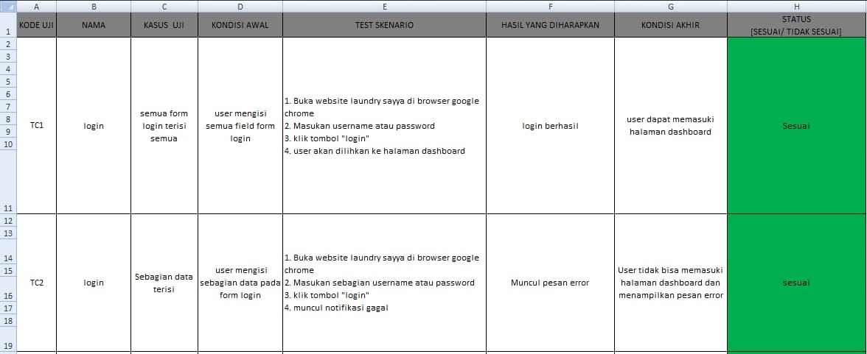

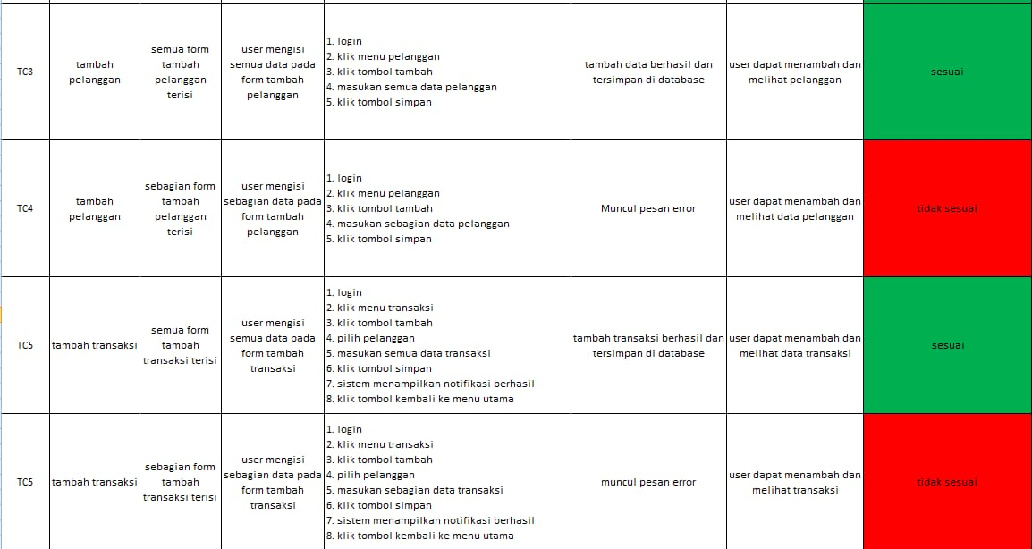

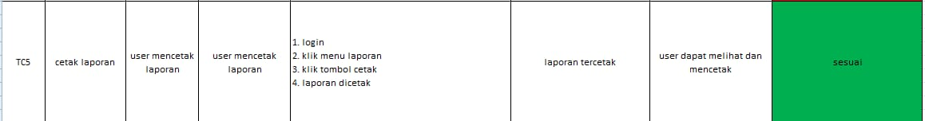

1. **REVISI**
2. **PENENTUAN DOMAIN DAN HOSTING**
3. Domain hosting : <https://laundryjodi.000webhostapp.com/>
4. Hosting : menggunakan web : id.000webhostapp
5. **UPLOAD WEB KE HOSTING**
6. **UPLOAD WEB KE GITHUB**
7. **PEMBUATAN USER GUIDANCE**

**s**