PROBLEM [1]

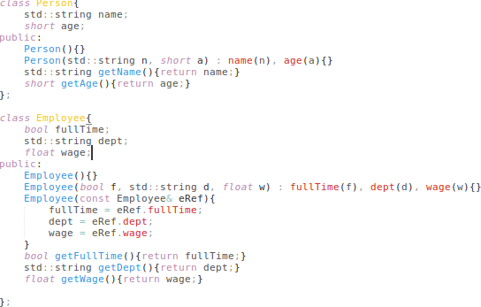

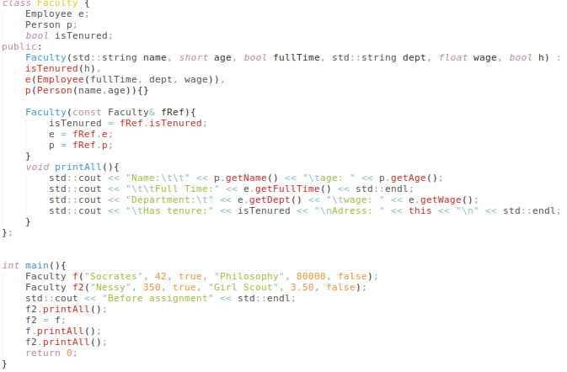

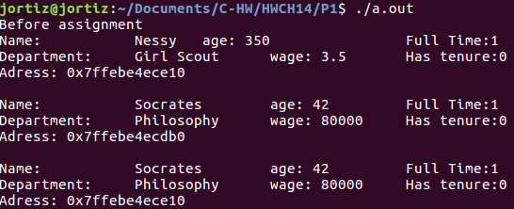

PROBLEM [2]
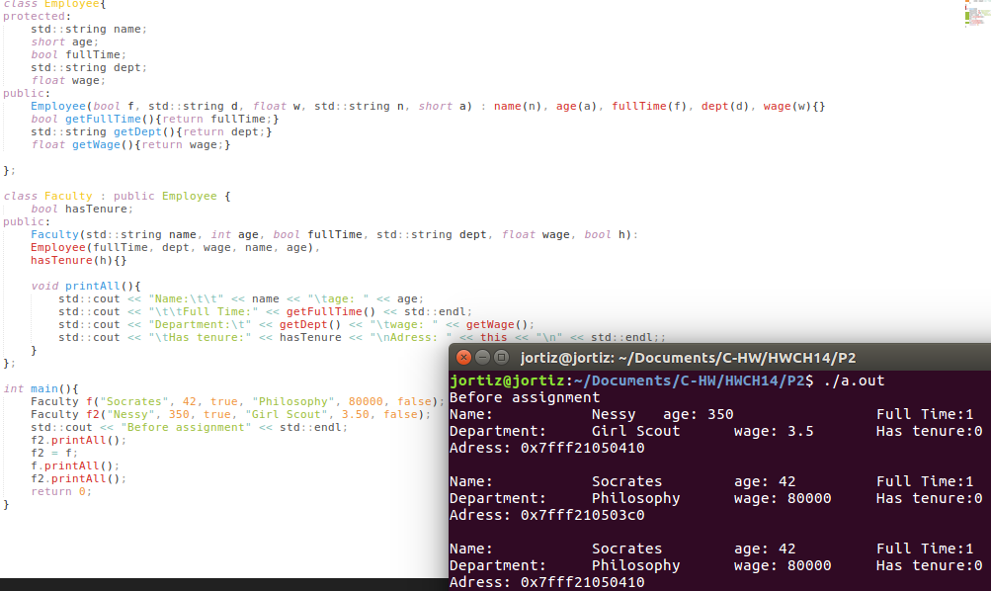
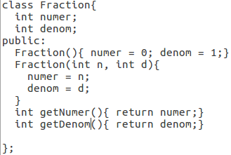
We now want a new class of Fraction-like objects, which, in addition to the functionality above, have the ability to keep track of whether they’re simple or not. (A simple fraction has no common factors between its numerator and denominator; simplifying a fraction is dividing both numerator and denominator by the common factor(s) in order to eliminate them.) Let’s call the new class FractionSimpleOrNot.

Explain briefly how you would use the following tools for the implementation of FractionSimpleOrNot:

(Composition) -
I would declare an object of type Fraction inside of FractionSimpleOrNot then use the getter functions to extract the data members inside of Fraction to then determine if the fraction is simple or not.

(Inheritance) -
I would have FractionSimpleOrNot derived from Fraction so I can have access to the numerator and denominator so I can then check if it’s simple or not.

(Multiple Inheritance) -
In this situation, I would not use multiple inheritance because there’s only one class to inherit from and adding another class to inherit from would only make this more complicated than it needs to be.

(Which of the above methods is the most appropriate? Explain:) -
I would use Inheritance because I wouldn’t need to use the getter functions if I make the data members protected or the membership operator. It would simplify the code a lot in this problem.

