**Protocol** - an agreement on how mthose programs will communicate.

**Daemon** - Long running program

**Web server** - Daemon that sends network messages only in response to requests coming in from the network.

**Web Client** - always initiates communication with the server.

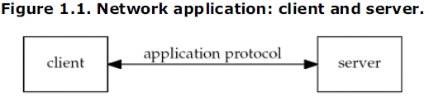

Clients usually communicate to only one server at any given time; however, a server can communicate to many clients at once.

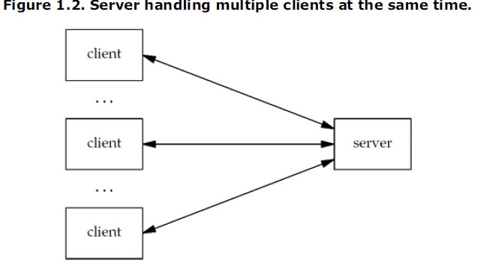We think of a communication via a network protocol but there are multiple layers of network protocols being used.

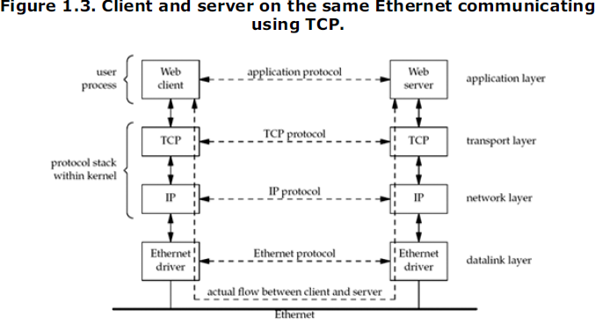**TCP –** Transmission Control Protocol. What web clients and servers use to communicate. **TCP USES THE INTERNET PROTOCOL (IP) AND INTERNET PROTOCOL COMMUNICATES WITH A DATALINK LAYER OF SOME FORM.**

