Engagement_import_and_clean.R

joost

Wed Jan 11 11:29:15 2017

#Engagement analysis  
  
#Load packages  
library(readxl)  
library(data.table)  
library(dplyr)

## -------------------------------------------------------------------------

## data.table + dplyr code now lives in dtplyr.  
## Please library(dtplyr)!

## -------------------------------------------------------------------------

##   
## Attaching package: 'dplyr'

## The following objects are masked from 'package:data.table':  
##   
## between, first, last

## The following objects are masked from 'package:stats':  
##   
## filter, lag

## The following objects are masked from 'package:base':  
##   
## intersect, setdiff, setequal, union

library(ggplot2)  
  
  
# Import Excel File  
engag16 <- read_excel("/Users/joost/Documents/Data and Revenue/Daily analysis/Daily revenue GhanaWeb PartII.xlsx", sheet=3, col_names = F, na = '0', skip = 2)

## Warning in read_xlsx_(path, sheet, col_names = col_names, col_types =  
## col_types, : [401, 2]: expecting numeric: got 'mean'

## Warning in read_xlsx_(path, sheet, col_names = col_names, col_types =  
## col_types, : [402, 2]: expecting numeric: got 'average'

## Warning in read_xlsx_(path, sheet, col_names = col_names, col_types =  
## col_types, : [403, 2]: expecting numeric: got 'st.dev.'

## Warning in read_xlsx_(path, sheet, col_names = col_names, col_types =  
## col_types, : [404, 2]: expecting numeric: got '-0x1.0082fp-36 0x1.ffb4p-135  
## 0x1.6e93ap+46 0x1.fffcp-135riation'

## Warning in read_xlsx_(path, sheet, col_names = col_names, col_types =  
## col_types, : [406, 2]: expecting numeric: got 'max'

## Warning in read_xlsx_(path, sheet, col_names = col_names, col_types =  
## col_types, : [407, 2]: expecting numeric: got 'min'

# Clean Data  
#colselect2 <- c(1, 2, 4, 5)  
colnames2 <- c('date', 'alexa_pv', 'uniques1000x', 'pages_per_unique', 'nr_articles', 'comments', 'page_per_visit', 'time_per_visit', 'comments_visitor', 'comments_article', 'visits_per_visitor')  
  
colnames(engag16) <- colnames2  
engag16 <- engag16[1:366,]  
engag16 <- as.data.table(engag16)  
  
#add column for weekdays and weekends  
  
engage16v2 <- engag16 %>% mutate(wday = weekdays(date, abbreviate = TRUE), weekend = ifelse(wday %in% c('Sat', 'Sun'), 'yes', 'no'))  
  
##!!!remove outliers (method just copied). Select 1 of 2 lines. Top = filter, bottom is NO FILTER  
engage16or <- engage16v2  
#engage16or <- engage16v2 %>% group_by(ad_slot_id) %>% filter(!(abs(count - median(count)) > 3*sd(count)))  
#engage16or[ , c("alexa_pv", "uniques1000x", "pages_per_unique", "comments_article")] <- lapply(engage16or[ , c("alexa_pv", "uniques1000x", "pages_per_unique", "comments_article")], function(x) {ifelse((abs(x-mean(x)) > 3 * sd(x)), 'NA', x)})  
  
engage16or[ , c("alexa_pv", "uniques1000x", "pages_per_unique", "comments_article")] <- lapply(engage16or[ , c("alexa_pv", "uniques1000x", "pages_per_unique", "comments_article")], function(x) {ifelse((abs(x-mean(x)) > 3 * sd(x)), NA, x)})  
  
   
 # group_by(element) %>%  
 # filter(!(abs(value - median(value)) > 2*sd(value))) %>%  
 # summarise_each(funs(mean), value)  
  
  
### Multiple pairwise comparison Plots  
library(lattice)  
splom(~engage16v2[2:9])

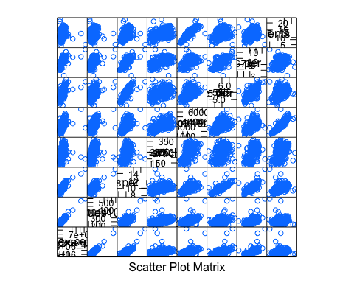

# ggcorplot(  
# data = engage16v2[2:6],  
# var_text_size = 5,  
# cor_text_limits = c(5,10))  
  
library(GGally)

##   
## Attaching package: 'GGally'

## The following object is masked from 'package:dplyr':  
##   
## nasa

ggpairs(engage16or, columns=c('alexa_pv', 'uniques1000x', 'pages_per_unique', 'nr_articles'),  
 diag=list(continuous="density", discrete="bar"), axisLabels="show")

## Warning in check_and_set_ggpairs_defaults("diag", diag, continuous =  
## "densityDiag", : Changing diag$continuous from 'density' to 'densityDiag'

## Warning in check_and_set_ggpairs_defaults("diag", diag, continuous =  
## "densityDiag", : Changing diag$discrete from 'bar' to 'barDiag'

## Warning: Removed 3 rows containing non-finite values (stat_density).

## Warning in (function (data, mapping, alignPercent = 0.6, method =  
## "pearson", : Removed 4 rows containing missing values

## Warning in (function (data, mapping, alignPercent = 0.6, method =  
## "pearson", : Removed 3 rows containing missing values

## Warning in (function (data, mapping, alignPercent = 0.6, method =  
## "pearson", : Removed 3 rows containing missing values

## Warning: Removed 4 rows containing missing values (geom_point).

## Warning: Removed 4 rows containing non-finite values (stat_density).

## Warning in (function (data, mapping, alignPercent = 0.6, method =  
## "pearson", : Removed 4 rows containing missing values

## Warning in (function (data, mapping, alignPercent = 0.6, method =  
## "pearson", : Removed 4 rows containing missing values

## Warning: Removed 3 rows containing missing values (geom_point).

## Warning: Removed 4 rows containing missing values (geom_point).

## Warning: Removed 3 rows containing non-finite values (stat_density).

## Warning in (function (data, mapping, alignPercent = 0.6, method =  
## "pearson", : Removed 3 rows containing missing values

## Warning: Removed 3 rows containing missing values (geom_point).

## Warning: Removed 4 rows containing missing values (geom_point).

## Warning: Removed 3 rows containing missing values (geom_point).

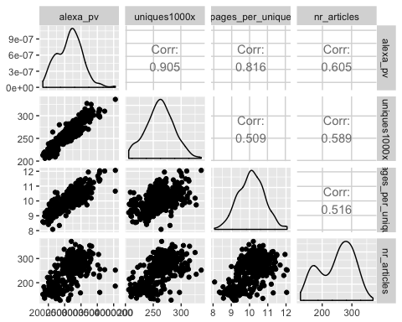

library(PerformanceAnalytics)

## Loading required package: xts

## Loading required package: zoo

##   
## Attaching package: 'zoo'

## The following objects are masked from 'package:base':  
##   
## as.Date, as.Date.numeric

##   
## Attaching package: 'xts'

## The following objects are masked from 'package:dplyr':  
##   
## first, last

## The following objects are masked from 'package:data.table':  
##   
## first, last

##   
## Attaching package: 'PerformanceAnalytics'

## The following object is masked from 'package:graphics':  
##   
## legend

chart.Correlation(engage16or[2:10],   
 method="spearman",  
 histogram=TRUE,  
 pch=16)

## Warning in plot.window(...): "method" is not a graphical parameter

## Warning in plot.xy(xy, type, ...): "method" is not a graphical parameter

## Warning in title(...): "method" is not a graphical parameter

## Warning in plot.window(...): "method" is not a graphical parameter

## Warning in plot.xy(xy, type, ...): "method" is not a graphical parameter

## Warning in title(...): "method" is not a graphical parameter

## Warning in axis(side = side, at = at, labels = labels, ...): "method" is  
## not a graphical parameter

## Warning in cor.test.default(x, y, method = method): Cannot compute exact p-  
## value with ties

## Warning in plot.window(...): "method" is not a graphical parameter

## Warning in plot.xy(xy, type, ...): "method" is not a graphical parameter

## Warning in title(...): "method" is not a graphical parameter

## Warning in cor.test.default(x, y, method = method): Cannot compute exact p-  
## value with ties

## Warning in plot.window(...): "method" is not a graphical parameter

## Warning in plot.xy(xy, type, ...): "method" is not a graphical parameter

## Warning in title(...): "method" is not a graphical parameter

## Warning in axis(side = side, at = at, labels = labels, ...): "method" is  
## not a graphical parameter

## Warning in cor.test.default(x, y, method = method): Cannot compute exact p-  
## value with ties

## Warning in plot.window(...): "method" is not a graphical parameter

## Warning in plot.xy(xy, type, ...): "method" is not a graphical parameter

## Warning in title(...): "method" is not a graphical parameter

## Warning in cor.test.default(x, y, method = method): Cannot compute exact p-  
## value with ties

## Warning in plot.window(...): "method" is not a graphical parameter

## Warning in plot.xy(xy, type, ...): "method" is not a graphical parameter

## Warning in title(...): "method" is not a graphical parameter

## Warning in axis(side = side, at = at, labels = labels, ...): "method" is  
## not a graphical parameter

## Warning in cor.test.default(x, y, method = method): Cannot compute exact p-  
## value with ties

## Warning in plot.window(...): "method" is not a graphical parameter

## Warning in plot.xy(xy, type, ...): "method" is not a graphical parameter

## Warning in title(...): "method" is not a graphical parameter

## Warning in cor.test.default(x, y, method = method): Cannot compute exact p-  
## value with ties

## Warning in plot.window(...): "method" is not a graphical parameter

## Warning in plot.xy(xy, type, ...): "method" is not a graphical parameter

## Warning in title(...): "method" is not a graphical parameter

## Warning in axis(side = side, at = at, labels = labels, ...): "method" is  
## not a graphical parameter

## Warning in cor.test.default(x, y, method = method): Cannot compute exact p-  
## value with ties

## Warning in plot.window(...): "method" is not a graphical parameter

## Warning in plot.xy(xy, type, ...): "method" is not a graphical parameter

## Warning in title(...): "method" is not a graphical parameter

## Warning in axis(side = side, at = at, labels = labels, ...): "method" is  
## not a graphical parameter

## Warning in cor.test.default(x, y, method = method): Cannot compute exact p-  
## value with ties

## Warning in plot.window(...): "method" is not a graphical parameter

## Warning in plot.xy(xy, type, ...): "method" is not a graphical parameter

## Warning in title(...): "method" is not a graphical parameter

## Warning in axis(side = side, at = at, labels = labels, ...): "method" is  
## not a graphical parameter

## Warning in plot.xy(xy.coords(x, y), type = type, ...): "method" is not a  
## graphical parameter

## Warning in plot.window(...): "method" is not a graphical parameter

## Warning in plot.xy(xy, type, ...): "method" is not a graphical parameter

## Warning in title(...): "method" is not a graphical parameter

## Warning in plot.window(...): "method" is not a graphical parameter

## Warning in plot.xy(xy, type, ...): "method" is not a graphical parameter

## Warning in title(...): "method" is not a graphical parameter

## Warning in cor.test.default(x, y, method = method): Cannot compute exact p-  
## value with ties

## Warning in plot.window(...): "method" is not a graphical parameter

## Warning in plot.xy(xy, type, ...): "method" is not a graphical parameter

## Warning in title(...): "method" is not a graphical parameter

## Warning in cor.test.default(x, y, method = method): Cannot compute exact p-  
## value with ties

## Warning in plot.window(...): "method" is not a graphical parameter

## Warning in plot.xy(xy, type, ...): "method" is not a graphical parameter

## Warning in title(...): "method" is not a graphical parameter

## Warning in cor.test.default(x, y, method = method): Cannot compute exact p-  
## value with ties

## Warning in plot.window(...): "method" is not a graphical parameter

## Warning in plot.xy(xy, type, ...): "method" is not a graphical parameter

## Warning in title(...): "method" is not a graphical parameter

## Warning in cor.test.default(x, y, method = method): Cannot compute exact p-  
## value with ties

## Warning in plot.window(...): "method" is not a graphical parameter

## Warning in plot.xy(xy, type, ...): "method" is not a graphical parameter

## Warning in title(...): "method" is not a graphical parameter

## Warning in cor.test.default(x, y, method = method): Cannot compute exact p-  
## value with ties

## Warning in plot.window(...): "method" is not a graphical parameter

## Warning in plot.xy(xy, type, ...): "method" is not a graphical parameter

## Warning in title(...): "method" is not a graphical parameter

## Warning in cor.test.default(x, y, method = method): Cannot compute exact p-  
## value with ties

## Warning in plot.window(...): "method" is not a graphical parameter

## Warning in plot.xy(xy, type, ...): "method" is not a graphical parameter

## Warning in title(...): "method" is not a graphical parameter

## Warning in cor.test.default(x, y, method = method): Cannot compute exact p-  
## value with ties

## Warning in plot.window(...): "method" is not a graphical parameter

## Warning in plot.xy(xy, type, ...): "method" is not a graphical parameter

## Warning in title(...): "method" is not a graphical parameter

## Warning in plot.xy(xy.coords(x, y), type = type, ...): "method" is not a  
## graphical parameter

## Warning in plot.window(...): "method" is not a graphical parameter

## Warning in plot.xy(xy, type, ...): "method" is not a graphical parameter

## Warning in title(...): "method" is not a graphical parameter

## Warning in plot.xy(xy.coords(x, y), type = type, ...): "method" is not a  
## graphical parameter

## Warning in plot.window(...): "method" is not a graphical parameter

## Warning in plot.xy(xy, type, ...): "method" is not a graphical parameter

## Warning in title(...): "method" is not a graphical parameter

## Warning in plot.window(...): "method" is not a graphical parameter

## Warning in plot.xy(xy, type, ...): "method" is not a graphical parameter

## Warning in title(...): "method" is not a graphical parameter

## Warning in cor.test.default(x, y, method = method): Cannot compute exact p-  
## value with ties

## Warning in plot.window(...): "method" is not a graphical parameter

## Warning in plot.xy(xy, type, ...): "method" is not a graphical parameter

## Warning in title(...): "method" is not a graphical parameter

## Warning in cor.test.default(x, y, method = method): Cannot compute exact p-  
## value with ties

## Warning in plot.window(...): "method" is not a graphical parameter

## Warning in plot.xy(xy, type, ...): "method" is not a graphical parameter

## Warning in title(...): "method" is not a graphical parameter

## Warning in cor.test.default(x, y, method = method): Cannot compute exact p-  
## value with ties

## Warning in plot.window(...): "method" is not a graphical parameter

## Warning in plot.xy(xy, type, ...): "method" is not a graphical parameter

## Warning in title(...): "method" is not a graphical parameter

## Warning in cor.test.default(x, y, method = method): Cannot compute exact p-  
## value with ties

## Warning in plot.window(...): "method" is not a graphical parameter

## Warning in plot.xy(xy, type, ...): "method" is not a graphical parameter

## Warning in title(...): "method" is not a graphical parameter

## Warning in cor.test.default(x, y, method = method): Cannot compute exact p-  
## value with ties

## Warning in plot.window(...): "method" is not a graphical parameter

## Warning in plot.xy(xy, type, ...): "method" is not a graphical parameter

## Warning in title(...): "method" is not a graphical parameter

## Warning in axis(side = side, at = at, labels = labels, ...): "method" is  
## not a graphical parameter

## Warning in cor.test.default(x, y, method = method): Cannot compute exact p-  
## value with ties

## Warning in plot.window(...): "method" is not a graphical parameter

## Warning in plot.xy(xy, type, ...): "method" is not a graphical parameter

## Warning in title(...): "method" is not a graphical parameter

## Warning in axis(side = side, at = at, labels = labels, ...): "method" is  
## not a graphical parameter

## Warning in plot.xy(xy.coords(x, y), type = type, ...): "method" is not a  
## graphical parameter

## Warning in plot.window(...): "method" is not a graphical parameter

## Warning in plot.xy(xy, type, ...): "method" is not a graphical parameter

## Warning in title(...): "method" is not a graphical parameter

## Warning in plot.xy(xy.coords(x, y), type = type, ...): "method" is not a  
## graphical parameter

## Warning in plot.window(...): "method" is not a graphical parameter

## Warning in plot.xy(xy, type, ...): "method" is not a graphical parameter

## Warning in title(...): "method" is not a graphical parameter

## Warning in plot.xy(xy.coords(x, y), type = type, ...): "method" is not a  
## graphical parameter

## Warning in plot.window(...): "method" is not a graphical parameter

## Warning in plot.xy(xy, type, ...): "method" is not a graphical parameter

## Warning in title(...): "method" is not a graphical parameter

## Warning in plot.window(...): "method" is not a graphical parameter

## Warning in plot.xy(xy, type, ...): "method" is not a graphical parameter

## Warning in title(...): "method" is not a graphical parameter

## Warning in cor.test.default(x, y, method = method): Cannot compute exact p-  
## value with ties

## Warning in plot.window(...): "method" is not a graphical parameter

## Warning in plot.xy(xy, type, ...): "method" is not a graphical parameter

## Warning in title(...): "method" is not a graphical parameter

## Warning in cor.test.default(x, y, method = method): Cannot compute exact p-  
## value with ties

## Warning in plot.window(...): "method" is not a graphical parameter

## Warning in plot.xy(xy, type, ...): "method" is not a graphical parameter

## Warning in title(...): "method" is not a graphical parameter

## Warning in cor.test.default(x, y, method = method): Cannot compute exact p-  
## value with ties

## Warning in plot.window(...): "method" is not a graphical parameter

## Warning in plot.xy(xy, type, ...): "method" is not a graphical parameter

## Warning in title(...): "method" is not a graphical parameter

## Warning in cor.test.default(x, y, method = method): Cannot compute exact p-  
## value with ties

## Warning in plot.window(...): "method" is not a graphical parameter

## Warning in plot.xy(xy, type, ...): "method" is not a graphical parameter

## Warning in title(...): "method" is not a graphical parameter

## Warning in cor.test.default(x, y, method = method): Cannot compute exact p-  
## value with ties

## Warning in plot.window(...): "method" is not a graphical parameter

## Warning in plot.xy(xy, type, ...): "method" is not a graphical parameter

## Warning in title(...): "method" is not a graphical parameter

## Warning in plot.xy(xy.coords(x, y), type = type, ...): "method" is not a  
## graphical parameter

## Warning in plot.window(...): "method" is not a graphical parameter

## Warning in plot.xy(xy, type, ...): "method" is not a graphical parameter

## Warning in title(...): "method" is not a graphical parameter

## Warning in plot.xy(xy.coords(x, y), type = type, ...): "method" is not a  
## graphical parameter

## Warning in plot.window(...): "method" is not a graphical parameter

## Warning in plot.xy(xy, type, ...): "method" is not a graphical parameter

## Warning in title(...): "method" is not a graphical parameter

## Warning in plot.xy(xy.coords(x, y), type = type, ...): "method" is not a  
## graphical parameter

## Warning in plot.window(...): "method" is not a graphical parameter

## Warning in plot.xy(xy, type, ...): "method" is not a graphical parameter

## Warning in title(...): "method" is not a graphical parameter

## Warning in plot.xy(xy.coords(x, y), type = type, ...): "method" is not a  
## graphical parameter

## Warning in plot.window(...): "method" is not a graphical parameter

## Warning in plot.xy(xy, type, ...): "method" is not a graphical parameter

## Warning in title(...): "method" is not a graphical parameter

## Warning in plot.window(...): "method" is not a graphical parameter

## Warning in plot.xy(xy, type, ...): "method" is not a graphical parameter

## Warning in title(...): "method" is not a graphical parameter

## Warning in cor.test.default(x, y, method = method): Cannot compute exact p-  
## value with ties

## Warning in plot.window(...): "method" is not a graphical parameter

## Warning in plot.xy(xy, type, ...): "method" is not a graphical parameter

## Warning in title(...): "method" is not a graphical parameter

## Warning in cor.test.default(x, y, method = method): Cannot compute exact p-  
## value with ties

## Warning in plot.window(...): "method" is not a graphical parameter

## Warning in plot.xy(xy, type, ...): "method" is not a graphical parameter

## Warning in title(...): "method" is not a graphical parameter

## Warning in cor.test.default(x, y, method = method): Cannot compute exact p-  
## value with ties

## Warning in plot.window(...): "method" is not a graphical parameter

## Warning in plot.xy(xy, type, ...): "method" is not a graphical parameter

## Warning in title(...): "method" is not a graphical parameter

## Warning in axis(side = side, at = at, labels = labels, ...): "method" is  
## not a graphical parameter

## Warning in cor.test.default(x, y, method = method): Cannot compute exact p-  
## value with ties

## Warning in plot.window(...): "method" is not a graphical parameter

## Warning in plot.xy(xy, type, ...): "method" is not a graphical parameter

## Warning in title(...): "method" is not a graphical parameter

## Warning in axis(side = side, at = at, labels = labels, ...): "method" is  
## not a graphical parameter

## Warning in plot.xy(xy.coords(x, y), type = type, ...): "method" is not a  
## graphical parameter

## Warning in plot.window(...): "method" is not a graphical parameter

## Warning in plot.xy(xy, type, ...): "method" is not a graphical parameter

## Warning in title(...): "method" is not a graphical parameter

## Warning in plot.xy(xy.coords(x, y), type = type, ...): "method" is not a  
## graphical parameter

## Warning in plot.window(...): "method" is not a graphical parameter

## Warning in plot.xy(xy, type, ...): "method" is not a graphical parameter

## Warning in title(...): "method" is not a graphical parameter

## Warning in plot.xy(xy.coords(x, y), type = type, ...): "method" is not a  
## graphical parameter

## Warning in plot.window(...): "method" is not a graphical parameter

## Warning in plot.xy(xy, type, ...): "method" is not a graphical parameter

## Warning in title(...): "method" is not a graphical parameter

## Warning in plot.xy(xy.coords(x, y), type = type, ...): "method" is not a  
## graphical parameter

## Warning in plot.window(...): "method" is not a graphical parameter

## Warning in plot.xy(xy, type, ...): "method" is not a graphical parameter

## Warning in title(...): "method" is not a graphical parameter

## Warning in plot.xy(xy.coords(x, y), type = type, ...): "method" is not a  
## graphical parameter

## Warning in plot.window(...): "method" is not a graphical parameter

## Warning in plot.xy(xy, type, ...): "method" is not a graphical parameter

## Warning in title(...): "method" is not a graphical parameter

## Warning in plot.window(...): "method" is not a graphical parameter

## Warning in plot.xy(xy, type, ...): "method" is not a graphical parameter

## Warning in title(...): "method" is not a graphical parameter

## Warning in cor.test.default(x, y, method = method): Cannot compute exact p-  
## value with ties

## Warning in plot.window(...): "method" is not a graphical parameter

## Warning in plot.xy(xy, type, ...): "method" is not a graphical parameter

## Warning in title(...): "method" is not a graphical parameter

## Warning in cor.test.default(x, y, method = method): Cannot compute exact p-  
## value with ties

## Warning in plot.window(...): "method" is not a graphical parameter

## Warning in plot.xy(xy, type, ...): "method" is not a graphical parameter

## Warning in title(...): "method" is not a graphical parameter

## Warning in cor.test.default(x, y, method = method): Cannot compute exact p-  
## value with ties

## Warning in plot.window(...): "method" is not a graphical parameter

## Warning in plot.xy(xy, type, ...): "method" is not a graphical parameter

## Warning in title(...): "method" is not a graphical parameter

## Warning in plot.xy(xy.coords(x, y), type = type, ...): "method" is not a  
## graphical parameter

## Warning in plot.window(...): "method" is not a graphical parameter

## Warning in plot.xy(xy, type, ...): "method" is not a graphical parameter

## Warning in title(...): "method" is not a graphical parameter

## Warning in plot.xy(xy.coords(x, y), type = type, ...): "method" is not a  
## graphical parameter

## Warning in plot.window(...): "method" is not a graphical parameter

## Warning in plot.xy(xy, type, ...): "method" is not a graphical parameter

## Warning in title(...): "method" is not a graphical parameter

## Warning in plot.xy(xy.coords(x, y), type = type, ...): "method" is not a  
## graphical parameter

## Warning in plot.window(...): "method" is not a graphical parameter

## Warning in plot.xy(xy, type, ...): "method" is not a graphical parameter

## Warning in title(...): "method" is not a graphical parameter

## Warning in plot.xy(xy.coords(x, y), type = type, ...): "method" is not a  
## graphical parameter

## Warning in plot.window(...): "method" is not a graphical parameter

## Warning in plot.xy(xy, type, ...): "method" is not a graphical parameter

## Warning in title(...): "method" is not a graphical parameter

## Warning in plot.xy(xy.coords(x, y), type = type, ...): "method" is not a  
## graphical parameter

## Warning in plot.window(...): "method" is not a graphical parameter

## Warning in plot.xy(xy, type, ...): "method" is not a graphical parameter

## Warning in title(...): "method" is not a graphical parameter

## Warning in plot.xy(xy.coords(x, y), type = type, ...): "method" is not a  
## graphical parameter

## Warning in plot.window(...): "method" is not a graphical parameter

## Warning in plot.xy(xy, type, ...): "method" is not a graphical parameter

## Warning in title(...): "method" is not a graphical parameter

## Warning in plot.window(...): "method" is not a graphical parameter

## Warning in plot.xy(xy, type, ...): "method" is not a graphical parameter

## Warning in title(...): "method" is not a graphical parameter

## Warning in cor.test.default(x, y, method = method): Cannot compute exact p-  
## value with ties

## Warning in plot.window(...): "method" is not a graphical parameter

## Warning in plot.xy(xy, type, ...): "method" is not a graphical parameter

## Warning in title(...): "method" is not a graphical parameter

## Warning in axis(side = side, at = at, labels = labels, ...): "method" is  
## not a graphical parameter

## Warning in cor.test.default(x, y, method = method): Cannot compute exact p-  
## value with ties

## Warning in plot.window(...): "method" is not a graphical parameter

## Warning in plot.xy(xy, type, ...): "method" is not a graphical parameter

## Warning in title(...): "method" is not a graphical parameter

## Warning in axis(side = side, at = at, labels = labels, ...): "method" is  
## not a graphical parameter

## Warning in plot.xy(xy.coords(x, y), type = type, ...): "method" is not a  
## graphical parameter

## Warning in plot.window(...): "method" is not a graphical parameter

## Warning in plot.xy(xy, type, ...): "method" is not a graphical parameter

## Warning in title(...): "method" is not a graphical parameter

## Warning in plot.xy(xy.coords(x, y), type = type, ...): "method" is not a  
## graphical parameter

## Warning in plot.window(...): "method" is not a graphical parameter

## Warning in plot.xy(xy, type, ...): "method" is not a graphical parameter

## Warning in title(...): "method" is not a graphical parameter

## Warning in plot.xy(xy.coords(x, y), type = type, ...): "method" is not a  
## graphical parameter

## Warning in plot.window(...): "method" is not a graphical parameter

## Warning in plot.xy(xy, type, ...): "method" is not a graphical parameter

## Warning in title(...): "method" is not a graphical parameter

## Warning in plot.xy(xy.coords(x, y), type = type, ...): "method" is not a  
## graphical parameter

## Warning in plot.window(...): "method" is not a graphical parameter

## Warning in plot.xy(xy, type, ...): "method" is not a graphical parameter

## Warning in title(...): "method" is not a graphical parameter

## Warning in plot.xy(xy.coords(x, y), type = type, ...): "method" is not a  
## graphical parameter

## Warning in plot.window(...): "method" is not a graphical parameter

## Warning in plot.xy(xy, type, ...): "method" is not a graphical parameter

## Warning in title(...): "method" is not a graphical parameter

## Warning in plot.xy(xy.coords(x, y), type = type, ...): "method" is not a  
## graphical parameter

## Warning in plot.window(...): "method" is not a graphical parameter

## Warning in plot.xy(xy, type, ...): "method" is not a graphical parameter

## Warning in title(...): "method" is not a graphical parameter

## Warning in plot.xy(xy.coords(x, y), type = type, ...): "method" is not a  
## graphical parameter

## Warning in plot.window(...): "method" is not a graphical parameter

## Warning in plot.xy(xy, type, ...): "method" is not a graphical parameter

## Warning in title(...): "method" is not a graphical parameter

## Warning in plot.window(...): "method" is not a graphical parameter

## Warning in plot.xy(xy, type, ...): "method" is not a graphical parameter

## Warning in title(...): "method" is not a graphical parameter

## Warning in cor.test.default(x, y, method = method): Cannot compute exact p-  
## value with ties

## Warning in plot.window(...): "method" is not a graphical parameter

## Warning in plot.xy(xy, type, ...): "method" is not a graphical parameter

## Warning in title(...): "method" is not a graphical parameter

## Warning in axis(side = side, at = at, labels = labels, ...): "method" is  
## not a graphical parameter

## Warning in plot.xy(xy.coords(x, y), type = type, ...): "method" is not a  
## graphical parameter

## Warning in plot.window(...): "method" is not a graphical parameter

## Warning in plot.xy(xy, type, ...): "method" is not a graphical parameter

## Warning in title(...): "method" is not a graphical parameter

## Warning in plot.xy(xy.coords(x, y), type = type, ...): "method" is not a  
## graphical parameter

## Warning in plot.window(...): "method" is not a graphical parameter

## Warning in plot.xy(xy, type, ...): "method" is not a graphical parameter

## Warning in title(...): "method" is not a graphical parameter

## Warning in axis(side = side, at = at, labels = labels, ...): "method" is  
## not a graphical parameter

## Warning in plot.xy(xy.coords(x, y), type = type, ...): "method" is not a  
## graphical parameter

## Warning in plot.window(...): "method" is not a graphical parameter

## Warning in plot.xy(xy, type, ...): "method" is not a graphical parameter

## Warning in title(...): "method" is not a graphical parameter

## Warning in plot.xy(xy.coords(x, y), type = type, ...): "method" is not a  
## graphical parameter

## Warning in plot.window(...): "method" is not a graphical parameter

## Warning in plot.xy(xy, type, ...): "method" is not a graphical parameter

## Warning in title(...): "method" is not a graphical parameter

## Warning in axis(side = side, at = at, labels = labels, ...): "method" is  
## not a graphical parameter

## Warning in plot.xy(xy.coords(x, y), type = type, ...): "method" is not a  
## graphical parameter

## Warning in plot.window(...): "method" is not a graphical parameter

## Warning in plot.xy(xy, type, ...): "method" is not a graphical parameter

## Warning in title(...): "method" is not a graphical parameter

## Warning in plot.xy(xy.coords(x, y), type = type, ...): "method" is not a  
## graphical parameter

## Warning in plot.window(...): "method" is not a graphical parameter

## Warning in plot.xy(xy, type, ...): "method" is not a graphical parameter

## Warning in title(...): "method" is not a graphical parameter

## Warning in axis(side = side, at = at, labels = labels, ...): "method" is  
## not a graphical parameter

## Warning in plot.xy(xy.coords(x, y), type = type, ...): "method" is not a  
## graphical parameter

## Warning in plot.window(...): "method" is not a graphical parameter

## Warning in plot.xy(xy, type, ...): "method" is not a graphical parameter

## Warning in title(...): "method" is not a graphical parameter

## Warning in plot.xy(xy.coords(x, y), type = type, ...): "method" is not a  
## graphical parameter

## Warning in plot.window(...): "method" is not a graphical parameter

## Warning in plot.xy(xy, type, ...): "method" is not a graphical parameter

## Warning in title(...): "method" is not a graphical parameter

## Warning in axis(side = side, at = at, labels = labels, ...): "method" is  
## not a graphical parameter  
  
## Warning in axis(side = side, at = at, labels = labels, ...): "method" is  
## not a graphical parameter

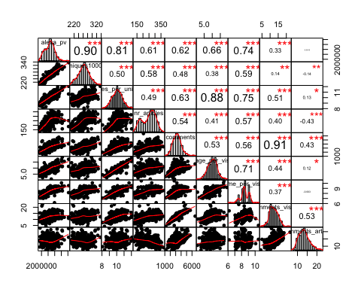

# Compare Weekend versus Weekdays  
ggplot(engage16or, aes(page_per_visit, fill = weekend)) + geom_bar()

## Warning: Removed 2 rows containing non-finite values (stat_count).

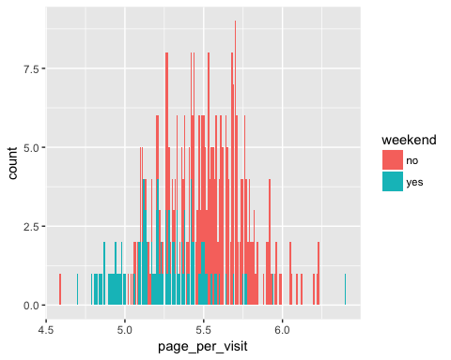

ggplot(engage16or, aes(weekend, page_per_visit)) + geom_boxplot()

## Warning: Removed 2 rows containing non-finite values (stat_boxplot).

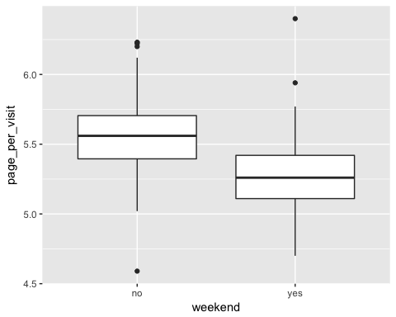

ggplot(engage16or, aes(weekend, alexa_pv)) + geom_boxplot()

## Warning: Removed 3 rows containing non-finite values (stat_boxplot).

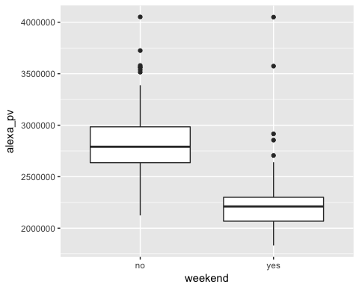

#weekend boxplot for one variable with outliers removed  
alexaWeekendor <- engage16v2 %>% select(c(2, 13)) %>%   
 group_by(weekend) %>%   
 filter(!abs(alexa_pv - median(alexa_pv)) > 2*sd(alexa_pv)) %>% ungroup() %>%   
 ggplot(aes(weekend, alexa_pv)) + geom_boxplot()  
alexaWeekendor

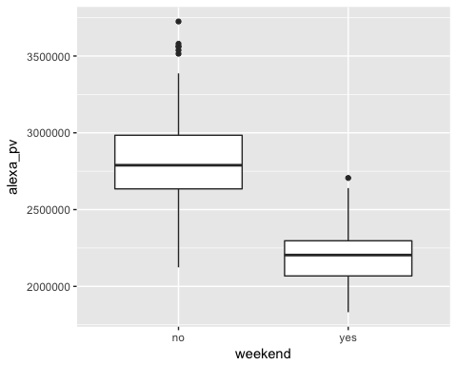

#Data per day  
ggplot(engage16v2, aes(date, uniques1000x, col = weekend)) + geom_point() + ylim(0, 350)

## Warning: Removed 4 rows containing missing values (geom_point).

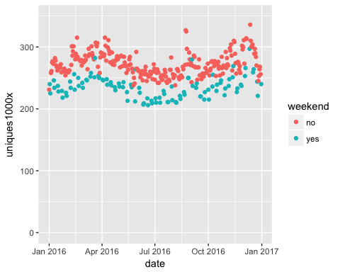

ggplot(engage16v2, aes(date, pages_per_unique, col = weekend)) + geom_point()

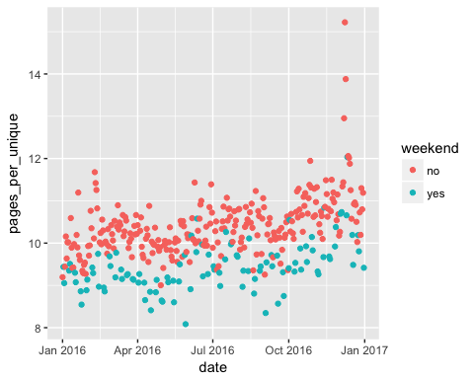

# Various analysis not based on dates  
ggplot(engage16v2, aes(comments, comments_article, col= weekend)) +   
 geom_point(alpha = 0.8) + stat_smooth(method = "lm")

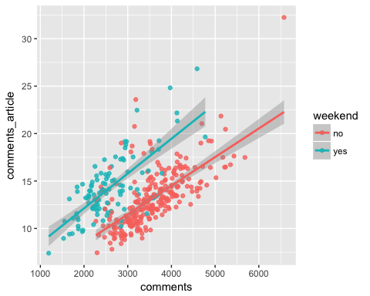

ggplot(engage16v2, aes(comments, nr_articles, col= weekend)) +   
 geom_point(alpha = 0.8) + stat_smooth(method = "lm")

