Week 1 Progress Report

Getting Started

Jody Holland

2025-10-20

## Progress This Week

* Moved into College and restarted work
* Have determiend what funding is available to me through my bursary (£75 a month for books, £3000 over the course for conferences, £500 a year for equipment).
  + Also some options for field work funding in SEA
* Started Feasibility Report and made good progress
  + Fleshed out background section (500 words)
  + Have aimed to produce a brief overview of the current “state of the science”
  + Pretty happy with the introduction
* Began work on a conceptual framework to hypothesise what could induce a landscape to be more or less prone to local leakage
  + Emphasised the context of the economic activities occurring
  + Exploring the concept of “Factor Mobility”
    - A concept taken from New Economic Geography (Krugman etc.)
    - Denotes the degree to which an activity/industry could move across borders and landscapes
    - Incorporates both how mobile the workforce might be and how regionally specific a particular activity might be
  + Also examined how landscape topography could interact with local leakage propensity beyond factor mobility
    - Specifically the positioning on the protected area within the landscape
    - PAs are often located in the most politically convenient places - not the most ecologically critical
    - Could mean that there is little economic pressure on the periphery of projects
    - Could also mean that the people living in the vicinity of the PA have little political or economic power to resist the imposition of a PA
* Read Dasguta’s Natural Capital
  + Not too much that I hadn’t already been introduced to
  + Was a pretty eloquent framing of ecological damage as a “tragedy of the commons” in absence of accurate pricing of natural captial
* Studied Brodie et al. (2023)
  + Pretty fascinating how they conclude that PAs can have positive impacts on biodiversity across a landscape
  + Notably in the case of mammals they find that PAs could lead to safeguarded source populations
    - That would incur density driven dispersal of animals across a landscape, even if that landscape is degraded habitat
  + This could mean that even if we see elevated habitat destruction around a project there could nonetheless be positive spillovers for biodiversity in the landscape
    - Land Sparing wins again?
* Set up Quarto website for progress tracking
  + When new reports are made they are automatically rendered as html, word, and pdf formats and added to the site.
* Began testing PACT V3 if it

## Problems Encountered

* Learning curve with Quarto
* Setting up proper file organization

## Plans for Next Week

* Create next weekly report
* Add more content structure
* Begin detailed literature review

# Picture of the Week

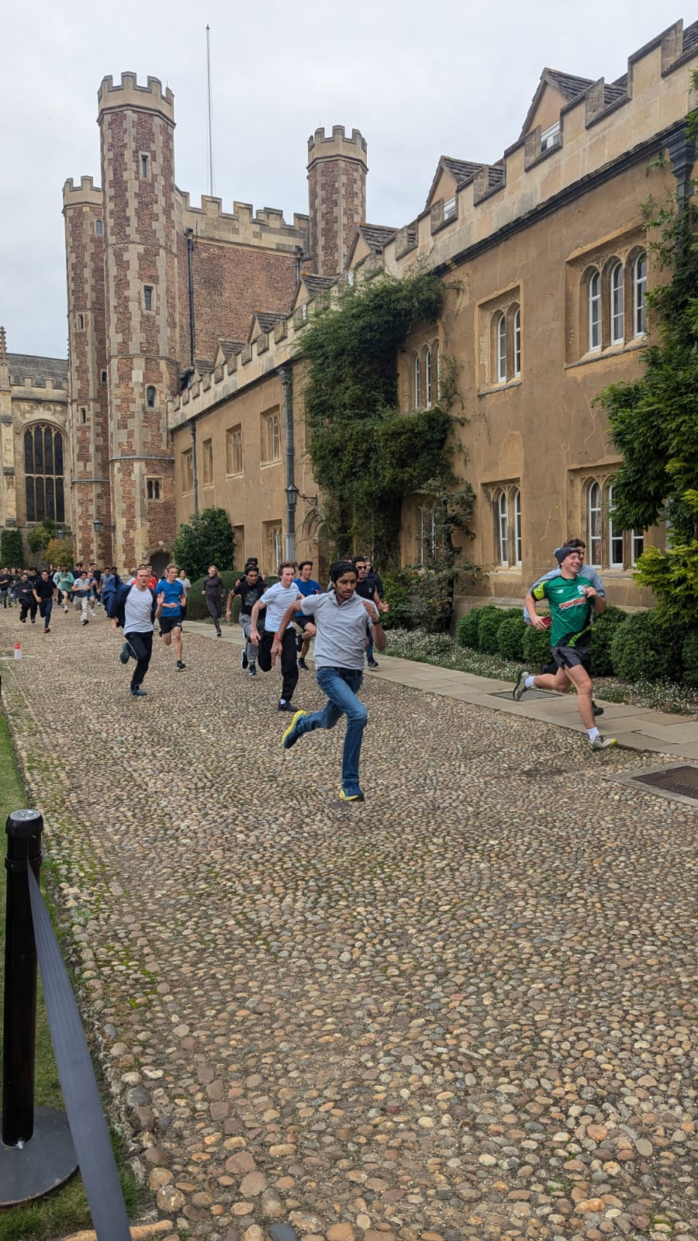

A picture I snapped of the Trinity Great Court Run

# Download This Report

* [PDF](251020_week1.pdf)
* [Word](251020_week1.docx)
* [Back to All Reports](../progress-reports.html)

*First progress report*