# 

CONTENTS

**Executive Summary** **4**

**Introduction and Agency Overview** **6**

**Community Profile** **8**

Demographics Today - Our community at a glance 10

Conditions of Poverty today 13

Poverty by Gender - below 100% FPL 14

Poverty by Age and Gender - Klickitat County 14

Poverty by Age and Gender - Skamania County 15

Poverty by Race/Ethnicity 15

Poverty by location 17

**Key Findings** **18**

Assets and Resources 18

Causes of Poverty today - and the needs they create 20

**Employment**  **21**

**Housing** **22**

**Transportation** **25**

**Food** **27**

**Healthcare** **29**

**Equity** **31**

Client Satisfaction 33

**Conclusions** **35**

WAGAP 2020 identified needs summary table 36

**Recommendations** **37**

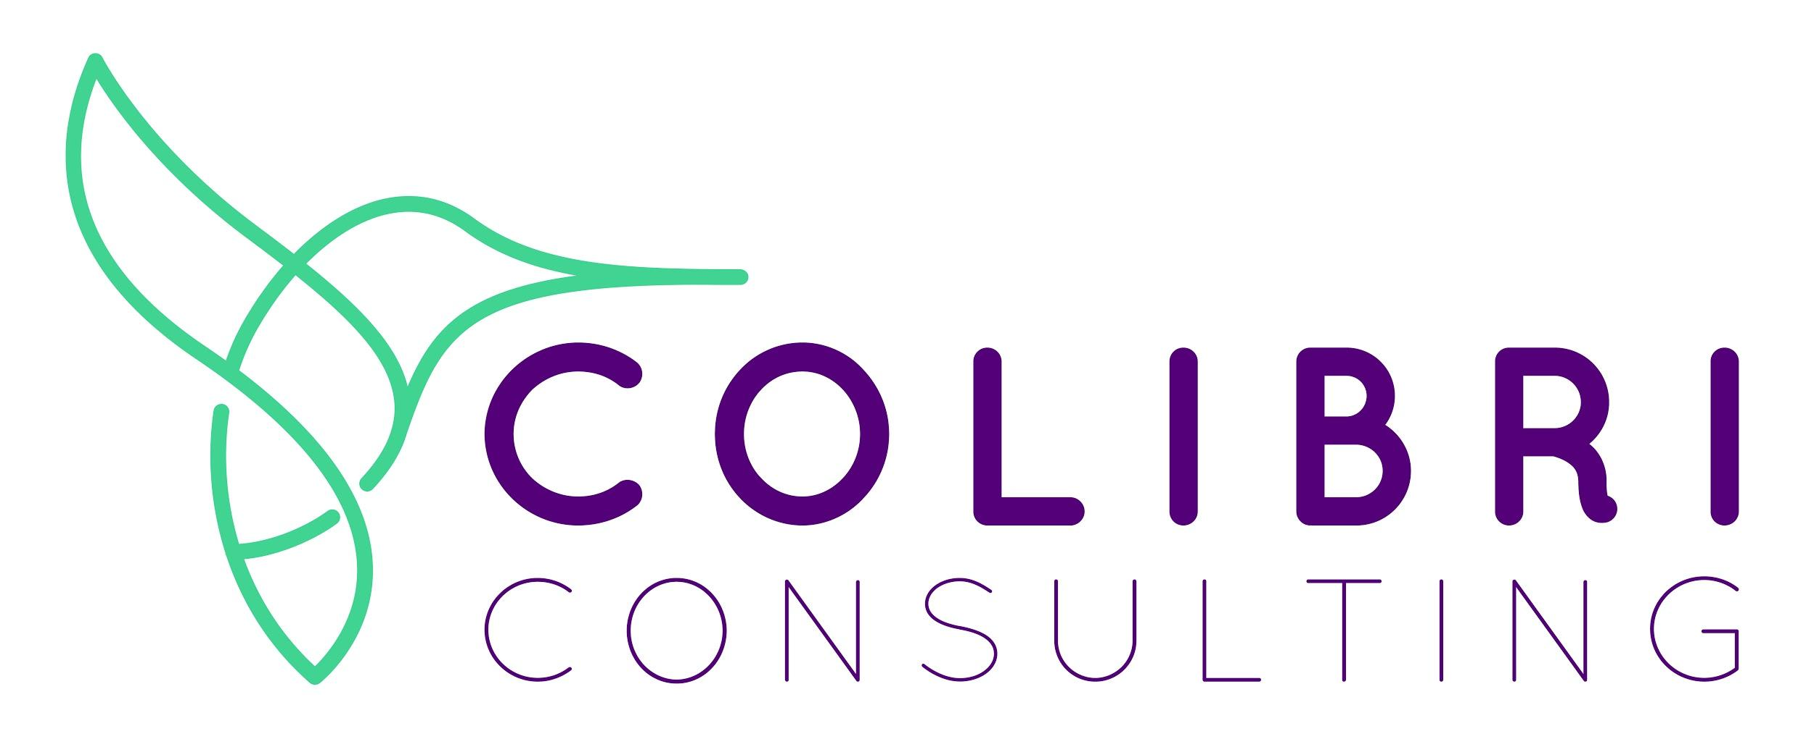

**Appendices** **42**

Appendix A. Methodology 43

Appendix B. Survey participant demographics 45

Appendix C. Partner survey questionnaire 47

Appendix D. Community member survey questionnaire 49

Appendix E. Key informant interview questions 51

Appendix F. Partner identified resources table (survey and interview responses) 52

# Executive Summary

*Problems of the present echo the problems of the past.*

WAGAP has been doing Community Needs Assessments in our area for many years and we’ve seen a pattern in the conditions of poverty, as the problems that cause people to struggle are repeated across the decades. The underlying causes of poverty in our region are multi pronged, but they are much the same as they were in 1964 at the beginning of our Community Action story.

Affordability in our region has long been an issue. In the ‘80s we saw our real estate market take off as our area became known for outdoor recreation. Some towns became tourist destinations or bedroom communities for the Portland metro area, while at the same time experiencing job losses from a declining timber industry and the closure of Goldendale’s aluminum plant. Housing prices have continued to soar throughout the 2020 pandemic, while unemployment has surged yet again. Poverty rates are higher than they are in the nation or the state and income inequality continues to be a problem. Minorities are suffering the highest poverty rates, while women - especially single mothers - have the lowest incomes and the greatest share of poverty in general.

More high paying jobs have come into the area through the tech sector, but many locals are not eligible for these jobs because of required training and education. Lack of access to jobs with good wages, affordable housing and transportation are the problems most concerning to people here, and these needs are tied to other problems like limited childcare options and access to higher education. Lack of access to healthcare and healthy food are also contributing to local poverty. These are huge issues that will take community involvement and investment, legislation, cultural shifts, and funding to address.

WAGAP has worked to reduce poverty since the 1960s, yet the dynamics of a changing rural area have created circumstances that continue to be challenging. Intergenerational poverty, trauma, discrimination, and a lack of resources in a rural area are part of the picture for many of our most vulnerable residents. Poverty has been a revolving door here. For each family that we help get back on their feet there are other families who come in seeking services. Our services cover a large region and a variety of locally relevant solutions are needed to reduce poverty. Fortunately many programs and agencies are already at work in our communities. By strengthening our collaborations we can make existing programs more effective and identify new, creative solutions to move the poverty needle as we move forward.

This assessment was conducted during the 2020 pandemic, amidst unusual hardship and increased unemployment. We expect our economy will recover to pre-pandemic levels over time, but as long as pre-pandemic poverty conditions call for Community Action, WAGAP will continue to answer that call.

We hope this assessment will help you understand the dynamics of our two county service area and we hope it will inspire you to become involved. WAGAP would not exist without the partnerships we have forged, the community who supports us, and the countless people who volunteer their time, money, and resources. Together we strengthen our community, and **together**the work continues…

Leslie Naramore

WAGAP Executive Director

# Introduction and Agency Overview

Nationwide, Community Action Agencies (CCAs), like WAGAP, are expected to base their strategies and service priorities on the needs and strengths in their communities. The Results Oriented Management and Accountability (ROMA) framework is a continuous cycle used by CCAs to best meet local needs. Assessing assets and needs in a community is the first phase of the cycle and sets the stage for agency planning and improvement.

**Results Oriented Management and Accountability (ROMA) cycle steps:**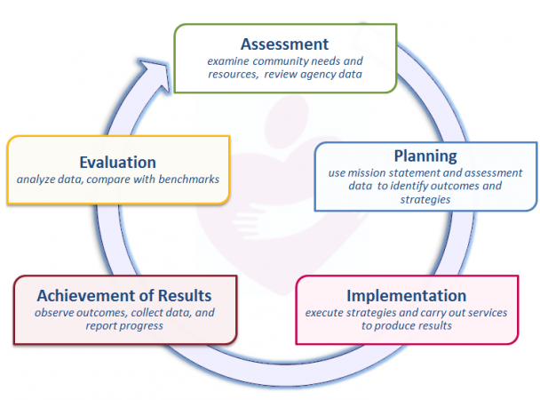

ROMA cycle illustration and assessment goals from ROMA Next Gen Needs Assessment guidelines[1]

As we embark on our next 3-year cycle, WAGAP partnered with Colibri Consulting to conduct a 2020 Community Needs Assessment for our service area. Input from diverse community members, staff and agency partners regarding community assets and needs was collected and analyzed, as outlined in Appendix A. Methodology.

This assessment targets the following ROMA Next Gen Needs Assessment goals:

* Assess level of poverty within the whole community
* Assess how well the needs of low income individuals and families are currently being met – including what assets and resources the community has
* Identify service barriers that limit the effectiveness of the current service network
* Assess relationships with key partners and stakeholders and identify how to strengthen them
* Build awareness of Community Action and our community agenda
* Develop recommendations that will enhance the community’s ability to address the concerns of low income individuals and families

WAGAP is the Community Action Agency for Skamania and Klickitat Counties. Our mission is to:

Strengthen community by inspiring hope

and helping people help themselves.

We reduce poverty by helping people meet basic human needs and increase their self-sufficiency. With 8 locations across two counties, we generate economic impact by bringing hundreds of thousands of grant dollars into the community annually and providing 35 permanent jobs (plus 10 new temp jobs created in response to COVID-19 related needs). Each year, thousands of people turn to WAGAP for short-term assistance and long-term solutions to help them take control of their lives and their futures. Programs offering nutrition assistance and food banks, emergency housing and homeless shelter, domestic violence prevention and crime victim services, youth substance abuse prevention, care coordination, home energy and weatherization assistance, on the job training, COVID-19 relief funds, and after school youth programs are some of the ways WAGAP is meeting the promise of Community Action.

***Who we serve:*** Our clients reflect local demographics, though we primarily serve those living in poverty - many of whom are unemployed. Our clients have lower rates of health insurance and college degrees than the rest of the local population, though they have a similar rate of high school graduation. In most cases our demographic did not change with the onset of COVID-19, but we did see an influx of clients: **4006 households served in 2020** vs. 3216 households in 2019. And we assisted more homeless people this year (402 people vs. 338 in 2019).

|  |  |
| --- | --- |
| **8572 WAGAP clients served in 2020 - about 1/4 of the population** | |
| Race/ethnicity | 6% Native American, 12% Latino, 69% White (non Latino) |
| Gender | ½ male - ½ female |
| Largest age group served | 25-44 year olds (27%) |
| Children served (<18 years) | 25% of all clients |
| Poverty | 55% below Federal Poverty Level, 71% below 200% FPL |
| Employment | 45% unemployed (<6 months), 29% unemployed (>6 months) or not in the labor force |
| Housing | 15% own their home |
| Homeless | 10% (402 clients) |
| Education | 85% of adults (age 25+) have grade 12 or higher diploma  (10% graduated college or trade school) |
| Health insurance | 76% are insured |

# Community Profile

### Historical context

Klickitat and Skamania Counties have much in common, despite some geographic and economic differences. Levels of **poverty** are above state and national averages, seasonal employment is common and affordable **housing** has become increasingly scarce. Both counties were hit hard by the 2008 recession and have again seen drastic job losses with the COVID-19 pandemic this year.

Levels of **education** have increased notably over the past two decades, though the percent of adults with college degrees still lags behind state and national averages. High school graduation hovers just above the 90% Washington state graduation rate in Klickitat, while rates are just below that in Skamania[2]. Both counties have suffered from **health care access** issues, with 30-40% of the population living in ‘Health Professional Shortage Areas’ with rates of local dentists, primary care and mental health providers well below state and national averages[3].

Klickitat County was home to the Klickitat and Wishram tribes for roughly 10,000 years before white settlers arrived in the 1850s - ultimately displacing the tribes mostly to the Yakama Reservation on the northern edge of the county. Much of the tribal economic base was destroyed in 1957 when Celilo Falls, a major fishing and trading center, was flooded by construction of The Dalles dam. Fewer than 700 indigenous people remain in the county, and fishing continues to be an important source of cultural and economic survival. The larger economy shifted to farming and timber, and later expanded into aluminium, then wine and unmanned aviation. Many jobs were lost in 2001 when the aluminum plant in Goldendale closed[4]. Since then employment has been somewhat volatile with job losses during the 2008-2009 recession, a strong recovery, followed by 2019 tech sector losses from cutbacks in the unmanned aviation industry, and recent pandemic unemployment hitting 12%[5]. All this has coupled with reduced affordable housing due to a booming tourist industry (converting long term housing to short term vacation rentals), land use limitations within the Columbia River Gorge National Scenic Area, and the growing tech sector attracting high wage earners to the community. The influx of high paying jobs has been an asset for our schools, and social service programs, which receive donations and volunteer hours from high wage earners. But local income inequality has been increasing since 2014[6] and few of our clients are qualified for these new jobs.

Most of Skamania County is forest land. Many families face their second or third generation of poverty after federal logging restrictions led to job losses in the timber industry. In 1992, unemployment topped 23% with the closure of Stevenson Co-Ply plywood mill - taking 10% of the county’s jobs with it[7]. The next year the Skamania Lodge opened with almost the same number of jobs, shifting the economy from timber to tourism almost overnight - lowering wages and driving people to find work elsewhere. With the growing tourist appeal, outside investors have purchased more homes - about 1 in 5 dwellings are now owned by non-residents. Meanwhile, income inequality marched upward until about 2015 when it began declining. Residents have continued to look for work elsewhere, and by 2018, 77% of Skamania’s earned income came from jobs outside the county[8]. The area has become a suburb for Portland and Vancouver, resulting in high housing prices despite a lack of housing inventory and employment opportunities.

# Recommendations

Many survey participants did not know about the kinds of services WAGAP offers. Increased communication and outreach to community supporters could attract donations and volunteers who are willing to help but do not know about needs or opportunities to become involved. New communication strategies, coupled with traditional methods like distributing flyers by mail and CHW outreach, to inform people about existing resources could also reach more of the most vulnerable populations.

Needs Assessment findings should be incorporated into WAGAP’s Strategic Planning efforts. Depending on organization capacity and planning results, different strategies for decreasing poverty will rise to the surface. Possible steps to consider, with potential to have greatest impact, are outlined below. Many of these were ideas generated during our partner focus group on collaborative strategies.

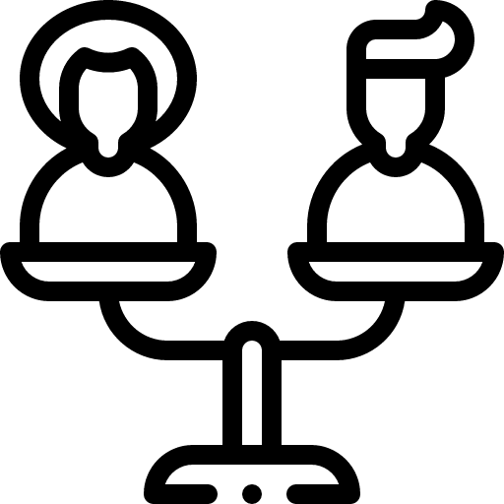

**EQUITY** - Several actions are recommended to build equity in our community, based on community member survey results, interviews and focus group responses:

* Collect stories about the lives, challenges and successes of struggling community members - use the process to build leadership, to help WAGAP and other agencies understand the needs and to support these populations in developing their own solutions.
* Increase cultural competence within the WAGAP team through trainings, and by hiring more Native American and Latino staff. Especially CHWs.
* Actively engage with Natives Along the Big River Coalition and Columbia River Inter-Tribal Fish Commission leaders and members to strengthen relationships and identify opportunities to support each other's poverty reduction efforts.
* Designate at least one WAGAP program leader to regularly participate in Gorge Health Equity Collaborative meetings and share learning with staff.
* Continue to develop outreach opportunities through the new Lyle food bank site.
* Include an equity survey question in the next Community Needs Assessment.

*The recent food bank site is helpful because people are spreading the word and seeing others going in and then they start to open up. Hygiene products, school supplies and dog food are sometimes handed out too. It could be a good place to do more outreach to the Native American community.*

~ Native American Community Health Worker, Lyle resident, interview response

**HEALTHCARE** - Continuing to strengthen WAGAP’s victim services, prevention, shelters and care coordination will help with mental and behavioral health needs as well as access problems. Related actions to consider include:

* Increase the availability of Community Health Workers, especially LatinX, Native American and others from minority groups.
* Work with partner networks to identify new, creative ways to address behavioral and mental health needs, as well as provider shortages.

Increasing drug and alcohol abuse education and treatment options was requested by many Community Member Survey participants. The Klickitat County Sheriff’s office has funding for partnering on Substance Use Disorder efforts (as shared in our partner survey). Other shared health partnership opportunities include:

*We could provide group therapy support for youth or for survivors of domestic violence but we would need funding or contract with WAGAP.*

~ Comprehensive Healthcare representative, survey response

*I would like to see a library partnership with mental health providers who come to the library weekly or bi-weekly - with appointment times. This can take stigma out of mental health.*

~ Goldendale Library representative, interview response

*I would love to develop [an affordable] social-emotional wellness after school program a couple days a week that includes physical activities, art, music, theater, etc.*

~ Flux Therapy representative, survey response

# Appendices

1. Methodology
2. Survey participant demographics
3. Partner survey questionnaire
4. Community member survey questionnaire
5. Key informant interview questions
6. Partner identified resources table (survey and interview responses)

## **Appendix A. Methodology**

CNA planning and data collection activities were conducted from July-December 2020. All planning sessions, interviews and focus groups were conducted by phone or online zoom gatherings, in accordance with COVID-19 restrictions (except for the WAGAP-Health Department focus group held before restriction mandates). Activities included:

* 1 WAGAP Leader & Klickitat County Public Health Department focus group for Community Health Improvement Plan (CHIP) input, sponsored by the Columbia Gorge Health Council, 2/20/2020, N=12.
* 2 WAGAP Leader meetings: 1 CNA planning session, N=7; 1 focus group defining community needs, N=10.
* Community Member Surveys, N=626 (for our population of 33,016 this gives a 95% confidence level, with 3.9 margin of error). Paper and online surveys distributed throughout the service area in both Spanish and English, COVID relief recipients were surveyed by phone. Promotion included Facebook, utility mailings, partner distribution, hand delivery at WAGAP points of service and to a Native American owned smoke shop, local fruit packinghouse and local plant nursery - see Appendix D. Community Member Survey Questionnaire.
* Partner surveys, N=40. Online surveys distributed through partner emails - see Appendix C. Partner Survey Questionnaire.
* 1 partner focus group, N=21 (including representatives from the public and private sectors, educational institutions, community and faith based organizations, plus 5 WAGAP team members). Focused on collaborative strategies to address needs.
* 1 Native American leaders focus group, N=4 (2 Native American community leaders, 2 WAGAP staff, including 1 Native American CHW). Focused on best practices for connecting with the Native American community, understanding needs and gathering input.
* 12 key informant interviews - see Appendix E. Key informant interview questions.
  + 2 **Community Health Workers** (Latina Elder, Native American community member)
  + 3 **Educational Institution** staff (Lyle School Counselor, White Salmon Schools Health and Wellness Coordinator and After School Programs Director)
  + 3 **Public Sector** representatives (Bingen-White Salmon Police Department, Skyline Hospital and Goldendale Library)
  + 1 **Private Sector** representative (Insitu)
  + 2 **Community Based**  organizations (Food Security Coalition - Gorge Grown Food Network, Worksource)
  + 1 **Faith Based** organization (Father’s House, Goldendale)

Data analysis and interpretation was completed by Colibri Consulting in January 2021. This included:

* Qualitative input compilation from WAGAP 2020 Community Needs Assessment interviews, focus groups and surveys. Connections between assets, needs and potential solutions identified. Qualitative data compared to quantitative results (for identification of similarities and differences between the two).
* Quantitative data review and analysis using the following sources:
  + WAGAP 2020 Community Needs Assessment survey data
  + WAGAP 2020 program data
  + Public and existing local data sources, primary source include:
    - U.S. Census Bureau, American Community Survey, 2014-2018 and 2015-2019
    - U.S. Bureau of Labor Statistics, 2019
    - Feeding America, 2017 and 2018
    - U.S. Department of Health and Human Services, Area Health Resource File, 2017
    - USDA Food Access Research Atlas, 2017
    - U.S. Department of Education, EDFacts, 2017‐2019
    - Local Employment Dynamics database, 2019
    - WA State Healthy Youth Survey, 2018
    - Columbia Gorge Regional Community Health Assessment, 2019
    - Gorge Wide Food Survey, Columbia Gorge CCO Consumer Advisory Council, 2015
* Summary graphics and data visualizations created with Tableau and Excel software, and/or gleaned from the CARES Engagement Network[9], DataUSA[10] or Broadstreet[11] websites

1. ROMA cycle illustration and assessment goals from ROMA Next Gen Needs Assessment guidelines from <https://communityactionpartnership.com/publication_toolkit/roma-next-gen-beyond-the-basics/>
2. U.S. Department of Education, EDFacts, 2017‐18. Retrieved from <https://engagementnetwork.org/assessment/chna_report/>
3. U.S. Department of Health and Human Services, 2017. Retrieved from <https://engagementnetwork.org/assessment/chna_report/>
4. <https://esd.wa.gov/labormarketinfo/county-profiles/klickitat>
5. U.S. Bureau of Labor Statistics, retrieved from <https://fred.stlouisfed.org/series/WAKLIC9URN> - Klickitat, <https://fred.stlouisfed.org/series/WASKAM9URN> - Skamania
6. U.S. Census Bureau, profile retrieved from <https://fred.stlouisfed.org/series/2020RATIO053039>
7. <https://esd.wa.gov/labormarketinfo/county-profiles/skamania>
8. U.S. Census Bureau, profile retrieved from <https://fred.stlouisfed.org/series/2020RATIO053059>
9. <https://engagementnetwork.org/assessment/chna_report/>
10. <https://datausa.io/>
11. <https://www.broadstreet.io/>