**REPORT TASK TRAINING REACT NATIVE**

**Git Link :**

**MASTER**

**PlayWithPalindrome.js**

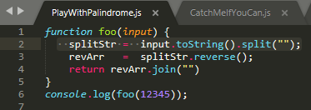

**CatchMeIfYouCan.js**

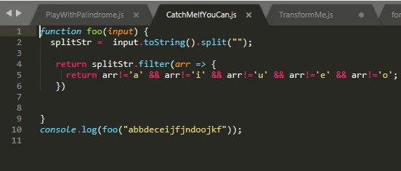

**TransformMe.js**

**CallbackAndYouPromises.js**

