If it’s too slow, I could prepare a sliced version of the items, already layout and sliced with the Bamboo labs printer in mind.
Like so:
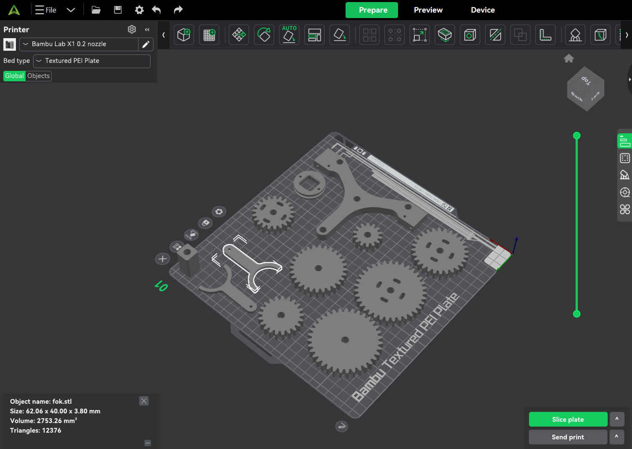

Only if this is necessary.

