V2
This folder contains parts for the version 2 of the gear box prints.
Updates: a frame and spacers that hold up the gearbox assembly and adjusted shifter forks.
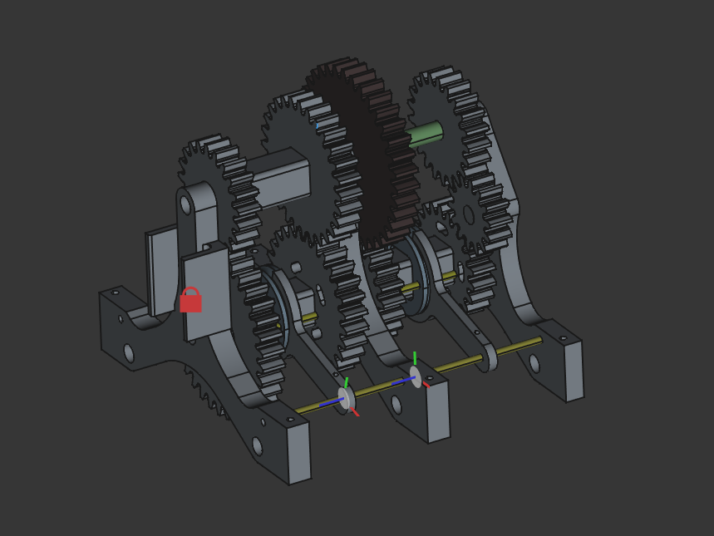
[ this is an image of what the assembly should look like ]

Below is a list of parts and quantities for printing:
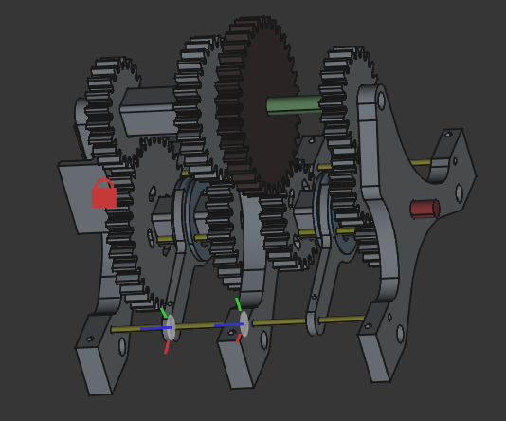
Fork

A2
D
Spacer_01_02
Spacer_01_01

Spacer_02_01
A2

A1

C2
B1
C1
B2
A1
Aligner
Slider

Name | Qty. | Description
Gear A1 | *2 | Gear with 21 teeth
Gear A2 | *2 | Gear with 21 teeth and slots
Gear B1 | *1 | Gear with 35 teeth
Gear B2 | *1 | Gear with 35 teeth and slots
Gear C1 | *1 | Gear with 28 teeth
Gear C2 | *1 | Gear with 28 teeth and slots
Gear D | *1 | Gear with 14 teeth
Aligner | *2 | Square prism with a smooth sides and hole at centre
Slider | *2 | Disk with a 4mm groove all round
Fork | *2 | Two-tined fork shaped (fits in slider groove)
Spacer_01_01 | *1 | Y shaped spacer with a mount for a motor (“Engine”)
Spacer_01_02 | *1 | Y shaped spacer
Spacer_02_01 | *1 | Odd Y shaped spacer with a mounting point for a gear

The relevant files are in the stl folder within V2 section of the project.
Regards, Joseph B. Ng’era

