MIRI Mobile Application

PID

john morrison

2018

Contents

Project Goals - 2

Scope / Objectives – 2

Objective 2

Deliverables 2

Functional requirements 3

Non-functional requirements 3

Approach – 3

Method of approach 3

Design 3

Software 4

Online 4

Project Organization – 4

Business Case – 5

Constraints – 6

Stakeholders – 6

Risks – 8

Project Risks 8

Project Controls – 9

Reporting frameworks – 9

Reports - 10

Schedule – 10

Design – 10

Sign Off – 12

Appendixes 13

# Project Goals -

**Background**

The client UK Astronomy Technology Center are one of the leading centers for research and development in astronomical technology. Recently their teams have been working on developing the MIRI (Mid InfraRed Instrument) camera for the JWST (James Webb Space Telescope). They would like an app made for the MRI. This apps purpose is to promote the MIRI & all who contributed to its development.

The development of the MIRI has been a joint project between several different organisations throughout Europe & North America. The goal of this project is to create an app that will highlight the European effort that went into making the development of the MIRI possible. This app is to be used at outreach events and seminars. The app will act as a digital pamphlet in these events.

The app will also include a QR code reader. This is to operate with anything put on display by the UKATC. Once a user scans the QR code information will be brought up on the user’s device. The QR code scanner will help the app to act as a digital pamphlet during tours or exhibitions for the UKATC

# Scope / Objectives –

## Objective

A mobile and web application to act as a digital pamphlet highlighting contributors from Europe to the MIRI camera with a built in QR code reader.

The contributors will be displayed on screen with clickable indicators to show information on each of them. The app is intended to be used at events such as seminars or conferences but must also be available for anyone to download from their app store.

When a contributor is selected 1 – 3 images must appear of either equipment or people relevant to the contributor’s involvement.

The QR code reader that links to the database must contain all the information about what the users will scan.

## Deliverables

The Deliverables for the project are

* Working application (mobile and web)
* Backend database containing collaborators and information
* Git repository for the source code
* Regular reports on development progress.
* Functioning QR Reader

## Functional requirements

* Clickable indicators on the screen
* Display the locations of the MIRI collaborators
* 1st click shows 1 - 3 images of equipment or persons of interests
* 2nd click provides further information on the equipment or persons of interests
* Give selected users the option to scroll though the images and information.

## Non-functional requirements

* Easy to navigate
* Security
* Design
* Maintainability.
* Storage
* Response time
* Reliability
* Register / log in system

# Approach –

## Method of approach

PRINCE2 reporting framework will be used to keep the client up-to-date with the team’s progress. A PBS (Product Breakdown Structure) will be given to the client so both client and team agree to the deliverables of the project. Highlight reports will be giving to the client every fortnight to monitor the teams progress.

We will use PRINCE2 alongside agile management method (Scrum) for dividing the workload amongst the team to reach each milestone. PRINCE2’s PID will be used to create the backlog of tasks that will be assigned to the team members.

## Design

Our first drafts of the app will be made in Microsoft PowerPoint, the open source software has a large variety of images, shapes and designs that will allow us to design mock ups for the app.

* PowerPoint

## Software

We will use a variety of software to build the front & back end of the app. Visual Studio & Xamarin app development will be used to create the front end. My SQL will be used to create the back-end database.

* Visual Studio
* Xamarin app development
* my SQL
* Draw.io

## Online

We will also be using online resources to help communicate and work together throughout the project. GitHub will be used by the developers to store the master branch of the code. A private drive will be made in google for the team to access. This drive will store reports and any documents the might be relevant to the development team such as meeting agendas and minutes. Finally discord messenger will be used for communicating between team meetings and holding online team meetings when we are not able to get together.

* GitHub
* Google Doc
* Discord

# Project Organization –

**Client and team roles**

Client - (UKITC) Joe Barret

Project Manager – John Morrison

Team Manager – Richard Donaldson

UI/UX Lead – Fraser Rae

Development - Brian Cleland

Alex Barker

Alistair Lester

**Project management team structure**

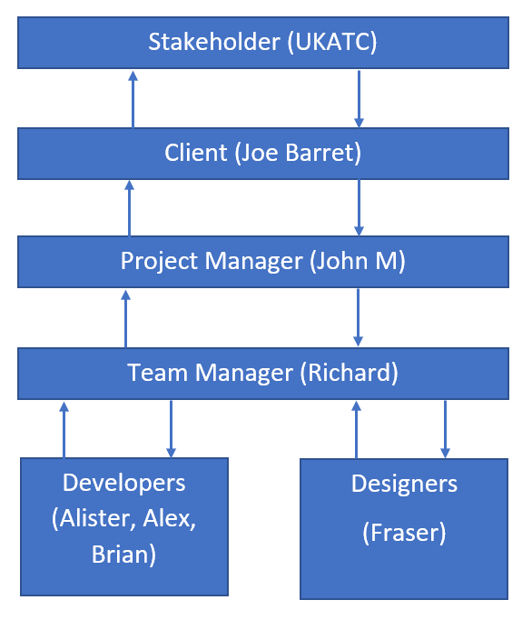

# Business Case –

The end product from this project will be an app to help the UKATC promote its own projects & achievement’s. An app is the best format to deliver this as it is easy for the client to make changes as time goes on. New projects can be added, or changes made to old ones easily. This means the client will not need to make other apps for future events as they would with a paper pamphlet. They can instead update the information for the QR reader to include the new projects.

# Constraints –

**Time**

The university has specified that this is a 13-week project to be finished by the 16th of May

**Resources**

All staff working on the apps development are students of Napier University. As such they will have other obligations to their classes and will have to balance their time between those classes & this project.

# Stakeholders –

Project Stakeholder – UKATC & those involved in the MIRI Partnership

Project Owner - Joe Barret

Users – Guests of the UKATC, Tour groups, Attendees at seminars, People interested in the MIRI development or the UIKATC itself.

**The MIRI Partnership**

UK

UK-ATC – European PI, Instrument Science, Optical Engineering, Spectrometer Pre-Optics & Calibration Sources.

Astrium Ltd – Project Office & Consortium Management, PA Coordination, System Engineering.

U. of Leicester – Mechanical Engineering, Primary Structure, MGSE.

RAL – Thermal Engineering & Hardware Integration, AIV Facility & Instrument Testing.

Cardiff - Cal Filament Unites.

Ireland

DIAS – Filters

Belgium

CSL – Input, Optics & Calibration Instrument Control Electronics Imager Mirrors.

U of Leuven – EGSE Software Support

France

CEA – Imager Coronagraph Analysis

LESIA/LAM – Coronograph

Spain

INTA – MIRI Telescope Simulator (MTS)

Sweden

U of Stockholm – Filters and Gratings

Denmark

DSRI – Hexapd

ESA/ESTEC – JWST Project Office Prodex Office

Netherlands

ASTRON – Spectrometer Main Optics

U. Leiden – Spectroscopy Analysis

Germany

MPIA Heidelberg – Electrical Engineering Cryo Mechanisms.

U of Koln – Low Resolution Spectrometer Double Prism

Switzerland

PSI – Contamination Control.

Cover – Cryo Harness

# Risks –

## Project Risks

1. **Team Members unavailable**

Likelihood – Medium Impact – Medium Responsible – PM

For any number of reasons our staff could be unavailable to help with the project. This would lead to more work for the resources we are already using. In this case the Project Manager will need to reassess the workload and divide out the tasks. If this is not enough then we must request more time for the project by extending the deadline.

1. **Project Falls Behind Schedule**

Likelihood – Medium Impact – Medium Responsible – PM

Issue and delays could happen that put the project behind schedule. During this time the Project Manager must reassess the project plan & schedule. Assigning more resources to the necessary tasks or removing time from other stages might be necessary. If the problem persists more time might be needed for the project.

1. **Overwrite code on GitHub**

Likelihood – Low Impact – Medium Responsible – TM

As all developers are working on code saved on a cloud service different version of the same code could appear. This would cause confusion among the developers and possibly delays for the project. This situation would be handled by the Team Manager. The developers will be setting up Web Hook on discord so we are aware of who and when changes are made to the master branch.

1. **Front end & back end not compatible.**

Likelihood – Low Impact – Medium/High Responsible – TM

While developing issue could arise trying to get different software to work together. Software should be tested as soon as possible to allow for time to fix any errors. If any occur the Team Manager is responsible for fixing the compatibility issues or finding other software. If these problems are not spotted early fixing them could require too much time causing us to close the project and salvage what we can.

1. **Project closed early.**

Likelihood – Very Low Impact – Very High Responsible – PM

If the client decides that the project is no longer relevant they may decide to close the project. If this happens the Project Manager must begin salvaging what progress the project has achieved and disband the team.

1. **Hardware Failure**

Likelihood – Low Impact – Low Responsible – PM

Most of our Team are using their own devices from home. Old hardware can be unreliable. All data for the project will be saved on a cloud service to prevent any loss through hardware faults. Also, the university provide laptop & computers 24/7 for its students should anyone need computers. The Project Manager will ensure that everyone has access to the hardware they need.

Risk Matrix Appendix Image 1.0

# Project Controls –

**Planning**

The project will be planned with PRINCE2 scheduling, report structure and risk assessment. This will be used alongside agile methods (SCRUM) when the project enters development. A risk register and a schedule will be made for the beginning of the project and updated as necessary by the project manager throughout the project life cycle.

**Team**

The team will hold weekly meetings to discuss our progress, new issues / risks & to assign resources to tasks. These meetings will be used to ensure all work done is within the scope of the project.

The team have set up online file sharing and messaging to keep in contact between meetings.

A team manager has been assigned to help the team coordinate and manager the project. The team manager will be responsible for maintaining the master branch of the code. They will also be responsible for all risks relating to the front & back ends development.

After the project is complete a project closure meeting will be called to assess and disband the team.

**Client**

PRINCE2 reporting framework will be used to keep the client up-to-date with the team’s progress. After the client has agreed to the PID regular highlight reports will be used.

# Reporting frameworks –

## Reports -

Project Initiation

* Project Initiation Document
* Schedule
* Risk Assessment & Matrix

Project Development

* Highlight Reports
* Risk Assessment (when updated)
* Schedule (when updated)

All reports except for the risk assessment will be carried out by the project manager for the client. Updates to the risk assessment will be complete by whoever was assigned to the risk that took place.

## Schedule –

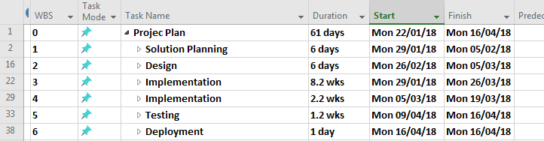

The PID is scheduled to be delivered to the client by 2nd of February.

Following the PID a total of 5 highlight reports will be given to the client on 16th of February. 2nd, 16th & 30th of March & the 13th of April.

More details of the schedule are in the appendixes, images 2.0 – 2.6

The milestones we have set for the project are

1. Solution planning milestone 5th / 2nd
2. Design Milestone 5th / 2nd
3. Implementation Mid-point Milestone 26th / 3rd
4. Implementation Milestone 19th / 3rd
5. Testing Milestone 16th / 4th
6. Deployment Milestone 16th / 4th

Design –

**Loading screen**  **Home Screen**

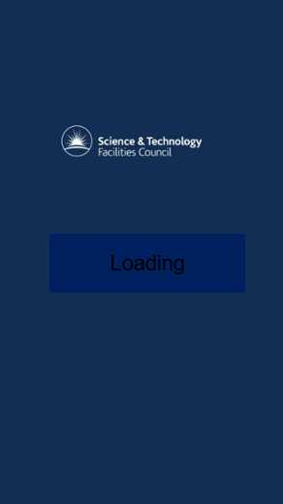Home Screen – Bars on the top right are for settings. Each of the square boxes will be an image & text to show a collaborators involvement.

# Sign Off –



Client Signature ________________________________ Date: __01/02/2018__

Project Managers Signature _______________________ Date: ____________

# Appendixes

1. Risk Matrix

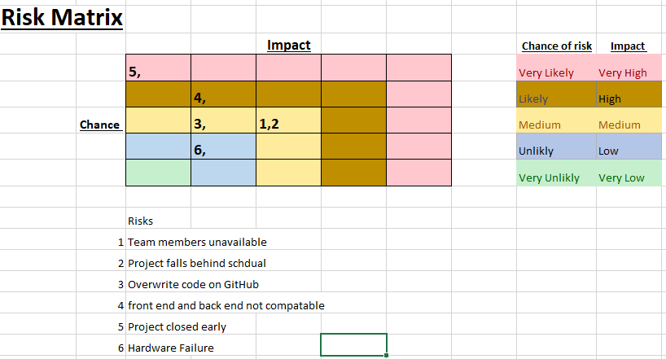

1. Schedule

2.1 Schedule Solution Planning

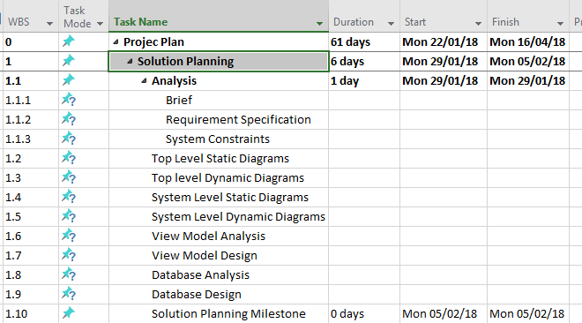

2.2 Schedule Design

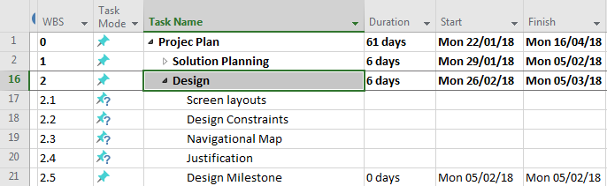

2.3 Schedule Implementation midpoint

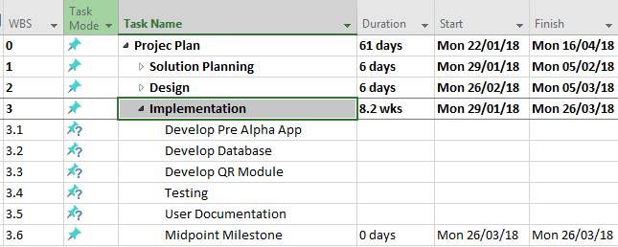

2.4 Schedule Implementation

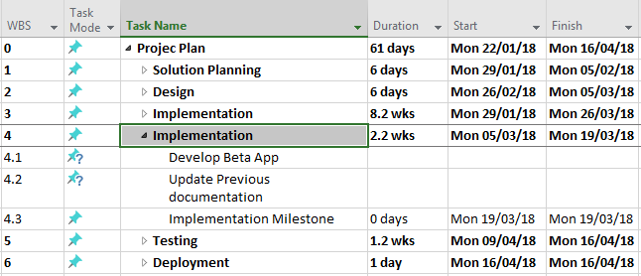

2.5 Schedule Testing

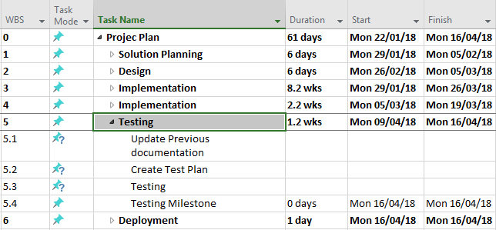

2.6 Schedule Deployment

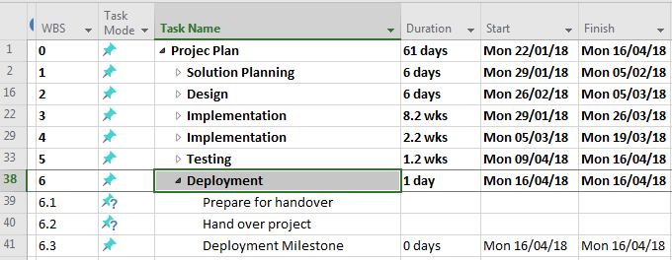

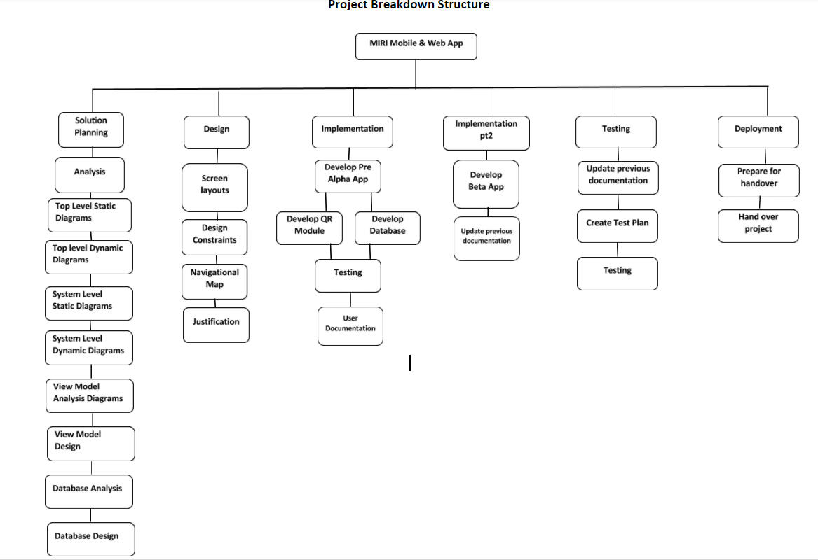3.0 Product Breakdown Structure