Joseph Boley
Data Analytics Bootcamp
Midterm (Messy IMDB Database)

INTRODUCTION

For this midterm project, I pulled from the four datasets available on the assignment, the dataset I pulled was the messy IMDB database. I did this for a couple of reasons. The first reason is that upon looking at the data, I saw it as a great opportunity to demonstrate cleaning capabilities, namely in the country, release_date, and name columns. The second reason is that I found that I would be able to answer the same questions I was aiming to answer with a Disney exclusive movie dataset with this dataset.

The business questions I hope to answer are as follows:

- Analysis on the composition of movie genres to see where directors have less movies to compete with
- Analysis on how engaged the countries are with their movies. This leads us to be able to figure if the audiences will engage with newer directors
- Analysis on what directors big budget productions might pull to make sure their movies are successes
- Analysis on the countries’ appetites for purchasing movies to see where big budget movie studios will need to release their movies in for maximizing profit potential

Some Trends that I hope to figure out are the following:

- Trend on the relation between rating score (0 to 10) and the revenue of a movie
- Trend and relation between directors and successful movies
- Trend on the relation between genres, MPAA ratings, and revenue
- Trend on the engagement of audiences and regions

These trends mirror at least tangentially to the business related questions I hope to answer.
The specific hypothesis that I am tested with the data are the following:
- The USA will have the most blockbusters due to having some of the more prolific directors such as the Russo brothers for the Avengers franchise
- The less-recognized G7 and not G7 countries will have less movies and thus less revenue by nature of numbers. This will be tested later by SQL queries.

Dataset Documentation

There are 9 columns inside this dataset, and they are the following:
- IMDB Title ID – Text
- Title – Text
- Release Year – Date
- Genre – Text
- Duration – Integer
- Country – Text
- Rating – Text
- Director – Text
- Revenue – Integer
- Votes – Float
- Score - Float

The TitleID represents the unique identifier for the movies that are within the IMDB dataset. The Title column represents the title of the movie. The release date represents the dates of the movie release schedules. Genre and duration are representative of the genre and timelength of the movie. The country is the country where the movie got released in. The rating is the rating from the MPAA for the movie. The director column represents the directors, or directors if there’s multiple directors in the movies. Revenue or Income is the data column to represent the money yielded from the movie’s release. Finally, Votes and Scores are representations on how much people voted to rate the movie from a scale of 1-10, and the resulting score respectively. The potential business values of these data columns are the business questions in the introduction. While looking at the dataset, I see various issues with missing values, inconsistent formatting, and removing duplicates. These will be detailed below.

Missing Values, Inconsistent Formatting, Removing Duplicate Fixes:

Release_Year:
For here, I have elected to change the formatting to a consistent “mm/dd/yyyy” format, and in order to do this, I have gone through and meticulously used the formulas to convert the text to date values in Excel. After this, I changed the format to my particular format. There were some values that needed to be corrected before being formatted, and I referred back to IMDB for these issues, manually editing the specific outliers.

Genre:
For Genre, There were no issues outside of the fact that there were multiple genre’d movies. For SQL, I have elected to use “text-to-columns” and adjusted the table to have everything be normalized per SQL rules. This is a choice that will be useful later.

Duration:
For Duration, There were issues with bad data, namely “Nan”, “Null”, “Not Applicable”, and other bad rows. For these, I elected to change all of these rows to blank values, highlighted the blank values with conditional formatting, and then manually went back and changed the values by referencing IMDB’s database online. This choice makes sense to me as I am working with “an IMBD database”.

Revenue:
(or income) This row had inconsistent formatting in the vein that it was formatted in a way that excel read it as text instead of numbers, and this is because there was a row that had an “o” in it instead of a zero along with other rows that had commas instead of a straight numerical value. For an SQL table, this would prove troublesome with using the values for SUM() functions.
I elected to clean this data up for easier manipulation in SQL later with VALUE() and “Find and Replacing”

Rating:
There were blank values along with multiple variants of “approved” (approved, unrated, #n/a), so I elected to combine them all under one umbrella of “unrated” by finding and replacing the others with the value of “unrated”. I also went and formatted the “PG” variants correctly by converting everything to UPPER()

Votes:
The formatting here is representative of countries that use periods (.) as delimiters and not commas. Outside of this, same issues with Revenue regarding SQL manipulation later. I have elected to format the numbers as straight numbers.

Country:
The formatting is inconsistent here where “USA” can be “US”, “Usa”, “US.”, or other variants. I found-and-replaced the values for a more uniform “USA”.

Score:
With Score, there were different delimiters between comma and period marks. There are other miscellaneous dirty characters that also needed to be removed. I formatted and cleaned it up by going with find-and-replace along with other excel functions.

Pivot Table Analysis and Data Visualization

I have created three pivot tables for analysis and that will be used for visualization through data charts. The first visualization that was shown is the revenue split between movie rating scores. The business question that can be answered from this is a relatively simple one. Namely, the business question that gets answered here is if there’s any correlation between movie rating scores and how much money gets generated from the revenue of the movie sales. This visualization answers the question by saying that a majority of the movies in the “8.X” range are the most monetarily successful, implying a link between the two, but not a directly linear link. The link that’s implied is a bell curve value. This can be considered a weak link as there are only 100 movies in here, which from a list of movies from the early 20th century to today is a small amount of movies, or alternatively, a very small dataset. The second visualization is a pivot table to demonstrate the revenue split between directors with a filter by region. This is a bar chart that is being visualized for the business question of “what director do we tap to make sure our movie makes the most money?” The reason for the filter is if you would like to support local directors as you’re trying to release a movie in that particular region. This visualization shows that Christopher Nolan and Anthony Russo are among the top of the directors for the United States region. The third visualization is a composition doughnut chart detailing the totality of the movies in the dataset by genre and rating. The business question that can be asked is a hypothetical question. This question is “should we entertain the idea of pushing through a {genre} movie that would be rated {MPAA Rating}”? The genre and MPAA ratings can be adjusted per the related question. This can be expanded upon with a revenue split pivot chart that can be tied to the same pivot table. Overall, the business question that will be answered is a generalized business question on the beginning logistics of how worth it will be to start producing a movie in that particular genre and rating area.

SQL Data Import Issues:

“Unique Constraint Failed”
As I was exporting the tables for analysis as .csv files, I repeatedly kept on receiving the same error on “UNIQUE CONSTRAINT FAILED” for my primary key on IMDB Dataset. What I realized when loading the .csv files into notepad++ was that the file had trailing empty rows. These had SQLite Studio throwing errors as empty trailing rows inherently get treated as duplicated rows. I removed the constraints, adjusted the errors by using DELETE FROM() commands, then re-ran the constraints to make sure my data is still validated.
Outside of this issue, there were no issues to note. I used the asterisk with generic SELECT queries to verify everything got converted over to SQLite Studio correctly.

The .SQL file has the explanations for the exploratory and business related queries, but for the sake of this report, I will provide a short one-sentence explanation:

Queries:
Exploratory Queries:

Query 1/1b: These queries groups the movie totals by the review scores of the movie. This is useful for figuring out what is the relational curve of movies in the data set by review score and genre.
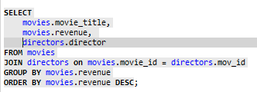
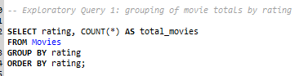
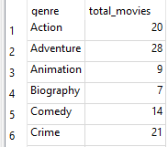
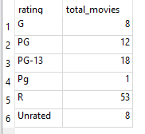
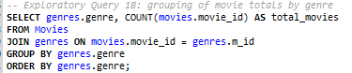

Query 2: this query is the SQL equivalent of the Director pivot chart, letting the business question of “what director do we pull to win bouts of money” to flourish.
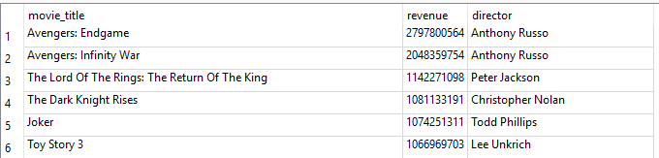

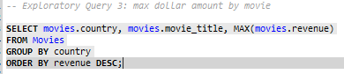
Query 3: This query demonstrates MAX() results.

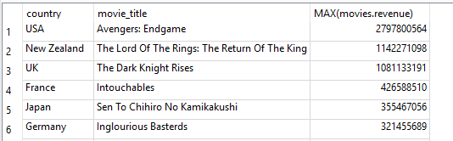

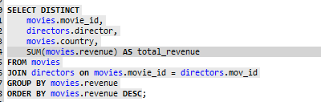
Query 4: This query ranks directors by revenue across all of the movies that they directed. It is another way of answering the “director business” question.

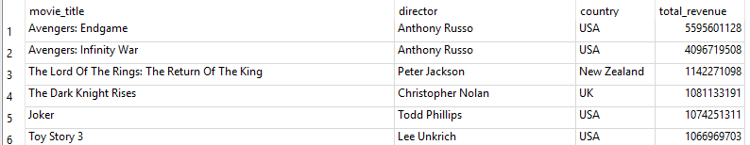

Not shown in this report is a generic “like” function utilization that will be shown in the .sql file for reference.

Queries: Business Analytical

Query 1: This query below demonstrates the business question on if there’s any relation between ratings of movies and revenue as well as amount of engagement and revenue. This could be used for informing business decisions along with other SQL queries about placing movie releases in specific markets to maximize revenue performance.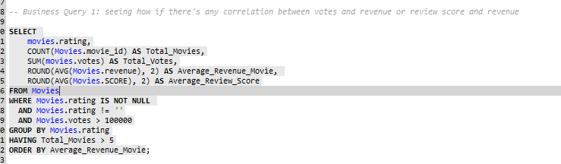

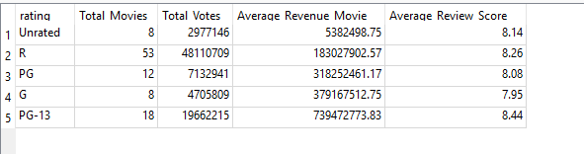

Query 2: This query could answer a question on figuring out which movies have the highest reviews in particular MPAA ratings. You can use this in tandem with a generalized query that details an aggregated total of them.
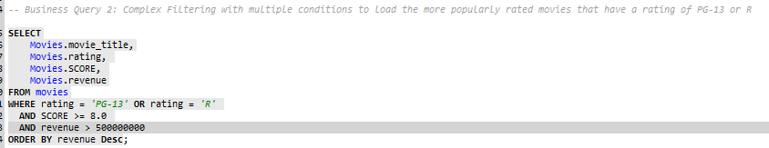

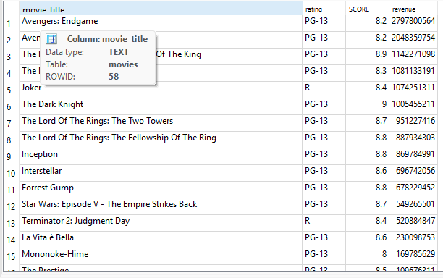

Query 3: This Query answers the question on fan engagement with movies released in the region. This could give insight as to if movies should be released in the region, or if the company would be throwing out potential blockbusters into “dead markets”.

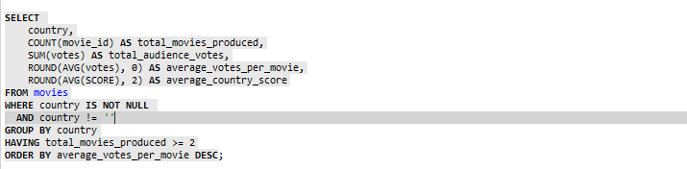

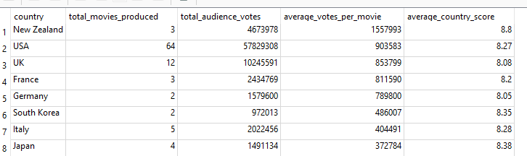

Conclusion of Report
With all of the data in mind, and in particular, the results from the queries, I have various strategies to be put into place. The first strategic suggestion and action to take is to hire the Russo brothers for any-and-all projects under the sun. The sheer revenue amount dwarves any of the other directors out of the water outside of Christopher Nolan or Robert Zemeckis. The next suggestion would be to look at pairing these directors with making more PG-13 and R rated movies, as it seems those movies have made the most money out of the movies in this dataset. The third suggestion and insight for stakeholders to take is to entertain the idea of releasing more movies into New Zealand, referring to the better engagement that New Zealanders have over Americans in relation to reviewing movies. This also is in reference to the mantra, “any publicity is good publicity”. The last insight that could be made by the stakeholders is to look at the relation between directors and the average rating of their movies. The excel graph would indicate that movies in the “pretty good” (8.2 to 8.8) range sell out the most, so once that relation between directors and average movie ratings gets unveiled, the stakeholders can start pushing towards hiring those directors to, once again, guarantee profits and fulfill a basic cushion of a bottom line.

