# Defi Options Trading

Team S-K

XIAO, Li LAKHANI, Harsh Sunil DONG, Wenyu

01 Dec 2022

## 1 Problem statement

DeFi options are low-barrier borderless instruments that can be easily traded among peers on the platform without involving brokers or paying brokerage. In recent years, defi options have gained the attention of traders due to their risk aversion and high liquidity, especially among hedgers and speculators. In general, there are two types of option trading: call and put. Call options allows the owner to buy a specified amount of underlying asset at a fixed price within a specific period of time, which is also the main theoretical basis of this paper. Conversely, a put gives the holder the right to sell the underlying asset at a specified price on or before expiration. In our project, we will establish an on-chain peer to peer option trading protocol built on MMD and cMMD(mock).

## 2 Design process

### 2.1 Back end

Stablecoin, Unstablecoin and Option contract stored on the back-end are three main contracts for this project. The former two contracts extend **ERC20**, while the latter performs the primary role of implementing transactions.

#### 2.1.1 Seller write option

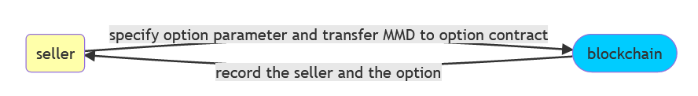

In the function of writing option, seller specifies option parameters stored on blockchain, including coin, strike price, premium, expiry and token amount. Blockcahin correspondingly record option information.

#### 2.1.2 Buy option

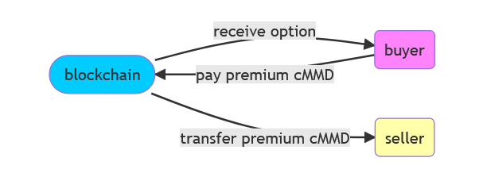

After seller uploads the option, buyers can browse the list of available options and pay premium cMMD if they decide to buy one. Meanwhile, the updated data and premium will be transferred to the seller.

#### 2.1.3 Exercise option

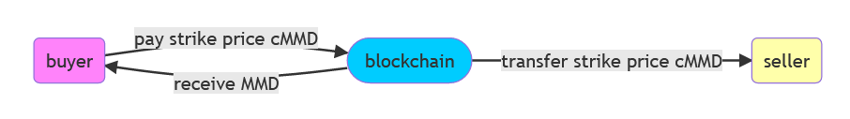

Within the expiry date, buyer pays seller the strike price with cMMD using blockchain as a hub. Then buyer will receive MMD from the blockchain.

#### 2.1.4 Seller cancel/retrieve option(to do)

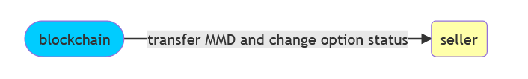

The functions of cancellation and retrieval are the process of active or passive cancellation of option transactions by the seller, which the seller will get MMD back and the status of option will be changed. Although it has been implemented at the back end, the front end does not display this part.

### 2.2 Front end

It is important to establish a connection to the MetaMask wallet, where stablecoin and unstablecoin come from. From the perspective of users, what comes to mind is a homepage with buyer and seller triggers. When clicking the button of option seller, users can see parameters of the option information, current price of MMD and account. In contrast, users will view the written options in the buyer page. Then, the exercise page contains not only purchased options but also further confirmation. In the cancel or retrieve page, the information and status of written option is necessary, which will be done later.

## 3 Final result

We implemented defi option trading protocol based on ERC20 and it can be used for actual transactions. Categorized by back-end contract functions, this section will start with the sequence of sellers selling options, buyers buying the options, and finally buyers exercising their options.

### 3.1 Deploy smart contract

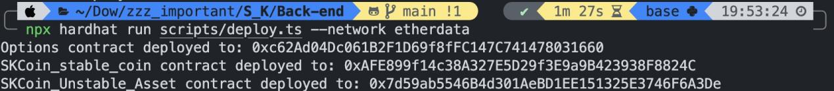

### 3.2 Stablecoin and unstablecoin contract

Import defined stablecoin(SSK)

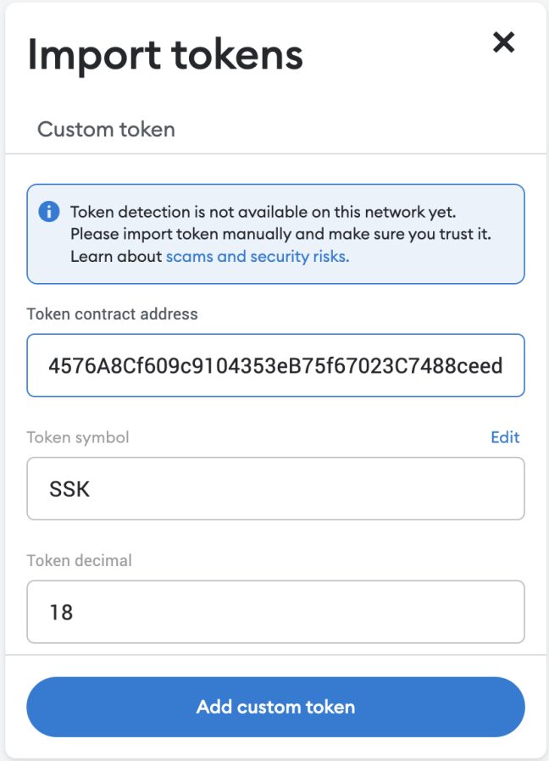 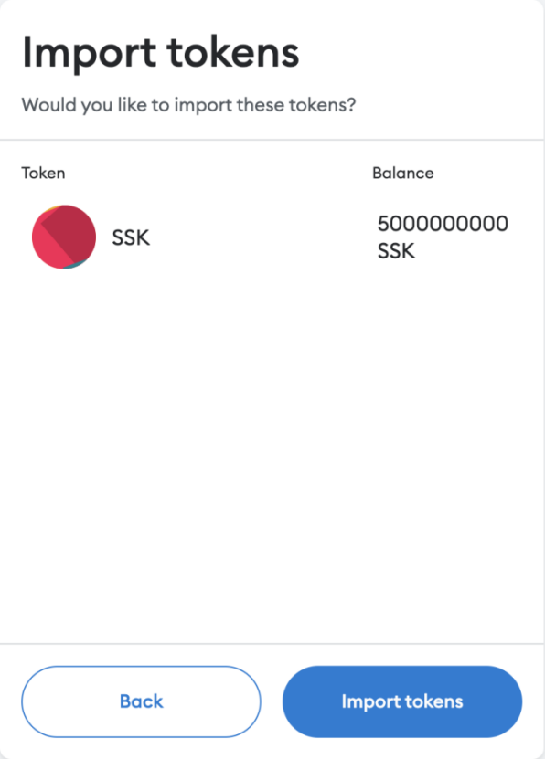

Import defined unstablecoin(USK)

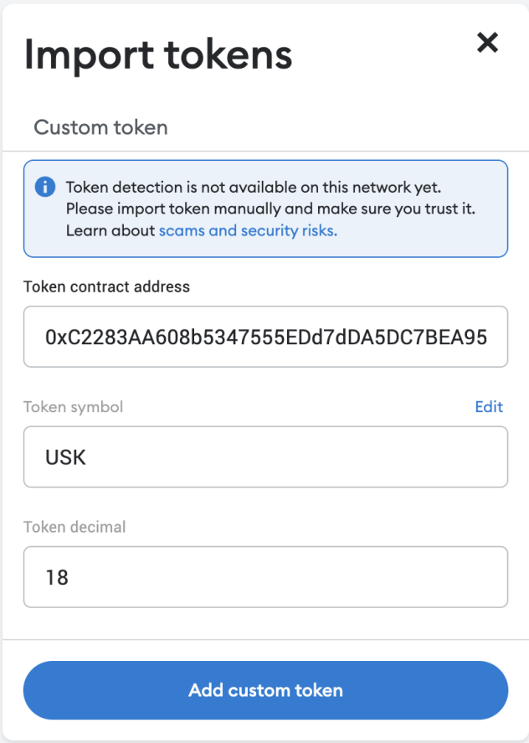 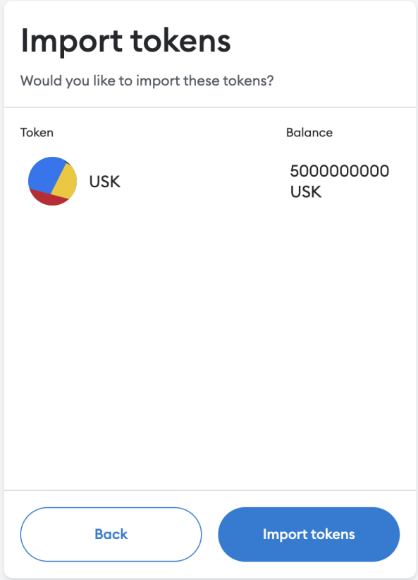

All coins in the wallet

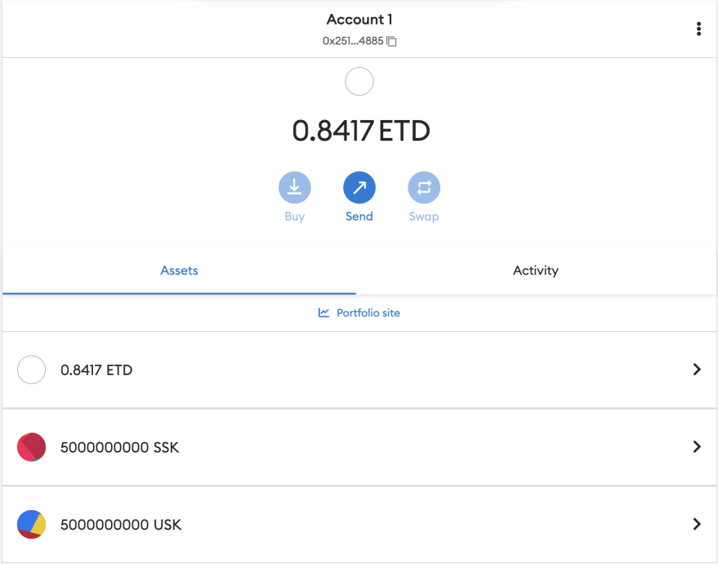

### 3.3 Option contract

When clicking on the homepage, there is currently no option contract on the blockchain.

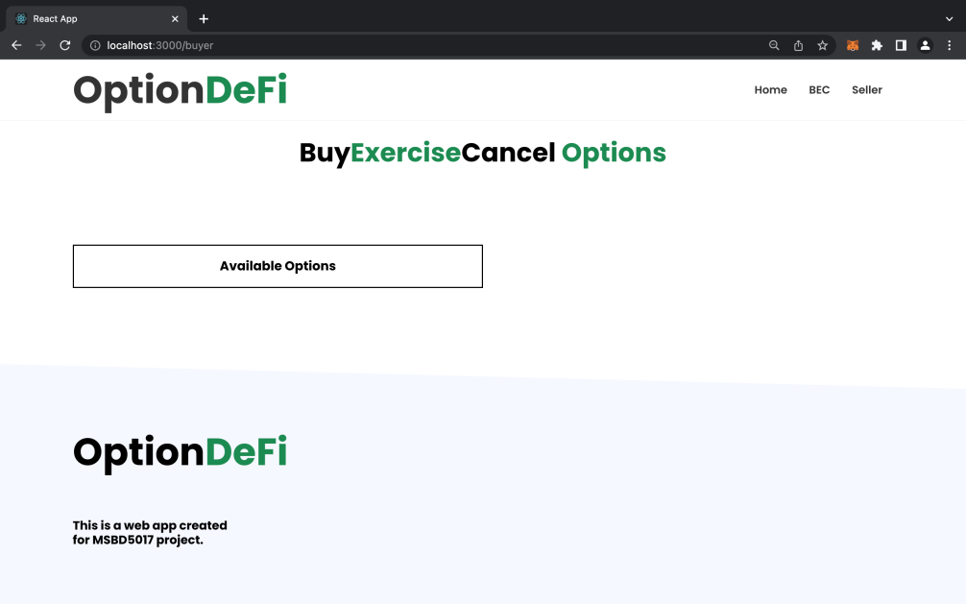

Connect to MetaMask wallet extension and view balance, which calls the “*connect wallet”* function of front-end.

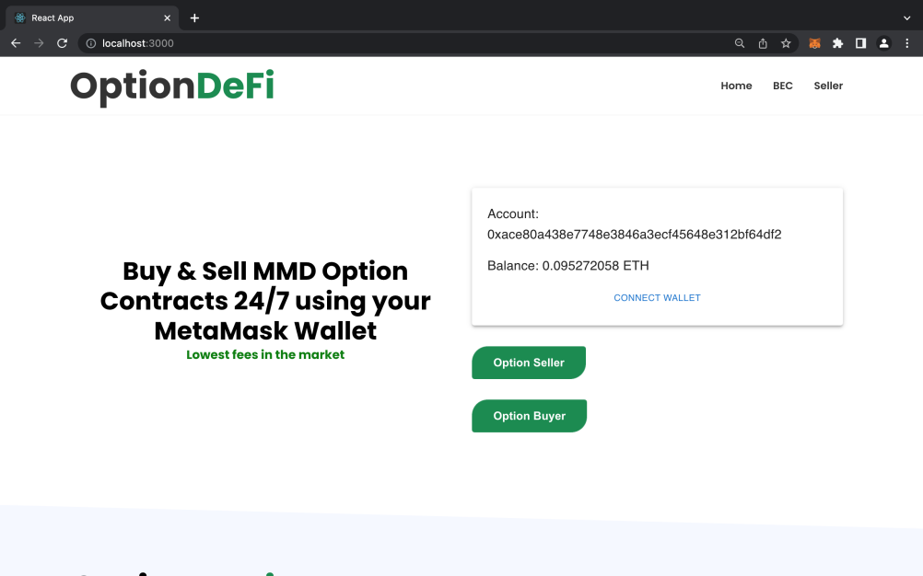

#### 3.3.1 Sell option

Writer specifies parameters of option, premium, strike, expiry and amount.

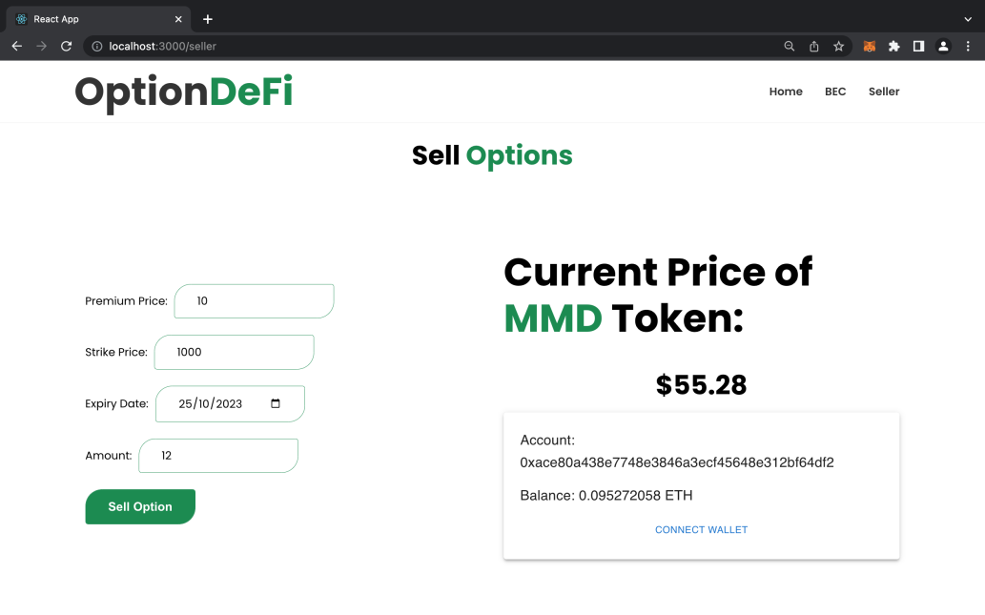

Approve unstablecoin from wallet to contract, using “*approve***”** function from smart contract, which extends **ERC20.**

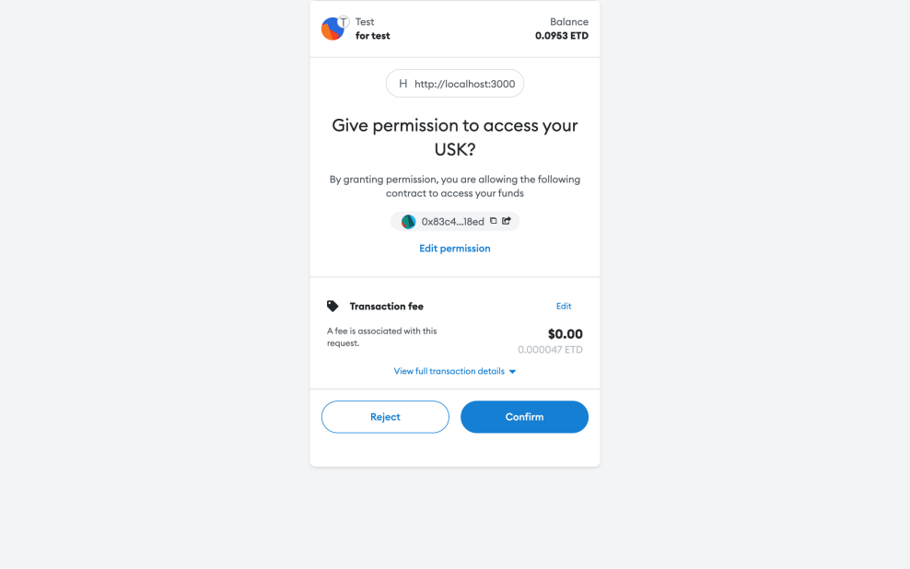

Transfer unstablecoin from writer to option contract.

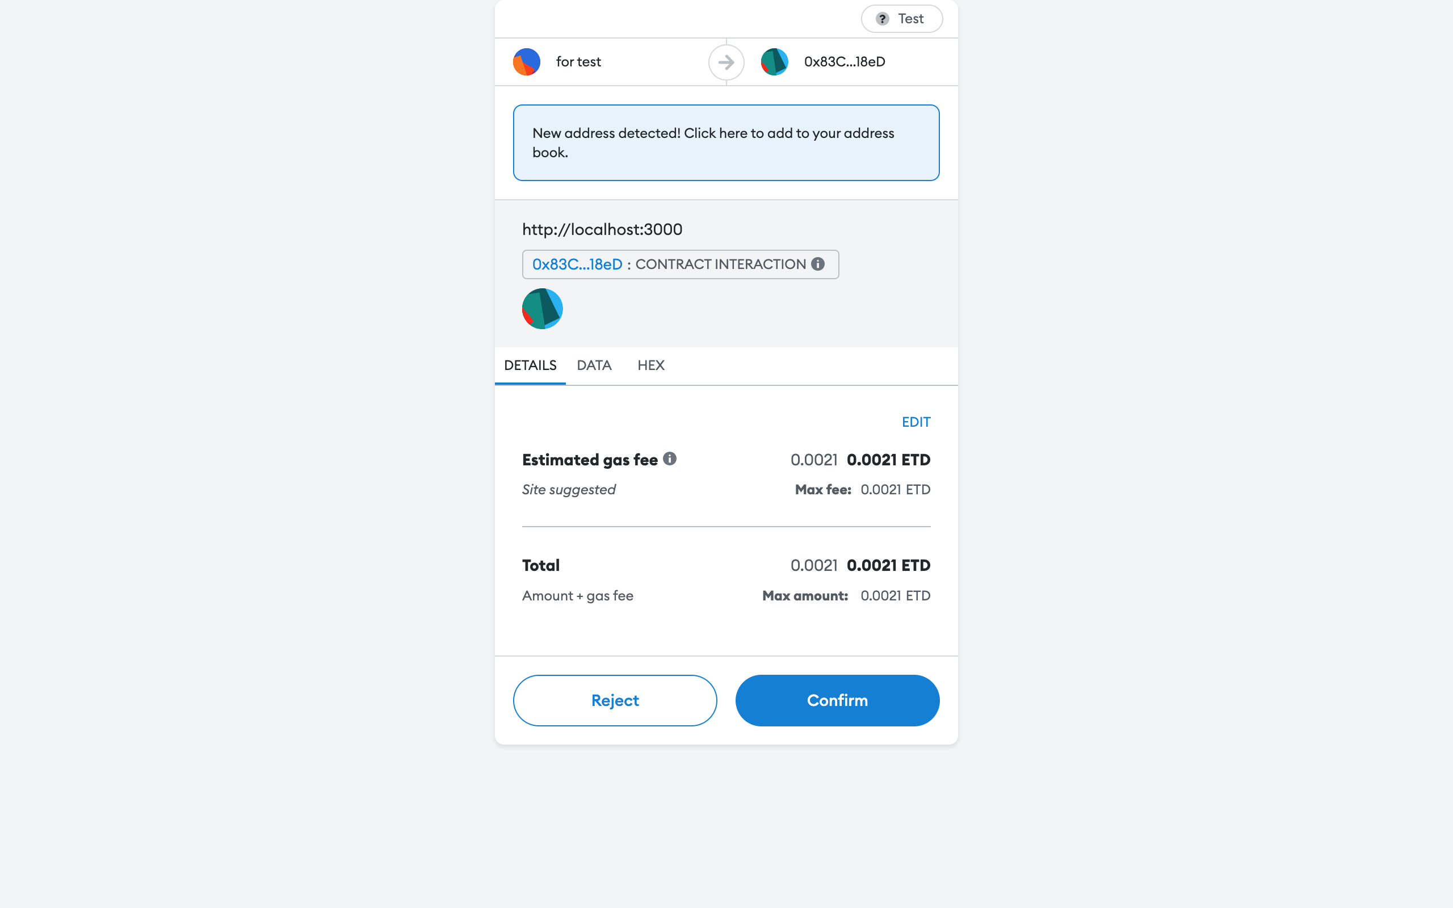

Check whether the functions of “*approve”* and “*transfer***”** work, from the unstablecoin contractwhich extends *ERC20*.

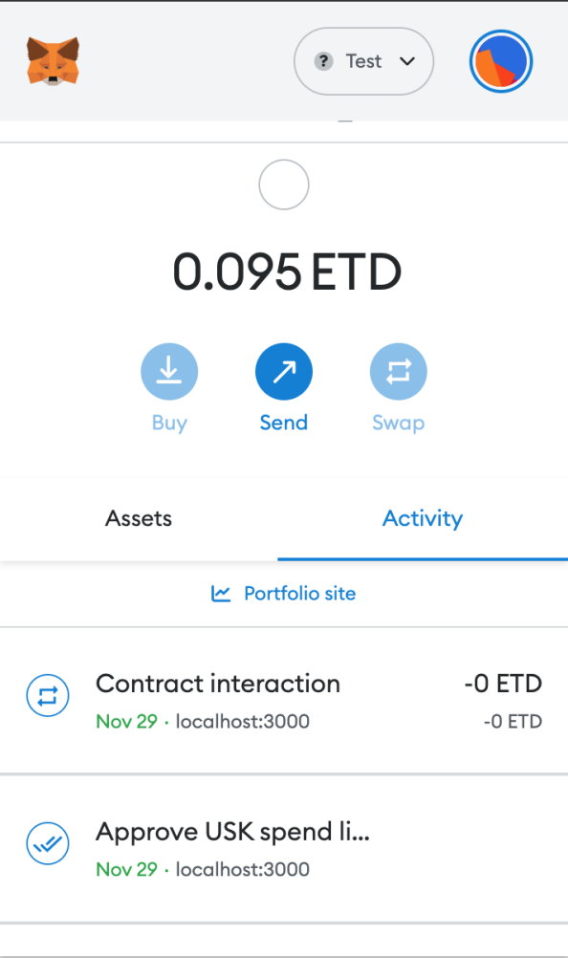

Details of the written option contract available on the blockchain

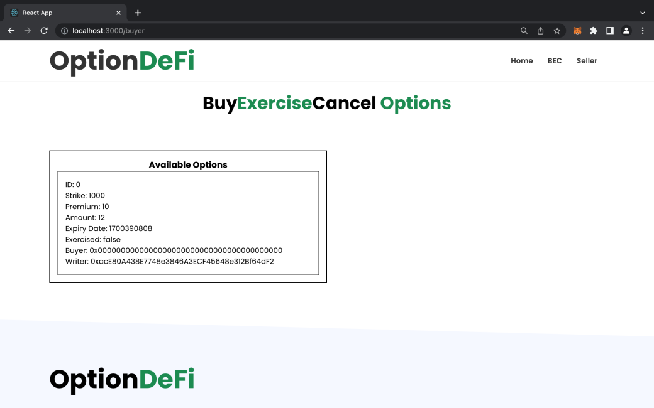

Write another option

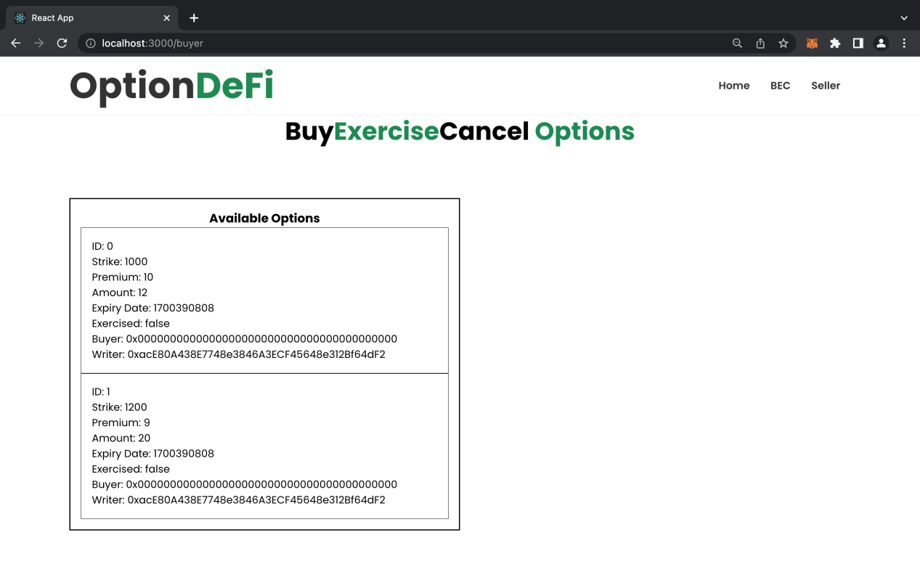

#### 3.3.2 Buy option

Buy the second option(ID: 1). In this screen, you can buy the option you want from the list.

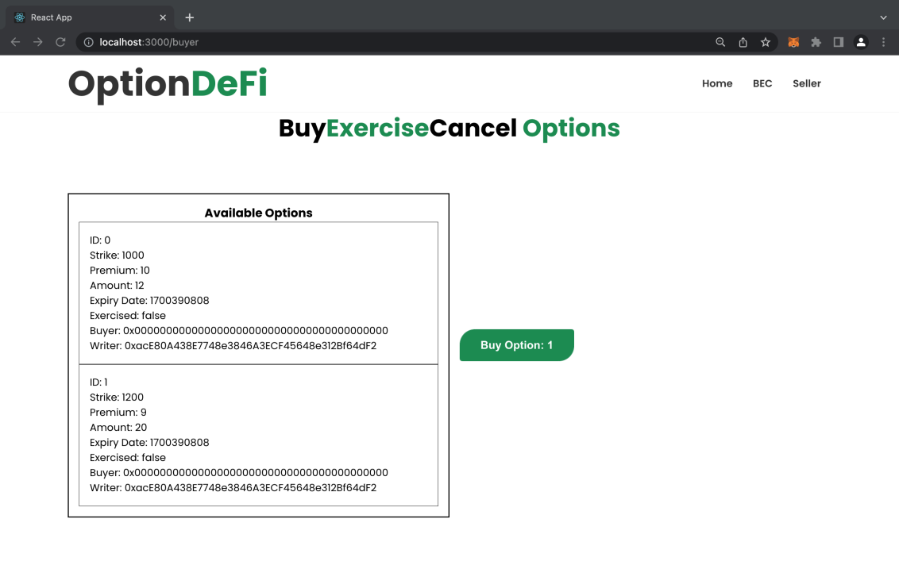

After clicking “Buy Option”, the system asks user to confirm.

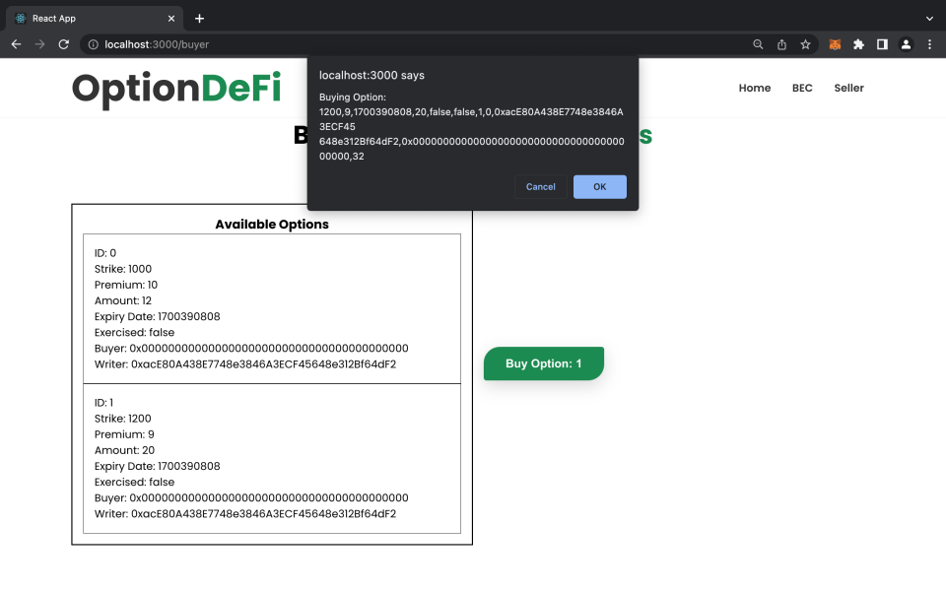

Approve stablecoin from the wallet to option contract.

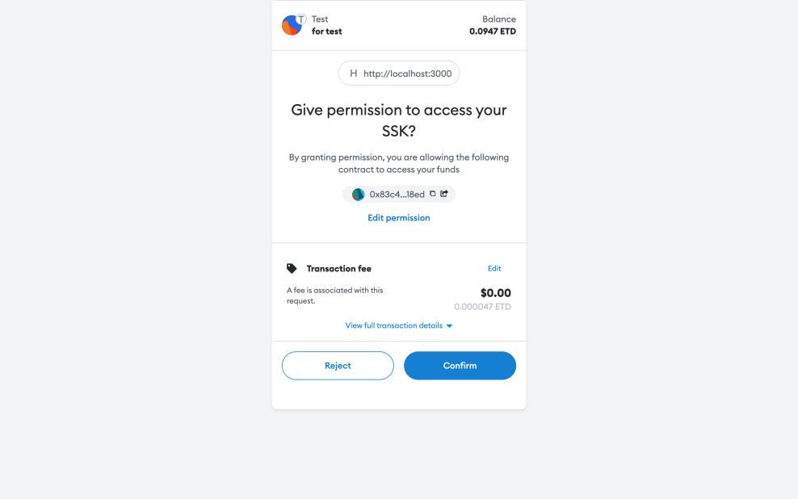

Transfer stablecoin from buyer to contract

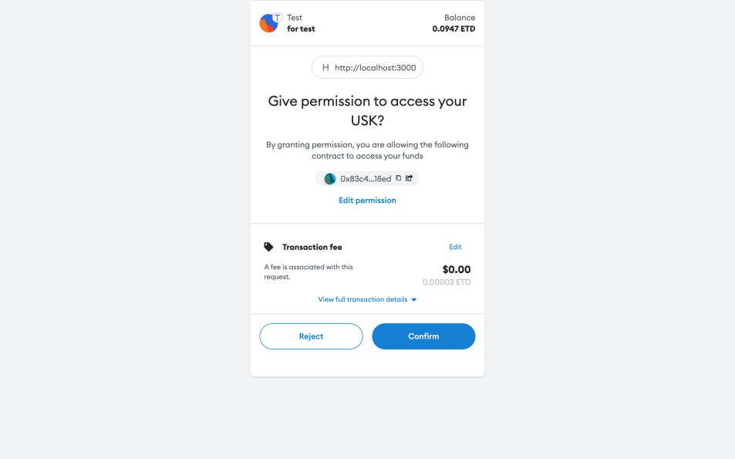

Transfer stablecoin from contract to writer

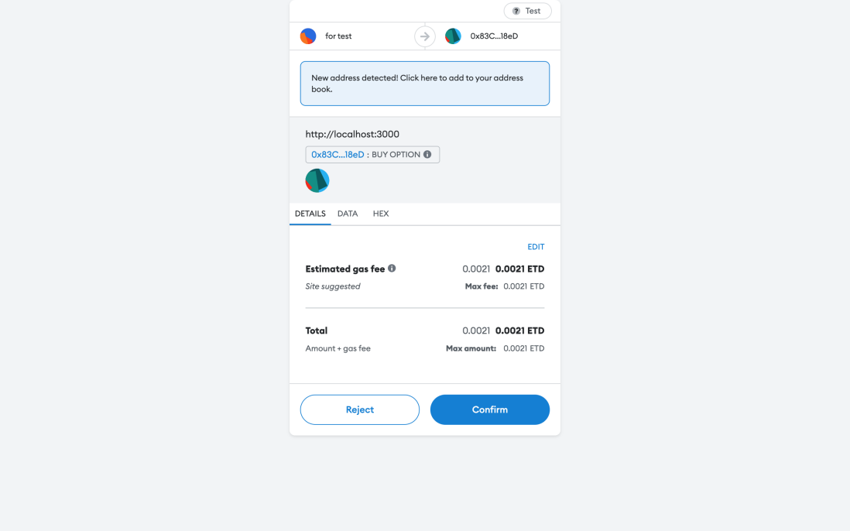

Verify the correctness of *“buy option”*. As expected, the buyer address of the contract bought has now been updated

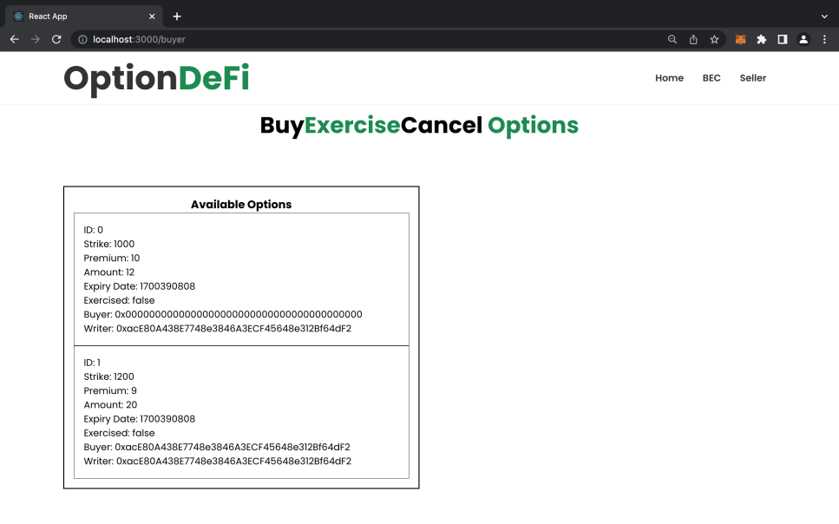

#### 3.3.3 Exercise option

Exercise the second option (ID: 1)

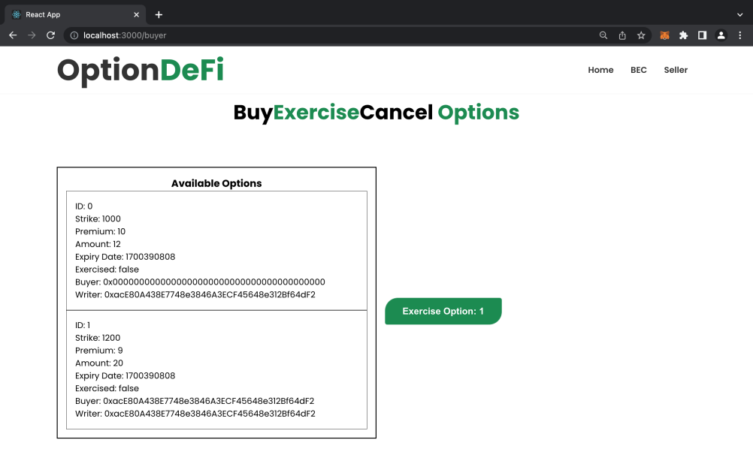

After clicking *“Exercise Option”*, the system asks user to confirm

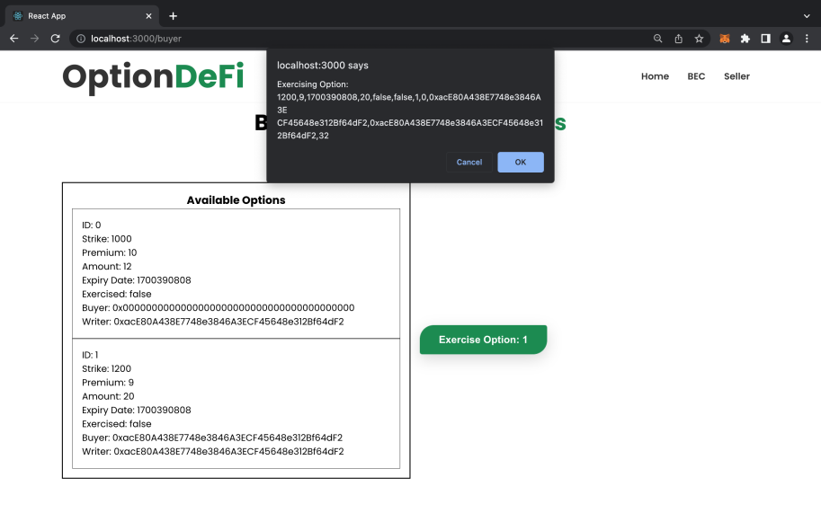

Do transaction,which transfers stablecoin from the buyer’s wallet to the contract



The whole transaction activities

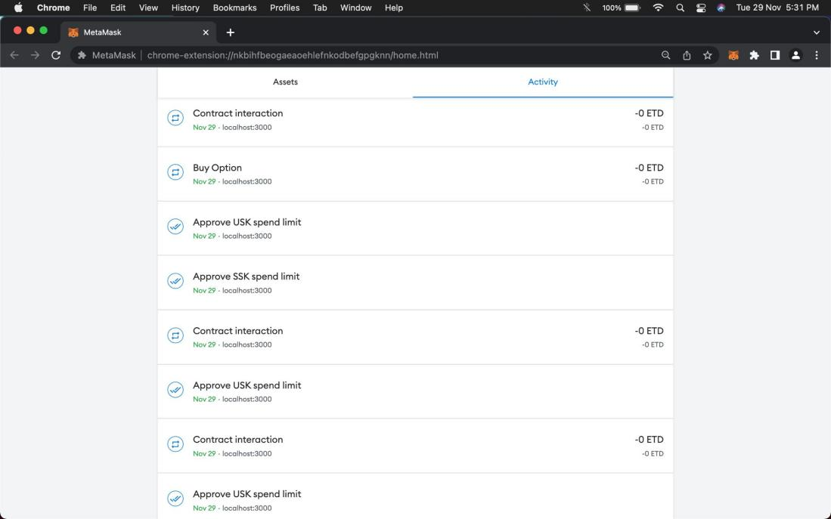

In conclusion, our project aims to give consumers access to a low-risk, open-source, decentralized software platform with the main functions of selling, buying, and exercising options.

## 4 Experience and harvest

With the assistance of our assistant professors, we gradually grasped the solutions to the problems we met in the practice, and we developed a deeper understanding of the use of defi on blockchain. The difficulties and obstacles we faced during front-end and back-end training are listed below.

### 4.1 Back end

1. Call the ERC20 interface in smart contract for transferring funds
2. Design option as an array with different attributes in smart contract
3. Write test case to test whether those functions in smart contract work
4. Deploy smart contract to blockchain

### 4.2 Front end

1. Connect MetaMask wallet in the front-end page
2. Connect smart contract (abi, contract address) in the front-end page
3. Transfer transaction with defined token in the front-end page
4. Call the function of option contract in the front-end page
5. Show option list in front-end page

## 5 Future Plan

Due to technical and token limitations, our research has several flaws. our goal in the future is to accomplish the following:

1. cMMD should be pegged to the USD
2. Exchange rate between cMMD and MMD should be floating
3. Implement a liquidity pool to allow buyers to decide the parameters of option they want to buy
4. Implement pricing function of option under 3
5. Logic for front-end interactions must be optimized, and quick feedback on errors must be provided.
6. Support different MMDs with uniswap

## 6 Acknowledgements

Building an options trading platform on the blockchain took approximately two months, during which we gradually came to understand the opportunities and challenges of web3. From choosing the topic's direction through drafting the report, the attentive guidance and assistance from Professor Lei were essential in this endeavor. Moreover, whenever we encounter code bugs or discuss our group's ideas , Qi wei always gives us timely and patient help. Therefore, we sincerely appreciate the help from Professor Zhibin Lei and TA Qi wei.

## 7 Github Repository

<https://github.com/Joe-Bradley/S_K>