**Morphology of street networks in urban neighborhoods in Ghana**

A Special Study submitted to the Department of Planning, Kwame

Nkrumah University of Science and Technology, Kumasi

in partial fulfilment of the requirements for the

Degree of Bachelor of Science in Human Settlement Planning

By

JOSEPH NORKPLIM ATTAH

**CHAPTER THREE**

**PRESENTATION OF STUDY RESULTS AND DISCUSSIONS**

**4.1 Introduction**

This chapter presents the various topological and geometric statistical indicators that characterize street networks extracted from the respected study neighbourhoods. It points out the various differences and similarities between the street networks from the selected study sites (Airport Residential Area, Darkuman, Nungua Central in Accra and Adum, Atonsu and Tafo of Kumasi), their implications on urban form and critical infrastructure and suggest solutions to some short comings identified from network structure and street patterns. It continues to advocate for conducting free and open research, publishing the data analytics framework, data, tools, and methodologies used in the study as an opensource project.

**4.2 Morphology of urban street networks in study areas**

Urban morphology is the study of the things and processes that make up environment, from geography, architecture to the social sciences, understanding how humans interact in the spaces they live in involve trying to understand firstly, the form and structure of spaces they live in and the choices underlying the creation and transformation of such spaces. Simply put, it is the study of urban form and structure. A brief visual morphological description of the network structure of streets from selected study areas are presented in **Figure 1**, the outlines make it easy to visualize the characteristic structure and patterns of street networks in the selected study areas. The street network graph (depicted in **Figure 1**) is constructed by defining 0.7 km2 bounding boxes around coordinates picked randomly from urban neighbourhoods in Accra and Kumasi in the same fashion as depicted in literature from Barthélemy & Flammini, (2008) and Boeing (2017) and extracting the graph and indicators using open source tooling and methodologies described in the previous chapter.

As Dumedah & Garsonu (2021) point out, the grid is more prevalent with a branching structure at the local scale than any other pattern in most networks in Ghana. The grid is usually indicative of a more connected network. Other characteristics include short street segments with multiple interconnections coupled with short routes which improve the resilience of the network in emergency situations (Sharifi & Yamagata, 2018). The characteristic structure of the network pattern is the grid. The Adum network has the characteristic radial pattern of a typical Kumasi street and this is because it is in the central part of the metropolis—most of the major streets seem to be emanating from Adum outwards or they converge at Adum depending on the scale at which you view it. Networks selected from Accra can be said to be more gridded and of a finer grain than networks from Kumasi and there are more intersections which improve the resilience of the network. Consequently, it can be said that the networks from both region are moderately fine grained networks, indicative of areas with relatively better planning regimes especially in Accra since it is the national capital of Ghana. Major streets from Airport Residential Area, Accra, has a characteristic parallel street segments with relatively fewer connections and dead-ends on the local scale. It depicts a kind of branching structure that is not as thorough and fine as that of Darkuman and Nungua Central, these two are of a finer grid than the Airport Residential Area network, they also have more interconnections between street segments. The characteristic network pattern of the Kumasi study areas slightly differ from one another, the Adum network is of the characteristic radial pattern as it is at the core of the metropolis. Atonsu features a characteristic diverging tail pattern with a coarse grid pattern on the local scale, also characterized by dead-ends. Tafo on the other hand features a moderate grid similar to networks from Accra.

Average street length which is also used as a proxy for block size (Boeing, 2017a) is 73m in Airport Residential Area, 86m in Darkuman, 89m in Nungua Central, 70m in Adum, 109m in Tafo and 92m in Atonsu. It is not surprising to see Atonsu and Tafo with the highest block sizes as its network structure is characterized by a diverging tail for Tafo and branching at the local scale and a coarse grid with more spaces for Tafo which is characteristically less resilient than the finer grid (Sharifi, 2019). Though all the networks are somewhat gridded, there are subtle difference in the structure of each of the grids characterising each of the respective study areas; Airport Residential Area has curvilinear streets with branching at the local scale, Darkuman, Nungua and Tafo has a kind of uneven grid with dead-ends at the local scale and Adum with its characteristic radial pattern with clustering at the eastern part of the network. Also an average node in each of the study areas (both in Accra and Kumasi) have 3 edges emanating from them, this speaks more to the similarities between the networks than differences—they are subtle and are factors of layout and topography than anything else (Dumedah & Garsonu, 2021a).

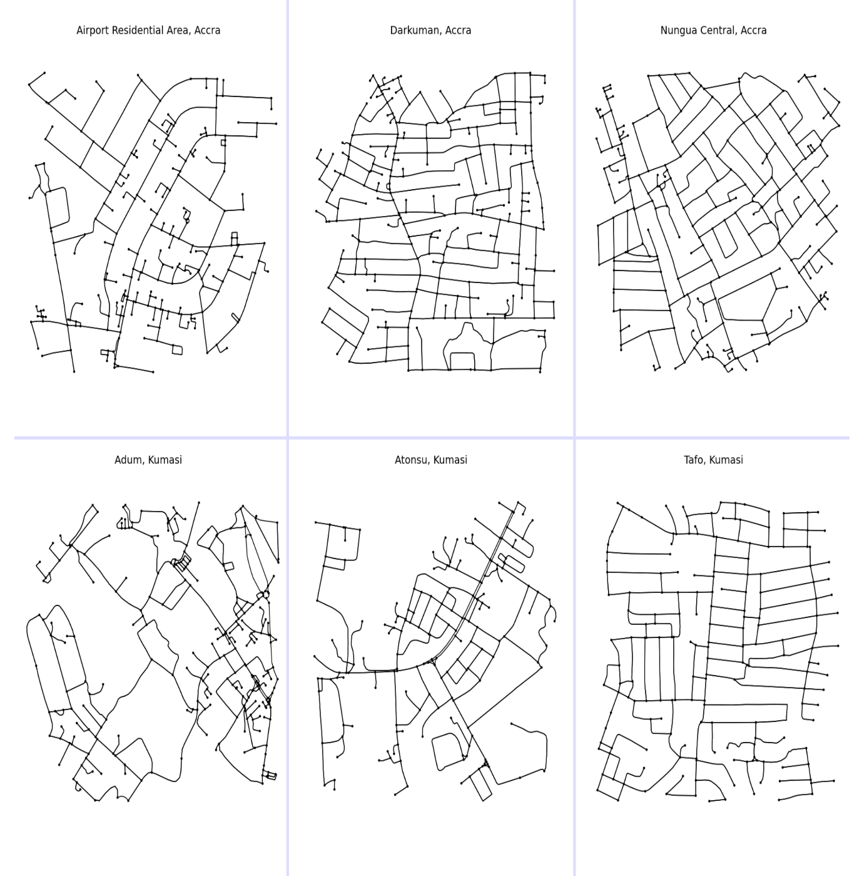

Figure 1. Six 0.7 km2 sections of street network from Accra (top half) and Kumasi (bottom half)

**4.3 Network Connectivity**

Seeing as the study areas happen to be the most populated cities and neighbourhoods in the country, we sample intersection and density metrics from both cities and the respective study areas to see how connected each network is. Intersection density is the total number of intersections per unit area of the network (in our case per km2 of network area). More connected networks have a higher intersection density and contributes to the resilience and redundancy of the network (Barthélemy & Flammini, 2008; Sharifi, 2019). It is noted, a highly connected network facilitates the smooth flow of information between nodes/edges in it. From the statistical measures in **Table 1**, the intersection density in Airport Residential Area is 99.219 intersections per km2, 115.546 intersections per km2 in Darkuman, 114.528 intersections per km2 in Nungua Central, 120.312 intersections per km2 in Adum, 83.103 intersections per km2 in Tafo, and 82.124 intersections per km2 in Atonsu, with Adum’s intersection density greater than all the others, although the difference in density counts are not that different considering all the networks. It is typical to have the more finely grained and gridded networks with a higher intersection density than other patterns specifically the tree-like structure and the radial pattern, which is not the case here. And that is because the Adum network is made up of the best of both network patterns, a radial pattern emanating from the core of the network with a branching and grid-like pattern on the local scale, this results in a shorter street segments and frequent intersections at the local scale providing the network with a better capacity to adapt in emergency situations. Comparatively, all networks are of a moderately high connectivity (Boeing, 2017b) comparable to networks at a global scale.

Consequently, all the encompassing networks have a high concentration of 1-way intersections and an even higher concentration of 3-way intersections. 2-way and 4-way intersection are not as prevalent in the networks, though there is fair amount of 4-way intersection than 2-way intersection—which are almost non-existent—in the networks. This is a good thing as connectivity is improved with more intersections, 1-way streets typically result in less connected networks that are prone to break downs in emergency situations and less choice routes for commuters (Boeing & Riggs, 2022; Sharifi, 2019). From the related literature, it is stated that more connected networks come with health benefits as they typically promote walkability by their characteristically smaller block sizes resulting in short pedestrian trips and encouraging active commuting with improved access to amenities and services (Sharifi, 2019).

Table 1. Statistical results for six street network sections from Accra and Kumasi

|  |  |  |  |  |  |  |
| --- | --- | --- | --- | --- | --- | --- |
| **Indicators** | **Accra** | | | **Kumasi** | | |
| **Airport Residential Area** | **Darkuman** | **Nungua Central** | **Adum** | **Tafo** | **Atonsu** |
| n - number of nodes | 245 | 272 | 250 | 278 | 185 | 180 |
| m - number of edges | 543 | 654 | 610 | 618 | 462 | 415 |
| Total edge length (km) | 39.576 | 56.163 | 53.954 | 44.780 | 50.352 | 38.639 |
| Avg edge length (m) | 72.884 | 85.877 | 88.449 | 72.459 | 108.988 | 93.105 |
| Avg street per node | 2.359 | 2.570 | 2.600 | 2.572 | 2.692 | 2.611 |
| Intersection count | 162 | 201 | 198 | 211 | 148 | 141 |
| Total street length (km) | 19.869 | 28.082 | 26.977 | 23.636 | 25.176 | 20.341 |
| Street segment count | 274 | 327 | 305 | 338 | 231 | 222 |
| Avg street length (m) | 72.514 | 85.877 | 88.449 | 69.928 | 108.988 | 91.627 |
| Avg circuity | 1.067 | 1.037 | 1.051 | 1.085 | 1.044 | 1.121 |
| Self-loop proportion | 0.004 | 0.000 | 0.000 | 0.000 | 0.000 | 0.000 |
| Clean intersection count | 118.000 | 159.000 | 154.000 | 118.000 | 127.000 | 98.000 |
| Node density (per km) | 150.054 | 156.361 | 144.606 | 158.515 | 103.879 | 104.840 |
| Intersection density (per km2) | 99.219 | 115.546 | 114.528 | 120.312 | 83.103 | 82.124 |
| Edge density (km/km2) | 24.230 | 32.286 | 31.208 | 25.533 | 28.273 | 22.505 |
| Street density (km/km2) | 12.169 | 16.143 | 15.604 | 13.477 | 14.137 | 11.848 |
| Clean intersection density (km) | 72.271 | 91.402 | 89.077 | 67.284 | 71.311 | 57.079 |
| Number of 1 way intersections | 83 | 71 | 52 | 67 | 37 | 39 |
| Number of 2 way intersections | 0 | 0 | 0 | 1 | 0 | 0 |
| Number of 3 way intersections | 156 | 176 | 194 | 194 | 131 | 133 |
| Number of 4 way intersections | 5 | 25 | 4 | 16 | 17 | 8 |
| Mean of avg neighbor degree | 2.661 | 2.809 | 2.748 | 2.591 | 2.883 | 2.595 |
| Mean of avg weighted neighbor degree | 0.094 | 0.045 | 0.044 | 0.064 | 0.032 | 0.041 |
| Avg degree centrality | 0.018 | 0.018 | 0.020 | 0.016 | 0.027 | 0.026 |
| Avg clustering coefficient | 0.027 | 0.006 | 0.008 | 0.058 | 0.010 | 0.067 |
| Avg weighted clustering coefficient | 0.004 | 0.001 | 0.001 | 0.007 | 0.001 | 0.006 |
| Max pagerank | 0.010 | 0.009 | 0.009 | 0.009 | 0.011 | 0.013 |
| Min pagerank | 0.001 | 0.001 | 0.001 | 0.001 | 0.002 | 0.001 |
| Diameter (km) | 2.664 | 2.716 | 2.418 | 2.776 | 2.894 | 2.851 |
| Radius (km) | 1.570 | 1.423 | 1.373 | 1.488 | 1.511 | 1.428 |
| Avg closeness centrality | 0.001 | 0.001 | 0.001 | 0.001 | 0.001 | 0.001 |
| Avg betweenness centrality | 0.051 | 0.049 | 0.051 | 0.057 | 0.064 | 0.065 |

**4.4 Network Centrality**

To really understand street network structure and form and how they affect human decisions in space, we have to understand that all components of the network are different, and how they differ depends on how they are laid out in space, its neighbourhood (other components incident to it) and how it interacts with its neighbourhood. Thus, it is essential to rank nodes/edges—the main constituents of a street network graph—to obtain the centrality (or ranking of importance) of nodes/edges in the system. Several measures of centrality exist and have been used in the existing literature (Barthélemy, 2004, 2011; Barthélemy & Flammini, 2008; Boeing, n.d., 2018; Dumedah & Garsonu, 2021b; O’Sullivan, 2014; Sharifi, 2019; Yen et al., 2021; Zhao et al., 2019) extensively, because of its importance for understanding the network’s form and functional relationship between nodes/edges and the critical roles they play in the network. From Table 1, the statistical measures of centrality that this study concentrates itself with include betweenness centrality, closeness centrality, PageRank, and degree centrality. This measures give insight into how connected and thoroughly configured the street network of a particular place is. Highly central nodes/edges in the system are priority elements and have to be given special attention and planned properly against failure, the disruption of central elements in the graph result in sometimes catastrophic chain reactions in the network (Sharifi, 2019). For instance, a highly central edge that is located in a disaster prone area (e.g. in a floodplain) can result in a catastrophic break in network and disrupt flow should disaster strike. It is therefore extremely necessary that planners and policymakers work together to protect, strengthen and make central nodes/edges redundant and resilient in anticipation of future phenomena that may or may not occur. The statistical indicators quantify what we can see qualitatively by plotting these variables on the street network graph for visual inspection. We take a closer look at each of the measure of centrality in the following subsections.

**4.4.1 Degree and Closeness centrality**

Closeness centrality indicates how close a node/edge is to all other nodes/edges in the graph, hence the “closeness”. Sometimes called the geodesic distance, it ranks network elements based how short the distance is between the element and other elements in the graph. The importance of this particular measure lies in its ability to identify specific nodes that control (or at the very least play a central role) in facilitating the flow of information through the network. **Figure 3**, which shows the spatial distribution of closeness centrality of each edge in each network of the selected study areas, shows that the highly central nodes which are depicted by lighter colour (see **Figure 2** for colormap of the graphs) are all situated in core of network and emanate outwards towards the least central nodes. Networks selected from Accra seem to have a lighter colored outer graph (which is indicative of high closeness centrality) than their counterparts selected from Kumasi. But on the average, the closeness centrality index of each selected area (from Table 1) is 0.001 which shows that the closeness centrality of the network regardless of whether situated in Accra or Kumasi are relatively same for all areas. Which also translates to the fact that the more accessible edges in the network are located at the core of each neighbourhood and accessibility decreases as you move outside the neighbourhood. This is not surprising, as there is usually more development efforts hence greater densities in the core of neighbourhoods that the outskirts. Also, it is the development of the urban core that attracts more people to these areas, a classic case of cause and effect becoming interchangeable. It is therefore advisable that planning efforts in these neighborhoods focus some of its attention on network periphery, improving accessibility to the outer part of the neighbourhood and its environs to facilitate flow to these parts and also to create a more redundant, resilient and loosely coupled network that can withstand disasters. To augment resilience of urban form in terms of accessibility, it is essential to consider closeness centrality when making decisions about the location of services and amenities (Sharifi, 2019).

Degree centrality ranks nodes based on how many connections they have. Many streets in most urban areas are characterized by moderate node degrees for most nodes in the network and few nodes with very high degree centralities (Sharifi, 2019). On the average, nodes in Airport Residential Area, Darkuman, Nungua Central, and Adum have 3 edges emanating from it, which is not surprising seeing as 3-way streets are dominant in these areas. On the other hand, Tafo and Atonsu in the Kumasi metropolis register an average of 3 streets emanating from each node in the network. Consequently, this measure is useful in less connected graphs to find nodes with unusually high degree centralities, because a failure in such nodes results in equally catastrophic damage to the network (Boeing, 2018; Sharifi, 2019).

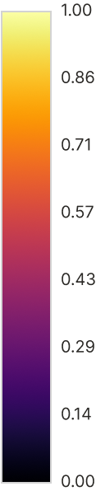

**Figure 2**. Colormap of the following street network graphs. For use coloured graphs

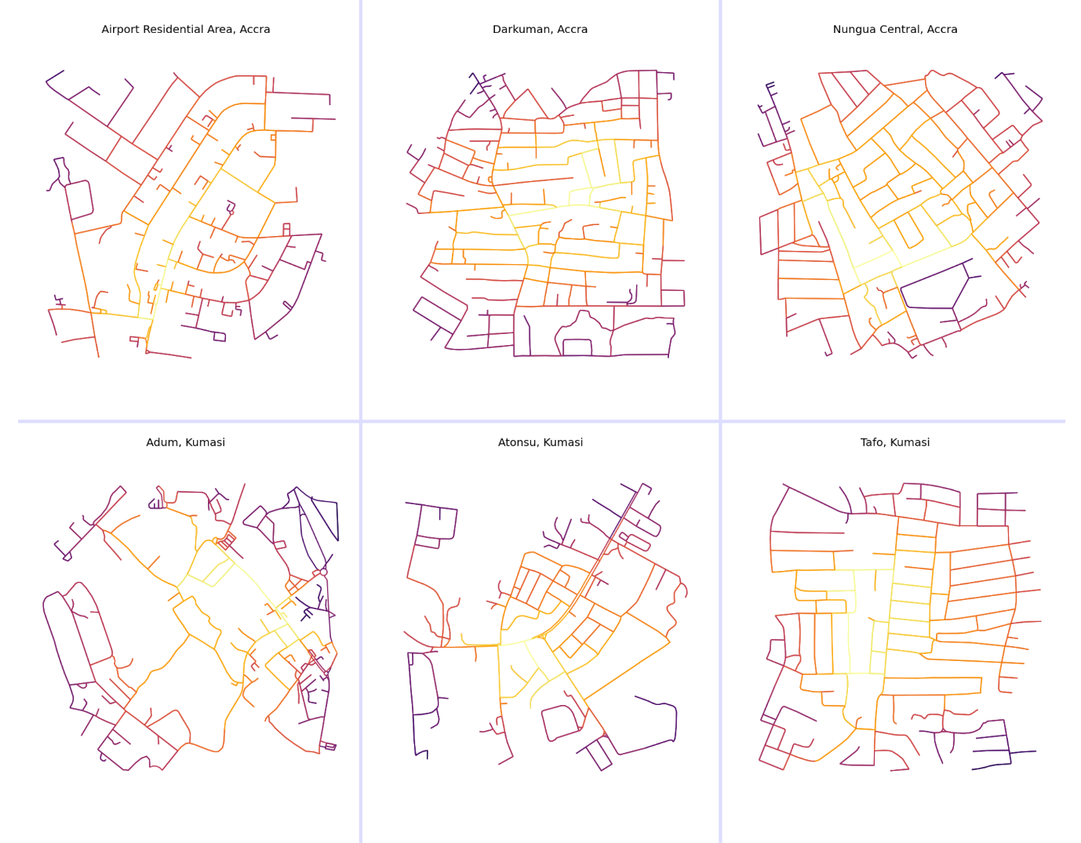

**Figure 3**. Sections of street network graph showing closeness centrality of edges.

**4.4.2 Betweenness centrality and PageRank**

Betweenness centrality is an important measure used to rank nodes/edges on their relative importance in the network, taking into consideration the number of shortest paths that pass through the node/edge. Thus, the node that appears most, in all shortest paths of the network is the node with the highest betweenness centrality. From Table 1, the average betweenness centrality indicates that 5% of all shortest paths pass through an average node in Airport Residential Area, Darkuman and Nungua Central in Accra. On the other hand, in Kumasi, 6 % of all shortest paths pass through an average node in Adum and Atonsu, and 7% in Tafo. Once again, these values do not vary much from each other. There are more similarities between network structures than there are differences. The spatial distribution of betweenness centrality for each node in the system provides slightly different lenses with which to view the betweenness centrality of each study site. From **Figure 4**, the spatial distribution of nodes with the highest shortest paths is located as usual at the core of most of the networks with few nuanced differences between each.

Nodes of high betweenness centrality in the Airport Residential Area are more concentrated slightly south of the urban core with fewer central nodes at the fringes as usual. This is great for economic purposes; more central nodes concentrated around the same place generate more traffic and hence are more economically viable for businesses but an uneven distribution is not good for resilience (Sharifi, 2019). Something slightly similar is prevalent in the Darkman street network too, the most central nodes (in lighter colors, **Figure 2**) are concentrated along the same edge—running north to south—which is also good for business but bad for resilience. The destruction of a single node in the middle might result in a catastrophic chain reaction in the network. Nungua Central, on the other hand, features a betweenness centrality distribution that is relatively evenly distributed in the network. This is characteristic of a more resilient network, one where highly central nodes appear at multiple places, at the eastern, north-western, and southern fringes of the network. Nodes in Kumasi follow the same pattern as Darkuman and Airport Residential Area network, in that, highly central nodes are concentrated at a single core of the network, it can be spotted in Adum in the eastern core of the network, central core in Atonsu (also running along the same edge as in Darkuman) and in Tafo also along the same edge running north to south. Boeing, (2017a) points out that, more important nodes are usually concentrated at the center of the more grid-like networks which can be seen in **Figure 4** except for Nungua Central’s street network graph which features a more even spatial distribution of betweenness centrality. Darkuman and Tafo networks are more prone to disruptions if one of their most important nodes fails, seeing as they are located along the same edge.

PageRank (Page & Brin, 1998) (a sub variant of the eigenvector family of centrality algorithms) developed by the founders of Google to rank hypertext links has found its effective use in the spatial network analysis literature (Barthélemy, 2011; Boeing, 2017a; Chin & Wen, 2015). It ranks nodes/edges based on not only its connections but also the structure, configuration and connections of incoming nodes/edges, it is most suited for directed graphs—street networks and other spatial networks. It simple ranks nodes/edges based on their connection and the connections of nodes/edges connected to it. This measure is useful for finding nodes that are central to the network not based on only their connectivity but also the connectivity of its neighbourhood, higher values of PageRank indicate nodes that are highly influential to the flow of information through the system. Maximum PageRank recorded for each network ranges from 0.009 to 0.013 for all study sites and minimum PageRank ranging from 0.001 to 0.002 (**Table** **1**). **Figure 5** presents a visual representation of the spatial distribution of the relative PageRank of nodes in each of the networks extracted for each study area, it provides more insight on the ranking on each individual node relative to its graph. One thing that is notably evident is that unlike the other centrality measures PageRank for all nodes is fairly distributed in the respective networks of each study area. This is due to the fact that there are dead-ends (which have relatively lower PageRank) prevalent at the local scale which prevents a lot of the core networks from having more structured neighbourhoods—in the graph theoretic sense—resulting in lower centrality. Since the influential nodes based on PageRank are dispersed in the network, it does not have a single point of failure which is good in emergency situations where the preva

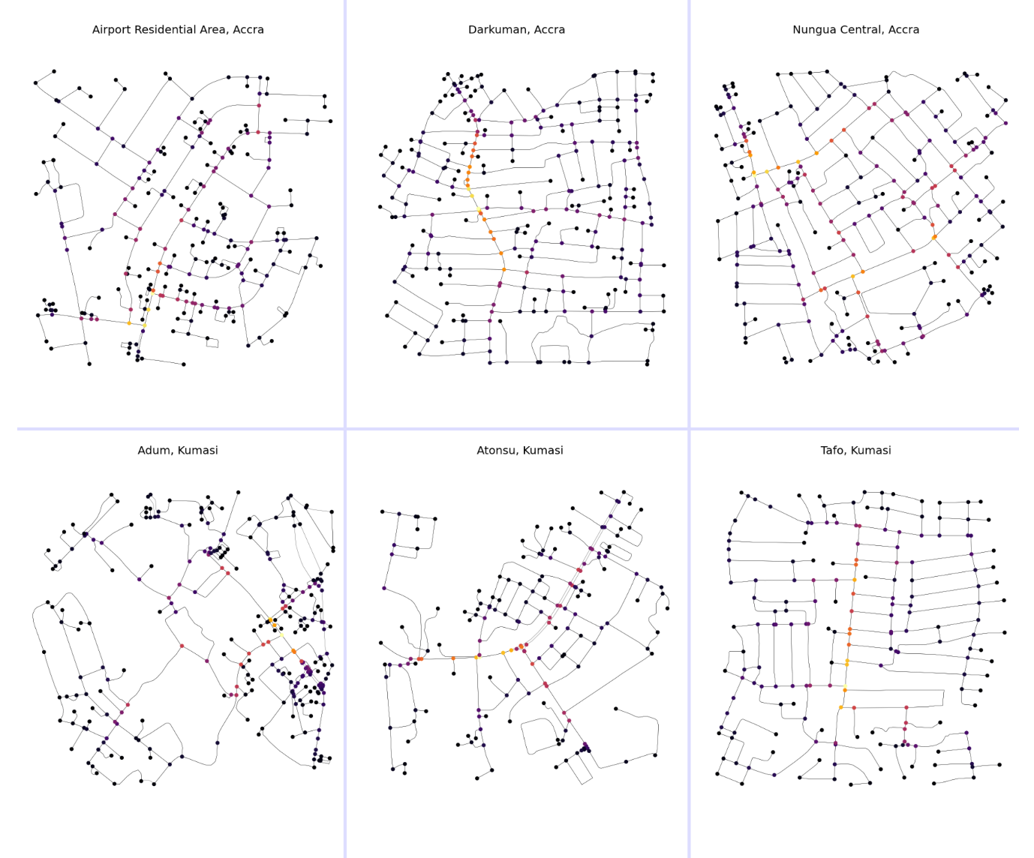

**Figure 4**. Sections of street network graph showing betweenness centrality of nodes.

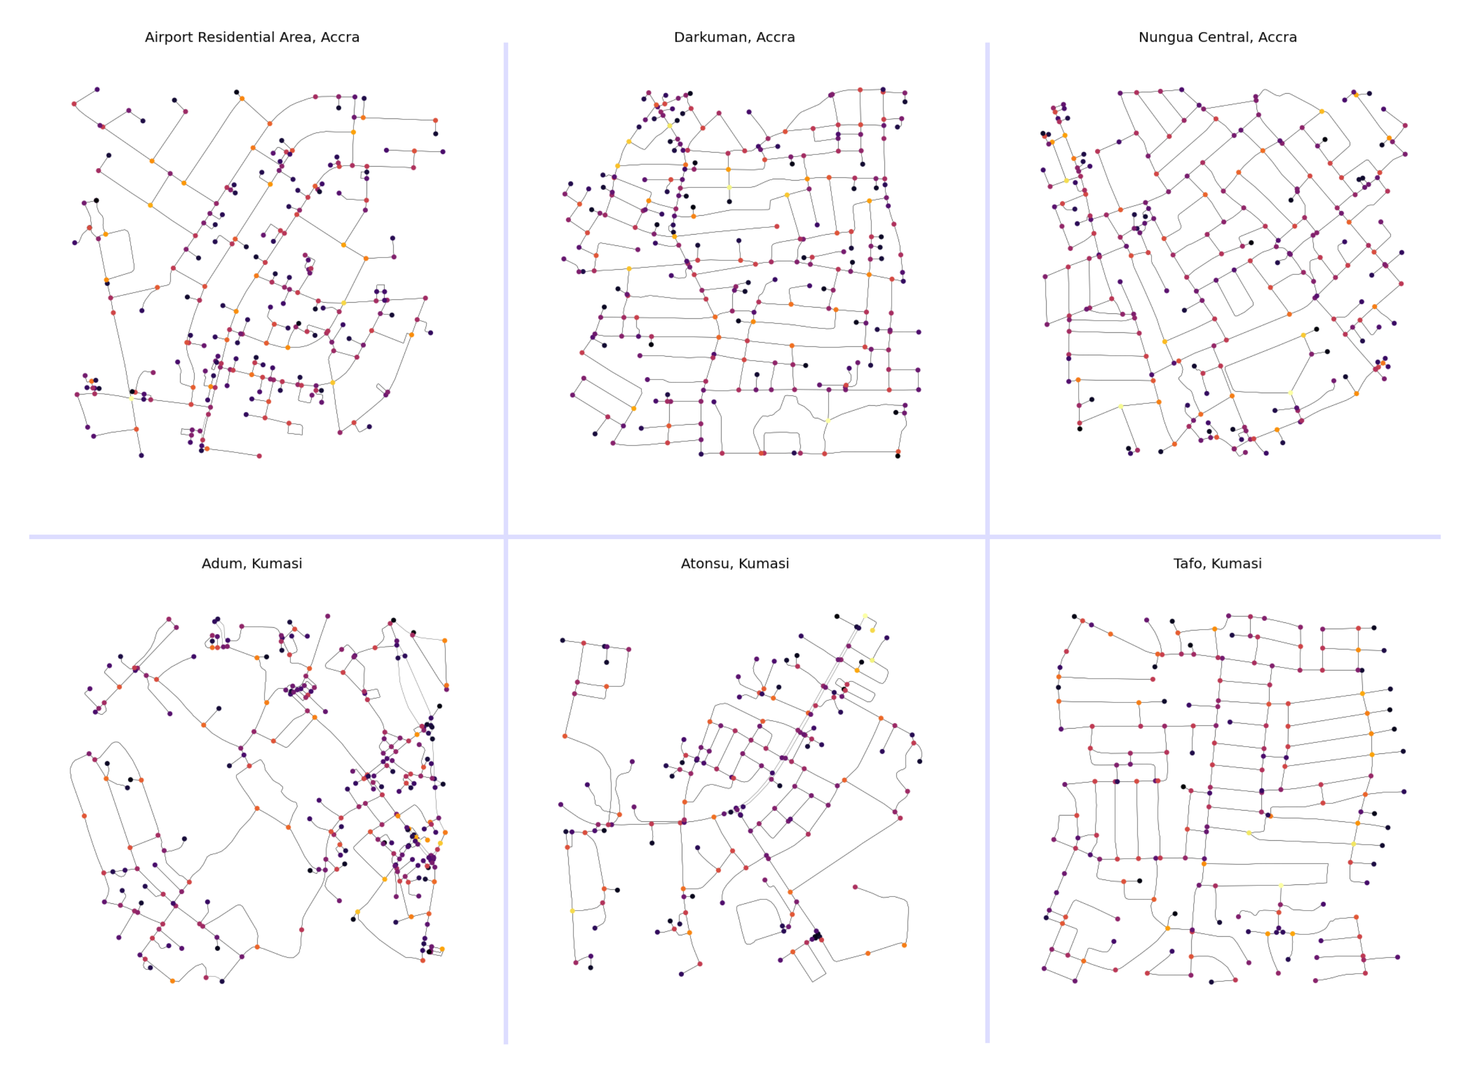

**Figure 5**. Sections of street network graph showing relative PageRank of nodes.

**4.5 Open Source Tool Building in the Context of the Analysis**

Although the advancement of modern technology has enabled an increase in the capabilities and usability of computation machines and tools, the current landscape of tools used in analysing urban form seem to be inconsistent with changes in technology (Fleischmann et al., 2021). Most researchers interested in quantitative geography, land-use planning, architecture or any kind of spatial analysis depend on tools and methodologies developed by big for profit firms, most notably ESRI (with product ArcGIS) which is not only proprietary but also not multiplatform, the available open source tooling for spatial analysis (QGIS) lacks in documentation and has a relatively smaller user base (Boeing, 2020). It is the authors experience that most undergraduate students will never get to learn about computational tools for spatial analysis—the kind employed in this study—beyond ArcGIS or QGIS because they are, for the most part not in the curriculum and so are not thought in the classroom. Most of these tools are reserved for use by only those well vexed in the technologies, mostly computer scientists and mathematicians, who are depended on to create the tools and algorithms we need for geo-spatial analysis. Since it is also the case that to use these tools one would have to have some preliminary knowledge of mathematics and computer science, the barrier to entry it raised a bit higher.

Thus, it became a necessity to engage in building the tools and framework without which this research will be lacking reproducibility and documentation. All tools used and those created as result of this study have more computation capability, are Turing-Complete and programmable, multiplatform (i.e. supports multiple operating environments), free and open source and are more documented than the traditional point-and-click tools that dominate the spatial analysis landscape. These tools not only enable reproducibility but also enable the easy sharing of research data and work. As such, all data, code and documentation is freely hosted in a public online repository that can be assessed at Ref (Joseph Norkplim, 2022).

**5.4 Discussion**

Spatial network analysis currently suffers from the lack of tools and proper methodologies for the empirical study of street networks as stated by Boeing (2017b), this problem can be said to exist on a larger scale in Ghana where street networks are not usually studied using any kind of computational or analytical tools before changes are made in the networks (Dumedah & Garsonu, 2021a). The shortcomings result in poorly informed decisions in transport planning efforts which in turn affect the sustainability of street networks in Ghana. It is also noted that performing spatial network analysis on street networks in Ghana is challenging because of the lack of agencies that provide spatial data for analysis and research (Dumedah & Garsonu, 2021a). It was therefore necessary that to undertake such a study, data had to be extracted from a freely available source using freely available tools to make the point that studies like this can be done on a larger scale to study street network variable that will be harder to examine without the use the methodologies adopted for this study.

Modern Spatial data science is the backbone of the study, all tools and methodologies are computational methods that evolved from data science tooling of the Python community, all tools are free and open source. It is also necessary to create a framework (consisting of code, data, documentation) as advocated by Boeing (2020). The tools allowed us to extract topological measures as well as metric measures of street networks of the defined study areas. It also allowed to for the visualization of different centrality indices which are valuable for assessing the connectivity and resilience of the street networks. This effort also helped us to visualize street network patterns that characterize our study areas.

Networks defined for the analysis comprise neighbourhoods from Accra (Airport Residential Area, Darkuman, Nungua Central) and Kumasi (Adum, Atonsu and Tafo). From these areas, the street network graph was constructed and different topological and geometric measures extracted using open source tools and data. A quantitative view of the network as represented by statistical variables presented in **Table 1** and the appropriate and qualitative visualizations generated and plotted in figures. It was found that the street networks in each of the urban neighbourhood studied are more similar than they are different, they are characterized by similar patterns with some nuanced differences as a result of topography and layout as studied by Dumedah & Garsonu (2021a). The grid pattern is prevalent at the local scale with few characteristic differences that affect resilience and connectivity of the networks. Neighbourhoods extracted from Accra are moderately gridded (except a curvilinear pattern in the Airport Residential Area with local grids), than networks from Kumasi. Accra has more finer grained networks, smaller block sizes and less circuitous network. Kumasi on the other hand, features a radial network with local branching in Adum, a diverging tail in Atonsu and a moderate grid in Tafo similar to networks from Accra.

Measures of Centrality which speak more to the configuration, connectivity, resilience and influence of network components were examined to rank nodes/edges on their relative importance to flow of information in the system. The different centrality measures include betweenness, closeness, degree centrality and PageRank. From the generated visualization of the various relative centrality indices, it became apparent that most of the networks feature nodes/edges of high centrality (betweenness, closeness and degree) clustered at the core of the respective networks, this as is stated by Sharifi (2019) is good for economy but bad for the resilience of the network. A different thing to the aforementioned phenomena is experienced with the PageRank of the nodes in the respective study area street networks, shows a more dispersed centrality of nodes in the network, where nodes of high centrality can even be seen along the fringes of the network (*see* **Figure 5**), this is indicative of the fact that influential nodes are not concentrated at a single point of the network, which is good for network resilience because in the case of emergencies multiple redundant routes exist for faster disaster response (Sharifi, 2019).

Finally, the data, analysis and findings speak to topology and geometry of the network but nothing about the socio-economic environment that the network affects and is affected by the networks. This is part is due to the limitation of data available on OpenStreetMap, recently mappers are trying to add more richer attributes namely, height of buildings, travel times, speed limits, street vegetation. A general limitation to researchers using OpenStreetMap for spatial analysis is the work is only as thorough as the data (which is crowdfunded, free and opensource). It is to be noted that, the networks’ studied consider flow of information only within the subsets that the graphs were constructed from and not the larger network—the metropolis.

**References**

Barthélemy, M. (2004). Betweenness Centrality in Large Complex Networks. *The European Physical Journal B*, *38*(2), 163–168. https://doi.org/10.1140/epjb/e2004-00111-4

Barthélemy, M. (2011). Spatial Networks. *Physics Reports*, *499*(1–3), 1–101. https://doi.org/10.1016/j.physrep.2010.11.002

Barthélemy, M., & Flammini, A. (2008). Modeling Urban street patterns. *Physical Review Letters*, *100*(13). https://doi.org/10.1103/PHYSREVLETT.100.138702

Boeing, G. (n.d.). *Planarity and street network representation in urban form analysis*. https://doi.org/10.1177/2399808318802941

Boeing, G. (2017a). OSMnx: New methods for acquiring, constructing, analyzing, and visualizing complex street networks. *Computers, Environment and Urban Systems*, *65*, 126–139. https://doi.org/10.1016/j.compenvurbsys.2017.05.004

Boeing, G. (2017b). OSMnx: New methods for acquiring, constructing, analyzing, and visualizing complex street networks. *Computers, Environment and Urban Systems*, *65*, 126–139. https://doi.org/10.1016/J.COMPENVURBSYS.2017.05.004

Boeing, G. (2018). Urban Spatial Order: Street Network Orientation, Configuration, and Entropy. *SSRN Electronic Journal*. https://doi.org/10.2139/ssrn.3224723

Boeing, G. (2020). The right tools for the job: The case for spatial science tool-building. *Transactions in GIS*, *24*(5), 1299–1314. https://doi.org/10.1111/TGIS.12678

Boeing, G., & Riggs, W. (2022). Converting One-Way Streets to Two-Way Streets to Improve Transportation Network Efficiency and Reduce Vehicle Distance Traveled. *Journal of Planning Education and Research*. https://doi.org/10.1177/0739456X221106334/ASSET/IMAGES/LARGE/10.1177_0739456X221106334-FIG1.JPEG

Chin, W. C. B., & Wen, T. H. (2015). Geographically modified PageRank algorithms: Identifying the spatial concentration of human movement in a geospatial network. *PLoS ONE*, *10*(10). https://doi.org/10.1371/JOURNAL.PONE.0139509

Dumedah, G., & Garsonu, E. K. (2021a). Characterising the structural pattern of urban road networks in Ghana using geometric and topological measures. *Geo: Geography and Environment*, *8*(1). https://doi.org/10.1002/geo2.95

Dumedah, G., & Garsonu, E. K. (2021b). Characterising the structural pattern of urban road networks in Ghana using geometric and topological measures. *Geo: Geography and Environment*, *8*(1), e00095. https://doi.org/10.1002/GEO2.95

Fleischmann, M., Feliciotti, A., & Kerr, W. (2021). Evolution of Urban Patterns: Urban Morphology as an Open Reproducible Data Science. *Geographical Analysis*. https://doi.org/10.1111/GEAN.12302

Joseph Norkplim, A. (2022). *AutoGIS Street Network Analytics Package*. https://github.com/Joe-Degs/AutoGIS/tree/master/test-thesis

O’Sullivan, D. (2014). Spatial network analysis. *Handbook of Regional Science*, 1253–1273. https://doi.org/10.1007/978-3-642-23430-9_67

Page, L., & Brin, S. (1998). The anatomy of a large-scale hypertextual Web search engine. *Computer Networks*, *30*(1–7), 107–117. https://doi.org/10.1016/s0169-7552(98)00110-x

Sharifi, A. (2019). Resilient urban forms: A review of literature on streets and street networks. *Building and Environment*, *147*, 171–187. https://doi.org/10.1016/J.BUILDENV.2018.09.040

Sharifi, A., & Yamagata, Y. (2018). Resilience-Oriented Urban Planning. *Lecture Notes in Energy*, *65*, 3–27. https://doi.org/10.1007/978-3-319-75798-8_1

Yen, Y., Zhao, P., & Sohail, M. T. (2021). The morphology and circuity of walkable, bikeable, and drivable street networks in Phnom Penh, Cambodia. *Environment and Planning B: Urban Analytics and City Science*, *48*(1), 169–185. https://doi.org/10.1177/2399808319857726

Zhao, P., Yen, Y., Bailey, E., & Sohail, M. T. (2019). Analysis of urban drivable and walkable street networks of the ASEAN smart cities network. *ISPRS International Journal of Geo-Information*, *8*(10). https://doi.org/10.3390/ijgi8100459