**Morphology Of Street Networks In Urban Neighborhoods In Ghana: An Open Source Approach**

A Special Study submitted to the Department of Planning, Kwame

Nkrumah University of Science and Technology, Kumasi

in partial fulfilment of the requirements for the

Degree of Bachelor of Science in Human Settlement Planning

By

JOSEPH NORKPLIM ATTAH

**September, 2022**

**ABSTRACT**

The growing population of the world resulting in increasing socio-economic problems have made it absolutely important that street networks, the vessel through which all things flow in space are investigated thoroughly with modern technological tools. In a simple study of six urban neighbourhoods across two cities Accra and Kumasi, Ghana, the study explores the relevance of using modern open source tools and data, computational science methodologies in investigating street networks. It also engaged efforts in creating a modern analytical framework that can help in automating the workflow involved in studying networks across multiple neighbourhoods in Ghana. To achieve this, several open source tools and methodologies were adopted and used in the construction of the framework using the computation data science model. In the study, it was found that street networks from urban neighbourhoods are more similar in their topological features and configuration than they are different, it was also asserted that neighbourhoods from urban neighbourhoods in Ghana do not vary much from other global neighbourhoods. This findings and results provide an overview of network structure and configuration across the study areas which form a basis for transportation and other planning efforts that seek to improve connectivity and resilience of network in urban centers across the country. The study advocates for the use and creation of open source tools and data to foster their adoption by both researchers, students and policy makers and sets a precedence by publishing the analysis framework and data as an open source project.

**Table of Contents**

CHAPTER ONE

BACKGROUND TO THE STUDY 1

1.1 Introduction 1

1.2 Problem Statement 2

1.3 Research Questions 4

1.4 Research Objectives 4

1.5 Significance of Study 4

1.6 Organisation of Study 5

CHAPTER TWO

REVIEW OF RELEVANT LITERATURE 6

1.7 Introduction 6

1.8 Street Networks And Models 6

1.9 Street Network Analysis 7

1.10 The Case for Open Tools and Data 8

1.11 Examples Of Studies Of These Kind in Local Literature 9

CHAPTER THREE

RESEARCH METHODOLOGY AND PROFILE OF STUDY AREA 12

1.12 Introduction 12

1.13 Study Area and Data Sources 12

1.14 Opensource Analytical Framework 14

1.15 Measures of Network Topology and Geometry 16

1.16 Variables and Data Collection 19

1.16.1 Spatial Data Collection and Analysis 20

[CHAPTER FOUR   
PRESENTATION OF STUDY RESULTS AND DISCUSSIONS 22](#_Toc116138415)

1.17 Introduction 22

1.18 Morphology of urban street networks in study areas 22

1.19 Network Connectivity 24

1.20 Network Centrality 26

1.20.1 Degree and Closeness centrality 27

1.20.2 Betweenness centrality and PageRank 29

1.21 Open Source Tool Building in the Context of the Analysis 33

1.22 Discussion 34

CHAPTER FIVE

SUMMARY OF FINDINGS, RECOMMENDATIONS AND CONCLUSION 37

1.23 Introduction 37

1.24 Summary of findings 37

1.25 Recommendations 39

1.26 Conclusion 39

1.27 Areas of further research 40

REFERENCES 42

**LIST OF FIGURES**

**Figure 3.1**. Graph theoretic model of Kumasi metropolis showing different topological and geometric features of the street network 14

**Figure 3.2**. Six 0.7 km2 sections of street network from selected study regions 21

**Figure 4.1**. Six 0.7 km2 sections of street network from Accra (top half) and Kumasi (bottom half) 24

**Figure 4.2**. Colormap for interpreting centrality visualization of the street network graphs. 28

**Figure 4.3**. Sections of street network graph showing closeness centrality of edges. 29

**Figure 4.4**. Sections of street network graph showing betweenness centrality of nodes. 32

**Figure 4.5**. Sections of street network graph showing relative PageRank of nodes. 33

**LIST OF TABLES**

**Table 3.1**. Descriptive statistic measures of topological and geometric network features used to evaluate street networks 18

**Table 4.1**. Statistical results for six street network sections from Accra and Kumasi 25

# CHAPTER ONE BACKGROUND TO THE STUDY

## Introduction

Street networks form the vessels through which the lifeblood of human settlements (people, services, goods, and information) flow. They underlie commutes, discretionary trips, and the location decisions of households and firms (Boeing, 2018b). More importantly, they help shape the urban structure and shape the way human interactions happen in space. They are so important and prevalent in our lives that it would be impossible to imagine a world in which street networks do not play an important role in how we live and interact with the immediate environment and the people around us.

The current output of urban transportation efforts in Ghana is subpar—and mostly becomes more of a problem after commissioning—this can be experienced by any person living in any city in Ghana. Commute times are longer because it takes twice as much time to travel between two endpoints. There is a huge divide between academic output on the subject and actual implementation of these ideas in our cities mostly due to the informal ways in which they evolve—that is if they are even considered at all—as Dumedah & Garsonu (2021a) argue, “very little is known from the literature about the spatial structure of urban road networks in Ghana, sub-Saharan Africa, or in areas with the similar informal layout of roads”. It will get increasingly harder to do urban planning in Ghana specifically in the transport sector because without a comprehensive view of the network structure and the possible effects of particular changes in intricate parts of the structure, planning efforts will continue to be shots in the dark and create more problems than they intend to solve (Dumedah & Garsonu, 2021b; Masoumi et al., 2019).

Establishing a clear relationship between street networks and their impact on the functioning of urban systems is necessary to better the planning of these systems. The spatial structure of street networks is essential to their function and performance, especially in the way they facilitate the flow of information (people, goods, services) between interconnected parts of the urban systems as a whole (Boeing, 2019c; Sharifi, 2019). Walkable and drivable street networks, an essential part of street networks can be investigated further using the computational network science approach, to tease out different variables that characterize them, from their configuration and structure to answering questions about the resilience of these networks, how they evolve and affect the way interaction happens in space (Boeing, 2018b; Sharifi, 2019).

Understanding the composition, configuration, and decisions underlying the way urban neighborhoods and cities are shaped helps shape future planning decisions and provides an avenue to scrutinize and better evaluate the effects of urban transportation planning efforts in Ghanaian cities and their neighborhoods. Accordingly, this study uses the computational network science approach as described by Geoff Boeing in his 2017 paper introducing OSMnx—a new tool to make the collection and analysis of urban street network data simple, consistent, and reproducible (Boeing, 2017a)—to tease out the variables that characterize the network structure and form of neighborhoods across two cities in Ghana, Accra, and Kumasi.

Consequently, using the computational network science and data science approach, this study provides a comprehensive description of street network topology and geometry across neighborhoods in two cities, in Ghana. The study examines the structural configuration of street networks in these neighborhoods, limiting the scope to data from neighborhoods in Accra and Kumasi. This is because they possess fine-grained road networks comparable to cities on a global scale based on intersections and street densities (Dumedah & Garsonu, 2021a). The study of the structural configurations and topology provides insight into the strengths of weaknesses of the network, and the structural arrangements that make networks resilient. Resilient networks improve accessibility for all people, reduce commute times, and have a positive impact on the proper functioning of other parts of the urban system. Whereas a street network system that is poorly designed without any insights into its structure and configuration, negatively impacts society as a whole (Sharifi, 2019; Sharifi & Yamagata, 2018).

Therefore, this research seeks to use an computational open-science approach to study street networks by converting street networks into primal graphs from which topological and geometric metrics can be gathered and analysed (Boeing, 2017b). It also contributes to the current tool landscape in pedagogy and policy by creating and documenting a minimal framework for analyzing street networks. All tools and data used in the study are free and open to the general public, making all the work carried out in this study easy to replicate, replicate and extend for other related uses.

## Problem Statement

Street networks in their primal form are systems of interconnected lines and points (edges and nodes in network science) which represents the street and road networks in any given area. The nodes (points) represent the intersection of roads and dead-ends whilst the edges represent the road segments connecting these points (Barthélemy, 2011b; Boeing, 2017a, 2020b).   
The forms that arise from the intricate interconnections of the nodes and edges making up the street networks are soo crucial they determine how we live and work in our cities; they affect lifestyle choices by influencing how mobile we can be; they influence health choices by affecting whether we choose to walk, bike or drive to destinations; and in cases of natural disasters, how fast disaster response can reach victims in need of help (Sharifi, 2019; Zamanifar & Hartmann, 2021).

Rapid urbanization and its associated effects on street networks and urban form have been widely studied and reported in Ghana (Cobbinah et al., 2016; Yankson, Paul, and Bertrand, 2012), this, coupled with the ad hoc approach to transportation planning that usually involves the expansion of street networks in cities to accommodate the increasing traffic with limited consideration for spatial configurations of the network (Dumedah & Garsonu, 2021a) the problems are becoming harder to ignore. Accordingly, these problems result in a significant impact on the performance of streets and street networks, and other urban systems that rely on street networks to function appropriately (Sharifi, 2019).

Even though there exists not much literature studying urban street networks in Ghana, many studies have been emerging all over the world studying topological relations, connectedness, and resilience of street networks (Boeing, 2018b, 2018c; Zhao et al., 2019), using empirical methods that are open and reproducible and can be taken advantage of by urban planners, policy makers, and pedagogy to better understand street networks and how they affect and shape human interactions and settlement decisions.

The lack of reproducible and open methods for street network analysis in Ghana makes it harder to understand how transportation and all urban planning, in general, is carried out (Dumedah & Garsonu, 2021a). There exist few empirical studies on urban networks making it harder to break into the field, especially for interested undergraduate students. Adopting a computational science approach to analyzing and understanding urban networks coupled with open data and tools gives students at all levels the opportunity to take advantage and to study and produce research that seeks to understand urban street network form.

Against this background, the main goal of this study is to fill in the gap in research works that seek to understand the structure of existing street networks in Ghana, specifically Accra and Kumasi by studying the structure of randomly selected neighborhoods from each city. To that end, this study seeks out how, using the graph-theoretic approach and tools, network configuration variables such as centrality, connectedness, and connectivity along with design-oriented variables like width, length, circuity, and street layout can play important roles in enabling a more conducive city that makes life and interaction easier.

## Research Questions

The research seeks to provide answers to the following questions:

1. Which sources and tools help in securing replicable and accurate data on street networks in Ghana?
2. Which relevant tools and methods can be used to accumulate data, model, and visualize data to be able to tease out the metrics that help understand urban street networks.
3. How relevant is the computational network science approach to understanding the form and structure of street networks in urban neighborhoods?
4. How can cities effectively and sustainably operationalize the open and reproducible computational science approach to studying urban street networks and incorporate it into transportation planning and urban planning to achieve desired results?

## Research Objectives

The main aims of the research is:

1. To identify reproducible and open ways for securing and analyzing street network data.
2. To explore modern computational data science approaches and freely available spatial data and tools to create replicable and verifiable analyses and comparisons of street network structure and form across city neighborhoods in Ghana.
3. To assess the importance of using open-data, open-science with the benefits of network science in the study of street networks on the local scale.
4. To provide a comprehensive addition to the current toolset and resources needed for effective studying of street networks and provide a minimal framework that can built upon to increase scope of studies like this done in Ghana.

## Significance of Study

The world is changing rapidly and technology has opened up new avenues for people in research, and pedagogy to understand our environments and the Spatio-temporal interactions that shape them. Using these new approaches in urban informatics it is possible to simulate future changes before rolling them out into physical space for human interaction. Street networks form the substrate for all human dynamics in space and understanding their structure and effects on spatial interactions will lead to making better decisions in urban planning efforts.

The importance of research seeking to understand street network form and morphology cannot be overstated in public health where researchers are showing the strong correlation between health and walkability and bike-ability of neighborhoods (Marshall et al., 2014), and in disaster management where understanding street network structure and form is helping plan better incident response (Zamanifar & Hartmann, 2021). It is most important that we study street networks because, they are amongst the most long-lived components of urban form and can stay in place for decades, sometimes even centuries. Therefore, their design and structure are likely to lock urban systems in either their positive or negative pathways (Sharifi, 2019).

## Organisation of Study

This document is presented as follows; chapter one includes an introduction and background of the study, stating the relevant problems and questions that the research seeks to address and its significance to the current research landscape. Chapter two contains a literature review of street networks and street network analysis using the methods and tools sought after by the author of this research, it surveys the current literature and discusses their influence on this study. It reviews and asserts the importance of doing open research and engaging in research tool building and and how these efforts help contribute to the current research landscape. Chapter three presents the analytical framework, tools, resources and methodologies used to conduct the study. It continues to make the case for freely available and open tools and how relevant they are to conducting verifiable and good research, not forgetting study areas and data sources relevant to the study. This chapter also serves as a brief documentation of relevant tools used in conducting the study. Chaper four presents the findings of the research, discusses the relevance of the findings to the current literature and objectives of the study. It presents the answers to the research questions and relates them to how they affect real world variables and scenarios. Finally, chapter five presents a summary of the entire researh, presenting the major arguments, findings and discussions from the study. It concludes by stating areas of further research and contribution.

# CHAPTER TWO REVIEW OF RELEVANT LITERATURE

## Introduction

This chapter reviews relevant literature surrounding the study of street networks, the evolution of such studies and works from old point-and-click tools—like QGIS and ArcGIS—to new autonomous ways, using programming languages to create automatable workflows using open data from open-science influenced by the open-source movement. It then continues to explore the different models that are used to model street networks in the literature and why the chosen one is best for modeling street networks in the study. It then concludes with justification from relevant works on why the chosen methods work best for both practicing planners and those in pedagogy.

## Street Networks And Models

Street networks are very important in any urban area in the world, they influence how things are situated in space and how information and data travel through space. As Boeing (Boeing, 2019a) put it, street networks organize and structure human spatial dynamics and flows. They underlie commutes, the patterns of settlement, discretionary trips, and the location decisions of households and businesses. It is important to note that the structure of these networks evolves and is influenced by multiple factors like economics, politics, urban design principles, and population density within particular geographic areas. One of the most important things about street networks is that they can be modeled as mathematical graphs which consist of nodes and edges intersecting to form a web of connections that maintain the geometric and topological features of real-world networks (Barthélemy, 2011b; Boeing, 2017b; Dumedah & Garsonu, 2021a; O’Sullivan, 2014)

In the study by Boeing (Boeing, 2020c), he justifies the use of these methods of analysis and states that they are ubiquitous in the current analysis literature. He starts by introducing street network models used in most of the research literature, including the planar model which does not retain the three-dimensional spatial information that is inherent in real-world street networks. These planar models—two-dimensional representations—make it harder to model and analyze networks consisting of underpasses and overpasses as he noted. He makes the case that even though, the planar model is not sufficient to represent the true nature of real-world networks, nevertheless, in developing parts of the world, where tunnels, overpasses, and underpasses are not prevalent in the street infrastructure the planar models are still useful and retain most of the information of the real world street network.

## Street Network Analysis

Complex networks are often organized in the form of graphs where nodes and edges intersect and are embedded in space, according to Barthélemy-Marc (Barthélemy, 2011a). Ranging from transportation, power grids, and social and contact networks, space is very important and topology and geometry alone do not suffice to characterize the true nature of these networks. It is, therefore, necessary that the structure of networks embedded in space—in this case, street networks—be studied because they are crucial to understanding the composition and evolutions of these networks, especially in modern urbanism. Street networks must be studied and analyzed to understand the transitions they go through and how resilient we can make these networks (Sharifi & Yamagata, 2018), because they are one of the most long-lived urban infrastructures and we can be locked into the positive or negative decisions that underlie their composition.

The analysis of street networks has been central to network science and transportation planning since its conception: its mathematical foundation; the famous Seven Bridges of Königsberg problem, through which Leonard Euler started the development of the field of graph theory for studying a network of bridges (Boeing, 2017a)—although it was not known as graph theory at the time. Spatial networks are often represented in the research literature as primal graphs of nodes connected by edges, How these graphs are connected is their topology, but there is another dimension to these graphs which is their geometry—because street networks are embedded in space—and thereby they possess shape, width, length among other measures. The mathematical graph model of a street network makes it easy to compute indicators of urban form such as block sizes, intersection density, node degrees, connectivity, circuity, centrality, and many others (Boeing, 2018a, 2020c; Brede, 2012; Jiang & Claramunt, 2004).

Street networks are considered by Boeing (Boeing, 2017a) as primal, non-planar, weighted multigraphs with self-loops. They characterize topology and metric measures (Barthélemy, 2011b). Metric measures such as length and area are crucial for transportation planning. Other indicators include the total number of nodes and edges in the network, coupled with their respective distances, centrality measures like betweenness centrality which evaluate the number of shortest paths that pass through each node or edge, which is an indicator of how resilient a network is: if a higher number of shortest paths passes through a particular node or edge, a failure of that node could result in catastrophic disconnects in the graph (Barthélemy, 2004; Boeing, 2017a). The closeness centrality measure is also employed to indicate the distance from a node to all others in the network: more central nodes are on average closer to all other nodes and rank higher in the system of graphs forming the network (Boeing, 2017a). Conversely, since street networks are modeled with graphs, the PageRank algorithm—the algorithm Google uses to rank web pages, which are represented as hyperlinked graphs—is another measure of centrality where nodes are ranked based on the structure of the incoming links and rank of the source node (Boeing, 2019a).

## The Case for Open Tools and Data

Scientists all around the world look at the world through the tools at their disposal for analysis. Computational tools help us understand the world around us better, it helps us to scrutinize and to seek out the reasons for things around us. But it is the case that most often, these tools and frameworks are built for and by academics and businesses for the sole purpose of their work and not necessarily shared with the general public: the methods used are not replicable and the data closed sourced and often hard to verify. As Boeing (Boeing, 2020d) puts it “to conduct better science, we need to build better tools. Such tool-building allows academics to better operationalize and hypothesis-test theory. Academic incentives must be aligned with the positive externalities of conducting open science and developing open-source spatial research software”. An example of this is the open-source mapping effort that generates the OpenStreetMap spatial database, and the many groups and communities formed around the effort.

Barrington-Leigh and Millard-Ball (2017) found that, as of 2016, OpenStreetMap was 83% complete worldwide, over 40% of countries (including many developing country’s) street networks were effectively 100% complete, and completeness was highest in both dense cities and sparsely populated areas. The use of open methods, tools, and data is setting a precedent for others to develop better geospatial planning efforts, especially in developing countries. These tools and methods help to create workflows that can be adapted to analyze networks on a much larger and broader scale than is achieved in recent studies as Boeing (Boeing, 2020a) demonstrated. Conversely, it gives urban planners the ability and opportunity to use the developments in research by pedagogy to better understand the urban form and develop and evolve it. Accordingly, it is also important that tools and methods be better documented so they are more accessible to the general public, these efforts will lower the barrier to entry for people who are interested in doing geospatial research and network analysis both in academics and in practice.

One such open source tool is OSMnx (Boeing, 2017b) which is used by academics, governments, urban planners, and many other people doing geo-analysis of spatial networks. This tool coupled with others like geopandas, pandas, and networkx are all products of incremental community work started by Boeing, Goeff, and many other researchers worldwide and sets a precedent that needs to be followed if a change is to be made in the field of planning and geospatial analysis and other fields that rely on similar tools, methods, and data. As he famously puts it “it is not Esri's job to satisfy all the theoretical needs of the spatial sciences”. Academics should set aside time to build theory-rich tools to answer difficult questions, rather than just produce empirical research and advance theory. Open-science, open-data and open-source movements address these issues by sharing scientific findings, data, and software for the good of society. (Boeing, 2020d).

It is nevertheless the case that, to use these tools one would require some computer programming skills which raises the bar of entry a little bit for those of a non-computer science background. But since a lot of geodata aggregation and analysis is tightly coupled with mathematical and computational methods—which mostly involve writing macros and scripts for cleaning data and occasionally automating workflows, few have been able to adapt to the new developments, methods, and tools. But most researchers interested in urban form analysis rely on GIS software packages such as ArcGIS or QGIS (Fleischmann et al., 2021a). Although intuitive to use, these software packages come with inherent barriers to accessibility. The reproducibility of the underlying research is compromised by the (often undocumented) sequence of decisions manually made, as pointed out by, Boeing (2020b) these toolkits rely on point-and-click interfaces and are inefficient in the era of big data. Due to the limited scope for automation and replicability, a lot of the research is compromised and not of the utmost practical value because the steps followed are manual sequences of decisions that are hard to document and replicate. Consequently, urban morphology—spanning geography, planning to architecture—is an area of study that is constantly focused on the analysis of urban form especially streets and their layout (since their the underlying infrastructure) processes involved in its evolution are important to understanding them (Oliveira 2016; Kropf 2017).

## Examples Of Studies Of These Kind in Local Literature

Very little is known from the literature about the spatial structure of urban roads networks in Ghana as stated by Dumedah & Garsonu (Dumedah & Garsonu, 2021a), and this is not even talking about street networks (of which road networks are an integral component). In their paper, it is asserted that the spatial structure of road networks shapes traffic flows on a network, and knowledge about this is important in assessing the environmental, economic, demographic, and social dimensions of cities (Xie & Levinson, 2007). Given the rapid urbanization and the growing pressure on urban roads in Ghana, it is important to investigate their spatial structure, efficiency, and connectivity measures to better inform their future management and future changes (Dumedah & Garsonu, 2021a).

He continues to state that, the spatial structure of road networks is rarely considered in transport planning schemes in Ghana. An improved understanding of the structure can lead to improved transport planning and management, and identification of problem areas to address. The study uses a spatial network science approach to characterize road networks in Ghana by using several indicators. The study provides geometric and topological descriptions of urban road networks in the 10 regional capitals of Ghana, with a focus on identifying their characteristic spatial configuration for improving traffic flow. A high-performing and resilient road network can directly facilitate the performance of other urban infrastructures (Freiria, 2015; Li, 2018; Liu, 2017; Sharifi, 2019), and the same is true of the larger street.

He concludes the study with the following findings, the majority of urban road networks in Ghana follow a radial pattern with either a gridded or branching configuration at the global scale. Only Accra and Kumasi are fine-grained and of comparable density to other global cities, based on intersection and street densities. Ghana's capital, Accra, has a typical grid structure with very small street blocks based on the length of individual road segments. The relatively flat topography of Accra facilitates the gridded pattern of the road layout. Kumasi depicts a radial pattern from the urban core and is associated with a branching structure at the local scale; this is partly associated with its central location with access to the major cities in the north, south, east, and west. Road layouts in Kumasi look to have been made to avoid physical barriers because of the area's moderately rugged topography. The findings provide the basis to inform transportation planning and management on critical issues. This conclusion is the reason for choosing Accra and Kumasi as study areas to better understand the finer grain network structure at a lower scale than Dumedah & Garsonu (Dumedah & Garsonu, 2021a) did in their study of urban road networks. And in this study, the overall network is considered, not only road networks as done by Dumeday & Garsonu (Dumedah & Garsonu, 2021b)

Though a thorough analysis framework was developed with the methods and tools advocated for by this study, the data and framework for the study were not made public. To replicate the work done in the study, one has to either contact the authors—and hope they are still holding on to the material and resources—or painstakingly recreate the framework and workflow used from scratch, making it harder to truly build on the work done in the study.

# CHAPTER THREE RESEARCH METHODOLOGY AND PROFILE OF STUDY AREA

## Introduction

This chapter presents the modern analytical and open-science methods, tools, and resources used during the research. It continues to emphasize the importance of supporting and doing open and collaborative research using modern computational tools at our disposal as researchers and policymakers. The overarching aim of this study is to show how these tools make it easier to understand the intricate structure of street networks, making the argument that the only way to make things better especially in developing countries is by joining forces and doing mutually beneficial work that can be built upon by both policy and pedagogy. It also stresses that this study seeks to build upon work done by Dumedah & Garsonu (2021b) to advance and popularize the use of the modern open-science and computational urban informatics field and its importance in transportation planning, settlement design, and other fields involved geospatial analytics.

## Study Area and Data Sources

The study area for this research encompasses six neighborhoods from two of the most populated districts in Ghana which comprise regional capitals in their respective regions, Accra and Kumasi. Accra (*see* Figure 1) the national capital of Ghana is by far the most populated and in a close second is, Kumasi (*see* Figure 2), which is the regional capital of the Ashanti Region. According to the provisional report from the population and housing census of Ghana conducted in 2021, one-third of persons living in Ghana live in either the Greater Accra Region with its capital Accra or Ashanti Region with its capital Kumasi.

All street network data is downloaded from OpenStreetMap, a collaborative open mapping project that provides spatial datasets covering every place on earth. As of 2016 it was reported to be 83% complete worldwide and of high spatial resolution (Boeing, 2020d; Haklay, 2010; Neis et al., 2011). Accessing the databases of OSM is free of any charges which is a huge motivator, especially for students wanting to conduct geospatial research. Also, for a country like Ghana where it is hard to obtain accurate and valuable geospatial datasets from any local agencies (Dumedah & Garsonu, 2021b), OSM is the best bet for obtaining data for any kind of geospatial analysis. However, it should be noted that, though the data from OSM is almost complete and of high quality, further preprocessing is needed to qualify the data for the kind of street network analysis described in this research.

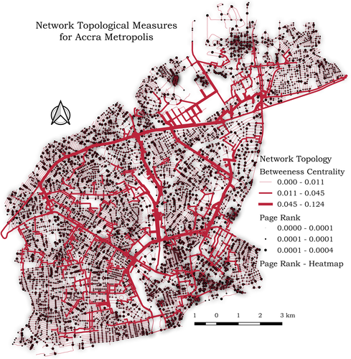

**Figure 3.1**. Graph theoretic model of Accra metropolis showing different topological and geometric features of the street network

*Source : Adapted from* (Dumedah & Garsonu, 2021b)

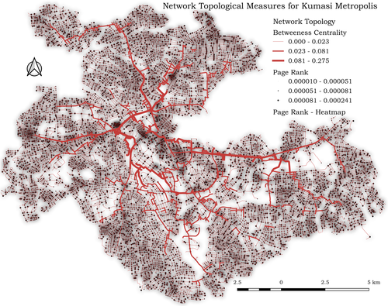

**Figure 3.1**. Graph theoretic model of Kumasi metropolis showing different topological and geometric features of the street network

*Source: Adapted from* (Dumedah & Garsonu, 2021b)

## Opensource Analytical Framework

Following the approach to produce research that qualifies as open in its entirety, all tools, methodologies, and resources used to create the analysis framework are open collaborative projects and free resources gathered from the internet. OSM data is obtained and preprocessed primarily with the OSMnx and NetworkX tools. This tool allowed us to acquire political boundaries and building footprints, and download, and construct street networks into multigraphs for further analysis. In the spirit of automating and documenting the workflow involved in carrying out the analysis, a separate python module, AutoGIS (Joseph Norkplim, 2022), was created to automate the processes involved in acquiring, visualizing, and obtaining topological and geometric measures from the data. This effort was done in direct response to the paper by Boeing (2020b) urging researchers to engage some of their efforts in building new tools and documenting existing ones to make the analytical landscape a more approachable one for the younglings in the field and break the dependence on firms who own most of the existing proprietary tools used in geospatial analysis.

All tools integral to the research include; 1. NetworkX, a python language package for exploration and analysis of networks and network algorithms, (Hagberg et al., 2008) was fundamental to a lot of the street network analysis that was undertaken and algorithms used. 2. Geopandas and Pandas, open source data analytics tools for fast and programmatic manipulation of data both geospatial or otherwise (Jordahl et al., 2019). 3. Jupyter notebook, another open source tool that provides a fully hosted in-browser python execution environment that facilitates the sharing of code snippets, workflows, data, and visualizations detailing the research process. It features a virtual lab environment for computational analysis and a community that actively develops, documents, and updates it to what is considered standard in the data analytics landscape (Boeing, 2019b; Randles et al., n.d.). 4. Matplotlib, a portable 2D plotting and imaging python package aimed primarily at the visualization of data (Barrett et al., 2005). At the heart of all these opensource tools is Python, a Turing Complete, general purpose, dynamically typed, interpreted, high-level programming language that for its expressiveness—due to its lux type system—is useful in the modern data analytics framework (Ayer et al., 2014; Van Rossum & Drake Jr, 1995).

For downloading and pre-processing of geospatial data, the autogis tool is responsible for taking coordinates or place names of the study area (mostly embedded in a CSV file) it geocodes the place names to coordinates or reverse-geocodes the coordinates to get the place names and then proceeds to use OSMnx to download and construct the street network graph of the specified areas. With the use of the Matplotlib tool, AutoGIS is capable of both interactive and static plotting of geographic coordinates in any CRS (Coordinate Referencing System). OSMnx uses the NetworkX tool to correct most of the anomalies that appear in representing geospatial data as multigraphs, it does these corrections by removing points along curves that separate single streets into multiple edges (Boeing, 2017a). All these are done under the hood and the process is not visible to the third-party user. Consequently, the output of all this work produces a graph-theoretic representation of the street network of the study areas, that we derive meaningful insights. All the processes, data, tools, and processes are completely documented, reproducible and open to the general public in the public repository specified in the reference (Joseph Norkplim, 2022).

## Measures of Network Topology and Geometry

The morphological and design properties coupled with the network's topology and its design have a great effect on the functioning of the network and how efficient the network is in its performance. And since street networks are the backbone of things flowing through space, the entire urban infrastructure is affected if the street network is affected. It is, therefore, necessary that the topological configuration, connectedness, robustness of the network, and its geometry—which is a concern of its design and placement in space—are measured and insights drawn from such measurements to guide the continuous development of the entire urban infrastructure (Boeing, 2018a; Sharifi, 2019).

From existing literature, the basic topological measures include the measures of density, connectedness, length, degrees of nodes, and edges in the graph-theoretic representation of the street network (Barthélemy, 2011a; Boeing, 2019c, 2020b). We measure for each network that we have, the total number of nodes and edges connecting those nodes or themselves—in the case of self-loops. The average of the node degree is calculated and indicates the connectedness of the network, higher values are indicative of a more connected graph with lots of options for turns (Yen et al., 2021). The optimal functioning of street networks hinges on the number and connectedness of nodes and edges (whether they are fine-grained or coarse-grained), their capacity, and how they are connected as Sharifi (2019) argues.

When talking about the topology of a network, centrality, and connectivity are major interwoven measures that are important to understanding how the network functions (or at the very least speculating it). Centrality is important because each node/edge in the network differs from the others, which can be a factor of its placement in space and its interaction with other elements in space, therefore there is the need to compute the importance (centrality) of each node/edge to the overall functioning of the network. A node’s degree is the number of edges incident to it (Boeing, 2017a). Therefore, the degree of centrality is used to rank nodes based on the number of edges/nodes connected (incident) to it. The more connected a node is to other nodes in the network, the higher its degree of centrality in the network. Other measures of centrality include betweenness centrality, closeness centrality, information centrality, and straightness centrality (Boeing, 2017a; Sharifi, 2019). The closeness centrality of a node is indicative of the time and distance required to reach other nodes (destinations) in the network assuming it is the source. It is essential to consider closeness centrality when making decisions about the location and accessibility of amenities and services (Sharifi, 2019). Betweenness centrality, on the other hand, is an indication of how many shortest paths pass through a certain node, this measure is particularly indicative of how central the nodes to the network. The higher the betweenness centrality of a node, the higher the number of shortest paths passing through it, which implies how central it is to commute behaviors as most rational commuters will pick routes that get them to their destinations in less time. An unevenly distributed betweenness centrality is indicative of a fragile network, one that when node(s) with high betweenness centrality fail (or are removed), the network breaks, and things come to a halt in the system (Boeing, 2020b; Sharifi, 2019).

Connectivity measures are used to examine the functionality of the street network under normal and/or in emergencies (Sharifi, 2019). The node connectivity of the network is indicative of how resilient the network is, especially concerning the minimum number of nodes to remove from the network to disconnect the network (Boeing, 2017a) and the same goes for the edge connectivity, it is the minimum number of edges to remove from the network to disconnect it and render it useless. A well-connected street network is expected to facilitate smooth origin-destination flow, reduce travel distance, and improve access to services, employment, and utilities; people often have a perception of certain trip length thresholds when making decisions to walk, bike, or drive (Sharifi, 2019). Consequently, having redundant connections (alternative routes) in the network is helpful to maintain the state of the network in the case of emergencies. Other measures of connectivity include intersection density—the number of nodes per unit area, the average distance between intersections, and characteristic path lengths. It is to be noted that, street patterns have a significant bearing on how connected the network is (Barthélemy & Flammini, 2008; Boeing, n.d.; Sharifi, 2019).

Other important topological and geometric measures extracted from OSMnx using the autogis tool are presented and summarized in Table 1, which is adapted from Boeing and Dumedah & Garsonu (2017a; 2021b). Emphasis is placed on network topological measures like clustering, which measures how strongly connected a network is (Boeing, 2017a). Consequently, the averages of nodes and edge degrees, connectivity indices, intersection densities, PageRank and centrality, and measures of street design intricacies like network patterns, area of the network, and block sizes are taken into consideration in the analyses because of how important they are to understanding the street network in all of its totality (Boeing, 2017a; Sharifi, 2019). It is to be noted that all metrics and measures are extracted from a planar graph model of the street network in the selected study areas.

**Table 3.1**. Descriptive statistic measures of topological and geometric network features used to evaluate street networks

|  |  |
| --- | --- |
| **Metrics and Measures** | **Description** |
| Area | The total area that the network covers |
| n – number of nodes | Number of nodes in the network |
| m – number of edges | Number of edges in the network |
| Proportion and count of streets per node | Number of streets incident to each node and the ratio of edges to each node |
| Average Street length | The average length of edges in the network, which is a proxy for block size |
| Intersection density | The ratio of the number of intersections to the total area of the network |
| Node/Edge densities | The ratio of total counts of nodes/edges to the area of the graph; is indicative of whether the network is fine-grained or coarse-grained |
| Average street per node | Average of the number of streets emanating from each node |
| Average circuity | The ratio of network distance to Euclidean distance (its inverse is directness); is a proxy for how long and complicated routes in the network are. |
| Self-loop proportion | The proportion of edges that have a single incident node. |
| Diameter/Radius | Maximum/minimum distance from a node to all other nodes in the network. |
| Degree Centrality | The average number of nodes that a node is connected to; is used to rank the importance of each node in the network. |
| Node/Edge connectivity | The minimum number of nodes/edges that have to be disconnected to disrupt the flow of information in the network. |
| Clustering Coefficient | The extent to which a node’s neighborhood (edges and nodes incident to it) forms a complete graph; high values are indicative of a self-sufficient and strong network structure. |
| Betweenness centrality | The proportion of shortest paths passing through the node; is indicative of node importance in the network. |
| Closeness centrality | The average distance from a node to all other nodes in the network. |
| Page rank | Ranking of nodes based on the structure of incoming edges. |

*Source: Adapted from* Boeing (2017b, 2019a) and Dumedah & Garsonu (2021a)

## Variables and Data Collection

The research starts out seeking to understand the current tool landscape as used in similar literature, one of its most salient objectives is to identify ways in which to secure free spatial data and tools for analytics. As put forward by Boeing (2020b) and Fleischmann et al., (2021), the current tool landscape of geospatial data analyses is dominated by point-and-click GIS tools (e.g. QGIS and ArcGIS) that do not take full advantage of the computational power that current computer systems come with, this is not to say they are not important. But they require more time to operate, are proprietary and difficult to document, and lack any form of comprehensive automation capabilities (especially for inexperienced people who are just starting out in the field). This raises the bar of entry for interested people both in policy and in research and limits the usability of these tools especially in this era of big data. Consequently, these limitations led the author of this work to contribute to developments in the field by creating and documenting tools that can be built upon by researchers and policymakers in the pursuit of studying urban street network form and structure. Graph theory as is employed by most studies involved in acquiring a modern intuitive view of spatial networks—of which street networks are an integral part—is the backbone of the current literature (Barthélemy, 2011b; Boeing, 2017b, 2019b, 2020d, 2021; Brede, 2012; Corcoran et al., 2013; Dumedah & Eshun, 2020; Dumedah & Garsonu, 2021b).

Constructing a graph model of street networks is no small feat and the use of tools that make it hard to automate the processes involved make it harder for interested people who are not well vexed in the mathematical and computational rigor required to do such work. The criteria for selecting the tools used in this research was 1. Tools that are free and open-source 2. Tools that do not require domain specific knowledge in computer science or mathematics; because tools like this are harder to work with. 3. Tools that are programmatic and easy to automate. 4. Tools that do not require any kind of special hardware to use; there are some analysis tools that require the use of GPUs (Graphic Processing Units) instead of CPUs (Central Processing Unit) to ran any kind of efficient analysis. 5. Tools that are more suitable for spatio-temporal network analysis. Considering the above criteria, only QGIS (Development Team, 2009) (and its network analysis tools) and Python—specifically OSMnx and NetworkX—make the cut as free and open-source tools (or ecosystems) used in the geospatial network analytics landscape. Based on google search indexing, searching for the keyword “geospatial network analysis tools” almost always yields a front page result listing ArcGIS Pro, a proprietary software package for geospatial analysis and ESRI, the company that creates, documents, updates and owns the software. It is almost as if the term geospatial analysis is synonymous with ArcGIS or other GIS related tooling. Point-and-click GIS tools were disqualified based on the premise that they are harder to automate and documentation and usability does not nearly reach the level that Python tools can boast of (Ayer et al., 2014; Boeing, 2020d). And because python is an open-source project, voluntary contributions to its usability and documentation make it an easy tool to learn and use. According to the TIOBE index, Python is the most popular programming language in the world, the criteria for this ranking is based on assessing the results of searches on the language, tooling, skilled engineers, courses (and documentation) and third-party vendors. It is also relatively easier to learn the python programming language as resources are numerous and available in various languages and formats, most of which are also free and open-source.

### Spatial Data Collection and Analysis

The study sites total six urban neighborhoods located in Accra and Kumasi, three from each district. To collect the data, 0.7 km2 bounding boxes are defined from randomly picked points in the various districts and the street network extracted from within the bounding boxes (see Figure 3). It is noted that these study sites are small and do not conform to local boundaries in their respective districts, but on a small scale are useful for visual comparisons of spatial variables inherent in network structure and configuration (Boeing, 2017a). Next, the autogis tool using the OSMnx python package downloads and constructs the directed street network graph of each selected site, projects them in the correct CRS (which is automatically determined at runtime) and plots them. It then proceeds with the NetworkX python package to calculate network topological and geometrical measures summarized in Table 1 for each graph model generated for every study site and aggregates them for further analysis and processing. These network variables are used to compare and contrast how different planning regimes and geographic features affect the structure of networks in different locations. The study identifies which districts possess more fine grained networks and which possess more coarse grained networks and how network patterns affect the functioning and resilience of the network (Sharifi, 2019).

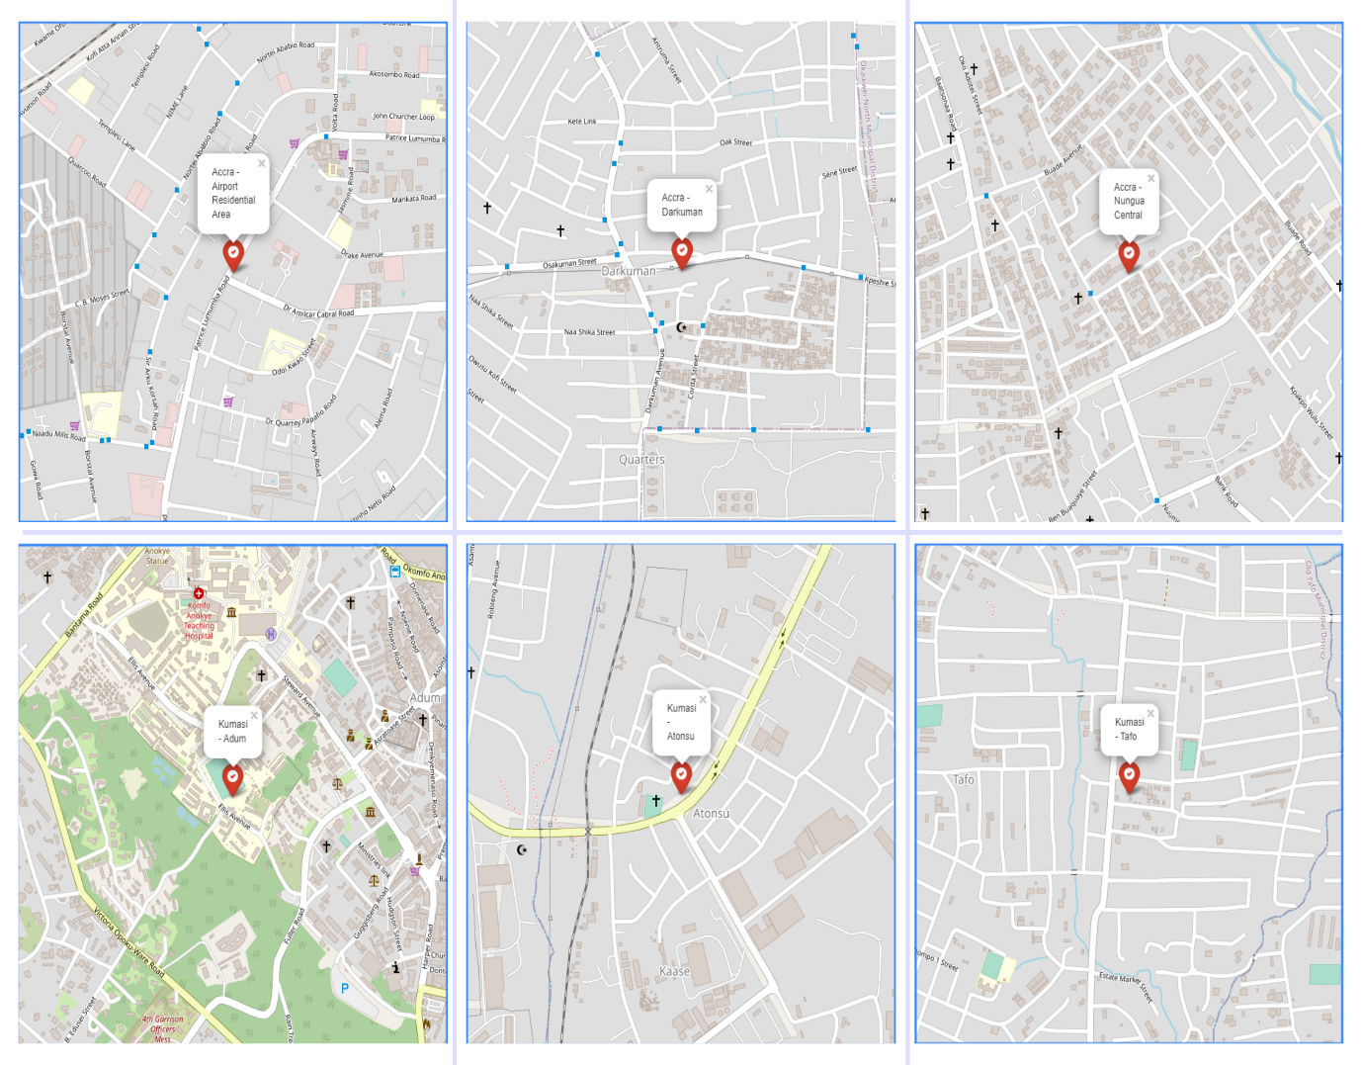

**Figure 3.2**. Six 0.7 km2 sections of street network from selected study regions

*Source:* Joseph Norkplim (2022)

# CHAPTER FOUR PRESENTATION OF STUDY RESULTS AND DISCUSSIONS

## Introduction

This chapter presents the various topological and geometric statistical indicators that characterize street networks extracted from the respected study neighbourhoods. It points out the differences and similarities between the street networks from the selected study sites (Airport Residential Area, Darkuman, Nungua Central in Accra and Adum, Atonsu and Tafo of Kumasi), their implications on urban form and critical infrastructure, and suggest solutions to some shortcomings identified from network structure and street patterns. It continues to advocate for conducting free and open research, publishing the data analytics framework, data, tools, and methodologies used in the study as an open source project.

## Morphology of urban street networks in study areas

Urban morphology is the study of the things and processes that make up the environment, from geography, and architecture to the social sciences, understanding how humans interact in the spaces they live in involves trying to understand firstly, the form and structure of spaces they live in and the choices underlying the creation and transformation of such spaces. Simply put, it is the study of urban form and structure. A brief visual morphological description of the network structure of streets from selected study areas is presented in **Figure 4.1**, the visual depictions of street form and structure make it easy to detect patterns of street networks in the selected study areas. The street network graphs (depicted in **Figure 4.1**) are constructed by defining 0.7 km2 bounding boxes around coordinates picked randomly from urban neighbourhoods in Accra and Kumasi in the same fashion as used in the literature from Barthélemy & Flammini, (2008) and Boeing (2017) and extracting the graph and indicators using open source tooling and methodologies described in the previous chapter.

As Dumedah & Garsonu (2021) point out, the grid is more prevalent with a branching structure at the local scale than any other pattern in most networks in Ghana. The grid is usually indicative of a more connected network. Other characteristics include short street segments with multiple interconnections coupled with short routes which improve the resilience of the network in emergencies (Sharifi & Yamagata, 2018). The characteristic network pattern that can be seen from each of the graphs is a coarse grid with multiple dead-ends at the local scale. The Adum network has the characteristic radial pattern of a typical Kumasi street and this is because it is in the central part of the metropolis—most of the major streets seem to be emanating from Adum outwards or they converge at Adum depending on the scale at which you view it. Networks selected from Accra can be said to be more gridded and of a finer grain than networks from Kumasi and more intersections improve the resilience of the network. Consequently, it can be said that the networks from both regions are moderately fine-grained networks, indicative of areas with relatively better planning regimes especially in Accra since it is the national capital of Ghana. Major streets from Airport Residential Area, Accra, have characteristic parallel street segments with relatively fewer connections and dead-ends on the local scale. It depicts a kind of branching structure that is not as thorough and fine as that of Darkuman and Nungua Central; these two are of a finer grid than the Airport Residential Area’s network, they also have more interconnections between street segments. The characteristic network pattern of the Kumasi study areas slightly differ from one another, the Adum network is of the characteristic radial pattern as it is at the core of the metropolis. Atonsu features a characteristic diverging tail pattern with a coarse grid pattern on the local scale, also characterized by dead-ends. Tafo on the other hand features a moderate grid similar to networks from Accra.

The average street length which is also used as a proxy for block size (Boeing, 2017a) is 73m in Airport Residential Area, 86m in Darkuman, 89m in Nungua Central, 70m in Adum, 109m in Tafo, and 92m in Atonsu. It is not surprising to see Atonsu and Tafo with the highest block sizes as the network structure is characterized by a diverging tail for Tafo with branching at the local scale and a coarse grid with more spaces for Tafo which is characteristically less resilient than the finer grid (Sharifi, 2019). Though all the networks are somewhat gridded, there is a subtle difference in the structure of each of the grids characterizing each of the respective study areas; Airport Residential Area has curvilinear streets with branching at the local scale, Darkuman, Nungua and Tafo have a kind of uneven grid with dead-ends at the local scale and Adum with its characteristic radial pattern with clustering at the eastern part of the network. Also, an average node in each of the study areas (both in Accra and Kumasi) has 3 edges emanating from it, this speaks more to the similarities between the networks than differences—they are subtle and are factors of layout and topography than anything else (Dumedah & Garsonu, 2021a).

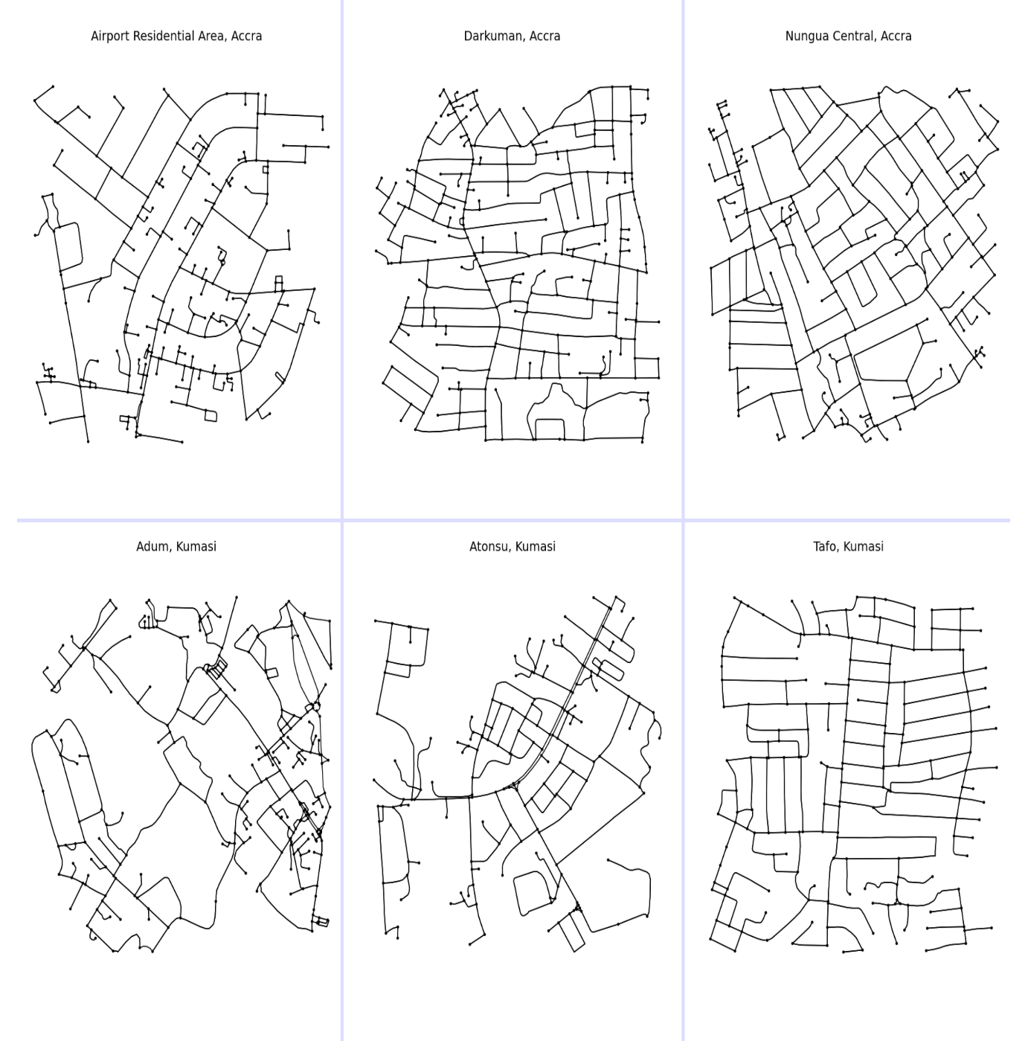

**Figure 4.1**. Six 0.7 km2 sections of street network from Accra (top half) and Kumasi (bottom half)

*Source:* Joseph Norkplim (2022)

## Network Connectivity

Seeing as the study areas happen to be the most populated cities and neighbourhoods in the country, we sample intersection and density metrics from both cities and the respective study areas to see how dense and connected each network is. Intersection density is the total number of intersections per unit area of the network (in our case per km2 of network area). More connected networks have a higher intersection density and contribute to the resilience and redundancy of the network (Barthélemy & Flammini, 2008; Sharifi, 2019). It is noted, a highly connected network facilitates the smooth flow of information between nodes/edges. From the statistical measures in **Table 4.1**, the intersection density in Airport Residential Area is 99.219 intersections per km2, 115.546 intersections per km2 in Darkuman, 114.528 intersections per km2 in Nungua Central, 120.312 intersections per km2 in Adum, 83.103 intersections per km2 in Tafo, and 82.124 intersections per km2 in Atonsu, with Adum’s intersection density greater than all the others, although the difference in density counts are not that different considering all the networks. It is typical to have the more finely grained and gridded networks with a higher intersection density than other patterns specifically the diverging tail structure and the radial pattern, which is not the case here. And that is because the Adum network is made up of the best of both network patterns, a radial pattern emanating from the core of the network with a branching and grid-like pattern on the local scale, this results in shorter street segments and frequent intersections at the local scale providing the network with a better capacity to adapt in emergencies (Sharifi, 2019). Comparatively, all networks are of moderately high connectivity (Boeing, 2017b) comparable to networks from the literature.

Consequently, all the encompassing networks have a high concentration of 1-way intersections and an even higher concentration of 3-way intersections. 2-way and 4-way intersections are not as prevalent in the networks, though there is a fair amount of 4-way intersections than 2-way intersections—which are almost non-existent—in the networks. This is a good thing as connectivity is improved with more intersections, 1-way streets typically result in less connected networks that are prone to breakdowns in emergencies and fewer choice routes for commuters (Boeing & Riggs, 2022; Sharifi, 2019). From the related literature, it is stated that more connected networks come with health benefits as they typically promote walkability by their characteristically smaller block sizes resulting in short pedestrian trips and encouraging active commuting with improved access to amenities and services (Sharifi, 2019).

**Table 4.1**. Statistical results for six street network sections from Accra and Kumasi

|  |  |  |  |  |  |  |
| --- | --- | --- | --- | --- | --- | --- |
| **Indicators** | **Accra** | | | **Kumasi** | | |
| **Airport Residential Area** | **Darkuman** | **Nungua Central** | **Adum** | **Tafo** | **Atonsu** |
| n - number of nodes | 245 | 272 | 250 | 278 | 185 | 180 |
| m - number of edges | 543 | 654 | 610 | 618 | 462 | 415 |
| Total edge length (km) | 39.576 | 56.163 | 53.954 | 44.780 | 50.352 | 38.639 |
| Avg edge length (m) | 72.884 | 85.877 | 88.449 | 72.459 | 108.988 | 93.105 |
| Avg street per node | 2.359 | 2.570 | 2.600 | 2.572 | 2.692 | 2.611 |
| Intersection count | 162 | 201 | 198 | 211 | 148 | 141 |
| Total street length (km) | 19.869 | 28.082 | 26.977 | 23.636 | 25.176 | 20.341 |
| Street segment count | 274 | 327 | 305 | 338 | 231 | 222 |
| Avg street length (m) | 72.514 | 85.877 | 88.449 | 69.928 | 108.988 | 91.627 |
| Avg circuity | 1.067 | 1.037 | 1.051 | 1.085 | 1.044 | 1.121 |
| Self-loop proportion | 0.004 | 0.000 | 0.000 | 0.000 | 0.000 | 0.000 |
| Clean intersection count | 118.000 | 159.000 | 154.000 | 118.000 | 127.000 | 98.000 |
| Node density (per km) | 150.054 | 156.361 | 144.606 | 158.515 | 103.879 | 104.840 |
| Intersection density (per km2) | 99.219 | 115.546 | 114.528 | 120.312 | 83.103 | 82.124 |
| Edge density (km/km2) | 24.230 | 32.286 | 31.208 | 25.533 | 28.273 | 22.505 |
| Street density (km/km2) | 12.169 | 16.143 | 15.604 | 13.477 | 14.137 | 11.848 |
| Clean intersection density (km) | 72.271 | 91.402 | 89.077 | 67.284 | 71.311 | 57.079 |
| Number of 1-way intersections | 83 | 71 | 52 | 67 | 37 | 39 |
| Number of 2-way intersections | 0 | 0 | 0 | 1 | 0 | 0 |
| Number of 3-way intersections | 156 | 176 | 194 | 194 | 131 | 133 |
| Number of 4-way intersections | 5 | 25 | 4 | 16 | 17 | 8 |
| Mean of avg neighbor degree | 2.661 | 2.809 | 2.748 | 2.591 | 2.883 | 2.595 |
| Mean of avg weighted neighbor degree | 0.094 | 0.045 | 0.044 | 0.064 | 0.032 | 0.041 |
| Avg degree centrality | 0.018 | 0.018 | 0.020 | 0.016 | 0.027 | 0.026 |
| Avg clustering coefficient | 0.027 | 0.006 | 0.008 | 0.058 | 0.010 | 0.067 |
| Avg weighted clustering coefficient | 0.004 | 0.001 | 0.001 | 0.007 | 0.001 | 0.006 |
| Max pagerank | 0.010 | 0.009 | 0.009 | 0.009 | 0.011 | 0.013 |
| Min pagerank | 0.001 | 0.001 | 0.001 | 0.001 | 0.002 | 0.001 |
| Diameter (km) | 2.664 | 2.716 | 2.418 | 2.776 | 2.894 | 2.851 |
| Radius (km) | 1.570 | 1.423 | 1.373 | 1.488 | 1.511 | 1.428 |
| Avg closeness centrality | 0.001 | 0.001 | 0.001 | 0.001 | 0.001 | 0.001 |
| Avg betweenness centrality | 0.051 | 0.049 | 0.051 | 0.057 | 0.064 | 0.065 |

*Source:* Joseph Norkplim (2022)*;*

## Network Centrality

To understand street network structure and form and how they affect human decisions in space, we have to understand that all components of the network are different, and how they differ depends on how they are laid out in space, their neighbourhood (other components incident to it) and how it interacts with its neighbourhood. Thus, it is essential to rank nodes/edges—the main constituents of a street network graph—to obtain the centrality (the ranking of importance) of nodes/edges in the system. Several measures of centrality exist and have been used in the existing literature (Barthélemy, 2004, 2011a; Barthélemy & Flammini, 2008; Boeing, n.d., 2018c; Dumedah & Garsonu, 2021b; O’Sullivan, 2014; Sharifi, 2019; Yen et al., 2021; Zhao et al., 2019) extensively, because of its importance for understanding the network’s form and functional relationship between nodes/edges and the critical roles they play in the network. From **Table 4.1**, the statistical measures of centrality that this study concentrates with include betweenness centrality, closeness centrality, PageRank, and degree centrality. These measures give insight into how connected and thoroughly configured the street network of a particular place is. Highly central nodes/edges in the system are priority elements and have to be given special attention and planned properly against failure, the disruption of central elements in the graph results in sometimes catastrophic chain reactions in the network (Sharifi, 2019). For instance, a highly central edge that is located in a disaster-prone area (e.g. in a floodplain) can result in a catastrophic break in the network and disrupt flow should that disaster strike. It is therefore extremely necessary that planners and policymakers work together to protect, strengthen and make central nodes/edges redundant and resilient in anticipation of future phenomena that may or may not occur. The statistical indicators quantify what we can see qualitatively by plotting these variables on the street network graph for visual inspection. We take a closer look at each of the measures of centrality in the following subsections.

### Degree and Closeness centrality

Closeness centrality indicates how close a node/edge is to all other nodes/edges in the graph, hence the “closeness”. Sometimes called the geodesic distance, it ranks network elements based on how short the distance is between the element and other elements in the graph. The importance of this particular measure lies in its ability to identify specific nodes that control (or at the very least play a central role) in facilitating the flow of information through the network. **Figure 4.3**, which shows the spatial distribution of closeness centrality of each edge in each network of the selected study areas, shows that the highly central nodes which are depicted by lighter colour (see **Figure 4.2** for colormap of the graphs) are all situated in the core of the network and emanate outwards towards the least central nodes. Networks selected from Accra seem to have a lighter colored outer graph (which is indicative of high closeness centrality) than their counterparts selected from Kumasi. But on average, the closeness centrality index of each selected area (from Table 1) is 0.001 which shows that the closeness centrality of the network regardless of whether situated in Accra or Kumasi is relatively the same for all areas. This also translates to the fact that the more accessible edges in the network are located at the core of each neighbourhood and accessibility decreases as you move outside the neighbourhood. This is not surprising, as there are usually more development efforts hence greater densities in the core of neighbourhoods than in the outskirts. Also, it is the development of the urban core that attracts more people to these areas, the classic case of cause becoming an effect. It is therefore advisable that planning efforts in these neighborhoods focus some of their attention on the network periphery, improving accessibility to the outer part of the neighbourhood and its environs to facilitate flow to these parts and also to create a more redundant, resilient, and loosely coupled network that is resilient against disasters. To augment the resilience of urban form in terms of accessibility, it is essential to consider closeness centrality when making decisions about the location of services and amenities (Sharifi, 2019).

Degree centrality ranks nodes based on how many connections they have. Many streets in most urban areas are characterized by moderate node degrees for most nodes in the network and few nodes with very high degree centralities (Sharifi, 2019). On average, nodes in Airport Residential Area, Darkuman, Nungua Central, and Adum have 3 edges emanating from them, which is not surprising seeing as 3-way intersections are dominant in these areas. On the other hand, Tafo and Atonsu in the Kumasi metropolis register an average of 3 streets emanating from each node in the network. Consequently, this measure is useful in less connected graphs to find nodes with an unusually high degree of centrality, because a failure in such nodes results in equally catastrophic damage to the network (Boeing, 2018c; Sharifi, 2019).

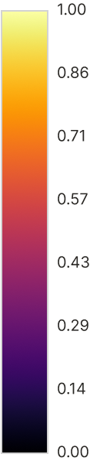

**Figure 4.2**. Colormap for interpreting centrality visualization of the street network graphs.

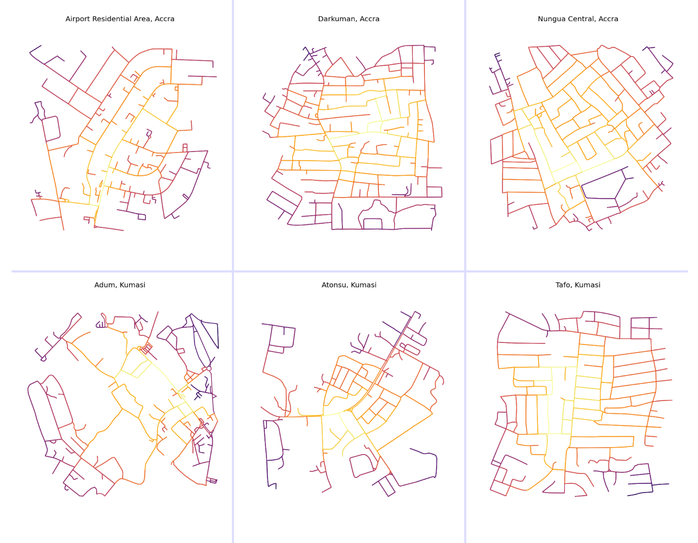

**Figure 4.3**. Sections of street network graph showing closeness centrality of edges.

*Source:* Joseph Norkplim (2022)

### Betweenness centrality and PageRank

Betweenness centrality is an important measure used to rank nodes/edges on their relative importance in the network, taking into consideration the number of shortest paths that pass through the node/edge. Thus, the node that appears most, in all shortest paths of the network is the node with the highest betweenness centrality. From Table 1, the average betweenness centrality indicates that 5% of all shortest paths pass through an average node in Airport Residential Area, Darkuman, and Nungua Central in Accra. On the other hand, in Kumasi, 6 % of all shortest paths pass through an average node in Adum and Atonsu, and 7% in Tafo. Once again, these values do not vary much from each other. There are more similarities between network structures than there are differences. The spatial distribution of betweenness centrality for each node in the system provides slightly different lenses with which to view the betweenness centrality of each study site. From **Figure 4.4**, the spatial distribution of nodes with the highest shortest paths is located as usual at the core of most of the networks with few nuanced differences between each.

Nodes of high betweenness centrality in the Airport Residential Area are more concentrated slightly south of the urban core with fewer central nodes at the fringes as usual. This is great for economic purposes; more central nodes concentrated around the same place generate more traffic and hence are more economically viable for businesses but an uneven distribution is not good for resilience (Sharifi, 2019). Something slightly similar is prevalent in the Darkman street network too, the most central nodes (in lighter colors, **Figure 4.2**) are concentrated along the same edge—running north to south—which is also good for business but bad for resilience. The destruction of a single node in the middle might result in a catastrophic chain reaction in the network. Nungua Central, on the other hand, features a betweenness centrality distribution that is relatively evenly distributed in the network. This is characteristic of a more resilient network, one where highly central nodes appear at multiple places, at the eastern, north-western, and southern fringes of the network. Nodes in Kumasi follow the same pattern as Darkuman and Airport Residential Area network, in that, highly central nodes are concentrated at a single core of the network, it can be spotted in Adum in the eastern core of the network, central core in Atonsu (also running along the same edge as in Darkuman) and in Tafo also along the same edge running north to south. Boeing, (2017a) points out that, more important nodes are usually concentrated at the center of the more grid-like networks which can be seen in **Figure 4.4**, except for Nungua Central’s street network graph which features a more even spatial distribution of betweenness centrality. Darkuman and Tafo networks are more prone to disruptions if one of their most important nodes fails, seeing as they are located along the same edge.

PageRank (Page & Brin, 1998) (a sub-variant of the eigenvector family of centrality algorithms) developed by the founders of Google to rank hypertext links have found its effective use in the spatial network analysis literature (Barthélemy, 2011a; Boeing, 2017a; Chin & Wen, 2015). It ranks nodes/edges based on not only its connections but also the structure, configuration, and connections of incoming nodes/edges, it is also suited for directed graphs—street networks and other spatial networks. It simply ranks nodes/edges based on their connection and the connections of nodes/edges connected to it. This measure is useful for finding nodes that are central to the network not based on only their connectivity but also the connectivity of its neighbourhood, higher values of PageRank indicate nodes that are highly influential to the flow of information through the system. The maximum PageRank recorded for each network ranges from 0.009 to 0.013 for all study sites and the minimum PageRank ranges from 0.001 to 0.002 (**Table** **4.1**). **Figure 4.5** provides a visual representation of the spatial distribution of the relative PageRank of nodes in each of the networks extracted for each study area, it provides more insight into the ranking of each node relative to its graph. One thing that is notably evident is that unlike the other centrality measures PageRank for all nodes is fairly distributed in the respective networks of each study area. This is because there are dead-ends (which have relatively lower PageRank) prevalent at the local scale which prevents a lot of the core networks from having more structured neighbourhoods—in the graph-theoretic sense—resulting in lower PageRank. Since the influential nodes based on PageRank are dispersed in the network, it does not have a single point of failure which is good in emergencies (Sharifi, 2019).

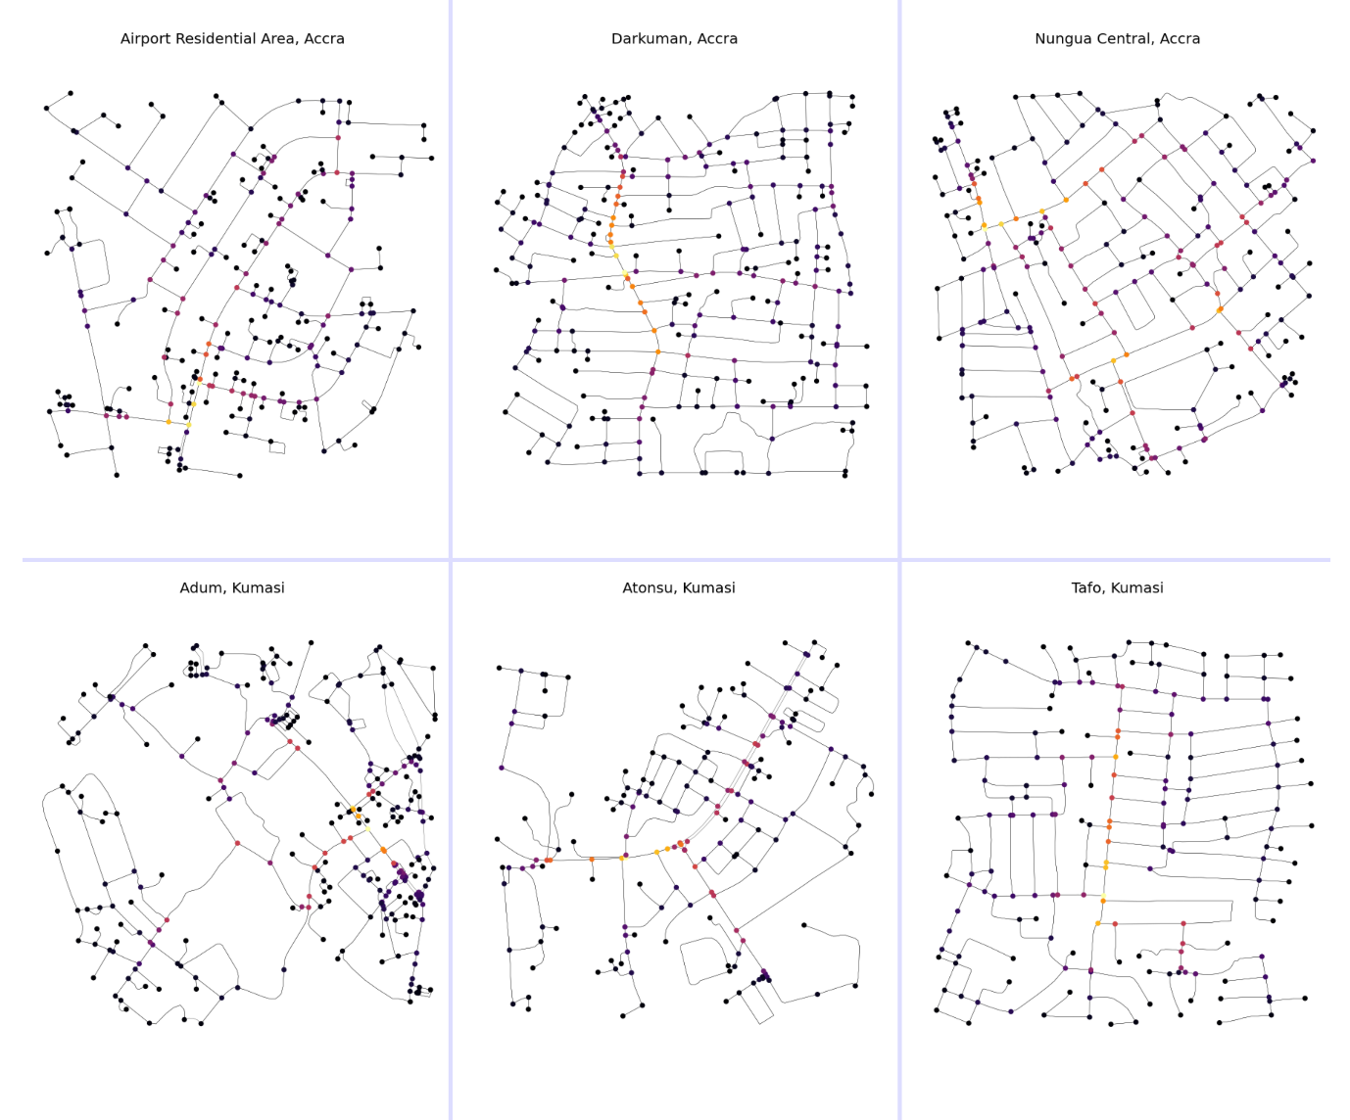

**Figure 4.4**. Sections of street network graph showing betweenness centrality of nodes.

*Source:* Joseph Norkplim (2022)

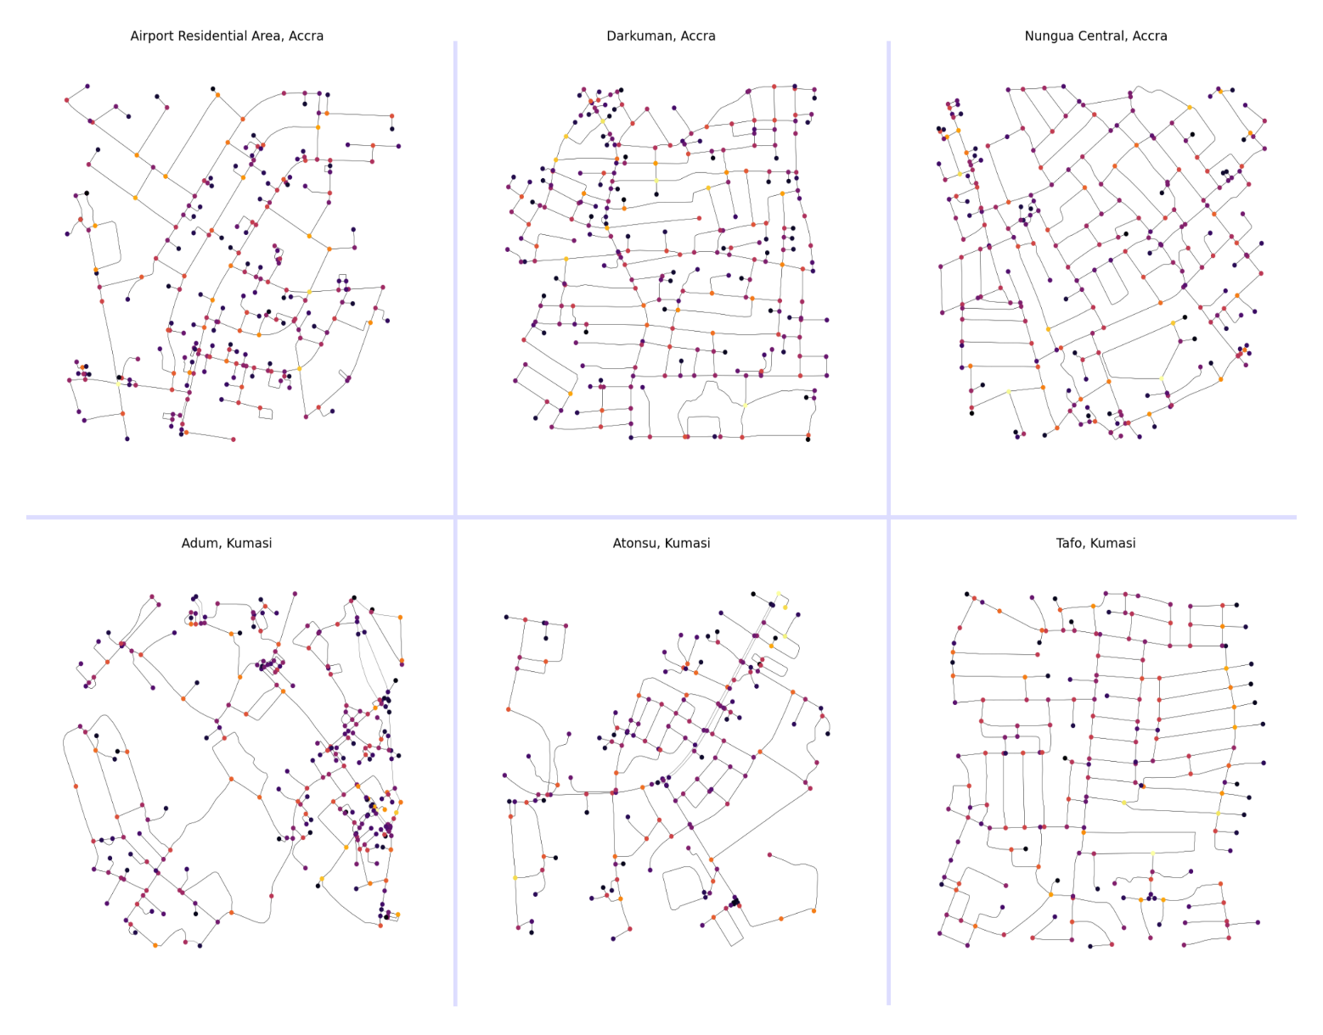

**Figure 4.5**. Sections of street network graph showing relative PageRank of nodes.

*Source:* Joseph Norkplim (2022)

## Open Source Tool Building in the Context of the Analysis

Although the advancement of modern technology has enabled an increase in the capabilities and usability of computation machines and tools, the current landscape of tools used in analyzing urban form seems to be inconsistent with changes in technology (Fleischmann et al., 2021b). Most researchers interested in computational aspects of quantitative geography, land-use planning, architecture, or any kind of spatial analysis-enabled field depend on tools and methodologies developed by big for-profit firms, most notably ESRI (with product ArcGIS) which is not only proprietary but also not multiplatform—does not run in multiple operating environments—the available open source tooling for spatial analysis (QGIS) lacks in the documentation and has a relatively smaller user base (Boeing, 2020d). It is the author's experience that most undergraduate students will never get to learn about computational tools for spatial analysis—the kind employed in this study—beyond ArcGIS or QGIS because they are, for the most part not in the curriculum and so are not taught in the classroom. Most of these tools are reserved for use by only those well vexed in the technologies, mostly computer scientists and mathematicians, who are depended on to create the tools and algorithms needed for quantitative geospatial analysis. Since it is also the case that to use these tools one would have to have some preliminary knowledge of mathematics and computer science, the barrier to entry is raised a bit higher (Boeing, 2020d; Fleischmann et al., 2021b).

Thus, it became a necessity to engage in building the tools and framework without which this research will be lacking in reproducibility and documentation. All tools used and those created as a result of this study have more computation capability, use Turing-Complete and programmable tools, are multiplatform (i.e. supports multiple operating environments), free and open source, and are more documented than the traditional point-and-click tools that dominate the spatial analysis landscape. These tools not only enable reproducibility but also enable the easy sharing of research data and work. As such, all data, code, and documentation are freely hosted in a public online repository that can be assessed at Ref (Joseph Norkplim, 2022).

## Discussion

Spatial network analysis currently suffers from the lack of tools and proper methodologies for the empirical study of street networks as stated by Boeing (2017b), this problem can be said to exist on a larger scale in Ghana where street networks are not usually studied using any kind of computational or analytical tools before changes are made in the networks (Dumedah & Garsonu, 2021a). The shortcomings result in poorly informed decisions in transport planning efforts which in turn affect the sustainability of street networks in Ghana. It is also noted that performing spatial network analysis on street networks in Ghana is challenging because of the lack of agencies to provide geospatial data for analysis and research (Dumedah & Garsonu, 2021a). It was, therefore, necessary that to undertake such a study, data had to be extracted from a freely available source using free tools to make the point that studies like this can be done on a larger scale to study street network variables that will be harder to examine without the use the methodologies adopted for this study.

Modern Spatial data science is the backbone of the study, all tools and methodologies are computational methods that evolved from data science tooling of the open source Python community. It was also necessary to create a framework—which is a continuous project consisting of code, data, and documentation—as advocated by Boeing (2020). The tools allowed us to extract topological measures as well as metric measures of street networks of the defined study areas. It also allowed for the visualization of different centrality indices which are valuable for assessing the connectivity and resilience of the street networks. This effort also helped us to visualize street network patterns that characterize our study areas.

Networks defined for the analysis comprise neighborhoods from Accra (Airport Residential Area, Darkuman, Nungua Central) and Kumasi (Adum, Atonsu, and Tafo). From these areas, the street network graph was constructed and different topological and geometric measures were extracted using open source tools and data. A quantitative view of the network is represented by statistical variables presented in **Table 4.1** and the appropriate and qualitative visualizations are generated and plotted in the figures. It was found that the street networks in each of the urban neighborhoods studied are more similar than they are different, they are characterized by similar patterns with some nuanced differences as a result of topography and layout as studied by Dumedah & Garsonu (2021a). The grid pattern is prevalent at the local scale with few characteristic differences that affect the resilience and connectivity of the networks. Neighbourhoods extracted from Accra are moderately gridded (except for a curvilinear pattern in the Airport Residential Area with local grids) than networks from Kumasi. Accra has finer-grained networks, smaller block sizes, and less circuitous networks (Dumedah & Garsonu, 2021a). Kumasi on the other hand features a radial network with local branching in Adum, a diverging tail in Atonsu, and a coarse grid in Tafo similar to networks from Accra.

Measures of Centrality which speak more to the configuration, connectivity, resilience, and influence of network components were examined to rank nodes/edges on their relative importance to the flow of information through the network. The different centrality measures include betweenness, closeness, degree centrality, and PageRank. From the generated visualization of the various relative centrality indices, it became apparent that most of the networks' feature nodes/edges of high centrality (betweenness, closeness, and degree) clustered at the core of the respective networks. This, as stated by Sharifi (2019), is good for the economy but bad for the resilience of the network. A different thing to the aforementioned phenomena is experienced with the PageRank of the nodes in the respective study area street networks, which shows a more dispersed centrality of nodes in the network, where nodes of high centrality can even be seen along the fringes of the network (*see* **Figure 4.5**), this is indicative of the fact that influential nodes are not concentrated at a single point of the network, which is good for network resilience because in the case of emergencies multiple redundant routes exist for faster disaster response (Sharifi, 2019).

Finally, the data, analysis, and findings speak to the topology and geometry of the network but nothing about the socio-economic environment that the network affects and is affected by the networks. This in part is due to the limitation of data availability, recently mappers are trying to add richer attributes to the OpenStreetMap database namely, the height of buildings, travel times, speed limits, and street vegetation among others. A general limitation to researchers using OpenStreetMap for spatial analysis is the work is only as thorough as the data (which is crowd-funded, free, and open source). It is to be noted that, the networks in this study only consider the flow of information within the subsets that the graphs were constructed from and not the larger network—the metropolis.

# CHAPTER FIVE SUMMARY OF FINDINGS, RECOMMENDATIONS AND CONCLUSION

## Introduction

This chapter presents a summary of the findings from the previous chapter, it discusses briefly the results and some implication of these results to research and policy. It presents these summaries in line with the objectives of the study and with recommendations aimed at giving possible measures to be taken to popularize open-source research of the kind used in the study to further the development of spatial analytics landscape for street networks.

## Summary of findings

The study of street networks as shown in the study has not advanced much beyond the use of point-and-click tools for geographic analysis of street patterns and form in the context of planning and planning research in Ghana. The lack of studies and data on the subject has resulted in numerous malformed spatial interventions that do little good to the already bad conditions of street networks in Ghana (Dumedah & Garsonu, 2021a). Against this background, the study set out to look for remedy to the situation by exploring modern technological tools and methodologies that can be adapted for the study of street networks; their patterns, forms/structure and configurations in space.

It was discovered that graph theory, the branch of mathematics concerned with the study of objects and their relationships has been used in many modern studies of street network form and structure in the western world. These representations of objects and the relationships between have been adopted in the following fashion, the objects (also called node/vertex) represents points of intersections of streets and the connections (also called the edge/link) form the relationship/connection between the objects—they link them together.

A major objective of the study was to explore and locate data sources that provide free and consistent geospatial data for the creation of a automated and replicable framework for the analysis of the data. This was achieved by using the OpenStreetMap collaborative mapping platform which offers API for accessing its databases. It was found that even though OSM provides near accurate and consistent geospatial data relevant for the analysis—especially in the global south—further preprocessing is required to convert geospatial data in its raw form into a graph theoretic representation. This was achieved by adopting the OSMnx python framework for downloading and doing the mathematical convertion of street networks to network graphs that were relevant to visualizing street patterns, geometric and topological statistical as well as visual characteristics of the respective study areas. The study also advocated for the adoption of open-research methodologies, which include making use of and creating open-source tools relevant not only in research but also in policy, use of free and public repositories to distribute data, framework, documentation (and code) without which the study cannot be reproduced. Consequently, the most salient objectives led to the creation of the the AutoGIS, street network analysis package that was essential to the the analysis of these study, it provided a concise way to document and share data, code and frameworks that were adopted for analyzing street networks in Ghana.

These methodologies were used together to visualize and extract the statistical variable of street networks in six urban neighourhoods in Ghana (depicted in **Figure 4.1** and **Table 4.1**). This visual and statiscal depictions of the various networks provided insight into the topological features of the networks. The study asserts the finding of Dumedah & Garsonu (2021a) which states that most of the street networks have some semblance to the grid pattern. Though not the major pattern of all street networks, the grid is prevalent in all the study networks. Some have it at the higher scale, this are typically the more developed areas and some have it at the local level. Kumasi’s characteristic radial and branching patterns are seen in the Atonsu and Adum networks. It was found that Accra’s networks are more gridded and therefore are more redundant and resilient if compared to the Kumasi network. The difference though, does not vary much between the networks as there are more similarities in the networks than differences. To identify nodes/edges of the network that play functional roles in transmitting information in the system; betweenness, closenesss, PageRank and degree centrality values of the networks were gathered and visually explored. It was found that all the networks, the most central nodes/edges—nodes/edges with highest betweenness, closeness and degree centrality measures—were clustered along single points in the networks some (Darkuman and Tafo networks) even along parallel edges. PageRank on the other hand, depicted a network with central nodes/edges fairly dispersed in the system, this as was stated is because of multiple dead-ends in the network at the local scale. Average block sizes for the networks match with more developed street networks in related literature (Boeing, 2017b). It is also to be noted that the grids characterizing the street networks if compared to similar study done by Boeing (2017a) reveal that the Ghanaian street networks have a coarser and uneven pattern, this is due to lax planning regimes and the informality that characterizes most transportation planning efforts in the country (Dumedah & Garsonu, 2021a). There are some differences in the morphology of the networks but those are subtle and are functions of layout than anything else.

## Recommendations

To contribute to popularizing studies involving the use of open source and computational methodologies in the study of street networks in Ghana, the researcher makes the following recommendations. It also includes some salient points on how to improve connectivity and resilience of the networks.

The following recommendations are made:

1. Researchers in the spatial analysis domain especially in transportation should go extra mile of making research data public and easily accessible to allow results and findings to be verified and encourage the replication of studies across different geographic areas.
2. People involved in spatial research and policy should invest some of their efforts in building tools and documenting already existing ones to ensure the barrier to entry for these methodologies are brought lower.
3. Dead-ends in street networks at the local scale should be connected to adjacent streets to improve connectivity of these network which also improves the resilience of these networks in emergencies.
4. The periphery of most networks have low centrality (betweennes, closeness, degree) values, improvements in their connectivity will not only improve connectivity within the networks studied but also improve the connections between the network and the surrounding networks. This also results a more connected metropolitan street network system.
5. Contributions to the OSM geodata repositories by local mappers and youth organizations should be intensified and supported by institutions and the government. The provision of tools and facilities for these groups and local community efforts will go a long to ensure that more people will get interested and contribute.

## Conclusion

The study of street networks need major improvements to enable informative decision making concerning planning efforts that seek to make neighbourhoods more livable for inhabitants. The adoption of the methodologies used in this study not only contribute to a wide spread adoption in tools and methodologies but also opens up a whole new frontier for analyzing street networks and easy gathering of socio-economic variabilities in these spaces. Findings from the study make a strong case for the adoption of these methodologies; analysis was much faster and is replicatable—anybody with slight knowledge of tools can do this same study or broaden the scope even—and freely available to the public. It was found that neighbourhoods in the study communities possess a coarse and uneven grid pattern, some with branching structure at the local scale and some characterized by radial pattern—the networks in Kumasi. Most of the street networks presented by the study were not visited in person for investigation but by employing tools, geodata was extracted from OSM and a graph theoretic representation of the street network constructed from the data. The graph models provided visual and statistical insight into patterns, geometry and topology of networks in the study communities, which was studied and appropriate recommendations.

In light of the of the various limitations encountered as a result of working alone on this project usually due to the lack of adequate computational resources to broaded the scope of the study and the scarcity of data on street networks in the local literature, it became necessary to create an open source framework and I am hopeful that in the future, urban informatics laboratories that engage in street network studies of this kind but on a much larger scale to provide more knowledge and insight into the morphology of street networks in Ghana. Also contributions to the study are encouraged.

To that effect, all data, code and documentation of the project can be found at ref. (Joseph Norkplim, 2022)

## Areas of further research

To advance the study of street network, the author is hopeful that the methodologies employed in the study are adopted for studies on a broader scope that this one. With clearly defined boundaries for each neighbourhood in Ghana, the analysis framework can be employed to investigate the network structure of every urban neighbourhood in the country. This will help characterize street patterns, topological and geometric measures for each neighbourhood to understand how this intricate forms and structures affect life at every place in the country.

To build on that, simulations of flow through street networks can be run on the graph models generated for each of the networks to identify in realtime the weak links in the networks. The statistical variabilities of these simulations on each network and how they relate with patterns, forms and structure of the network can be aggregated and analysed, providing insight into how changes to the network can affect livability and socio-economic processes surrounding them.

To push this further, machine learning models can be trained on these simulations to detect and report beforehand weak links that could result in catatrosphic breaks in the network and affect flow of information through it. Studies can run multiple simulations of change of state in the network structure and record the effects of this changes on network connectivity, centrality and resilience.

# REFERENCES

Ayer, V., Miguez, S., & Toby, B. (2014). Why scientists should learn to program in Python. *Powder Diffraction*, *29*, S48-D64. https://doi.org/10.1017/S0885715614000931]

Barrett, P., Hunter, J., Miller, J. T., Hsu, J.-C., & Greenfield, P. (2005). *matplotlib -- A Portable Python Plotting Package*.

Barthélemy, M. (2004). Betweenness Centrality in Large Complex Networks. *The European Physical Journal B*, *38*(2), 163–168. https://doi.org/10.1140/epjb/e2004-00111-4

Barthélemy, M. (2011a). Spatial Networks. *Physics Reports*, *499*(1–3), 1–101. https://doi.org/10.1016/j.physrep.2010.11.002

Barthélemy, M. (2011b). Spatial networks. *Physics Reports*, *499*(1–3), 1–101. https://doi.org/10.1016/J.PHYSREP.2010.11.002

Barthélemy, M., & Flammini, A. (2008). Modeling Urban street patterns. *Physical Review Letters*, *100*(13). https://doi.org/10.1103/PHYSREVLETT.100.138702

Boeing, G. (n.d.). *Planarity and street network representation in urban form analysis*. https://doi.org/10.1177/2399808318802941

Boeing, G. (2017a). OSMnx: New methods for acquiring, constructing, analyzing, and visualizing complex street networks. *Computers, Environment and Urban Systems*, *65*, 126–139. https://doi.org/10.1016/j.compenvurbsys.2017.05.004

Boeing, G. (2017b). OSMnx: New methods for acquiring, constructing, analyzing, and visualizing complex street networks. *Computers, Environment and Urban Systems*, *65*, 126–139. https://doi.org/10.1016/J.COMPENVURBSYS.2017.05.004

Boeing, G. (2018a). Planarity and Street Network Representation in Urban Form Analysis. *SSRN Electronic Journal*. https://doi.org/10.2139/ssrn.3191236

Boeing, G. (2018b). The Morphology and Circuity of Walkable and Drivable Street Networks. *SSRN Electronic Journal*. https://doi.org/10.2139/ssrn.3119939

Boeing, G. (2018c). Urban Spatial Order: Street Network Orientation, Configuration, and Entropy. *SSRN Electronic Journal*. https://doi.org/10.2139/ssrn.3224723

Boeing, G. (2019a). *The Morphology and Circuity of Walkable and Drivable Street Networks*. https://doi.org/10.31235/osf.io/edj2s

Boeing, G. (2019b). Urban street network analysis in a computational notebook. *Region*, *6*(3), 39–51. https://doi.org/10.18335/region.v6i3.278

Boeing, G. (2019c). Urban spatial order: street network orientation, configuration, and entropy. *Applied Network Science*, *4*(1). https://doi.org/10.1007/s41109-019-0189-1

Boeing, G. (2020a). A multi-scale analysis of 27,000 urban street networks: Every US city, town, urbanized area, and Zillow neighborhood. *Environment and Planning B: Urban Analytics and City Science*, *47*(4), 590–608. https://doi.org/10.1177/2399808318784595

Boeing, G. (2020b). Planarity and street network representation in urban form analysis. *Environment and Planning B: Urban Analytics and City Science*, *47*(5). https://doi.org/10.1177/2399808318802941

Boeing, G. (2020c). Planarity and street network representation in urban form analysis. *Environment and Planning B: Urban Analytics and City Science*, *47*(5), 855–869. https://doi.org/10.1177/2399808318802941

Boeing, G. (2020d). The right tools for the job: The case for spatial science tool-building. *Transactions in GIS*, *24*(5), 1299–1314. https://doi.org/10.1111/TGIS.12678

Boeing, G. (2021). Spatial information and the legibility of urban form: Big data in urban morphology. *International Journal of Information Management*, *56*. https://doi.org/10.1016/j.ijinfomgt.2019.09.009

Boeing, G., & Riggs, W. (2022). Converting One-Way Streets to Two-Way Streets to Improve Transportation Network Efficiency and Reduce Vehicle Distance Traveled. *Journal of Planning Education and Research*. https://doi.org/10.1177/0739456X221106334/ASSET/IMAGES/LARGE/10.1177_0739456X221106334-FIG1.JPEG

Brede, M. (2012). Networks—An Introduction . Mark E. J. Newman. (2010, Oxford University Press.) $65.38, £35.96 (hardcover), 772 pages. ISBN-978-0-19-920665-0. . *Artificial Life*, *18*(2), 241–242. https://doi.org/10.1162/ARTL_R_00062

Chin, W. C. B., & Wen, T. H. (2015). Geographically modified PageRank algorithms: Identifying the spatial concentration of human movement in a geospatial network. *PLoS ONE*, *10*(10). https://doi.org/10.1371/JOURNAL.PONE.0139509

Cobbinah, P. B., Poku-Boansi, M., & Asomani-Boateng, R. (2016). Urbanisation of Hope or Despair? Urban Planning Dilemma in Ghana. *Urban Forum*, *27*(4). https://doi.org/10.1007/s12132-016-9293-9

Corcoran, P., Mooney, P., & Bertolotto, M. (2013). Analysing the growth of OpenStreetMap networks. *Spatial Statistics*, *3*, 21–32. https://doi.org/10.1016/j.spasta.2013.01.002

Dumedah, G., & Eshun, G. (2020). The case of Paratransit - ‘Trotro’ service data as a credible location addressing of road networks in Ghana. *Journal of Transport Geography*, *84*, 102688. https://doi.org/10.1016/j.jtrangeo.2020.102688

Dumedah, G., & Garsonu, E. K. (2021a). Characterising the structural pattern of urban road networks in Ghana using geometric and topological measures. *Geo: Geography and Environment*, *8*(1). https://doi.org/10.1002/geo2.95

Dumedah, G., & Garsonu, E. K. (2021b). Characterising the structural pattern of urban road networks in Ghana using geometric and topological measures. *Geo: Geography and Environment*, *8*(1), e00095. https://doi.org/10.1002/GEO2.95

Fleischmann, M., Feliciotti, A., & Kerr, W. (2021a, July 1). Evolution of Urban Patterns: Urban Morphology as an Open Reproducible Data Science. *Geographical Analysis*. https://doi.org/10.1111/gean.12302

Fleischmann, M., Feliciotti, A., & Kerr, W. (2021b). Evolution of Urban Patterns: Urban Morphology as an Open Reproducible Data Science. *Geographical Analysis*. https://doi.org/10.1111/GEAN.12302

Hagberg, A., Schult, D., & Swart, P. (2008). Exploring Network Structure, Dynamics, and Function using NetworkX. *Undefined*.

Haklay, M. (2010). How good is volunteered geographical information? A comparative study of OpenStreetMap and ordnance survey datasets. *Environment and Planning B: Planning and Design*, *37*(4), 682–703. https://doi.org/10.1068/B35097

Jiang, B., & Claramunt, C. (2004). Topological analysis of urban street networks. *Environment and Planning B: Planning and Design*, *31*(1), 151–162. https://doi.org/10.1068/b306

Jordahl, K., Bossche, J. Van den, Wasserman, J., McBride, J., Gerard, J., Tratner, J., Perry, M., Farmer, C., Cochran, M., Gillies, S., Bartos, M., Culbertson, L., Eubank, N., maxalbert, Fleischmann, M., Hjelle, G. A., Arribas-Bel, D., Ren, C., Rey, S., … Trengrove, J. (2019). *geopandas/geopandas: v0.4.1*. https://doi.org/10.5281/ZENODO.2585849

Joseph Norkplim, A. (2022). *AutoGIS Street Network Analytics Package*. https://github.com/Joe-Degs/AutoGIS/tree/master/test-thesis

Marshall, W. E., Piatkowski, D. P., & Garrick, N. W. (2014). Community design, street networks, and public health. *Journal of Transport & Health*, *1*(4), 326–340. https://doi.org/10.1016/J.JTH.2014.06.002

Masoumi, H. E., Terzi, F., & Serag, Y. M. (2019). Neighborhood-scale urban form typologies of large metropolitan areas: Observations on Istanbul, Cairo, and Tehran. *Cities*, *85*, 170–186. https://doi.org/10.1016/j.cities.2018.09.005

Neis, P., Zielstra, D., & Zipf, A. (2011). The Street Network Evolution of Crowdsourced Maps: OpenStreetMap in Germany 2007–2011. *Future Internet*, *4*(1), 1–21. https://doi.org/10.3390/FI4010001

O’Sullivan, D. (2014). Spatial network analysis. *Handbook of Regional Science*, 1253–1273. https://doi.org/10.1007/978-3-642-23430-9_67

Page, L., & Brin, S. (1998). The anatomy of a large-scale hypertextual Web search engine. *Computer Networks*, *30*(1–7), 107–117. https://doi.org/10.1016/s0169-7552(98)00110-x

QGIS Development Team. (2009). *QGIS Geographic Information System*. http://qgis.org

Randles, B. M., Golshan, M. S., Pasquetto, I. V, & Borgman, C. L. (n.d.). *Using the Jupyter Notebook as a Tool for Open Science: An Empirical Study*. https://doi.org/10.1016/j.future.2011.08.004

Sharifi, A. (2019). Resilient urban forms: A review of literature on streets and street networks. *Building and Environment*, *147*, 171–187. https://doi.org/10.1016/J.BUILDENV.2018.09.040

Sharifi, A., & Yamagata, Y. (2018). Resilience-Oriented Urban Planning. *Lecture Notes in Energy*, *65*, 3–27. https://doi.org/10.1007/978-3-319-75798-8_1

Van Rossum, G., & Drake Jr, F. L. (1995). *Python reference manual*. Centrum voor Wiskunde en Informatica Amsterdam.

Yankson, Paul and Bertrand, M. (2012). *Introduction : challenges of urbanization in Ghana*. https://www.researchgate.net/publication/280638627_Introduction_challenges_of_urbanization_in_Ghana

Yen, Y., Zhao, P., & Sohail, M. T. (2021). The morphology and circuity of walkable, bikeable, and drivable street networks in Phnom Penh, Cambodia. *Environment and Planning B: Urban Analytics and City Science*, *48*(1), 169–185. https://doi.org/10.1177/2399808319857726

Zamanifar, M., & Hartmann, T. (2021). Decision attributes for disaster recovery planning of transportation networks; A case study. *Transportation Research Part D: Transport and Environment*, *93*, 102771. https://doi.org/10.1016/J.TRD.2021.102771

Zhao, P., Yen, Y., Bailey, E., & Sohail, M. T. (2019). Analysis of urban drivable and walkable street networks of the ASEAN smart cities network. *ISPRS International Journal of Geo-Information*, *8*(10). https://doi.org/10.3390/ijgi8100459